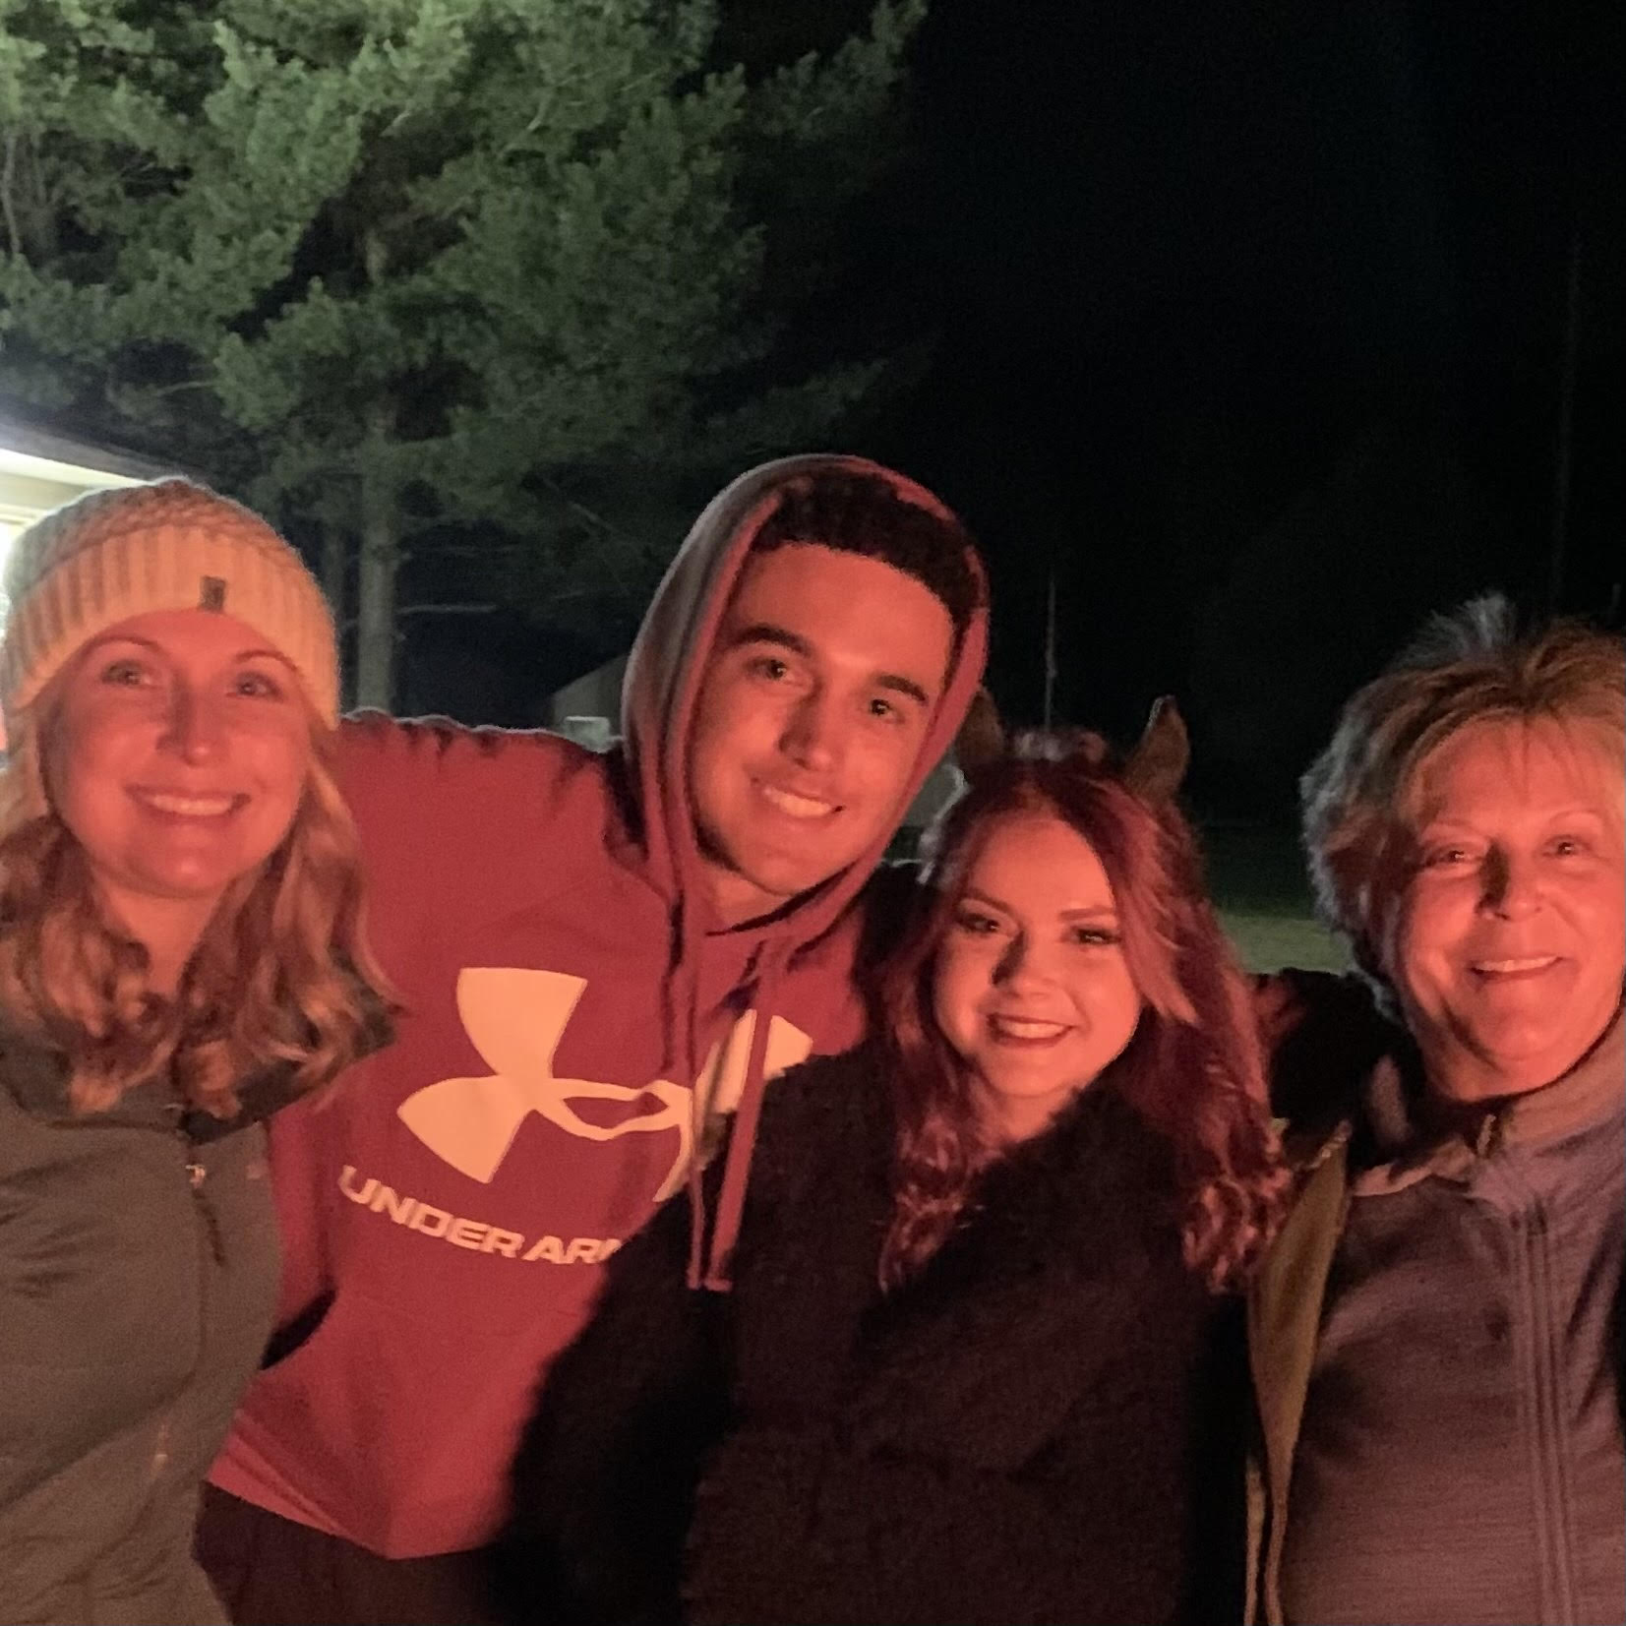

Kevin Windom | 4147798302 | kevinwindom7@gmail.com

# About me

I love python

# Work Experience

**Walmart** *2020-2021*Sales Associate

**Muskego High School** *2017-2021*Learning python on CodeHS

# Skills

* Team Player
* Attention to Detail
* Problem Solving