3GPP TSG RAN WG1 #72bis R1-130869
Chicago, USA, 15th – 19th April 2013

Agenda item: 7.2.6.2
Source: Broadcom Corporation
Title: Observations on Large Scale Parameter Models for 3D System Simulation
Document for: Discussion and Decision

Introduction
This contribution deals with the generation and modeling of Large Scale Parameter (LSP) maps for 3D system simulation. Some previous contributions suggest that new 3D system simulation scenarios and guidelines should be relatively minor deviations from the legacy 2D system simulations. Here we present some modelling ideas for discussion and further study. The intent here is to explore what is reasonably achievable from the modelling (and simulator programing) perspective. We present no measurement or analysis data to support these models, but it is hoped that this discussion will inform future measurement campaigns.
We present three proposals for discussion and further study.
- Non-stationary LSP fields that account for dependence on distance from eNB.
- A vertical LSP map proposal for high-rise buildings as a stack of localized 2D maps.
- A hybrid O-to-I (or I-to-I) model proposal consisting of a global 2D LSP for in-building UEs on floors below the average building height plus localized high-rise building maps.
LSP map calculation represents a significant system simulation computational load. There are multiple maps (LOS, NLOS, O-to-I, etc.) for each eNB location, and these maps must be re-calculated for each simulation drop. For these reasons we are aware that modeling proposals should be evaluated with a keen eye towards computational load.

Non-Stationary LSP Fields
The guidelines of [1], [2] and [3] specify that Transformed Large Scale Parameter (TLSP) fields are spatially stationary Gaussian random fields with circularly symmetric exponential spatial correlation. However, recent contributions [4], [6], have pointed out that in a 3D environment the elevation angle spread depends strongly on distance to the eNB with larger elevation angle spreads occurring near the eNB. Moreover, from Figure 1 of [4] (Samsung) it is evident that NLOS azimuthal angle spread (particularly angle of arrival) should also be highly correlated with elevation angle spread, both with increasing magnitude in close vicinity to the eNB. Data from [6] (Nokia Siemens Networks, Nokia) indicates that there is a strong inverse distance relationship for the mean elevation spread.
Our proposal here is only a very minor extension of TLSP model of [1], [2] and [3].
Proposal 1: TLSP fields should be generated as the zero mean – unit variance, spatially stationary Gaussian fields with constant inter-TLSP correlation and constant spatial correlation distance (per TLSP). Non-stationary LSP fields can be achieved by modulating the mean and/or variance of the TLSP-to-LSP transformation.
The purpose of this proposal is to restrict non-stationarity to the TLSP-to-LSP transformation. The methodology and implementation of TLSP field generation (including spatial filtering and network wrapping continuity) are not altered.
We note that the idea of modelling a non-stationary LSP field in this manner is not without precedence. The SMa-LOS and RMa-LOS scenarios of TR36.814 [1] specifies different shadow fading standard deviation for distances greater or less than the breakpoint from then eNB, which describes a field with a step non-stationarity. See Table B.1.2.1-1 of [1].

Multi-floor Buildings

Some Initial Observations
Indoor LSP fields are different in character from outdoor LSPs in some important ways. These include
- These maps can be localized to specific building locations (as opposed to global network maps with network wrap-around continuity, etc.).
- Indoor LSPs have lower correlation distances than outdoor maps.
- Indoor UEs have low mobility (nearly stationary).
- Indoor UE concentrations may be relatively dense.
Consider the impact of the first two bullets. TLSP maps are generally constructed by spatial filtering on a discrete map grid or lattice. Lower correlation distances require a finer grained TLSP lattice. Consider square map area of side length , let 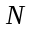 denote the number of map lattice points on the side of the square. Then the separation between map lattice points is 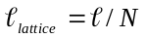, and this distance should be on the order of, or smaller than, the smallest correlation distance. Filtering is typically performed by a spatial FIR filter with an impulse response that covers a circular disk of radius , and this radius is chosen to be a multiple of the largest correlation distance. Then the number of lattice points inside of the impulse response disk is 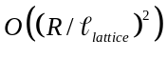 = 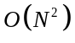. Since there are 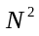 lattice points to filter within the square, we see that the computation load is actually 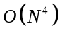 per unit area of TLSP map! Clearly, low correlation distances present a severe computational challenge.
However, indoor TLSP maps are localized. They can be restricted to just the footprint of specific buildings, as opposed to being global maps that cover the entire network. This does increase the complexity of the scenario specification and the code needed to generate localized maps, but the reduction of computation load is well worth it given the computation impact of low correlation distances.

Vertical LSP Maps for High-Rise Buildings
3D system simulation does not generally imply that the LSP maps should be generalized to three dimensions. For example, [5] (Nokia Siemens Networks, Nokia) argues that a 2D LSP map is sufficient. Tall multi-floor buildings, however, may be an exception. It does not make much sense that the ground floor and 20th floor of a tall building should be modelled by a single LSP map, or even by a common set of map statistics. Neither should successive floors be uncorrelated.
Here we present two modelling proposals for multi-floor buildings as illustrated in Figure 1. The first proposal is model LSP maps for successive floors of a high-rise building as a stack of correlated 2D maps. The second proposal is a hybrid model that differentiates between in-building maps for average height buildings and the upper floors of high-rise buildings. This hybrid model is consistent with the recommendations of [5], but the global 2D map only applies for buildings of typical height.

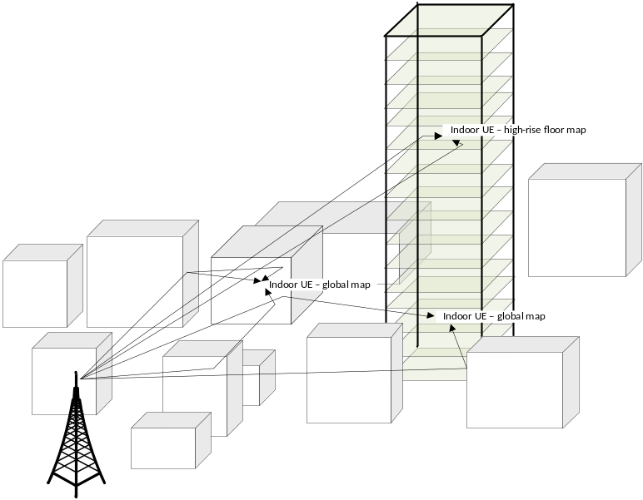
Figure 1: Illustration of urban environment with high-rise building.

Vertical LSP Modelling as a Stack of 2D Maps
Vertically correlated floor maps can be generated by the following steps.
- Generate a sequence of 2D TLSP maps 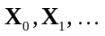for successive floors that are uncorrelated from floor to floor, and spatially i.i.d. (This step includes the inter-eNB correlation step, inter-TLSP correlation and TLSP spatial correlation, as in the procedure of [3].)
- Generate vertically correlated but horizontally i.i.d. maps: 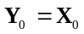 and
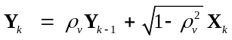
for 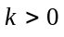 where 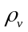 is the correlation between successive floors.
Spatial filtering is then applied on each floor map 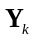 to impose the exponential spatial correlation. This auto-regressive procedure produces an inter-floor correlation of 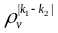 for floors and 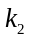. Relative to the original WINNER-II procedure, the only things new here are the generation of multiple maps for successive floors, and the insertion of step 2 to achieve floor-to-floor correlation.
This procedure can be simplified by generating maps only for, say, every 5th floor and using floor-to-floor interpolation for the in-between floors.
This procedure is “reasonably achievable” because the intent is to create the vertical aspect only for tall buildings that represents only a small fraction of the scenario geography, but not necessarily a small fraction of the UE traffic.
Proposal 2: Consider a vertical LSP model for multi-floor high-rise buildings as a stack of correlated 2D maps with floor-to-floor correlation induced by the autoregressive recursion .
In the appendix of this contribution we re-examine the methodology of TLSP generation via filtering on a spatial lattice. We reconsider the direct method of generating the TLSPs via transformation from uncorrelated Gaussian random variables (and using a successive conditioning idea from [9]). This method was considered and rejected in the WINNER-II report [3] due to the size of the required covariance factorization for a network with hundreds or thousands of UEs. However, in the context of localized building maps, where there may be only 10 or 20 active UEs on a single floor, the covariance factorization computation may not so onerous in comparison to the of spatial filtering. Cholesky factorization is 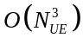 computation. While we provide no precise analysis of computation, details of the alternative method are presented in the appendix, and we believe this method is worthy of further consideration.

A Two Part Model for Lower and Upper Floors
Next, we argue that all floors are not created equal [10]. For a high-rise building, we should not expect that O-to-I LSPs will behave the same on the 20th floor as on the ground floor. At first this may seem like a daunting modelling problem. Actually, it is not. The idea is to build on the existing 2D Urban scenarios. Many urban environments consist of a few very tall buildings embedded in an environment of buildings that typically have only a few floors. The proposed model is to use a global O-to-I map only for building floors that are under 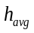 = the average building height of the background environment. Localized multi-floor maps, as in Proposal 2, would then be applied only to buildings that exceed . The motivation here is that UEs that are at or under the average environment height will have propagation conditions that are highly dependent on the structure of the background environment, but this background environment should play much less of a role for UEs on the upper floors.
Proposal 3: The indoor urban environment can be modelled with a two part model consisting of the legacy Urban models for indoor propagation to floors below the average building height, and localized high-rise maps of the type proposed in Section 3.2.1 for floors above the average building height, as illustrated in Figure 1.
This kind of two part model is supported by the following data taken from Table 2 of [11] for three western US cities. See also the ftp site [12] for detailed building statistics of several western US cities. Clearly, the ratio of maximum-to-average building height is on the order of 10-to-1. Moreover, the fact that the standard deviation (for Los Angeles and Phoenix) is larger than the average indicates that standard deviation is highly influenced by a few tall buildings within a background of many moderate and low buildings.
 | Los Angeles | Phoenix | Salt Lake City
Avg. Building Height (m) | 12.0 | 5.6 | 12.0
Standard Deviation (m) | 22.7 | 7.6 | 10.2
Maximum Building Height (m) | 331.0 | 137.0 | 128.2

Conclusion
This contribution has presented the following proposals for discussion and further study.
Proposal 1: TLSP fields should be generated as the zero mean – unit variance, spatially stationary Gaussian fields with constant inter-TLSP correlation and constant spatial correlation distance (per TLSP). Non-stationary LSP fields can be achieved by modulating the mean and/or variance of the TLSP-to-LSP transformation.
Proposal 2: Consider a vertical LSP model for multi-floor high-rise buildings as a stack of correlated 2D maps with correlation induced by the autoregressive recursion .
Proposal 3: The indoor urban environment can be modelled with a two part model consisting of the legacy Urban Micro-cellular model for indoor propagation to floors below the average building height, and localized high-rise maps of the type proposed in Section 3.2.1 for floors above the average building height, as illustrated in Figure 1.

References
- 3GPP TR 36.814, “Further advancements for E-UTRA physical layer aspects.”
- ITU-R M.2135-1, Guidelines for evaluation of radio interface technologies for IMT-Advanced, 2009.
- WINNER-II deliverable D1.1.2, WINNER II channel models.
- R1-130303, Samsung, “Initial study and proposals for 3D channel modelling,” 3GPP TSG RAN WG1 Meeting #72, St. Julian’s, Malta, Jan. 2013.
- R1-130498, Nokia Siemens Networks, Nokia, “Shadow fading observations for 3D channel model,” 3GPP TSG RAN WG1 Meeting #72, St. Julian’s, Malta, Jan. 2013.
- R1-130500, Nokia Siemens Networks, Nokia, “Detailed 3D Channel Model,” 3GPP TSG RAN WG1 Meeting #72, St. Julian’s, Malta, Jan. 2013.
- R1-130768, Samsung, et al., “WF on scenarios for UE-specific elevation beamforming and FD-MIMO,” 3GPP TSG RAN WG1 Meeting #72, St. Julian’s, Malta, Jan. 2013.
- R1-130793, Ad-Hoc Chair, “Summary of ad-hoc session on 3D-channel model for elevation beamforming and FD-MIMO,” 3GPP TSG RAN WG1 Meeting #72, St. Julian’s, Malta, Jan. 2013.
- H. Claussen, “Efficient modelling of channel maps with correlated shadow fading in mobile radio systems,” IEEE 16th International Symposium On Personal, Indoor and Mobile Radio Communications, 2005.
- Council on Tall Buildings and Urban Habitats (CTBUH), Height Calculator, [Online]. Available: http://www.ctbuh.org/TallBuildings/HeightStatistics/HeightCalculator/tabid/1007/language/en-GB/Default.aspx.
- S. J. Burian, et al., “Building height characteristics in three US cities,” MIT SENSEable City Laboratory (http://senseable.mit.edu), 2002.
- National Building Statistics Database, University of Utah and Los Alamos National Laboratory. http://www.nudapt.org/pdf/ - FTP cite containing morphological studies for several western US cities, including Albuquerque, Houston, Los Angeles, Oklahoma City, Phoenix, Portland, Salt Lake City and Seattle.
- J. Sadowsky, et al., “Interpolation Distortion in Large Scale Parameter Maps for Wireless System Simulation,” Broadcom Corp., Irvine, CA, Mar. 2013.

Appendix: Comments on TLSP Generation for Localized Maps with a Moderate Number of UEs
The general method of generating correlated Gaussian variables is to apply a matrix square root of the desired covariance matrix, called the “scaling matrix,” to a vector of i.i.d. standard Gaussians. Referring to this method, the WINNER-II reference [3] (quite correctly, in context) states
“This approach is not appropriate for correlation of [a] large number of parameters, since the dimensions of the scaling matrix are increasing proportionally to the total number of TLSPs in all links (squared dependence in number of elements). For that reason it is more convenient to generate separately the influence of LSP cross-correlation and exponential [spatial] auto-correlation.”
This is the rationale for generating TLSP maps by filtering on a fixed lattice and then interpolating to specific UE locations [13]. In the context of localized building floor maps, however, where the number of UEs per floor may only be on the order of 10-20, this rationale may no longer be valid.
For the purpose of discussion, first consider a single floor independent of other floors in the building. The total number of variables is 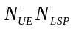. The WINNER-II text, nonetheless, does somewhat overstate the computation issue. We do not need to factor a single 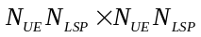 matrix. Let 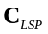 denote the 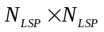inter-TLSP correlation matrix. Then we need to calculate 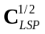 only once, to produce 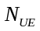independent vectors 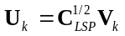 where is UE index, and the 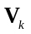s are uncorrelated vectors of size 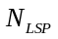with identity covariance. The vectors each have correlation matrix , but as a collection of vectors they are uncorrelated. Fix any particular LSP as indicated by the LSP index . Then 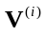 = 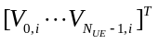 is a vector of i.i.d. zero mean, unit variance Gaussian random variables. We may thus dispense with the fixed LSP index . Let 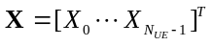 denote the samples of the TLSP field. Then the correlation matrix 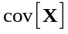 is determined by the correlation distance and the distances between the UEs. This 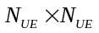 correlation matrix can be factored and applied to the vector 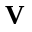 to obtain the desired TLSP samples.
The point is that the computation load is factorizations of correlation matrices for each drop of UEs. (Actually, the number of distinct factorizations is the number of distinct correlation distances 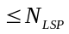.) Since the computation load for an Cholesky factorization is 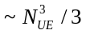 FLOPs, this is a substantially smaller load than a single factorization.
It is well known that can be ill-conditioned, so the factorization should be done with an eigen-decomposition, and possibly a reduced rank transformation, but this factorization is a one-time calculation. For the following discussion, we only need to consider the spatial correlations for multiple samples of a single TLSP.
The factorization of can be performed using the triangular Cholesky factorization. The advantage of the Cholesky algorithm is more efficient than eigen-value decomposition, but it can be numerically unstable for poorly conditioned matrices. In the present context, we are talking about a localized maps having perhaps as many as 10-20 active UEs (at the high end), not the hundreds or thousands of UE present in a macro-cellular global map. We can guarantee that this matrix is well conditioned by imposing a simple minimum separation between UEs requirement, which should be quite reasonable requirement. The short correlation distance of indoor maps also tends to result in well-conditioned covariance matrices.
The above argument has been aimed at LSP generation on the floor of a single building. However, given that the simulation scenario specifies building locations and geographic footprint, we could model the global indoor maps as a set of independent building maps. Given low indoor correlation distances, a set of independent indoor maps generated using this direct scaling matrix approach should be significantly more efficient than one global map produced by filtering on a grid.
Now, consider the issue of inter-floor correlation. Here too there is an efficient solution allowing arbitrary numbers of UEs and random placement of UEs on different floors. The trick is to borrow an idea from Claussen [9] who used conditional Cholesky factors to achieve a block-by-block spatial filtering on the x-y plane. Here we propose to use the same recursive successive conditioning idea, but the twist here is to apply it to the recursive generation of TLSP samples for successive floors of our stack of 2D maps.
In order to be precise, we also need to generalize the notation a bit. Let 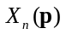 denote the spatial field model for the 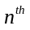floor as a function of an arbitrary position on the x-y plane. (Here we need only consider a single LSP – not the vector of . As above, inter-TLSP correlation is part of the construction.) Each is a stationary Gaussian random field on the x-y plane with circularly symmetric exponential spatial correlation, but the sequence of fields is uncorrelated from floor-to-floor. The autoregressive model applies to these fields, not the successive finite sets of samples as determined by the UE locations. The autoregressive recursion is:
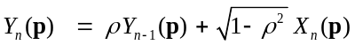 for 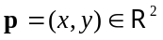.
Now, let 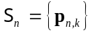 denote the set of (randomly placed) UE locations on the floor. Let 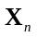 = 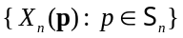 and 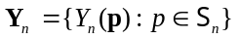. Of course, the floor-to-floor uncorrelated samples can be generated independently floor by floor as described above. We shall next show that the conditional distribution of 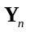 given 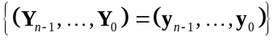 is equivalent to the conditional distribution of given just 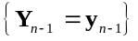, which is not immediately obvious from . The trick is to apply successive conditioning. For the inner conditioning, we condition on the entire fields 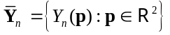. Clearly from we have conditional distribution of given is the same thing as the conditional distribution of given 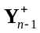 = 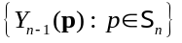. Note that and 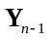are not the same sets of samples. is the set of samples from locations 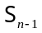. is the set of 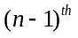 floor 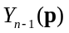 samples at the floor UE locations 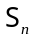. These are different sets of UEs on different floors, having different locations on the x-y plane.
Formally, the successive conditioning argument is perhaps best stated in terms of expectations of an arbitrary transformation 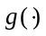. (If you prefer working with probabilities, just substitute event indicator functions for .) The argument is
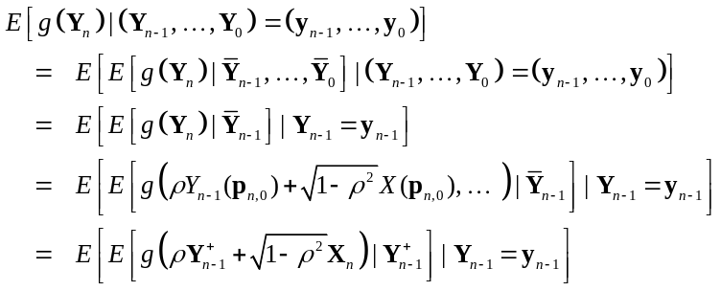
The 2nd line above is the application of the successive conditioning principle. The 3rd and 4th lines apply the autoregressive property of successive fields . In the last line, we have just written out the expression for 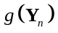 and noted that the only points of 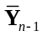that determine are the samples , and hence, the rest of the conditioning can be ignored. The only random variables left in the inner conditional expectation are the samples = and , which are uncorrelated. Thus,
.
In words, this last line says that the conditional distribution of the samples given all the lower floor samples 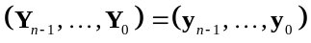 is equivalent to the conditional distribution given just 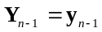. Moreover, the conditional p.d.f. 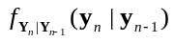 is just the appropriate convolution of 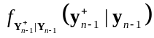 and 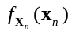 because these are (conditionally and unconditionally) independent. Thus, we can sample from the conditional p.d.f. by first generating independent samples of from and from , and then combining as 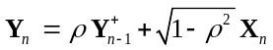.
Of course, is a Gaussian p.d.f. as determined by its conditional mean and covariance matrices. First observe that
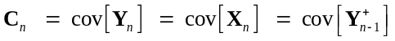
because all three correlation matrices are generated from the same UE location set . Also define 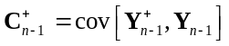. Then
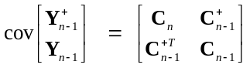
from which it follows that
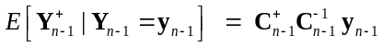
and
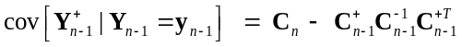.
The matrix inversions can be calculated using triangular Cholesky factorization, which was the same factorization used to generate the sample 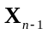in the previous iteration.
To summarize, given 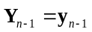 we generate the sample vector from the steps
- Generate from the Gaussian distribution with mean and covariance .
(This uses the factorization of 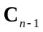that was stored in the previous recursion).
- Generate from the zero mean Gaussian distribution with covariance 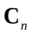.
(Store the factorization of for application to in the next iteration.)
- 

