**Memo V1.0: Dependencies and Libraries for Analytic Tools**

Author: Chen Wang (Tech Services)

Mailto: [cwang138@illinois.edu](mailto:cwang138@illinois.edu)

**Architecture**

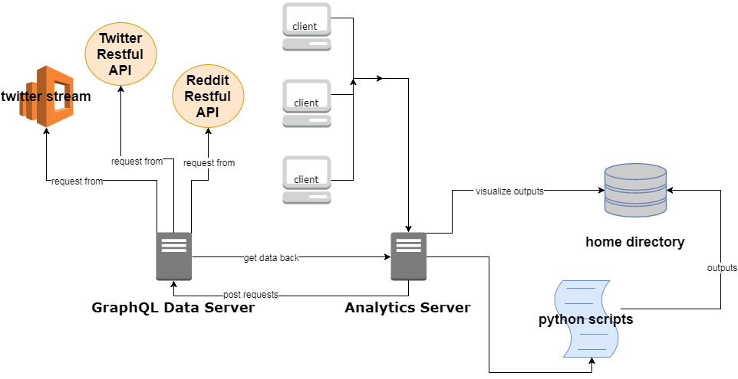

**Code Structures**

./package.json 🡪 npm start will invoke this package.json in which concurrently boost up the data server as well as the analytics server

./app.js 🡪 main of the analytics app

./public 🡪 bootstrap css, customized javascript code on client side, logos and images

./scripts 🡪 python scripts that do the computing and analysis of the social media data collected

./routes 🡪 analytics app’s routes

./views 🡪 analytics app’s webpage templates

./graphql 🡪 this directory hosts the GraphQL data server code

./graphql/app.js 🡪 main for the data server

./graphql/API 🡪 how graphql will actually interact with social media platforms and get data

./graphql/data/schema 🡪 graphql data schema

./graphql/bin/www 🡪 invoke the graphql server

**Python and its dependency library**

* Install python on Ubuntu:

$ sudo apt-get update

$ sudo apt-get install python3.6

* Check if pip is installed:

$ command -v pip3

* Add libraries via site-packages

Site-packages.zip contains all the dependency libraries (including a few minor custom change)

Unzip site-package.zip, and merge it to python’s Lib/site-package directory. Usually this path depends on where you installed your python. Ask me if you cannot find it (cwang138@illinois.edu)

* Alternatively, install libraries via pip:

Install pip if it’s not installed:

<https://pip.pypa.io/en/latest/installing/>

curl [https://bootstrap.pypa.io/get-pip.py -o get-pip.py](https://bootstrap.pypa.io/get-pip.py%20-o%20get-pip.py)

python get-pip.py

* Use Pip to install dependency libraries:

pip3 install sklearn

pip3 install pyLDAvis

pip3 install …

* List of dependency libraries used in the scripts

|  |  |  |
| --- | --- | --- |
| **Command** | **Description** | **Custom change** |
| pip3 install numpy scipy matplotlib pandas | Scipy stack for data science | no |
| pip3 install pyldavis | Visualize LDA topic modeling | yes |
| pip3 install scikit-learn | Machine learning packages | no |
| pip3 install plotly | Create visualization in HTML format | no |
| pip3 install python-dotenv | Read environment variables from .env | no |
| pip3 install beautifulsoup4 | Beatifulsoup is for parsing html | no |
| pip3 install nltk  python -m nltk.downloader all. | Natural language processing stacks | no |
| pip3 install git+https://github.com/erikavaris/tokenizer.git | Reddit tokenizer | yes |
| Pip3 install twython | Twitter specified | no |

**Analytics APP (NodeJS server 1)**

* Install nodejs and npm (package manager)

$ sudo apt-get install nodejs

$ sudo apt-get install npm

$ node -v

$ npm –v

* package.json in the root directory is the dependencies for analytics app

under root directory, $ npm install

* list of dependencies and its details

|  |  |
| --- | --- |
| **Libraries** | **Description** |
| adm-zip | ADM-ZIP is a pure JavaScript implementation for zip data compression for NodeJS |
| body-parser | Parse incoming request bodies in a middleware before your handlers, available under the req.body property. |
| cookie-parser | Parse Cookie header and populate req.cookies with an object keyed by the cookie names. |
| csv-string | Parse and Stringify for CSV strings in the same fashion as JSON parser |
| debug | A tiny node.js debugging utility modelled after node core's debugging technique. |
| dotenv | Dotenv is a zero-dependency module that loads environment variables from a .env file into process.env. |
| express | Fast, unopinionated, minimalist web framework for node. |
| express-session | Create a session middleware in express framework. |
| fs | Nodejs’s filesystem |
| jsonexport | This module makes easy to convert JSON to CSV and its very customizable. |
| morgan | HTTP request logger middleware for node.js |
| node-fetch | A light-weight module that brings window.fetch to Node.js |
| nodemailer | Send e-mails from Node.js |
| nodemon | For use during development of a node.js based application. |
| oauth | A simple oauth API for node.js . |
| path | Nodejs’s path system |
| pug | Pug is a high performance template engine heavily influenced by Haml and implemented with JavaScript for Node.js and browsers. |
| python-shell | A simple way to run Python scripts from Node.js with basic but efficient inter-process communication and better error handling. |
| serve-favicon | Node.js middleware for serving a favicon. |

**Data Server (NodeJS server 2)**

* Install nodejs and npm (package manager)

Same as above

* package.json in the “ ./graphql” directory is the dependencies for the data server

cd into “graphql” directory, $ npm install

* list of dependencies and its details

|  |  |
| --- | --- |
| **Libraries** | **Description** |
| aws-es | A Node.js binding for Amazon's Elasticsearch service which requires Amazon's Signature Version 4. |
| aws-sdk | AWS SDK for JavaScript |
| bluebird | Full featured Promises/A+ implementation with exceptionally good performance |
| body-parser | Parse incoming request bodies in a middleware before your handlers, available under the req.body property. |
| cookie-parser | Parse Cookie header and populate req.cookies with an object keyed by the cookie names. |
| cors | Node.js CORS middleware |
| dataloader | A data loading utility to reduce requests to a backend via batching and caching. |
| debug | A tiny node.js debugging utility modelled after node core's debugging technique. |
| dotenv | Dotenv is a zero-dependency module that loads environment variables from a .env file into process.env. |
| elasticsearch | The official low-level Elasticsearch client for Node.js and the browser. |
| express | Fast, unopinionated, minimalist web framework for node. |
| express-graphql | Production ready GraphQL HTTP middleware. |
| graphql | A Query Language and Runtime which can target any service. |
| http-aws-es | Use the elasticsearch-js client with Amazon ES |
| morgan | HTTP request logger middleware for node.js |
| node-fetch | A light-weight module that brings window.fetch to Node.js |
| nodemailer | Send e-mails from Node.js |
| nodemon | For use during development of a node.js based application. |
| oauth | A simple oauth API for node.js . |
| path | Nodejs’s path system |
| pug | Pug is a high performance template engine heavily influenced by Haml and implemented with JavaScript for Node.js and browsers. |
| request | A simple way to run Python scripts from Node.js with basic but efficient inter-process communication and better error handling. |
| serve-favicon | Node.js middleware for serving a favicon. |
| snoowrap | A JavaScript wrapper for the reddit API |
| twitter | Twitter API client library for node.js |
| when | A lightweight Promises/A+ and when() implementation, plus other async goodies. |