Kevin Wong

November 06, 2019

Foundations of Programming: Python

University of Washington

Professor: Randal Root

Assignment 05

**Introduction**

For assignment 5, we are to modify a new script that manages a "ToDo list." The "ToDo" file will contain two columns of data, "Task" and "Priority." We will then load the columns into a Python Dictionary object. The user will have a few options to view, add, remove and save data to the file.

**Assignment**

We are provided a starting template script to modify as our own to complete this assignment. This new script manages a “ToDo list” text file. The file contains two columns of data, “Task” and “Priority”. When starting the script, the two columns will be loaded in a Python dictionary object, where each dictionary represents one row of data, and these rows must be added to a Python List object to create a table of data.

When the user runs the program, a “ToDoList” text file will be created if one does not already exist. If this is so, selecting option 1 to show current data will reveal none, as show in Figure 1.

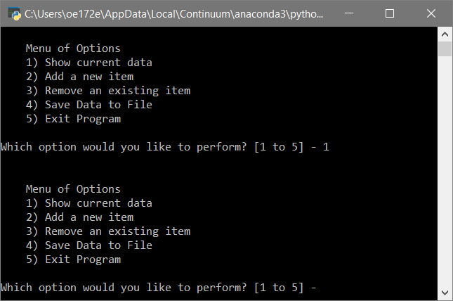

**Figure 1. Screenshot of the display menu of options with user selecting option 1 when no data currently exist**

Next, if the user chooses the option 2 to add a new item, the user will be prompted to enter the task name and the priority value. Figure 2 shows an example of the user with inputs of “Mop” and “2” as the “Task” and “Priority” respectively. Next, when the user selects option 1 to display the current data, it will display it as shown in Figure 2.

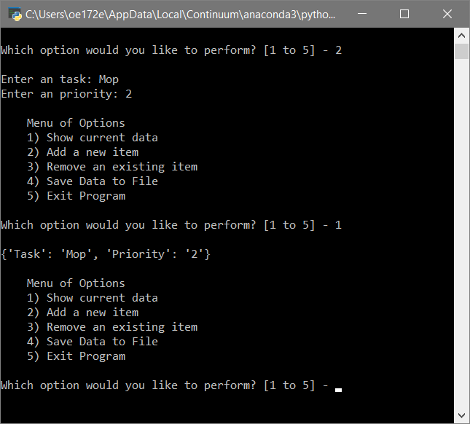

**Figure 2. Screenshot of user adding a new item and displaying it.**

Figure 3 shows when the user decides to add another new task, “Dry” and then selects the option display the new list. Note that now we have 2 list in the table.

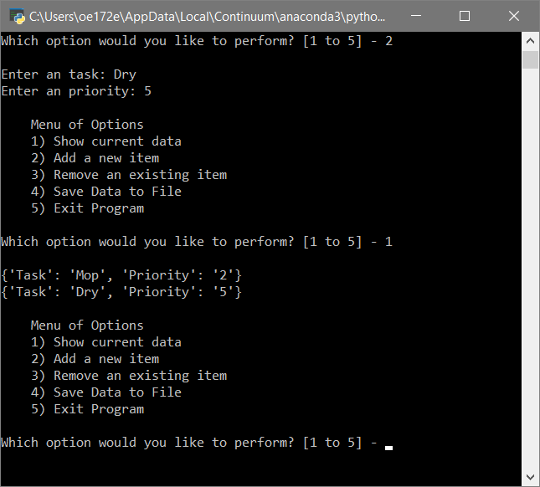

**Figure 3. Screenshot of user adding another new item and then displaying the new list.**

In Figure 4, the user selects the option 2 to add another new item, “Spray” to the list/table. And then selects option 3 to remove the existing item, “Dry”. The user then selects option 1 to display the current data to confirm that it really has been removed.

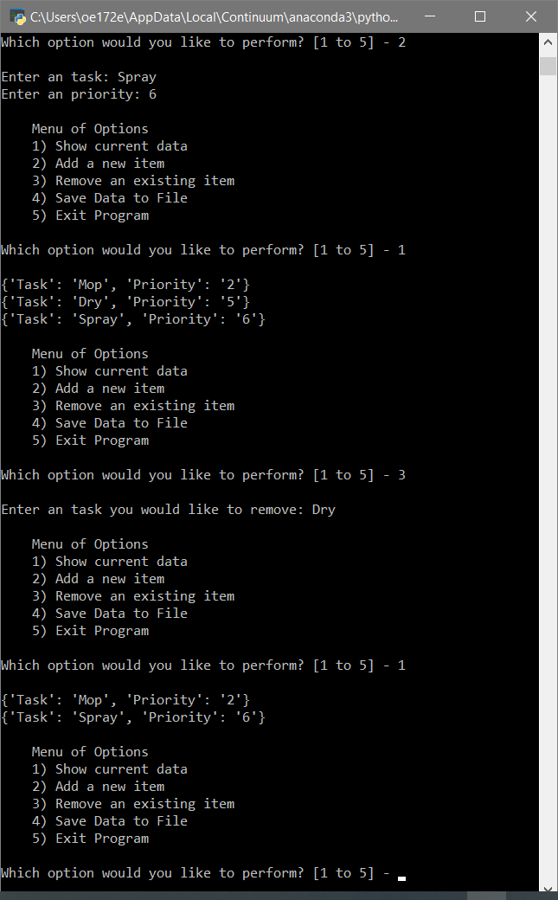

**Figure 4. Screenshot of user adding a new item, then deleting an existing item and then displaying the current data.**

In Figure 5, when the user selects option 4 to save the data.

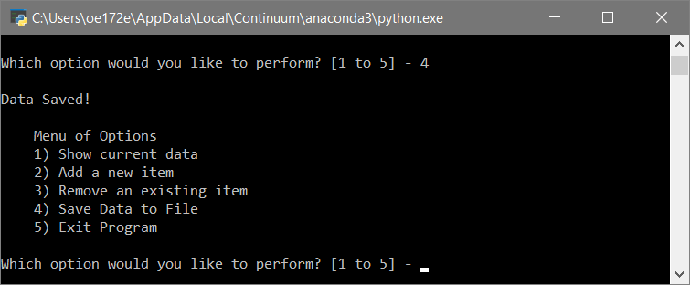

**Figure 5. Screenshot of the user selecting option 4 to save the data.**

In Figure 6, opening the text file, “ToDoList.txt” reveals the data saved.

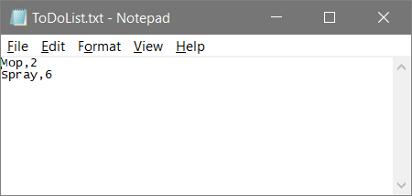

**Figure 6. Screenshot of the data saved in text file, “ToDoList.txt”.**

After selecting option 5 to exit the script and then running the program again, when the user selects option 1 to display the current data, the existing data from the text file will be pulled in and displayed as shown in Figure 7.

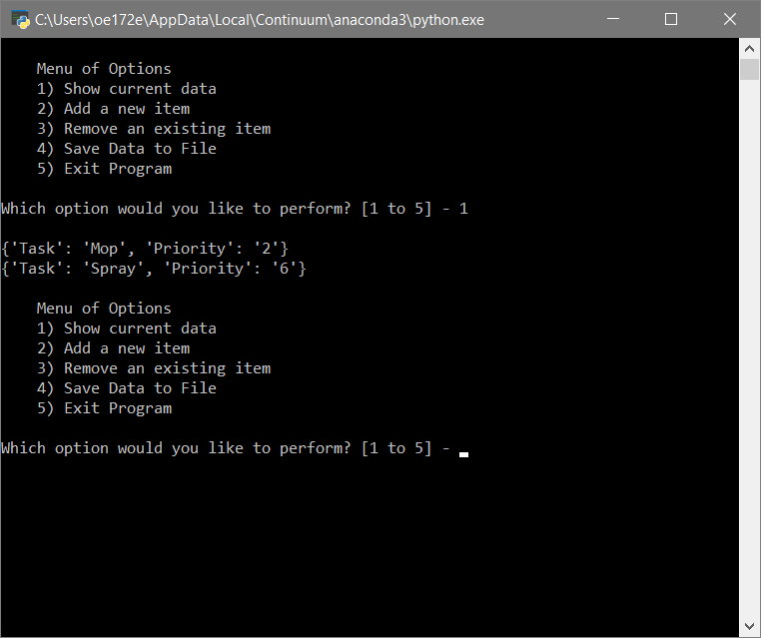

**Figure 7. Screenshot of the script closed and started again to display the current data in the file still exist.**

**Code**

Figure 8 and 9 displays the code.

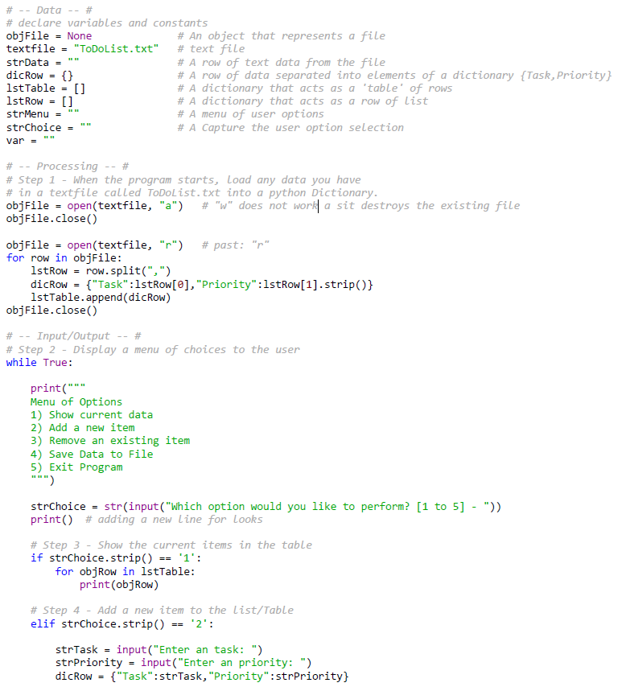

**Figure 8. A Screenshot of the first portion of the code.**

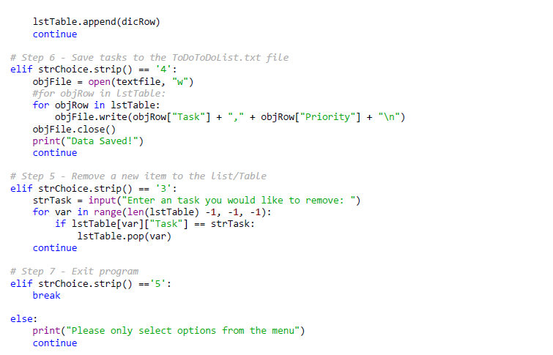

**Figure 9. Screenshot of the rest of the code.**

**Readings**

1. **Chapter 5 ofPython Programming for the Absolute Beginner(Third Edition) by Michael Dawson.**

## **Module 5 PDF - Mod5PythonProgrammingNotes**

1. <https://www.afterhoursprogramming.com/tutorial/python/lists/>

(Website did not work)

1. <https://www.afterhoursprogramming.com/tutorial/python/dictionaries/>

(Website did not work)

1. <http://www.afterhoursprogramming.com/tutorial/Python/Reading-Files/>

(Website did not work)

**Videos**

# Assignment 05 Python Mod5 Project by Randal Root

# <https://youtu.be/P5wOsnPjn6Y>

1. **Python Coding - Reading and Writing to Text Files – www.ComputerScienceUK.com**

<https://youtu.be/m0o0CkYsDzI>