**Predict Aircraft Engine Remaining Life Cycle Use Case**

**Data Description and Objective:** The engine is operating normally at the start of each time series, and develops a fault at some point during the series. In the training set, the fault grows in magnitude until system failure. In the test set, the time series ends some time prior to system failure, and the objective is to predict the number of remaining operational cycles before engine failure. **]]]**

Imagine yourself sitting in an airplane and heading back home and visiting your family which you have not seen for a few years, but suddenly you hear a huge noise. Soon after, you see all the lights are turned off, feel that the plane is descending rapidly and hear all the passengers around you screaming. At that point, your excitement turns to fear and fright, and you know that there is extremely low chance that you are going to survive. Hence, acknowledging when an aircraft engine fails to operate is essential because it can prevent such tragedies from happening. Moreover, it save significant amount of human labor resources and money by preventing to repair a soon-to-be dead engine.

Due to safety operations, aircrafts are examined every once while, and inspectors upload the information onto an application, which eventually forms a big dataset. However, predicting when an engine fails to operate with traditional approaches is difficult. There are thousands types of engines, and each engine varies from another even when they are classified as same type. Furthermore, each engine starts with different degrees of initial wear and manufacturing variation which are considered normal, increasing the difficulty for humans to accurately predict aircraft engine remaining life cycle. Hence, it’s extremely important to construct a predictive model that can extract important characteristics of each particular engine and estimate its remaining life cycle.

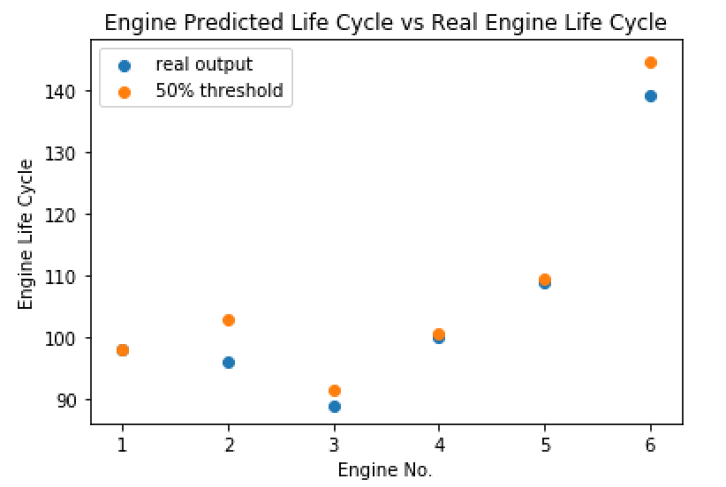We have constructed a good performance predictive model which calculates the probability of engine survival at each life cycle for an engine. Once an engine’s life cycle surpasses the 50 percent probability of engine failure, it means that the likelihood of engine breakdown is high. The graph below presents some of the engines’ 50 percent probability of engine failure versus real engine failure life cycle. From the few engines that we have examined here, we can see that they fail to operate few life cycles after they reach the 50 percent benchmark, in which some of them halt right after. Henceforth, the model results performs well With high performance model, people can employ it to predict remaining life cycle, which help them make preparation in advanced in getting rid of the aircraft engine and replacing it with a new one.

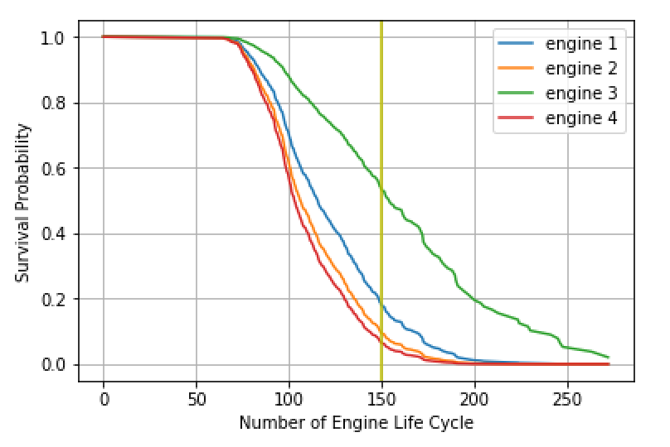

The dataset obtained contains 4 types of aircraft engines, and each colored line in the graph represents an engine out of each type. From the graph above, we can see that engine 3 have a higher chance of surviving longer compared with other engines. When number of engine life cycle equals to 50, engine 3 has a probability of more than 50 percent of survival rate while other three engines have survival rate of below 20 percent. Henceforth, the type which engine 3 belongs to tends to work for a longer period of time compared with other types of engine.