Student: Kevin Zamora Amela
Subject: English 2 (DAM)

Hi there!

¿Are you able to adapt to coming technological revolution?
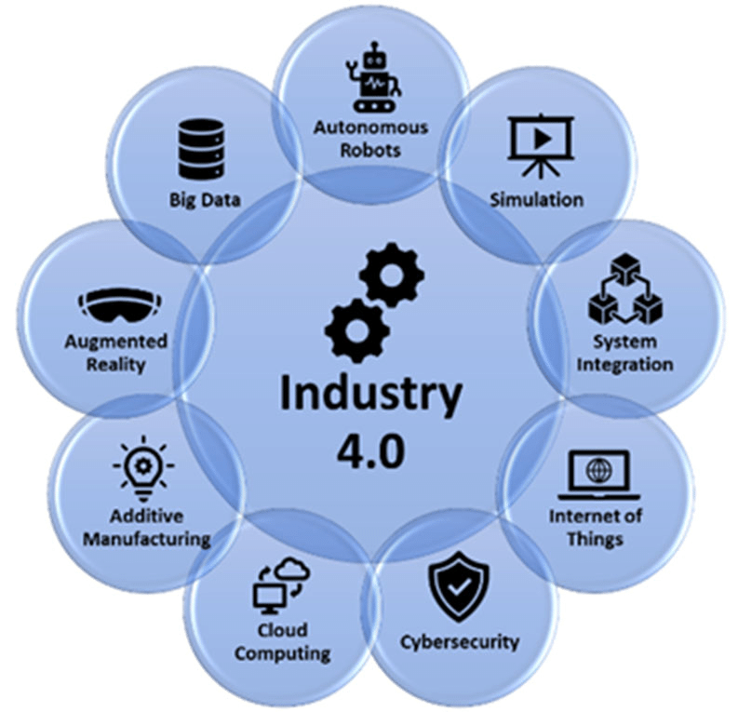
Is widely known that artificial intelligence an other emerging technologies, that are concerned in the “industry 4.0 movement and trend, have appeared and are currently modulating almost all our life.

Day by day, it becomes more and more relevant and important at time to develop all the aspects presents in our daily life. And nowadays, the number of new technological job opportunities grows constantly. If you don’t believe me, you should research into the main “finding job portals” and discover what business are demanding right now. All of this is already a fact and we can demonstrate with a lot of educational and job reviews that are published online.

In conclusion, we should think much more about it, make better decisions and starting with remodulating and improving our education system. It isn’t running properly and we must wake up!

