Instructions for creating electronic student files in advance of charter school closure:

The Commissioner of Education is charged with ensuring that student records from closed charter schools are preserved in a safe, efficient, and secure manner.

All Texas public schools are required by law (13 Texas Administrative Code (TAC) §7.125(a)(6)) to maintain and permanently retain student record data. This data includes academic records of students in grades 9-12, records of access to student information, scholastic census records, and accreditation reports.

When a charter school is closed, current and previous students’ records must be transferred to a commissioner-designated custodian who is capable of maintaining the records and making them readily accessible to students, parents, former school employees, and other persons entitled to access. 19 TAC §100.1203(b). The custodian’s responsibilities may include fulfillment of requests for those records from other public schools to which a student may transfer; or from post-secondary institutions pursuant to a request from the student.

In order to make such records accessible, the following procedures must be completed by the charter school’s administrative staff after the academic year has ended, but before the school’s closure date.

The following process assumes the charter school uses a commercially available Student Information Software (SIS) application to electronically house current and previous student data in a database. Each SIS vendor in use by Texas public schools provides an extract facility/utility that allows an authorized user to extract a student record from the database into an Extensible Markup Language (XML) formatted file, which is typically uploaded into the Texas Records Exchange (TREx) application for transmission to another school district or charter.

1. On a PC or a network server create a directory to contain all the student records and any pertinent supporting documents. Within that directory, create a sub-directory entry for each student whose records will be transferred to the records custodian. The naming convention and directory structure will be as follows:
Directory Name = Student Records
SubDirectory Names:
#### = last 4 digits of the Student ID
LastName = student’s last name
underscore
FirstName = student’s first name

Example: 5678Doe_John

2. An authorized staff member at the closing charter will access the charter’s SIS using its extract facility and extract each student’s record and place it into that student’s subdirectory created in step 1 above.

3. The staff member will then scan and store all pertinent attachment documents into the same student’s subdirectory. The resulting directory would look like this:
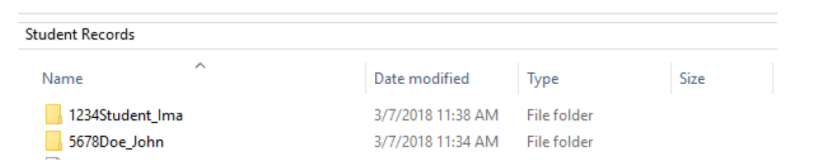
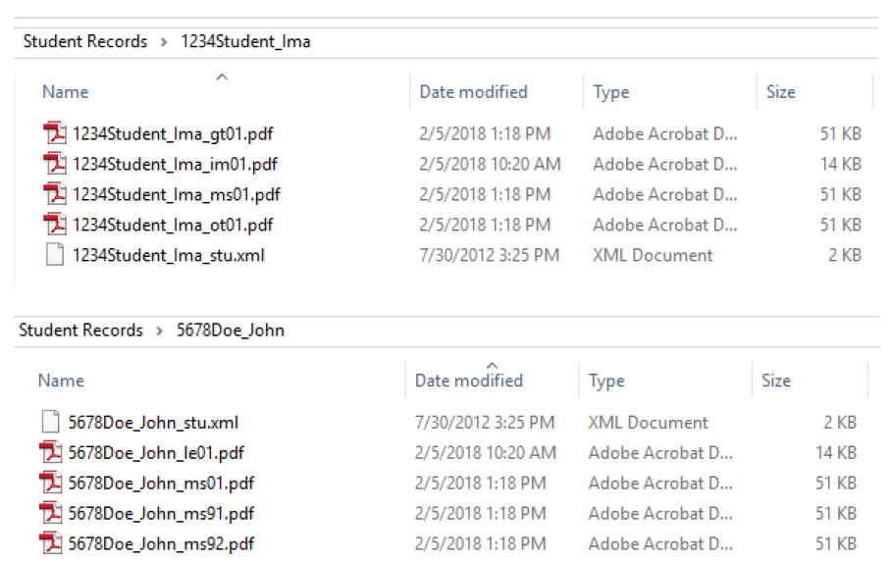

Note that the extract file and attachment file naming conventions are described in the TREx Data Standards overview section. They are included below:

File Requirements
• File size limitation: 32MB
• Extract files (xml filetype) naming convention:
####LastName_FirstName_descriptor

#### = last 4 digits of the Student ID
LastName = student’s last name
FirstName = student’s first name
Descriptor = stu (student record)

Order | 1 | 2 | 3 | 4 | 5 | 6
Description | Last 4 digits of student ID | Student Last Name | Underscore | Student First Name | Underscore | 3-character descriptor
Example | 5678 | Doe | _ | John | _ | stu
Example: 5678Doe_John_stu

• Attachment naming convention:
####LastName_FirstName_Descriptor##

#### = last 4 digits of the Student ID
LastName = student’s last name
FirstName = student’s first name
Descriptor = le (Limited English Proficiency (LEP) attachment)
im (Immunization record attachment)
gt (Gifted/Talented (GT) attachment, such as a GT profile)
ms (Miscellaneous record)
ot (Other – to be used for any document that the district is uncomfortable giving any indication of what is contained within the document)
tl (Transcript Legend)
## - two-digit generation number (01-99)* to allow for multiple attachments within type

*Note: Numbers 81-89 under ms (miscellaneous record) are strictly reserved for Disciplinary Action attachments. Numbers 91-99 under ms (miscellaneous record) are strictly reserved for Individual Education Plan (IEP) attachments.

Order | 1 | 2 | 3 | 4 | 5 | 6 | 7
Description | Last 4 digits of student ID | Student Last Name | Underscore | Student First Name | Underscore | 2-character descriptor | 2-digit generation number
Example | 5678 | Doe | _ | John | _ | Ms | 91
Example: 5678Doe_John_gt01 (indicates the attachment is a GT record)
5678Doe_John_ms91 (indicates the attachment is related to an IEP)
5678Doe_John_ms01 (indicates miscellaneous attachment is not IEP-related)

4. Download the completed Student Records Directory to a flash drive and provide to the TEA or TEA-appointed conservator within 10 days of closure.

