Database at start:

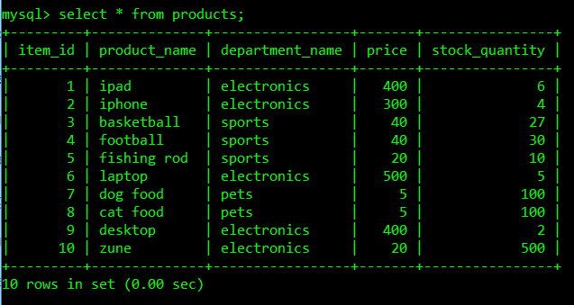

Running ‘node bamazoncustomer’ on the command line after installing dependencies results in the array of json objects being displayed and a prompt being raised:

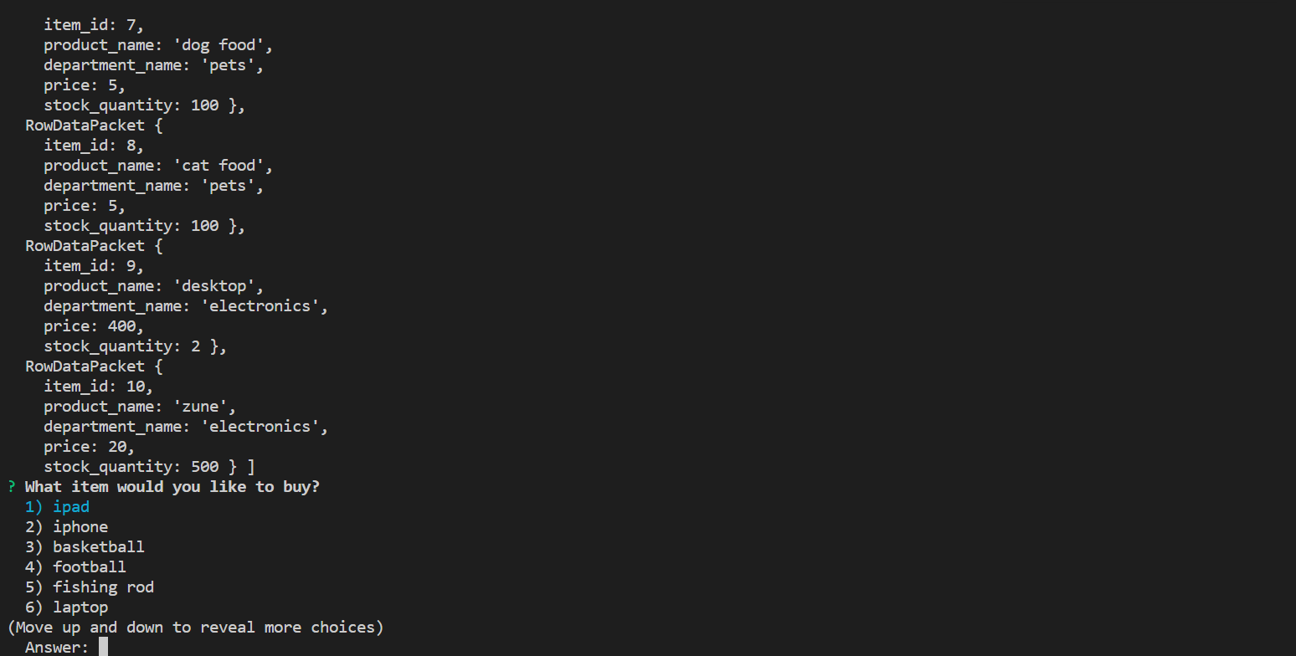

Enter in the item id to select the item in the prompt:

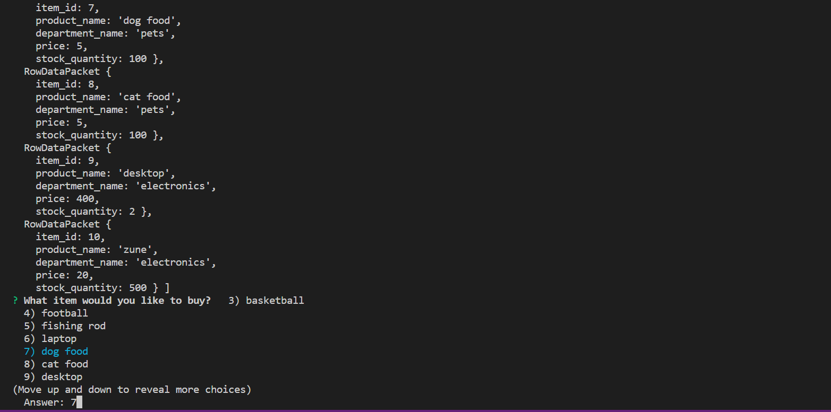

Then it will ask you for a quantity which you can enter in and the terminal will log the total spent:



Selecting all items from the product table in mysql shows that the quantity for dog food has been updated from 100 to 88:

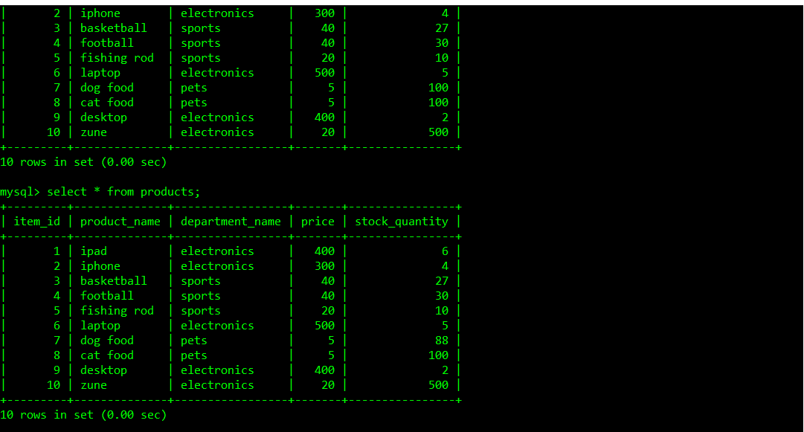

If you try to buy more than what is in stock, the terminal will let you know you can’t buy that much and the quantity in the database will remain unchanged:



