# 企业安全监控zabbix安装部署方案

# 前言：安装方式

Yum安装所有相关软件包

Yum+tar包安装

# 一、yum安装依赖包

## 1．1安装前准备

### 1．1．1更新epel源

wget -O /etc/yum.repos.d/epel.repo http://mirrors.aliyun.com/repo/epel-6.repo

### 1．1．2下载zabbix安装包

[root@linux-node1 ~]#mkdir /home/oldboy/tools

[root@linux-node1 ~]#cd /home/oldboy/tools

[root@linux-node1 tools]# wget -q http://repo.zabbix.com/zabbix/2.4/rhel/6/x86_64/zabbix-release-2.4-1.el6.noarch.rpm

[root@linux-node1 tools]# rpm -ivh zabbix-release-2.4-1.el6.noarch.rpm

## 1．2 开始安装 zabbix

yum -y install zabbix zabbix-server zabbix-server-mysql #<==ZABBIX SERVER相关

yum -y install zabbix-web zabbix-web-mysql #<==Apache、Php Web界面环境

yum -y install zabbix-agent #<== ZABBIX客户端

yum -y install mysql-server mysql #<==MySQL客户端与服务端

**###安装zabbix依赖的服务软件包**

yum -y install zabbix zabbix-server zabbix-server-mysql zabbix-web zabbix-web-mysql zabbix-agent mysql-server mysql

## 1．3 修改mysql的配置文件my.conf

cp /usr/share/mysql/my-medium.cnf /etc/my.cnf

vim /etc/my.conf

**###放在[mysql]下面**

default-storage-engine = innodb

innodb_file_per_table

collation-server = utf8_general_ci

init-connect = 'SET NAMES utf8'

character-set-server = utf8

**启动mysql**

/etc/init.d/mysqld start

## 1．4 初始化 zabbix 存储数据的数据库 MySQL

[root@linux-node1 ~]# mysql -e "create database zabbix character set utf8 collate utf8_bin;"

[root@linux-node1 ~]# mysql -e "grant all on zabbix.* to zabbix@localhost identified by 'zabbix';"

[root@linux-node1 ~]# cd /usr/share/doc/zabbix-server-mysql-2.4.6/create

**#导入数据**

[root@linux-node1 create]# mysql zabbix<schema.sql

[root@linux-node1 create]# mysql zabbix<images.sql

[root@linux-node1 create]# mysql zabbix<data.sql

[root@linux-node1 create]# mysqladmin -uroot password oldboy

**#修改时区**

[root@lb01 conf.d]# vim /etc/httpd/conf.d/zabbix.conf

php_value date.timezone Asia/Shanghai

**#启动zabbix-server服务**

/etc/init.d/zabbix-server start

## 1．5 安装zabbix客户端

yum install zabbix-agent -y

**修改配置文件**

[root@linux-node1 zabbix]# cat -n /etc/zabbix/zabbix_agentd.conf |grep 85

85 Server=127.0.0.1

185 ### Option: BufferSize

285 #Full path to location of agent modules.

[root@linux-node1 ~]# cat /etc/zabbix/zabbix_server.conf |grep -E "DBPassword|DBHost|DBUser"

DBHost=localhost

DBUser=zabbix

DBPassword=zabbix

rpm –ivh http://repo.zabbix.com/zabbix/2.4/rhel/6/x86_64/zabbix-release-2.4-1.el6.noarch.rpm  
yum –y install zabbix-agent  
vim /etc/zabbix/zabbix_agentd.conf   
Server=  
/etc/init.d/zabbix-agent start  
netstat -lnupt |grep 10050

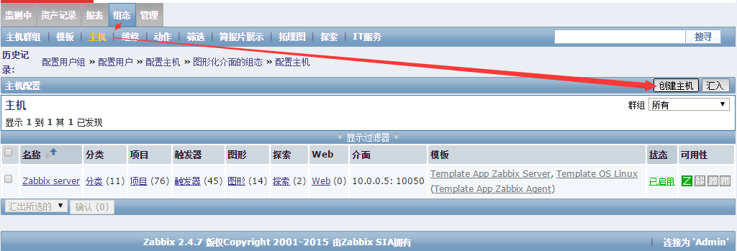  
  
  
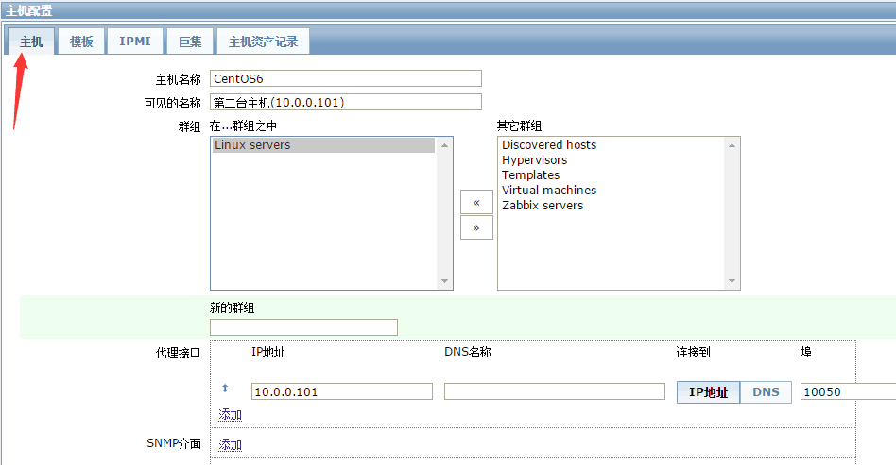  
  
  
<http://www.xuliangwei.com/xubusi/117.html> zabbix利器

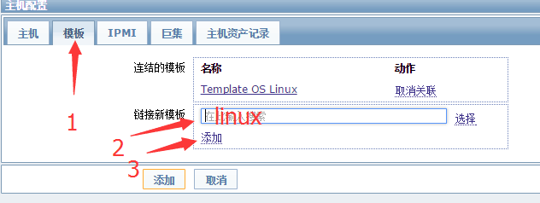

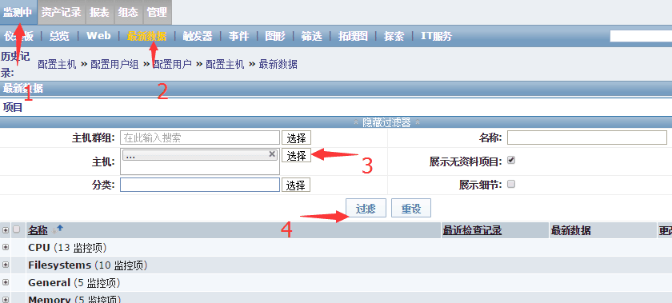

## 1．6 解决中文乱码问题

yum -y install wqy-microhei-fonts

ll /etc/alternatives/zabbix-web-font   
  
  
rm –f /etc/alternatives/zabbix-web-font  
  
ln -s /usr/share/fonts/wqy-microhei/wqy-microhei.ttc /etc/alternatives/zabbix-web-font

## 自定义zabbix模板

yum -y install zabbix-get

zabbix_get -h

[root@linux-node1 ~]# zabbix_get -h

Zabbix get v2.4.7 (revision 56694) (12 November 2015)

usage: zabbix_get [-hV] -s <host name or IP> [-p <port>] [-I <IP address>] -k <key>

Options:

-s --host <host name or IP> Specify host name or IP address of a host

-p --port <port number> Specify port number of agent running on the host. Default is 10050

-I --source-address <IP address> Specify source IP address

-k --key <key of metric> Specify key of item to retrieve value for

-h --help Display help information

-V --version Display version number

Example: zabbix_get -s 127.0.0.1 -p 10050 -k "system.cpu.load[all,avg1]"

[root@linux-node1 ~]# zabbix_get -s 127.0.0.1 -p 10050 -k "system.cpu.load[all,avg1]"

0.000000

统计登录系统的用户多少

258 UserParameter=login-user,who|wc -l

Zabbix 传给脚本3个参数$1（邮件收件人） $2（邮件主题） $3（邮件内容）

[root@linux-node1 ~]# grep Alert /etc/zabbix/zabbix_server.conf

### Option: AlertScriptsPath

# AlertScriptsPath=${datadir}/zabbix/alertscripts

AlertScriptsPath=/usr/lib/zabbix/alertscripts

[root@linux-node1 ~]#

[root@linux-node1 ~]# cd /usr/lib/zabbix/alertscripts/

[root@linux-node1 alertscripts]# vim send_email.sh

echo "$1" "$2" "$3" >>/tmp/test

[root@linux-node1 alertscripts]# chmod +x send_email.sh

[root@linux-node1 alertscripts]# pwd

/usr/lib/zabbix/alertscripts

[root@linux-node1 alertscripts]# ll

-rwxr-xr-x 1 root root 32 Dec 11 17:13 send_email.sh

[root@linux-node1 alertscripts]# vim send_email.sh

echo "$1" "$2" "$3" >>/tmp/test

[root@Zabbix-Server alertscripts]# vim email.sh

#!/bin/bash

email_File=/tmp/email.log

function main(){

echo "$3" >$email_File

/usr/bin/dos2unix $email_File

/bin/mail -s "$2" "$1" <$email_File

}

main "$1" "$2" "$3"

# 二、二进制软件包安装

## 2．1 准备环境

### 1、LAMP环境搭建

yum install httpd php mysql mysql-server php-pdo php-mysql gcc gcc-c++ glibc mysql mysql-devel libxml2-devel curl-devel net-snmp net-snmp-devel libssh2-devel OpenIPMI-devel php-gd php-xml php-mbstring php-bcmath -y

### 2、下载zabbix二进制软件包

[root@linux-node1 ~]# mkdir /home/oldboy/tools

[root@linux-node1 ~]# cd !$

cd /home/oldboy/tools

[root@linux-node1 tools]# rz

rz waiting to receive.

开始 zmodem 传输。 按 Ctrl+C 取消。

100% 14660 KB 14660 KB/s 00:00:01 0 Errors

[root@linux-node1 tools]# ll

total 14664

-rw-r--r-- 1 root root 15012768 Nov 12 18:42 zabbix-2.4.7.tar.gz

方法二

wget http://jaist.dl.sourceforge.net/project/zabbix/ZABBIX%20Latest%20Stable/2.4.7/zabbix-2.4.7.tar.gz

### 3、启动Apache服务

/etc/init.d/httpd start

### 4、拷贝mysql配置文件

cp /usr/share/mysql/my-medium.cnf /etc/my.cnf

cp: overwrite `/etc/my.cnf'? y

### 5、修改mysql的配置文件my.conf

cp /usr/share/mysql/my-medium.cnf /etc/my.cnf

vim /etc/my.conf

**###放在[mysql]下面**

default-storage-engine = innodb

innodb_file_per_table

collation-server = utf8_general_ci

init-connect = 'SET NAMES utf8'

character-set-server = utf8

**启动mysql**

/etc/init.d/mysqld start

**#第一次启动mysql数据库，会初始化数据库出现两次OK表示正常**

## 2．2 测试LAMP环境是否正常

### 1、创建一个php主页测试

cd /var/www/html/

cat info.php

<?php

phpinfo();

?>

### 2、浏览器查看结果



**###正常！**

## 2．3 创建mysql数据库

mysql #<=====进入数据库

mysql> create database zabbix; #<=====创建zabbix库

mysql> grant all on zabbix.* to zabbix@localhost identified by 'zabbix'; #<=====授权zabbix管理用户

### 将zabbix数据导入到数据库中

cd /home/oldboy/tools/

tar xf zabbix-2.4.7.tar.gz

[root@linux-node1 tools]# cd zabbix-2.4.7/database/mysql/

[root@linux-node1 mysql]# pwd

/home/oldboy/tools/zabbix-2.4.7/database/mysql

-rw-r--r-- 1 1000 1000 972946 Nov 12 18:39 **data.sql**

-rw-r--r-- 1 1000 1000 1978341 Nov 12 18:12 **images.sql**

-rw-r--r-- 1 1000 1000 104816 Nov 12 18:39 **schema.sql**

**###将上面sql数据导入到mysql数据库中**

### 导入数据顺序

**#导入数据**

mysql -u zabbix –p zabbix zabbix < schema.sql

mysql -u zabbix -p zabbix zabbix < images.sql

mysql -u zabbix -pzabbix zabbix < data.sql

**#给数据库root创建密码**

mysqladmin -uroot password 123

**#重新启动数据库**

/etc/init.d/mysqld restart

Stopping mysqld: [ **OK** ]

Starting mysqld: [  **OK** ]

**#修改时区**

[root@lb01 conf.d]# vim /etc/httpd/conf.d/zabbix.conf

php_value date.timezone Asia/Shanghai

**#启动zabbix-server服务**

/etc/init.d/zabbix-server start

### 编译安装zabbix

yum -y install net-snmp-devel curl-devel

yum install php-pecl-ssh2.x86_64 libssh2-devel.x86_64

cd /home/oldboy/tools/zabbix-2.4.7

./configure --prefix=/etc/zabbix/zabbix_server --enable-server --with-mysql --enable-ipv6 --with-net-snmp --with-libcurl --with-libxml2 --with-openipmi --with-ssh2

***********************************************************

* Now run 'make install' *

* *

* Thank you for using Zabbix! *

* <http://www.zabbix.com> *

***********************************************************

make install

将zabbix程序移动到默认站点目录下

[root@linux-node1 zabbix-2.4.7]# cd frontends/php/

mv ./* /var/www/html/

chown apache.apache -R /var/www/html/

修改配置文件

cd /etc/zabbix/zabbix_server/etc

[root@linux-node1 etc]# pwd

/etc/zabbix/zabbix_server/etc

[root@linux-node1 etc]# ll

total 20

-rw-r--r-- 1 root root 13296 Dec 12 10:03 zabbix_server.conf

drwxr-xr-x 2 root root 4096 Dec 12 10:03 zabbix_server.conf.d

[root@linux-node1 etc]# grep '^[a-Z]' zabbix_server.conf

LogFile=/tmp/zabbix_server.log

DBHost=localhost

DBName=zabbix

DBUser=zabbix

DBPassword=zabbix

[root@linux-node1 etc]#

启动zabbix服务

/etc/zabbix/zabbix_server/sbin/zabbix_server -c /etc/zabbix/zabbix_server/etc/zabbix_server.conf

**#终于tab完了，这个路径太长了，启动太麻烦**

检查是否开启

lsof -i :10051 |wc -l

55

日志文件路径

tail -f /tmp/zabbix_server.log

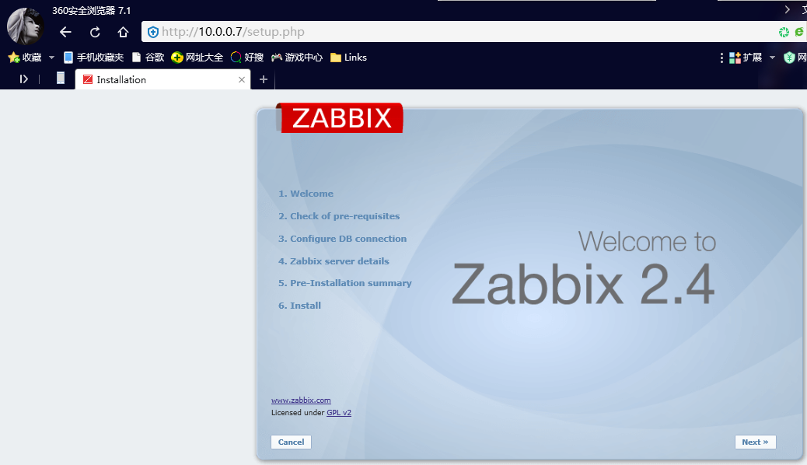

报错：

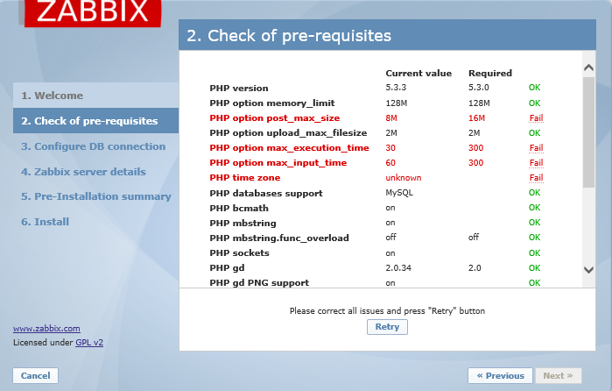

解决方法：

vim /etc/php.ini #<====修改php配置文件

729 post_max_size = 16M

440 max_execution_time = 300

449 max_input_time = 300

946 date.timezone = PRC #<====PRC中华人民共和国

修改之后重启Apache服务

/etc/init.d/httpd restart

Stopping httpd: [ **OK** ]

Starting httpd: [ **OK** ]

**###就没有问题。**

## 2．4 安装客户端软件包

### 2．4．1更新epel源

wget -O /etc/yum.repos.d/epel.repo http://mirrors.aliyun.com/repo/epel-6.repo

### 2．4．2安装客户端软件

yum install zabbix22-agent -y

[root@lvs ~]# top -u zabbix -c

top - 14:45:45 up 7:24, 2 users, load average: 0.00, 0.00, 0.00

Tasks: 82 total, 1 running, 81 sleeping, 0 stopped, 0 zombie

Cpu(s): 0.0%us, 0.0%sy, 0.0%ni,100.0%id, 0.0%wa, 0.0%hi, 0.0%si, 0.0%st

Mem: 486644k total, 205952k used, 280692k free, 30904k buffers

Swap: 767996k total, 0k used, 767996k free, 63768k cached

PID USER PR NI VIRT RES SHR S %CPU %MEM TIME+ COMMAND

2295 zabbix 20 0 76488 1188 736 S 0.3 0.2 0:01.86 zabbix_agentd: listener #3 [waiting for connecti

2291 zabbix 20 0 76488 952 532 S 0.0 0.2 0:00.00 zabbix_agentd -c /etc/zabbix/zabbix_agentd.conf

2292 zabbix 20 0 76488 960 536 S 0.0 0.2 0:07.63 zabbix_agentd: collector [idle 1 sec]

2293 zabbix 20 0 76488 1188 736 S 0.0 0.2 0:02.05 zabbix_agentd: listener #1 [waiting for connecti

2294 zabbix 20 0 76488 1188 736 S 0.0 0.2 0:02.00 zabbix_agentd: listener #2 [waiting for connecti

2296 zabbix 20 0 76500 956 500 S 0.0 0.2 0:00.78 zabbix_agentd: active checks #1 [idle 1 sec]