Assignment No.: 1

**Assignment Cover Sheet**

|  |  |  |  |
| --- | --- | --- | --- |
| **Student Information (For group assignment, please state names of all members)** | | | **Grade/Marks** |
| **Name** | | **ID** |  |
| Agnes Ng Xin Yee | | B2000193 |  |
| Aishwarya A/P Amit Chhabra | | B2101229 |  |
| Charles Voo Kar Seng | | B2000426 |  |
| Florence Tan Xin Yi | | B1900444 |  |
| Kevin Wong Hao Zhen | | B2000854 |  |
| Tai Yong Kang | | B2100547 |  |
| Yang Zi Hao | | B2100296 |  |
| Yong Ruo Xuan | | B2000441 |  |
| **Module/Subject Information** | | | **Office Acknowledgement** |
| **Module/Subject Code** | MPU3263 | |  |
| **Module/Subject Name** | Communication and Leadership Skills | |  |
| **Lecturer/Tutor/Facilitator** | Mr. Simon Lim, Chee Hooi | |  |
| **Due Date** | 31st March 2022 | |  |
| **Assignment Title/Topic** | Project Execution- Safety of Women in Society | |  |
| **Intake (where applicable)** | January 2022 | |  |
| **Word Count** | 7480 words | | **Date/Time** |
|  |  |  |  |

**Declaration**

. I/We have read and understood the Programme Handbook that explains on **plagiarism**, and I/we testify that, unless otherwise acknowledged, the work submitted herein is entirely my/our own.

. I/We declare that no part of this assignment has been written for me/us by any other person(s) except where such collaboration has been authorized by the lecturer concerned.

. I/We authorize the University to test any work submitted by me/us, using text comparison software, for instances of plagiarism. I/We understand this will involve the University or its contractors copying my/our work and storing it on a database to be used in future to test work submitted by others.

Note:1) The attachment of this statement on any electronically submitted assignments will be deemed to have the same authority as a signed statement.

 2) The Group Leader signs the declaration on behalf of all members.

|  |  |  |
| --- | --- | --- |
| Signature: Aishwarya | | Date: 30th March |
| mail: [b2101229@helplive.edu.my](mailto:b2000548@helplive.edu.my) | |  |
| **Feedback/Comments\*** | | |
| **Main Strengths** | | |
|  | | |
|  | | |
|  | | |
|  | | |
|  | | |
|  | | |
| **Main Weaknesses** | | |
|  | | |
|  | | |
|  | | |
|  | | |
|  | | |
|  | | |
|  | | |
| **Suggestions for improvement** | | |
|  | | |
|  | | |
|  | | |
|  | | |
|  | | |
|  | | |
|  | **Student acknowledge feedback/comments** | |
|  | |
| Grader’s signature | Student’s signature: | |
| Date: | Date: | |
|  |  |  |

Note:

1)A soft and hard copy of the assignment shall be submitted.

2)The signed copy of the assignment cover sheet shall be retained by the marker.

3)If the Turnitin report is required, students have to submit it with the assignment. However, departments may allow students up to **THREE** (3) working days after submission of the assignment to submit the Turnitin report. The assignment shall only be marked upon the submission of the Turnitin report.

*Use additional sheets if required

Table of Contents

Effectiveness of the plan 5

The difficulties faced during project execution and ways to overcome 7

Any changes between your plan and your actual execution 9

Achievements in executing the project 11

Survey data interpretation 11

Interview Data Interpretation 15

Conclusion 17

References 18

Appendix 19

Appendix A 19

Part A: Cause of women’s safety issues 19

Part B: Effects of women’s safety issues 21

Part C: Effects of women’s safety issues 23

Appendix B 29

Appendix C 36

# Effectiveness of the plan

During the planning phase of the project, we put a lot of time and attention into debating our topic. Long meetings were held as we brainstormed multiple ideas for each topic and agreed to select the most suitable topic that would be relatable to college students. Additionally, we planned our projects according to the roles of our thinking hats. In this way, it ensured an easy transition into executing the project. Moving on, we collect the required information through both qualitative and quantitative research. Each group member interviewed one interviewee and collected their subject matter opinion for qualitative purposes. Furthermore, we devised a survey questionnaire to ask the opinions of 150 college students for quantitative research.

Our group had also booked a session with Mr. Simon to present our project plan. In that session, we presented the objectives and other processes that we will go through while executing the project. While presenting all the parts to Mr. Simon, he did not have major comments on our presentation, except for one part, the questionnaire. Before our presentation, we had prepared a rough draft questionnaire to be presented to Mr. Simon. He stated that the questionnaire prepared was not clear enough to achieve our objectives. To illustrate, some of our questions are not clear enough and, therefore, could create confusion for the participants who will be answering them. We heeded Mr. Simon’s advice and made all the necessary changes before sending the questionnaire out to participants through various means such as social media. Moreover, Mr. Simon also stated that while the overall flow of our presentation glided smoothly, we should always try to make a breakthrough and achieve something greater. As a group, we will definitely keep this in mind and try out best to strive for better for our upcoming final presentation. After spending a few days polishing everything, we executed our plan. We also had a meeting to have a check that everything was on the right track. Following data collection, we solicited input from our respondents and participants on the survey and interviews. The remarks provided by our respondents were relatively meaningful and insightful.

To wrap up, our research plan has been going as expected and on track with minor changes as we had taken in a lot of considerations and points of view of every member in our group to create a plan that can achieve what we are looking for. The comments from Mr. Simon have made our plan to become more effective and efficient in achieving our goals. Early preparation with the plan of our upcoming work progress also ensures effectiveness in terms of time management. Time and effort expended by each group member were critical factors in ensuring the plan's efficacy until the plan's implementation phase.

# The difficulties faced during project execution and ways to overcome

Due to the spread of COVID-19, we had to conduct an online meeting instead of a face-to-face meeting. During the online meeting, we have faced different opinion problems when discussing our assignment. This caused us to have a bit of an argument during the meeting. However, fortunately, we are able to say our own opinion and clear out this problem in a peaceful way and didn’t cause any major problems to our group. When we are scheduling our meeting time, we have faced difficulties with our schedules. Since everyone in our group had a different class schedule, it was difficult to find a time slot when everyone was available to have a meeting online and discuss our group's assignments. Therefore, to overcome this problem, we scheduled all of our meetings in the evening to avoid conflicts with class time. Through the cooperation of the group members, each of our group members was able to attend all the online meetings.

During the first meeting, we ran into difficulty: our meetings were not participative. In our first meeting, the group members rarely shared their opinions and did not even speak up when we discussed the group assignment. This caused the meeting to become inefficient as it took too much time to collect the opinions of all group members. Therefore, our group leader suggested that in future meetings we should attend the meeting by representing our own thinking hat's roles. Since each group member had chosen a thinking hat that best suited their individual traits before the first meeting, we then decided to discuss our group assignment based on our thinking hats after the first meeting, which made the meeting more efficient. After our first discussion, we have decided on a few topics and info that needed to be researched and included in the assignment. However, after collecting all data and including it in our assignment, we realized that some of the data are not closely related to our assignment topic. Thus, we had to remove that data from our assignment and save it as our backup data in case we needed it.

Next, when the questionnaire was initially set up, the questions in the questionnaire were not linked to our objectives, which resulted in the questions becoming meaningless because it is not relevant to our objectives. Not only that, but we also realized that our questionnaires are too lengthy, which will cause our respondents difficulty and a lengthier time to interpret and answer the questions. Thus, we decided to have a meeting that focuses on modifying our questionnaire by combining some of the related questions or shortening our questions to make them clear and easier to understand.

During the period of data collection through the survey, we collected the questionnaires much later than expected. According to our plan, we had to analyze the data and write a report based on it in week 9, so we should have collected all the data by then. However, by the day before week 9, we only had 88 responses, far below our goal of 150 responses. After the reminder from our team leader in the WhatsApp group, suggesting we promote and share the questionnaire, we were able to accomplish our goal in just two days. Throughout the group assignment, we conveyed our information through WhatsApp rather than Microsoft Teams. This resulted in lecturers not getting an update on our group discussions as soon as possible. However, we still conducted our group meetings through Microsoft Teams, which kept the lecturer informed of what we were discussing during the meeting. In all meetings, we use Chinese as our primary communication language rather than English. We discovered this problem during our third meeting, but we still decided to use Chinese to communicate during the meeting since it is easier to understand and state our own opinion. However, we still use English as our primary language when communicating in the WhatsApp group and Microsoft Teams.

That concluded all of the difficulties that we had encountered thus far in the course of our project's execution. Even though we faced various hurdles, we were able to execute and complete our project with due diligence and team collaboration.

# Any changes between your plan and your actual execution

Among the changes we faced between our group’s plan and actual execution was the finalization of the interview question. We were supposed to finalize the interview questions by Week 6. However, due to mid-term week closely approaching, during week 8, everyone discussed and agreed to maintain the same questions as the survey questions with one condition: the interviewee should not have participated in the survey question. This is to ensure the answer are not repetitive and we can garner a more detailed or even attain a different perspective of the questions. However, during week 10, concerns were raised again after confronting seniors and other group members on how they conducted their interview questions. To clarify the concerns, we quickly confronted our lecturer regarding the issue. Our lecturer addressed our concerns as quickly as possible. He encouraged us to ask ourselves if the interview questions can be maintained the same as survey questions while guiding us on the right track instead of blindly following seniors’ instructions without rationale. With his guidance, all of us successfully completed our interview.

Furthermore, we had various changes regarding our survey questionnaire. To begin, we had a particularly difficult time finalizing the survey questions. We struggled with segregating the questions into similar parts while maintaining relevancy to the awareness of women’s safety issues in Malaysia. After several meetings and discussions, we finally settled down on the questions and presented them to our lecturer. During the presentation, we were advised to alter the style of questions. To illustrate, instead of the usual, same old multiple-choice questions, we could include a qualitative element to it by using open-ended questions. This would allow respondents to answer in a variety of ways without being constrained in their thinking. We took the lecturer's recommendations and tweaked the questions. It is reasonable to conclude that the current survey with the lecturer’s valuable feedback is better suited for our project.

To add, despite going through the survey questions multiple times, we still managed to miss out on tiny details on the survey questionnaire. For instance, our age group was clashing as the grouping of numbers was placed incorrectly. This caused the respondents confusion on which answer to choose. We also got multiple inquiries from participants asking whether should they do basic research on the law of sexual harassment before answering our survey questions. To address this, we immediately stepped in and added a description to the relevant question (Appendix C, Part 4). Lastly, some participants were also confused about whether can they choose multiple answers for a single question. To solve this and achieve the accuracy of data, we quickly amended the survey questionnaire and asked them to choose the best, utmost suitable answer based on their opinion.

Overall, apart from all the above, we definitely managed to stick to our original plan and executed it as closely as possible with minimal changes.

# Achievements in executing the project

## Survey data interpretation

Our survey questions are filled out by university students in Malaysia to gain more understanding of women's safety issues from their perspective. Our survey questions are divided into 4 parts. Part 1 is the background of the respondents. From our survey questions data, 54% of respondents are female and 46% are male respondents. Besides that, the major age range of respondents is based on 15 to 20 years old with 53.3% and the second age range of respondents is based on 21 to 30 years old with 21.3%. Next, 89.3% of respondents are local students and the other 10.7% are international students. Furthermore, the largest education level of respondents is Bachelor’s degree with 68.7% and 23.3% of respondents are Diploma level, followed by 6% for Master’s degree.

Part 2 of our survey questions is the cause of women’s safety issues. Most respondents believe that sexual harassment is the top public safety issue that women encounter in Malaysia which is 36.7%. Followed closely by 29.3% of respondents who think that robbery is the second most safety issue that women encounter in Malaysia. Other respondents chose options such as domestic violence, grouping, stalking, rape, and flashing. This data proves to be hand in hand with the report of The Star said that there are 57% of women in Malaysia had been facing sexual harassment when they are walking on the streets (Online, T. S. (2021, September 21). Next, when asked about which factor is most likely to increase the probability of women’s safety issues, 38.7% of respondents feel that lack of public safety awareness and education is the main cause of the issue. Followed by location as the second cause with 30% votes as places with poor street lighting, less crowded, and abandoned area largely adds to the rise of safety issues in Malaysia. Also, other respondents chose options such as lack of security, sharing too much daily and personal information on social media, going out alone, dressing sense, and time of the day as factors that fuel the safety issues in our country.

Part 3 of our survey questions focus is on the effect of women’s safety issues. 83.3% of respondents will share their experiences with surrounding people when they hear about women’s safety issues. Another 16.7% of respondents will not share their experiences as they do not take women’s safety issues seriously, or have never heard about them. Not only that, 40.7% of respondents chose that as a male, they will accompany and protect their female friends when she is alone and 29.3% of respondents chose that they will remind their female friends to be vigilant when they see the news report about women’s safety issues. There are also 18.7% of respondents who will raise awareness of women’s safety issues, for example, they will tell their female friends to bring a self-defense kit or learn some self-defense skills. 11.3% of respondents will not take any initiative about the women’s safety issues. Lastly, most respondents think that the impact of public safety issues on women is depression which is 22% and the second impact is emotional tension which is 20.7%. Also, some respondents believe that anxiety, shame, gynecological problems, and resisting contact with men are the impacts of public safety issues on a woman. Furthermore, 5 respondents said that all of these above are the impacts of public safety issues on a woman. Women's safety issues have a significant impact on their mental health and have instilled fear in them. On a daily basis, sexual harassment victims fear going out alone and, in some situations, limit their public appearance.

As for the prevention part of women's safety issues, when asked if the respondent thinks the current laws protect women well, 51.3% of respondents answered yes and 48.7% of respondents answered no. The reasoning behind respondents choosing no is respondents seeing news of criminals breaking the law and being able to get away with it without getting arrested.

Apart from that， when questioned about the views of 150 respondents regarding what is the best way to minimize and improve the issue of women’s safety in Malaysia, it involved several answers. Among 32.7% of respondents think that security needs to be enhanced. The reason most people choose this is that they think the criminal dare not commit crimes in a high-security place. 28% of respondents think that the government needs to enforce the law and 13.3% of respondents think that women need to be educated to wear appropriate clothing. In addition, there are also respondents indicating that police patrolling on the street, street lighting needs to be enhanced alongside attending awareness campaigns. Finally, we managed to retrieve some qualitative data from respondents as some of them gave different and unique answers that were not given in the options such as, educating the men and learning self-defense.

Based on the questionnaires, 28% of respondents will call the police when they see a woman facing safety issues and 22% of respondents will choose to take pictures as evidence. Most people choose to call the police as they believe it will scare off gangsters without putting themselves in danger. Apart from that, a few of the respondents will shout, fight back and keep silent accordingly. Apart from these options, some of the respondents say they will evaluate the situation to see how to help and pretend to be the victim's friend and step up to pull him aside.

According to the statistics, most public safety awareness should the respondent or their female friends have is to always travel in a group, possessing a rate of 26%. The reason most people would choose this is because they think that criminals are less likely to attack a group. In addition, 23.3% of respondents choose the learning self-defense training option and 22% of respondents will bring a self-defense spray. Besides that, carrying a self-defense alarm, informing their friends of their real-time location, and pretending to not live alone by putting the male items in front of the door are some of the public safety awareness that respondents or their female friends should have. In addition to the above measures, the emergency button on the phone is another answer provided by the respondent. Some respondents have also chosen all of the options. This can be seen as the public has a certain level of awareness concerning public safety issues in Malaysia.

Next, we asked respondents 3 scenario-based questions regarding the implementation of certain measures to test if they are effective. To start, we asked whether women parking implemented by the government is effective, 64 % of respondents answered yes and 36% of respondents chose no. Those respondents who chose no, believe that there are still some ignorant people who continue to park in those areas, despite the parking being specially allocated to female drivers. Apart from that, when asked about whether do they think promoting the self-defense kit online is effective, 74.7% of respondents chose yes and 25.3% of respondents chose no. The reason that the respondents chose no is that they think that bad guys are not afraid of these things. According to the questionnaires, 61.3% of respondents think that campaigns about women’s safety issues implemented by the government are effective and 38.7% of respondents think it is ineffective. Respondents who chose no, feel that the implementation of such campaigns by the government, might result in a lack of audience unless successful propaganda is achieved.

To put it in a nutshell, based on the questionaries, sexual harassment is one of the women's public issues that occur in our country. The causes of the above issues may be the lack of public safety awareness and education. Apart from that, the other cause of women's safety issues is the current law. Based on statistics, many respondents believe that the current law is not enough to protect women, and enforcement of the law needs to happen to minimize the problem. Therefore, society as a whole can come together to reinforce this awareness, especially among university students.

## Interview Data Interpretation

According to the data we collected through interviews, most interviewees believed sexual harassment to be the public safety issue that women most often encounter in Malaysia, alongside answers such as catcalling, burglary, and trespassing. When asked what increases the probability of such issues, most of them believe it is due to a lack of awareness and education about this topic. Moreover, locations with less crowd, no CCTV footage, and poor street lighting also largely contribute to women’s safety issues. From the interview, we noticed a unique answer that states women with children specifically in less crowded places raise the probability of facing such issues.

Proceeding into the next part, all interviewees would share their experiences without any hesitation regarding safety issues. Upon witnessing safety issues, interviewees believe that from a male’s perspective, they would most definitely accompany female friends and sisters and remind them to be extra vigilant. Men would also do their part by encouraging communications regarding this topic to increase awareness. An interviewee would even take things one step further, by utilizing social media to forward information regarding women’s safety to mutual friends. Moving on, most interviewees believed that the impact of public safety issues on women is emotional tension and anxiety. After such a traumatic experience, interviewees feel that women might lack confidence and start to resist contact with strangers.

As for the final part, the prevention and minimization of women’s safety issues, interviewees have an equally mixed opinion regarding the effectiveness of the law in regards to women’s safety in Malaysia. Half of the interviewees believe that the current law in Malaysia is sufficient in protecting women well as it has enforced many acts and imposed multiple fines and punishments, which creates fears and refrains offenders to cause harm to women. On the contrary, the rest half of the interviewees believe that the law is insufficient and inadequate as there are still many aspects to conquer and the punishment is not severe enough. Also, interviewees believe that the best way to minimize and improve on the issue is by enforcing the law and regulations. In addition, enhancement of security such as self-defense kits, tracking devices, and patrolling cars should take place in Malaysia. Unique answers such as educating boys and girls from a young age on how to protect and respect women should be widely discussed. Furthermore, an interviewee recommended collaboration among all levels of society, and government to cooperate with NGOs to mainstream and integrate regulations that promote women’s safety. Upon noticing women facing safety issues, interviewees will take measures such as shouting to grab the surrounding’s attention and calling the police. Amongst them, we found unique measures such as taking pictures as evidence and analyzing the situation with caution before proceeding forward to help the victim. Interviewees believe that self-defense kits, safety alarms, and pepper spray are amongst the best public safety awareness tools that women should have. Apart from that, women should refrain from going out alone and ask male friends to accompany them. An interviewee even mentioned the utilization of tracking devices to update close ones about safety issues.

To gauge a better idea of the effectiveness of the implementation of safety issues, we asked interviewees a couple of scenario-based questions. Firstly, all interviewees agree that the implementation of women's parking is effective. This is because women would feel at ease as the bright pink sign can easily attract people’s attention if there were any suspicious activity happening. Next, carrying a self-defense kit is extremely effective as it provides protection for women. An interviewee even made a statement about every woman owning at least one self-defense kit. Lastly, when asked about government campaigns regarding women’s safety issues, most interviewees agreed that it is effective as it can convey the message and increase the awareness of the public. However, few interviewees believe that campaigns are ineffective as words would just fly over their heads. Furthermore, only a fixed amount of people who are concerned about women's safety issues would participate in the campaign. People that never care about women's safety issues are not likely to participate in these campaigns. Only the campaigns that have successful propaganda and great exposure to the public but not just the fixed range of people can increase the awareness of women's safety issues.

# Conclusion

In a nutshell, Women's safety awareness is still a big concern in the sample of our research. Both the results from the survey and questionnaire indicate that the intervention issue is the most common and challenging issue faced by our sample. It is also aligned with the background information that we have previously done in the planning. We also found that different samples have different causes of the issue which the most common causes stated in this project are less intervention from the government and also low discipline of the male community. But to our surprise that there are more and more ways being implemented to counter this issue. However, when we probe further, we knew that our samples are not just waiting for others' help. They find the solution to the current situation and some of them even stated that they had prepared themselves with a self-defense kit and to be more cautious. But yet, not surprisingly, there are still a lot of our respondents that believe the safety of women is still not guaranteed in Malaysia.

In conclusion, we have achieved our objective which is to understand the real perceptions of University students on women's safety awareness. This project contributed to opening the eyes of university students in Malaysia to this issue. Both qualitative and quantitative data were collected from the sample chosen by us from the target community. A clear portrayal of the attitude and thought of our sample on the topic is provided in this project. Both the qualitative and quantitative data had been tidied up by us and converted into a short paragraph for rough explanation Graph charts and pie charts are also included in our project to visualize the quantitative data clearly (Refer to Appendix B). The detailed and actual data can be referred to in Appendix A, B, and C. It is the essence of our whole project.

# References

Online, T. S. (2021, September 21). Survey: 57% of Malaysian women experience verbal sexual harassment on the streets. The Star. Retrieved March 23, 2022, from <https://www.thestar.com.my/news/nation/2021/09/21/survey-57-of-malaysian-women-experience-sexual-harassment-verbally-on-the-streets>

# Appendix

## Appendix A

*Data collected through interview*

### Part A: Cause of women’s safety issues

1. **From your point of view, what are the public safety issues that women encounter the most in Malaysia?**

Participant 1: I think it would most probably be sexual harassment.

Participant 2: I would say the most is catcalling in Malaysia.

Participant 3: I think is sexual harassment is a women’s public safety issue that often occurs in our surroundings because always can see it on the news.

Participant 4: I think sexual harassment is the most common women's safety issue in Malaysia because I have heard a lot about it from social media and people around me. It can come from a friend, a coworker, a supervisor, and even a friend on Facebook, for example, some people may receive sexually explicit photos or text messages.

Participant 5: Sexual harassment.

Participant 6: I think it is sexual harassment.

Participant 7: In my opinion, Sexual harassment and domestic violence are the most serious in Malaysia.

Participant 8: In my point of view, the most public safety issues encountered by women in Malaysia are trespassing, burglary as women are often key targets of crime in public spaces such as snatch theft.

1. **Which one of the factors is most likely to increase the probability of women’s safety issues in Malaysia?**

Participant 1: I would say it is a variety of causes, such as places with poor lighting, lack of CCTV footage and also going out alone in the middle of the night. But most importantly, I would say is the lack of public safety awareness. People these days need to be educated, if not women’s safety issues are never going to be solved in Malaysia.

Participant 2: I would say is a lack of education, because many of them did not receive the proper education to respect women.

Participant 3: I think the places with poor street lighting and the less crowded place are most likely to increase the probability of women’s safety issues.

Participant 4: In Malaysia, many alleys are with poor lighting, which is dangerous for those who need to pass through especially when passing alone during late night.

Participant 5: I think it is the location.

Participant 6: I think it is the lack of public safety awareness and education.

Participant 7: I think that it is a lack of public safety awareness and education.

Participant 8: In my opinion, Women being alone in a less crowded area or with small children would increase the probability of women’s safety issues in Malaysia.

### Part B: Effects of women’s safety issues

1. **When you or your friends hear about safety issues, will you share your experiences, in order to remind others?**

Participant 1: Yes, I would definitely share my experience with others.

Participant 2: Yes I will, if it helps, I will definitely share my experience.

Participant 3: I will share it with my friends to increase their public safety awareness.

Participant 4: Yes, of course.

Participant 5: Sure, I will

Participant 6: Yes, I will definitely remind others.

Participant 7: Yes, I will share my experience.

Participant 8: Yes, Whenever I heard about safety issues or faced any safety issues, I would always share them with my friends on my experiences and always remind them to be alert to their surroundings whenever they are being alone.

1. **What would you or your male friends do when you see news reports of women's safety issues?**

Participant 1: I would most probably share it with my friends and family. I will also try to spread awareness to everyone else and accompany my friend or sister when going out at night to keep them safe.

Participant 2: We normally just talk about how serious is it, because physically we could not do anything.

Participant 3: I will increase my awareness of women’s safety issues.

Participant 4: We will always go out in a group and ask male friends to walk behind us.

Participant 5: I think my male friends will accompany me when I am alone.

Participant 6: I will definitely remind my female friends to be vigilant.

Participant 7: They will accompany and protect their female friend when she is alone and remind female friends to be vigilant.

Participant 8: We would forward each other and our mutual friends the news to raise safety awareness of each other.

1. **What are the impacts of public safety issues to women?**

Participant 1:It might be really traumatizing for the girls and they might lack confidence. They may be scared. Overall, it is a bad effect on them.

Participant 2: It makes them, scared and lacks confidence.

Participant 3: I think they will be resisting contact with men.

Participant 4: This may cause anxiety for women when they go out, they will be afraid of encountering the same issues.

Participant 5: I think it is emotional tension.

Participant 6: I think it is emotional tension because women always need to be worried about their safety when they need to go out alone.

Participant 7: This will bring emotional tension to women and will impact their resisting contact with men.

Participant 8: Women often feel anxious to be alone and conduct exercises, or travel alone as people might target us. Other than that, it will also increase the financial cost as The threat of danger in public spaces often prompts women to ride-sharing services, drive, take public transport. Besides, it also impacts women’s mental health.

### Part C: Effects of women’s safety issues

1. **Do you think the current laws protect women well?**

Participant 1: Yes, I believe so.

Participant 2: I think the law does not do a good job in protecting women, the punishment is not severe enough.

Participant 3: Yes, I think the law has the effect of deterring the bad guys.

Participant 4: I think the current law in Malaysia may not be sufficient to protect women well because if the law is enough to protect women, then we would not hear of so many issues about women's safety.

Participant 5: I think yes because the current laws have enforced many Acts and imposed fines and punishment for the prisoners.

Participant 6: I think the current laws protect women well because the current laws have imposed sanctions on those that cause harm to women. This will prevent the criminal to commit such a crime due to the fear of these punishments.

Participant 7: no, I don’t think the current law protects women well.

Participant 8: In my opinion, the current laws in Malaysia such as the Domestic Violence Act 1994 do protect women and the current law in Malaysia is sufficient to protect women.

1. **In your opinion, what is the best way to minimize and improve on the issue of women's safety in Malaysia?**

Participant 1: I would say all girls should carry a self-defense kit that contains pepper spray, or any tracking devices that their family members would be able to track if anything happens. They should also enhance the security, such as having CCTV and have patrolling cars around the neighborhood so that girls feel safe and would be able to go out at night with comfort.

Participant 2: I would say, educate the man, tighten the law.

Participant 3: I think the best way to minimize the issues of women’s safety in Malaysia is to. increase the security system like CCTV, the police patrol the less crowded areas.

Participant 4: Maybe the government can put more effort into women's safety issues like enforcing regulations more strictly.

Participant 5: I think can enhance the security.

Participant 6: I think parents and schools should educate both boys and girls about women’s safety issues when they are young. We should educate boys to respect women and teach girls to protect themselves. As long as men respect women, none of these issues would even have occurred.

Participant 7: In my opinion, the best way is to enforce the law to protect women.

Participant 8: In my opinion, This would take the collaboration of all persons living in this country across all levels of society - in our families, communities, schools, workplaces, law enforcers, and government. The Malaysian government should work together with NGOs to mainstream and integrate policies that ensure the personal safety of women across all legislation.

1. **What would you do if you saw a woman facing safety issues right now?**

Participant 1: I would personally go up to her and try to help her as much as possible. Try to calm her down and analyze the situation and try to help as much as possible with caution.

Participant 2: -

Participant 3: I will shout to get other people's attention.

Participant 4: I will take photos as evidence and then shout to get attention.

Participant 5: I will call the police.

Participant 6: I will call the police.

Participant 7: I will take pictures as evidence and shout lastly call the police.

Participant 8: I would offer my help to her if I saw a woman facing safety issues right now. For example, I would also shout and create awareness among the people surrounding the situation and ask for help from more people to prevent the woman from getting hurt.

1. **What public safety awareness should you or your female friends have?**

Participant 1: They should probably inform everyone where they are going and keep everyone updated and have their tracker on alongside the self-defense kit.

Participant 2: -

Participant 3: I think the most public safety awareness should me or my female friends have is..always travel in groups.

Participant 4: Don’t go out alone and ask male friends to accompany us.

Participant 5: I will bring a self-defense spray.

Participant 6: I think the best way is to carry a self-defense alarm.

Participant 7: I think that bringing a self-defense spray is the best choice.

Participant 8: In my opinion, I and my female friend should have public safety awareness such as knowing the NGOs that provide help when we face safety issues. For example, Women Aid’s Organization Hotline. Also, whenever we feel unsafe, make sure to always leave and contact our friends or family for help.

1. **How do you view women's parking implemented by the government?**

Participant 1: I believe women's parking is effective in ensuring women’s safety.

Participant 2: I think it is convenient, and feeling at ease when going everywhere.

Participant 3: I think women’s parking is not effective for us because it is not popular in our country.

Participant 4: I think it is very good and very friendly for women

Participant 5: I think women's parking is one of the best ways to protect women because the area of parking is lack lighting and this area is most dangerous.

Participant 6: I think women's parking is effective because the single female driver would be more secure as any man that comes near to the women's parking area would be suspicious and obvious. The bright pink sign can easily attract people's attention so when there is a crime has occurred, people will easily notice it.

Participant 7: This concept is good, but not for women or not alone women will also park at women's parking, the provisions of the women's parking need to be improved.

Participant 8: I resonated with the initiative for the implementation of women's parking. As for me, would tend to search for the women's parking area to park whenever I drove alone to the malls as I felt safer.

1. **How do you view self-defense kits sold online?**

Participant 1: I think the self-defense kit is effective.

Participant 2: I think it is convenient, and feel at ease when going everywhere.

Participant 3: Yes, because nowadays technology is advanced, it is a good way to promote these …………….. self-defense kits to the public.

Participant 4: I think every woman should bring along at least a self-defense kit, especially for those who always travel alone.

Participant 5: I think the self-defense kit can protect women well when she is walking alone.

Participant 6: I think it is effective because it can provide protection to women as very few women have learned self-defense training.

Participant 7: I think it is good, but in the Malaysian market is difficult to buy self-defense kits, these are not popular in Malaysia even among Malaysian women.

Participant 8: I think self-defense kits do increase the self-awareness of women's safety as I was a woman who also had a self-defense kit with me whenever I travel. Hence, I do think that promoting self-defense kits would increase the awareness of women's safety as it could serve as a tool for people who might harm women.

1. **How do you view campaigns about women’s safety issues implemented by the government?**

Participant 1: In my opinion, I do not think campaigns are effective.

Participant 2: In my opinion, I don’t think it makes any difference as the words will just fly over their heads.

Participant 3: I think the campaign is not effective for us because it is not popular in our country.

Participant 4: I think it is a good way to raise awareness among women, especially students.

Participant 5: I think the government implemented the campaign about women’s safety issues is effective because it can increase the awareness of women and decrease the case of women’s safety issues in Malaysia

Participant 6: I think the campaign is not effective because usually, only a fixed number of people who are concerned with women's safety issues would participate in the campaign. People that never care about women's safety issues are not likely to participate in these campaigns. Only campaigns that have successful propaganda and great exposure to the public but not just the fixed range of people can increase the awareness of women's safety issues.

Participant 7: A campaign can convey female self-protection consciousness, if have a campaign I will go for it and learn a lot of women's safety knowledge from there.

Participant 8: I think campaigns are often the main way that an organization interacts with the public and gets your organization's message out to people. Hence, it can create safety awareness among the women in the society to recognize the safety issues in Malaysia.

# Appendix B

**PART 1 Background of respondents**

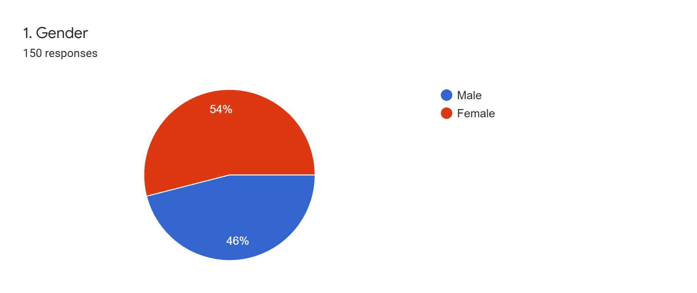

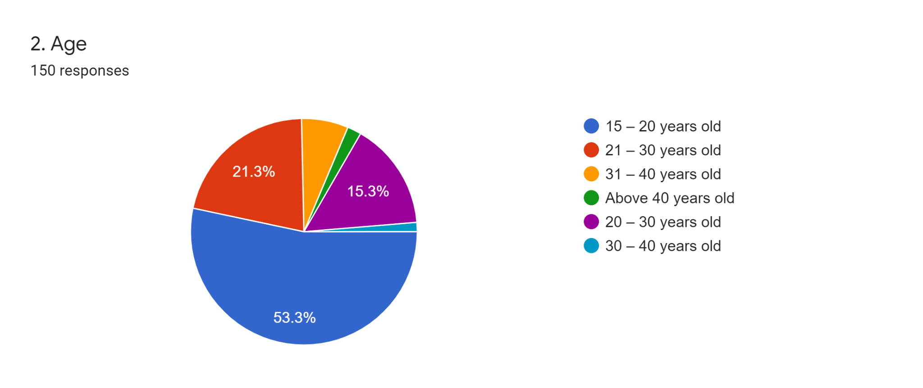

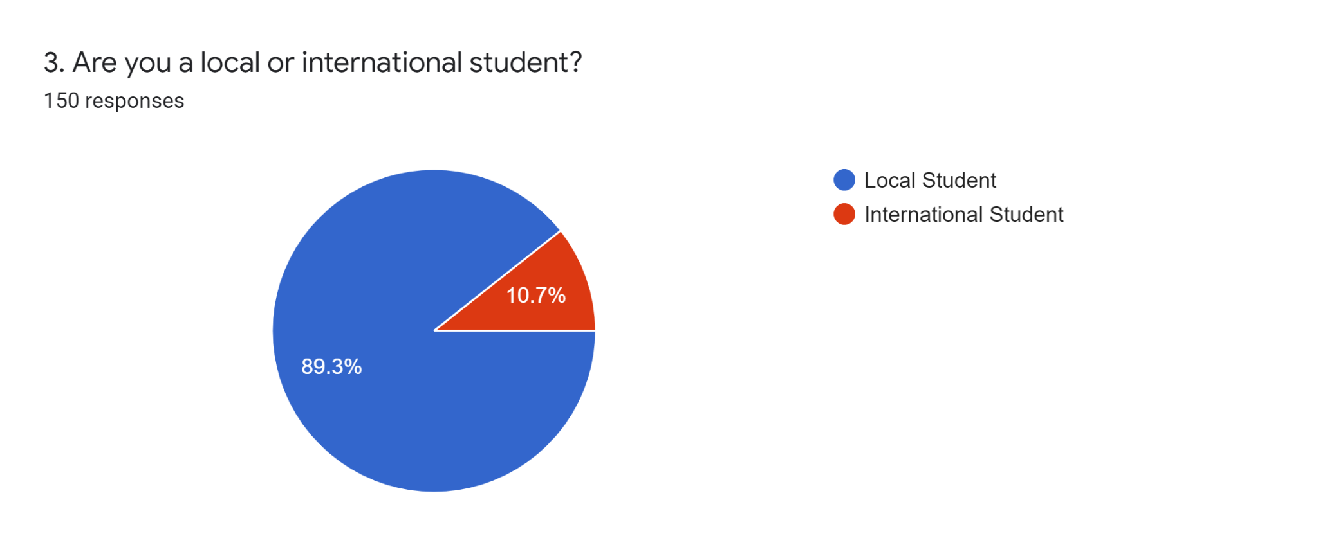

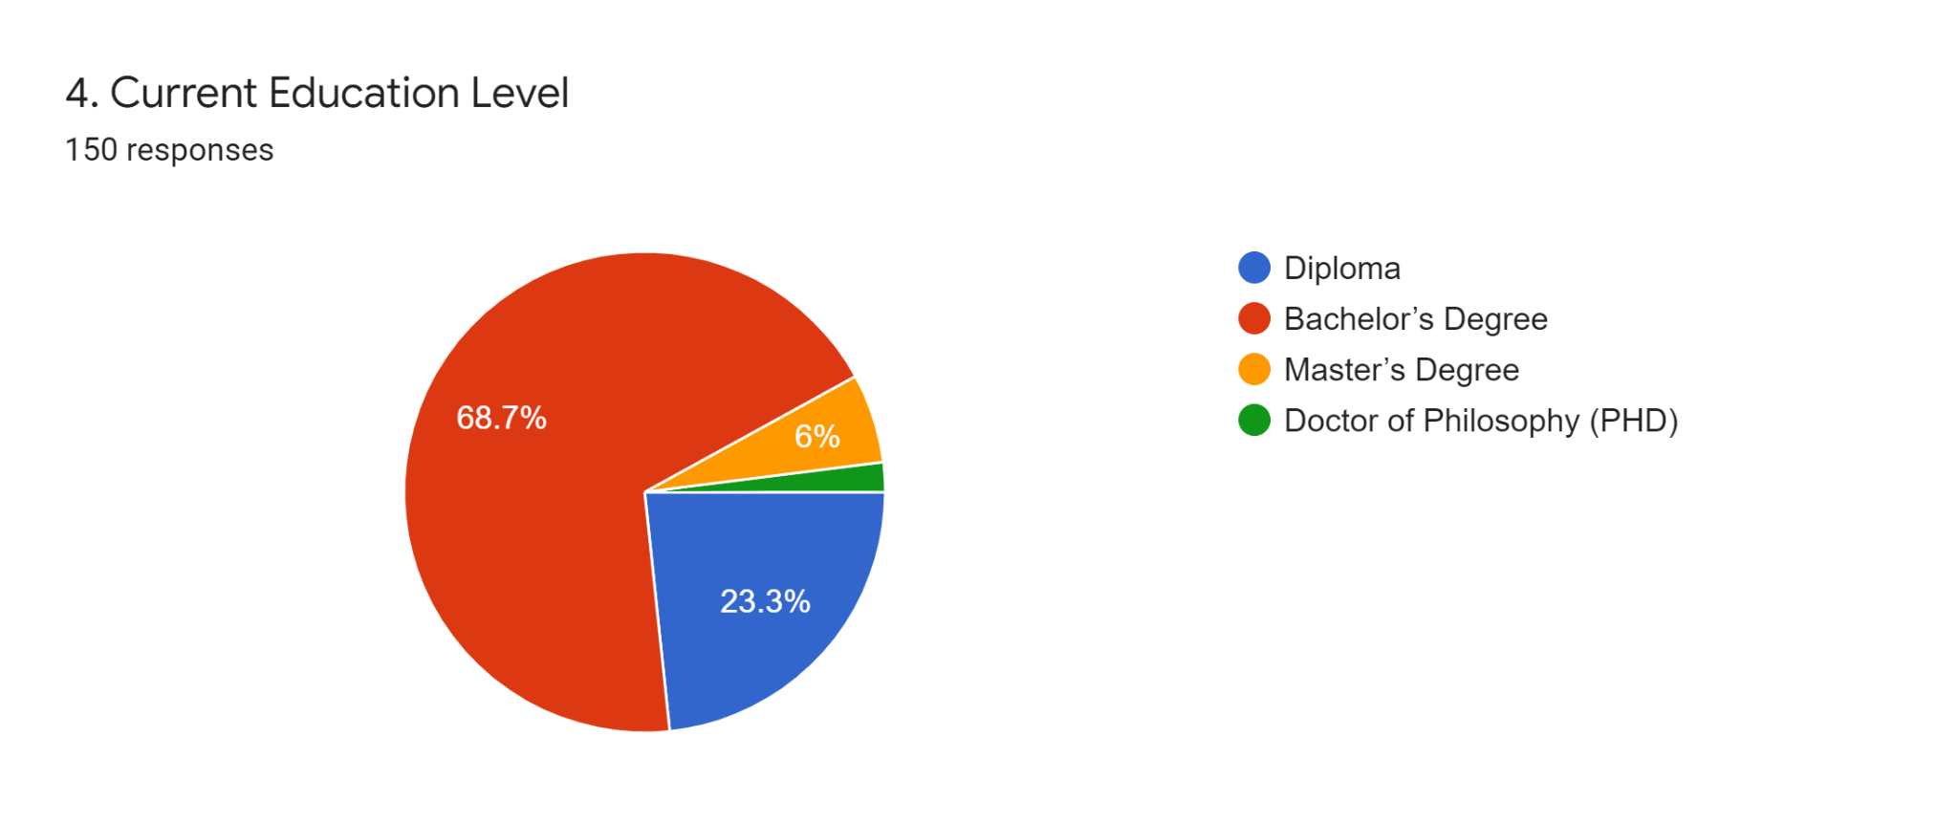

**PART 2 Cause of women’s safety issue**

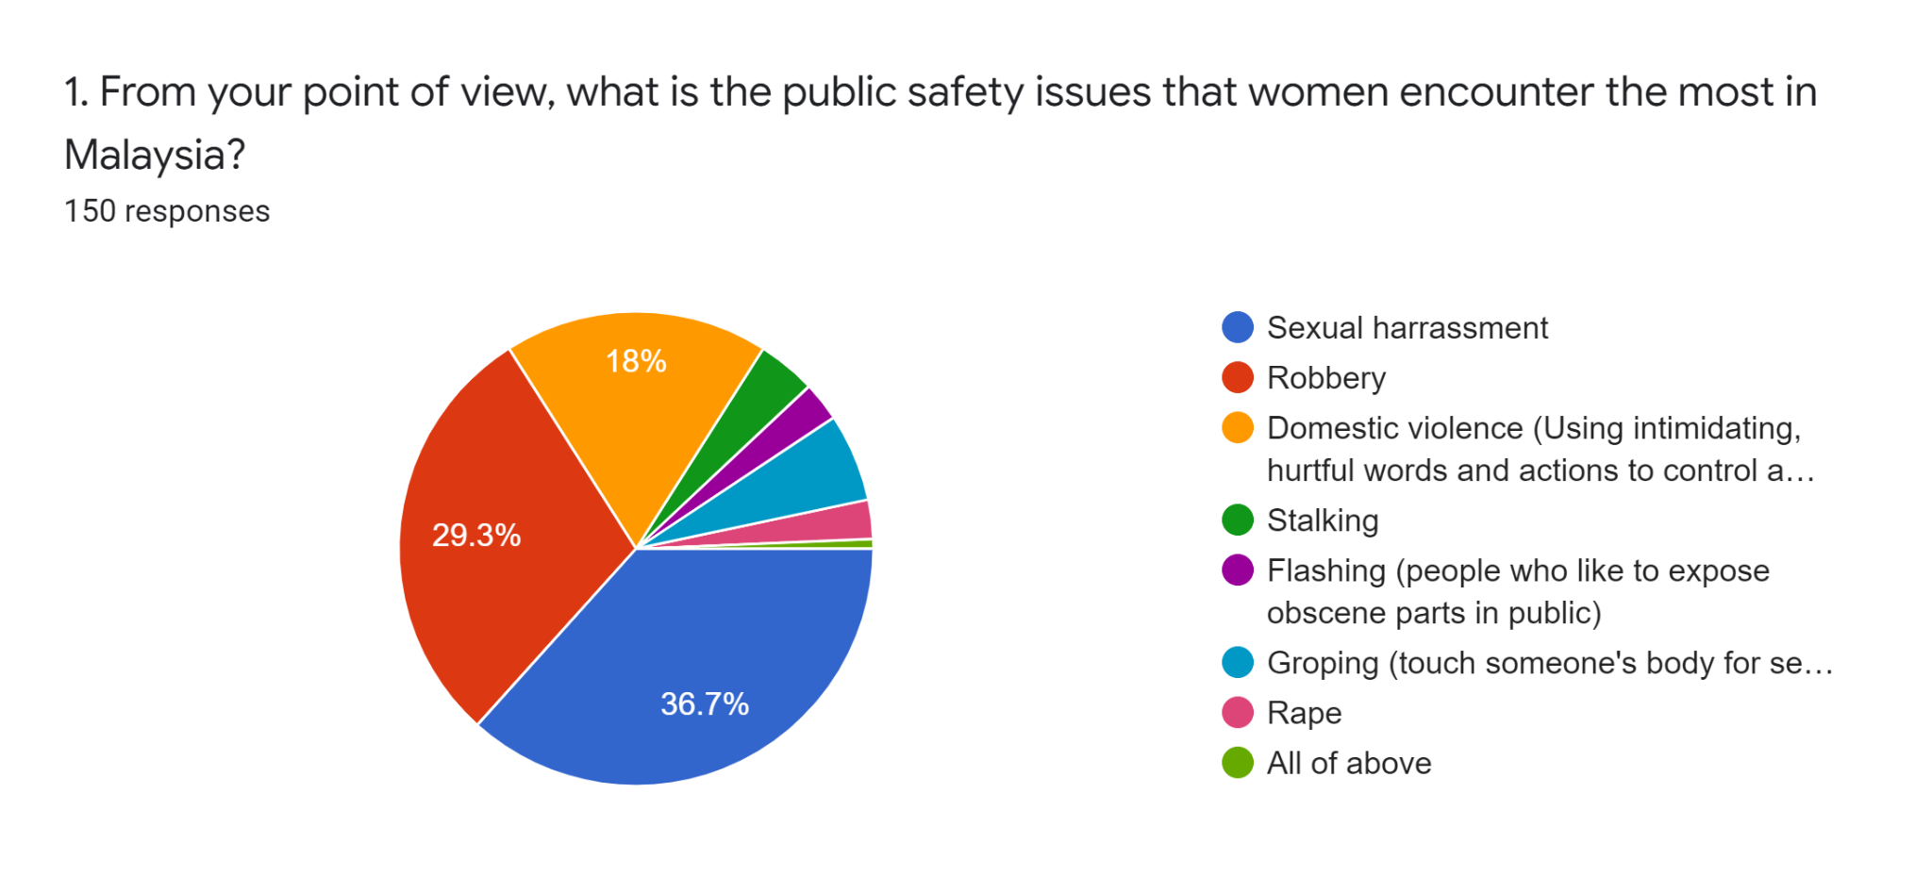

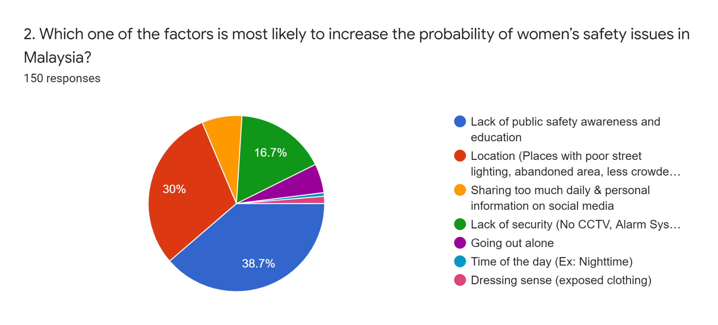

**PART 3 Effect of women’s safety issue**

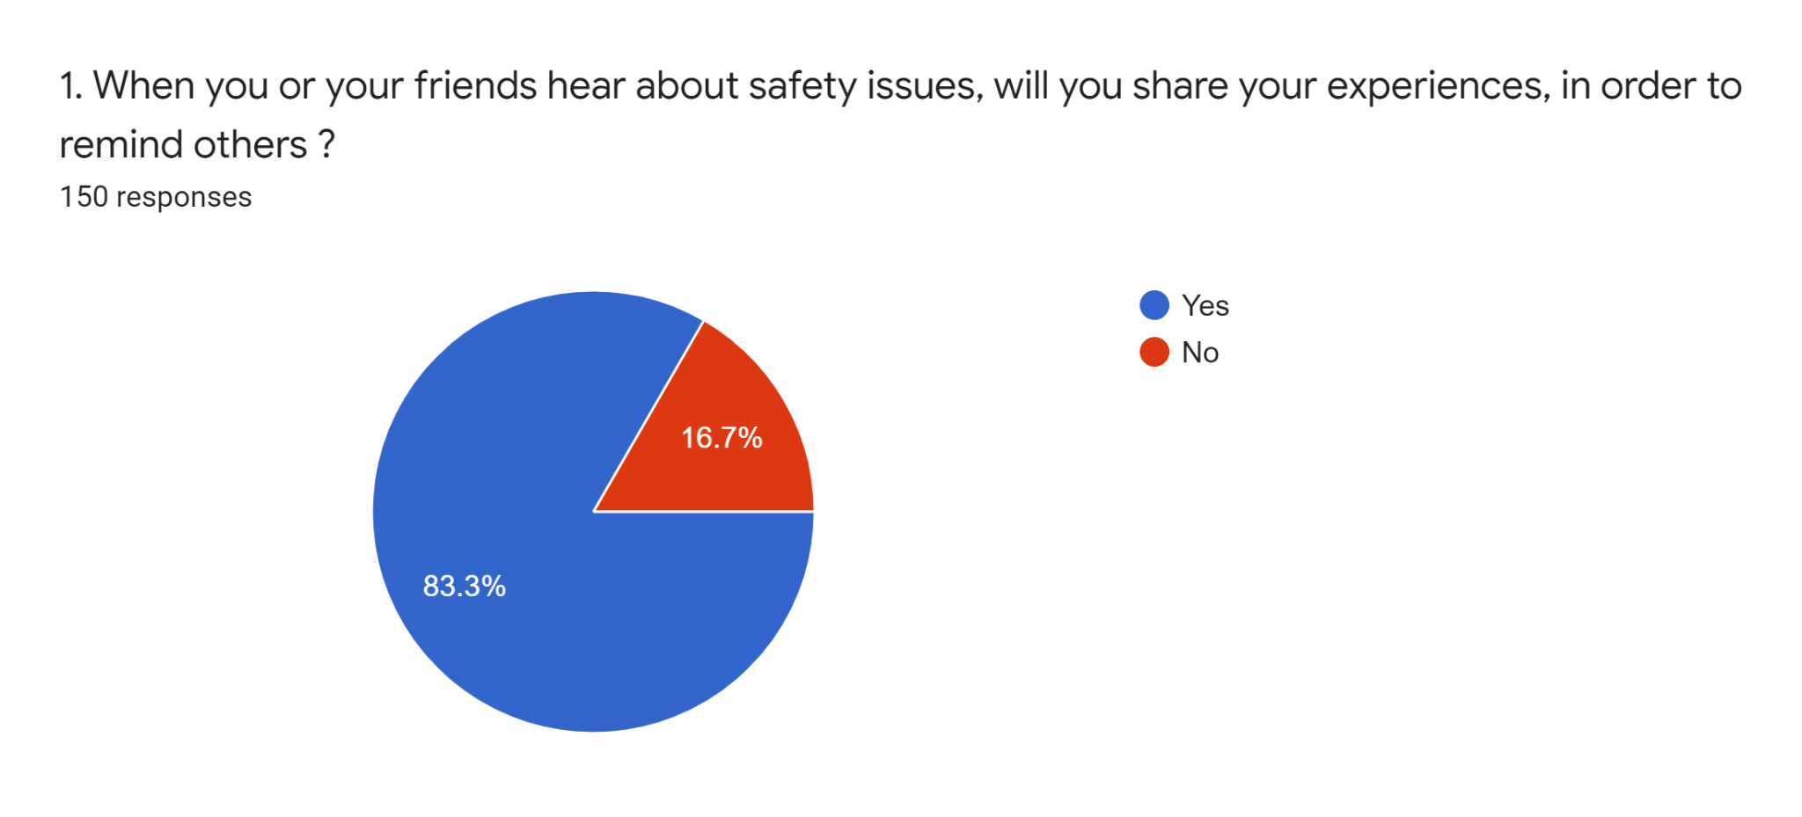

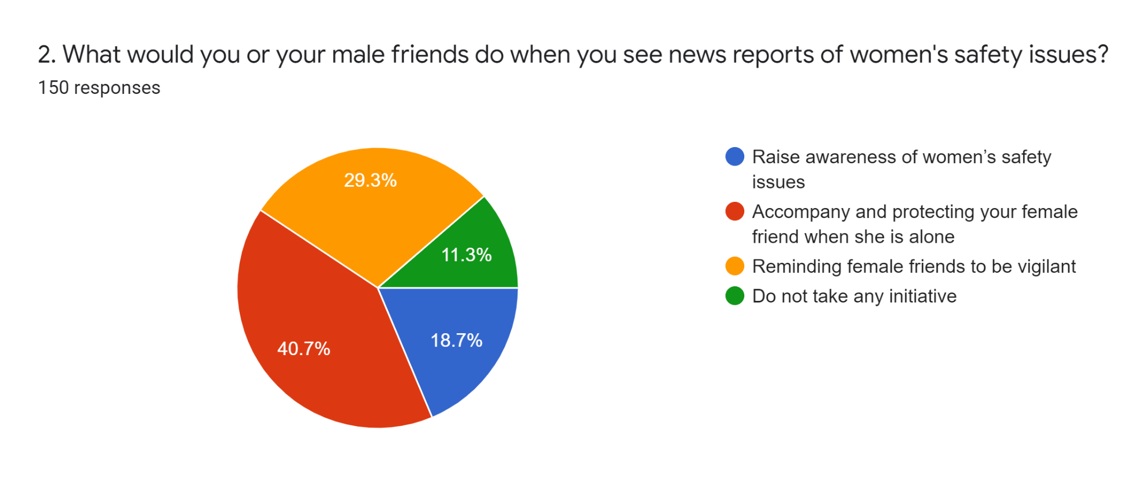

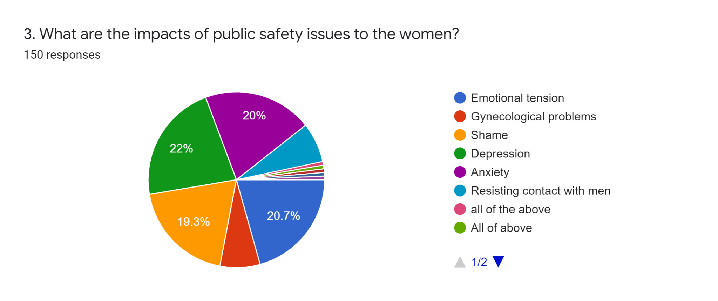

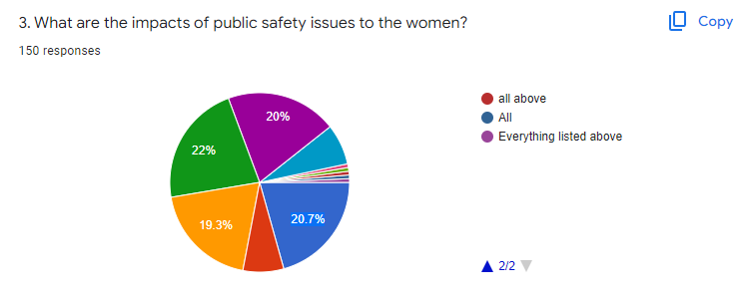

**PART 4 Prevention of women’s safety issues**

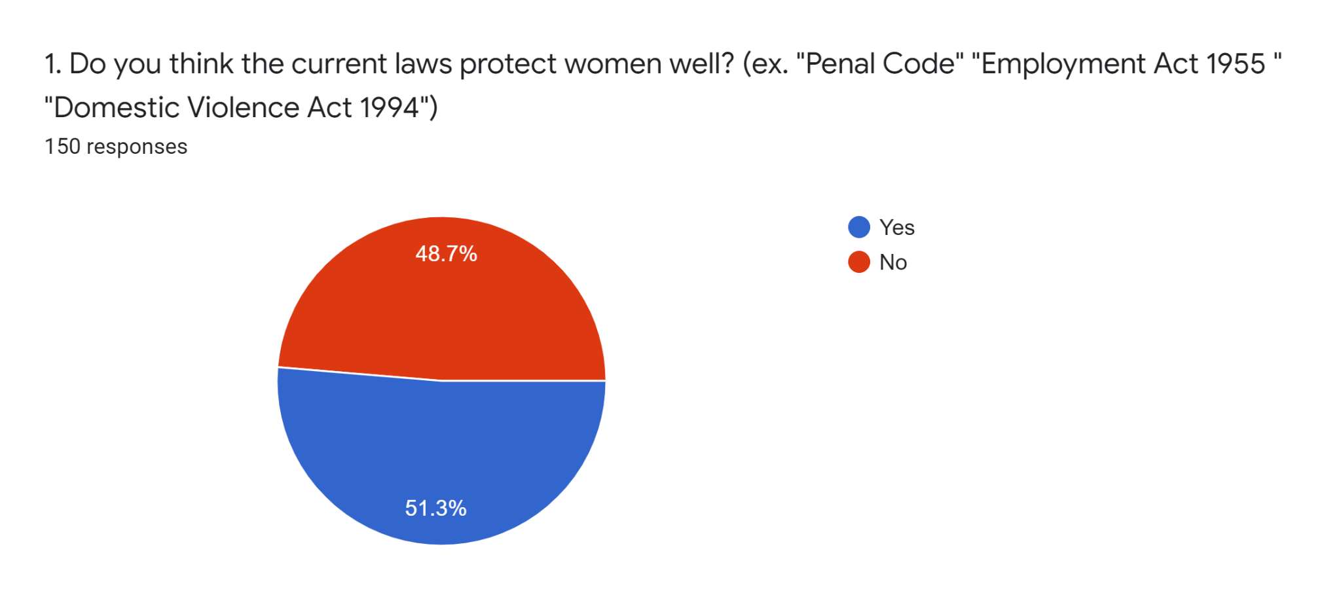

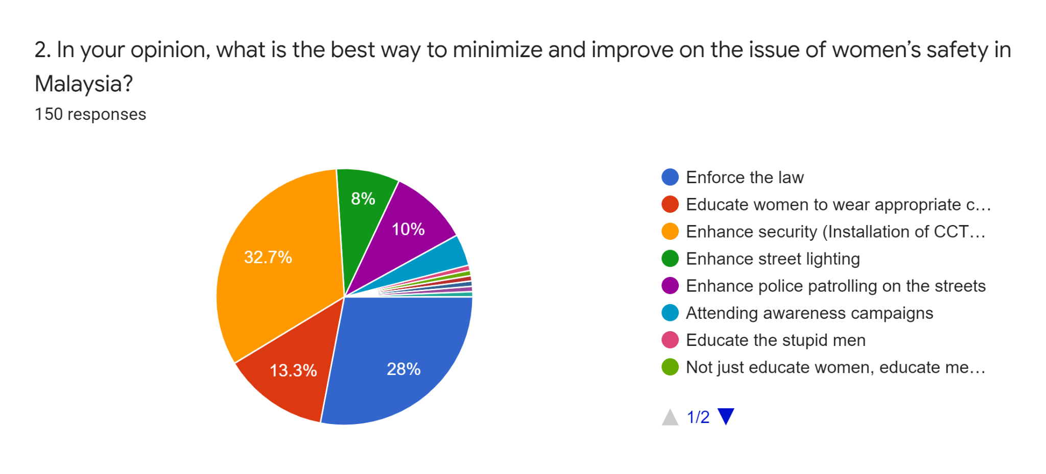

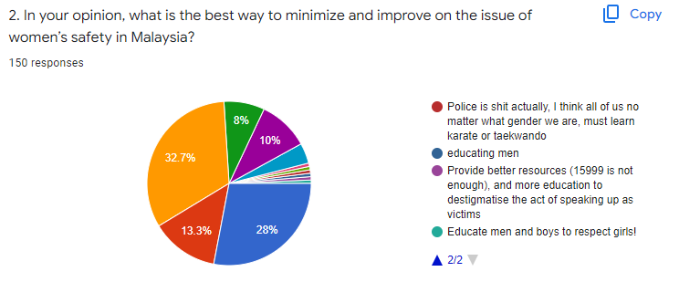

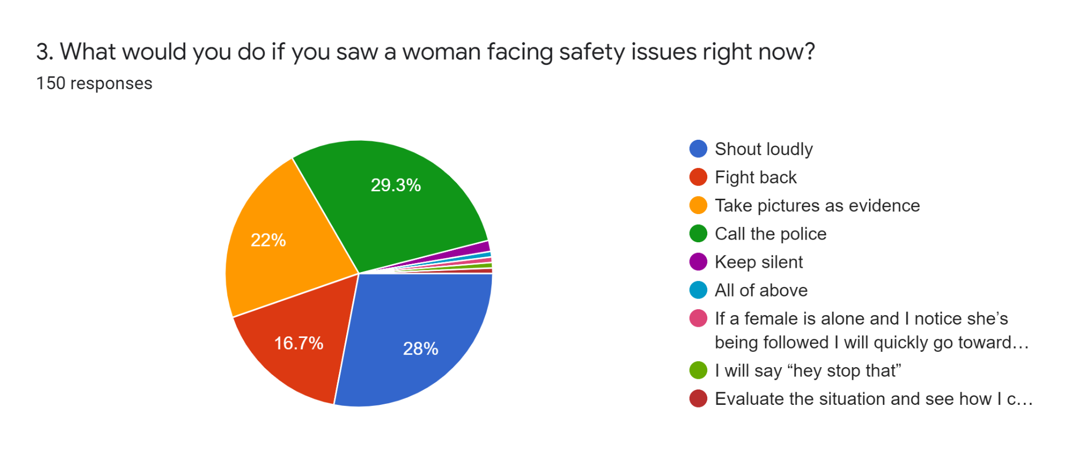

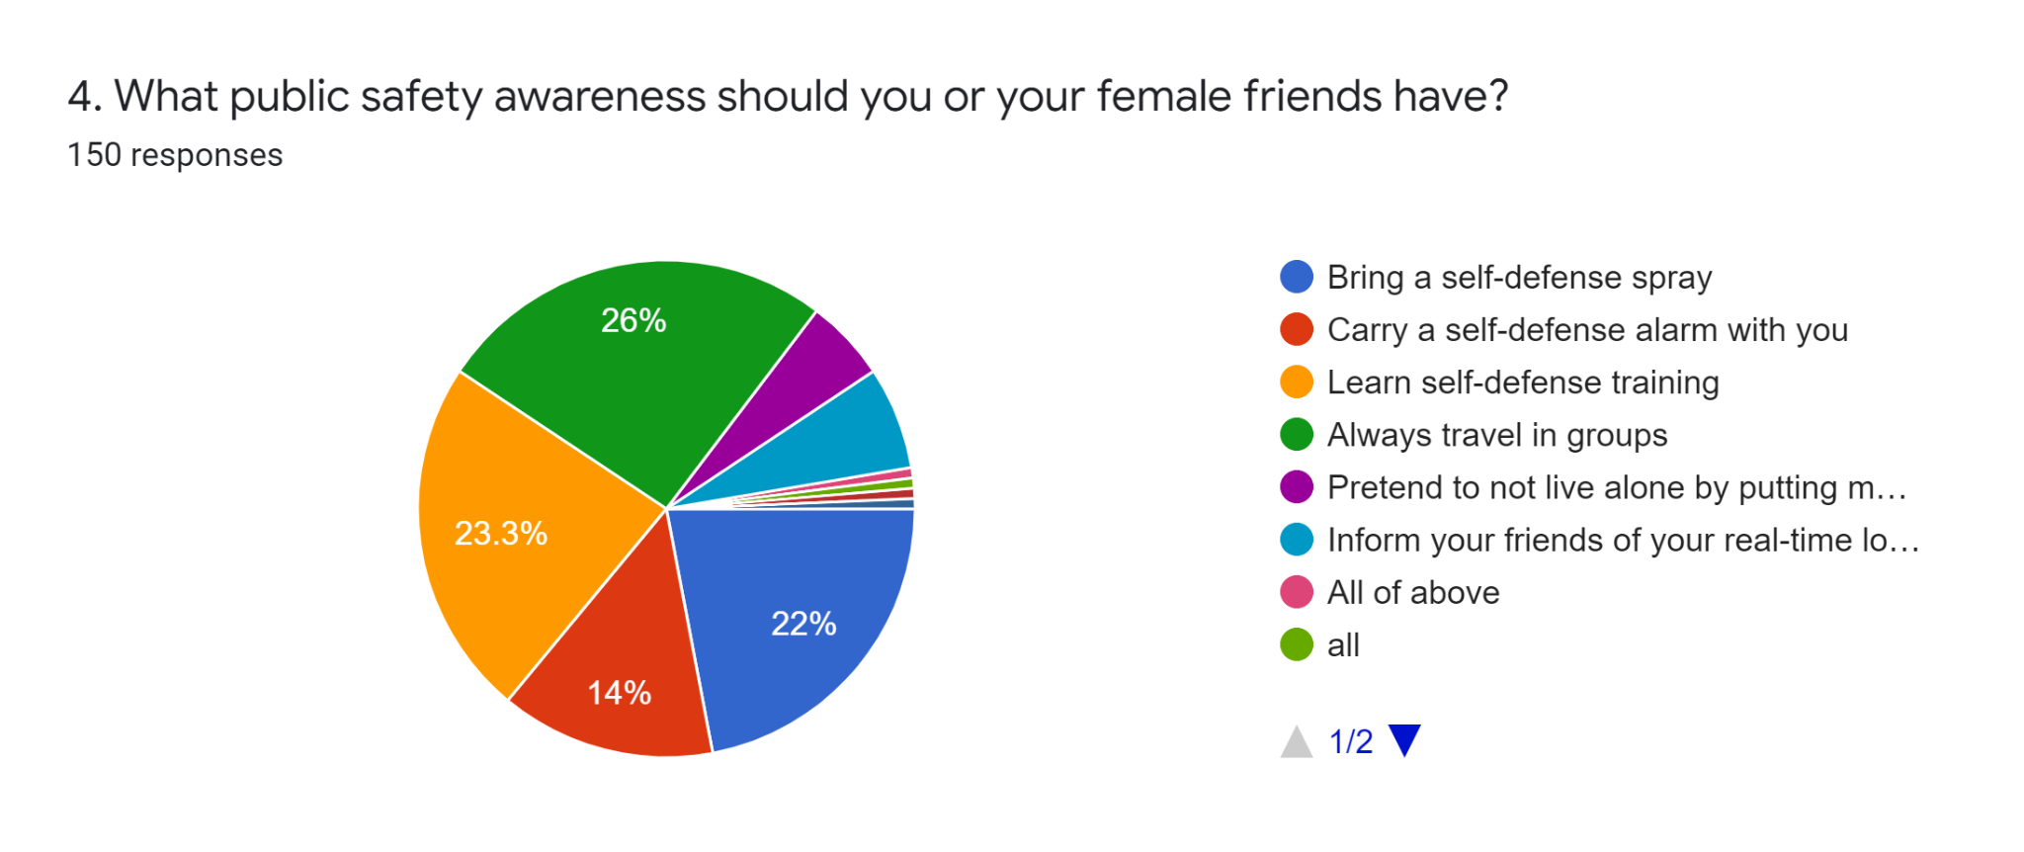

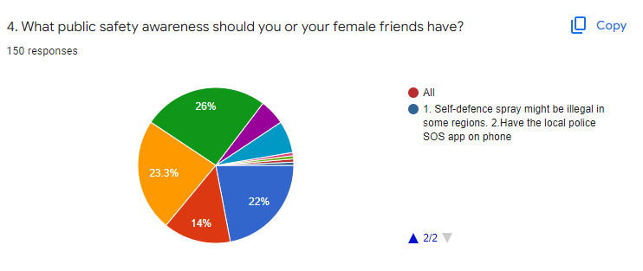

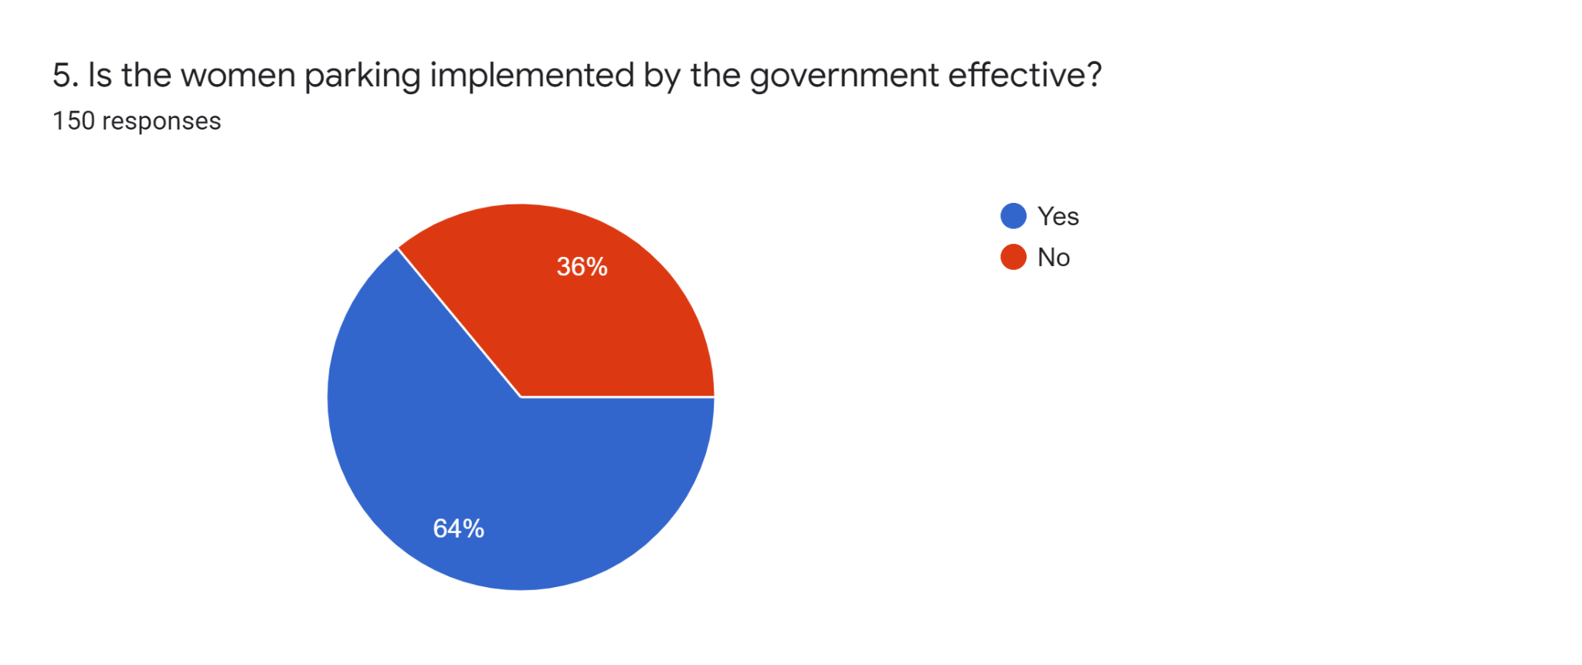

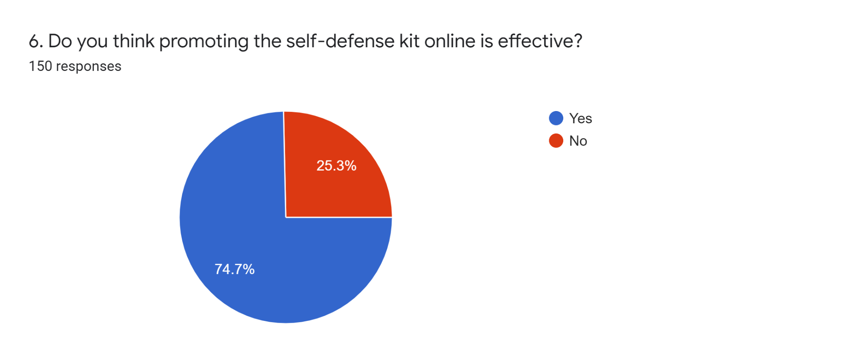

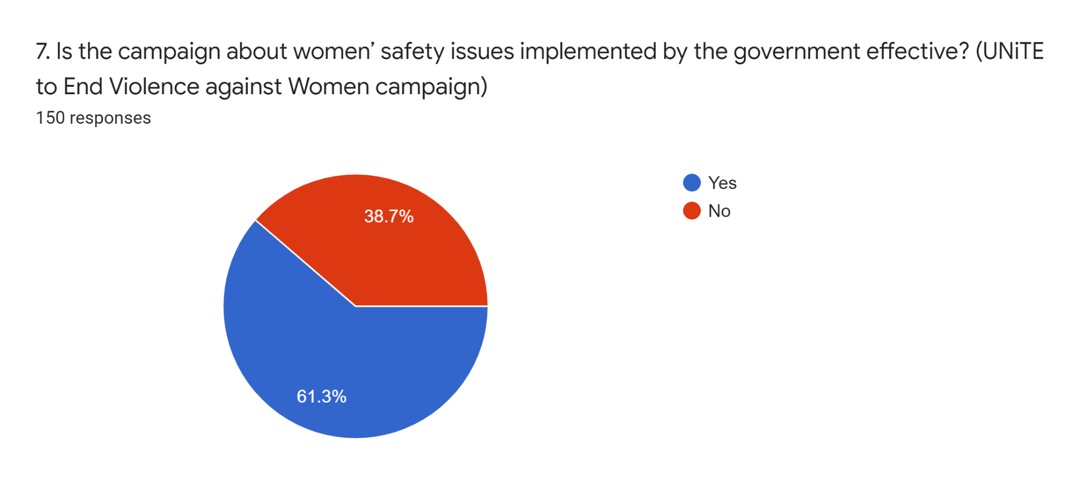

# Appendix C

**Part 1: Background of respondents**

|  |  |
| --- | --- |
| **Question** | **Answer** |
| **1. Gender** | **a. Male**  **b. Female** |
| **2. Age** | **a. 15 – 20 years old**  **b. 21 – 30 years old**  **c. 31 – 40 years old**  **d. Above 50 years old** |
| **3. Are you a local or international student?** | **a. Local Student**  **b. International Student** |
| **4. Current Education Level** | **a. Diploma**  **b. Bachelor’s Degree**  **c. Master’s Degree**  **d. Doctor of Philosophy (PHD)** |

**Part 2: Cause of women’s safety issue**

|  |  |
| --- | --- |
| **Question** | **Answer** |
| **1. From your point of view, what are the public safety issues that women encounter the most in Malaysia?** | **a. Sexual harassment**  **b. Robbery**  **c. Domestic violence (Using intimidating, hurtful words and actions to control a partner)**  **d. Stalking**  **e. Flashing (people who like to expose obscene parts in public)**  **f. Groping (touch someone's body for sexual pleasure without consent**  **g. Rape**  **h. Other: _______** |
| **2. Which one of the factors is most likely to increase the probability of women’s safety issues in Malaysia?** | **a. Lack of public safety awareness and education**  **b. Location (Places with poor street lighting, abandoned area, less crowded place)**  **c. Sharing too much daily & personal information on social media**  **d. Lack of security (No CCTV, Alarm System, Patrolling of police & security guards)**  **e. Going out alone**  **f. Time of the day (Ex: Nighttime)**  **g. Dressing sense (Exposed clothing)**  **h. Other: _______** |

**Part 3: Effect of women’s safety issue**

|  |  |
| --- | --- |
| **Question** | **Answer** |
| **1. When you or your friends hear about safety issues, will you share your experiences, in order to remind others?** | **a. Yes**  **b. no** |
| **2. What would you or your male friends do when you see news reports of women's safety issues?** | **a. Raise awareness of women’s safety issues**  **b. Accompany and protect your female friend when she is alone**  **c. Reminding female friends to be vigilant**  **d. Do not take any initiative**  **e. Other: _______** |
| **3. What are the impacts of public safety issues to women?** | **a. Emotional tension**  **b. Gynecological problems**  **c. Shame**  **d. Depression**  **e. Anxiety**  **f. Resisting contact with men**  **g. Other: _______** |

**Part 4: Prevention of women’s safety issues**

|  |  |
| --- | --- |
| **Question** | **Answer** |
| **1. Do you think the current laws protect women well? (ex. "Penal Code” “Employment Act 1955 " "Domestic Violence Act 1994")**  **Description:**  **“Penal Code” - A broader definition of rape and harsher penalties**  **“Employment Act 1955” - Sexual harassment at work**  **“Domestic Violence Act 1994” - An Act to offer legal protection for victims of domestic violence and its relating issues** | **a. Yes**  **b. No** |
| **2. In your opinion, what is the best way to minimize and improve on the issue of women’s safety in Malaysia?** | **a. Enforce the law**  **b. Educate women to wear appropriate clothing**  **c. Enhance security (Installation of CCTV and alarm system)**  **d. Enhance street lighting**  **e. Enhance police patrolling on the streets**  **f. Attending awareness campaigns**  **g. Other: _______** |
| **3. What would you do if you saw a woman facing safety issues right now?** | **a. Shout loudly**  **b. Fightback**  **c. Take pictures as evidence**  **d. Call the police**  **e. Keep silent**  **f. Other: _______** |
| **4. What public safety awareness should you or your female friends have?** | **a. Bring a self-defense spray**  **b. Carry a self-defense alarm with you**  **c. Learn self-defense training**  **d. Always travel in groups**  **e. Pretend to not live alone by putting male items in front of the doors**  **f. Inform your friends of your real-time location**  **g. Other: _______** |
| **5. Is the women's parking implemented by the government effective?**  **\*Women's parking spaces are specially designated and identified parking spaces in parking garages and parking lots to be used by women. They are usually near exits to increase the safety of women, to facilitate parking, or to facilitate walking to shopping or employment destinations.** | **a. Yes**  **b. No** |
| **6. Do you think promoting the self-defense kit online is effective?** | **a. Yes**  **b. No** |
| **7. Is the campaign about women’s safety issues implemented by the government effective? (UNiTE to End Violence against Women campaign)** | **a. Yes**  **b. No** |