Empiria: A Composable, Browser-Based Environment for Simulation-Based Statistics Education
May 2026

Abstract
Simulation-based reasoning—building a sampling distribution empirically before meeting it as a formula—is now central to statistics teaching, but the supporting software is typically siloed: each applet addresses one concept and its output cannot feed the next step, so the workflow students must internalize stays implicit. This article describes Empiria, a free, open-source, browser-based environment that makes that workflow explicit by representing it as a composable dataflow graph: students wire small modules together with cables and watch every intermediate quantity update in real time—optionally beside the live mathematical formula each node computes. Empiria runs with no installation on any modern device, ships sixteen guided lessons and a short tour, and exports figures, data, and fully reproducible patches. Its closed-form routines are verified against R to machine precision and its randomised procedures against published reference values, so the tool is auditable as well as legible. It is available at <[live tool — withheld for review]>.
Keywords: Teaching Statistics; simulation-based inference; statistics education; sampling distributions; bootstrap; reproducibility; educational technology; dataflow

Introduction
The case for reorganizing introductory statistics around simulation-based reasoning, rather than closed-form normal-theory derivation, is by now well established. Cobb (2007) argued that the curriculum had over-invested in analytic derivations at the expense of randomization- and simulation-based approaches in which the sampling distribution is built empirically before it is named; the simulation-based-inference movement subsequently built curricula around that idea (Rossman & Chance, 2014) and reported measurable gains in students’ reasoning about p-values and confidence intervals (Tintle et al., 2015), and the GAISE College Report codified the corresponding recommendations—foster active learning, use real data, integrate technology, and emphasize statistical thinking (American Statistical Association, 2016). A sustained research literature documents why this is hard: students struggle to form durable intuitions about sampling variability and the sampling distribution of an estimator, and they benefit from manipulating parameters and observing the consequences in real time (Chance et al., 2004; delMas et al., 2007; Garfield & Ben-Zvi, 2009).
The pedagogical principle is now mainstream; what remains uneven is the toolkit through which it is delivered. The existing landscape is fragmented. Sampling-distribution visualizers address sampling variability (Chance et al., 2004; delMas et al., 2007); TinkerPlots supports school-level exploratory analysis (Konold & Lehrer, 2008) and CODAP extends this to data science for younger learners (Finzer, 2013); NetLogo is the dominant agent-based-modeling environment (Wilensky, 1999); StatKey supports a full simulation-based-inference curriculum in the browser (Lock et al., 2021); and a large number of single-purpose applets (for example, the Rossman/Chance collection and Seeing Theory) and instructor-built R Shiny dashboards address specific techniques. Each of these tools is effective within its domain, but each is also self-contained: the output of one cannot be piped into the next analytical step. This matters because the workflow students must internalize—data-generating process → sampling → estimation → inference → diagnostics—is exactly a composable pipeline, and one-applet-per-concept tools render that pipeline invisible.
This article describes Empiria, an open-source, browser-based environment that restores composition at the level of the platform. In Empiria a student builds an analysis as a dataflow graph: small modules (“nodes”) are connected by cables, a global clock advances the computation, and the output of any node is a signal that can be routed into any other. The entire inferential pipeline therefore sits on a single screen, wired together, with every intermediate quantity visible and manipulable as it updates. The contributions of the tool, and of this article, are: (1) a composable, signal-flow interaction model for simulation-based inference that makes the inferential workflow explicit; (2) a live mathematical-notation view that renders each module’s formula with the current values substituted, tying symbolic form to direct manipulation; (3) a zero-installation, cross-device implementation with sixteen ready-made lessons and a guided tour; and (4) a verification methodology (exact numerical recipes, deterministic seeding, and an automated test suite checked against R) that makes the tool auditable rather than merely persuasive.

Background and related tools
Empiria’s nearest neighbors are the sampling-distribution visualizers studied in the statistics-education literature (Chance et al., 2004; delMas et al., 2007), TinkerPlots (Konold & Lehrer, 2008), CODAP (Finzer, 2013), NetLogo (Wilensky, 1999), the StatKey tools that accompany a simulation-based-inference curriculum (Lock et al., 2021), the Rossman/Chance and Seeing Theory applet collections, and the many instructor-authored R Shiny applications. These tools established that dynamic, manipulable visualization supports the construction of sampling intuitions, and Empiria builds directly on that finding.
Empiria differs from these precedents in three respects. First, it is a composable signal-flow environment rather than a single-purpose application. Even free, browser-based simulation tools such as StatKey present one analysis per screen; in Empiria the output of any module is a signal that can be routed into any other, so a parametric sampler can feed a sampling-window estimator, which can feed a hypothesis test or a bootstrap, with no copy-paste or context switch. Second, it lowers the cost of authoring new teaching material: where a Shiny applet requires fluency in R, HTML, and reactive programming, an Empiria activity is assembled by wiring existing modules, and a new module is a single function with a small parameter schema. Third, it treats numerical correctness and reproducibility as first-class, testable properties (described below), so that the tool can be audited by a skeptical instructor rather than taken on trust. Empiria does not aim to replace analytic software such as R; it is a complementary, simulation-first interface intended to make the elementary operations of sampling, estimation, inference, and diagnosis directly manipulable.

Design

The dataflow canvas
Empiria presents an infinite canvas on which the user places typed nodes and connects their ports with cables. Every node exposes labelled input ports on its left and output ports on its right; dragging a cable from an output to an input establishes a dependency. A global clock advances the graph in topological order, and on each tick every node reads its inputs, updates its internal state, and renders a small visualization matched to the quantity it computes. A complete analysis is thus laid out left to right as a visible chain (source → transform → statistic → display), and every intermediate value is observable as it changes (Figure 1). This interaction model is a deliberate descendant of the dataflow and analog-computing traditions (visual patch-and-cable environments and the differential analyzers that preceded digital computation), in which the wiring is the program.
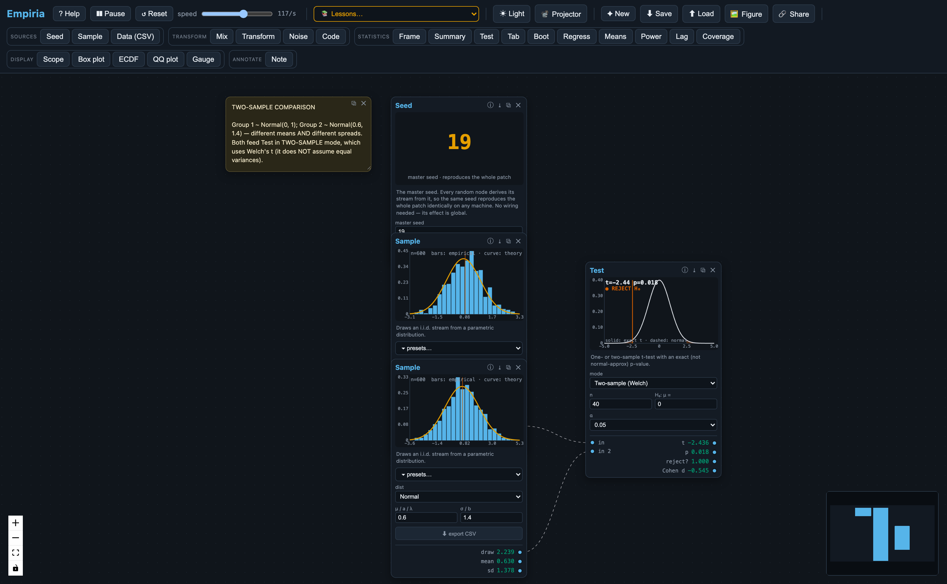
Figure 1. A two-sample comparison assembled on the Empiria canvas. Two independent samplers—each drawing from its own population and showing a live histogram—feed a single test node that overlays the t reference distribution and reports the statistic and decision. The analysis is built as wired modules rather than invoked as a function call, so the data-generating process → sampling → estimation → inference workflow is laid out left to right with every intermediate quantity visible at once.
The clock speed is adjustable from roughly one tick per second—slow enough to watch individual draws accumulate—to several thousand per second for rapid convergence, with the current rate displayed. Light and dark themes, a large-type “projector” mode for lecture rooms, and a colorblind-safe palette support classroom use.

The engine and reproducibility model
Empiria’s computational core is implemented as a dependency-free TypeScript engine that is independent of the user interface. All randomness derives from a single seeded Mersenne-Twister generator (Matsumoto & Nishimura, 1998); the standard Math.random is never used, because it is neither seedable nor reproducible across browsers. Each stochastic node derives its own stream deterministically from the master seed and its node identifier, so that adding or removing a node does not perturb the others. A patch—the complete description of the nodes, their parameters, the wiring, and the master seed—serializes to a small JSON document that can be saved as a file or encoded into a shareable URL; loading it reconstructs the simulation byte-for-byte on any machine. Computation is performed in IEEE-754 double precision with no platform-specific code paths, so a worked example is exactly reproducible across operating systems and devices.

Computational footprint
Because Empiria runs entirely in the browser, its only requirement is a current browser: there is no server, and after the initial download—a single static bundle of roughly 0.4 MB (about 130 KB gzipped)—it runs offline. The numerical workload is light. On a contemporary laptop (Apple M4, single-threaded) the engine sustains on the order of 2.6 million ticks per second for a typical few-node patch and tens of thousands per second for a busy canvas of around sixty nodes, with memory in the tens of megabytes; the per-node cost is well under a microsecond and grows linearly with the number of nodes. Because the interactive clock is capped at a few thousand ticks per second, the on-screen frame rate—not the arithmetic—is the limiting factor, which leaves ample headroom on the low-power hardware (Chromebooks, tablets) typical of classrooms. The benchmark is a short script in the repository, so these figures can be reproduced and checked on any machine.

The module library
The modules are organized on the palette into five families (Table 1). Sources generate or import data; transforms reshape a signal; statistics estimate, test, or summarize; displays render a signal; and an annotation node lets the instructor leave explanatory text that travels with the patch.
Table 1. The Empiria module library.
Family | Modules
Sources | Seed (master seed), Sample (parametric distribution with real-world presets), Data (CSV import)
Transform | Mix (mixtures), Transform (y = a·f(x)+b), Noise (measurement error), Code (continuous → ordinal/Likert)
Statistics | Frame (mean/SD/SE), Summary (descriptives), Test (one/two-sample t), Tab (χ² and Cramér’s V), Boot (BCa bootstrap), Regress (OLS), Means (sampling distribution of the mean), Power (power / Type-I error), Lag (autocorrelation), Coverage (confidence-interval coverage)
Display | Scope (time trace), Box (box plot), ECDF, QQ (normal quantile–quantile), Gauge (units readout)
Annotate | Note (editable, saved with the patch)
Each statistic ships with a visualization designed for the concept it represents: a histogram with a confidence band, a scatterplot with a fitted line and prediction band, a null t-distribution with shaded rejection regions and the normal approximation overlaid for contrast, a bootstrap distribution annotated with its bias-correction diagnostics, and a confidence-interval “coverage” display that stacks repeated intervals and colors those that miss the true value.

Pedagogical rationale
Empiria’s design draws on established findings from the statistics-education and mathematical-cognition literatures, which it operationalizes through the principles below.
Dynamic, manipulable visualization supports the construction of sampling intuitions. Students who manipulate parameters and watch sampling distributions respond in real time develop more durable inferential intuitions than those who encounter the same material as static figures (Chance et al., 2004; delMas et al., 2007; Garfield & Ben-Zvi, 2009; for a recent review, Gok & Goldstone, 2024). Empiria adopts this throughout: every parameter is a control, every estimator is a live trace, and every confidence interval is a band that visibly widens and narrows with the sample.
Concrete-to-abstract sequencing scaffolds inferential thinking. Empiria’s patch grammar lets a procedure be enacted before it is symbolized. A two-sample t-test is, in Empiria, a literal sequence of objects the student wires together—two samplers, a sampling-window estimator on each branch, and a test module that consumes both—so that when the algebraic formula is later introduced, each symbol corresponds to a module the student has already manipulated.
Live notation ties manipulation to symbolic form. A persistent difficulty in statistics is that formulas stay inert: a student can read t = (x̄ − μ₀)/(s/√n) without connecting any symbol to something they can change. Empiria can render, beneath every node, the formula that node computes in standard mathematical notation, written as a chained equality—the symbolic expression, the current values substituted into it, and the result—and updated on every tick (Figure 2). Manipulating the patch is therefore reflected immediately in the equation: as a sample grows the student watches s shrink and the denominator s/√n shrink with it; widening the gap x̄ − μ₀ drives the t-statistic up; a Transform node shows y = 2·x + 1 evaluating a specific input to a specific output beside the scatter it produces. The same patch can thus be read two ways at once—picture-first for intuition and notation-first for formalism—so the symbolic layer becomes a manipulable object rather than a static artifact, which directly addresses the symbol-grounding gap the concrete-to-abstract literature identifies. Because the notation is rendered with the browser’s native MathML, the feature adds no dependency and no meaningful weight.
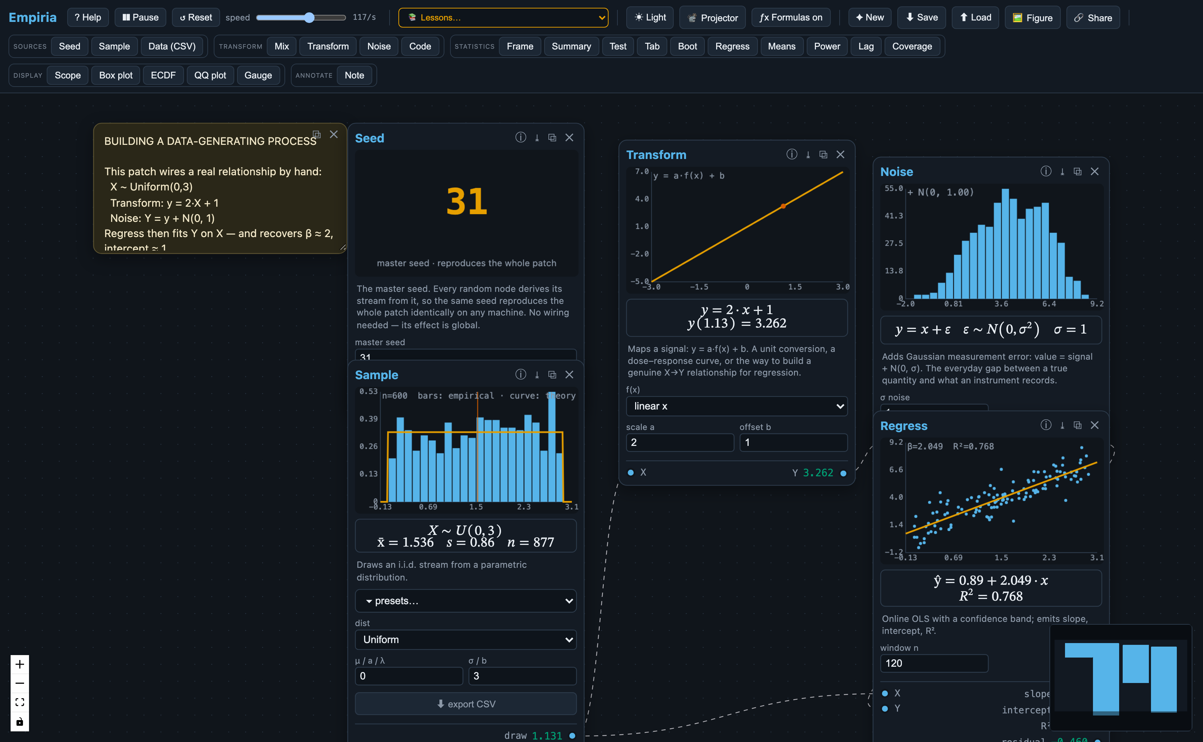
Figure 2. The live-notation view (toggled on). Beneath each node, the formula it computes is rendered in standard notation with the current values substituted in: the Sample node shows its data-generating distribution and running estimates, the Transform node shows y = 2·x + 1 evaluated at a specific input, the Noise node shows y = x + ε with ε ∼ N(0, σ²), and the Regress node reports the recovered ŷ = a + b·x and R². As the user changes a parameter or rewires the graph, every equation updates on the next tick.
Composition makes the inferential workflow visible. Because the output of any module is routable into any other, the data-generating process → sampling → estimation → inference → diagnostics pipeline is a single wired chain rather than a sequence of disconnected applets. This directly targets the structure the reform literature identifies as the learning objective (Cobb, 2007; Tintle et al., 2015).
Modular composition invites customization and independent exploration. Because activities are assembled from interchangeable parts rather than delivered as fixed applets, a student is not confined to a scripted task: a patch can be rewired, one distribution or estimator swapped for another, a parameter nudged so that the downstream consequences propagate visibly, or something the instructor never specified built from scratch (Figure 3). This open-ended, constructionist mode—understanding by building and tinkering (Papert, 1980)—is supported directly by the dataflow canvas and by the analog-computing intuition it inherits: a model is something one assembles from manipulable parts and operates, not a result one reads off. The visual immediacy of the per-node displays makes such exploration legible, because a change made anywhere is immediately visible everywhere downstream.
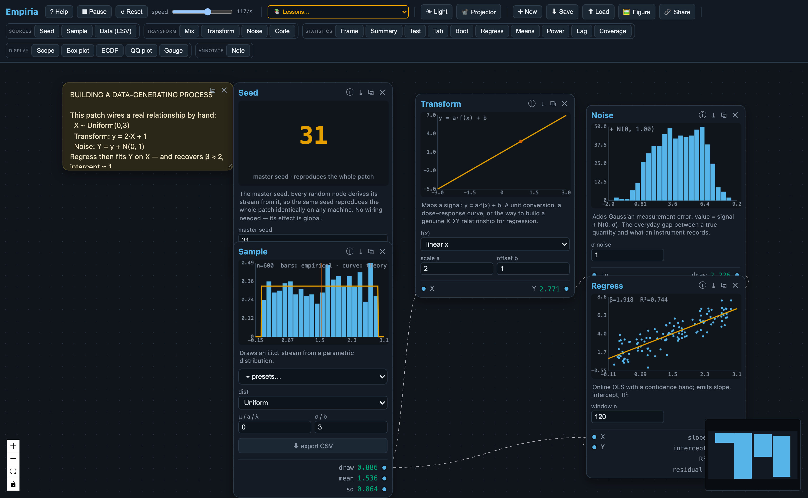
Figure 3. Building a data-generating process from interchangeable parts. A uniform predictor (Sample) is passed through a deterministic Transform ($y=2x+1$) and a Noise module before a Regress node recovers the relationship online and reports the fitted slope and intercept. Because the model is assembled rather than scripted, a student can swap the transform, change the amount of noise, or rewire the graph and watch every downstream view update—the build-and-tinker, analog-computing mode of working the design is meant to invite.
These principles are operationalized in sixteen bundled lessons, each a self-contained worksheet consisting of a patch plus an explanatory note, and a four-step guided tour (Law of Large Numbers → bootstrap → t-test → confidence-interval coverage) with previous/next navigation. The same modules serve a range of audiences: a general-education class can place a sampler and a sampling-window estimator and watch the standard error shrink as 1/√n; an introductory course can add regression, testing, and the bootstrap as a live picture of the workflow students will later carry out in R; and a graduate methods seminar can use the platform to interrogate small-sample behavior or to compare bootstrap intervals against analytic ones. What differs across audiences is the depth at which the underlying mathematics is examined, not the tool.

Illustrative classroom use
Several bundled lessons illustrate the range. A Law of Large Numbers activity wires a sampler into a growing sampling window; as the clock runs, the mean settles on the population value and the standard error contracts visibly. A bootstrap activity resamples a fixed dataset and draws the bootstrap distribution of a statistic—making the sampling distribution explicit without a formula—and reports a bias-corrected and accelerated interval (Efron, 1987; Hesterberg, 2015) (Figure 4). A small-sample t-test activity overlays the exact Student-t null distribution against the normal approximation, so that students see the normal mislead at low degrees of freedom and watch the reject/retain decision flip from sample to sample. A confidence-interval coverage activity repeats the whole experiment and tallies how often the interval covers the true mean, giving an operational meaning to “95% confidence.” A central-limit activity shows that the means of batches drawn from a skewed population are themselves approximately normal. An exploratory-data-analysis activity fans one imported dataset into a summary table, a box plot, an empirical CDF, and a normal quantile–quantile plot, so that the same data are seen four ways at once. In each case the patch is seeded, so an instructor can distribute it, have students run it, and be confident that every result reproduces.
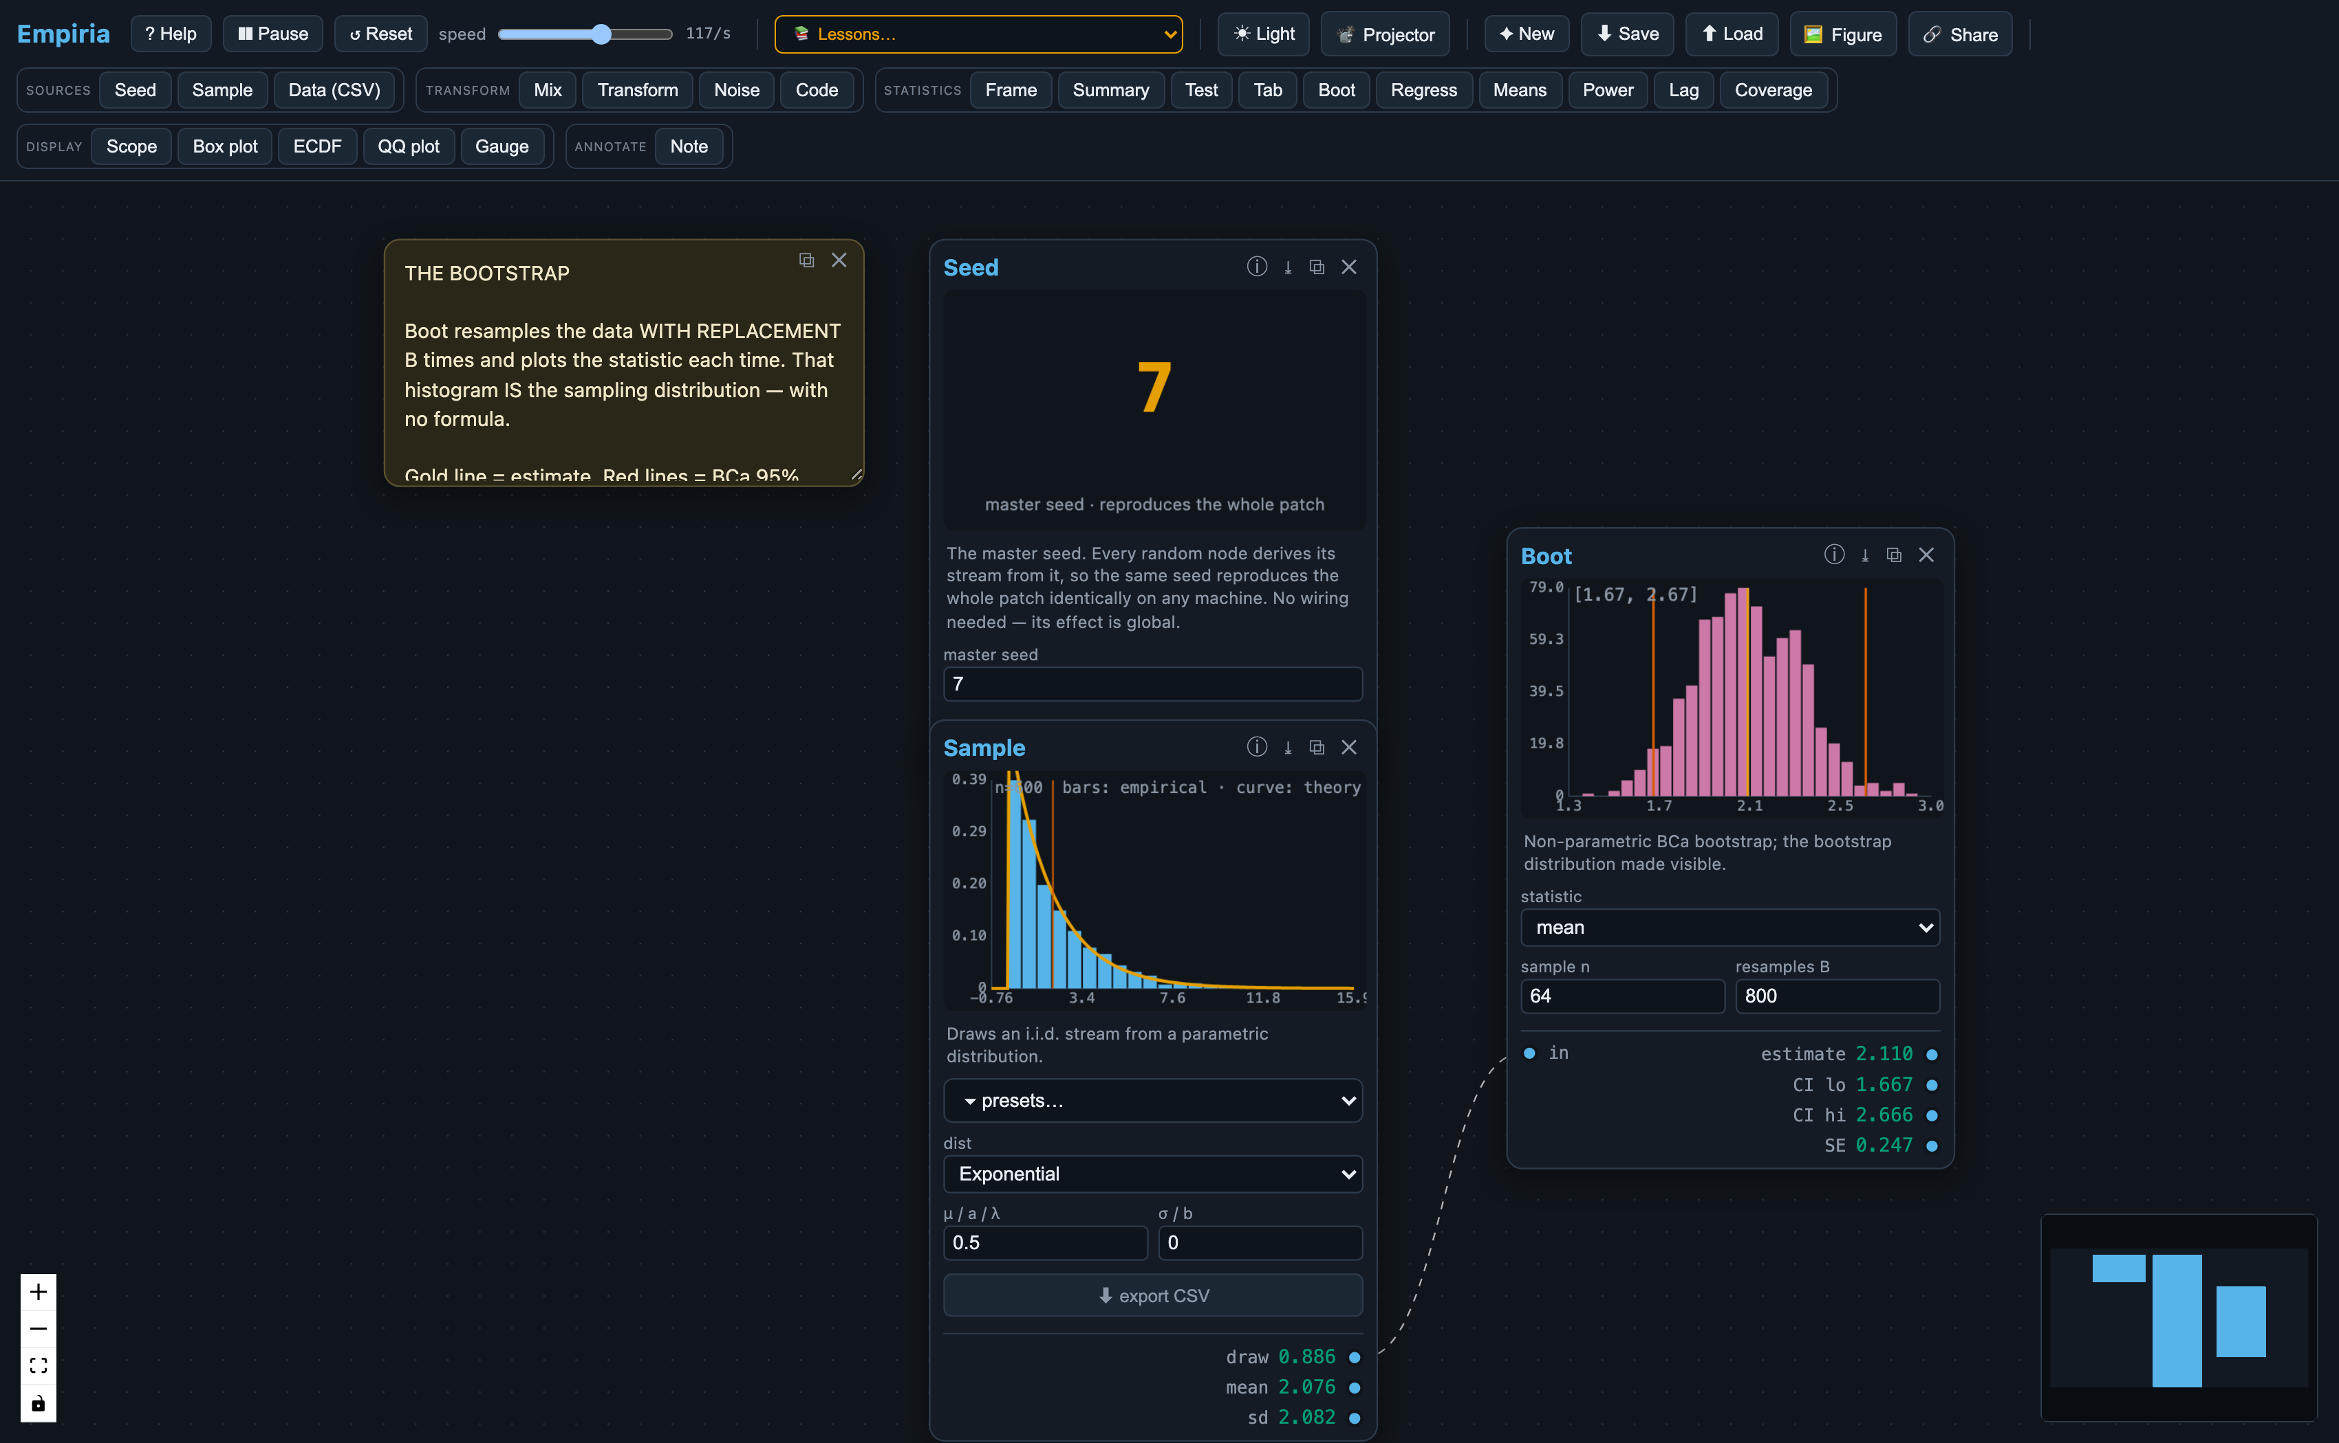
Figure 4. Simulation made visible. A sample drawn from a skewed (exponential) parent is resampled with replacement by the Boot module, whose histogram (magenta) is the bootstrap sampling distribution of the mean, annotated with a bias-corrected and accelerated interval. The sampling distribution is constructed empirically and watched as it forms, before any closed-form expression is introduced.

Numerical correctness and reproducibility

Verifying the numerics
Because the pedagogy depends on the displayed numbers being correct rather than merely plausible, Empiria treats verification as part of the artifact. Where introductory tooling has often relied on normal-theory approximations, Empiria computes closed-form quantities with their exact numerical recipes: the two-tailed Student-t and χ² tail probabilities are evaluated through the regularized incomplete beta and gamma functions using continued-fraction expansions (Press et al., 2007); confidence-interval critical values use the exact t quantile rather than the z ≈ 1.96 approximation; and bootstrap intervals are bias-corrected and accelerated (Efron, 1987).
These routines are checked by an automated test suite that compares each result against R to machine precision—covering the incomplete beta and gamma functions, Student-t probabilities and critical values, the normal CDF and quantile, one-sample and Welch two-sample t-tests, ordinary least squares, the contingency-table χ² and Cramér’s V, autocorrelation, and the descriptive moments—and against the canonical Mersenne-Twister test vector for the generator. The suite also verifies system-level properties: byte-identical reproduction under a fixed seed, the contraction of the standard error under the Law of Large Numbers, approximately nominal (95%) confidence-interval coverage, and a Type-I error rate near α under the null. An accompanying R script regenerates every reference value independently, so a reviewer can confirm the reference values themselves rather than only the tool’s self-consistency, and a verification document maps each routine to its algorithm, citation, reference command, and test. Finally, because a patch is seeded JSON, a student can export any node’s data to CSV and reproduce the statistic in R as an external check; the same patch and seed yield an identical export on any machine.

Development with AI coding assistance
Empiria’s implementation was carried out with the help of AI coding assistants (large language models used as programming aids). We disclose this as a matter of scholarly practice, and because it bears on a legitimate concern: software produced with substantial machine assistance may contain plausible-looking but incorrect numerical behavior, and a reader is right to ask whether the displayed statistics can be trusted. The answer here is methodological rather than rhetorical. The trustworthiness of Empiria’s outputs does not rest on the provenance of the code that produces them; it rests on an external verification regime that is independent of how the code was written.
Concretely, every numerical routine is checked against an authoritative reference implementation—R’s statistical functions (pt, qt, pchisq, pnorm, qnorm, t.test, lm, chisq.test, acf, quantile), the boot package for the BCa interval, and the canonical Mersenne-Twister test vector—to machine precision, with Monte-Carlo tolerances stated explicitly where resampling is involved. Those reference values are produced by an independent R script that a reviewer can rerun and compare against the literals asserted in the test suite, so the check confirms the reference values themselves rather than only the tool’s internal self-consistency. A test that compares to R cannot be satisfied by code that is merely persuasive: it passes only if the number is right, whoever or whatever wrote the code.
We also separate authorship from correctness. The statistical methods, the choice of exact recipes over normal-theory approximations, the pedagogical claims, and the interpretation of every result were specified, reviewed, and are vouched for by the author; the AI tools accelerated implementation, they did not make statistical decisions, and the author takes full responsibility for the software and the manuscript. Because the full audit trail maps each routine to its algorithm, citation, reference command, and test, and because the entire suite runs from three commands, any reviewer can reproduce the verification in minutes rather than taking our word for it.

Data and code availability
Empiria is released under the GPL-3.0 license and runs in any modern browser with no installation. The live application is at <[live tool — withheld for review]>; the source code, the automated test suite, the verification materials, the bundled lessons, and the documentation are in the public repository at <[repository — withheld for review]>. The exact version described here is tagged in the repository, and a snapshot of that version will be archived with a permanent DOI (Zenodo) upon acceptance, so that the reviewed software remains citable independently of later development. The figures in this article are screenshots of the running application; the patches that generate them are included among the bundled lessons.

Limitations and future work
Empiria’s contribution is a design: an interaction model grounded in established findings about manipulable visualization and simulation-based reasoning, paired with auditable numerics and reproducible, shareable patches. Its defining affordances are visual, analog-computing-inspired, and modular, and they are intended to support guided activities as well as the open-ended, learner-directed exploration in which a student customizes a patch, substitutes one component for another, and reaches a result by building rather than by following a script.
We should be explicit about what this article does not establish. It offers no evidence of learning gains from Empiria itself: the pedagogical claims above are design rationale, grounded in prior findings about related tools, and whether they translate into measurable outcomes is an open empirical question. Reviews of simulation tools are a useful corrective here: interactive visualization does not by itself guarantee understanding—students can watch a sampling distribution narrow and still misread it as a distribution of individual values—so the surrounding tasks and design details do much of the work (Gok & Goldstone, 2024). The affordances are available to instructors and students today, but their educational value remains to be demonstrated.
A formal study of classroom learning outcomes is the natural next step, and one we have not yet carried out. We are designing a within-instructor, between-section comparison in an introductory course—contrasting an Empiria-augmented condition against a matched condition that uses comparable static and applet-based visualizations, with sampling-variability and inference subscales of a validated assessment, together with a transfer task, as outcomes, to test whether these affordances translate into measurable gains. That study will be pre-registered, with its hypotheses and analysis plan deposited before any data are collected.
Two practical considerations are worth noting for adopters. Because a node-and-cable interface is initially unfamiliar, the bundled guided tour and lesson patches are designed to lower the activation cost and to give students a scaffold from which to begin tinkering; and because the modules are visually engaging, the suggested classroom integration is additive to, rather than a replacement for, a standard analytic workflow. On the technical side, confidence intervals for proportions currently use the normal (Wald) form, and the bootstrap is validated by its coverage behavior and by exact tests of its components rather than by a value-for-value match to a specific resampling implementation.

Conclusion
Empiria operationalizes the central recommendation of the statistics-education reform literature—that students build the sampling distribution before they name it—by making the inferential workflow a composable, manipulable object rather than a sequence of disconnected applets. By pairing that interaction model with exact, independently auditable numerics and reproducible, shareable patches, it aims to be trustworthy as well as legible: a tool a student can learn from and an instructor can verify.

Disclosure statement
The author reports no competing interests. No funding supported this work. AI-based coding assistants (large language models) were used as programming aids during development of the software. All statistical methods and numerical results were specified by the author and verified against independent reference implementations, as described in Numerical correctness and reproducibility; the author takes full responsibility for the content of the software and the manuscript.

References
- American Statistical Association, Guidelines for Assessment and Instruction in Statistics Education (GAISE) College Report 2016, American Statistical Association, 2016. https://www.amstat.org/education/gaise
- B. Chance, R. delMas, J. Garfield, Reasoning about sampling distributions, in: D. Ben-Zvi, J. Garfield (Eds.), The Challenge of Developing Statistical Literacy, Reasoning, and Thinking, Springer, 2004, pp. 295–323. https://doi.org/10.1007/1-4020-2278-6_13
- G. W. Cobb, The introductory statistics course: A Ptolemaic curriculum?, Technology Innovations in Statistics Education, 1(2007). https://doi.org/10.5070/T511000028
- R. delMas, J. Garfield, A. Ooms, B. Chance, Assessing students’ conceptual understanding after a first course in statistics, Statistics Education Research Journal, 6(2007), 28–58. https://doi.org/10.52041/serj.v6i2.483
- B. Efron, Better bootstrap confidence intervals, Journal of the American Statistical Association, 82(1987), 171–185. https://doi.org/10.1080/01621459.1987.10478410
- W. Finzer, The data science education dilemma, Technology Innovations in Statistics Education, 7(2013). https://doi.org/10.5070/T572013891
- J. Garfield, D. Ben-Zvi, Helping students develop statistical reasoning: Implementing a statistical reasoning learning environment, Teaching Statistics, 31(2009), 72–77. https://doi.org/10.1111/j.1467-9639.2009.00363.x
- S. Gok, R. L. Goldstone, How do students reason about statistical sampling with computer simulations? An integrative review from a grounded cognition perspective, Cognitive Research: Principles and Implications, 9(2024), 33. https://doi.org/10.1186/s41235-024-00561-x
- T. C. Hesterberg, What teachers should know about the bootstrap: Resampling in the undergraduate statistics curriculum, The American Statistician, 69(2015), 371–386. https://doi.org/10.1080/00031305.2015.1089789
- C. Konold, R. Lehrer, Technology and mathematics education: An essay in honor of Jim Kaput, in: L. D. English (Ed.), Handbook of International Research in Mathematics Education, 2nd ed., Routledge, 2008.
- R. H. Lock, P. F. Lock, K. Lock Morgan, E. F. Lock, D. F. Lock, Statistics: Unlocking the Power of Data, 3rd ed., Wiley, 2021. StatKey: https://www.lock5stat.com/statkey.
- M. Matsumoto, T. Nishimura, Mersenne Twister: A 623-dimensionally equidistributed uniform pseudo-random number generator, ACM Transactions on Modeling and Computer Simulation, 8(1998), 3–30. https://doi.org/10.1145/272991.272995
- S. Papert, Mindstorms: Children, Computers, and Powerful Ideas, Basic Books, 1980.
- W. H. Press, S. A. Teukolsky, W. T. Vetterling, B. P. Flannery, Numerical Recipes: The Art of Scientific Computing, 3rd ed., Cambridge University Press, 2007.
- A. Rossman, B. Chance, Using simulation-based inference for learning introductory statistics, WIREs Computational Statistics, 6(2014), 211–221. https://doi.org/10.1002/wics.1302
- N. Tintle, B. Chance, G. Cobb, S. Roy, T. Swanson, J. VanderStoep, Combating anti-statistical thinking using simulation-based methods throughout the undergraduate curriculum, The American Statistician, 69(2015), 362–370. https://doi.org/10.1080/00031305.2015.1081619
- U. Wilensky, NetLogo, Center for Connected Learning and Computer-Based Modeling, Northwestern University, 1999. http://ccl.northwestern.edu/netlogo/

