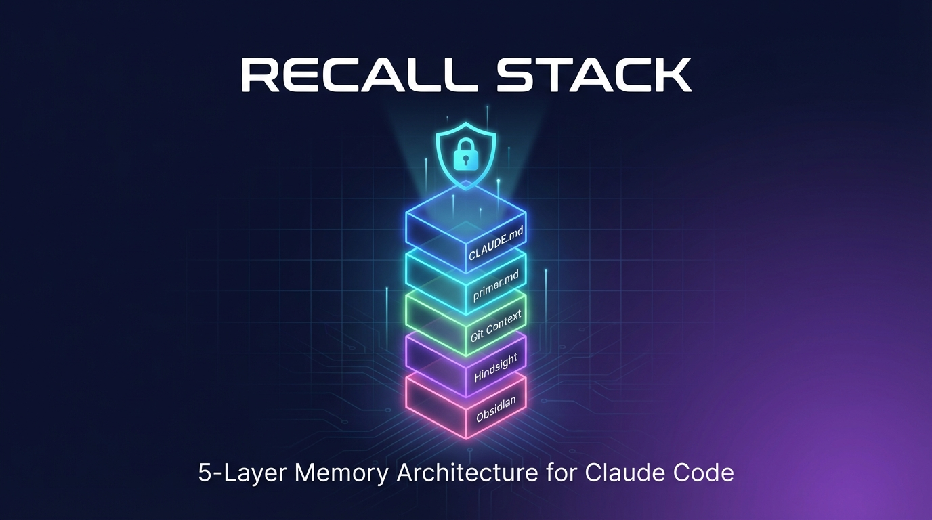

Recall Stack
The 5-Layer Memory Architecture for Claude Code

By kevinliaksai
March 2026

Originally created by @keshavsuki
Forked, adapted & maintained by @kevinliaksai

Why You Need This
Most people set up CLAUDE.md and call it done. But CLAUDE.md is just a rules file. It tells Claude who it is. It does NOT remember what you did yesterday, what went wrong last week, or what patterns work best.
Most people only implement Layer 1. Some reach Layer 2. Almost nobody has all five.
This guide changes that.

The 5-Layer Architecture

Layer 1: CLAUDE.md — The Foundation
- Location: ~/.claude/CLAUDE.md
- Purpose: Permanent rules and preferences
- Loads automatically each session
- Does NOT: Remember anything, update itself, or learn from mistakes
- Think of it as your "constitution" — important, but not enough on its own

Layer 2: primer.md — Living Memory
- Location: ~/.claude/primer.md
- Rewrites itself after every completed task
- Tracks: active project status, completed work, next steps, open blockers
- If you kill the terminal mid-session, the last state is already saved
- Capped at 100 lines — always lean, always current

Layer 3: Git Context — Codebase Awareness
- Activated via SessionStart hook
- Injects live codebase context at every launch
- Shows: current branch, last 5 commits, modified files
- Claude knows what changed before you type a word

Layer 4: Hindsight — Behavioral Learning
- Uses SessionStart + SessionEnd hooks
- Extracts behavioral patterns from past sessions
- Not retrieval. Actual learning.
- Powered by Hindsight (open source, by Vectorize)
- Requires Docker (uvloop needs Linux; Docker provides it on any OS)

Layer 5: Obsidian Vault — Your Knowledge Base
- Shell alias with --add-dir flag
- Makes your entire Obsidian vault available as context
- Syncs to mobile via iCloud or Obsidian Sync
- No plugin required — just point Claude at your vault

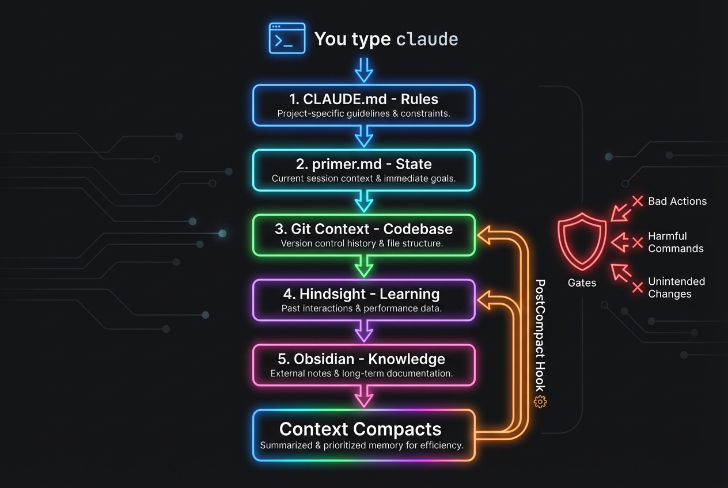

The Secret Weapon: Gates
Memory tells the agent what to do. Gates physically PREVENT what it should NOT do.

Memory = "please remember not to force push" (gets lost on compaction)
Gates = tool call denied before execution (survives everything)

Built-in Gates
Gate | Blocks | Level
no-force-push | git push --force | block
no-rm-rf-root | rm -rf / or rm -rf ~ | block
no-credentials-in-files | API keys in file writes | block
no-git-reset-hard | git reset --hard | warn

Auto-promotion: Correct Claude 3 times for the same mistake → automatically becomes a gate.

How It All Flows
When you type claude:
- CLAUDE.md loads → "how should I behave?"
- primer.md loads → "where did we leave off?"
- SessionStart hook fires → "what changed in the codebase?"
- Hindsight recall fires → "what patterns should I follow?"
- Obsidian vault mounts → "what's in the knowledge base?"

When context compacts mid-session:
- PostCompact hook fires → re-injects git context + patterns
- Active gates reminded → Claude knows what is blocked

Quick Start — One Command Install
git clone https://github.com/kevli770/recall-stack.git
cd recall-stack
bash setup.sh --obsidian ~/path/to/your/vault

What setup.sh does:
- Copies CLAUDE.md and primer.md to ~/.claude/
- Copies hooks to ~/.claude/hooks/ and makes them executable
- Writes hook config to ~/.claude/settings.json
- Adds --add-dir alias for Obsidian vault
- Optionally copies post-commit hook

Layer 4: Hindsight Setup (Docker)
- Install Docker Desktop
- Run the container:
export ANTHROPIC_API_KEY=your-key-here
docker run -d --name hindsight --restart unless-stopped \
-p 8888:8888 -p 9999:9999 \
-e HINDSIGHT_API_LLM_PROVIDER=anthropic \
-e HINDSIGHT_API_LLM_API_KEY=$ANTHROPIC_API_KEY \
-v hindsight-data:/home/hindsight/.pg0 \
ghcr.io/vectorize-io/hindsight:latest

- Create memory bank (one-time):
curl -s -X PUT http://localhost:8888/v1/default/banks/claude-sessions \
-H 'Content-Type: application/json' \
-d '{"name": "claude-sessions"}'

Resource | URL | Notes
Hindsight API | http://localhost:8888 | REST API
Hindsight UI | http://localhost:9999 | Web Dashboard

Supported providers: anthropic, openai, gemini, groq, ollama, lmstudio

Without Hindsight? No problem — hooks skip Layer 4 gracefully. You still get layers 1, 2, 3, 5, and Gates.

What Survives What
Event | Layers 1-2 | Layer 3 | Layer 4 | Layer 5 + Gates
New session | Fresh | Fresh | Fresh | Active
Context compaction | Safe | Re-injected | Re-injected | Active
Terminal crash | primer.md saved | Lost | Lost | Active

Summary
Layer | What it does
CLAUDE.md | Permanent rules. You edit manually.
primer.md | Current state. Overwrites after every task.
Git Context | Branch, commits, files. Fresh every launch.
Hindsight | Behavioral learning. Learns over time.
Obsidian | Full knowledge base. All your notes.
Gates | Blocks bad actions. Survives everything.

Credits
Originally created by @keshavsuki
Forked, adapted, and maintained by @kevinliaksai
Powered by Hindsight for behavioral learning
Repository: github.com/kevli770/recall-stack
License: MIT

