R099220103 資工所 陳柏佑

Construct a class Kernel to handle the different kernel pattern, each instantiation includes pattern, origin of the pattern and the method get_direction to calculate the offset in the pattern.

1. Dilation

Check the binary image, if the pixel is white(or > threshold), dilating the point through the 3-5-5-5-3 pattern.

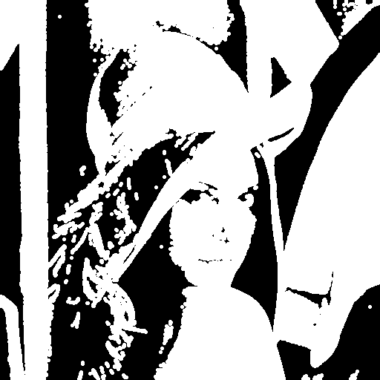

1. Erosion

Check the binary image, if all of the pixel are match with the 3-5-5-5-3 pattern, make the origin be white.

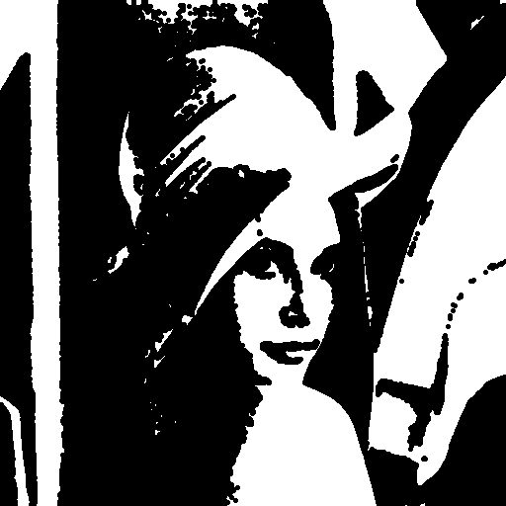

1. Opening

Dealling the binary image with erosion function, and then dilation it.



1. Closing

Dealling the binary image with dilation function, and then erosion it.

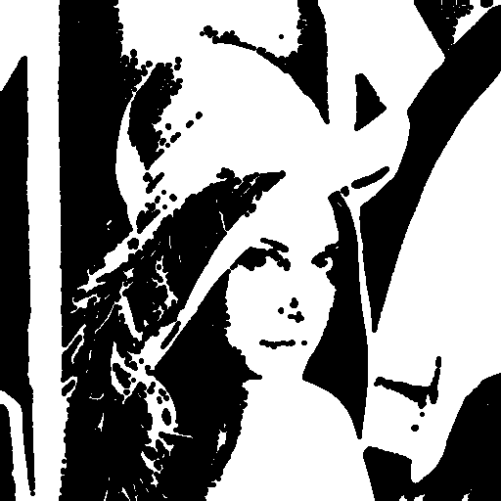

1. Hit-and-miss transform

First,changing the binary image into erosion with the L pattern whose origin is (1,0).

Second, ,changing complement of the binary image into erosion with the L pattern whose origin is (0,1).

At last, union the two image if both of their pixel are white.

