R099220103 資工所 陳柏佑

Construct a class Kernel to handle the different kernel pattern, each instantiation includes pattern, origin of the pattern and the method get_direction to calculate the offset in the pattern.

Defining the original image is O, the kernel is K.

1. Dilation

Check the gray-scale image, dilating the point through the 3-5-5-5-3 pattern, we said k is the coordinate of K, o is the coordinate of O, find the maximum of O(o-k) + O(k) then modify it.

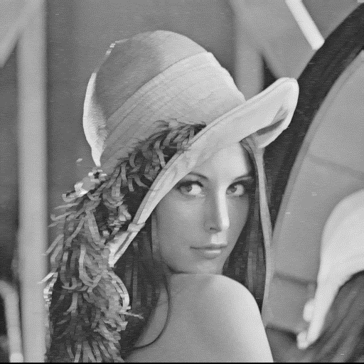

1. Erosion

Check the gray-scale image, dilating the point through the 3-5-5-5-3 pattern, we said k is the coordinate of K, o is the coordinate of O, find the minimum of O(o+k) - O(k) then modify it.

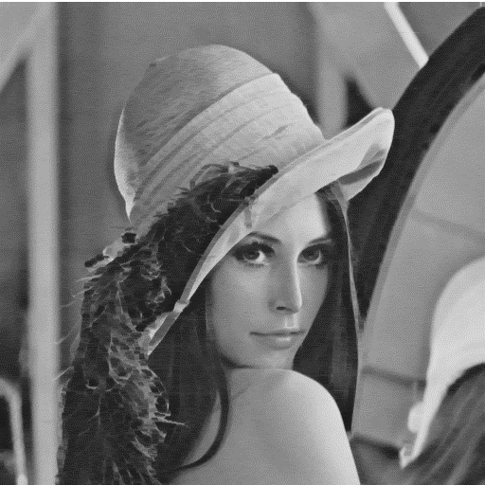

1. Opening

Dealling the gray-scale image with erosion function, and then dilation it.

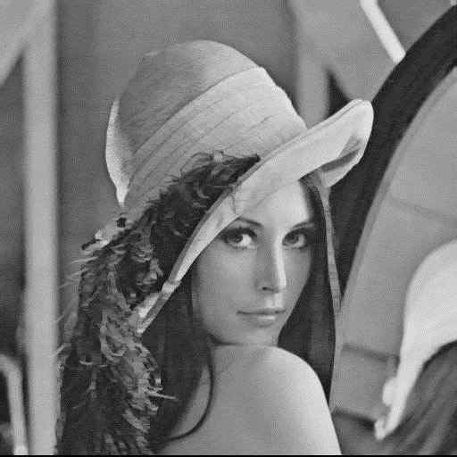

1. Closing

Dealling the gray-scale image with dilation function, and then erosion it.

