R099220103 資工所 陳柏佑

Roberts operator with threshold = 12

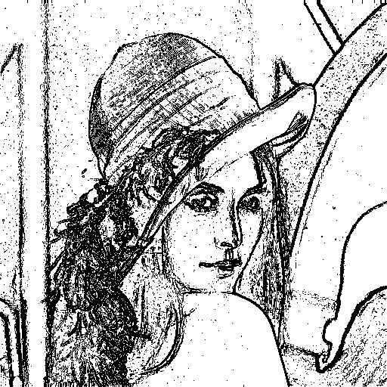

Navigate the points surround the pixel in the boundary, if the position is out of range, padding it.

Calculate the gradient magnitude = sqrt( (bottom_right – origin)^2 + (bottom – right)^2), if the value >= threshold, make the pixel value 0, else 255.

Roberts operator with threshold = 30

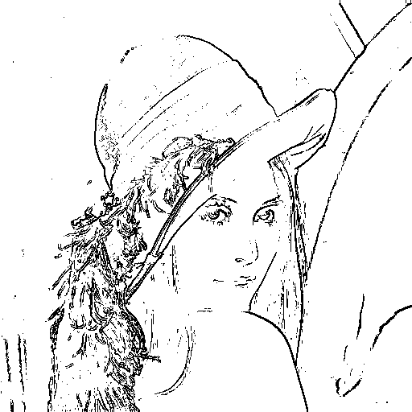

Prewitt edge detector with threshold = 24

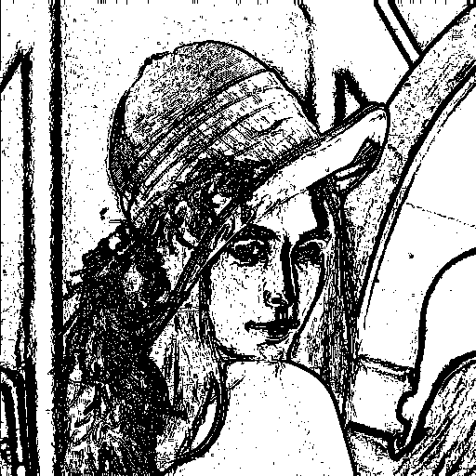

Calculate the gradient magnitude = sqrt( p1^2 +p2^2), if the value >= threshold, make the pixel value 0, else 255.

Sobel edge detector with threshold = 38

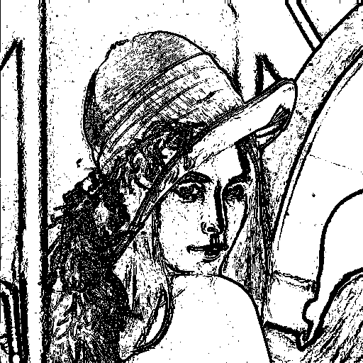

Calculate the gradient magnitude = sqrt( s1^2 +s2^2), if the value >= threshold, make the pixel value 0, else 255.

Frei and Chen gradient operator with threshold = 30



Calculate the gradient magnitude = sqrt( f1^2 +f2^2), if the value >= threshold, make the pixel value 0, else 255.

Kirsch compass operator with threshold = 135

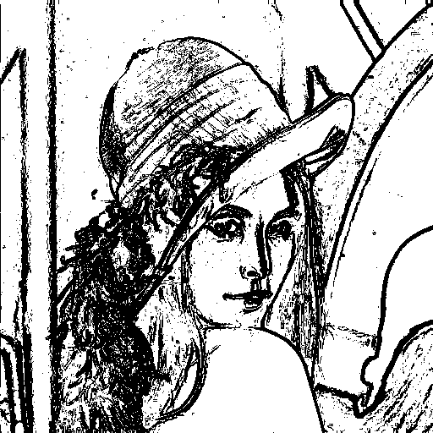

Calculate the gradient magnitude =max(k0 to k7), if the value >= threshold, make the pixel value 0, else 255.

Robinson compass operator with threshold = 43

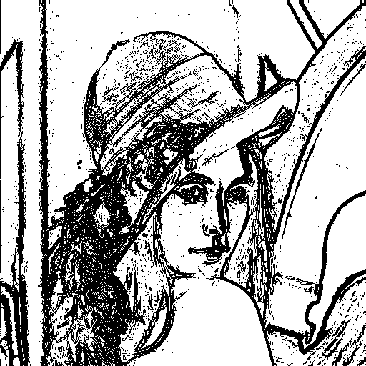

Calculate the gradient magnitude =max(r0 to r7), if the value >= threshold, make the pixel value 0, else 255.

Nevatia-Babu 5×5 operator threshold = 12500



Calculate the gradient magnitude =max(N0 to N5), if the value >= threshold, make the pixel value 0, else 255.