**Blinkit Analysis**

* See all the data imported:

SELECT * FROM blinkit_data

* **DATA CLEANING:**

Cleaning the Item_Fat_Content field ensures data consistency and accuracy in analysis. The presence of multiple variations of the same category (e.g., LF, low fat vs. Low Fat) can cause issues in reporting, aggregations, and filtering. By standardizing these values, we improve data quality, making it easier to generate insights and maintain uniformity in our datasets.

UPDATE blinkit_data

SET Item_Fat_Content =

CASE

WHEN Item_Fat_Content IN ('LF', 'low fat') THEN 'Low Fat'

WHEN Item_Fat_Content = 'reg' THEN 'Regular'

ELSE Item_Fat_Content

END;

After executing this query check the data has been cleaned or not using below query

SELECT DISTINCT Item_Fat_Content FROM blinkit_data;

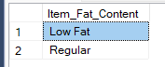

**A. KPI’s**

**1. TOTAL SALES:**

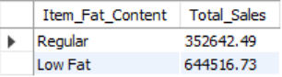

**2. AVERAGE SALES**



**3. NO OF ITEMS**

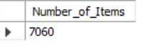

**4. AVG RATING**



**B. Total Sales by Item Type:**

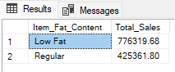

**C. Total Sales by Item Type**

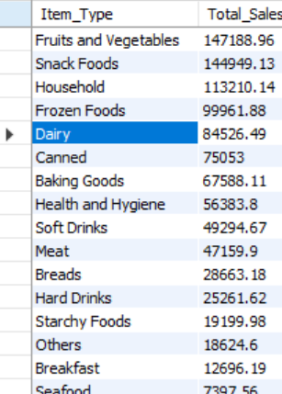

**D. Total Sales By Outlet Establishment Year**

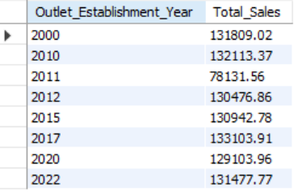

**E. Percentage of Sales by Outlet Size**

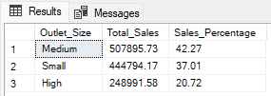

**F. Sales by Outlet Location**

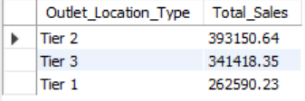

**G. All Metrics by Outlet Type:**

