**Creating hash values**

We are going to create and evaluate the hash values for two files. W will use Linux commands to calculate the hash of two files and observe any differences in the hashes produced. Then, we'll determine if the files are the same, or different.

**Tasks we will complete:**

* Listing the contents of the home directory
* Comparing the plain text of the two files presented for hashing
* Computing the **sha256sum** hash of the two separate files
* Comparing the hashes provided to identify the differences

**Generating hashes for files**

* We use the ls command to list the contents of the directory. Two files, file1.txt and file2.txt, are listed.
* We use the cat command to display the contents of the file1.txt file:

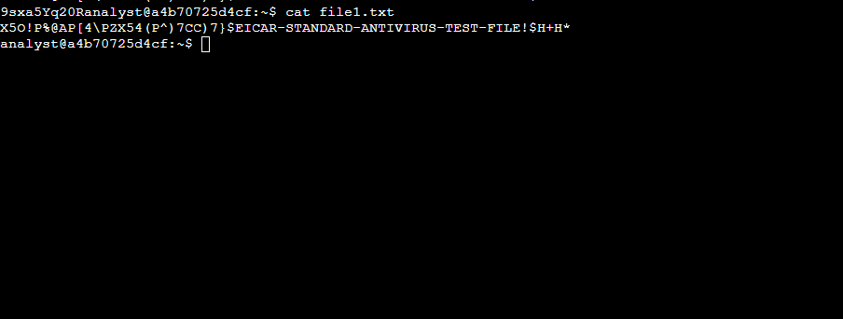

* Use the cat command to display the contents of the file2.txt file:

* Use the sha256sum command to generate the hash of the file1.txt file:

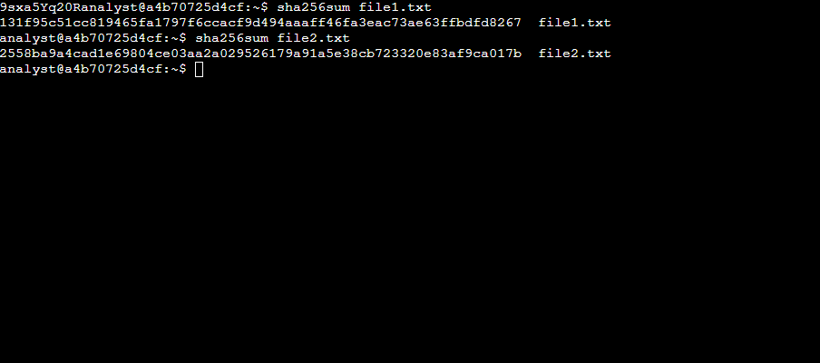

**Comparison of hashes**

We then proceed to write the hashes to two separate files and then compare them to find the difference.

* Use the sha256sum command to generate the hash of the file1.txt file, and send the output to a new file called file1hash and use the sha256sum command to generate the hash of the file2.txt file, and send the output to a new file called file2hash:

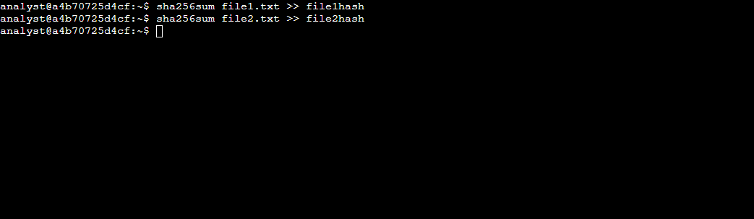

We can manually display and compare the differences.

* Use the cat command to display the hash values in the file1hash and file2hash files.
* Inspect the output and note the difference in the hash values.



We can use the cmp command to compare the two files byte by byte. If a difference is found, the command reports the byte and line number where the first difference is found.

1. We then the cmp command to highlight the differences in the file1hash and file2hash files:

