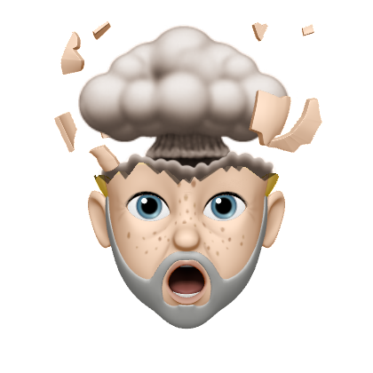

This will be a brief About Me file once I have constructed it.