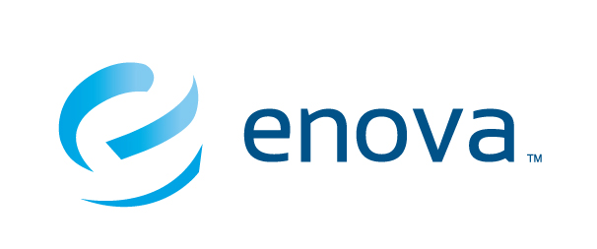

**Enova Data Smackdown Rules and Overview**

The Enova Data Smackdown is a data analysis competition unlike any other. In contrast to many other contests that test only modeling skills, the Data Smackdown will challenge you in all the major steps of completing an analytical project in the real-world. Specifically, it will require you to use all of the three main skill sets of data science:

1. Mathematics expertise

2. Computer science skills

3. Business strategy and acumen

The structure of the competition is designed to loosely follow the CRISP-DM phases of data mining. Those are:

1. Business Understanding

2. Data Understanding

3. Data Preparation

4. Modeling

5. Evaluation

6. Deployment

**Agenda (subject to change):**

6:00 - 6:30 PM: Teams arrive, register, get set up and enjoy some free food

6:30 PM: USB drives will be provided to each of the teams and the competition will begin

10:30 PM: Teams will be required to return their USB drives containing the required files

10:30 - 11:00 PM: Judges from Enova will review the answers provided. The top four teams will be announced

11:00 PM - 12:00 AM: The top four teams will have 10 minutes each to present to the judges and other participants

12:00 AM: The winners will be announced and prizes will be awarded

**Judging Criteria:**

Submissions will be judged based off the presentation provided and the scored validation data set. Specifically, the following criteria will be employed:

1. Business Understanding: Does the team demonstrate that they understand the question being asked? Did they frame the problem in a logical way?

2. Data Understanding: How did the team explore the data? What useful insights were gained from descriptive statistics?

3. Data Preparation and Modeling: What techniques did the team explore? Why was a particular technique chosen? Did they execute on the techniques accurately?

4. Evaluation: How did the team validate their conclusions? How accurate were their predictions?

5. Recommendations: What conclusions were drawn from their analysis? What next steps do they recommend? What things went well and what would they have done differently?