**Data Visualization: Assignment 2**

Kevin Morris 14315027

# **Part 1**

# **Part 2**

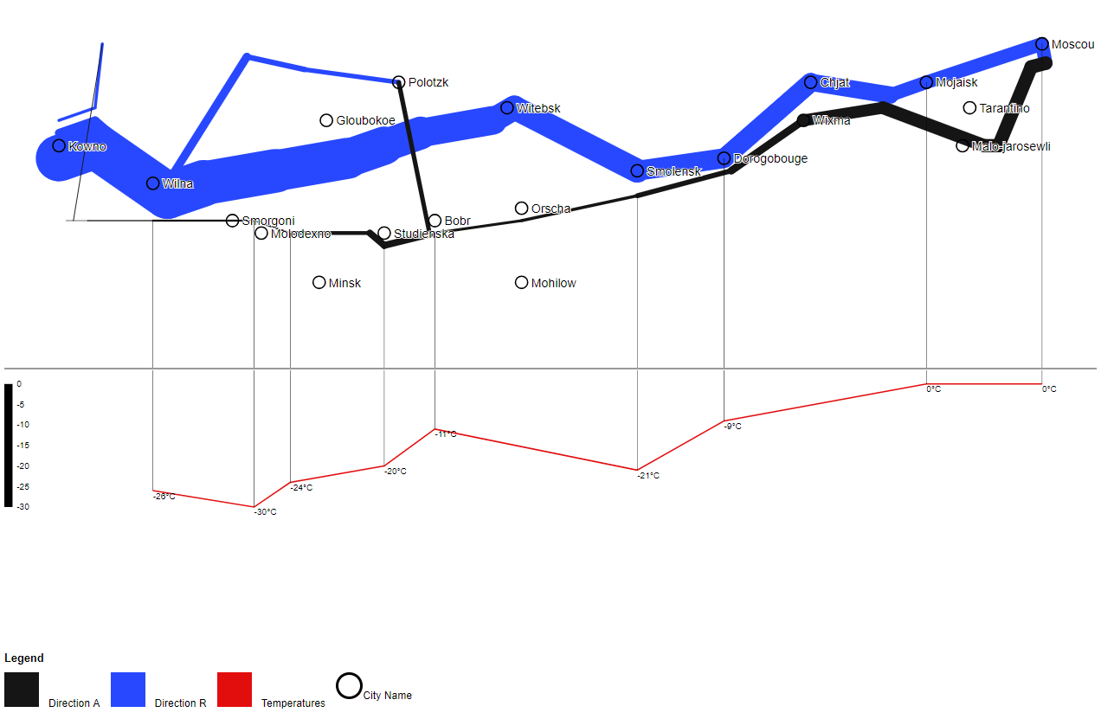

# **Description**

* The first thing I did was convert the CSV file into a JSON file, as I find JSON file’s easier to access and use.
* Once all the data was converted I started working out how to display the three main graphs into one display. The three graphs are the cities, temperatures and the survivors.
* The temperature graph was a simple chart which was a line graph displaying all the temperatures values and a y-axis to the left.
* The svg element took in the temp value and longitude value as the x and y value on the graph.
* I created a createGraph function which took in the svg element, the data and the map.
* This function declared the y-axis and x-axis values and their domains to display the values.
* The other function created was the lonValues function which returned the longitude and latitude of the city’s locations.
* The final graph was the survivors which had to increase in stroke depending on the number of survivors. This was taken by taking in the number of survivors for that specific value and returning a stroke width normalised between 0-100.
* I used a library mapmap which allowed for the display and the creation of the charts and graphs.
* The final part was the legend in which displays what the colours represent.