Our top picks are ABF [NYPCB (8046 TT)>UMTC (3037 TT)]> Chroma (2360 TT), also recommend AP Memory (6531 TT), UMC (2303 TT), ASIC (GUC 3443), Nanya (1303 TT)

US stock top pick should be INTC and BE, also recommend COHR, CRDO>AMAT. ALAB we maintain Neutral given too high expectations for CXL to Google

JP stock top pick is TEL and Furukawa/Fujikura, add Toppan/Ebara/Sumitomo into watch list given possibility for glass substrate business and also beneficiary on TSMC supply chain.

Vital Event:
8/27 NVDA
8/28 MRVL
8/27-29 Jackson Hole
9/3 AVGO
9/2-4 Semicon TW
Oct Anthropic IPO

Trading idea
- Long INTC short ARM
- Long TEL short Screen (or only long TEL)
- Long SK Hynix or Samsung
  - Or Long SK Hynix short SK ADR
  - Can take profits for some parts.
- Long UMC short wafer (GWC)
- Long GUC short MTK
- Long AMAT short KLAC
- Long BE
- Short Taiyo Yuden when rebound
- Long COHR > LITE given more upside on FY28 for InP substrate yield rate improvement and module shipment upside to boost GM outlook
  - SMTC may can long before event due to stronger NPO outlook to boost TIA demand
- mainly Dell short (or Long Wistron short Dell)
- Short ALAB when share price is close to US400

Our view on short/long-term thesis
Short-term
- Most HF turns cautious and few position for Asia markets.
- Prefer US/TW market over KR/JP due to relatively few macro issues to weigh on valuations
- Beta-driven in 3Q26
  - So buy high-beta like AIDC, memory, ABF, SPE

Long-term
- Chases for rising portion on BOM cost or bottleneck one
- Selects optics, memory, CPU, AIDC, ABF
  - COHR>LITE
  - DRAM>NAND
  - INTC
  - BE
  - UMTC

Position survey
Consensus long: AMAT, INTC, LITE, BE, ABF (UMTC, NYPCB), GUC, TEL, King slides, CCL (EMC, TUC) , SK Hynix, NVDA
Consensus short: ARM, KLAC, wafer, TW PCB
HF long: Nanya, ITEQ, Kokusai, SMTC, MRVL, Yageo
LO long: Kioxia, Samsung, AMD, Advantest, Sumitomo

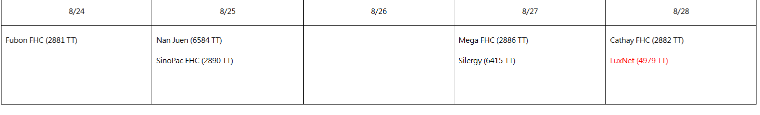
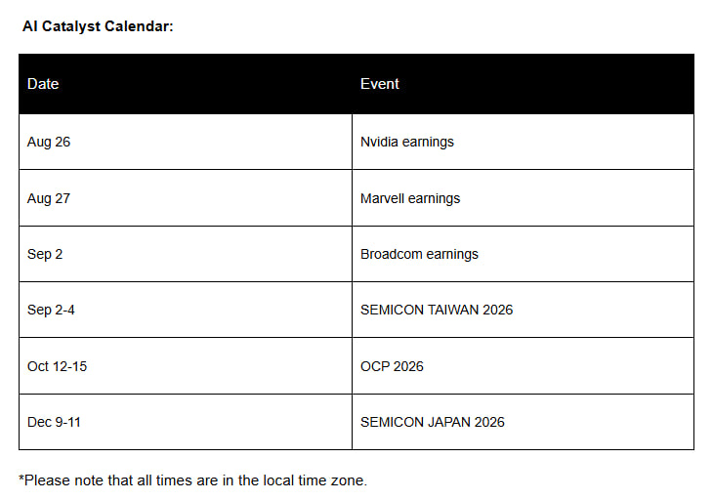
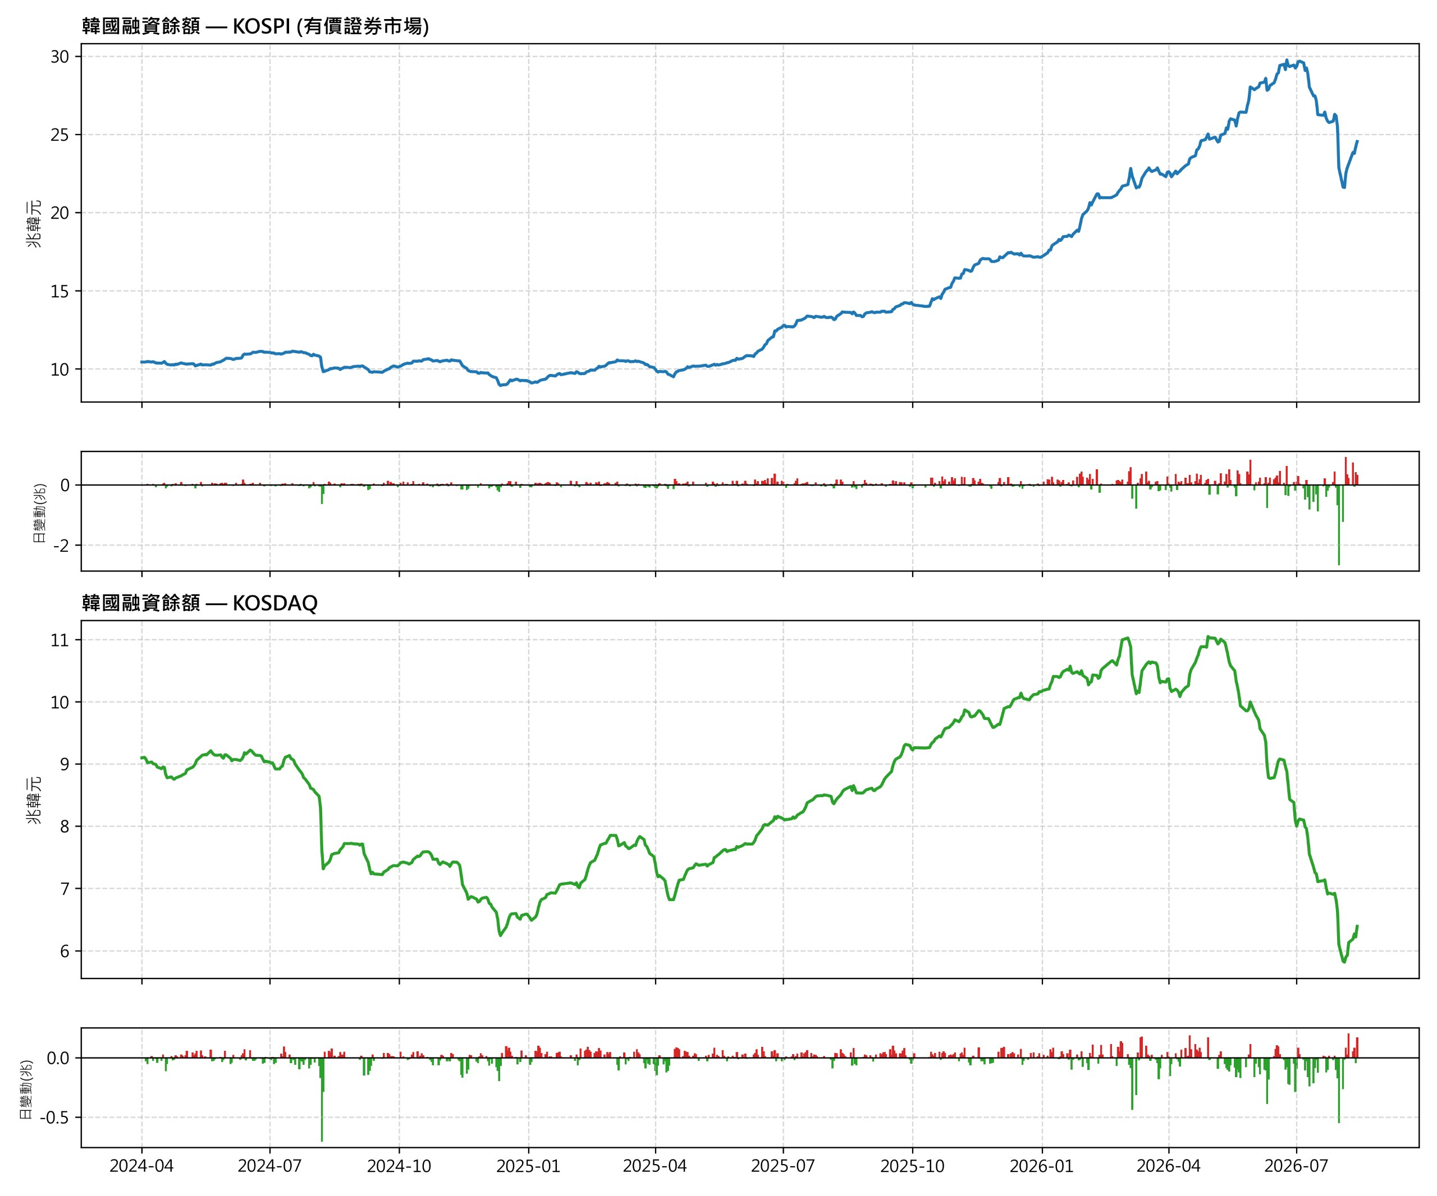

NVDA preview – skewed to Neutral due to too high expectations…
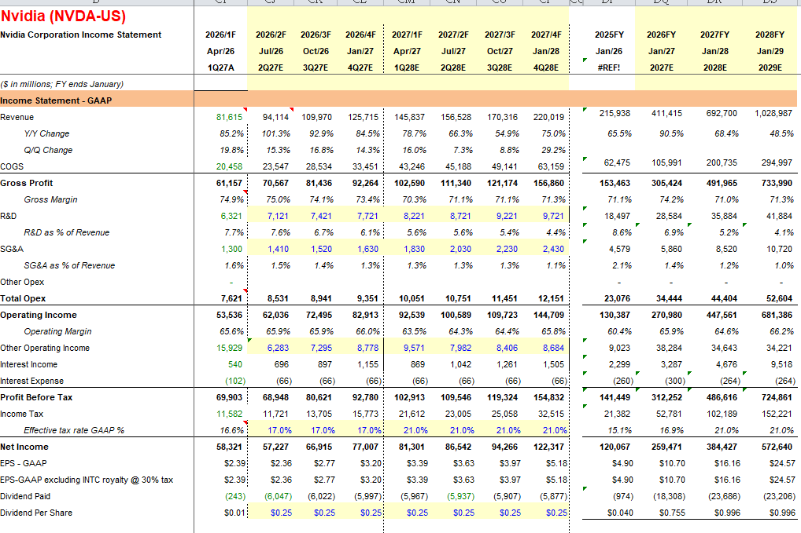
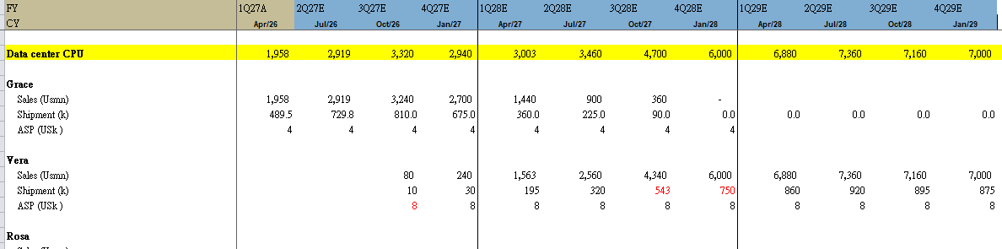
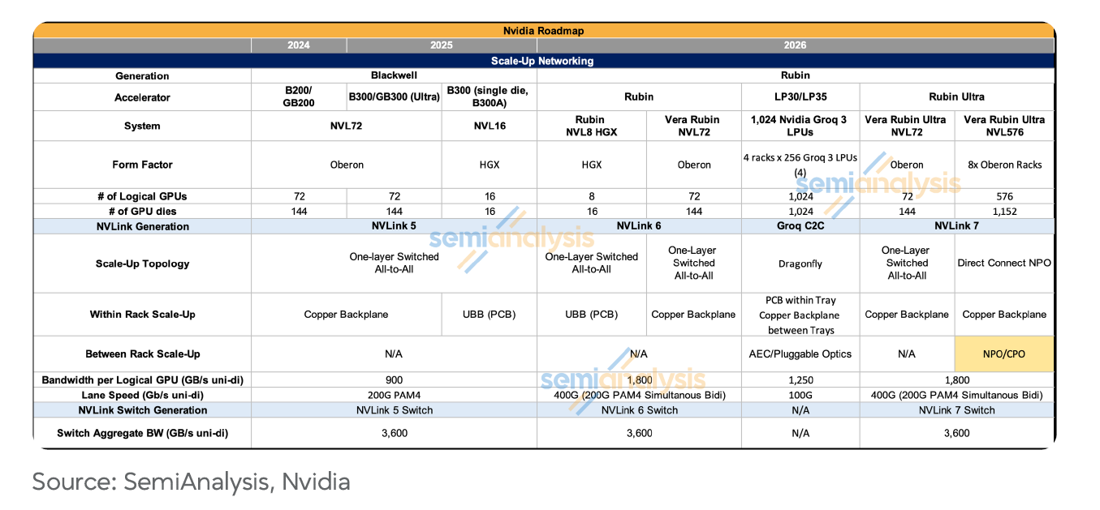
- CY2Q26 results: largely in line
  - Sales: US95B, largely in line with sell/buyside consensus
  - GM: ~75%
- CY3Q26 guidance: largely in line with sellside consensus, but below US buyside consensus…
  - Sales: US108B
    - In actual, sales can reach US114B, largely in line with US buyside consensus of US110-120B
- It may highlight VR has started shipment.
- Market focuses on Rubin/RU shipment and CPO/NPO progress…
- Shipment
  - Blackwell
    - 3/4q26: 1.8/1.5M
  - Rubin
    - 3/4q26: 200/600k
- What’s our difference vs con?
  - Relatively pessimistic on RU
    - We believe no significant volume in 2027…
  - 2027 COWOS is near 950k given TSMC’s capacity constraint, below bull’s 1100-1200k
- So we give Neutral rating on this earnings call, but TP is US320, based on 20x FY28 EPS.

MRVL preview – near-term guidance won’t have upside, skewed to Neutral due to most positives already priced in
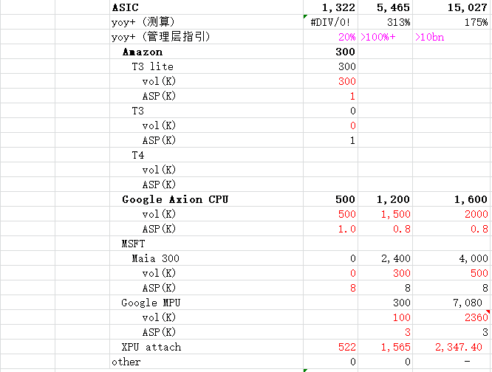
- Most HF wants to play for this earnings call, so we hold relatively conservative view on share price reaction.
- CY2Q26 results: largely in line
- CY3Q26 guidance: non-event given near-term not having numbers no upside…
  - Sales: our estimate of 14% qoq growth vs consensus of 11-15% qoq growth, largely in line
  - GM: 58-59%, largely in line with consensus
- Market all watches on MRVL’s longer-term guidance on FY28/29, especially on AWS’ tn3/4, MSFT’s MAIA300/320 & Cobalt 200/300, Google’s MPU, CPU, CXL switch & TPU V10 (Merope) and Meta’s ASIC opportunities.
  - Also wants to know about progress on 1.6/2.4T DSP and TAM
    - However, we think most positives have priced in when releasing LTA with Google, so we hold more conservative view on this earnings call
- Also needs to monitor on GM side because MRVL’s ASIC business are not all for turnkey business (front-end + back-end)
  - So longer-term ASIC segment GM may be 40-50%..., severely GM dilutive
- What’s our difference vs con?
  - FY29 EPS of US15.7, below HF’s US16-20 consensus, due to fewer ASIC shipment and lower GM forecasts on its inferior design capability
  - DSP supply may be fewer than bull’s forecasts given TSMC’s capacity supply constraint on N3/2
- Our TP is US263, based on 35x FY28 EPS, so our rating is Neutral

ABF/CCL/PCB update
SemiAnalysis 今天出了一篇報告，標題是：PTFE Pushing Copper Further，這篇報告在 dislocation.
在講 PTFE 目前是生益提供給 CCL 端，但會改成生益出 PTFE 去給板廠做加工，但是生益因為地緣的關係，不會出給台灣的板廠。
所以本來台光+欣興，現在改成生益+滬電，在暗示台光+欣興掉單。
但說說我個人的理解：生益本來就是 PTFE 的一供這沒錯，但台虹也有在送 PTFE 認證，預計會成為二供，並且台虹確定有供給台光，所以台廠在 PTFE 取得上，應該是沒有問題。
除非台虹沒過認證，但大機率是會過的。
- Based on our check, 8039 (台虹) hasn’t passed verification from WUS yet, and EMC tends not to use PTFE-based solution for NVDA’s CCL.
- SY indeed has passed WUS’ verification as first supplier, and we believe if NV wants to adopt PTFE solution in RU, it will be adopted in smaller board like IO board…
- RU compute board is still M10+Q-glass solution with largest possibility.
- ABF: no impact…

PCB spec update
- AWS T4
  - Compute board: 6+ HDI with 34 layers
    - CCL: M9 (higher chance) or M8.5
- TPU V9 series
  - Compute board: 6+ HDI with 24 layers
    - CCL: M9 or M8.5
- TPU V8i (Sunfish)
  - Compute board: WUS>LIN>TTM>Victor>ISU>2368>4958(前四家各有20%的Share)。

- E-glass also hiked price by 15-20% in July.
- Low-dk/dk2 supply even turns more severe in 2H26 due to new GPU/ASIC to go MP like Rubin or TPU V8
- Nanya (1303 TT)’s CCL UTR has risen to 90% in July, implying undersupply to turn severe for lower-end CCL (below M6)
  - Positive to CN supply chain and Nanya

ABF update
UMTC
- LTA only locks for volume not for pricing ceiling
- Its Rubin HDI share may rise to 30-40% due to poor yield rate for VG

- T-glass pricing will hike another 15-20% in 2H26.

CPO testing update
- Based on our check, I2/3/4 equipment pull-in may be slower than expected given TSMC’s delay on yield rate improvement on COUPE
  - It may ramp up in 2H27 or even 4Q27.
    - Negative to related players like MPI, TER, Chroma, Advantest…

Memory update
明年HBM价格:
HBM4 1.8 gb *8 =15块, 其他人2块多一些, SK明年目前听到是1gb 2.9-3块, 1GB 24块(明年有机会占到NV 2/3), 三星MU 32-34块per GB

Avg without NV: HBM4 4-4.5 Gb (32-36块 per GB), 今年2.4-2.8 per Gb, 三星MU给NV的价格其实也差不多, 但SK会比这个低(给NV的)但幅度低多少不确定, 大概3块钱左右(但有点太低感觉)
- Althesia’s view: only 60% ASP growth for HBM4, below our estimate of 70%
- Near-term sentiment may be still stressed…

ASIC update
- Bizlink mentioned that Rubin and T3’s pull-in is not strong as previous expected, so it may be downside risk for NV and AWS supply chain…
- GUC has acquired Google’s v10 TPU compute-die back-end, CPU Axion 2, MSFT’s MAIA200 and Cobalt 200, Meta’s Phoebe
  - AWS’ CPU is engaging to acquire the order now.

Optics update
View in browser
SemiAnalysis
NPO Turning the Lights Up
Timothy Chang
Wednesday, August 19, 2026
Executive Summary
We lean toward reading Rubin Ultra NVL576 scale-up as NPO with an internal laser rather than CPO with an external laser, based on our supply chain checks and the 400mW ELS capacity constraint. We acknowledge that Nvidia is still pursuing the CPO path in parallel, where ELS remains the technically superior design.> CPO progress delay in line with our survey
NPO allows optics to capture more value in scale-up earlier than CPO would, driven by the NVL576 form-factor mix rising to over 50% on favorable budget and NPO’s stronger supply chain readiness.
Key NPO beneficiaries span sockets (Lintes 6715.TW; Lotes 3533.TW), modules (Zhongji Innolight 300308.SZ; EoptoLink 300502.SZ; Coherent COHR), transceiver PCB (Avary Holding 002938.SZ), and Lasers (Sumitomo 5802.JP; YJ Semi 688498.SH; Lumentum LITE).
Switch-tray PCB vendors also benefit from the NVL576 mix shift and NPO’s board-level socketing. Victory Giant, WUS, ISU Petasys, and TTM are the likely board suppliers.
We Lean Toward Reading Scale-up For Rubin Ultra NVL576 as NPO with Internal Lasers
We believe Nvidia is pursuing two paths at the same time: CPO with an external laser (ELS) source and NPO with an internal laser source (ILS). We lean toward reading Rubin Ultra NVL576 scale-up NPO as using an internal laser rather than external laser based on our supply chain checks and the 400mW ELS supply constraint. We think NPO is the primary track but acknowledge Nvidia is probably still pursuing the CPO path in parallel.
We want to highlight that ELS remains the technically superior architecture, since it keeps the laser die away from the module and prevents mode hopping. Additionally, keeping the LASER die away from the module also reduces the load on the thermal control system, since even small changes in temperature lead to noticeable changes in wavelength accuracy. Putting the laser inside the module is a suboptimal choice. But the 400mW ELS supply cannot support the Rubin Ultra NVL576 ramp on the timeline required. Moving the laser inside the module lets Nvidia use lower-power lasers and qualify a wider vendor base, solving the near-term capacity bottleneck even at the cost of the cleaner design.
NPO Allows Optics to Capture More Value in Scale-up Earlier Than CPO Would
In “Powered Down, Lights Off: 800VDC Pushout and CPO Delays”, we warned the market about CPO’s yield and fiber-attach challenges pushing out its mass production timeline for scale-out CPO, though we reiterated that our scale-up CPO estimates remained unchanged. We have since revised scale-up NPO+CPO estimates considerably, driven by increases in NPO estimates. In our “NPO Takes the Baton” and “Nvidia’s NPO Adventure” notes, we proposed NPO as an interim solution during the transition, which actually enables higher scale-up optics volume until CPO ramps with initial but meaningful single-digit $B key equipment TAM in 2028 before increasing multiple fold in 2029.
Our latest research shows NPO enables optics to capture more value in the scale up connectivity earlier than CPO would. This is driven by the NVL576 form-factor mix ramping, on the back of two factors:
Budget: The recent Rubin Ultra HBM despec (384GB down to 192GB) freed up budget for a much larger NPO scale-up optics buildout. Memory’s share of total rack cost of ownership fell from roughly 40% to 28% post despec, and on the VRU NVL576 NPO SKU, scale-up networking spend tripled from 4% to 12% of rack cost as the freed budget funded that buildout. Despite that reallocation, rack BOM still declined overall, from $7.9M to $6.6M per rack.> For Rubin BOM cost, current ODM’s feedback is still US6.5-7M per rack, skewed to higher-end
Supply Chain Readiness: We believe that NPO is significantly more scalable in the next one to two years given its socketed module like a traditional transceiver which the supply chain is familiar with. On the other hand, CPO’s switch die attach yield remains poor, and package-level testing remains a bottleneck, as we discussed in our previous note.

We expect that CPO will take the baton from NPO from 2029 and beyond, accounting for most of the scale-up optics market by value.
Net net, NPO gives Nvidia and its customers a much larger incentive to push Rubin Ultra NVL576 form-factor mix than CPO could have supported, since CPO could only sustain a comparatively small Rubin Ultra NVL576 penetration. We lean toward a high proportion of Rubin Ultra shipping as NVL576, potentially above 50%. This is a far larger increase in optical scale-up content value than we had previously modeled.
Source: SemiAnalysis
Key NPO Beneficiaries
Socket
We see socket vendors as direct beneficiaries since NPO/Pluggable CPO would be mounted on PCB/substrates through sockets respectively.
Lintes (6715.TW): The electrical and optical interconnect subsidiary of Lotes, is one of the main beneficiaries of the NPO socket transition. It is already Coherent’s socket partner for NPO modules, giving it a path into a certified AMD project (likely MI500), and potentially getting Rubin Ultra NVL576 orders. Its qualification work with Astera Labs further opens a second growth vector through the open UALink ecosystem.
Lotes (3533.TW): Lotes does contract manufacturing for Lintes on the NPO socket. Separately, Nvidia is evaluating Lotes directly for its own socket project. This one is a socket on substrate solution, different from what we picked up in our Chinese supply chain check and Lintes’ approach. We think this is likely a pluggable CPO solution Nvidia is still evaluating.
Samtec, Amphenol, TE Connectivity, and Molex are also competing in the NPO socket race. We’re now seeing Samtec’s Si-Fly connector chosen for Trainium 4’s compute tray, while TE and Molex are already licensing the same connector standard and Amphenol has confirmed to join.
Module
Module makers will get more content value per OE in NPO compared to CPO. In NPO they provide the full OE module after they assemble it, while in CPO the assembly and packaging job goes to the foundry, leaving them only able to provide components. An NPO module is built in a similar way to a traditional pluggable transceiver, which is why the existing pluggable module makers are positioned to win Nvidia’s NPO business from the start.
Zhongji Innolight(300308.SZ): The largest Nvidia 1.6T module provider, alongside its ~60% combined share with Eoptolink of Nvidia’s 800G volume. We believe its scale and lead in high-bandwidth transceiver manufacturing make it possible for Innolight to win NPO business from Nvidia too. Per our supply chain check, these providers already have NPO orders from AWS, and Nvidia demand remains at the forecasting stage we believe is likely to be realized.
EoptoLink(300502.SZ): Same thesis as Innolight. Per multiple independent China supply chain checks, EoptoLink has already been supplying NPO modules to Nvidia alongside Innolight for months, ahead of Coherent and the other Western module makers.
Coherent(COHR): On its fiscal 4Q26 earnings call on August 12, CEO Jim Anderson said the ultra-high-power CW laser now ramping at its Texas and Sweden facilities is tied to CPO applications covered under the Nvidia partnership, with revenue starting in the December quarter. He also reaffirmed CPO for scale-up remains on track for the second half of calendar 2027. We believe this keeps Coherent on the CPO path for Rubin Ultra NVL576. Anderson also described NPO content as comparable to CPO and said the company is engaged with nearly every major customer on one or the other, so we remain positive on Coherent picking up NPO modules for Nvidia too.
Transceiver PCB
The board inside the transceiver module already runs on mSAP (modified semi-additive process), the same technology phones use, to place the optical engine and electronics closer together. NPO increases demand for this same board and pushes its price roughly 4x higher than the 1.6T version, and only a handful of vendors can mass-produce it.

