**Software Requirements and Design Document**

**For**

**Group <Anabolix>**

Version 1.0

**Authors**:

Kevin N

Samuel C

Russel L

Tiffany M

Carter R

# Overview (5 points)

*The Anabolix app was inspired by quarantine negatively affecting our physical health, made to aid users in their fitness journey. We plan to use the Android Studio IDE to implement a wide array of tools that the user can take advantage of for multiple use cases on their Android mobile device.*

*The tools we will be implementing include a Pedometer, An account login feature so users can track their progress, an alarm system for reminders, a calorie counter, and many other things. The system should function as an all in one fitness tool for users’ convenience.*

# Functional Requirements (10 points)

*1. Track Movement of the Device(Medium)*

*2. Track Environmental Data ie. Weather, Altitude, Time etc.(Medium)*

*3. Display Media ie. Training videos (Low)*

*4. Verify Account Information to Track Individual User Data (High)*

*5. Allow User to Specify if/when to be Notified by the App ie. for an alarm reminder,   
 workout milestones, etc. (Medium)*

# Non-functional Requirements (10 points)

*1. Device must secure user data*

*2. Mobile Device must be able to run simple applications.*

*3. Must have an Android Device to use the System*

# Use Case Diagram (10 points)

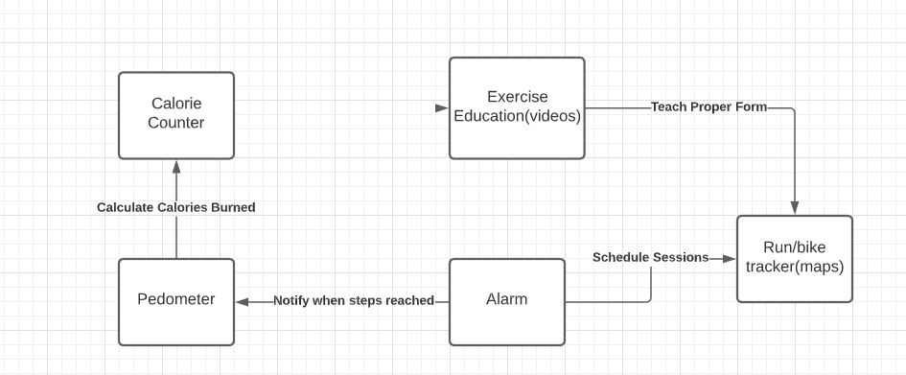

# Class Diagram and/or Sequence Diagrams (15 points)

For designing the system, we will use this class architecture

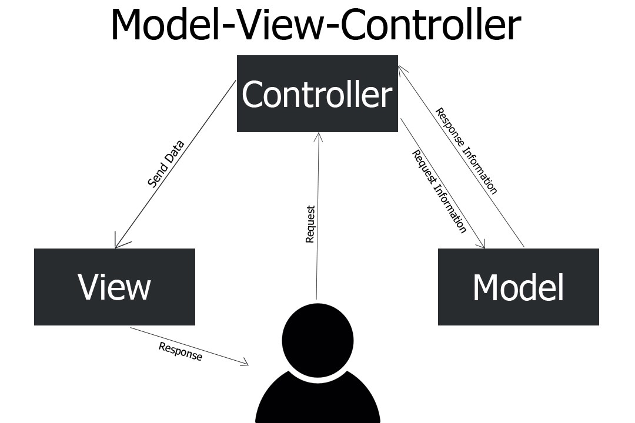

# Operating Environment (5 points)

*This application will be developed using Android Studio 3.5.3 (Android 10 API level 29). This app will only run on devices using Android 10 and up.*

# Assumptions and Dependencies (5 points)

*Assuming that users will have android devices with most standard features. ie. Sensors to track movement.*