Lab 7 User Interface (Android Studio)

**Step 1:** Create a simple Android Application using Android Studio. Follow the option **File -> NewProject**. Now name your application as **MyFirstUI** using the wizard window as follows:

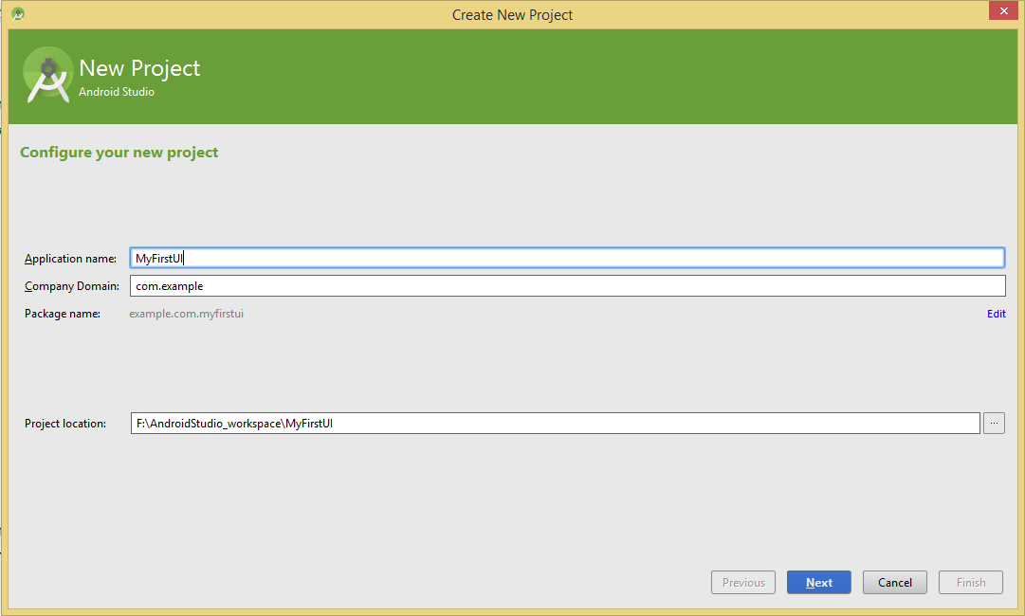

Then you need to choose a higher API level:

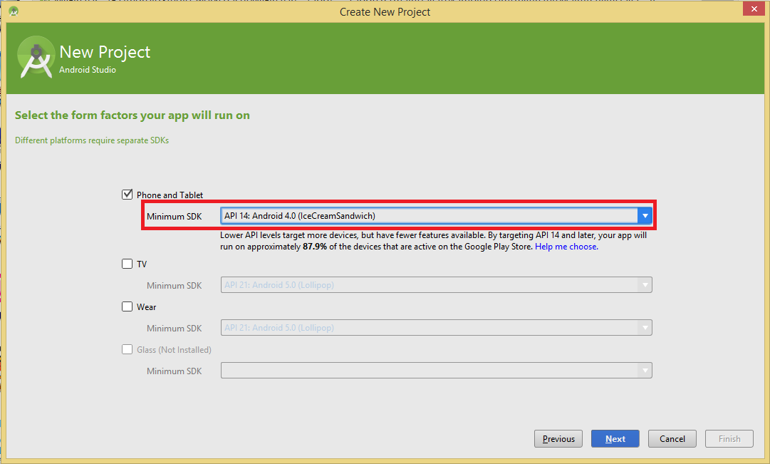

In the end, the files of this project will be display as following:

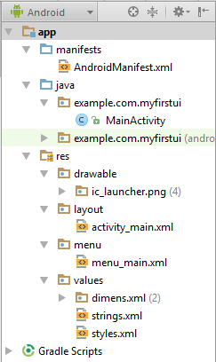

**Step 2**:

Following is the content of the modified main activity file *java/com.example.myfirstui/MainActivity.java*. This file can include each of the fundamental lifecycle methods. This class needs implements View.OnClickListener and AdapterView.OnItemClickListener interface. Then we override a button onclick method and onItemClick method in it:

package example.com.myfirstui;

import android.support.v7.app.ActionBarActivity;

import android.os.Bundle;

import android.util.Log;

import android.view.Menu;

import android.view.MenuInflater;

import android.view.MenuItem;

import android.view.View;

import android.widget.AdapterView;

import android.widget.ArrayAdapter;

import android.widget.Button;

import android.widget.EditText;

import android.widget.ListView;

import android.widget.TextView;

import android.widget.Toast;

import java.util.ArrayList;

public class MainActivity extends ActionBarActivity implements View.OnClickListener , AdapterView.OnItemClickListener {

TextView mainTextView;

Button mainButton;

EditText mainEditText;

ListView mainListView;

ArrayAdapter mArrayAdapter;

ArrayList mNameList = new ArrayList();

@Override

protected void onCreate(Bundle savedInstanceState) {

super.onCreate(savedInstanceState);

setContentView(R.layout.activity_main);

mainTextView = (TextView) findViewById(R.id.main_textview);

mainTextView.setText("Set in Java!");

mainButton = (Button) findViewById(R.id.main_button);

mainButton.setOnClickListener(this);

mainEditText = (EditText) findViewById(R.id.main_edittext);

mainListView = (ListView) findViewById(R.id.main_listview);

// Create an ArrayAdapter for the ListView

mArrayAdapter = new ArrayAdapter(this,android.R.layout.simple_list_item_1, mNameList);

// Set the ListView to use the ArrayAdapter

mainListView.setAdapter(mArrayAdapter);

}

@Override

public boolean onCreateOptionsMenu(Menu menu) {

// Inflate the menu; this adds items to the action bar if it is present.

MenuInflater inflater = getMenuInflater();

inflater.inflate(R.menu.menu_main, menu);

return super.onCreateOptionsMenu(menu);

}

@Override

public boolean onOptionsItemSelected(MenuItem item) {

switch (item.getItemId()) {

// action with ID action_refresh was selected

case R.id.action_help:

Toast.makeText(this, "Help selected", Toast.LENGTH_SHORT).show();

break;

// action with ID action_settings was selected

case R.id.action_settings:

Toast.makeText(this, "Settings selected", Toast.LENGTH_SHORT).show();

break;

case R.id.action_share:

Toast.makeText(this, "Share selected", Toast.LENGTH_SHORT).show();

break;

case R.id.action_refresh:

Toast.makeText(this, "Refresh selected", Toast.LENGTH_SHORT).show();

break;

default:

break;

}

return true;

}

@Override

public void onClick(View v) {

mainTextView.setText(mainEditText.getText().toString()+ " is learning Android development!");

mNameList.add(mainEditText.getText().toString());

mArrayAdapter.notifyDataSetChanged();

}

@Override

public void onItemClick(AdapterView parent, View view, int position, long id) {

// Log the item's position and contents

// to the console in Debug

Log.d("omg android", position + ": " + mNameList.get(position));

}

}

Following will be the content of *res/layout/activity_main.xml* file to include a button, TextView, EditText, ImageView and ListView. When we click the button, what user input in EditText will display in TextView and list in ListView:

<RelativeLayout xmlns:android="http://schemas.android.com/apk/res/android"

android:layout_width="match_parent"

android:layout_height="match_parent">

<TextView

android:id="@+id/main_textview"

android:layout_width="wrap_content"

android:layout_height="wrap_content"

android:layout_marginLeft="20dp"

android:layout_marginTop="20dp"

android:text="@string/textview"/>

<Button

android:id="@+id/main_button"

android:layout_width="wrap_content"

android:layout_height="wrap_content"

android:text="@string/button"

android:layout_marginTop="63dp"

android:layout_below="@+id/main_textview"

android:layout_alignLeft="@+id/main_textview"

android:layout_alignStart="@+id/main_textview" />

<EditText

android:id="@+id/main_edittext"

android:layout_width="wrap_content"

android:layout_height="wrap_content"

android:hint="@string/hint"

android:layout_marginTop="49dp"

android:layout_below="@+id/main_button"

android:layout_alignLeft="@+id/main_button"

android:layout_alignStart="@+id/main_button" />

<ImageView

android:layout_width="wrap_content"

android:layout_height="wrap_content"

android:src="@drawable/ic_launcher"

android:layout_marginLeft="49dp"

android:layout_marginStart="49dp"

android:id="@+id/imageView"

android:layout_alignTop="@+id/main_button"

android:layout_toRightOf="@+id/main_button"

android:layout_toEndOf="@+id/main_button" />

<ListView

android:id="@+id/main_listview"

android:layout_width="match_parent"

android:layout_height="300dp"

android:layout_weight="1"

android:layout_below="@+id/main_edittext" />

</RelativeLayout>

We need add some strings in res/values/strings.xml file:

<?xml version="1.0" encoding="utf-8"?>

<resources>

<string name="app_name">MyFirstUI</string>

<string name="textview">Hello world!</string>

<string name="action_settings">Settings</string>

<string name="button">Update The TextView</string>

<string name="hint">A Name</string>

</resources>

Then we add some option menus in res/menu/menu_main.xml file:

<menu xmlns:android="http://schemas.android.com/apk/res/android"

xmlns:app="http://schemas.android.com/apk/res-auto"

xmlns:tools="http://schemas.android.com/tools" tools:context=".MainActivity">

<item android:id="@+id/action_help"

android:title="help"

app:showAsAction="ifRoom" />

<item android:id="@+id/action_settings"

android:title="settings"

app:showAsAction="never" />

<item android:id="@+id/action_share"

android:title="share"

app:showAsAction="never" />

<item android:id="@+id/action_refresh"

android:title="refresh"

app:showAsAction="never" />

</menu>

**Step 3:**

Let's try to run our modified **MyFirstUI application** we just modified. I assume you had created your AVD while doing environment setup. At first, start your existed **AVD**, and then click **Run** Eclipse Run Icon icon from the toolbar. Choose this AVD, and click “OK”:

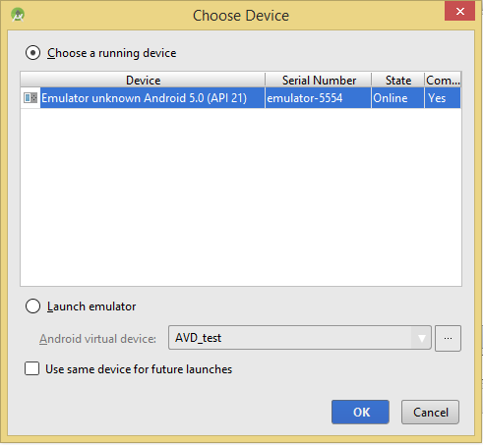

Then the AVD will display, we add name like as following:

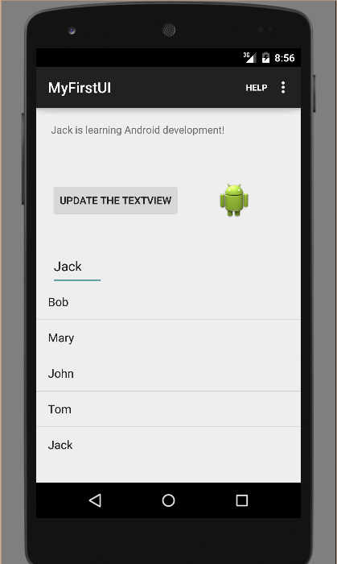

Then we can click the “help” button:

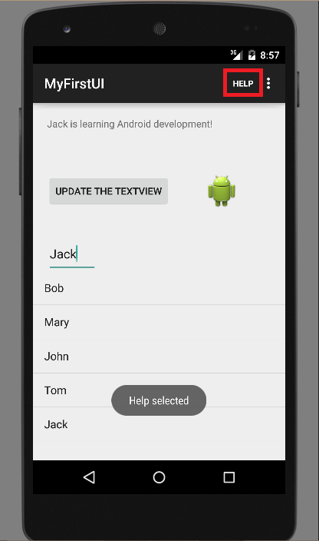

Then click the button in the right top of Action bar:

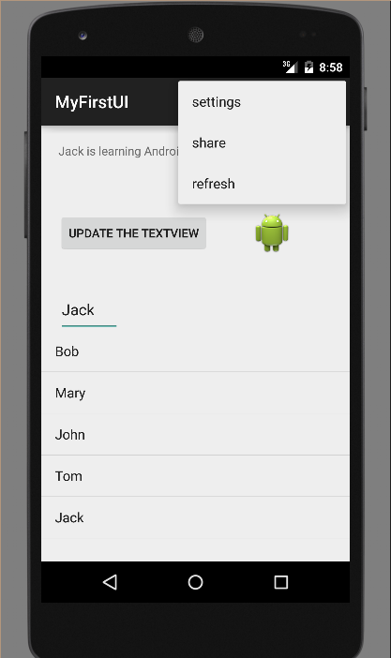

We can click “setting” button, “share” button and “refresh” button.

