Lab : Android Fragments (Android Studio)

**Step 1:** Create a simple Android Application using Android Studio. Follow the option **File -> NewProject**. Now name your application as **MyFragments** using the wizard window as follows:

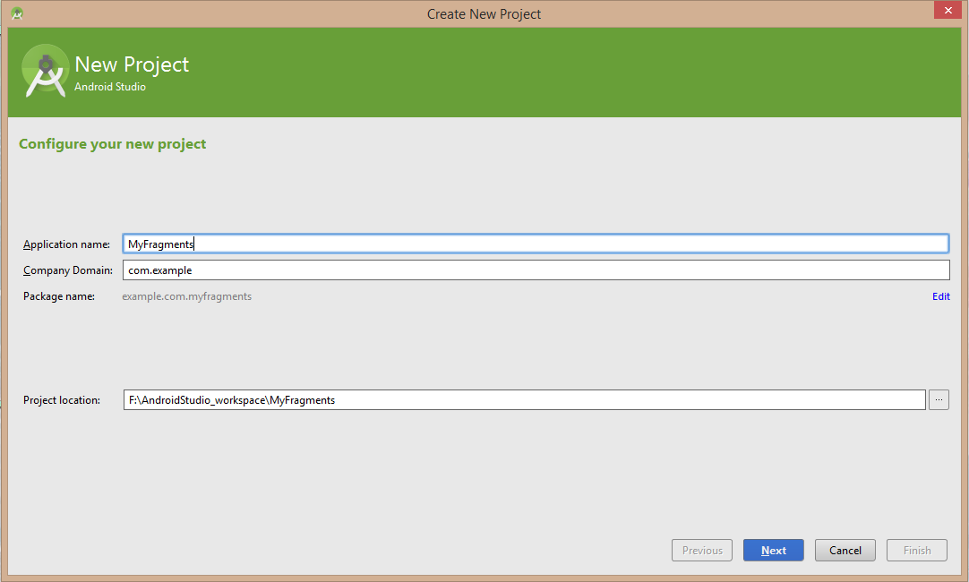

**Step 2:**

Modify main activity file MainActivity.java as shown below in the code. Here we will check orientation of the device and accordingly we will switch between different fragments. Following is the content of the modified main activity file *java/com.example.myfragments/MainActivity.java*.

package example.com.myfragments;

import android.os.Bundle;

import android.app.Activity;

import android.app.FragmentManager;

import android.app.FragmentTransaction;

import android.content.res.Configuration;

import android.view.WindowManager;

public class MainActivity extends Activity {

@Override

protected void onCreate(Bundle savedInstanceState) {

super.onCreate(savedInstanceState);

Configuration config = getResources().getConfiguration();

FragmentManager fragmentManager = getFragmentManager();

FragmentTransaction fragmentTransaction =

fragmentManager.beginTransaction();

if (config.orientation == Configuration.ORIENTATION_LANDSCAPE) {

LM_Fragment ls_fragment = new LM_Fragment();

fragmentTransaction.replace(android.R.id.content, ls_fragment);

}else{

PM_Fragment pm_fragment = new PM_Fragment();

fragmentTransaction.replace(android.R.id.content, pm_fragment);

}

fragmentTransaction.commit();

}

}

Create two fragment files *LM_Fragement.java* and *PM_Fragment.java* under *com.example.myfragments* package.

Following is the content of *LM_Fragement.java* file:

package example.com.myfragments;

import android.app.Fragment;

import android.os.Bundle;

import android.view.LayoutInflater;

import android.view.View;

import android.view.ViewGroup;

public class LM_Fragment extends Fragment{

@Override

public View onCreateView(LayoutInflater inflater,

ViewGroup container, Bundle savedInstanceState) {

return inflater.inflate(

R.layout.lm_fragment, container, false);

}

}

Following is the content of *PM_Fragement.java* file:

package example.com.myfragments;

import android.app.Fragment;

import android.os.Bundle;

import android.view.LayoutInflater;

import android.view.View;

import android.view.ViewGroup;

public class PM_Fragment extends Fragment{

@Override

public View onCreateView(LayoutInflater inflater,

ViewGroup container, Bundle savedInstanceState) {

return inflater.inflate(

R.layout.pm_fragment, container, false);

}

}

Create two layout files *lm_fragement.xml* and *pm_fragment.xml* under res/layout directory.

Following is the content of *lm_fragement.xml* file:

<?xml version="1.0" encoding="utf-8"?>

<LinearLayout

xmlns:android="http://schemas.android.com/apk/res/android"

android:orientation="vertical"

android:layout_width="fill_parent"

android:layout_height="fill_parent"

android:background="#7bae16">

<TextView

android:layout_width="fill_parent"

android:layout_height="wrap_content"

android:text="@string/landscape_message"

android:textColor="#000000"

android:textSize="20px" />

</LinearLayout>

Following is the content of *pm_fragment.xml* file:

<?xml version="1.0" encoding="utf-8"?>

<LinearLayout

xmlns:android="http://schemas.android.com/apk/res/android"

android:orientation="horizontal"

android:layout_width="fill_parent"

android:layout_height="fill_parent"

android:background="#666666">

<TextView

android:layout_width="fill_parent"

android:layout_height="wrap_content"

android:text="@string/portrait_message"

android:textColor="#000000"

android:textSize="20px" />

</LinearLayout>

Make sure you have following content of *res/values/strings.xml* file:

<?xml version="1.0" encoding="utf-8"?>

<resources>

<string name="app_name">MyFragments</string>

<string name="action_settings">Settings</string>

<string name="hello_world">Hello world!</string>

<string name="landscape_message">This is Landscape mode fragment

</string>

<string name="portrait_message">This is Portrait mode fragment

</string>

</resources>

**Step 3:**

Let's try to run our modified **MyFragments application** we just modified. I assume you had created your AVD while doing environment setup. At first, start your existed **AVD**, and then click **Run** Eclipse Run Icon icon from the toolbar. Choose this AVD, and click “OK”:

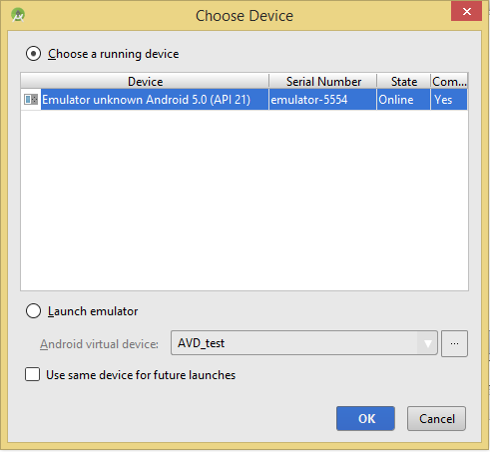

Then the AVD will display like as following:

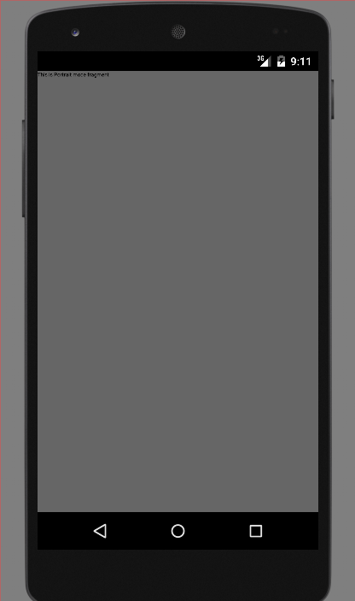

To change the mode of the emulator screen, let's do the following:

* fn+control+F11 on Mac to change the landscape to portrait and vice versa.
* ctrl+F11 on Windows.
* ctrl+F11 on Linux.

Once you changed the mode, you will be able to see the GUI which you have implemented for landscape mode as below:

