Kevin Speyer

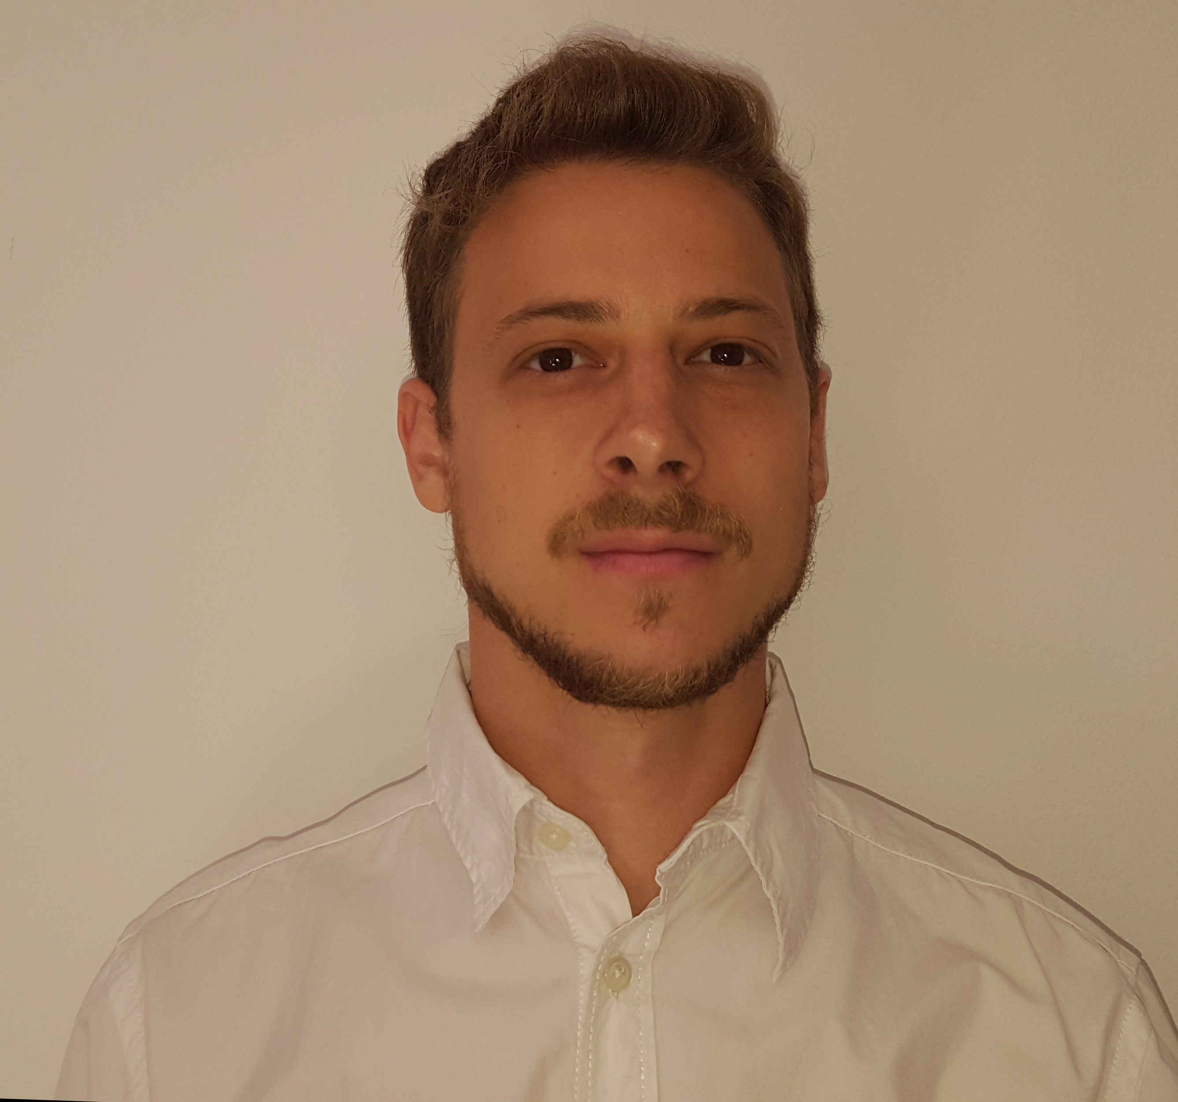
Nationality: Argentinian and German

E-mail: speyer.kevin@gmail.com

Telephone: +54 9 11 6208 9696

Date of Birth: 11th May 1987

Address: Ballivian 3283, Buenos Aires, Argentina

Current Position

4/2014 – to date: PhD candidate in Physics.
Thesis: “Simulations of liquid flow confined by semiflexible polymer brushes”
University of Buenos Aires, Argentina
Workplace: National Atomic Energy Commission (CNEA)
Scholarship: 2014 - 2019 by the National Scientific and Technical Research Council (CONICET)
Supervisor: Dr. Claudio Pastorino

Education

2014 - to date PhD Candidate in physics by the University of Buenos Aires with a scholarship of the National Scientific and Technical Research Council (CONICET)

2006 - 2014 Lic. in physics by the University of Buenos Aires (MS equivalent). (Avg: 9.26 / 10)

1999 - 2004 High school Pestalozzi.

2004 Sprachdiplom Stufe II, German Language Certificate of the Education Ministers Conference

12/2003 - 3/2004 Student Exchange in Germany, attending classes and staying with a German host family.

2002 Sprachdiplom I, German Language Certificate of the Education Ministers Conference

2001 Preliminary English Test, Cambridge University.

Scholarships & Internship

10/2016 & 3/2016 International Centre for Theoretical Physics to participate in Workshops

3/2014 – 3/2019 National Scientific and Technical Research Council (CONICET), full scholarship for PhD studies

12/2004 Bayer, paid internship

Conferences

9/2017 102th National Reunion of the Argentine Physics Association

11/2016 Frontiers in Physical Science, Max Planck, Argentina

10/2016 Introductory School on Parallel Programming and Parallel Architecture for High-Performance Computing, ICTP, Italy

3/2016 4th Workshop on Advanced Techniques for Scientific Programming and Management of Open source Software Packages, ICTP, Italy

9/2015 100th National Reunion of the Argentine Physics Association

6/2015 4th International Workshop "Theory and Computer Simulation of Polymers: New Developments”, Germany

3/2015 Workshop: Dynamics in Soft and Hard Condensed Matter, Argentina

11/2014 First Argentinian Microfludics Workshop

9/2014 5th Argentinian Soft Matter Encounter

9/2014 99th National Reunion of the Argentine Physics Association

Languages

Spanish: Native

English: Fluent

German: Fluent

Portuguese: Basic

Programming Languages

Advanced in: Linux environment, Python, C++, Fortran, LabView, awk, Matlab and git

Teaching and Work Experience

8/2015 – 12/2015 Teaching Assistant at the Sábato institute of the San Martín National University for Introduction to Computer Simulation

3/2013 – 12/2014 Teaching Assitant at the physics department from the University of Buenos Aires for Physics I for Biologists and Physics II for Biologists

3/2012 - 12/2013 Teaching Assistant at the Common Basic Cycle (Foundation Year equiv.) at the University of Buenos Aires for Physics and Introduction to Biophysics

2/12/04 - 31/12/04 Internship at Bayer S.A. in the Trade Marketing area de la Unidad de Negocios Bayer Health Care (BHC), performing administrative tasks.

Publications

- Brushes of semiflexible polymers in equilibrium and under flow in a super-hydrophobic regime
K. Speyer and C. Pastorino, Soft Matter, 2015, 11, 5473–5484
DOI:10.1039/C5SM01075F

- Droplet transport in a nanochannel coated by hydrophobic semiflexible polymer brushes: the effect of chain stiffness
K. Speyer and C. Pastorino, Langmuir, 2017, 33 , 10753–10763
DOI:10.1021/acs.langmuir.7b02640

Interests and Skills

- Polymer Physics, Soft Matter and Microfluidics

- Atomistic and coarse grain high performance computer simulations

- Statistical Analysis of Big Data

- Experience with Laboratory Equipment and single-board microcontrollers (Arduino & Raspberry Pi)

