**Module 3: Forecasting Financial Time Series**

Kevin Ogudugu

Data Analytics, College of Professional Studies, Northeastern University

ALY6050: Introduction to Enterprise Analytics

Amin Karimpour

June 9, 2024

**Part 1**

**I**

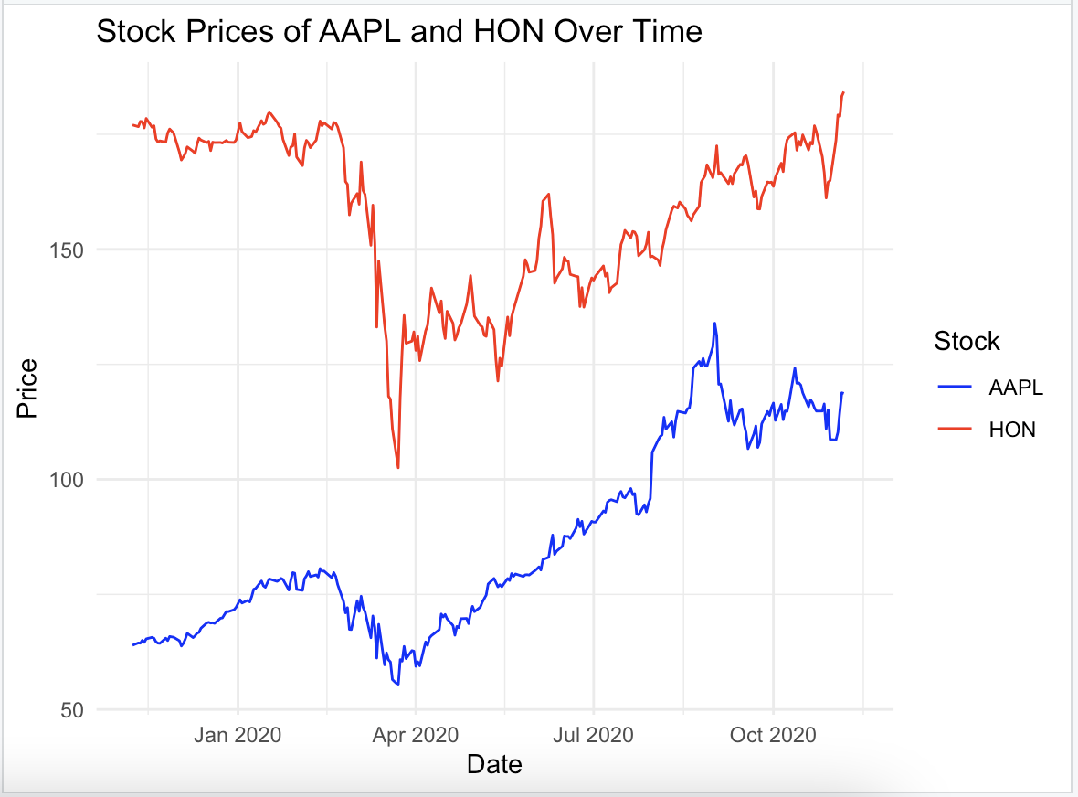

The line chart for Apple Inc. (AAPL) and Honeywell International Inc. (HON) stock prices indicate significantly different trends. Apple’s stock increased significantly after a significant decline from April 2020. Similarly, Honeywell’s stock experienced a decline before a clear uptrend during the same period. This was likely due to the nature of the market conditions during the COVID-19 pandemic which was around this period with both having sharp drops, which resulted in a quick turnaround. Furthermore, the recovery by AAPL was more stable than HON implying possible variant impacts of market conditions on these firms. By analyzing this, we can see that Apple is a dynamic player in this market whereas Honeywell is relatively stable during the period considered.

**II**

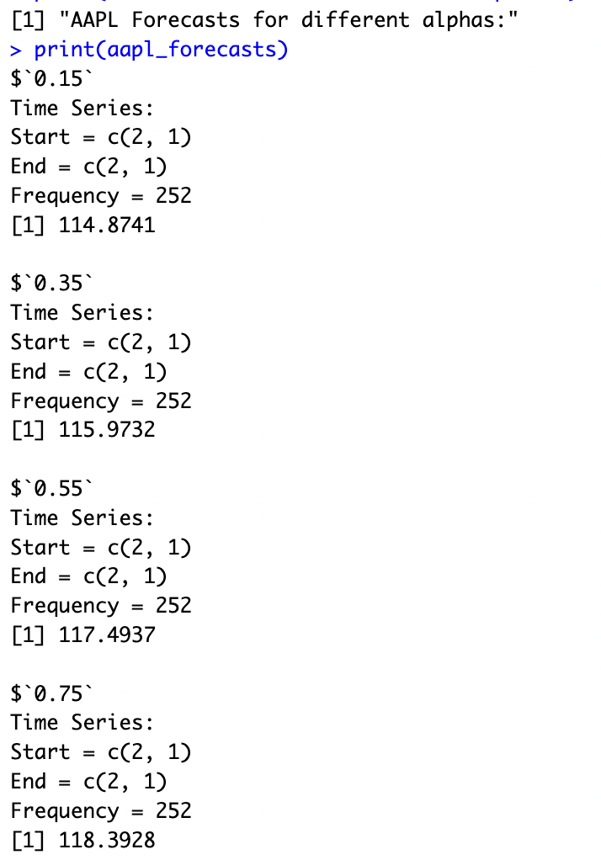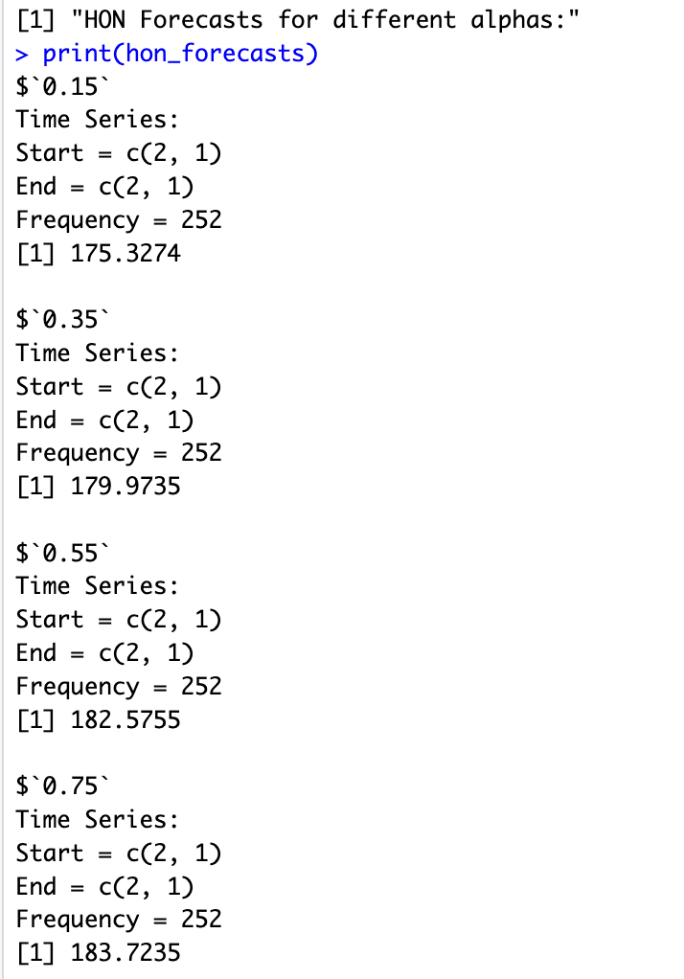

These results showed how sensitive our projections are to changes in α-the smoothing parameter. As α increases, the forecasts seem to become more responsive to recent shifts in the data leading to raised predictions with larger α values, which is one of the main principles behind exponential smoothing: higher values for α give more importance to most recent observations so that the forecast reacts more actively on each occasion when there is change in stock price.

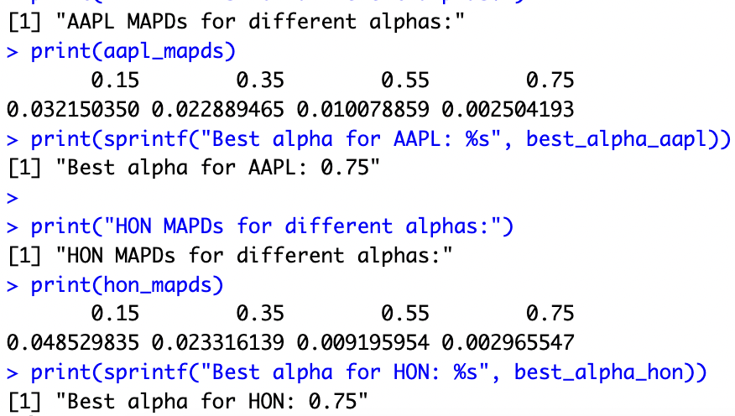

The best α for forecasting “AAPL” was 0.75, with an MAPD of around 0.0025, meaning that this value of α is the most appropriate in addressing the trend effects while suppressing noise in AAPL stock data. Also, the best α for “HON” was 0.75 with an MAPD of 0.0029, meaning it also manages recent price changes and fluctuations within HON stock data. Using a higher α in both cases means more weight is attached to the more recent observations by the forecasting model making it more effective for these stocks during this period of study. On two occasions, the most accurate forecasts for AAPL and HON stocks were made using an alpha value of 0.75 suggesting a high degree of responsiveness to recent market shifts.

The greater α mostly focuses on the most current observations, however, having lower alpha may make it lag behind capturing such fast changes leading to less timely predictions. Furthermore, an Alpha = .075 helps the model quickly adjust to new trends and reduce prediction lag providing a balance that avoids overfitting. In both cases, the most accurate forecasts are achieved by setting α at 0.75 which is indicated by minimum values of MAPD’s that are obtained, implying that putting more weight on recent observations allows predicting next value better than when older trends are stronger indicators.

**III**

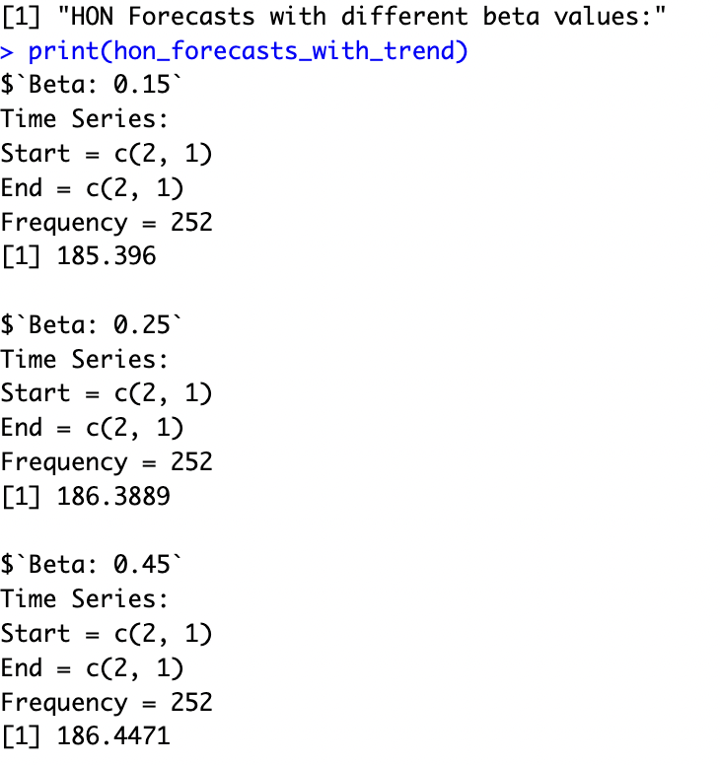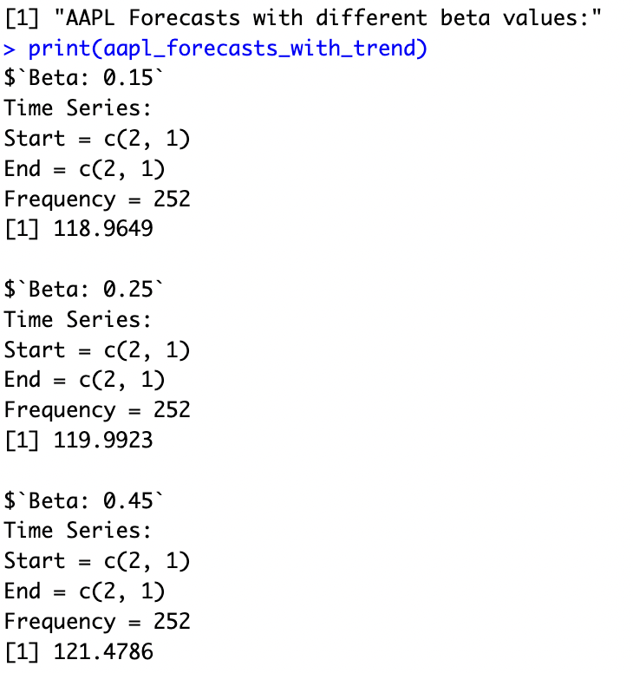

Similarly, for “HON”, an increase in β from 0.15 to 0.25 would yield an increase in the forecast value and a further increase of β to 0.45 still shows a reduction in the forecast price, which indicates that the model is overstating its power with larger β values. On the other hand, as β increases from 0.15 to 0.45, so do the forecasted values, which means that this model brings stronger upward trends in stock price data when more weights are put on β. This suggests that higher beta models anticipate increasing trends which is logical if stocks are going up.

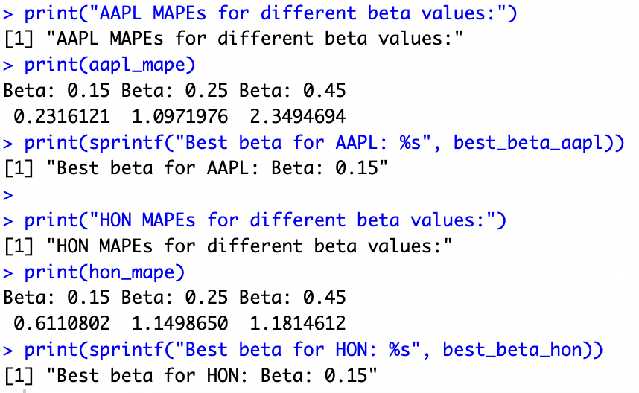

The lowest value of β which is 0.15 gave accurate predictions for both AAPL and HON, meaning that low recent trend change sensitivity helps these models, thus weak and inconsistent price trends for these shares do not justify using high beta models. Therefore it means less responsive forecasts which are more stable may be preferred since they avoid overfitting to short term fluctuations which may not be persistent in nature.

**Part 2**

**I**

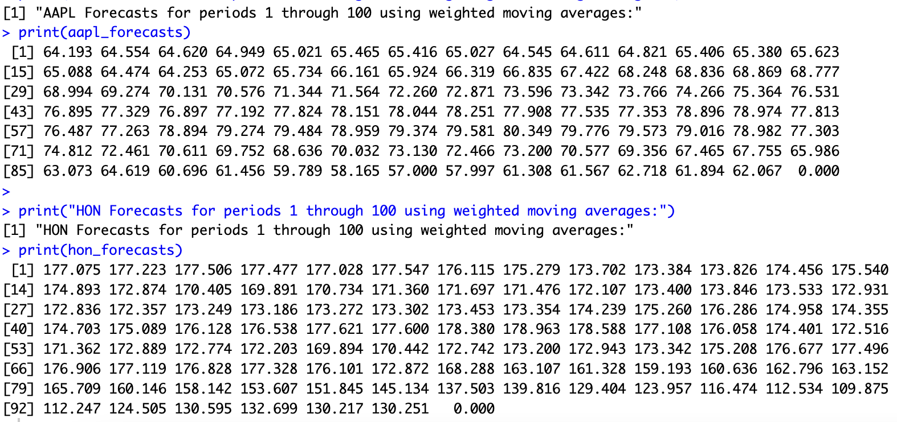

The first 100 periods of AAPL and HON stock predictions are calculated using a three period weighted moving average with weights 0.5, 0.3, and 0.2 to smooth out short-term volatilities and show underlying trends effectively. Fluctuations in the forecasts for both stocks reflect this method that captures ups and downs in the market every time as well as being considering recent changes while maintaining an adjusted direction of the stock prices. This helps with considering recent information while making the forecasts relevant for predicting short term outcomes better thus increasing their accuracy.

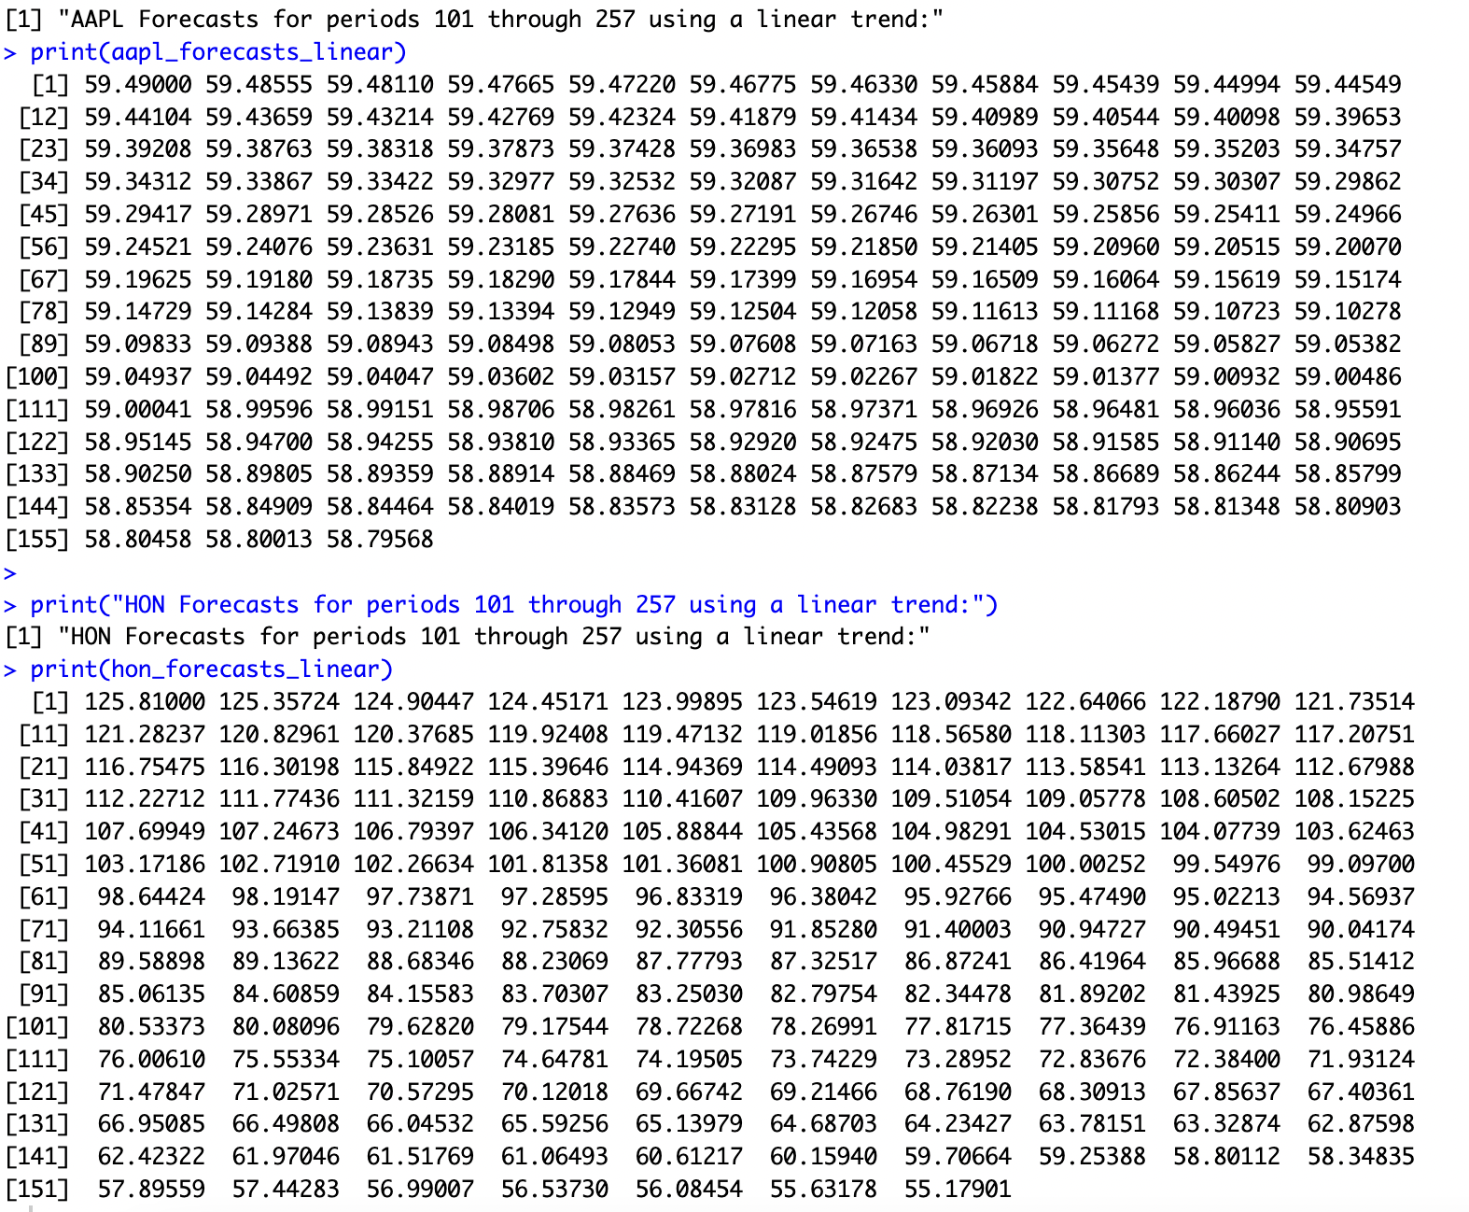

For instance, based on linear trend from observed values of period 101, we forecasted AAPL and HON stock prices from periods 101 to period 257. Comparisons between forecasted values and actual closing prices obtained from Yahoo Finance showed significant differences suggesting short term swings that were not captured by the model used, or a potential miscalculation. The model appears to have made a mistake as predicted values for AAPL and HON appeared too small compared to what was actually observed in Yahoo finance.

**II**

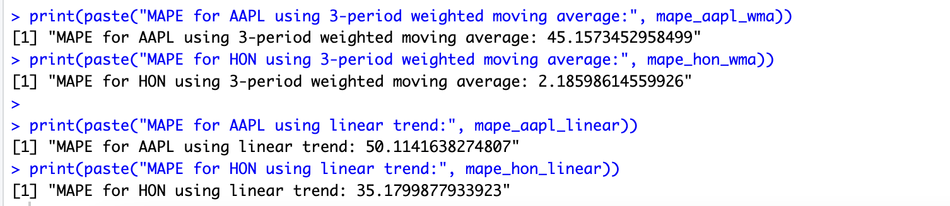

The three-period weighted moving average method has an MAPE of 2.19% for HON which is more accurate than one with a linear trend. However, for AAPL the three-period weighted moving average method was better than the linear trend method. Therefore, from HON’s case, it is clear that weighted moving averages better accuracy while linear trends are worse for both stocks. However, it is important to note that these discrepancies might indicate possible errors or inappropriateness of the calculation methods.

**Part 3**

**I**

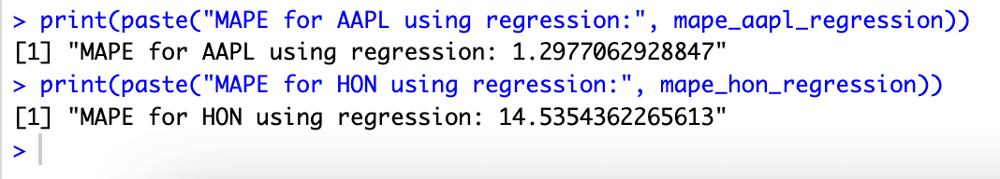

As indicated by MAPEs of 1.30% and 14.54%, respectively, on using simple regression to forecast AAPL and HON prices from periods 1-257.The regression approach provided the best forecasts for AAPL in comparison to a three-period weighted moving average and a linear trend method. On the other hand, in terms of accuracy, it was seen that the weightage used in forecasting Hon stock was done correctly. Therefore, as demonstrated by the decrease in MAPE over time; this shows how inaccurate our data can become without us realizing it.

**II**

#### 

Residuals on both AAPL and HON show visible trends over time indicating that they are not independent. Therefore, it implies that the linear regression model failed to capture some underlying structure which is time-dependent. This means residuals have different variances for each fitted value, implying heteroscedasticity. Spread of residuals changes across the range of fitted values suggesting heteroscedasticity.

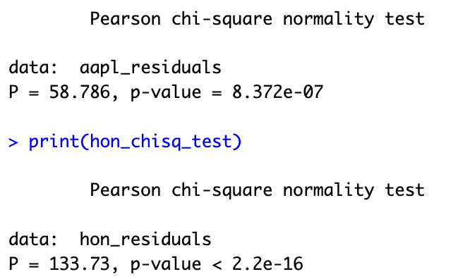

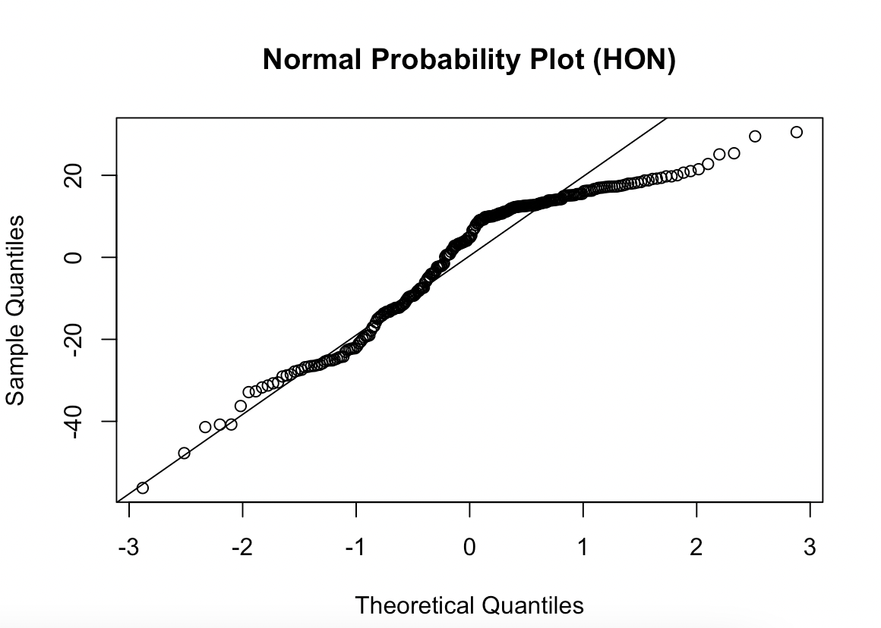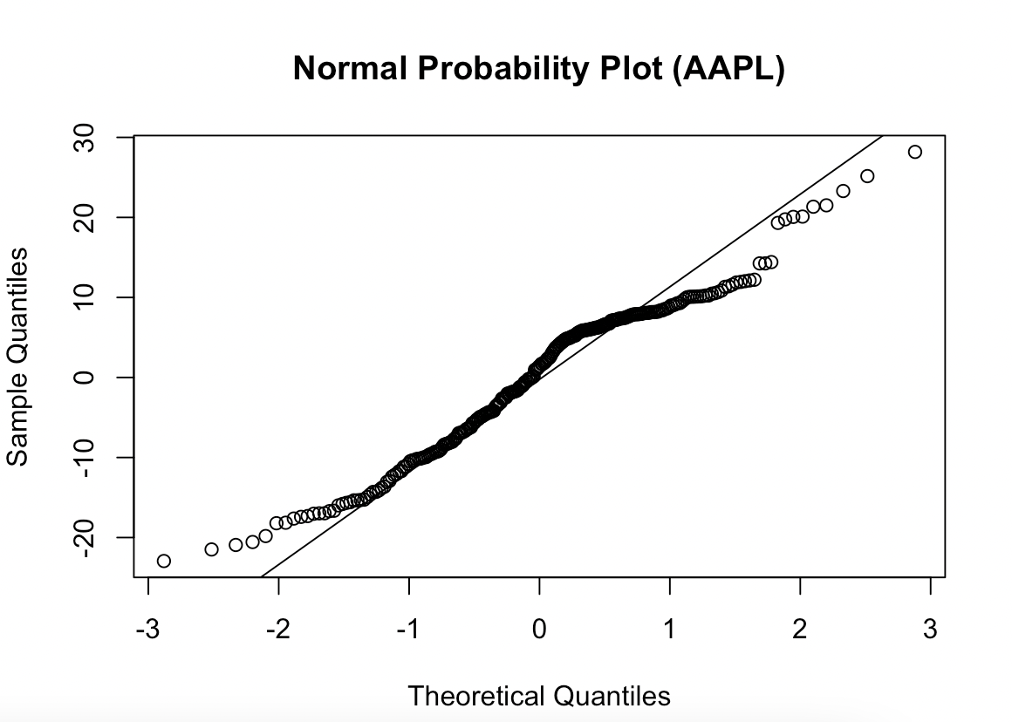

Selecting the percentages (P and Q) for each stock, which depends on different factors such as risk tolerance, investment goals, and the performance analysis from Parts 1-3 of this project, when forming a portfolio (𝜋) made up of AAPL (𝑋) and HON (𝑌) stocks. Based on MAPE analyses, AAPL has been more accurate and stable in its forecasts. This therefore justifies marginally higher investment in AAPL. One possible allocation strategy is: –AAPL (P): 60% HON (Q): 40%. This allocation balances the higher accuracy and performance of AAPL while maintaining significant exposure to HON, thus diversifying risk. However, individual preferences and market conditions should always guide the final decision.

The residuals are not normally distributed as evidenced by their deviations from theoretical lines on both Normal Probability Plots for AAPL and HON. In terms of Chi-Squared Tests, the P-values obtained from such tests likewise imply that normality was not satisfied; this is because these tests yielded those p-values much smaller than 0.05(AAPL:8.372×10−78.372 \times 10^{-7}8.372×10−7; HON: <2.2×10−16<2.2 \times 10^{-16}<2.2×10−16), leading to the rejection of null hypothesis that residuals are normally distributed.

**Final Question**

The selection of the percentages (P and Q) allocated for each stock when forming a portfolio (𝜋) containing AAPL (𝑋) and HON (𝑌), depends on several factors such as risk tolerance, investment goals, performance analysis from Parts 1-3 of this project among others. AAPL has been more accurate and stable in its forecasting going by MAPE analysis results .Hence a little bit higher allocation towards AAPL might be justified. One possible allocation strategy could be: AAPL (P): 60% HON (Q): 40%. This results in a higher accuracy and performance for AAPL while it maintains a significant exposure to HON, managing risk through diversification.