**Module 5: Using Linear Programming Models to maximize profits**

Kevin Ogudugu

Data Analytics, College of Professional Studies, Northeastern University

ALY6050: Introduction to Enterprise Analytics

Amin Karimpour

June 20, 2024

**1.**

P = 169.99x1+359.99x2+290.99x3+55.99x4

**Constraints:**

330x1 + 370x2 +410x3 + 159x4 ​≤ 170,000

Go-karts = 8*5 ft pallets

Generators/pressure washers = 5*5 ft pallets

Water pump = 0.25/ 5*5 pallet

5x1 + 8x2 + 5x3 + 1.25x4 ≤ 82*30

x1 + x2 ≥ 0.3(x1 + x2 + x3 + x4)

x3 ≥ 2x4

**Non-negativity** = x1, x2, x3, x4 ≥ 0.

**3.**

**Results:**

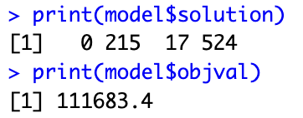

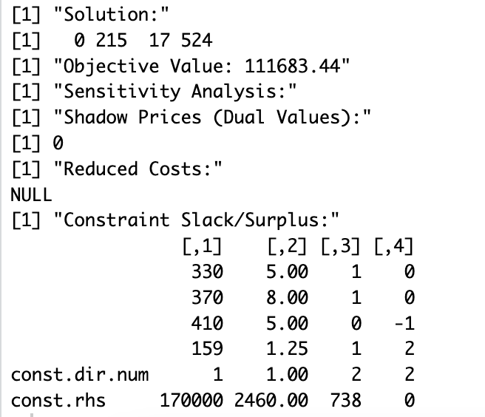

After conducting a sensitivity analysis, including the constraints we have the following results. Null shadow price for the budget constraint indicates that the present budget does not limit earnings, as shown by a surplus of $330, which means that some money from the allocated budget is not utilized. Warehouses also have excess capacity in terms of space, especially for go-karts. The scarcity constraint on stock-outs for pressure washers and go-karts implies that this minimum level condition has just been met whereas there is a need to cover up for insufficiency in generator-to-water pump ratio due to it falling below twice as many generators.

**4.**

By using linear programming models, we can determine the specific inventory levels for each of the four products as well as total optimal monthly profit. Profitability margins or operational realities do not justify stocking any pressure washers at all, according to the model. However, Go-Karts are strongly advised since they should have an inventory level of 215 items, proving they are cost-effective with respect to the existing budgetary estimates and area limitations. On the other hand, generators can be maintained at 17 units probably because they may have high costs or less favorable margins, market demand is strong while the cost profit ratio is favorable, leading to 524 cases at Water Pumps.

Considering all the products, this model will guide us on how to achieve maximum revenue and minimum cost per month so that an optimal monthly profit of $111,683.44 can be realized. This is achieved by using resources strategically within budgetary limitations, warehouse space considerations and inventory policies constraints. Therefore, it works out the recommended stock levels for each product with attention given to costs incurred during sales as well as their contributions towards overall profitability, hence ensuring that it effectively operates in its new distribution center which in turn increases profitability.

**5.**



Any decrease in price below $499.99 would not allow pressure washer’s optimal solution value change from zero to a non-zero number. A takeaway from this finding is that the current selling price has already reached the binding point for making pressure washer a good choice amongst other models featured in linear programming problems. Nonetheless, it was excluded according to the constraints dictated by those who made decisions on behalf of the company administration regarding which products should be produced under what circumstances. This implies that price is possibly not the only reason why it has been excluded from the optimal inventory such as space occupancy, relative cost to budget limit or profitability in relation to other products. However, changing other variables like reducing purchase cost, optimizing space allocation, or modifying inventory policies might make stocking pressure washers beneficial at the current selling price. Alternatively, more investigation of these factors or adjusting some constraints in the model may be necessary to include pressure washers into stocks.

**6.**

The output of linear programming and its sensitivity analysis indicates that the initial $170,000 was not fully expanded since there is $330 slack remaining on that budgetary constraint. Moreover, there was a shadow price for this constraint which was 0. This means that any increase in the budget within its current set up will not result in an increase in net monthly profit. Accordingly, with existing conditions such as product pricing and cost structures, it may be unnecessary and ineffective to allocate additional funds to the purchasing budget for purposes of increasing profitability.

However, we need to consider other adjustments within the model for extending the budget before choosing not to increase it. These might require rethinking about product mix and pricing among other things, particularly about products that are excluded from the optimal solution like pressure washers. Additionally, it might be possible to exploit optimization opportunities in respect of inventory levels and storage strategies taking into consideration surplus space and under-utilized budget. In doing so, it is possible that better profits could be made from high-margin products such as go-karts or even better overall product offerings could be given with no increase in budgets.

To sum up, increasing the budget without a corresponding strategy on how to utilize these extra funds effectively may not work well. Instead, optimizing current resources and probably expanding or adding new products within the existing constraints of the budget would be more prudent. If later modifications show that expanding the budget would result in higher earnings then only an increased allocation can justify an investment through rise in net income.

**7.**

The models output and sensitivity analysis have indicated that the current utilization of warehouse space was ineffective because the space constraints were not fully used. In particular, there is excessive capacity in the go-karts and other product space categories, which suggests that it is beyond the company’s requirements under optimal product strategy. The implication for this underutilization is that the firm could perhaps work optimally with a smaller warehouse whilst still maintaining its effective operation without sacrificing its profits or any operational cost such as rent, utilities, and maintenance. However, flexibility has to be considered before advising on whether to downsize. In case more things will be added or inventory levels increased due to market demand then keeping this size or choosing a slightly larger warehouse would make sense. Through this process, they could experience growth without immediate relocations or additional capital investment upon seeking new locations. That would also create some kind of a cushion to handle seasonal fluctuations in inventories.

Finally, I recommend that in the absence of any plans for major product range expansion or increase in inventory levels one should opt to lease a smaller warehouse so as to reduce any unnecessary expenses. The perfect size will be defined by the space requirements of optimized products that can be recalculated based on product dimensions and volumes. If there is a decision to downsize, substantial savings is likely to occur and improve monthly profits directly by trimming fixed costs. However, if there are expectations for growth or diversification, it may be wise to maintain or slightly increase the size of the warehouse so as to prepare for expansion without immediate constraints on space.