**Kevin Valenzuela**

**September 25, 2018**

**Digital Image Processing**

**Assignment 2**

**Part 1: Apply Filters to an Image**

For this part I applied different filter to an image. Including an averaging filter, sobel filter, Laplacian filter and median filter. For my own kernels I chose a vertical filter and horizontal filter. The differences can be viewed in my results.

 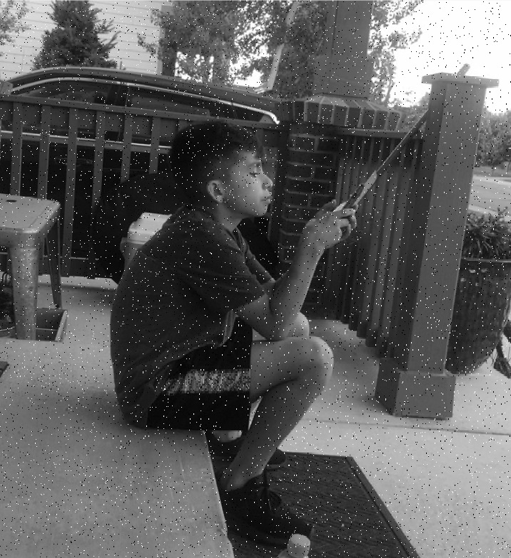

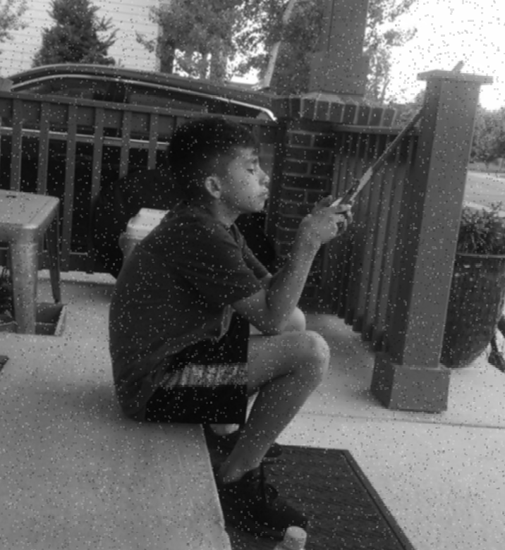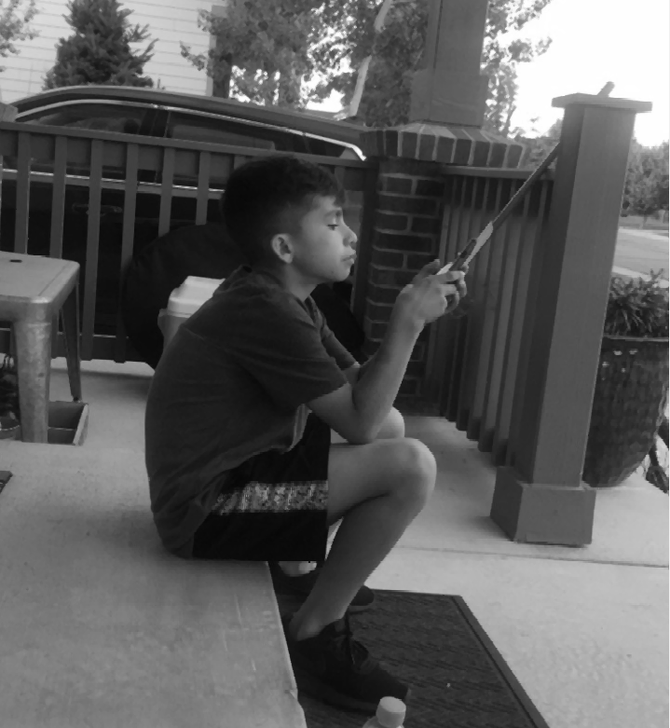

Above, I turned the original into gray scale and added some noise to it. I then applied the averaging filter and median filter too. The median filter got rid of the noise better than the averaging.

Below, I applied some edge filters. You can really spot some of the differences when the kernel is made for horizontal edges and vertical edges.

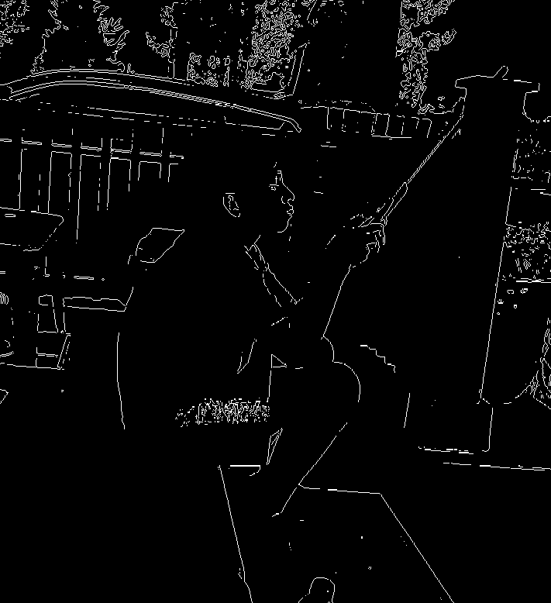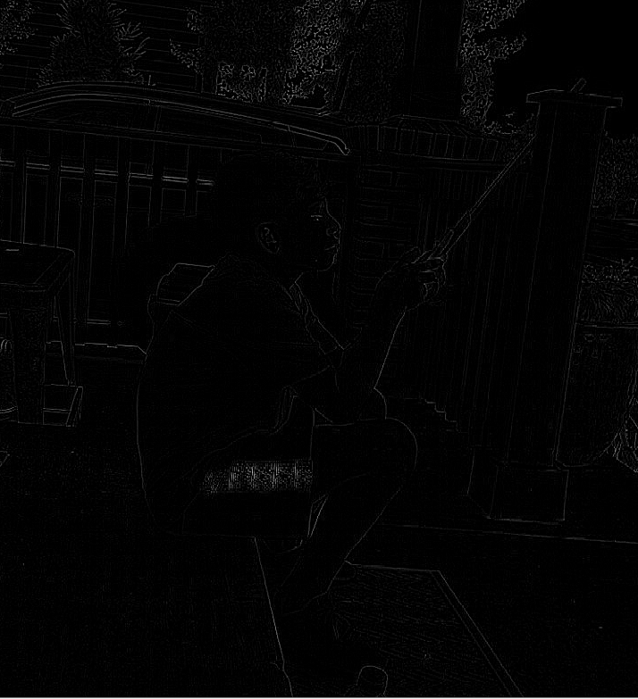

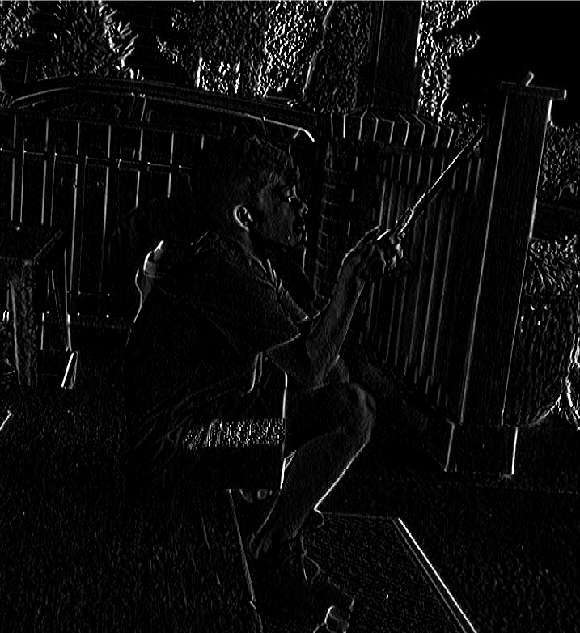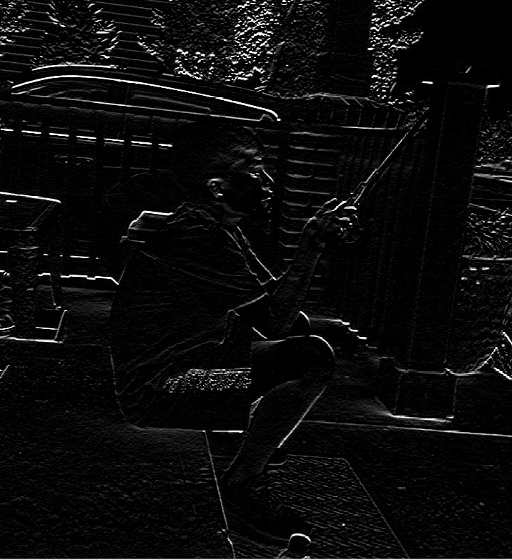

**Part 2: Iris Boundary**

This part of the assignment required applying a filters and kernels to an image of an eye to get the iris boundary only. The first thing that was done was applying an edge filter, this would make it easier to see the circle outside of the iris. To find the edged circle a kernel was made. The kernel that was made was initially all filled with zero’s and then an inner circle filled with one’s was applied to it to detect the circular shape. After that, anything outside of the radius of the center of the iris would be made black by making the pixel values to zero.

