Kevin Valenzuela

October 14, 2018

Digital Image Processing

Assignment 3

A challenge that comes with skin detection is illumination in an image that can be processed as skin. This cause inaccurate results when detecting skin. For example on the screenshot below, we can see that the bottom left skin detection also detected the illuminated background as skin.

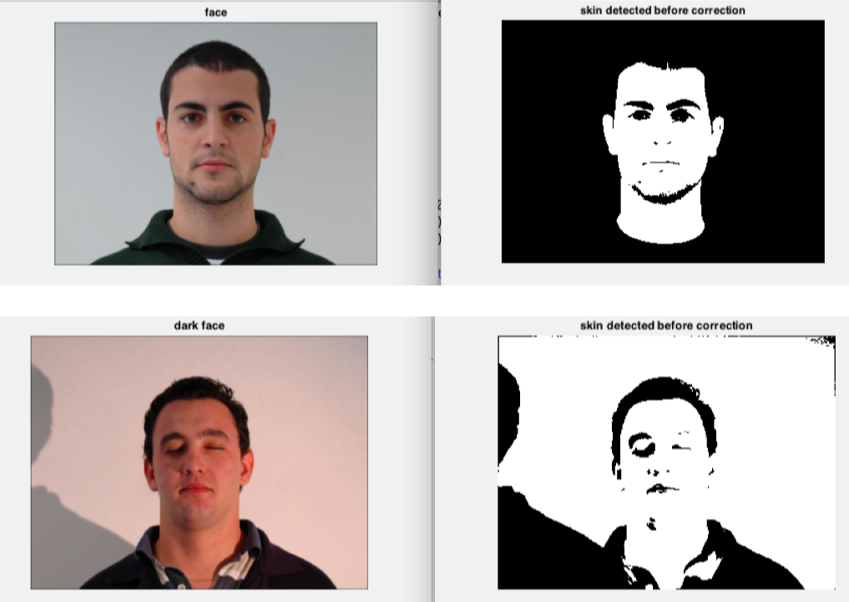

To fix this I did a bit of research on a few ways to resolve the issue. One of the more interesting things I found was the gray world algorithm. The Gray World algorithm is a white balance method that assumes that your image, on average, is a neutral gray. Gray world assumption only holds if we have a good distribution of colors in the scene. Assuming that we have a good distribution of colors in our image, the average reflected color is assumed to be the color of the light. Therefore, we can estimate the illumination color cast by looking at the average color and comparing it to gray.

I research on how to manipulate the pixels to get the result. The mean of the three components (R,G,B) is used as the illumination estimate of the image. The pixel value is scaled by s1 = avg/avgi. Where avgi is the channel mean and avg is the illumination estimate. Below are the steps I took.

1. Get R,G,B components of input image.
2. Take inverse of average of each component
3. Get the scaling right by getting max/min
4. Scale the values by dividing average by max value
5. Put results into image after multiplying by original value

Below is my result of applying the input image through this normalization.

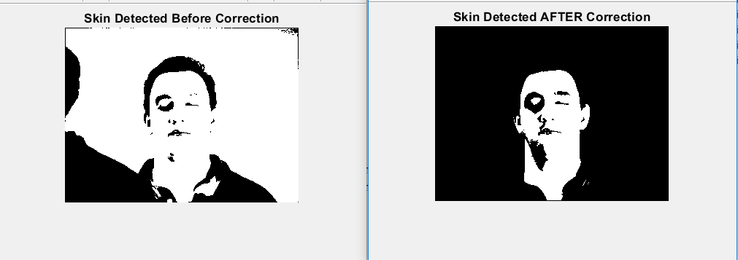

The resources I used for this solution can be found below and can also be found in comments within my code.

**Resources**

https://www.mathworks.com/matlabcentral/fileexchange/40937-gray-world-colour-correction

https://web.stanford.edu/~sujason/ColorBalancing/grayworld.html

https://www.codeproject.com/Articles/653355/Color-Constancy-Gray-World-Algorithm