Firmware Implementation & Feature Overview

According to our discussions, I have successfully implemented all the requested features. The development focused primarily on three critical areas: emergency requirements, comprehensive event logging, and precise weight data reading.
Below is a detailed summary of the implementation and the technical decisions made.

1. Advanced Logging System
I have implemented a new logging structure that goes beyond simple pill counts and timestamps. The system now includes Event and Event Type parameters, allowing us to clearly distinguish between Normal (N), Tamper (T), and Warning (W) events.
New Log Events Added:
Event | Event Type
VIAL_RESTARTED | Warning
PILL_CHANGE | Normal
BLE_LOCK_CMD | Normal
BLE_UNLOCK_CMD | Normal
EMERGENCY_UNLOCK | Warning
SAFETY_TIMEOUT | Warning
MANY_PILLS_CHANGE | Tamper
OUTSIDE_WINDOW_CHANGE | Tamper
LOW_BATTERY_5 | Warning
LOW_BATTERY_2 | Warning

Shutdown & Power Monitoring: Since a shutdown event occurs without warning, I added specific logs to track power status indirectly:
- Logs for Low Battery status (at 5% and 2%).
- A log generated the moment the device is turned on. This allows us to pinpoint exactly when the device was powered off by identifying the gap between the last log and the "power on" timestamp.

2. Safety & Hardware Features
- Watchdog Timer: A 5-second watchdog has been added to ensure system stability.
- Safety Timeout: An automatic safety timeout feature has been implemented.
- Solenoid Protection:
  - The solenoid lock cannot be opened if less than 1 minute has passed since the last opening.
  - The lock status automatically switches (re-locks) 5 seconds after unlocking.
- Emergency Unlock Button: Implemented with a 5-second press requirement for activation.

3. Calibration & Load Cell Optimization
You previously suggested a three-step or two-point calibration process. To validate this, I conducted a linearity test using a generic Chinese load cell (unbranded) as a representative sample. The results apply to similar load cell models.
By testing the measured values at 10 equal weight intervals, I determined that the load cell is sufficiently linear for our needs. Therefore, a complex multi-point calibration is unnecessary. Instead, I optimized the method to calibrate directly using pill weight rather than known standard weights (e.g., 1kg, 2kg). This approach reduces calculation volume and eliminates errors introduced by unnecessary conversion steps.

4. New BLE Commands
I have added the following BLE commands to manage the pill taking window and security:
Name | Command | Description
SET_PILL_INTERVAL | 0xB4 | Requires Auth Key
SET_PILL_INTERVAL | 0xB5 | Requires Auth Key
SET_SAFETY_TIMEOUT | 0xB6 | Requires Auth Key
ADD_ADMINKEY | 0xEF | No Auth Key Needed and key can only be set once
READ_LOGS | 0x33 | Requires Auth Key
DELETE_LOGS | 0x34 | Requires Auth Key

5. Boot & Debugging Logs
The firmware provides extensive debugging data during reset:
- Hardware Checks: Logs verify the status of all connected modules/ICs.
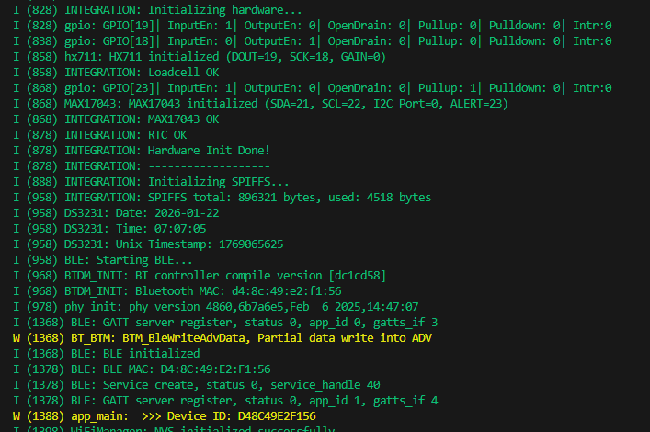
- Device ID: The firmware automatically uses the ESP32’s unique base MAC address as the Device ID.
- NVS Storage: Configs and data are saved in Non-Volatile Storage. (See attached images for NVS and WiFi Saved Configs).
saved configs on the ESP32 non-volatile storage (NVS) (image attached)
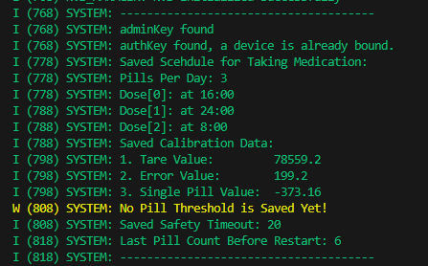
WiFi Saved Configs on the ESP32 non-volatile storage (NVS)
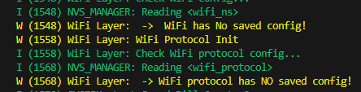

6. Data Structure & Sync
The cached log data uses a JSON structure for clarity. When you send a request_sync command, the data is received in the following format:
Json:
{"ts": 1769073375, "type": "T", "evnt": "OUTSIDE_WINDOW_CHANGE", "chng": 1, "cnt": 6}

Note: The chng (change) and cnt (count) fields are only included in Normal and Tamper events.
Debugging Command:
I added an independent commands, READ_LOG_FILE (0x33) and DELETE_LOG_FILE (0x34), which both requires an auth key. This first command reads the cached log file and prints it and the second one deletes the file. These commands are intended solely for debugging and are separate from the standard sync commands.
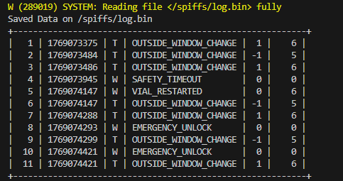

7. Important Note on Load Cell Behavior
Based on my testing, it is important to note two inherent characteristics of the load cells and the HX711 ADC module:
- Voltage Sensitivity: The HX711 is highly dependent on supply voltage. Any fluctuation in the supply voltage will directly result in reading errors for the load cell and, consequently, incorrect pill weight calculations.
- Mechanical Creep: After placing pills on the load cell, the read value tends to increase over time. This is due to a material property known in engineering as "Creep" (the tendency of a solid material to move slowly or deform permanently under the influence of mechanical stresses). This is a fundamental characteristic of the load cell mechanism, and unfortunately, it cannot be fully corrected via software.

All details we discussed have been implemented as requested. Please let me know if you have any questions regarding these updates.

Best Regard,
Alireza
M-Bytron Electronics Team

