Please find below the confirmed flashing instructions and technical specifications for the delivered firmware.

Flashing Instructions

For this phase of the project, the flashing requirements remain consistent with the previous milestones. The details below are based on the actual ESP-IDF production flash configuration used for this firmware. I have also attached a screenshot of the flashing log for your reference, demonstrating successful programming and initialization.

1. Build Target
- ESP32 module: ESP32-WROOM-32D (dual-core, rev v3.1)
- Crystal: 40 MHz
- Flash size: 4 MB
- Flash mode: DIO
Manufacturing readiness:
This build is suitable for EVT/DVT manufacturing. It is a standard ESP-IDF production build with no debug-only dependencies.

2. Flashing Procedure
- Recommended flashing tool:
esptool.py (Espressif official tool)
- Verified flashing command (used successfully):
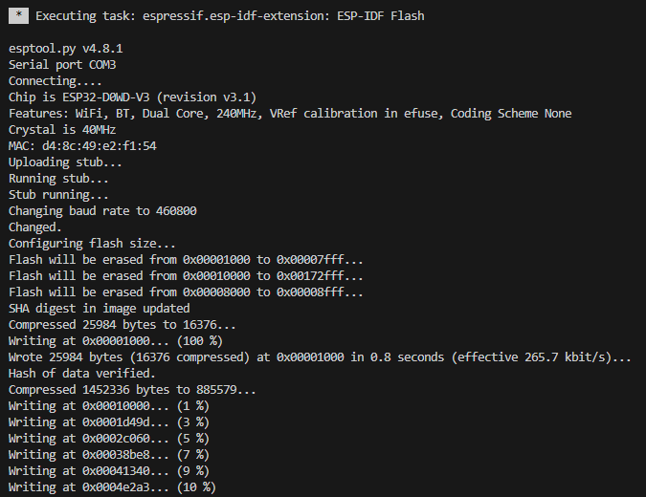
- Baud rate:
460800 baud (verified stable). Higher speeds may work, but this is the validated value.

3. Boot & GPIO
- Boot-strap pins:
Standard ESP32 strapping applies (GPIO0, GPIO2, GPIO12, GPIO15).
No non-standard or CM-specific handling is required beyond normal ESP32 flashing.
- Solenoid behavior at boot:
The solenoid will NOT actuate during boot.
All related GPIOs are initialized in a safe, inactive state until firmware startup completes.

The firmware uses the following GPIO pin assignments:
Function | Pin
LOCK_PIN | GPIO5
SDA_PIN | GPIO21
SCK_PIN | GPIO22
BAT_ALRT | GPIO23
LC_DOUT_PIN | GPIO19
LC_SCK_PIN | GPIO18
EMERGENCY_UNLOCK_PIN | GPIO4

Emergency Button Implementation: The emergency button circuit utilizes a standard push button. This design allows the button to be implemented in a deep hole (recessed mount) to prevent accidental activation. The function triggers only when the button is pressed and held for more than 5 seconds. Below is the schematic of the circuit used to implement the emergency button:
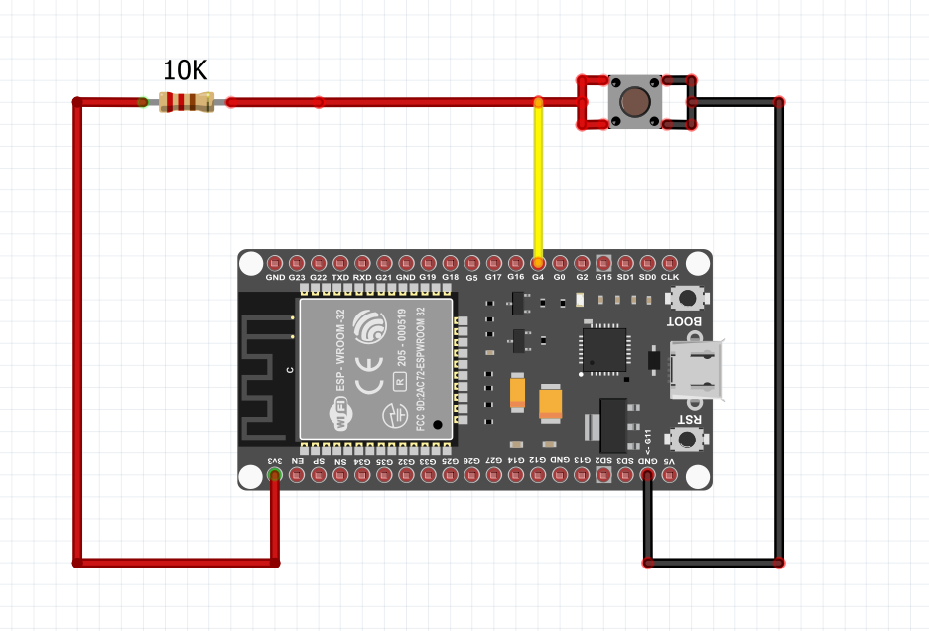

Important note regarding GPIOs:
All listed GPIOs are safe for production use and do not interfere with ESP32 boot or flashing behavior.

4. Power & Timing
- Expected input power during test:
3.3 V regulated supply, capable of handling ESP32 peak current (recommended ≥500 mA).
- Typical boot time:
Approximately 1–2 seconds from power-on to application start.

If you encounter any issues during the flashing process or have questions regarding the implementation, please feel free to reach out.

Best,
Alireza
M-Bytron Electronics Team

