

THE UNIVERSITY OF THE WEST INDIES

EXAMINATION OF APRIL - MAY 2007

Code and Name of Course: CS31A – Operating Systems Paper: B.Sc.

Date and Time: April 30, 2007 at 1:00 PM Duration: 2 hrs

INSTRUCTIONS TO CANDIDATES: This paper has 7 pages and 5 questions.
- Answer Questions 1 and 2 any other two (2) Questions.
- Show work where relevant.
- Calculators are allowed

SECTION 1 (COMPULSORY QUESTIONS)

QUESTION 1 (12 MARKS)

- State two goals that the designers of operating systems seek to meet and critically assess the achievement (or compromise) of each of these goals by the Windows 2000 operating system. [4]

- Write an algorithm to describe how the files in the /proc filesystem can be used to report information regarding the status of all active children of a specific process. Your algorithm should accept a single input being the process id of the process whose children are to be reported on. Please describe any data structures that your algorithm uses. [4]

- A System Administrator creates new user accounts with the new user’s first name as user id and the user’s last name as default password. For example, an account that is created for John Smith will have user id john and default password smith. Explain briefly why this practice poses a serious threat to system security and suggest an alternative approach that would lessen this threat. [4]

** End of Question 1 **

QUESTION 2 (12 MARKS)

The following C program is executed on a UNIX computer system as a foreground process. The shell from which the program is launched has process id 67. The program is run as a process with id 4578 and creates a child process with id 6766.

void main()
{
Message #1
pid_t forkvalue;

forkvalue = fork();
if (forkvalue == 0)
Message #2
{
printf(“My parent is %d\n”, getppid());
execl(….);
printf(“My process id is %d\n”, getpid());
}
else
Message #3
printf(“BLOP\n”);
}

- Drawing on your knowledge of concurrency in computer systems, explain why it is not possible to predict the order in which the labeled messages will be displayed when the program is run. [4]

- What text is displayed when the statement labeled Message #1 is executed
i. If Message #1 is displayed before Message #2? [1]
ii. If Message #2 is displayed before Message #1? [1]

- State one UNIX system call that can be used to ensure that the labeled messages are displayed in a specific order and describe how this system call would be used in the program above to achieve this objective. [3]

- State one condition that will cause Message #2 to be displayed when the program is run [1]

- How would the use of threads improve the performance of this program, if at all? [2]

** End of Question 2 **

END OF SECTION 1 (COMPULSORY QUESTIONS)
SECTION 2 (DO ANY 2 QUESTIONS)

QUESTION 3 (18 MARKS)

a. Given P₀←R₀, P₁→R₀, P₀→R₁ and P₁←R₁, where P_{i} represents process i and R_{j} represents resource j, draw the resource-allocation graph assuming one unit each of R₀ and R₁. Do we have deadlock? Why or why not? [4]

Please see Appendix A for the diagrams that are to be used in this part of the question.

Figure 2 (given in Appendix A) depicts the contents of selected i-nodes and data blocks for a filesystem. The filesystem has 10,000 blocks each of size 2KB. Block #1, and block #2 store the boot block, and super block respectively. 100 blocks are used for i-nodes. The rest of the blocks are used as data blocks.

Each i-node is 32 bytes and stores 10 addresses of length 2-bytes each, plus other file accounting information. There are eight direct addresses and two single indirect addresses in each i-node. An indirect block stores each address in a 16-bit word. What is the largest file that can be stored? What is the maximum number of files that can be created on this filesystem? [4] [2]

- Draw a directory tree showing the files and directories that are described by the data. [4]

- An active process is running in the directory whose i-node number is 876. Give two pathnames (one relative and the other absolute) that this process can use to reference the file whose i-node number is 12. [1]

- The file system consistency check utility reports that block #400 is a part of the free list. Is this an issue? If it is, state one action that can be taken to resolve the issue. [2]

v. Briefly discuss the likely impact on system performance that will result from using a smaller block size than that which is used by this filesystem at present. Specifically, how will such a change impact on disk utilization, storage capacity, and data transfer rate of the filesystem? [3]
** End of Question 3 **
QUESTION 4 (18 MARKS)

  - You will have encountered the use of bitmaps and linked lists for managing the allocation of memory (both secondary memory and primary memory). Discuss the use of these two structures with respect to space and time efficiencies. [4]

Please see Appendix B for the tables that are referred to in this part of the question.
b. The Translation Lookaside Buffer and Segment Table for an active process are shown in Figure 3 of Appendix B. The system has 16 page frames of 4KB each. Each process can have up to 4 segments of up to 8 pages each. Addresses are in the form (s, a) where a specifies an address in segment s.

- What is the size of the virtual address space of this computer? How many pages does the process described by the tables in Figure 3 occupy? [2]

- Using the information in Figure 3, calculate the physical address corresponding to the virtual address (0, 8200). [3]

- Explain what happens if the process attempts to write the value 0FF3C₁₆ to address (0, 1060). [1]

- Given that the TLB shown in Figure 3 uses FIFO replacement policy state which TLB entry will be replaced if a TLB miss occurs. Would the victim entry be the same under the LRU replacement policy? [2]

- Calculate the total time taken to access the word at address (3, 8200) if the access times for the TLB, primary memory, and secondary storage are 12ns, 30ns and 30ms respectively. You should assume that the segment table, and all page tables are loaded in memory and that no cache memory is being operated between primary memory and the processor. State all assumptions you make. [6]
** End of Question 4 **

QUESTION 5 (18 MARKS)

a. Table 1 (below) is a list of arrival times, and CPU burst times for four processes. The processes run on a computer system that schedules CPU time using a round robin scheduling algorithm with a quantum of 2 CPU cycles.

Process | Burst | Arrival time
P1 | 5 | 0
P2 | 3 | 2
P3 | 1 | 3
P4 | 1 | 6
Table 1: Processes

- Draw a Gantt Chart to depict scheduling of the CPU for these processes. State all assumptions you make. [4]

- Hence, or otherwise, determine the CPU utilization rate, and the average turnaround time for the running of these four processes. [4]

- Discuss how the results you have calculated in part ii would be affected if context-switching time of 1 CPU cycle is taken into consideration. [2]

b. A directory listing is shown in Figure 1 (below).
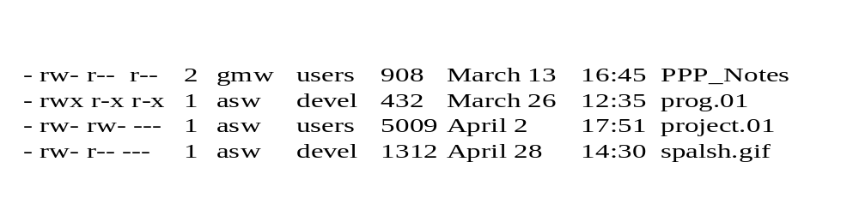
Figure 1: Directory Listing

- Represent the ownerships and permissions shown in the directory listing as an access matrix. Please note that asw is a member of two groups (users and devel) and that gmw is a member of only users. Treat each of the two users and two groups as a domain, so the matrix has four rows (one per domain), and four columns (one per file). [4]

- Represent the access matrix from part (i) as Access Control Lists. [4]

** End of Question 5 **

END OF SECTION 2

** END OF QUESTION PAPER **
Appendix A: Diagrams for Question 3

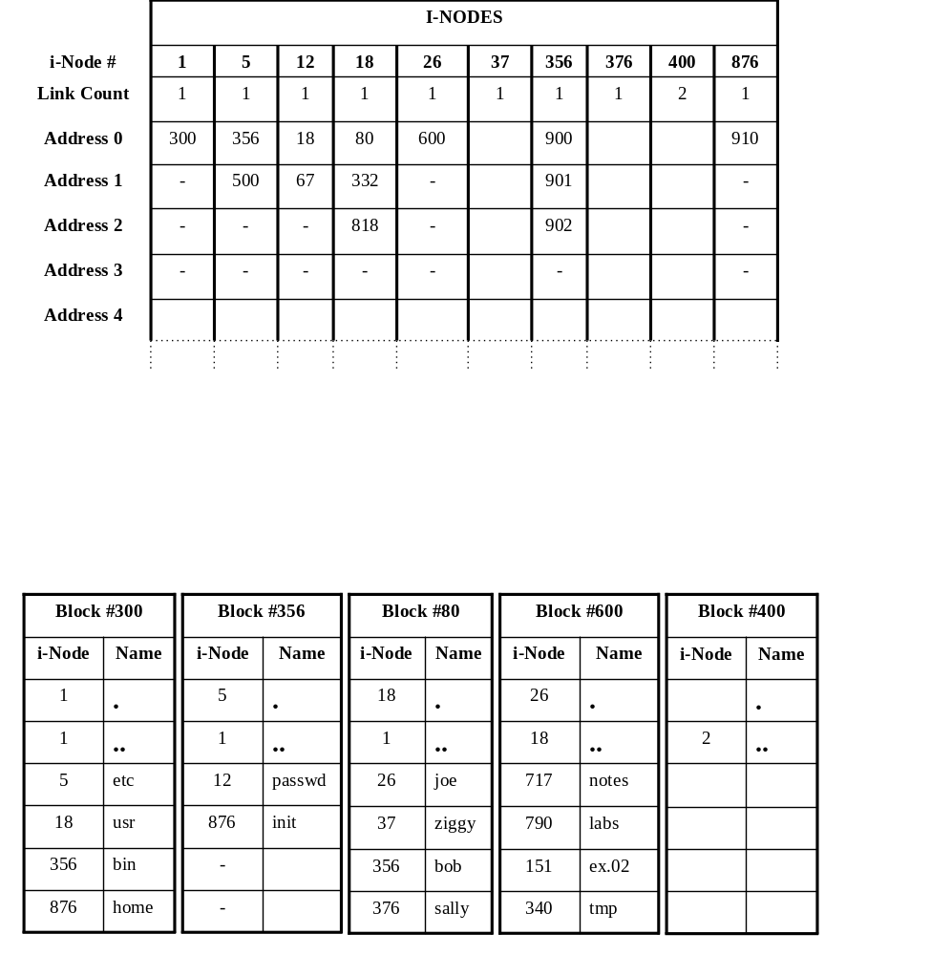
Figure 2: Selected i-nodes and data blocks of a filesystem

Please Note:

      - Only 4 of the 10 addresses that are stored in an i-node are shown.
      - A dash “-“ represents the null pointer.
      - Some blocks are not shown in the diagram

Appendix B: Diagrams for Question 4

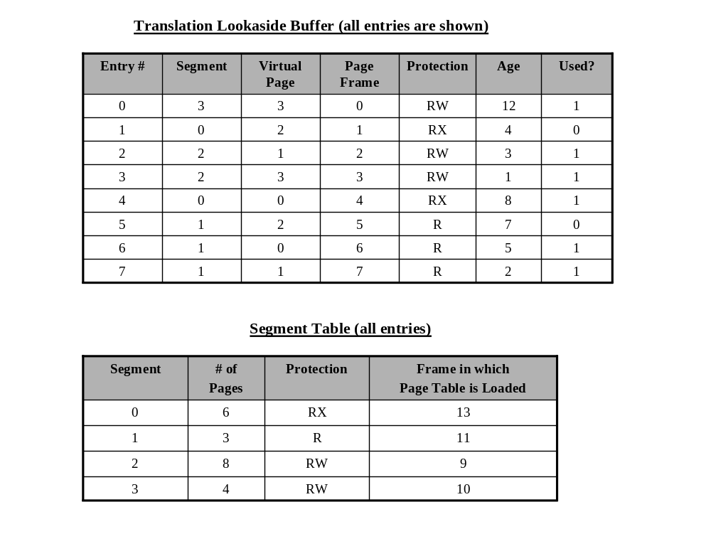
Figure 3: TLB And Segment Table for an active process

