|  |  |
| --- | --- |
| **Ex. No. 1** | **Design a Web Page using HTML** |
| **Date of Exercise** | 05/01/2021 |
| **Web Host Link** | https://25012002.000webhostapp.com/ex1.html |
| **YouTube Link** | https://youtu.be/-C-q4_Zwn7U |

**Aim**

**To Create a HTML web page for your Personal Profile that conforms to HTML features and has the following elements:** *doctype, html, meta (in the revised html5 format), title, head, body, div, p, headings, image, anchor, table, list, html comment .*

**Description**

The <title> tag defines the title of the document. The title must be text-only, and it is shown in the browser's title bar or in the page's tab.

The <head> element is a container for metadata (data about data) and is placed between the <html> tag and the <body> tag.

The <body> element contains all the contents of an HTML document, such as headings, paragraphs, images, hyperlinks, tables, lists, etc.

The <table> tag defines an HTML table.

An HTML table consists of one <table> element and one or more [<tr>](https://www.w3schools.com/tags/tag_tr.asp), [<th>](https://www.w3schools.com/tags/tag_th.asp), and [<td>](https://www.w3schools.com/tags/tag_td.asp) elements.

The <tr> element defines a table row, the <th> element defines a table header, and the <td> element defines a table cell.

The <a> tag defines a hyperlink, which is used to link from one page to another.

The most important attribute of the <a> element is the href attribute, which indicates the link's destination.

The <img> tag is used to embed an image in an HTML page.

Images are not technically inserted into a web page; images are linked to web pages. The <img> tag creates a holding space for the referenced image.

The <style> tag is used to define style information (CSS) for a document.

Inside the <style> element you specify how HTML elements should render in a browser.

**Program**

<!DOCTYPE html>

<html lang="en">

<head>

<meta charset="UTF-8">

<meta http-equiv="X-UA-Compatible" content="IE=edge">

<meta name="viewport" content="width=device-width, initial-scale=1.0">

<title>Ex-1</title>

</head>

<body style="background-color: rgb(238, 227, 228);">

<h1 align="center">My Resume</h1>

<table width="100%">

<tr>

<td width="20%"></td>

<td width="30%" style="font-size: 20px">

<strong>

kevin daniel<br>

200/A5,A.T.C NAGAR,PERYIYA PUDHUR<br>

Salem-6360012<br>

6382818342<br>

kevindaniel2002225@gmail.com<br>

</strong>

</td>

<td width="50%" align="center">

<img src="Images/kevin.JPG" width="200", height="250">

</td>

</td>

</table>

<hr>

<h2>Links</h2>

<table width="100%">

<tr>

<td>

<a href="#">my webiste</a>

</td>

<td>

<a href="https://www.karunya.edu/">My college</a>

</td>

<td>

<a href="mailto:kevindaniel200225@gmail.com">E-mail</a>

</td>

<td>

<a href="tel:6382818342">Phone no</a>

</td>

<td>

<a href="https://www.linkedin.com/in/kevindaniel25/">

<img src="Images/linkedin.png" width="100">

</a>

</td>

<td>

<a href="https://www.instagram.com/_.kevin_.william/">

<img src="Images/Instagram.jpg" width="100">

</a>

</td>

</tr>

</table>

<hr>

<h2 id="c1">Career objective</h2>

<p style="font-size: 15px;">

To work sincerely and be devoted towards my goal. Always trust the process I do

and do it with whole-hearted. To be a good performer overall.Always have the faith in the work I do. To be a team-worker and also be good in individual performance.

</p>

<hr>

<h2 id="a1">Academic Profile</h2>

<table border="1" width="100%">

<tr>

<th>Education</th>

<th>School/College</th>

<th>Percentage of marks</th>

<th>Year of passing</th>

</tr>

<tr>

<td>10th</td>

<td>SRK Matriculation Higher secondary</td>

<td>96%</td>

<td>2017</td>

</tr>

<tr>

<td>12th</td>

<td>SRK Matriculation Higher secondary</td>

<td>80%</td>

<td>2019</td>

</tr>

<tr>

<td>B.tech CSE</td>

<td>Karunya institute of technology and sciences</td>

<td>70%</td>

<td>2023</td>

</tr>

</table>

<hr>

<h2 id="t1">Technical Skills</h2>

<ul>

<li>Python</li>

<li>C++</li>

<li>DBMS</li>

<li>HTML</li>

<li>CSS</li>

<li>JavaScript</li>

</ul>

<hr>

<h2 id="c2">Certifications</h2>

<p>Bootcamp in Udmey: Python</p>

<a href="https://www.linkedin.com/posts/kevindaniel25_udemy-course-completion-certificate-activity-6849645686926008320-NRsk">link</a>

<p>Networking essentials in CISCO</p>

<a href="https://www.credly.com/badges/09b76a65-4286-42e0-90e6-bb5c15489287?source=linked_in_profile">link</a>

<hr>

<h2 id="p1">Project</h2>

<p>This is a mini project of a simple music player created using HTML,CSS,JavaScript</p>

<a href="https://25012002.000webhostapp.com/">Music player link</a>

<hr>

<table border="1" width="100%">

<tr style="background-color: yellow;">

<th colspan="10">TIME TABLE</th>

</tr>

<tr style="background-color: blue;">

<th>Day</th>

<th>hour 1</th>

<th>hour 2</th>

<th>hour 3</th>

<th>hour 4</th>

<th>hour 5</th>

<th>hour 6</th>

<th>hour 7</th>

<th>hour 8</th>

<th>hour 9</th>

</tr>

<tr>

<th style="background-color: brown;">Monday</th>

<td rowspan="5" style="background-color: green;">Assembly</td>

<td>subject 1</td>

<td colspan="3" align="center" style="background-color: gray;">lab-1</td>

<td rowspan="5" style="background-color: gold;">Lunch</td>

<td>subject-3</td>

<td>subject-4</td>

<td></td>

</tr>

<tr>

<th style="background-color: brown;">Tuesday</th>

<td>subject-4</td>

<td>subject-2</td>

<td>library</td>

<td></td>

<td>subject-1</td>

<td>subject-3</td>

<td></td>

</tr>

<tr>

<th style="background-color: brown;">wednesday</th>

<td>subject-3</td>

<td></td>

<td>subject-2</td>

<td>subject1</td>

<td colspan="3" align="center" style="background-color:darkblue;">placement-training</td>

</tr>

<tr>

<th style="background-color: brown;">Thursday</th>

<td>subject-2</td>

<td>subject-1</td>

<td></td>

<td>subject4</td>

<td>subject-3</td>

<td></td>

<td>library</td>

</tr>

<tr>

<th style="background-color: brown;">friday</th>

<td>subject-1</td>

<td>subject-2</td>

<td></td>

<td>subject-4</td>

<td colspan="3" align="center" style="background-color: gray;">Lab-2</td>

</tr>

</table>

<hr>

<h2>Photo Gallery</h2>

<img src="Images/leo-messi-balon.jpg" width="33%" height="275px">

<img src="Images/neymar.jpg" width="33%">

<img src="Images/messi-neymar.jpg" width="33%">

<br>

<hr>

<table width="100%">

<tr>

<td><a href="#c1">Career objective</a></td>

<td> <a href="#a1">Academic Profile</a></td>

<td><a href="#t1">Technical Skills</a></td>

<td><a href="#c2">Certifications</a></td>

<td><a href="#p1">Project</a></td>

</tr>

</table>

<hr>

</body>

</html>

**Output**

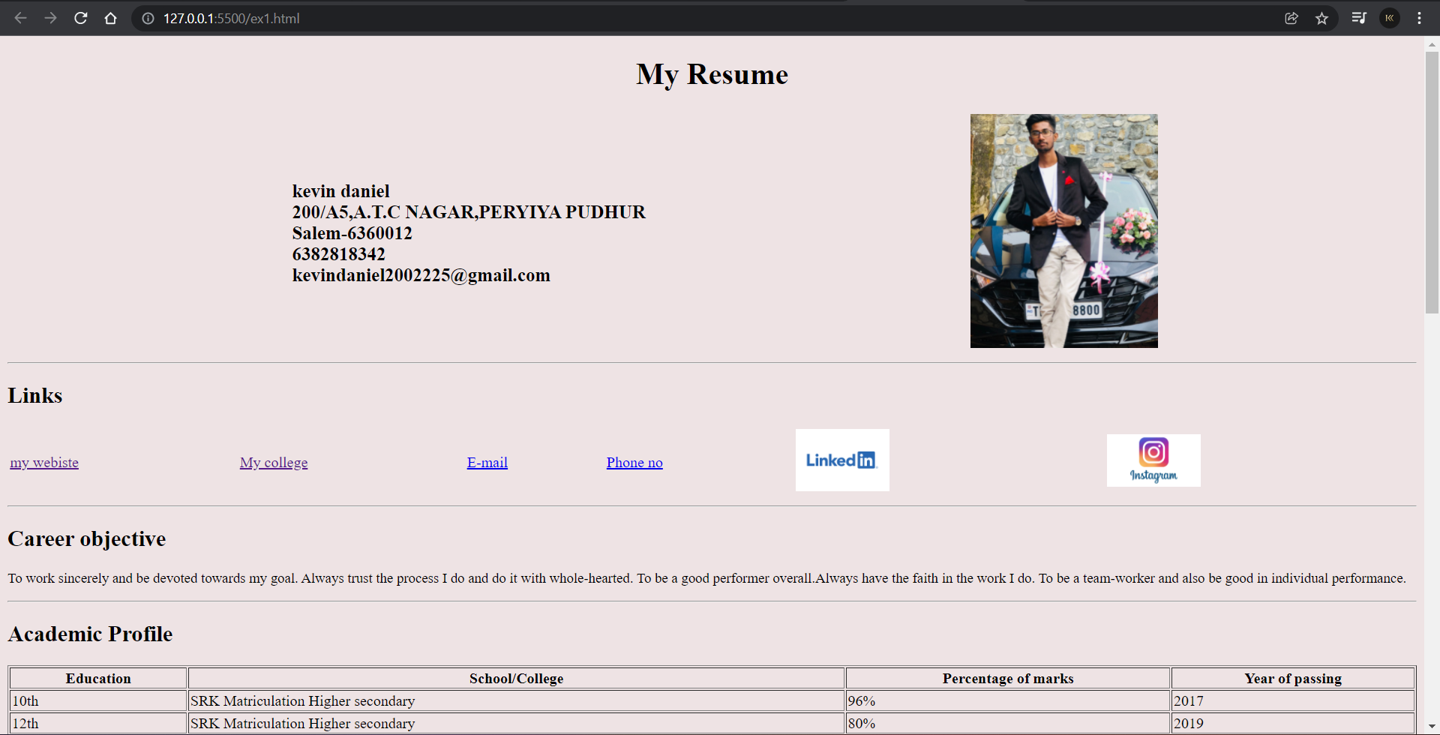

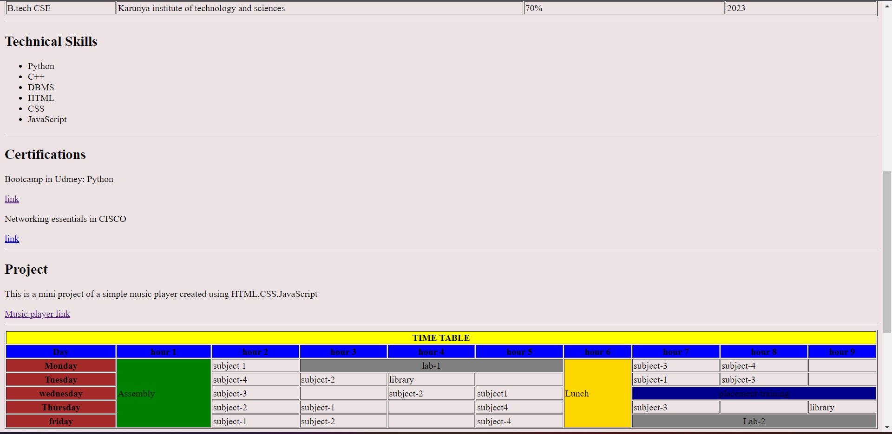

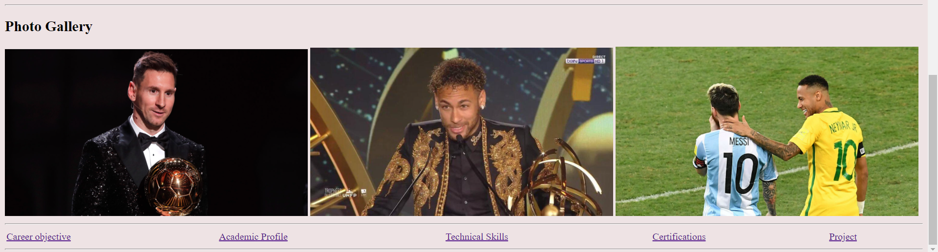

**Result**

The webpage is successfully created.