1811ICT/2807ICT/7001ICT Programming Principles Workshop 4

School of Information and Communication Technology

Griffith University

Ghadeer Alkhunaizi

|  |  |
| --- | --- |
| Goals | In this workshop we create interactive scripts that make decisions and/or loop. |
| When | Week 5 |
| Marks | 2 |
| Due | Workshop programming problems by 11:59pm on 16 April |

# Before your workshop class:

* Read all of this document.
* Review the lecture notes sections 1 to 13.
* **Complete the pre-workshop questions posted on the course website**.

# Workshop activities

At any stage, when you are stuck, *ask your tutor*!

## Problem 1

*Problem:* Write a program that reads whole numbers typed by the user until a zero is entered, then prints the number of positive numbers that were entered. Sample run:

Enter a number: 3

Enter a number: -2

Enter a number: 5

Enter a number: 6

Enter a number: -100

Enter a number: 70

Enter a number: 22

Enter a number: 68

Enter a number: 0   
6 positive numbers were entered.

*Answer*: Copy your code in the space given below and insert screenshots of your program output for two scenarios of your own choosing.

***Copy your code here***

*#Enter a number: 3*

*#Enter a number: -2*

*#Enter a number: 5*

*#Enter a number: 6*

*#Enter a number: -100*

*#Enter a number: 70*

*#Enter a number: 22*

*#Enter a number: 68*

*#Enter a number: 0*

*#6 positive numbers were entered.*

*#1. get the first sentinel*

*#2. test the sentinel*

*#3. refresh the sentinel*

*positive_number = 0*

*aNum = 1*

*aNum = int(input("Enter a number: "))*

*while aNum != 0:*

*print(aNum)*

*aNum = int(input("Enter a number: "))*

*if aNum > 0:*

*positive_number += 1*

*elif aNum < 0:*

*positive_number += 0*

*print(positive_number ,"positive number Were entered.")*

***Insert your screenshots here***

## Problem 2

*Problem:* In mathematics, the Fibonacci sequence is defined such that each Fibonacci number is the sum of the two preceding ones, starting from 0 and 1. That is, F1 = 0, F2 = 1, F3 = 1, F4 = 2, ..., Fn = F(n-1) + F(n-2). Write a program that given an input n, outputs the first n Fibonacci numbers. The format of output is that at most 4 numbers can be displayed in a row. Sample run:

|  |
| --- |
| Enter a positive number: 6  0 1 1 2  3 5  Enter a positive number: 10  0 1 1 2  3 5 8 13  21 34 |

*Answer*: Copy your code in the space given below and insert screenshots of your program output for the following two scenarios:

* Enter a positive number: 8
* Enter a positive number: 15

***Copy your code here***

*num = int(input("how many to print: "))*

*if num < 1:*

*print("Invalid entry, try again")*

*num = int(input("How many to print: "))*

*fib1 = 0*

*fib2 = 1*

*print_Fib = fib1 + fib2*

*count = 0*

*if num == 1:*

*print(fib1)*

*elif num == 2:*

*print(fib1, fib2)*

*else:*

*for i in range(0, num):*

*print_Fib = fib1 + fib2*

*print(fib1, fib2, print_Fib)*

*print(fib1, end=" , ")*

*count = 3*

*if count == 4:*

*print()*

*count = 0*

***Insert your screenshots here***

## Problem 3

*Problem:* Given an input number n, print a diamond shape with 2*n-1 rows.

Sample run:

|  |
| --- |
| Enter a positive number: 3  xxx  xxxx  xxxxx  xxxx  xxx |

*Answer*: Copy your code in the space given below and insert screenshots of your program output for the following two scenarios:

* Enter a positive number: 1
* Enter a positive number: 5

*a = int(input("Enter a positive number:"))*

*b = a*

*c = a*

*for i in range(1, a + 1):*

*print(" "*(b-1), "*"*(2*i-1))*

*b -= 1*

*if i == a:*

*for y in range(1, a):*

*print(" " * y, "*" * (2 * c - 3))*

*c-=1*

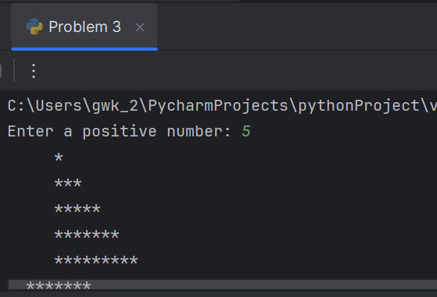

## Problem 4 (Optional, 1811ICT students are strongly encouraged to try)

*Problem:* A palindrome is a number or a text phrase that reads the same backwards as well as forwards. Examples of palindromes are 123321, 1234321, 55555, 22, 454, 1, 0. Write a program that reads in a positive integer number, and prints out whether or not that number is a palindrome. Sample run:

Enter a positive number: 12321

12321 is a palindrome

Enter a positive number: 1234

1234 is not a palindrome

*Answer*: Copy your code in the space given below and insert screenshots of your program output for the following two scenarios:

* Enter a positive number: 345543
* Enter a positive number: 92321

# Submission and marking

Please submit this document with copied codes and inserted screenshots using the provided submission link in the course website. Students get 2 marks if they complete two or more problems correctly, or 1 mark if they complete one problem correctly, or 0 marks without any attempt.