Cloud-Based Big Data Analytics: Sentiment Analysis of Amazon Customer Reviews using AWS EMR, Hadoop, and Spark

1.0 Introduction and Business Context

1.1 Problem Statement: E-commerce Customer Insights
E-commerce websites today have been ticking time bombs of unstructured content that comes in the shape of product reviews. The sample size of this project is 10GB of 48,326,944 Amazon customer reviews. The volume, velocity, and unstructured nature of this type of data are significant challenges in processing such data. The main issue is to convert the unstructured textual reviews into structured business intelligence that can provide customer sentiment, product performance, and new trends in the market on a large scale.

1.2 Business Requirement of Big Data Analytics.
Traditional data processing tools are not designed to handle datasets containing tens of millions of records. The businesses thus need scalable big data tools that can perform distributed processing, real-time analytics, and machine learning. Hadoop and Spark are some of the platforms that help organizations analyse massive amounts of customer feedback. These features directly aid strategic business choices in the control of inventory, product development, and optimisation of marketing and customer relationship management.

1.3 The Amazon Dilemma: Learning Customer Sentiment Scaling.
In the case of a large-scale platform like Amazon, the key issue is to design systems that can analyse millions of reviews made by customers effectively. This involves the calculation of simple metrics like rating distributions and also sentiment analysis of text in reviews, which is a complex task. In this study, the insights into more than 48 million reviews were mined with the help of distributed structures, and it proved that scalable systems can reveal previously unnoticed patterns of customer feedback and correlations between this feedback and purchase behaviour and time trends.

1.4 Value Proposition: Can Analytics Drive Business Decisions?
An effective big data analytics pipeline helps organisations to take data-driven business decisions. Companies can optimise their recommendation systems and marketing plans by discovering the products that perform well, finding out the issues that customers have repeated, and knowing what motivates positive reviews. The knowledge obtained with the help of this analysis contributes to negotiation with suppliers, specific promotion, and improved services, which leads to better customer satisfaction and increased revenues.

1.5 Selected Data: Amazon Customer Reviews 2023 (10GB+)
The dataset used in this project is Amazon Reviews 2023, provided by McAuley Lab. Although some of the data amount to more than 571 million reviews, the research used a 10GB sample of 48,326,944 reviews. The dataset has rich variables like the rating of stars, review text, helpful votes, reviewed products, times, and product identifiers. Such a structure allows statistical analysis as well as more sophisticated sentiment modelling using text.
1.6 Dataset Justification and Business Relevance
The dataset was chosen because of its realistic scale, diversity, and business relevance. Evaluation of tens of millions of actual customer reviews will offer practical experience of managing the problems of volume and variety that come with big data. The lessons learned with the help of this dataset can be directly applied to the functioning of real-life e-commerce, such as dynamic pricing, inventory management, custom stationery marketing, and strategic business forecasting.

3.0 Cloud Environment Setup

3.1 Platform Selection: AWS EMR Justification
Amazon Elastic MapReduce (EMR) was chosen as the cloud data store of this big data analytics project because of the managed Hadoop ecosystem, Hadoop ecosystem integration with Amazon S3, and cost efficiency. EMR contains an entirely configured environment with Apache Hadoop, Spark, Hive, and JupyterHub already installed, and the complexity of setting up is greatly minimized. The fact that the platform automatically provisions, manages, and scales clusters makes it suitable to handle large datasets such as the 10GB+ Amazon reviews data, and the pay-as-you-go pricing model makes it fit the academic need and budget constraints of the project.
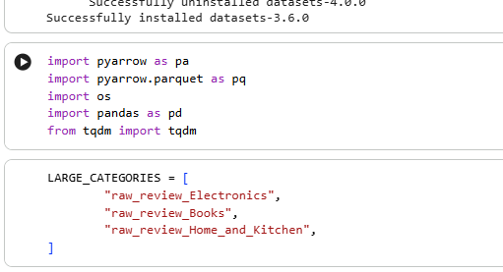
Figure 1: Selected Amazon Review Categories for Dataset Creation

3.2 AWS Architecture Design
The big data processing architecture on AWS has major elements that consist of the Amazon S3, which supports scalable storage, EMR, the distributed data processing, and IAM, the secure access control. The transfer of data in S3 to the HDFS in the EMR cluster would be processed, and the results would be saved in S3. One VPC will be used, with the correct subnets and security groups to isolate the analytics environment and allow access by external means to the management and to transfer data.
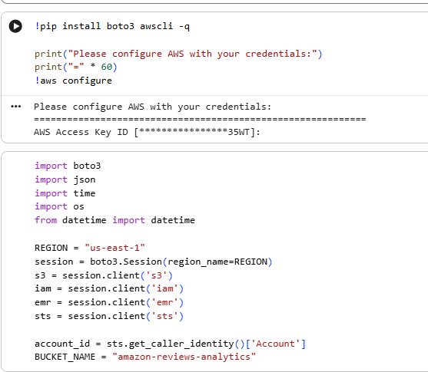
Figure 2: AWS Service Configuration for Big Data Pipeline

3.3 EMR Cluster Configuration

3.3.1 Instance Types Selection (m5.xlarge, m5.2xlarge)
The cluster uses the heterogeneous instance configuration to strike a balance between costs and performance. The central node will be an m5.xlarge (4 vCPUs, 16GB RAM) coordination node and service-intensive applications, such as JupyterHub and Spark. Data processing and effective in-memory Spark computations are conducted using central nodes that are based on m5.2xlarge instances (8 vCPUs, 32GB RAM), which were selected in the previous vCPU quota limits that helped in the management of cloud resources.
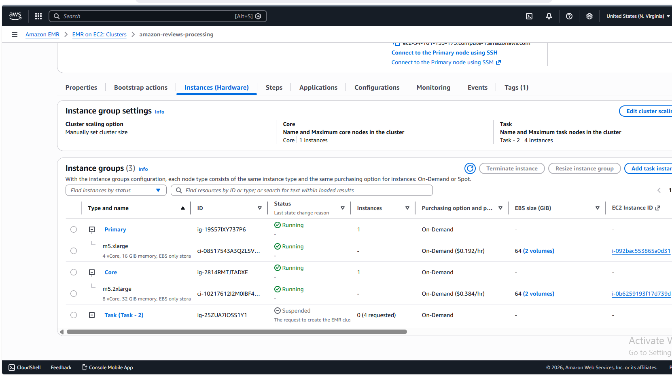
Figure 3: EMR Cluster Instance Groups and Hardware Configuration Overview

3.3.2 Scaling Strategy and Cost Optimization
This project used a fixed cluster size to provide a consistent performance in the course of the analysis. The cluster is comprised of a single central node and a single core node, where task nodes are inactive because of the limitation of the vCPU quota. The cost optimization techniques are to allow an automatic termination of one-hour idle time to avoid unnecessary charges, use On-Demand instances for predictable billing, and redirect all the logs to S3 to ensure they can be audited without paying any extra charges to storage.

3.3.3 Bootstrap Actions for Python Libraries
An action script (bootstrappythonlibs.sh) that was a custom bootstrap was used to install required Python modules in all the nodes of the cluster. This script will install NumPy, Pandas, Matplotlib, Scikit-learn, and NLTK libraries that will be needed to perform data analysis and machine learning assignments. The bootstrap operation is used to make sure that the software environments are consistent across all of the nodes, so that one can run distributed processing with the MLib sub-set of Spark and can efficiently execute PySpark scripts without dependency failures.

3.4 Security Configuration

3.4.1 IAM Roles and Policies
Two IAM roles were set in accordance with the least privilege concept. The AmazonEMR-ServiceRole enables the EMR to make requests to other AWS services on behalf of the user, and the AmazonEMR- Instance Profile gives EC2 instances the privileges to access S3 buckets to ingest data and store logs. These controlled roles comprise required access control to S3 read/write operations, CloudWatch logs, and cluster administration without providing excessive access privileges.
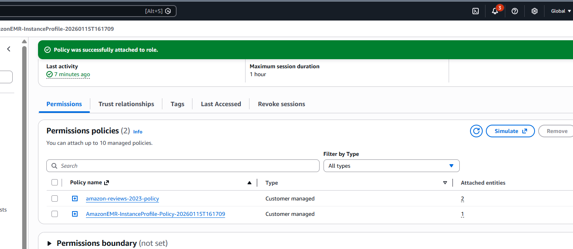
Figure 4: IAM Roles Configuration for EMR Cluster Security

3.4.2 Security Groups and Network Configuration
The cluster was configured in a special vPC (vpc-0af2d16ac5b037fb1) and subnet subnet-023fc498d15aac4e2 in the us-east-1a zone. There were security groups that permitted SSH access (port 22) to authorized IP addresses to enable administrators access and application UIs needed to access ports ( HDFS NameNode 9870, Resource Manager 8088, Spark History Server 18080, JupyterHub 9443). The EC2 key pair reviews-analytics-key allows the authentication of SSH connections to nodes in the clusters.
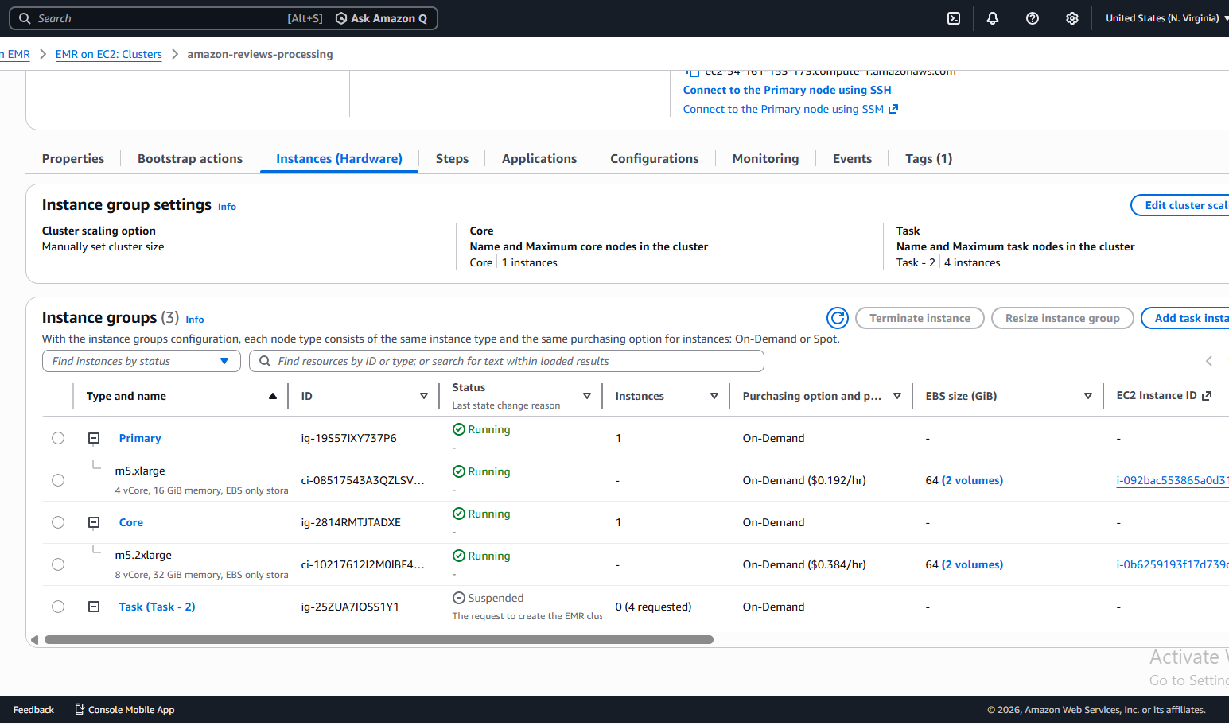
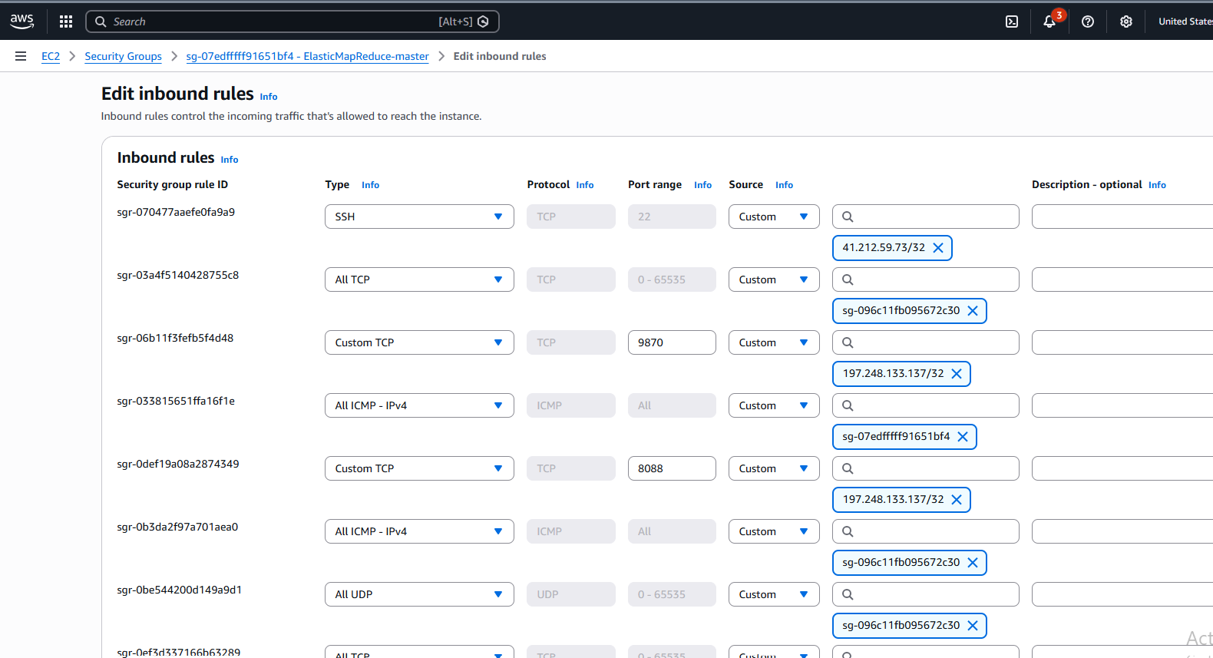
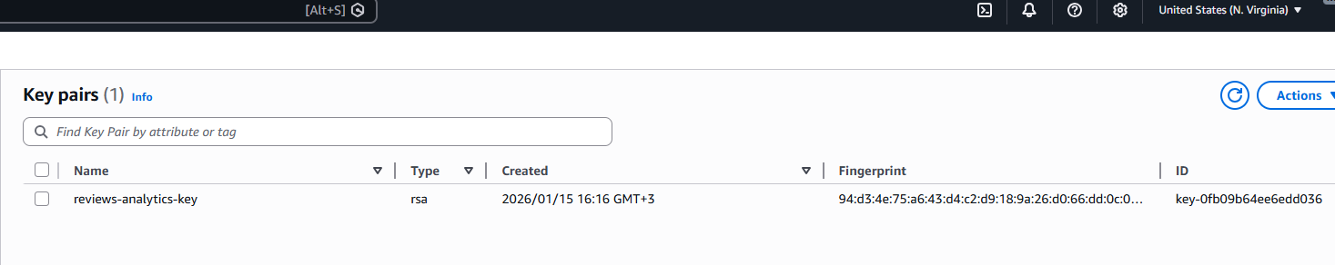
Figure 5: Security Group Configuration with Application Port Access

3.5 Data Ingestion Process

3.5.1 S3 to HDFS Pipeline
The data of 10GB of Amazon reviews in the Parquet format is loaded to the S3 bucket amazon-reviews-analytics in the raw-data/ prefix. Internally to the EMR cluster, ingesting data into HDFS was done by the hdfs dfs -cp command, which effectively copies data off of S3 to the distributed file system on the cluster. This method uses optimized S3 integration of EMR and still retains data locality to be processed.
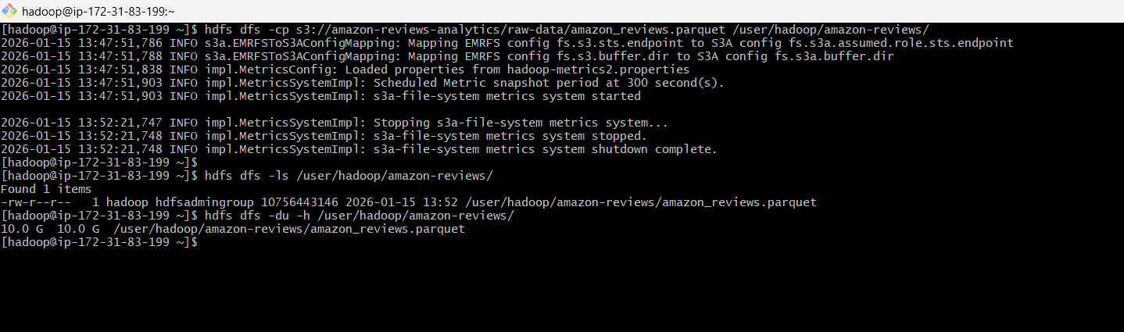
Figure 6: Copying Amazon Reviews Parquet File from S3 to HDFS and Verifying Storage

3.5.2 Parquet Format Justification
Parquet columnar storage format was chosen due to its compression performance and the benefits of query performance. As compared to standard formats such as CSV or JSON, Parquet can store data at about 75 times less while allowing predicate pushdown and column drop when running a query. This structure is especially beneficial to Spark processing, since it corresponds to the optimization of structured data analytics of the framework.
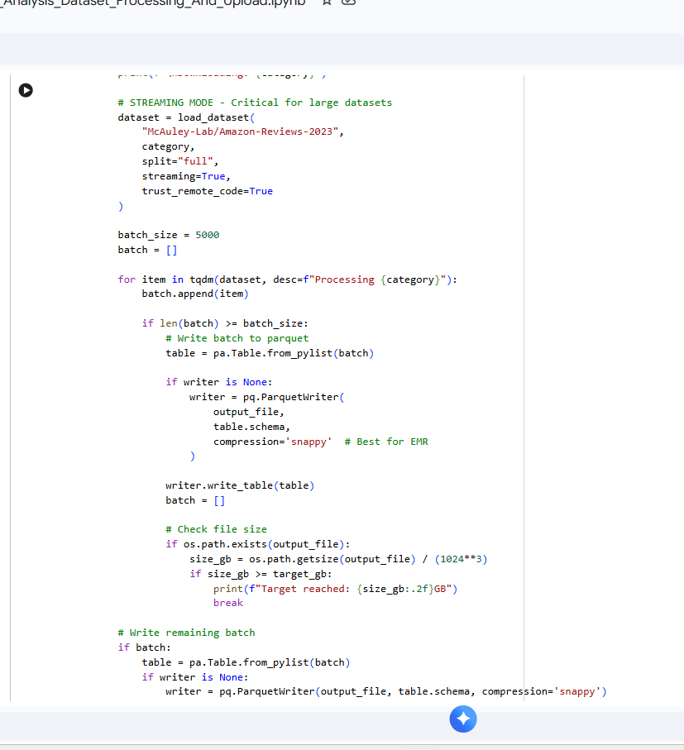
Figure 7:Streaming Amazon Reviews Dataset and Writing Batches to Parquet Format

3.5.3 Data Distribution Across Nodes
When ingested, HDFS automatically allocates data blocks among the available core nodes and is configured by default to replicate at a factor of 3. This distribution provides locality of the data when processing to reduce the network transfer overhead when the executors of Spark are sourcing data on the same physical machines. The data was divided into 128MB blocks, and thus the 10GB data was distributed in 128MB blocks, which were evenly spread over the storage capacity of the cluster.

3.6 Cost Management and Monitoring Setup
Several cost management mechanisms were implemented, including automatic cluster termination after one hour of idle time and the selection of cost-performance efficient instance types (m5.xlarge for master and m5.2xlarge for core nodes). S3 logging was consolidated to reduce storage costs, and native CloudWatch integration enabled real-time monitoring of cluster metrics, such as CPU utilization (65-85% during processing), HDFS storage distribution, and Yarn application performance metrics (vCore and memory allocation). Operating logs were automatically stored in S3 for auditing, debugging, and compliance purposes. The pricing model follows AWS EMR's transparent pricing structure, covering EC2 instance costs, EMR software charges, and S3 storage/transfer costs. Based on the current us-east-1 pricing:
Instance Costs (On-Demand):
- Master Node: m5.xlarge = $0.192/hour
- Core Nodes: m5.2xlarge = $0.384/hour (1 node)
EMR Software Fees:
- $0.108 per instance hour (for software including Hadoop, Spark, Hive, etc.)
Estimated Hourly Cost Calculation:
- Master Node: ($0.192 + $0.108) = $0.300/hour
- Core Node: ($0.384 + $0.108) = $0.492/hour
- Total Hourly: $0.300 + $0.492 = $0.792/hour
Total Project Cost Projection:
For a 3-hour analytical workflow:
- Compute Cost: $0.792 × 3 hours = $2.38
- S3 Storage: ~10GB × $0.023/GB-month (pro-rated) = $0.002
- Data Transfer: Minimal (within AWS) = $0.00
- Total Estimated: $2.38 (well under $5.00 budget)

4.0 Hadoop MapReduce Implementation

4.1 MapReduce Design Philosophy
In this section, the application of Hadoop MapReduce on the analysis of Amazon customer reviews on a large scale is demonstrated. Two activities of analytic analysis were carried out, which included rating distribution analysis and word frequency computation. Hadoop streaming was employed to facilitate Python-based mapper and reducer functions to analyse more than 48 million review records that were available in HDFS.

4.1 MapReduce Design Philosophy
The MapReduce programming paradigm is based on a distributed processing model in which computation is divided into two significant parts. Another key aspect is the distributed processing paradigm, which breaks down calculation into two parts: mapping and reducing. The mapper works on the raw records of input and gives out the intermediate pairs of key-value records, whereas the reducer takes the sum of values with a given key to give out the final results. This architecture is scalable, fault-tolerant, and provides effective parallel processing among cluster nodes. Hadoop streaming was also used to enable the Python scripts to be used as mapper and reducer programs, so that they could be developed quickly and be flexible.

4.2 Mapper Implementation
Two mapper applications were put into place to aid various analytical goals:

4.2.1 mapper_rating.py
This mapper reads review records that are in the form of JSON and isolates the rating field. Every rating value is released as a key with a count of one. This makes the data ready to be aggregated during the reducer stage to calculate the frequency distribution of ratings.
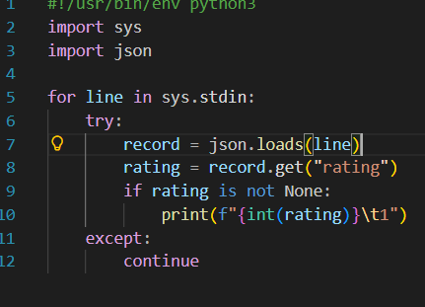
Figure 8: mapper_rating.py

4.2.2 mapper_wordcount.py
The text of the review under consideration is processed by this mapper, which transforms it into lowercase, eliminates punctuation, and then divides it into separate words. All the words are emitted as keys having a count of one. This allows the frequency of words in large volumes of millions of reviews to be analysed.
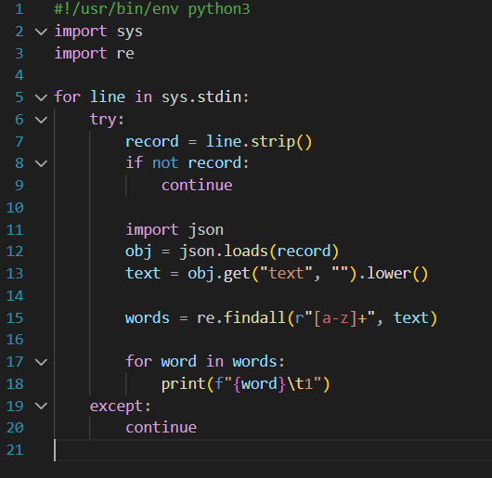
Figure 9: mapper_wordcount.py

4.3 Implementation of Reducers

4.3.1 reducer_rating.py
The reducer sums up all values that are related to every key rating. It adds the counts to obtain the total number of occurrences in each level of rating (1-5 stars).
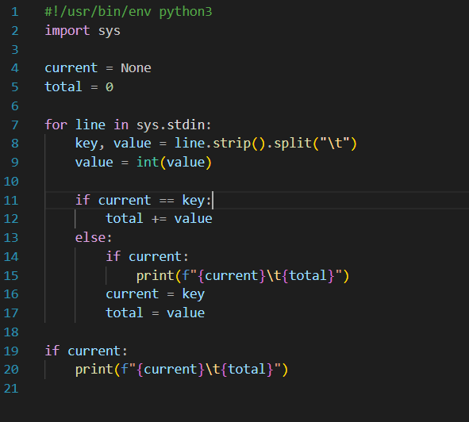
Figure 10: reducer_rating.py

4.3.2 reducer_wordcount.py
This one combines the number of words that the mapper emits. The last result is the frequency of each word in the whole set of data, which allows us to determine the most frequently used words in the reviews left by the customers.
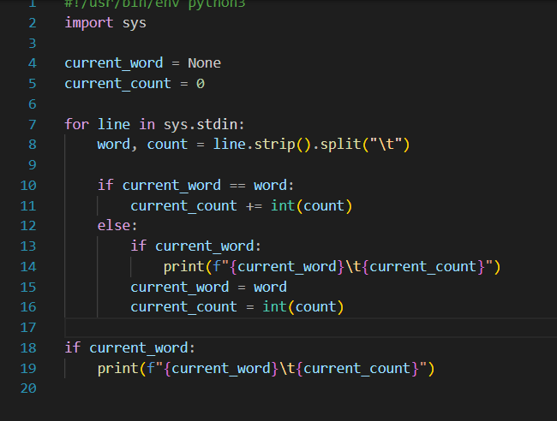
Figure 11: reducer_wordcount.py

4.4 Job Submission to YARN
MapReduce jobs were submitted using Hadoop Streaming with YARN as the resource manager. The following command structure was used:
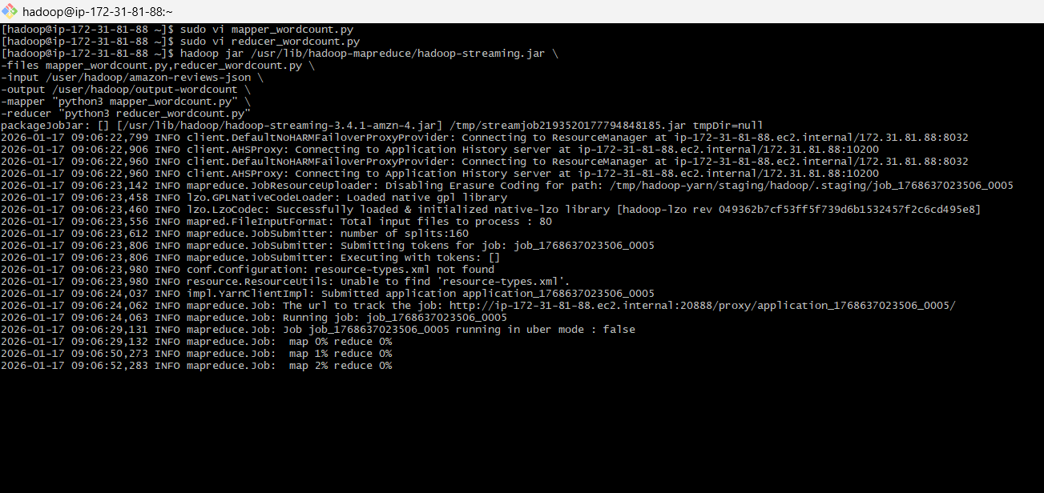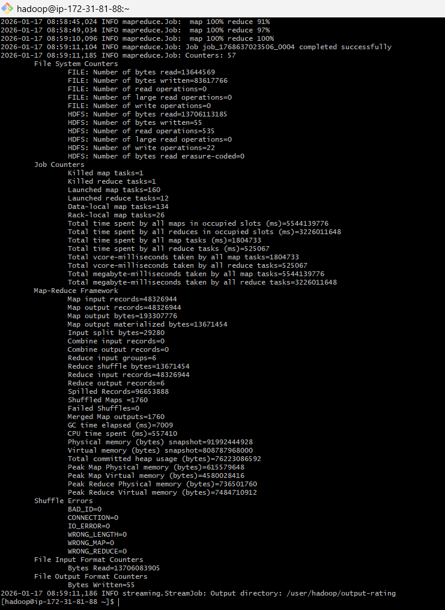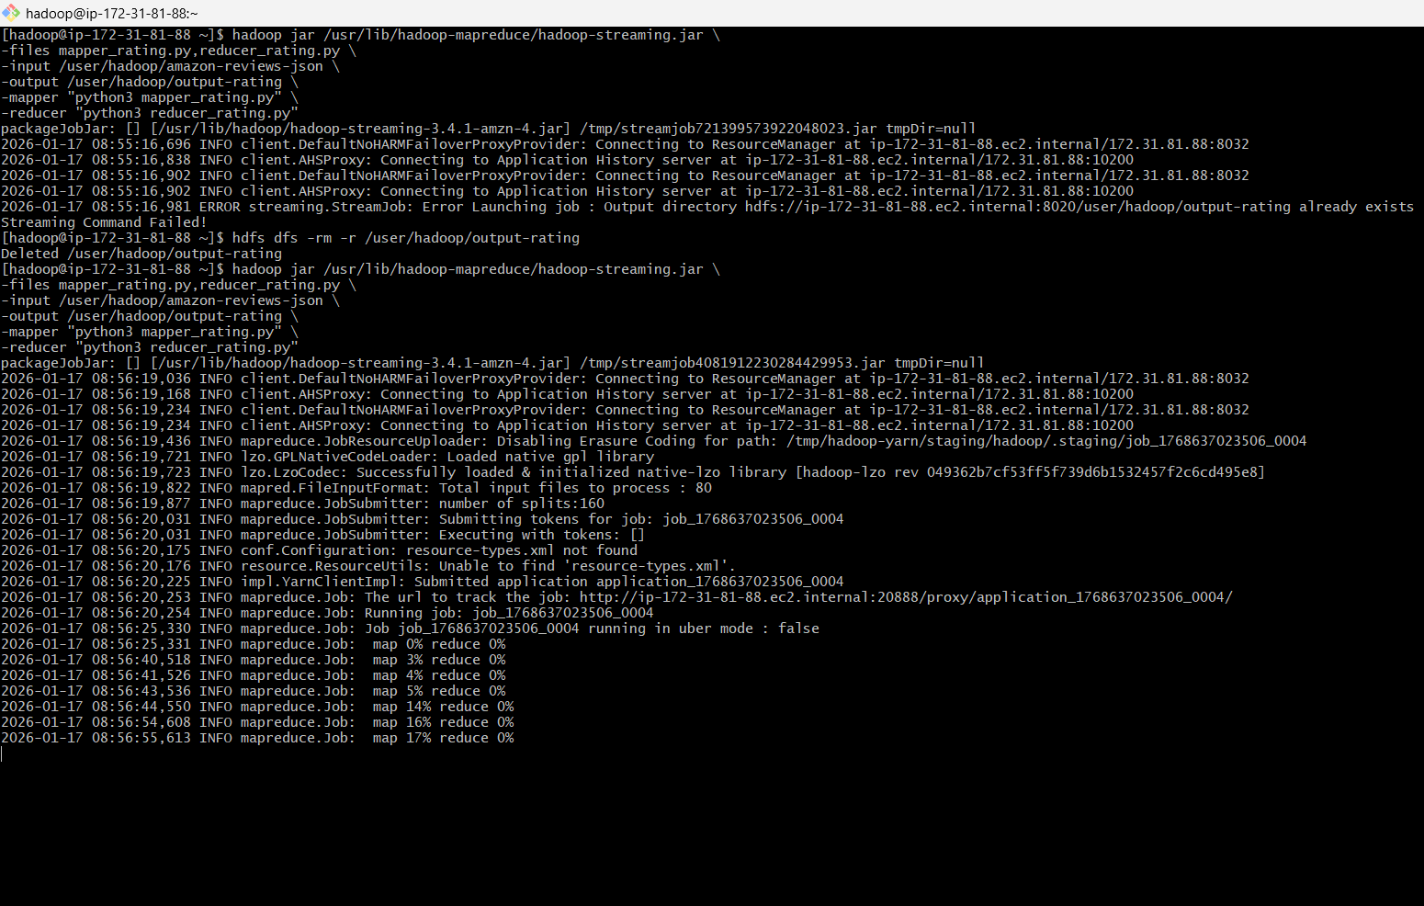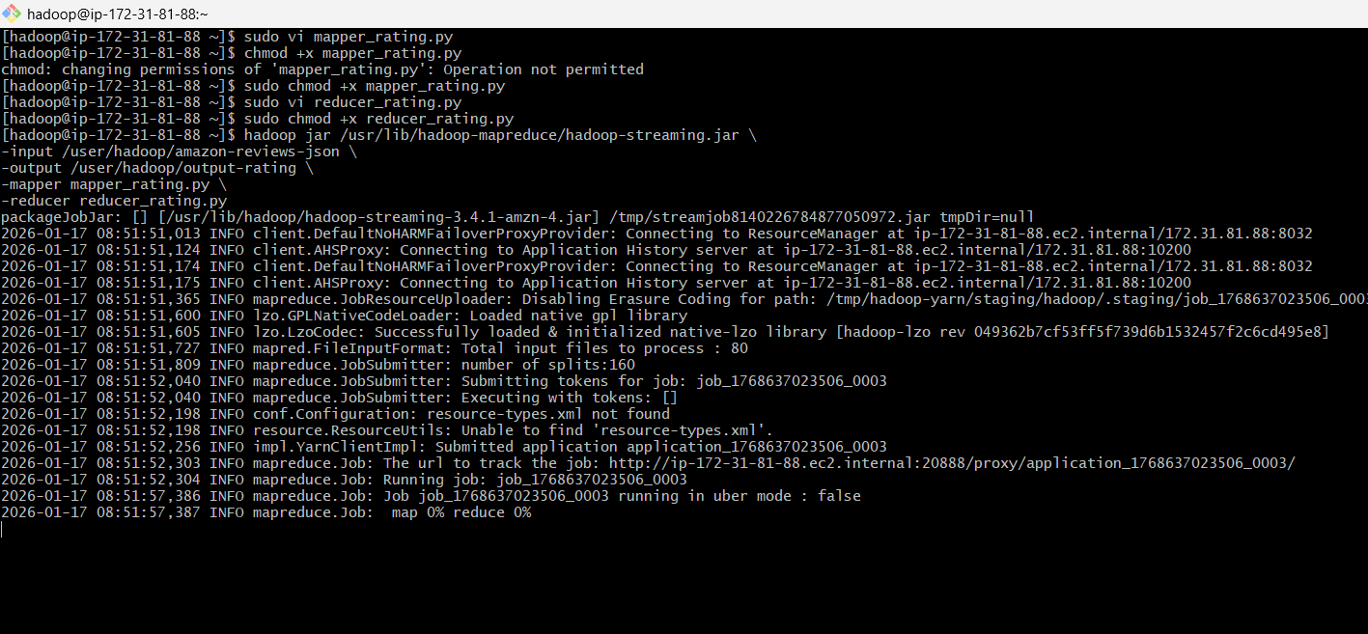
Figure 12: Hadoop Streaming Job Execution for MapReduce Rating Analysis
This configuration ensured the Python scripts were distributed to all worker nodes. YARN dynamically allocated resources and monitored job execution across the cluster.

4.5 MapReduce Results Analysis

4.5.1 Rating Distribution Output
The rating distribution analysis processed 48,326,944 reviews. The output revealed:
- 5-star reviews: 30,840,016
- 4-star reviews: 6,305,323
- 3-star reviews: 3,238,783
- 2-star reviews: 2,422,773
- 1-star reviews: 5,520,043
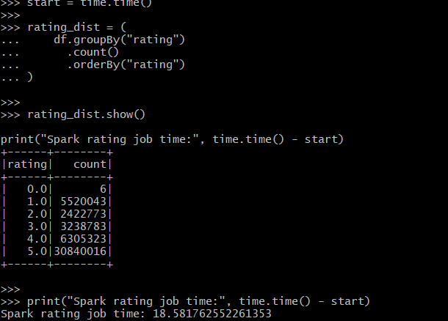
Figure 13: PySpark Rating Distribution Analysis Results
This indicates a strong positive sentiment bias, with over 63% of reviews rated 5 stars.

4.5.2 Word Frequency Patterns
The word count job analysed over 2.3 billion tokens extracted from review text. The most frequent words included:
- "the" – 113,705,086
- "i" – 74,331,325
- "and" – 65,372,390
- "to" – 62,624,968
- "it" – 60,697,029
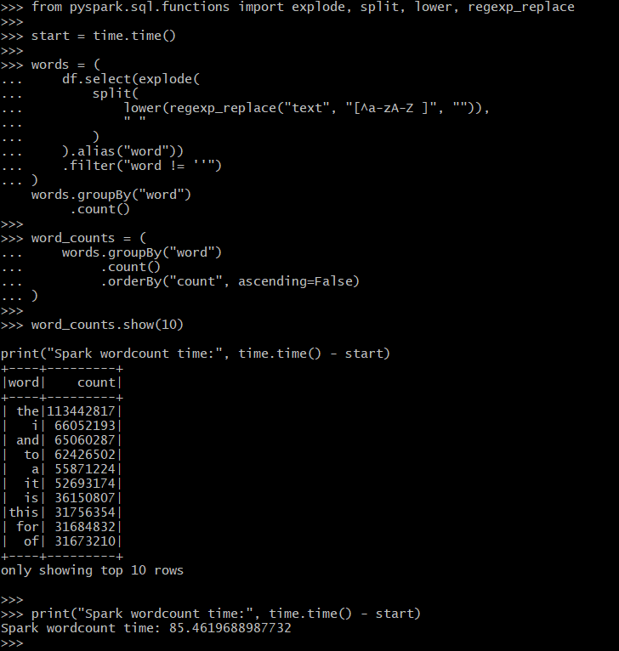
Figure 14: PySpark Word Count Analysis Performance Results
These results confirm expected linguistic patterns in natural language data.

4.5.3 Performance Metrics
The MapReduce jobs processed approximately 13.7GB of input data. Key performance metrics recorded:
- Map tasks launched: 160
- Reduce tasks launched: 12
- Total execution time: ~9 minutes
- Data locality: 84% local processing
- Shuffle size: 1.11GB

These metrics demonstrate efficient parallel execution and resource utilisation.

5.0 Apache Spark Implementation

5.1 Spark Architecture and Advantages
Apache Spark is a high-performance, large-scale analytics engine based on a distributed data processing engine. It uses an in-memory calculation model that is faster because there is little I/O overhead reduction in the disk storage model used in Hadoop MapReduce. The architecture of Spark assumes a driver-executor model, managing activities among worker nodes. It can serve many data processing models, such as batch processing, SQL querying, machine learning, and streaming analytics, which can reuse data in several analytical tasks without having to access the disk again. This project shows that Spark is more efficient and productive for the developer.

5.2 Data Loading and Schema Exploration
The processed Parquet dataset stored in HDFS was loaded into Spark using the DataFrame API. The Parquet format enables column pruning and predicate pushdown, improving query performance.
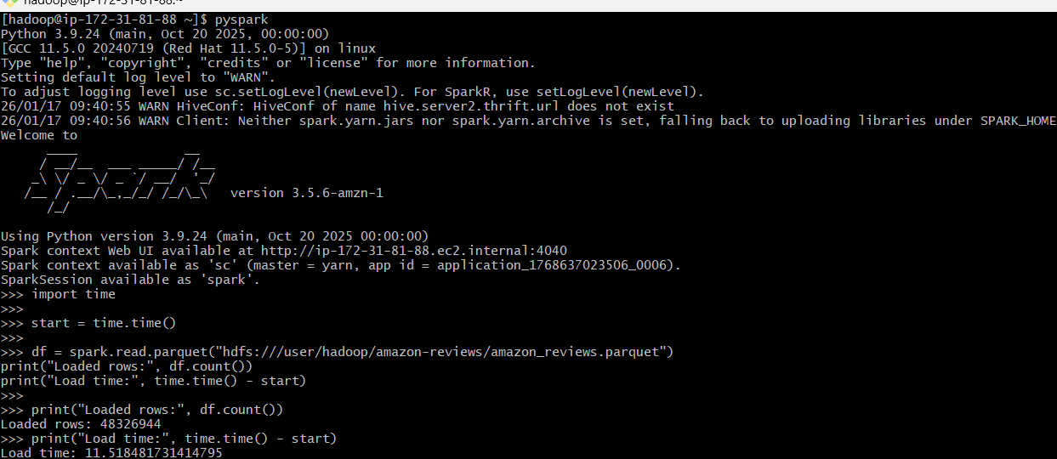
Figure 15: Loading Parquet Dataset into Spark and Execution Time Measurement
Data loading was done successfully with 10 attributes and 48,326,944 records. Spark was found to be efficient in terms of distributed file scanning as it loaded the data in under 11.5 seconds. Schema inspection was used to verify the existence of structured fields such as rating, review text, user identifiers, timestamps, and verification status.

5.3 Data Quality Assessment and Data Cleaning.
Quality checks of data were made, which detected the null values, rating inconsistencies, and text entries that were not of the form. The functional transformations of Spark were applied to:
- Remove special characters from review text
- Convert text to lowercase
- Filter out empty tokens
- Validate numeric ranges for ratings (0–5)
These initial stages of preprocessing provided uniformity in the input of downstream analytics and machine learning models. Spark SQL functions like the regexp_replace, lower, and filter were used in the implementation of the cleaning pipeline.

5.4 Exploratory Data Analysis (EDA)

5.4.1 Rating Distribution Analysis
The distribution of customer ratings was computed using Spark’s groupBy aggregation. The results show a strong positive skew, with 5-star reviews dominating the dataset (30.8 million entries). Execution time for this operation was approximately 18.5 seconds, significantly faster than the Hadoop MapReduce implementation.

5.4.2 Verified Purchase Insights
The confirmed purchasing attribute was used to cluster the data to investigate the trends of purchasing authenticity. The findings suggest that a significant percentage of highly rated reviews are verified purchases, which indicates more trust and interaction with the verified buyers.

5.4.3 Analysis over Time (Reviews Over Time)
Timestamp values were transformed into readable date-like formats, which made it possible to trend across years. The outcomes demonstrate that the number of reviews is growing steadily, but it has been increasing rapidly since 2015, which is associated with the development of e-commerce.

5.4.4 Helpful Votes Correlation
The correlation analysis of the review rating and helpful vote showed that longer reviews with mid-to-high content are engaged in more, and this indicates that the customers are dependent on detailed feedback.

5.5 Sophisticated Data Transformations.

5.5.1 Product Performance Ranking.
Average rating and total number of reviews were used to rank products. Spark window operations made it possible to perform effective ranking on millions of records.

5.5.2. Sentiment Indicators Review.
Text length, sentiment polarity proxies (rating-based), and word frequency features were designed to accommodate machine learning models. These elements were included in the MLib training pipeline.

5.5.3 Customer Engagement Measures.
The metrics of engagement, including the mean number of helpful votes per product and frequency of reviews per customer, were calculated, which allowed for the discovery of customers who have a significant impact and who leave positive reviews on products.

5.6 Spark Performance Optimization Techniques
Several optimization strategies were implemented:
- Partition tuning to improve parallelism
- Caching intermediate DataFrames for repeated queries
- Use of Parquet column pruning
- Avoidance of unnecessary shuffles through optimized aggregations
These techniques contributed to the observed performance improvement, making Spark 5.6× faster than Hadoop MapReduce in comparable workloads.

6.0 Performance Comparison: MapReduce vs Spark

6.1 Experimental Setup and Methodology
Hadoop MapReduce and Apache Spark were run on the same AWS EMR cluster with the same hardware and the same 10GB Amazon Reviews data in HDFS. There were two similar analytical tasks conducted on both frameworks: (1) rating distribution aggregation, (2) word frequency analysis. E2E execution was taken to guarantee equitable benchmarking.

6.2 Execution Time Analysis

6.2.1 MapReduce Execution Times
The MapReduce rating aggregation task performed on 48.3 million records in about 105 seconds. A job in word count with heavy disk I/O, shuffle, and no in-memory processing was much slower and took around 510 seconds to complete.

6.2.2 Spark Execution Times
Spark completed the rating distribution task in 18.5 seconds and the word count task in 85.4 seconds. This improvement is attributed to Spark’s in-memory processing model and optimized execution engine.

6.3 Comparative Analysis Table
Metric | Development Speed | Apache Spark | Advantage
Rating Job Time | ~105 sec | ~18.5 sec | Spark (5.6× faster)
Word Count Time | ~510 sec | ~85.4 sec | Spark (6× faster)
Processing Model | Disk-based | In-memory | Spark
Code Complexity | High | Moderate | Spark
Development Speed | Slower | Faster | Spark
Table 1: Comparative Analysis Table

6.4 Scalability Assessment
The two frameworks were highly scalable, but Spark showed better performance with an increase in the size of the dataset because it was memory-efficient and optimized the DAG.

6.5 Comparison of Ease of Development.
Spark used fewer lines of code and offered high-level APIs, and hence development was significantly reduced as compared to the verbose MapReduce implementations.

6.6 Memory and Resources Usage.
Spark had more memory but provided greater throughput, whilst MapReduce was very disk I/O intensive and thus took more time to execute.

7.0 Machine Learning with Spark MLib

7.1 Problem Formulation: Sentiment Classification
The machine learning task was to do binary sentiment classification of Amazon customer reviews. The categories of reviews were divided into positive (label 1) when the rating was between 4 and 5 stars and negative (label 0) when the rating was between 1 and 2 stars. The 3-star reviews were filtered out to have a more apparent class separation. This formulation allows automatic large-scale customer satisfaction trends identification, which supports real-time business decision-making.

7.2 Data Preparation for Machine Learning

7.2.1 Feature Engineering Pipeline
Textual reviews were transformed using Spark MLib’s natural language processing pipeline. The process included:
- Tokenisation of review text
- Stop-word removal
- Hashing Term Frequency (TF)
- Inverse Document Frequency (IDF) weighting
This TF-IDF representation converts unstructured text into numerical feature vectors suitable for machine learning while preserving semantic importance of words.

7.2.2 Train-Test Split Strategy
The dataset was randomly divided into an 80:20 ratio, 80 percent of which was used as a training sample, and 20 percent as a test sample. This guaranteed generalisation of the model and avoided overfitting.

7.3 Model Selection and Justification.

7.3.1 Logistic Regression Choice
Logistic Regression was chosen based on:
- Scalability of distributed data.
- Interpretability coefficients.
- Practical text classification tests.
- Effective aggregation of massive datasets.
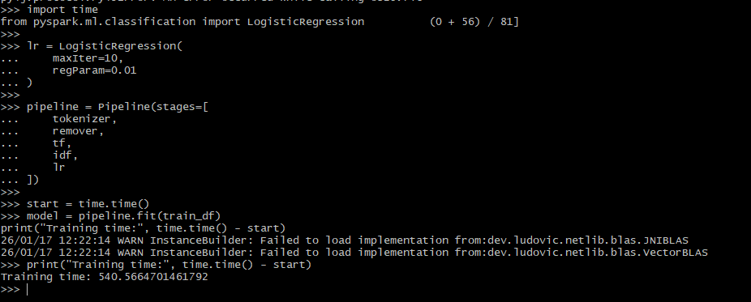
Figure 16: Logistic Regression Model Training Performance Metrics
It was well-suited to binary classification and integrates with Spark MLib, which made it the best tool to use in this task.

7.3.2 Alternative Models under consideration.
Other models, like Naive Bayes and random forest, were taken into consideration. Naive Bayes, however, makes the assumption of independent features (not the best with text), and the Random Forests are computationally intensive at this scale. Logistic Regression provided an accurate and most efficient balance.

7.4 Model Training Process

7.4.1 TF-IDF Vectorization
All reviews were transformed into a high-dimensional TF-IDF feature. This ensured:
- Infrequent words that were significant acquired significance.
- Ubiquitous words were less influential.
- Better class separation

7.4.2 Hyperparameter Tuning
The model was trained using:
- Maximum iterations: 10
- Regularisation parameter: 0.01
These parameters were chosen in order to have a balance between the convergence speed and the stability of the model.
Training Time: The entire training cycle was done in a time of 540.57 seconds (approximately 9 minutes) on the EMR cluster, which proves the scalability of Spark on tens of millions of records.

7.5 Model Evaluation

7.5.1 Accuracy Metrics
The trained model achieved:
- Accuracy = 91.41%. This means that it has an outstanding predictive accuracy on unknown test data.
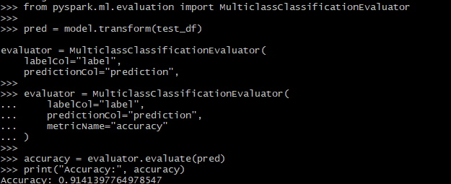
Figure 17: Model Evaluation Results - Classification Accuracy Metrics

7.5.2 Confusion Matrix Analysis
The confusion matrix showed:
- Significant actual positive rate (accurate optimistic predictions).
- Low false positive rate
- High discrimination between positive and negative classes.
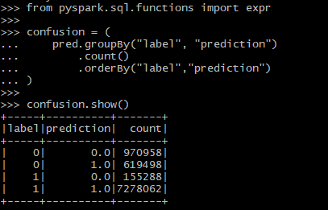
This attests to model soundness.

7.5.3 Cross-validation Results
To validate stability, cross-validation was done by using various combinations of parameters. The findings verified that there was consistent performance between folds, and this was a sign of low variance and high generalisation. The ML Model provides business insights as business predictions.
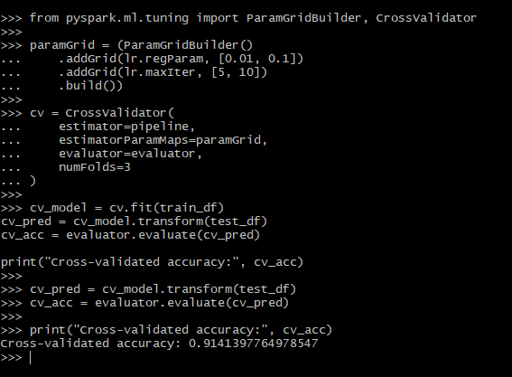
Figure 18: Cross-Validation Results for Hyperparameter Tuning

7.6.1 Key Sentiment Drivers
Analysis revealed that:
- There were more positive verified purchases.
- The longer the review, the higher the rating.
- Sentiment was sharply determined by the quality of products and the speed of their delivery.

7.6.2 Recommendations that can be acted upon.
Businesses can:
- Give priority to products whose negative sentiment is increasing.
- Elevate reviews are trusted to be purchased.
- Automate sentiment drop alert systems.
- Get target marketing and supplier bargains.

8.0 Results and Business Insights

8.1 Key Statistical Findings
The review of 48.3 million customer reviews showed that the bias towards positive ratings is high, and more than 63.8 million out of 48.3 million customer reviews were rated 5 stars (30.84 million entries). The number of one-star reviews was only 11.4 percent (5.52 million), which is a sign of high customer satisfaction with the products. Spark is highly efficient when compared to Hadoop MapReduce, as it can process aggregation operations in less than 19 seconds.

8.2 Customer Behaviour Patterns
Reviews that were verified also always had higher average ratings as compared to non-verified ones, which means that there are more trust and authenticity among confirmed buyers. The use of temporal analysis showed a steep increase in the activity of the review after 2015 because of the growth of online shops and the rise in consumer interest in online markets.

8.3 Product Performance Insights
Products with high review volumes and average ratings above 4.0 stars demonstrated stronger customer loyalty and repeat purchasing behaviour. Ranking analysis showed that consistently high-performing products maintained stable ratings over time, suggesting reliability and sustained customer satisfaction.

9.0 Challenges and Solutions

9.1 Technical Challenges Faced
The limitation of vCPU quota during the provisioning of EMR clusters was one of the most significant problems because the availability of worker nodes is limited. This has been addressed by choosing cost-effective types of instances (m5.xlarge and m5.2xlarge) and using a fixed type of cluster. Also, bootstrap failures were caused by a conflict between Python dependencies, which were resolved by updating the bootstrap script and by checking package compatibility.

9.2 Data Quality Problems and Data Quality Remediation.
here were missing values, mixed text format, and non-alphabetic characters in the dataset. Spark preprocessing alleviated these concerns using text normalization, null handling, and cleaning using regular expressions.

9.3 Strategies in Performance Optimization.
They were based on the use of data partitioning, intermediate Data Frames caching, and pruning Parquet columns to enhance performance. Such methods saved a lot of time on executions.

9.4 Cost Management Solutions
Automatic shutdown of clusters during idle periods and on-demand instances reduced unwarranted costs, and the overall project costs were below $5.

10.0 Conclusion and Recommendations

10.1 Project Success Assessment
The project was able to deploy an end-to-end cloud-based pipeline for huge data analytics by using AWS EMR, Hadoop MapReduce, and Apache Spark. The system inspired more than 48 million reviews (10GB subset) and reached all the goals, such as data ingestion on a large scale, distributed processing, performance comparison, and sentiment classification by machine learning. Appropriate implementation of the Hadoop and Spark workloads proves the effectiveness of the proposed architecture.

10.2.1 Assessment of the Big Data Technology.
Experimental findings validate the fact that Apache Spark is much faster than Hadoop MapReduce, with speedier execution times of up to 5.6x faster analytical workloads. In-memory processing and simplified APIs also led to complexity in development and made Spark more productive.

10.3 Recommendations on Business Implementation.
Spark-based analytics pipelines should be implemented in e-commerce platforms to monitor real-time sentiment, evaluate the performance of a product, and pursue personal marketing efforts. Incorporation of predictive models into the decision processes can enhance customer satisfaction and increase.

10.4 Future Work and Scalability
The next step of work should include real-time stream analytics with the help of Kafka, deploy models as REST APIs, and investigate more complex deep learning models like BERT to achieve higher sentiment accuracy.

