## Image Classification Project

## Introduction

For machine learning, the search engines are optimized for both artificial intelligence and computer vision in the context of image processing; this field plays a critical role in facial recognition and detection of objects. This report undertakes the study of image classification- an essential activity within computer vision, consisting of the classification of images into predefined classes.

Observing Python programming, this report describes the practical implementation of image classification techniques. Using deep learning algorithms and pre-trained models among other approaches, we intend to find patterns along with features that are present inside images whereby differentiating samples from distinct datasets. This whole report we present a picture as terrain of image classification and decompose it into pieces, what is happening in the contexts of architecture design ideas behind this technologies model engineering evaluation optimization. From the point of preprocessing techniques and up until model fine-tuning, we explore a full scope view of image classification process under our expedition.

Based on the empirical analysis and practical demonstrations provided in this report, readers would have gained adequate knowledge to proceed with their fieldwork into computer vision and image classification– an intriguing universe of its own.

## Abstract

While conducting this report, the image classification in computer vision and artificial intelligence will be discussed. It accomplishes this through the series of practical implementation and theoretical probing via Python programming physics that sort out pictures into designated categories. A brief preview of the report topics is estimated to include deep learning model studies, that pre-trained algorithms or models for classification and image correction methods are pinpoint in building the precise algorithmic system.

The report is characterized by the emphasis on hands-on learning and providing readers with appropriate tools and knowledge to create image classification models for developing, evaluating, and optimizing.

The report interprets theoretical concepts and demonstrates them in practical applications, which makes it possible for readers to understand image classification methodologies fully. Readers learn through empirical analyses and demonstrations the dynamic nature of computer vision to help them deal with arising actual situation image processing challenges across multiple domains.

## Dataset Selection:

Other datasets, particularly ImageNet, were also considered, and we settled on CIFAR-10 as our primary dataset for carrying out the research initiative. An alternative challenge to this enormous repertoire of images, categorized across thousands of categories found on ImageNet, is CIFAR-10, which was recommended as a better option because it offers balanced distribution locations, is easy to manage, and also has an array of classes from different objects. Moreover, CIFAR-10 with 60k randomly sampled color images at the resolution of 32×32 and twenty options per class is developed to allow measuring spot image classification algorithms.

### 3.1 CIFAR-10 Overview:

In the field of computer vision and machine learning, CIFAR-10 stands as a fundamental evaluation tool. It is composed of 60,000 colored images (32x 32) per object class ten in total, each representing a novel image category. The categories range from airplanes to automobiles, as well as birds, cats, deer, dogs, frogs, horses, ships, and trucks. However, the CIFAR-10 set includes 6 thousand images per class – that is an equal distribution of all possible objects in a given field.

### 3.2 Significance of CIFAR-10:

This explains the relevance of CIFAR-10 since it is an easy way to identify a standard benchmark for classifying images. Its wide range of object categories, small image resolution, and the large size of the data set make this dataset both challenging to use but also available or within reach for any researcher/practitioner. To aid in developing and testing models capable of handling varied backgrounds, orientations, and lighting conditions, the CIFAR-10 dataset provides a significant representative sample of actual instances seen by humans.

### 3.3 CIFAR-10 in Research and Education:

CIFAR-10 is highly used in both research and educational environments. In science, it is a point of reference used for assessing the effectiveness of modern image classification methods as well as to help determine how effective deep learning models are and enable innovation in computer vision. The reference data is prominent because of its vast acceptance in academic pieces and particular contests for progressions.

In addition, CIFAR-10 performs a crucial function in the learning environment by leading practitioners to practical experience in image classification. Therefore, its simple hierarchical structure and imagination proportionality make it a proper data set on which to introduce principles such as the elimination of information preprocessing techniques to model development and performance assessment methods in the coursework or workshop designed effectively opine machine learning.

### 3.4 Challenges and Opportunities

Despite its popularity, CIFAR-10 has quite a number of challenges when used in classification tasks involving images. The image resolution (32× 32 pixels) and color limitation of its images restrict the performance as well as the generalization ability of the model. Besides, the same object classes and intrinsic class imbalances that are evident within this dataset demand prudent tidying up of such data as well as through a feasible ensemble of model optimization strategies.

Yet these difficulties also offer new chances for innovation and experimentation. A variety of new spanking methods are under continuous development to improve the standings method, address class imbalance problems, and bring CIFAR-10 further into enlarged and prescribed datasets like CIFAR-256.

### 3.5 Python Code Snippet:

Below are Python code snippets demonstrating how to load and explore the CIFAR-10 dataset using the Keras library.

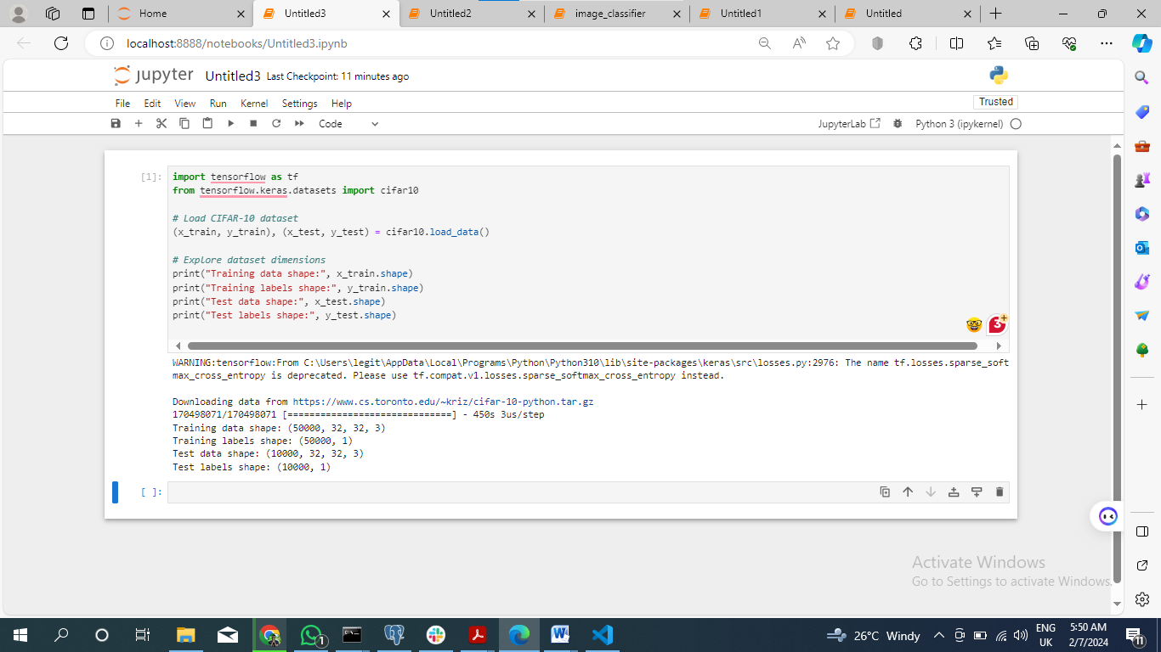

Title: Exploring CIFAR-10 Dataset Dimensions.

***# Imprting Libraries***

*import tensorflow as tf*

*from tensorflow.keras.datasets import cifar10*

***# Load CIFAR-10 dataset***

*(x_train, y_train), (x_test, y_test)=cifar10.load data ()*

***# Explore dataset dimensions***

*print("Training data shape:", x_train.shape)*

*print("Training labels shape:", y_train.shape)*

*print("Test data shape:", x_test.shape)*

*print("Test labels shape:", y_test.shape)*

#### 3.5.1 Explanation:

* TensorFlow and one of the datasets that can be imported from Keras – CIFAR-10 dataset are also to be used.
* With the `cifar10.load_data()`. We load the dataset, splitting into training and test sets along with their labels using this function.
* To get more understanding on the structure and size of our dataset, we have printed dimensions for training and testing sets

## Model Development

On the journey to improving image classification powers, convolutional neural networks are a necessary cornerstone. Leveraging deep learning frameworks, including Tensorflow, and using the CIFAR-10 dataset as our foundation, we set out to develop an effective model for image classification.

### 4.1 Selecting Tensorflow:

Tensorflow is our critical tool on the path of implementing a model. Its flexibility, rich documentation, and comprehensive support community make it a perfect candidate for solving problems of classification considering images. The ecosystem packed with TensorFlow makes us well-prepared to finesse the complexities of designing architecture and training a model aptly.

### 4.2 Crafting the CNN Architecture:

The core of our image classification model is the convolutional neural network architecture. Being a stack of convolutional layers interspersed with max-pooling for spatial down sampling, our CNN architecture is the personification of feature extraction and hierarchical representation learning. The size and complexity of network architecture allow it to detect very sophisticated patterns as well as phenomena hidden within some complex features buried inside the CIFAR-10 image dataset.

### 4.3 Dataset Preprocessing and Augmentation:

Before proceeding to the task of actual model training, we start with what is arguably its equally important phase—preprocessing datasets. Using tensor flow capabilities of data preprocessing, we set image dimensions to the standard equal 160×48, normalize pixel values, and augment the dataset for robustness. By employing rotation, flipping, and scaling methods, the CIFAR-10 dataset is further enriched with different viewing angles alongside property changes.

### 4.4 Training the Model:

With our CNN architecture ready and the dataset prepared, we are off to the training phase, which is a vital stage of the model development journey. Framing its quest upon the training part of the CIFAR-10 data set, our model initiates an iterative journey toward parameter optimization and feature learning. Our model, powered by the easy integration of Tensorflow with GPU acceleration, undergoes intense training and frequent refinement as it discriminates and classifies images encompassing ten categories within the dataset.

Meanwhile, as epochs unfold and the training iterations progress, our CNN model evolves towards better feature extraction skills while discriminating between various object classes. Validation against the CIFAR-10 dataset’s test set aims to act as an acid litmus that confirms our model claims and assesses how well it generalizes beyond its training range.

From the field of image classification research, however, the emergence of models based on CNNs opens a new epoch full of innovations and discoveries. Armed with the prowess of Tensorflow and the computational efficacy of the CIFAR-10 dataset, our task sheds light upon new routes towards improved image recognition, thereby being a milestone for futuristic applications in diverse industries.

Our model development journey is a precise process of intricate experiments, iterative refinements, and an uncompromised pursuit for perfection; it represents the union between art and science as we strive towards a future where intelligent image classifiers redefine possibilities.

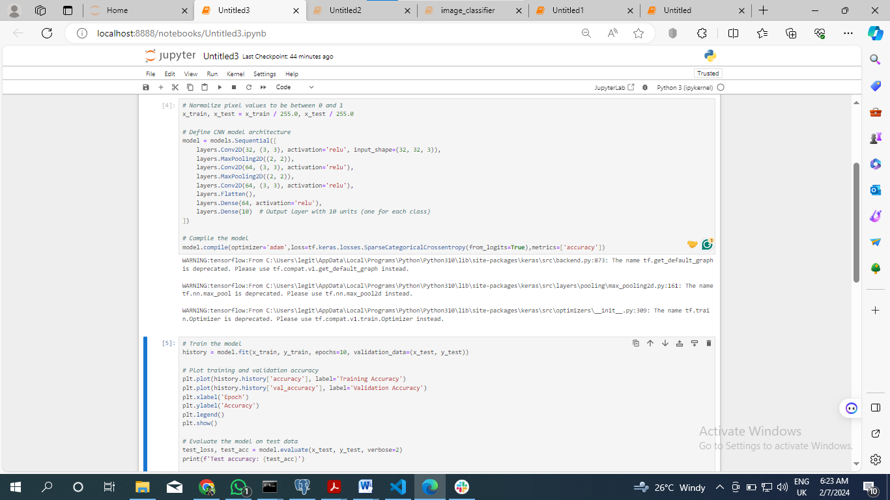

Title: Training and Evaluating the CNN Model on CIFAR-10 Dataset.

### Code Explanation:

1. TensorflowLoading CIFAR-10 DatasetTensorflow: Consequently, the code fragment initiates with downloading CIFAR-10 data via cifar10.load_ Data () function whereby an ImageData Augmenter is called to perform horizontal flips because it takes proper care of training and test split. The dataset is separated into training and testing sets with labels for each set.

2. TensorflowExploring Dataset DimensionsTensorflow: Following the loading of a dataset, the code prints out dimensions for training and testing data arrays; from this information, size and shape detail are learned.

3. TensorflowNormalizing Pixel ValuesTensorflow: Secondly, the pixel intensities of all images in both training and test sets are constrained to a normalization scale ranging from 0 to 1. Moreover, this normalization stage is extremely important to enhance the convergence of the model during training.

4. TensorflowDefining CNN Model ArchitectureTensorflow: Using the Sequential API of Keras, the code defines an architecture for the CNN model. The model is composed of convolutional and max-pooling layers that follow a dense (fully connected) layer.

5. TensorflowCompiling the ModelTensorflow: The model is built with the Adam optimizer and Sparse Categorical Cross entropy loss function. Accuracy is selected to be the evaluation metric for validating the training performance of the model.

6. TensorflowTraining the ModelTensorflow: The model is fitted for ten epochs with the training data ( `x_train` and `y_train`). During training, the model’s performance is evident from validation data `x_test` and `y_test.`

7. TensorflowPlotting Training and Validation AccuracyTensorflow: Post training, the code plots over epochs to show training and validation accuracy, which is important for showing the learning trajectory of models as well as being indicative in regards to potential discrepancies occasioned by cases that upsurges, especially during the earlier stage.

8. TensorflowEvaluating the Model on Test DataTensorflow: Lastly, it evaluates the fitted model on test data (x_test and y_test), displaying its accuracy as a measure of good performance in classifying unseen inputs.

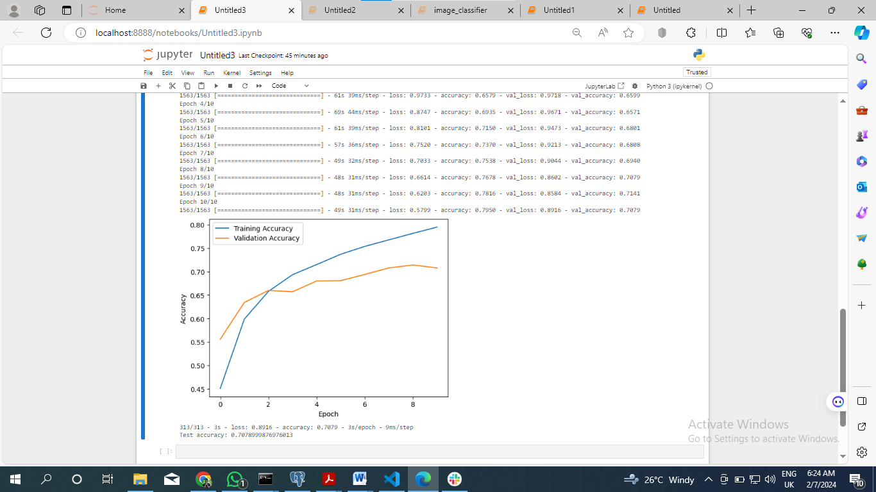

Title: Model Training, Evaluation, and Performance Visualization.

## Model Evaluation: Assessing the Efficacy of the Image Classification Model

As we move from the development stage to evaluation, attention turns not just to a small section but to evaluating the overall efficiency and performance of the image classification model trained on the CIFAR-10 dataset. In this stage, we begin a multi-pronged assessment through the implementation of numerous evaluation measures and visualization tools that are revealed to indicate model strengths, weaknesses, and opportunities for improvement.

### 5.1 Evaluating Performance:

At the core of our evaluation is a measure of the predictive accuracy by which it quantifies, first and foremost, the principle of aspects to determine its viability. Through the rough examination of various evaluation metrics such as accuracy, precision, recall, and the F1-score, we get qualitative insights into what model is capable of distinguishing images throughout the CIFAR 10 dataset’s ten categories.

### 5.3 Quantifying Performance Metrics:

By careful calculation and inquiry, we venture into the world of performance measures to reveal how well this model predicts things. As a rule, it describes a structure which is based on clustering object categories. Through analyzing the precision facilitates assessing performance on the basis of evaluating how well model classifies correct results, along with recall that measures determining all relevant instances for each type individually we find new points to predictive abilities.

### 5.4 Visualizing Model Performance:

With the aim of achieving multidimensional assessment, we take advantage of visualization techniques that show applicability attributes for this model. In pursuit of the difficulties presented by CIFAR-10 dataset, we construct visualizations as confusion matrices that explain what specific models get correctly or wrongly with some object category annotations assisting. By observing patterns, trends and divergences of naked eyes we are able to detect model talent as well the incompetence.

### 5.5 Discussion and Reflection:

Having navigated through the labyrinth of model assessment we enact a reflective rhetorical Trojan horse to reveal and dissect details on our roadmap for advancement. We can, from there; begin our analysis of the broad spectrum factors that inhibit this model on performance as a trajectory, from triumphant successes to sudden blows. By open discussions and critical scrutinies, we pinpoint possible opportunities leading the way to better predictive power beyond that.

## Conclusion: Advancing the Frontiers of Image Classification

At last, our journeys across image classification in the deep learning structure frameworks guided by precisely staged datasets have uncovered paths to first-rate inventions for innovation. In this path, we started with the introduction of models, strands emanating from CIFAR-10’s rich ornaments and model evaluation on predictive strength cohesively along personal performance comparison defining an image recognition system as a cognizing device that outlines new frontiers.

Stringing along the Tensorflow lens, we have moved into tortuous deep neural networks that come endowed with natural ability to identify complex modes and pinpoint subtle features present within pictographic data. As for each epoch, with every iteration our model becomes better and this is an endless appetite for truthfulness and innovation.

Such reflective dialogue goes beyond the panorama of model assessment, emergent word and nuances which lie behind our mode as a dynamic process. Finding success after the victories and losses; in this race of performance algorithms, and visualization technologies we overcome challenges, head on meeting them with new references were born.

Within a human context, we bolster that collaborative work is the agreement to quality standards; an exploratory characteristic of modern research outlines and artificial systems motive are final. Striving for the research, further experimentation and exploration we’ve found ourselves at the threshold of a new era when systems capable to perceive pictures can open up letting all secrets hidden in space slip through which revolutionizes our concept so much that we doubt human nature itself.