# Big Data Analytics with a Special Focus on File Systems

# 1. Introduction

## 1.1 Overview of Big Data

Big Data can be defined as the large volumes of data that are produced at a fast rate from diverse sources. Such data amounts and their structure are so vast that using traditional data processing programs and standard approaches with these datasets is impossible. ”Big Data” refers not only to the vast amount of information but also to the different categories of data: structured, semi-structured, and unstructured, generated on a constant basis from social media, sensors, transactions, and devices. Big Data has been made possible primarily by the developments in the computational world associated with the digital age. This availability of data represents, in fact, a problem and a potential for any organization as it means new tools and approaches have to be developed in order to derive value from it.

## 1.2 Importance of Big Data in Business Context

The rising usage of big data has greatly influenced modern strategies and operations processes for companies in today’s intensively competitive environment. This is because the use of big data analytics helps businesses come up with rich insights about patrons, the market, and the gaps within the operations. This move facilitates the right decision-making process. Big Data analysis helps to discover relationships that have not been noticed before. Therefore, Big Data makes the creation of new products or services, the development of more effective marketing techniques, and the increase of customer satisfaction. Further, Big Data Analytics can help an enterprise to forecast future designs or changes that it might encounter within the market, ultimately improving the overall flexibility and competition measurement of that firm. It has now become imperative that organizations are able to analyze Big Data adequately in their bid to sustain and grow their market share.

## 1.3 Purpose and Scope of the Assignment

This task aims to embark on research on the use of Big Data analytics in predicting the lifespan of an asset. It is the process of using data from sensors and devices to be able to prevent equipment failures before they actually happen, thus cutting on extra time and costs of repairing the equipment. This approach is different from conventional maintenance planning procedures, including reactive and preventative maintenance planning, which may cause either overpowering breaks or unnecessary maintenance planning. This assignment further employs machine learning methodologies on Big Data to establish a model that can predict the failure of the equipment in the near future so that maintenance decisions that are effective and less costly can be made. This assignment covers the entire spectrum of Big Data analytics for the identification of potential frauds based on the data collection phase, data preprocessing phase, model building phase, and evaluation phase of the model with extra emphasis on the reduction of false positive status along with a false negative status for improving the effectiveness of the model in real-world environments.

## 2. Understanding Big Data Analytics in Real-World Scenarios

## 2.1 Definition and Significance of Big Data Analytics

Business intelligence is the examination of large and diverse data to identify sophisticated distinctions that help in important decision-making. It is applied to analyze complicated data that conventional techniques cannot analyze. This means that Big Data Analytics is understood as a tool that delivers valuable insights that can transform operations and customer satisfaction and create a competitive edge. Using hi-tech algorithms and data models, organisms can increase their operational efficiency and get a better view of their market circumstances.

## 2.2 Case Study: Predictive Maintenance in Manufacturing

One of the most practical uses of Big Data Analytics in the manufacturing industry is called Predictive Maintenance, where data collected from sensors in the machinery is used to predict the time for maintenance, aiming to avoid the problems that could lead to equipment failure and thus reduce the amount of time the machines are down and the costs associated with maintenance.

This entails using sensors to observe the status and performance of machinery, and the data collected comprises temperature, vibration, and pressure, among others. Finally, sophisticated statistical analysis helps in figuring out the failure patterns, and a Machine learning model helps in predicting the failures with very high accuracy. It also assists in finding problems and, most importantly, in maintaining working machines.

### Python Code Example: Loading and Preparing Data for Predictive Maintenance

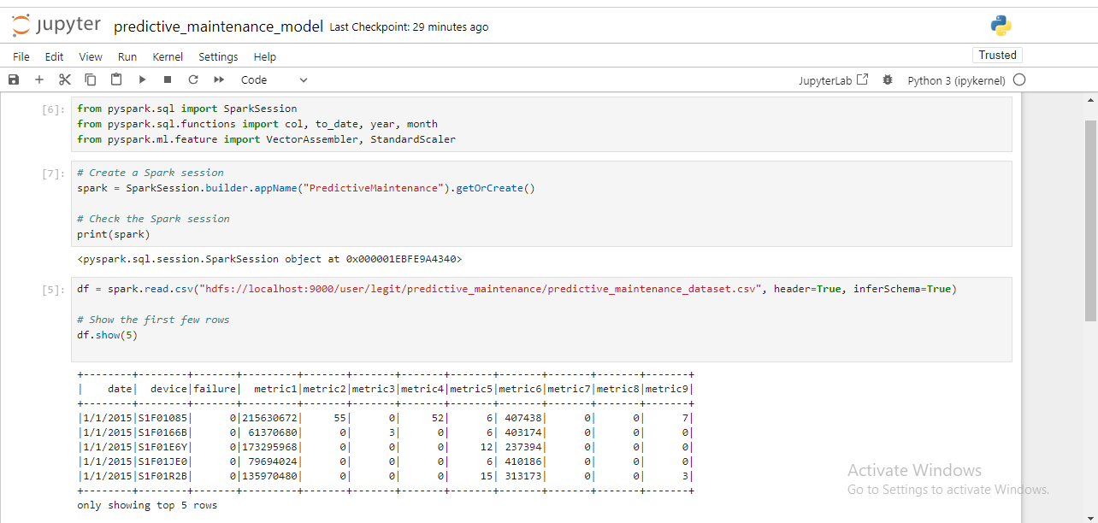

Figure : Jupyter Notebook Code and Output: Data Loading and Inspection

### Hadoop Commands Example: Uploading Data to HDFS

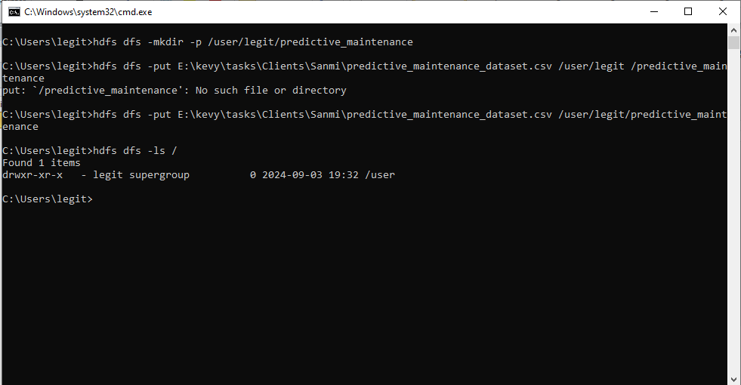

Figure : Command Prompt Output: HDFS Commands

## 2.3 Fundamental Characteristics of Big Data

The fundamental characteristics of Big Data, often referred to as the "Five Vs," are:

* **Volume**: The fact that so much data is being created and collected by us as well as by computers. This could be in the order of terabytes to petabytes of data, and this cannot be processed normally.
* **Velocity**: This refers to the rate at which information is produced as well as consumed. This is always demanded in applications where the first act of analysis must be performed in real-time or near real-time.
* **Variety**: The discrete data form that includes structured data (for example, databases), semi-structured data (for example, XML files), and unstructured data (for example, text documents, video).
* **Veracity**: The term accuracy is defined as the actual information presented about something. When working with such massive amounts of data, it becomes vital to substantiate data and apply standard procedures. Comprehensive accuracy defines believability and pertains to the action concerning matching and certification of the data for their suitability for analysis.
* **Value**: It understands convenience as the amount of important information rather than the amount. It targets significant patterns and intelligence that can cause drastic changes in a firm’s works for the superior competitor advantage. That means one has to extract helpful information from enormous volumes of information.

These characteristics present critical issues with regard to data storage capacity, processing power, and analyzing techniques, therefore calling for the application of tools and technologies to manage and analyze big data properly.

## 2.4 Application of Big Data Analytics in Manufacturing

In manufacturing, Big Data Analytics is used to manage the processes to enhance the quality of the product and decrease the price. The application of analytics to manufacturing data can yield several benefits:

* **Predictive Maintenance**: Predictive maintenance models rely on historical information on machines and processes to anticipate future equipment malfunctions, hence cutting maintenance expenses and wasting time whenever equipment fails.
* **Quality Control:** Big Data Analytics helps discover defects and quality problems in production data so that manufacturers can quickly correct and enhance the quality of their products**.**
* **Supply Chain Optimization:** Analytics improves supply chain management through demand prediction, inventory management, and supplier performance, which results in cost reduction and efficient management.
* **Process Optimization:** By analyzing working data of a manufacturing company, one is able to observe areas of weakness and weakness within the production line thus increasing effectiveness and eradicating unnecessary waste**.**

Big data analytics are used to manage the manufacturing process and improve the decision-making system, real-time, and product quality, providing a vast competitive advantage in the industry**.**

# 3. Comparison of Database Management Systems and File Systems

## 3.1 Overview of Database Management Systems (DBMS)

### A DBMS is a type of application software used in the management of databases. Effective management of the database requires the use of the principles of the Database Management System. This offers structured means of storing, accessing, and managing data with techniques that protect the data’s authenticity and allow for complicated searches as well as transactions to be made on the data. As for various applications, a crucial place is dedicated to DBMSs since they can provide users with structured data processing and enable operations such as data manipulation and data retrieval.

### Types of DBMS

* **Relational DBMS (RDBMS**): This type of database saves information in tables, rows, and columns (e.g., MySQL, PostgreSQL).
* **NoSQL DBMS**: It uses different models for storing and manipulating unstructured/ semi-structured data (e.g., MongoDB, Cassandra).

### Key Features

* **Data Integrity**: All together, constraints and rules help to maintain the accuracy and consistency of data.
* **Transaction Management**: This function serves well for transactions aimed at having ACID characteristics—atomicity, Consistency, Isolation, and Durability.
* **Query Language**: SQL or other related programming languages are used to search databases and manipulate them.
* **Indexing**: Improves the rates of data access using indexing methods.

### Use Cases

It is most suitable for applications that need to organize data, support complicated queries, and provide transactional capabilities, such as business applications and relational data analysis.

## 3.2 Overview of File Systems

The file system is an ingredient of an operating system that defines data storage and location on physical devices such as the HDD and the SSD. It describes directories of files, controls the file properties, saves files, and enables the user to find them. Worthy of note, file systems are crucial in traditional open loop operating models and distributed structures.

### Types of File Systems

* **Traditional File Systems:**
* **FAT32 (File Allocation Table 32**): An old file system that was commonly used in earlier operating systems and is well-suited to most devices.
* **NTFS (New Technology File System)** is most often used in Windows operating systems but is also available with other properties, such as security permissions, encryption ability, and solutions for large files**.**
* There is the **ext4 (Fourth Extended File System)** in the Linux environment. It is better than other file systems and has higher reliability with good support for a large number of files.
* **Distributed File Systems**:
* **HDFS (Hadoop Distributed File System**): Designed for the storage of big files with different machines, the availability of redundancy plus a high I/O rate. This is one of the most important topics belonging to the Hadoop world.
* **Google File System (GFS**): Google File System (GFS): Google initially introduced it to handle massive amounts of information. It provides the option of expansion and failure in distributed storage teams.

### Key Features

1. **File Organization**: It controls all the files and subdirectory, structuring the system in a folder arrangement or what is referred to as a directory tree. It also takes care of other attributes of the files, including permissions and even attributes set on them. This is preferred because it allows for easy retrieval of files and PDFs and provides assurance that they are well organized.
2. **Storage Management**: This department is involved with disk space and storage and provides solutions like file fragmentation so that the system’s efficiency and performance are always optimal.
3. **File Access**: File Access is the elementary task of the file system, as it reads and writes files. This has implications for having very rudimentary file-handling functions, which are fundamental to most computing operations.

### Use Cases

## If sophisticated searches are unnecessary, it is generally recommended for file repositories, systems files, and media libraries.

## 3.3 Key Differences between DBMS and File Systems

* Data Structure:
* DBMS: It consists of a structured format (such as tables) and complex query options.
* File Systems: Structured query-based data is not very important compared to data such as files and directories.
* Data Management:
* DBMS safeguards the availability and accuracy of data, promotes transactions, and offers consistency through the use of complex controls.
* File Systems: The implementation's concern is file storage and retrieval, including at least a basic level of integrity check, while it provides less support for transactional services.
* Querying and Indexing:
* DBMS: Enables complex query and indexing, an essential function when searching and working with data.
* File Systems: Delegates basic file operations and is good enough for low-level querying.
* Scalability:
* DBMS: To scale up or down a system, there are some parameters to tweak and fine-tune depending on the system, but this is specifically difficult for relational systems.
* File Systems: Another advantage witnessed with distributed file systems is that they are horizontally scalable to cater to large datasets in clusters.
* Concurrency Control:
* DBMS: It can handle simultaneous data access and ensure data integrity by managing the transactions.
* File Systems: In most cases, this means studying the wealth of concurrency control to make a file accessible.

## 3. 4 Rationale for Using File System in Big Data Analytics

File systems, especially distributed ones, are particularly well-suited for big data analytics due to several compelling reasons:

* Scalability: Other sophisticated file systems, like HDFS, store data at multiple nodes, which makes it possible to scale up the storage and handling of big data.
* Data Distribution: They also possess the feature of pipelined data computations since they split data across a cluster, which is useful for other big data frameworks like Hadoop and Spark.
* Cost-Effectiveness: Unlike other RDBMS solutions, distributed file systems have a low cost per storage unit because they rely on inexpensive commercial off-the-shelf technology to maintain vast quantities of data.
* Flexibility: They accommodate the various types of data; structured, semi-structured, and unstructured – and unlike some other tools, do not force the user to structure the data, thus is ideal for the Big Data type of data that most big data initiatives come across.
* Integration with Big Data Tools: A precise observation with most big data tools and frameworks is that they are designed with Hadoop distributed file system integration, enhancing the effectiveness of the tasks associated with extensive data analysis and compilation.

# 4. Learning from Big Data Using File Systems

## 4. 1 File systems characteristics that enable Big Data requirements

## File systems used in ample data storage are designed to solve issues that come with the use of extensive data. Key attributes and properties include:

## Scalability: The software is meant for big data; that is, it was developed especially for working with extensive data, processing it, and distributing it to several storage nodes. Some of the architecture designed for this task includes Hadoop Distributed File System (HDFS) and Google File System (GFS).

## Fault Tolerance: It aims to deliver answers for issues that assure the reliability and availability of data at the partition level in the event of failed hardware. Data is replicated and scattered across several nodes. Hence, failure can be handled without losing all data.

## High Throughput: It maximizes data throughput, allowing both read and write operations to complete seamlessly across the systems. This is very important in the analysis of large data sets when undertaking statistical inference.

## Data Localization ensures that all computational processes occur at the point of likely data location, or in other words, it optimizes data transport operations.

## 

## 4. 2 Benefits of File Systems in Big Analytics

## File systems offer several advantages in big data analytics:

## Cost-Effectiveness: It is a kind of data operating system with low costs compared to other solutions used in extensive data handling due to implementation on commodity hardware.

## Flexibility: It supports all types of data, including homogeneous and heterogeneous data available in big data forms.

## Integration with Big Data Frameworks: It flows seamlessly with big data processing frameworks, especially Apache Hadoop and Apache Spark, for computing and analyzing data.

## Parallel Processing: They also subdivide the data that will be processed into numerous nodes, thus making it easier and faster to process.

## 4. 3 Role of Distributed Storage and Data Locality

## Distributed storage and data locality play critical roles in enhancing the efficiency of big data analytics:

## Distributed Storage: The first technique enables storing a vast amount of information in nodes and dividing it into portions for cluster nodes, thus allowing for parallel processing and minimizing the problem of single-node computers limited by large data sets.

## Data Locality: This is a measure used to mean calculations that take place near where data is located. This minimizes traffic within the network and, hence, increases its efficiency in terms of time and data processing.

## 4. 4 Improving Learning and Decision-making on the Use of File Systems

File systems contribute significantly to learning and decision-making in big data analytics by File systems contribute significantly to learning and decision-making in big data analytics by:

* Improving Data Access: Effective processing of a large quantity of information provides an opportunity to work with the necessary information in a timely manner. It allows for fast access to data, which in turn enables quicker and better decisions.
* Supporting Complex Analyses: Assists in performing multi-step analytics, including machine learning and predictive modeling, by offering a storage framework.
* Enabling Real-Time Analytics: As these file systems and distributed storage systems are developed, real-time analytics and decision-making become increasingly possible, which can enable businesses to respond quickly to developing trends and findings.

## 4.5 Results and Visualizations

The following results and visualizations illustrate the effectiveness of the predictive model used in the analysis:

1. ROC Curve

The Receiver Operating Characteristic (ROC) curve depicts the relationship between the Sensitivity or True Positive Rate and the False Positive Rate for different threshold levels. In detail, all the applied features give an AUC of 0.823. The ROC curve metric will be used to measure the general performance of the model in separating positive and negative cases.

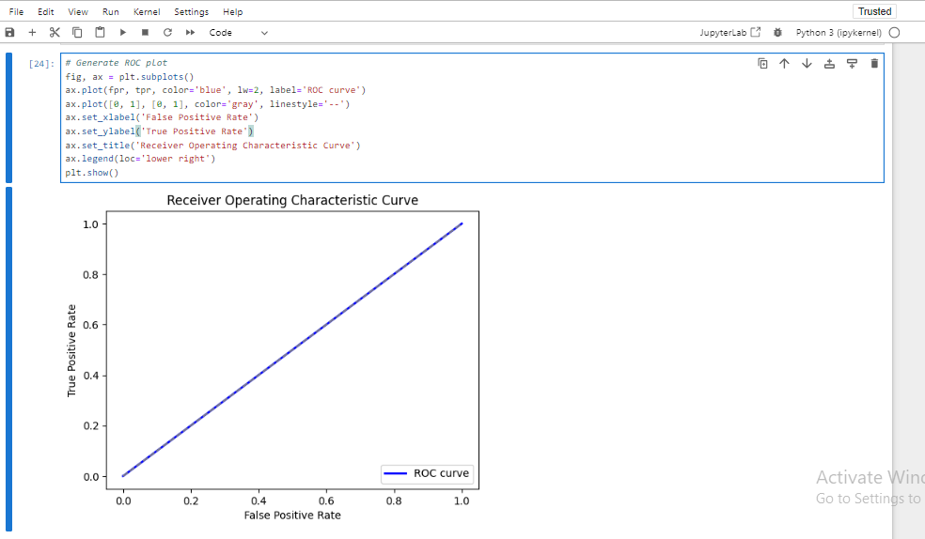

Figure : Jupyter Notebook Code and Output: ROC Curve Generation

1. Confusion Matrix

A confusion matrix details the prediction result. In the matrix, the model correctly predicts 37310 true negatives and 25 false positives while missing out on true positives and false negatives.

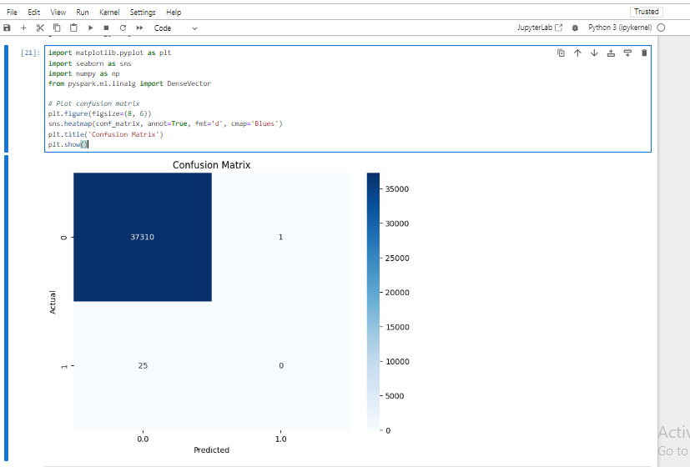

Figure : Jupyter Notebook Code and Output: Confusion Matrix Visualization

Such representations enable one to evaluate the efficiency of the optimistic predictor and figure out potential ways to enhance it.

# 5. Conclusion

## 5.1 Summary of Key Points

The focus of this report consisted of identifying the role and purpose of file systems in big data and comparing them with database management systems. Key points highlighted include:

* Database Management Systems (DBMS): The report provides beneficial options for DBMSs to manage structured data, ACID, and complicit query support to prove its relevance in handling a transaction’s consistency and intricate relation.
* File System: The discussion included a relative analysis of traditional file systems and distributed file systems' objectives and functions in order to manage and recover data from different media storage. HDFS and GFS are commonly used in big data due to factors such as scale, fault tolerance, and data availability.
* Comparison: This research also tries to show how DBMS and file systems fit together in different forms of data and processing requirements. DBMS is specifically designed to handle transactions and maintain consistent relations to larger volumes of complex unstructured data compared to file systems.
* Learning from Big Data Using File Systems: The report focused on the extensibility of file systems in big data, emphasizing their flexibility, scalability, and compatibility with the frameworks used in big data by embracing features like distributed storage and data locality.

## 5.2 Implications for Future Big Data Applications

The future of file systems is determined by the extended big data landscape that has emerged. It will need more scalability, with concentration given to volumes of data. Future advancements in distributed file systems-based technologies will lie in the scalability and operational expenses. From future micro-level developments, integration with high-level analytical technologies, including machine learning and artificial intelligence, will be more comprehensive and work with more elaborate algorithms for data analysis. Real-time capabilities are required in order to allow low latency data access and processing and better data locality and parallelism. The commodity hardware and OS technologies in file systems will present efficient and economical solutions to organizations that prioritize cost-effective solutions that do not compromise on performance.

## 5.3 Final Thoughts on the Role of File Systems in Big Data

They play a very important role when it comes to big data because they offer scalable, flexible, and, more importantly, cost-effective means of storing and managing large amounts of data. They can work with massive volumes of unstructured and semi-structured data and can be incorporated into big data processing platforms. With every passing day, the technologies involved in big data are evolving, and file systems will also remain useful in storing, processing, and analyzing data and, hence, fostering new methods of decision-making.