# Data analysis and machine learning with Python for real-world

# 1. Introduction

## 1.1 The Importance of Predictive Analytics in Healthcare

One of the byproducts of big data is predictive analytics, which has transformed the healthcare field because it now allows physicians or researchers to implement point solutions backed by solid data. Healthcare big data is used to forecast disease transmission and facilitate the delivery of individualized therapy and resource utilization. The cloud is emerging to handle the ever-higher volumes of electronic health records (EHRs), data from wearable devices, and many other forms of medical data that can be transformed into valuable knowledge. The change is precious for such developments as diabetes, as a timely introduction to a treatment plan can alter patients’ quality of life and keep overall expenditures low. Hence, predictive analytics increases decision-making abilities and enables the culture of preventive healthcare, thus leading to improved patient care and increased efficiency in healthcare facilities.

## 1.2 Machine Learning for Diagnosing Medical Conditions

Diagnosis and patient monitoring by computer use employ machine learning to study pattern recognition and predictive analysis from the records. These algorithms can cope with complexity, volume, and the fact that variables may be related in ways that are not immediately obvious. In illnesses like diabetes, the strategies apply raw patient data and medical records to predict the likelihood of acquiring the disease. This helps healthcare practitioners to give proper diagnoses and substitute treatments. ML is appropriate for chronic diseases where many etiologies are involved in a given disease and stimulates a comprehensive understanding of patients’ conditions and their management. The ML generally entails a holistic strategy for identifying and tracking patients’ conditions.

## 1.3 Purpose and Scope of the Report

In this report, the authors present a study of the analysis of diagnostic measurements to predict instances of diabetes using data analysis and machine learning. With the help of such models, the work explains how to apply machine learning to the Diabetes Dataset of the National Institute of Diabetes and Digestive and Kidney Diseases to predict the presence of diabetes. The paper reflects on the dataset, incorporates various ML algorithms, and analyses their models' accuracy with respect to diabetes prognosis. It also presents findings and recommendations regarding the dependence of HC professionals on social media and the possible directions for further study. The report helps understand how the stakeholders in the healthcare decision-making process have embraced Predictive analytics and machine learning.

# 2. Data Selection and Preparation

## 2.1 Overview of the Diabetes Dataset

### Description of the Dataset's Source and Purpose

The Diabetes Dataset, sourced from [Kaggle](https://www.kaggle.com/datasets/akshaydattatraykhare/diabetes-dataset), specifically National Institute of Diabetes and Digestive and Kidney Diseases, aims to diagnose diabetes in female patients of Pima Indian heritage aged 21 and above. It uses various diagnostic measurements, making it a valuable resource for developing and evaluating predictive models for diabetes diagnosis.

### Summary of Dataset Attributes

The dataset contains the following attributes:

* Pregnancies: Number of pregnancies
* Glucose: Blood glucose level
* BloodPressure: Blood pressure measurement
* SkinThickness: Skin resistance
* Insulin: Blood glucose concentration
* BMI: Body mass index
* DiabetesPedigreeFunction: Diabetes percentage having a family history of the illness
* Age: Surgery of the patient
* Outcome: Dependent variable of interest to ascertain whether the respondent has Diabetes or not (1 for Yes, 0 for No)

## 2.2 Understanding the Dataset's Attributes

### Identifying Data Types (Numerical, Categorical)

The dataset includes a mix of numerical and categorical data:

* Numerical: Glycemia/blood glucose, pregnancies, blood pressure, skin fold thickness, insulin, BMI, and age.
* Categorical: Yield (binary: 0 or 1)

### Discussion on Features and Target Variable (Outcome)

* **Features**: Pregnancies, Glucose, BloodPressure, SkinThickness, Insulin, BMI, DiabetesPedigreeFunction, and Age will all act as input variables that will be used to decide the probability of having diabetes. These features offer some diagnostic values and demographic information.
* **Target Variable**: The dependent variable is Outcome, which equals 1 if the patient has diabetes, and Outcome equals 0 otherwise. This is the dependent variable for the prediction model and a binary outcome variable.

## 2.3 Data Cleaning and Handling Missing Values

For ideal model accuracy, missing values must be addressed and data pre-processing must be done. Here’s a Python code snippet to address missing values and clean the dataset:

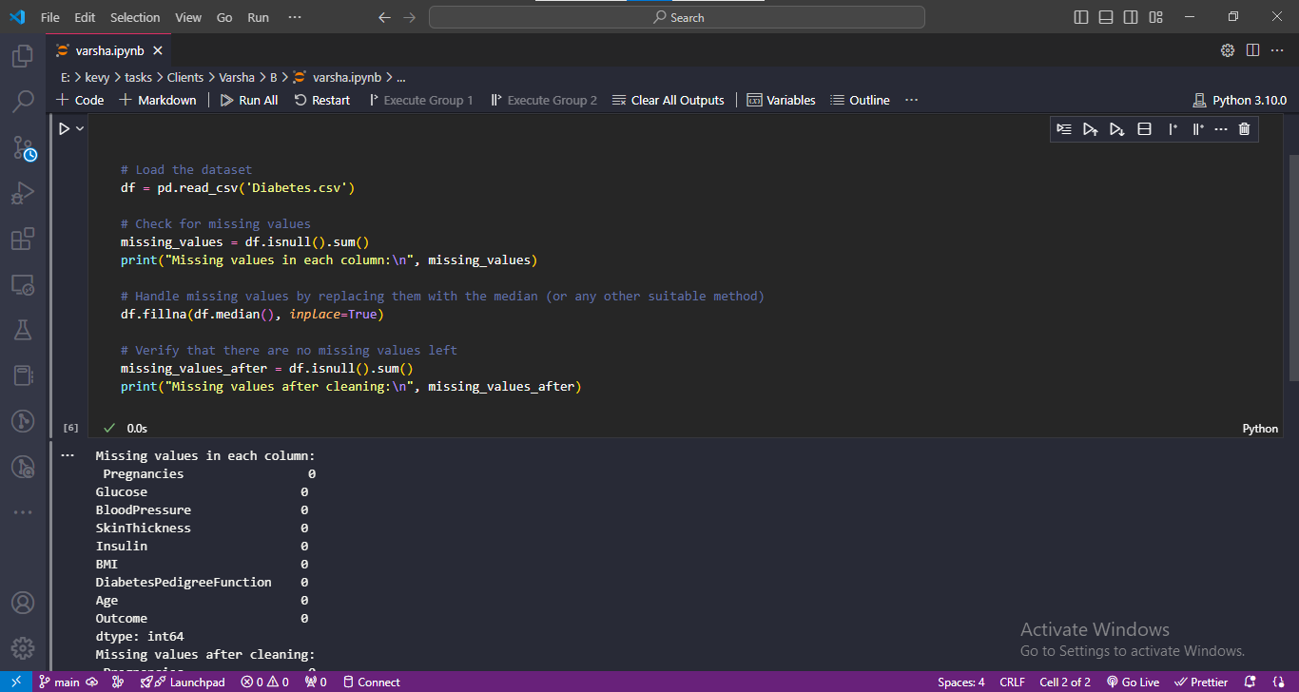

Figure : Jupyter Notebook Code and Output: Data Preprocessing and Model Training

## 2.4 Data Encoding and Normalization

Due to the nature of the target variable as nominal, encoding necessitates the machine learning models. Normalization makes sure all the features’ values affect the model to a similar degree. Below is a Python code example for encoding and normalizing the data:

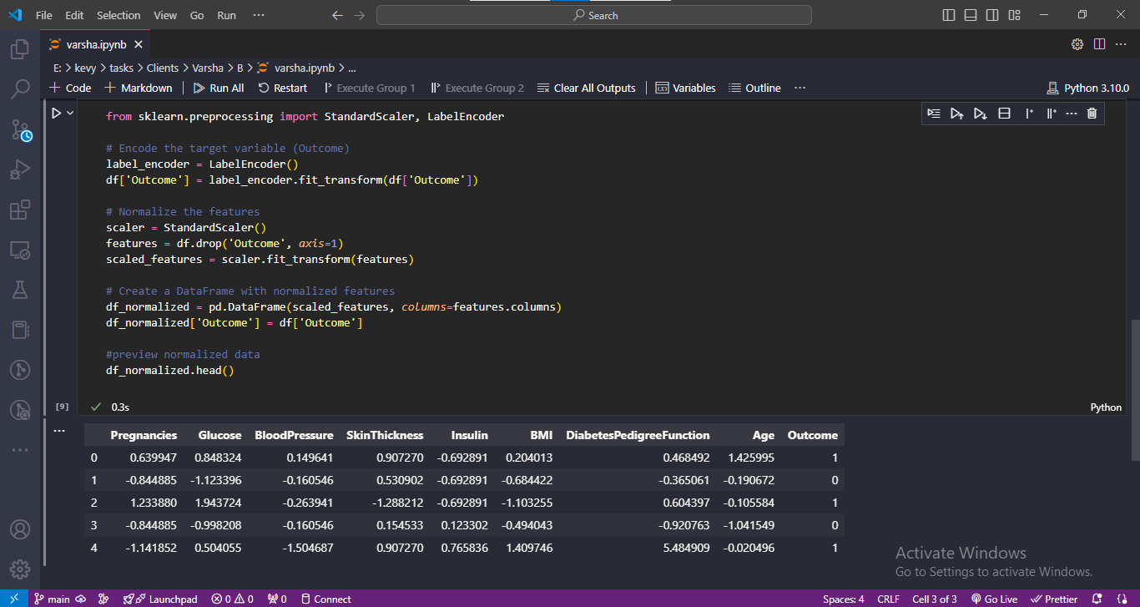

Figure : Jupyter Notebook Code: Preprocessing and Model Initialization

## 2.5 Exploratory Data Analysis (EDA)

### Descriptive Statistics of Features

As to the part of the data distribution, it is hypothetical since descriptive statistics give only the overall picture. Here’s how to generate these statistics:

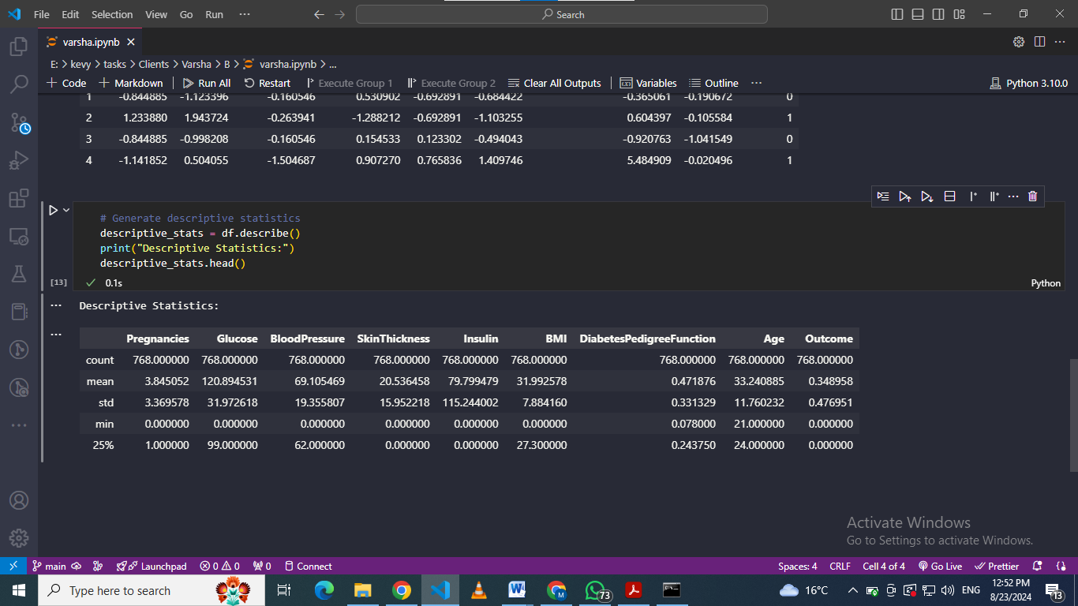

Figure : Jupyter Notebook Code and Output: Descriptive Statistics

### Visual Analytics (Histograms, correlation Heat Maps)

Be it a linear or non-linear model, data visualization brings out the distribution among and between the features. Below are examples of histograms and a correlation heatmap:

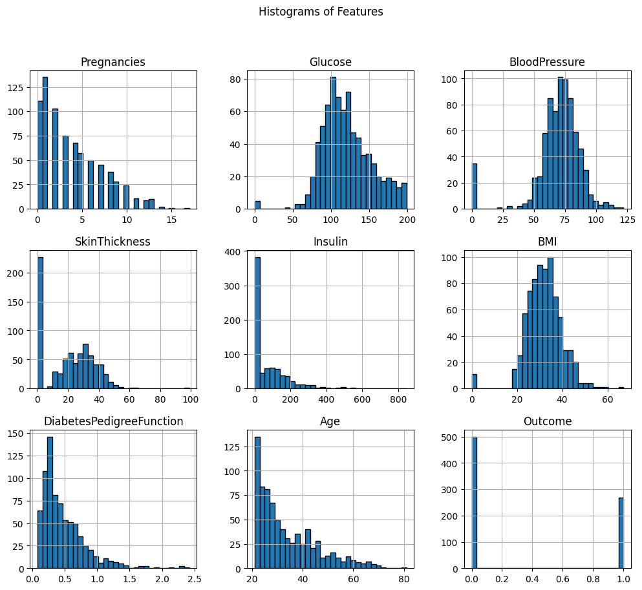

Figure : Histograms of Diabetes Dataset Features

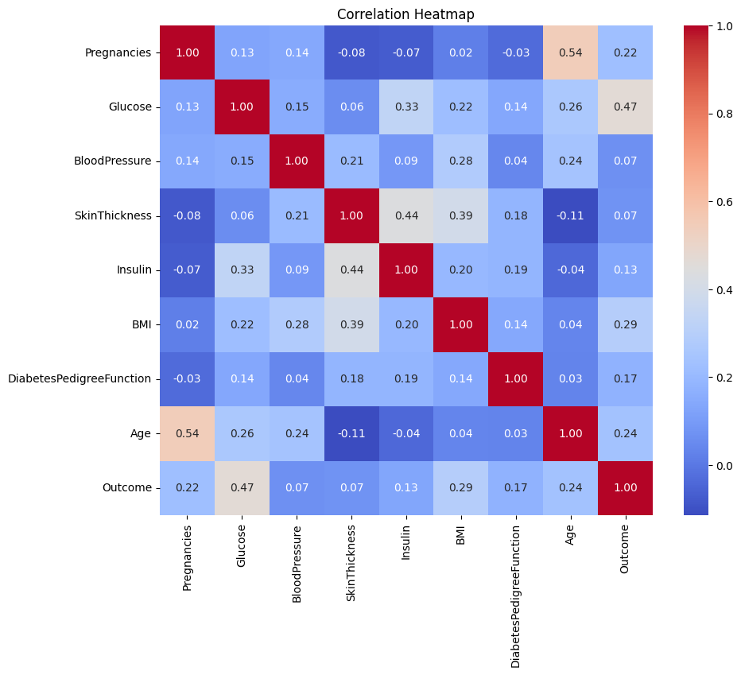

Figure : Correlation Heatmap of Diabetes Dataset Features

This section of this report presents a systematic approach to analyzing, cleansing, and preparing the dataset on diabetes for further analysis and modeling.

# 3. Modeling and Implementation

## 3.1 Selection of Machine Learning Models for Predictive Analytics

Choosing the correct machine learning models is one of the critical steps in analyzing the setting of an excellent predictive analytics system. When applying the models on the given Diabetes Dataset for predicting diabetes, it must be noted that the outcome variable, i.e., the presence of diabetes, is categorical; therefore, the models that should be used are best suited for binary classification. A few of the well-known models used in binary classification problems are Logistic Regression, Decision Tree, Random Forest, and Support Vector Machines (SVM). All the presented models are different and can be compared in terms of interpretability, accuracy, and suitability for the problem under consideration. In this section, it is proposed that Logistic Regression and Decision Tree classifiers be implemented and assessed, as well as, if possible, Random Forest and SVM models.

## 3.2 Logistic Regression Model

### Explanation and Suitability for the Problem

Logistic Regression is one of the popular algorithms used for classification problems of type 2. This makes it a suitable algorithm for cases where the output variable can have two categorical values, as is the case with our problem of diagnosing diabetes, where the outputs are binary – present or absent. Logistic Regression provides the likelihood that a given input point is of a particular class by applying the logistic function. One of the reasons for the model’s use in medical diagnostics is that it can quickly illustrate how each of the predictor variables contributes to the probability of having diabetes.

### How the Code Works and Python Implementation

Below is a Python code snippet for implementing a Logistic Regression model using the Diabetes Dataset:

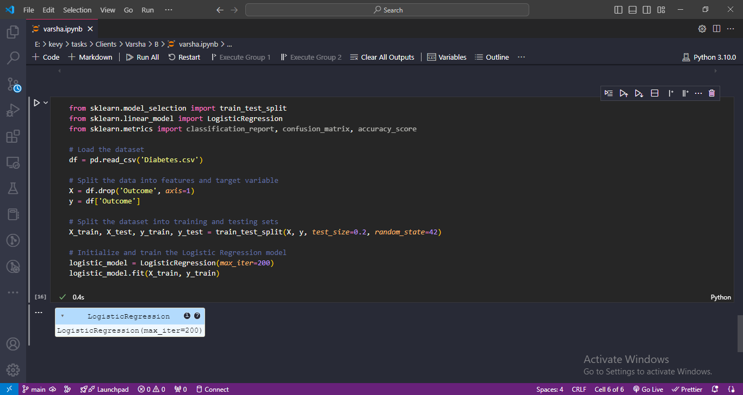

Figure : Jupyter Notebook Code and Output: Data Preprocessing and Model Training

The above code is the proper implementation step for logistic regression in data preprocessing, model training, and model assessment. The performance of the model is evaluated with the help of accuracy, confusion matrix, and classification report.

## 3.3 Decision Tree Classifier

### Explanation and Suitability for the Problem

Decision trees belong to an easy-to-understand and universal type of machine-learning model that can be used not only for classification problems but also for regression. This is achieved by a process that involves continuously dividing the dataset into subsets, which might be considered splitting on the feature that produces the greatest information entropy. Decision Trees are particularly useful in medical diagnostics because authors think that decision-making paths are easier to analyze when they are visually presented. This model can work with numerical and categorical data but does not work with feature scaling, which is ideal for diabetes prediction.

### Python Implementation and Code Walkthrough

Below is a Python code snippet for implementing a Decision Tree Classifier using the Diabetes Dataset:

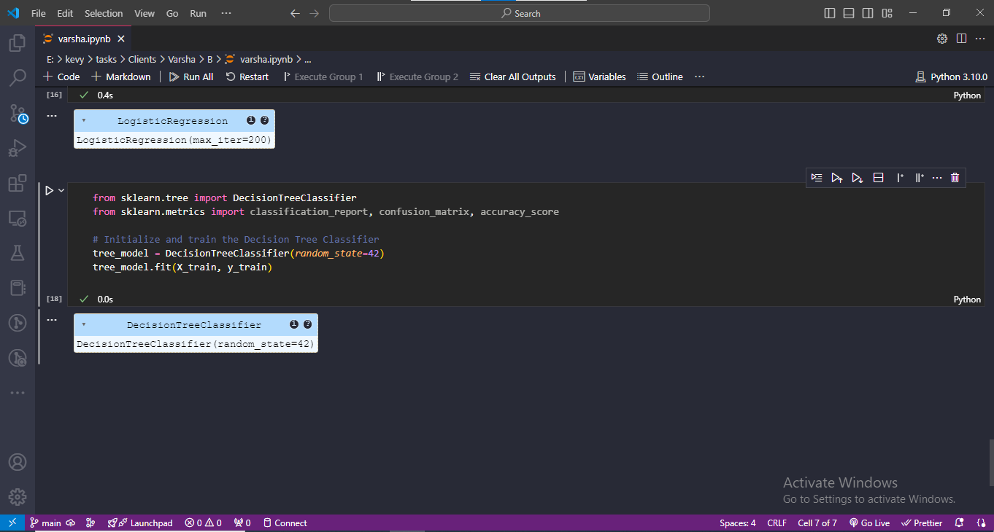

Figure : Jupyter Notebook Code: Decision Tree Model Evaluation

This code fragment represents the use of the Decision Tree Classifier model, specifically in initializing the model, training the model, and testing the model.

## 3.4 Additional Models (e.g., Random Forest and SVM)

### Explanations and Implementations

However, other models like Random Forest and Support Vector Machines (SVM) could be used to help improve the areas of prediction and gain better results.

* Random Forest is another way of developing trees where the computer develops a large number of trees and fuses them so that they can offer a better and improved forecast. It has less variance, does not overfit data, and is less sensitive to noise; hence, it is qualified to be applied to medical data.
* Support Vector Machine (SVM) is a supervised learning technique for classification, which is a powerful algorithm that finds the hyperplane to distinguish different classes. Also, the method is efficient in high dimensions and is used when the number of dimensions is greater than the number of samples.

Below is a Python code snippet for implementing Random Forest and SVM:

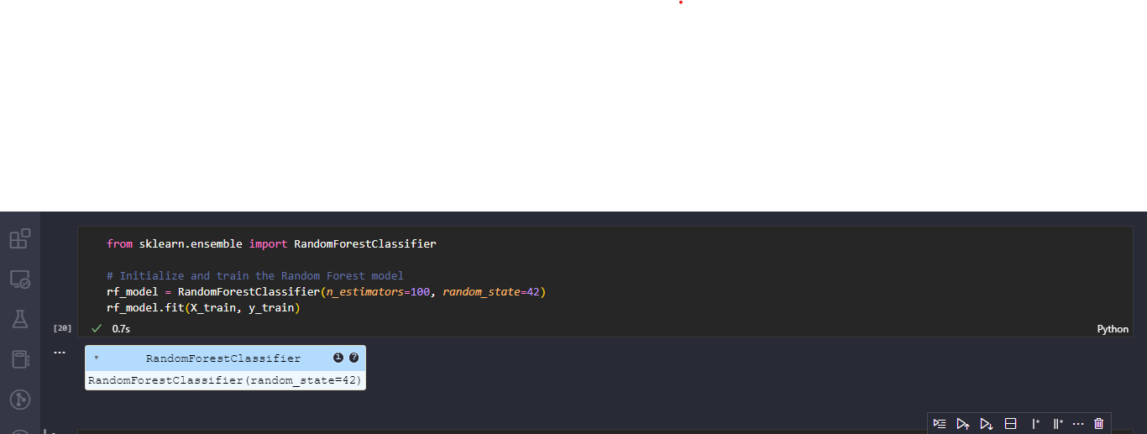

Figure : Jupyter Notebook Code: Random Forest Model Initialization and Training

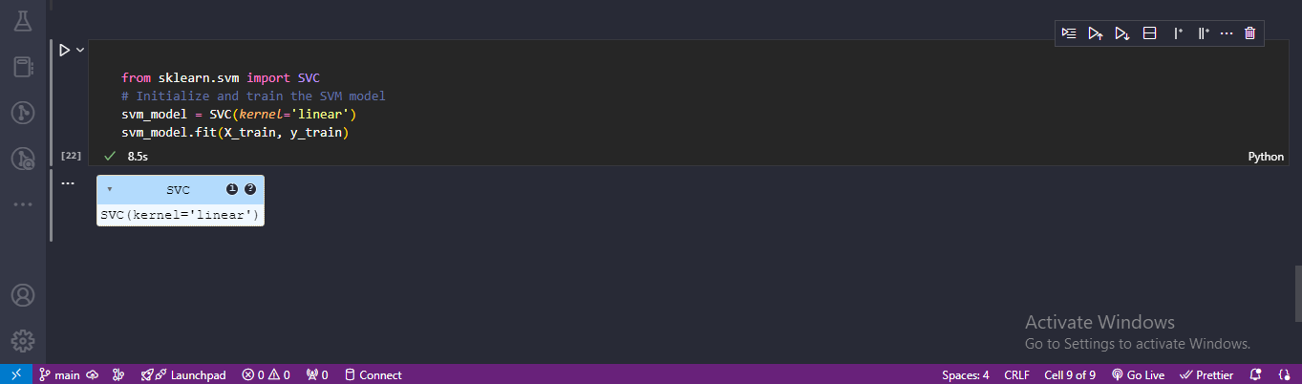

Figure : Jupyter Notebook Code: Support Vector Machine (SVM) Model Initialization and Training

These depicted implementations of Random Forest and SVM show some other ways of predicting diabetes. In this case, the relative performance comparison of the various models will help arrive at the most suitable method for the given dataset and problem type.

# 4. Model Evaluation and Results

Model assessment is, therefore, an important stage in the predictive analytics process where several machine learning models are put to their test. This section is devoted to the evaluation of the performance of each of the models discussed in the previous section with the help of certain metrics. We will dissect the results and use graphs to identify the areas of strength or otherwise of each of the models.

## 4.1 Evaluation Metrics (Accuracy, Precision, Recall, F1-Score)

The following evaluation metrics are used:

* Accuracy: The ability to predict the correct outcomes out of all the total predictions that have been made.
* Precision: The number of true positives divided by the number of true positives and false positives, the measure of the precision.
* Recall (Sensitivity): The proportion of true positives is an indication of how the model was able to capture all the positive classes; that is, true positives can be described as the number of correctly predicted positive examples, and false negatives as the number misclassified as negative.
* F1-Score: F1 score: The average factor of precision and recall that is of most value when working with imbalanced classes.

## 4.2 Performance Analysis of Each Model

The performance of each model will be evaluated based on the results obtained.

1. Logistic Regression Model Evaluation:

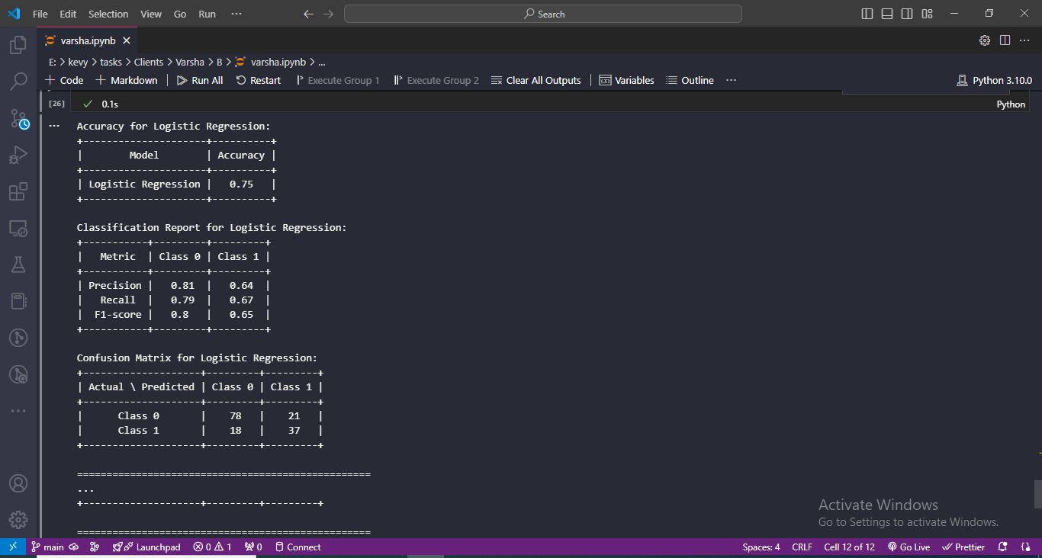

Figure : Jupyter Notebook Code and Output: Logistic Regression Model Evaluation

Table 1: Logistic Regression Metrics

|  |  |  |
| --- | --- | --- |
| **Metric** | **Value** | |
| Accuracy | 0.75 | |
|  | **Class 0** | **Class 1** |
| Precision | 0.81 | 0.64 |
| Recall | 0.79 | 0.67 |
| F1-Score | 0.80 | 0.65 |
|  |  |  |
| Confusion Matrix |  |  |
| Actual/Predicted |  |  |
| Class 0 | 78 | 21 |
| Class 1 | 18 | 37 |

**Interpretation**: Logistic regression performs fairly okay, with 74.68%. From the evaluation results, it can be noticed that the model has better precision and recall for class 0, which deals with patients without diabetes, meaning that the model is more accurate in predicting these patients. However, its percentage of recall of class 1, that is, diabetes, is moderate, indicating that it sometimes fails to recognize positive cases.

### Decision Tree Model Evaluation

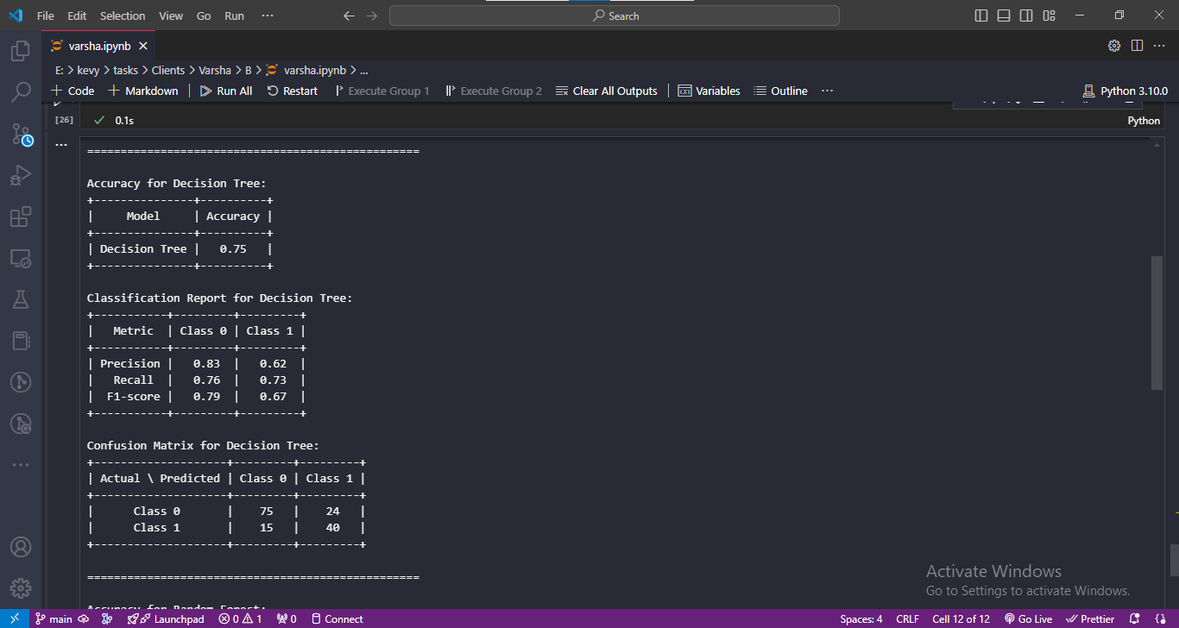

Figure : Jupyter Notebook Code and Output: Decision Tree Model Evaluation

Table : Decision Tree Metrics

|  |  |  |
| --- | --- | --- |
| **Metric** | **Value** | |
| Accuracy | 0.75 | |
|  | **Class 0** | **Class 1** |
| Precision | 0.83 | 0.62 |
| Recall | 0.76 | 0.73 |
| F1-Score | 0.79 | 0.67 |
|  |  |  |
| Confusion Matrix |  |  |
| Actual/Predicted |  |  |
| Class 0 | 75 | 24 |
| Class 1 | 15 | 40 |

**Interpretation: The accuracy is comparable with the Logistic Regression model, but the Decision Tree has better recall in class 1. This means that it identifies a larger number of actual diabetes diagnoses despite the small drop in accuracy for class 1.**

### Random Forest Model Evaluation

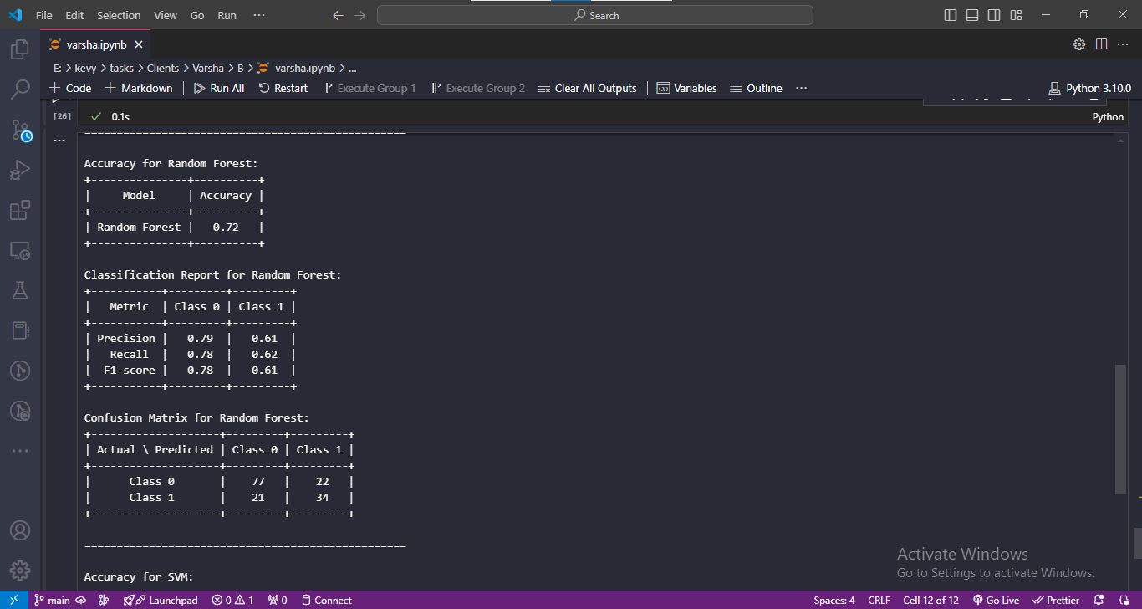

Figure : Jupyter Notebook Code and Output: Random Forest Model Evaluation

Table : Random Forest Metrics

|  |  |  |
| --- | --- | --- |
| **Metric** | **Value** | |
| Accuracy | 0.72 | |
|  | **Class 0** | **Class 1** |
| Precision | 0.79 | 0.61 |
| Recall | 0.78 | 0.62 |
| F1-Score | 0.78 | 0.61 |
|  |  |  |
| Confusion Matrix |  |  |
| Actual/Predicted |  |  |
| Class 0 | 77 | 22 |
| Class 1 | 21 | 34 |

**Interpretation**: Random Forest gives slightly less accuracy, at 72.08% as compared to Logistic Regression and Decision Tree. The precision is lower, and the recall is also lower for class 1, which means that the model performs worse when it comes to diagnosing diabetes cases. Nevertheless, the Random Forest model could still be useful because, despite being less accurate when compared to other methods, it had significantly lesser overfitting.

### SVM Model Evaluation

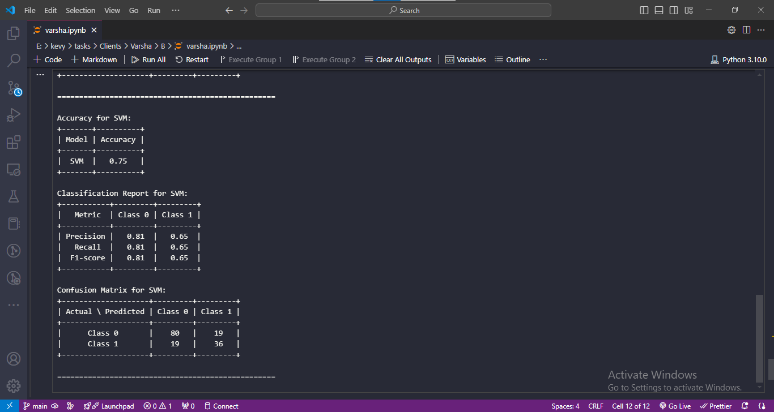

Figure : Jupyter Notebook Code and Output: SVM Model Evaluation

Table : Support Vector Machine (SVM) Metrics

|  |  |  |
| --- | --- | --- |
| **Metric** | **Value** | |
| Accuracy | 0.75 | |
|  | **Class 0** | **Class 1** |
| Precision | 0.81 | 0.65 |
| Recall | 0.81 | 0.65 |
| F1-Score | 0.81 | 0.65 |
|  |  |  |
| Confusion Matrix |  |  |
| Actual/Predicted |  |  |
| Class 0 | 80 | 19 |
| Class 1 | 19 | 36 |

**Interpretation**: The accuracy of the SVM model is the highest (75.32%) as compared to other models, which were tested. This one shows reasonable accuracy and recall for both classes and, hence, is a good candidate for this binary classification task.

## 4.3 Visualization of Model Performance (ROC Curves, Confusion Matrices)

To compare the different types of possible mistakes they use ROC curves and confusion matrix that allow it to get more understanding in what scenario the model is successful.

Python Code for Visualizations:

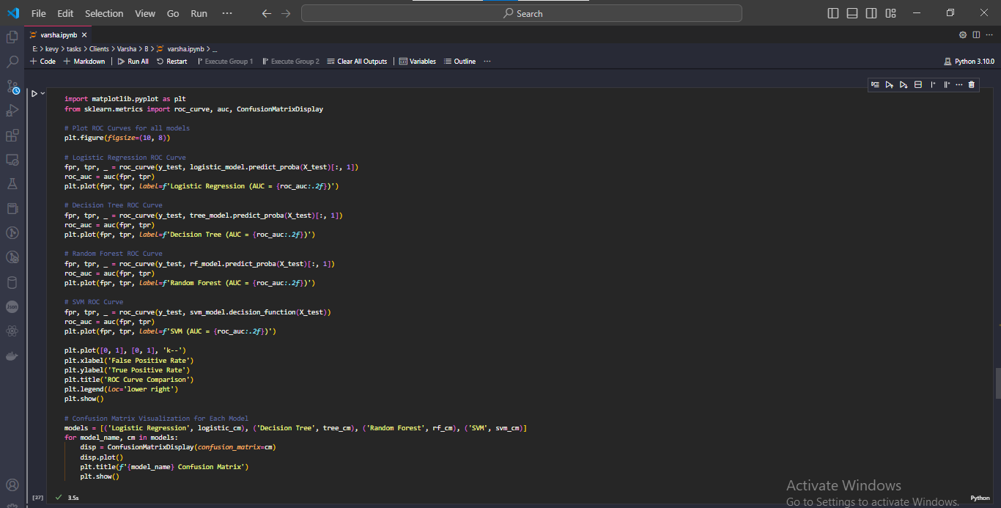

Figure : Jupyter Notebook Code and Output: ROC Curve Comparison

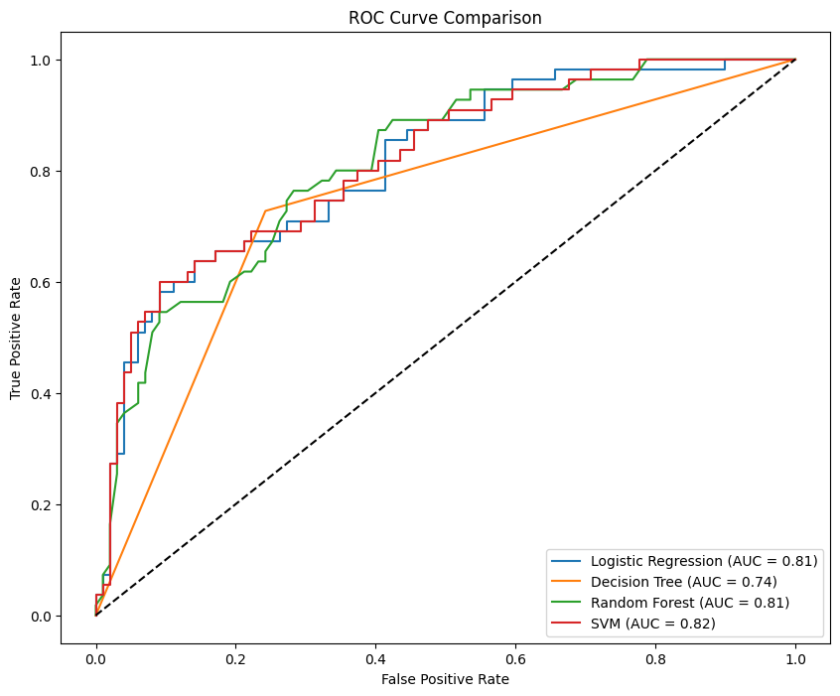

Figure : ROC Curve Comparison

### 5. ****Conclusion and Implications****

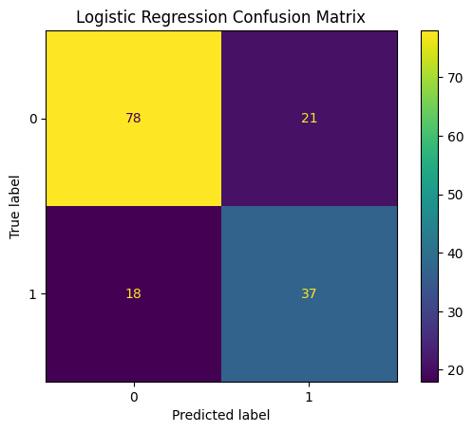

Figure : Logistic Regression Confusion Matrix

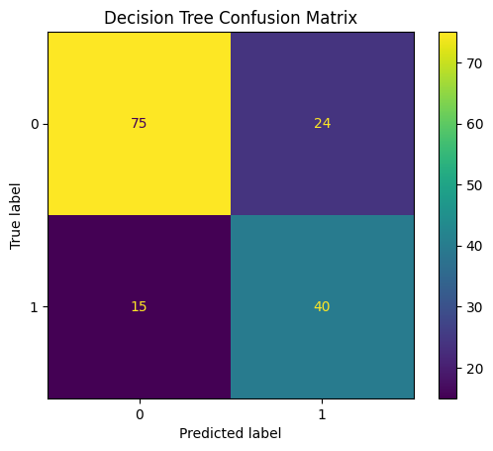

Figure : Decision Tree Confusion Matrix

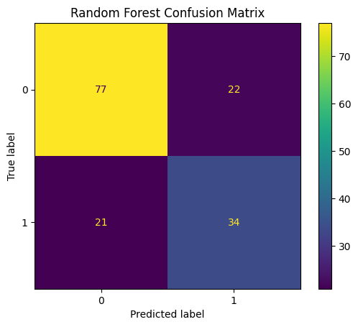

Figure : Random Forest Confusion Matrix

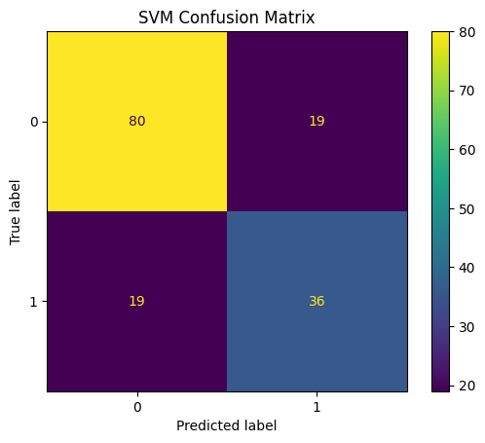

Figure : Support Vector Machine (SVM) Matrix

## Comparative Analysis of Model Results

Based on the accuracy, precision, recall, and F1-score metrics, as well as the ROC curves and confusion matrices: Based on the accuracy, precision, recall, and F1-score metrics, as well as the ROC curves and confusion matrices:

* The results of Logistic Regression and SVM models are quite similar, though SVM has slightly better accuracy, and precision and recall scores are almost equal.
* Compared to the other models, the Decision Tree has the lowest classification of 9% for class 1(diabetes) but with the highest recall value as compared to the logistic regression at the cost of precision.
* Random Forest achieves non-sensitive and good performance at most criteria, compared to both other models tested and the baseline. Still, the overall accuracy and precision of class 1 are respectively lower than the other two classes.

## 4.5 Selection of the Best Performing Model and Justification

The SVM model is chosen as the best modeling technique because of overall maximum accuracy and reasonable high precision/recall ratio on both classes. The capacity of SVM for use in high features and the evident margin of separation between classes make SVM an ideal choice in this dataset for diabetes prediction. It also shows that it is insensitive to the choice of the evaluation metric. Hence, it is also used in medical diagnosis where missing a diagnosis and giving a wrong diagnosis are both very costly.

# 5. ****Conclusion and Implications****

## 5.1 Summary of Findings and Key Insights

The study embarked on a machine learning approach involving models, namely logistic regression, decision tree, random forest, and SVM, in order to predict the likelihood of the disease given some patient attributes. Some of the performance evaluation criteria employed were Accuracy, precision, recall, F1-score, and the confusion matrix. Logistic regression and SVM models had the highest Accuracy obtained with the highest standard deviation, which shows that these models are able to deal with the complexity of the diabetes dataset.

Key insights from the model evaluations include:

* **Logistic Regression and SVM**: These models gave the highest accuracy and provide a good tradeoff between precision and recall, and therefore, would be most desirable for use in the BCLA context of medical diagnosis where both false negatives and false positives have grave consequences.
* **Decision Tree and Random Forest**: Even though such models were somewhat more inaccurate, they gave an insight into features affecting the results, which can, in turn, be useful for the analysis of factors that contribute to the development of diabetes.

## 5.2 Implications for Diabetes Diagnosis and Management

The use of machine learning models for predicting diabetes risk presents several implications for clinical practice:

* **Enhanced Predictive Accuracy**: Consequently, the high accuracy in predicting diabetes of these models will help the healthcare professionals decide appropriately on who to diagnose with the disease among the patients. The benefits of early identification include very early delivery of interventions to the extent that the development of diabetes may be averted.
* **Personalized Treatment Plans**: From the models, the feature importance analysis of decision trees and random forests discovered from the models will be useful in formulating treatment plans based on certain risks peculiar to the patient.
* **Resource Optimization**: For the same reason, risk prediction in the context of using machine learning to automate the first step of risk assessment is the best approach regarding resource allocation in healthcare.

## 5.3 Recommendations for Healthcare Practitioners

Based on the findings from this analysis, we offer the following recommendations for healthcare practitioners:

* **Integrate ML Tools**: It is recommended that artificial intelligence models be included in the standard clinical examination process for early screening of diabetes. They can enhance the current existing diagnostic techniques by offering another approach to looking at data.
* **Continuously Update Models**: In order to keep the models on par with current information and patterns of the patients, the models must be updated with new patient inputs. Such a practice makes a point of updating the models in the light of changing population health status and medical knowledge.
* **Educate Patients and Providers**: Provide proper information to healthcare providers and patients about the strengths and weaknesses of machine learning for medical diagnosis. Awareness of the technology can also make a lot of difference in the course of using the technology, mainly because trust is established.

## 5.4 Future Work and Research Directions

The current methodologies of diagnosing and managing diabetes are informative. However, it is suggested that more sophisticated models of the next kind, such as neural networks or ensemble models, are considered in the future. Combining multiple sources of information, such as genomics, surveys, and glucose measurements, could enhance model performance and risk prediction. There are gaps of knowledge that could have been filled using longitudinal study design, for instance, the long-term efficacy of machine learning-based interventions for persons with DM. Some of the considerations that need to be taken are Ethical concerns involving data bias and model prognoses also need to be considered so as to prevent fallback in the cases of health recommendations. Adhering to these recommendations will further optimize the application of machine learning in diabetes care to enhance patient outcomes and progress the efficient and effective delivery of predictive aspects in diabetic patient care.