**Sustainable Drug Release and**

**Making PU(Polyurethane) foam**

A progress report submitted in partial fulfilment of the CP301 project

by

**Kewal singh (2022MMB1383)**

Under the Guidance of

# Dr. ATHARVA POUNDARIK



DEPARTMENT OF METALLURGICAL AND

MATERIALS ENGINEERING

**INDIAN INSTITUTE OF TECHNOLOGY ROPAR**

**May 2025**

# Executive Summary

**Background:** Sustained drug release systems are essential for maintaining consistent therapeutic levels and improving patient compliance. Polyurethane (PU) foam is a promising material due to its tunable structure, biocompatibility, and ability to provide controlled drug delivery. Utilizing biodegradable PU foams also supports environmental sustainability in pharmaceutical applications

**Problem Statement:** polyurethane (PU) foam drug delivery systems face challenges in precisely controlling drug release rates and ensuring complete biocompatibility with minimal inflammatory response, limiting their clinical applicability.

**Hypothesis:** Optimizing the porosity and chemical composition of biodegradable polyurethane foam will enable controlled, sustained drug release while maintaining biocompatibility and reducing side effects.

**Conceptual Approach:**

* Drugs are incorporated into PU foam during synthesis or by post-fabrication soaking.
* The foam’s porous structure enables gradual and controlled drug diffusion.
* Foam properties like pore size and hydrophilicity are tailored to adjust release rates.
* Biocompatible and customizable PU foam can be shaped for specific medical applications

**Preliminary Work:** Initial work involved synthesizing drug-loaded polyurethane (PU) foam samples and conducting in vitro studies to observe their drug release behavior under controlled conditions. Early results demonstrated that PU foam’s structure and composition significantly influence the rate and pattern of drug release.

**Impact:** PU foam-based drug delivery systems provide sustained, controlled medication release, improving patient outcomes.

**Table of Contents**

|  |  |  |
| --- | --- | --- |
| LIST NO | CONTENT | PAGE NO |
| 1 | PROJECT REPORT | 1 |
| 2 | EXECUTIVE SUMMARY | 2 |
| 3 | TABLE OF CONTENT | 3 |
| 4 | INTRODUCTION | 4 |
| 5 | LITERATURE REVIEW | 5 |
| 6 | CHALLENGES IN LITERATURE REVIEW | 7 |
| 7 | EXPERIMENT | 8 |
| 8 | PU FOAM | 9 |
| 9 | CALCULATION | 10 |
| 10 | OPTICAL MICROSCOPY | 12 |
| 11 | RESULTS | 13 |
| 12 | OBSEVATIONS | 14 |
| 13 | PRPOSED WORK | 15 |
| 14 | SUMMARY | 15 |
| 15 | REFERENCE | 16 |

# CHAPTER 1 Introduction

Biodegradable polymeric foams, such as those based on polyurethane (PU), are increasingly explored for sustainable and efficient drug delivery due to their tunable structure and biocompatibility. Incorporating carboxymethyl cellulose (CMC) into PU foam further enhances its properties: CMC acts as a renewable feedstock that improves thermal stability, water absorption, and swelling capacity, making the composite foam highly suitable for medical applications like wound dressings and controlled drug release. The combination of PU and CMC results in a superabsorbent, porous material that can retain and gradually release therapeutic agents, while also supporting environmental sustainability through the use of biodegradable and renewable components

**Challenges and Importance**

* **Mechanical Limitations:** PU foams modified with CMC and other cellulose derivatives often exhibit lower fatigue and tear resistance compared to conventional materials, which can limit their durability in demanding biomedical application.
* **Foam Stability and Compatibility:** Achieving uniform dispersion and compatibility of CMC within the PU matrix can be challenging; improper incorporation may lead to phase separation, collapse during curing, or compromised foam structure.
* **Processing Constraints:** High concentrations of cellulose-based additives can increase viscosity, making foam formation more difficult and potentially resulting in non-uniform cell structures or reduced mechanical strength .
* **Performance Trade-offs:** While biobased modifications enhance sustainability, they may also lead to decreased stiffness, lower yield strength, and difficulties in meeting established standards for foam density and closed-cell content.
* **Extractability and Binding:** Not all cellulose derivatives are fully bound in the foam; some remain extractable, which can affect the stability and long-term performance of the drug delivery system.

**Importance**

Incorporating carboxymethyl cellulose (CMC) into polyurethane (PU) foam significantly enhances the foam’s biocompatibility, liquid absorption, and swelling capacity, making it highly effective for medical applications such as wound dressings and drug delivery systems. The superabsorbent and shape-retaining properties of CMC-PU foams not only expedite healing by efficiently managing wound exudate but also support environmental sustainability through the use of biodegradable and renewable materials.

| **Application Area** | **Description & Examples** |
| --- | --- |
| **Wound Care** | Used in wound dressings and negative pressure wound therapy (NPWT) due to high absorbency and moisture control. |
| **Orthopedic Supports** | Provides cushioning and support in splints, casts, braces, and positioners[1](https://www.pfa.org/medical-case-study/)[5](https://foamtecmedical.com/polyurethane-foam-the-chameleon-of-medical-foam/). |
| **Medical Device Components** | Used in catheters, tubing, surgical drapes, and as coatings for probes and gloves for biocompatibility. |
| **Implants & Prosthetics** | Short-term implants, artificial hearts, pacemaker insulation, and prosthetic liners due to biocompatibility and durability. |
| **Mattresses & Cushions** | Hospital bedding, wheelchair cushions, and mattress toppers for pressure relief and patient comfort. |
| **Packaging & Protection** | Protects delicate medical instruments and devices during storage and transport. |
| **Surgical Sponges & Swabs** | Highly absorbent foams used for fluid removal and infection control during surgical procedures. |
| **Respiratory Devices** | Filters and humidifiers in respiratory care, benefiting from PU’s airflow and moisture retention. |
| **Biodegradable & Antimicrobial Products** | Eco-friendly, single-use medical products and antimicrobial foams for infection control. |

# CHAPTER 2 Literature Review

## 

Hydrogels are three-dimensional polymer networks capable of absorbing significant amounts of water or biological fluids. Their biocompatibility, soft tissue-like consistency, and tunable properties make them suitable candidates for controlled drug delivery, biomedical engineering, and environmental applications.

**1. Carboxymethyl Cellulose (CMC)-Based Hydrogels**

Carboxymethyl cellulose (CMC) is a biodegradable, water-soluble polysaccharide derived from cellulose. In the study by Lima et al. (2020) [*HidrogelCMC (2).pdf*], CMC was used to synthesize superabsorbent hydrogels with nanocellulose (NC) as reinforcement and citric acid as a crosslinking agent. The synthesis involved the use of eco-friendly components and methods, aligning with sustainability objectives in material development.

**Composition Summary**

* **CMC**: 2wt%
* **Citric Acid (Crosslinker)**: 3 wt%
* **Nanocellulose (NC)**: 0%, 5%, 10%, ,15 wt%,20%
* **Solvent system**: Acetone and distilled water

**Key Characteristics**:

* **Swelling Capacity**: Highest at 10% NC classifying them as superabsorbent.
* **Mechanical Strength**: Improved significantly with NC addition.
* **FTIR**: Confirmed esterification and hydrogel crosslinking .
* **Morphology (SEM)**: Porous and interconnected structure, suitable for drug diffusion.
* **pH Responsiveness**: Effective swelling in pH 4 and 7 environments.

These properties render the hydrogel suitable for controlled drug release, especially in agricultural and pharmaceutical contexts.

**2. Sustainable Polyurethane Foams as Complementary Material**

IN the development of polyurethane foams (PUFs) using fully renewable polyester polyols derived from sorbitol. While not hydrogels, these PUFs highlight sustainable approaches to polymer production and provide context for eco-friendly materials in biomedical applications.

**Key Points**:

* Polyester polyols were synthesized via esterification without toxic catalysts.
* High biobased content achieved: final foam formulation.
* Chemical and physical blowing agents (water )influenced foam structure and kinetics.
* Resulting materials showed good mechanical, thermal, and processing properties.

This study supports the broader theme of using renewable feedstocks in functional polymer systems, relevant for scaffolds or matrices in drug delivery.

**3. Supportive Calculations and Analysis**

The *Calculations.pdf* file includes theoretical and empirical formulations for polyurethane materials and contributes to the validation of chemical ratios and swelling behavior predictions for CMC-based systems. These calculations assist in:

* Balancing component weights and ratios in hydrogels.
* Modeling swelling index and gelation time based on component variation.
* Estimating reinforcement effects of NC on hydrogel behavior.

Such quantitative data provide a useful foundation for scaling up lab-scale formulations into practical biomedical or environmental solutions.

**Challenges in Literature Review**

**1. Limited Drug Release Data**

Although the hydrogel systems developed by NC showed promising swelling behavior and mechanical stability, they lack specific data on drug encapsulation and release profiles. Most studies focus on water absorption rather than tracking the controlled release of actual therapeutic compounds under physiological conditions.

**2. Optimization Trade-offs**

The incorporation of nanocellulose enhances mechanical strength but introduces a trade-off with swelling capacity. At higher NC concentrations over-crosslinking reduces porosity and water uptake, which could impair drug diffusion. Achieving the optimal balance between strength and swelling remains a key challenge.

**3. Environmental and Toxicological Uncertainties**

While the polyols and crosslinkers (e.g., citric acid) are biobased, **toxicological assessments** of the final hydrogel matrix (especially with NC or residual solvents) are rarely conducted. Long-term environmental impact studies are also missing, particularly for large-scale applications such as agricultural water retention or packaging.

**4. Incomplete Characterization Metrics**

The literature often reports **qualitative findings or limited mechanical testing**. Standardized mechanical testing under simulated body conditions (e.g., tensile strength, compression, viscoelasticity under hydration) are essential but often not included or incomplete.

**5. Comparability Across Studies**

Different studies use **non-uniform terminology, testing conditions, and formulations**, making cross-comparisons difficult. For example, swelling tests conducted at different pH levels or durations make it hard to benchmark hydrogel performance across different research groups.

# CHAPTER 3 EXPERIMENT

The chemical composition of the medium manganese steel sample used in this study is: **Table Sample Composition**

|  |  |
| --- | --- |
| **Component** | **Typical Amounts/Concentrations** |
| CMC | 2% |
| NaOH | 5-35% |
| Stearic acid | 0.1-0.4 g |
| Solvent | 20–100 mL |
| Water (for washing) | As needed |
| Acetone/Ethanol/Methanol | For washing/precipitation |

## ➢ Sample Preparation

1. Cellulose was added to 100 mL of isopropanol in a reaction vessel and stirred.
2. A 30% NaOH solution was added slowly to the suspension while stirring continuously for 30–60 minutes at room temperature.
3. Stearic acid was added to the CMC mixture.
4. The reaction was maintained at 60–70°C for 3–4 hours with continuous stirring.
5. After completion of the reaction, the mixture was cooled to room temperature.
6. After that add the water CMC crosslinker measure the weight swelling.
7. And also measure degradation at 60degree Celsius .

• 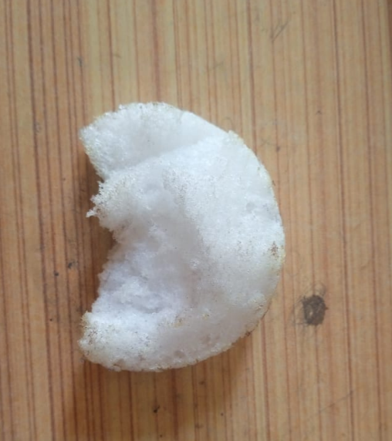

**(a)**

**PU FOAM**

**1. Materials Used**

| **Component** | **Purpose** |
| --- | --- |
| **Polyol** | **Base material for foam matrix** |
| **Isocyanate** | **Crosslinking agent** |
| **Blowing Agent** | **Creates foam structure** |
| **Catalyst** | **Speeds up reaction** |
| **Surfactant** | **Stabilizes foam cell structure** |
| **Optional Additive** | **For drug loading, color, or property tuning** |  |

**2. SAMPLE PREPARATION**

**Mixing of Polyol and Additives**

* Polyol was taken in a clean beaker.
* Catalyst, surfactant, blowing agent, and any additives were added to the polyol and stirred vigorously using a mechanical or magnetic stirrer for 2–3 minutes**.**

**Step 2: Addition of Isocyanate**

* The required amount of isocyanate was added quickly to the polyol mixture.
* The entire mixture was stirred rapidly for about 10–30 seconds to ensure uniform reaction**.**

**Step 3: Pouring and Foaming**

* The reacting mixture was poured into a mold or allowed to freely rise in an open container.
* Foam formation occurred within 1–2 minutes due to the gas released by the blowing agent.
* The foam was left to expand and set for approximately 15–30 minutes.

**Step 4: Curing**

* The foam was cured at room temperature (25–30°C) or in an oven at 50–70°C for 24 hours to ensure complete crosslinking and removal of any residual reactants.

**Step 5: Cutting and Storage**

* After curing, the foam was demolded and cut into desired sample dimensions using a sharp blade or hot wire cutter.
* Samples were stored in airtight containers to avoid moisture absorption before further testing.

**CALCULATION CMC:-**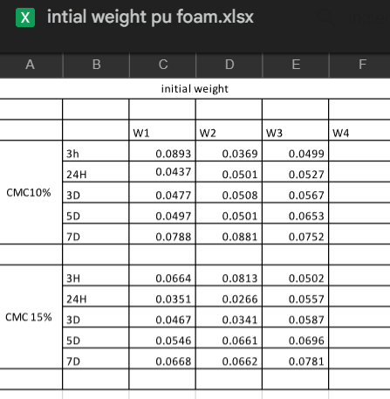

**(A)**

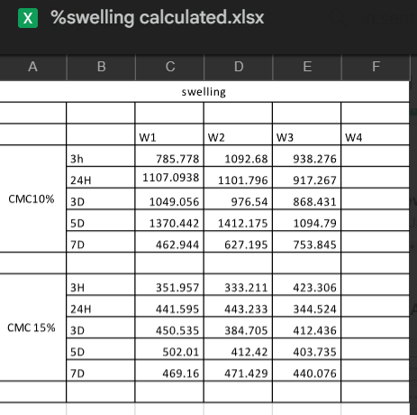

**(B)**

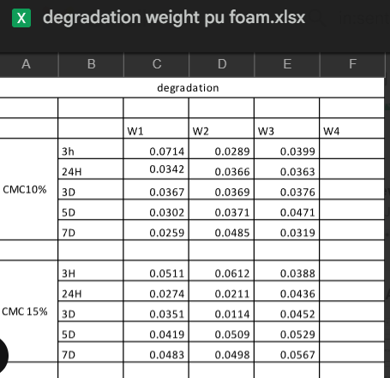

**(C)**

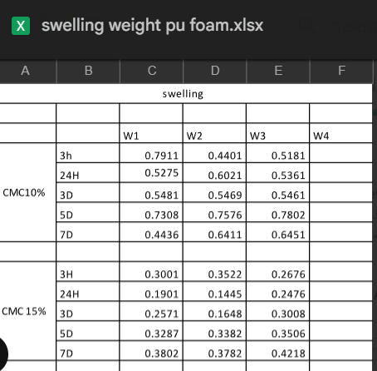

**(D)**

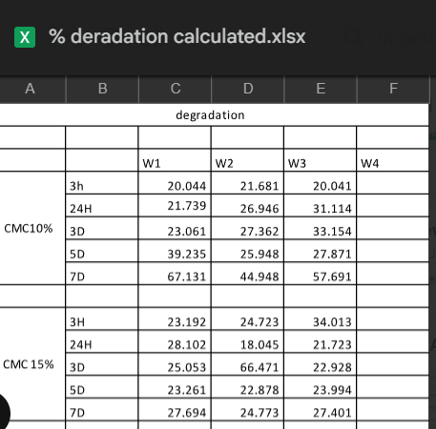

## OPTICAL MICROSCOPY METHODOLOGY

**Sample Preparation for Microscopy**

1. **Sample Preparation**
   * Cut PU foam into thin, flat slices to ensure even illumination and clear imaging.
   * Ensure the sample surface is clean and free from dust or loose particles.
2. **Microscope Setup**
   * Use a standard optical microscope (light or stereomicroscope) with suitable magnification (typically 10x–40x for foam structure).
   * Employ contrast enhancement techniques such as phase contrast, polarization, or digital filters if needed to better visualize cell boundaries.
3. **Image Acquisition**
   * Capture digital images of multiple representative regions of the foam to account for structural inhomogeneity.

4. **Image Processing and Analysis**

* Import images into image analysis software (ImageJ).
* Apply preprocessing steps such as grayscale conversion, background correction, and thresholding to distinguish pores from the matrix.
* Use algorithms to calculate morphological parameters:
  + Surface porosity (fraction of area occupied by pores)
  + Pore area and size distribution
  + Shape factor (to assess pore irregularity

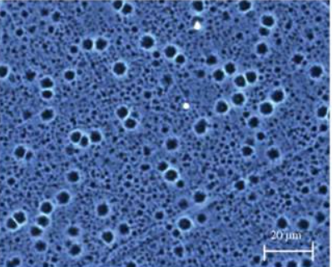

**(a)**

## Results And Observations:

**Polyurethane (PU) foam** exhibits a range of mechanical physical, and thermal properties that make it suitable for various industrial applications.

Mechanical Properties

* **Density Impact**: PU foam properties are highly dependent on density.

**Compression and Tension**:

* + Higher-density foam has greater compressive and tensile strength compared to lower-density foam .kg/m
  + Tensile strength parallel to foam rise: 0.79 MPa (62 kg/m³).

**Anisotropy**: PU foam shows anisotropic behavior, with strength properties higher in the direction of foam rise.

**Fatigue Resistance**: Under repeated loading permanent deformation occurs if compressive stress exceeds 0.25 MPa Below this threshold, the modulus of elasticity remains stable.

**Thermal Properties**

* **Thermal Conductivity**: Rigid PU foam has very low thermal conductivity, typically in the range of 0.022–0.028 W/mK, making it highly efficient as an insulation material.
* **Thermal Stability**: The closed-cell structure enhances insulation performance and resistance to environmental factors.

## ➢ Observations

**SEM images** provide detailed visualization of the microstructure of PU foam, showing the size, shape, and distribution of pores (cells) within the foam.

* SEM images help quantify parameters like surface porosity, pore area, and shape factor, which are critical for predicting the foam's mechanical and filtration properties.
* The presence of irregularly shaped pores and variations in pore area are often observed, influenced by the foam's formulation and processing conditions.
* With higher magnification, finer details of the cell walls and the internal structure become apparent, aiding in the assessment of foam uniformity and defect analysis.

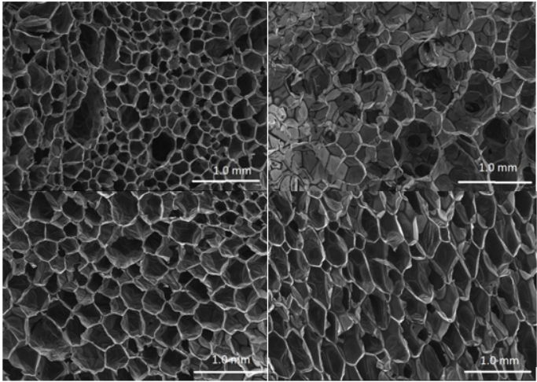

**DSC analysis** measures the heat flow associated with thermal transitions in PU foam, such as glass transition temperature (T*g*), melting, and crystallization

* The glass transition temperature (Tg) is a key parameter for PU foam, indicating the temperature range where the foam transitions from a rigid to a more rubbery state. Rigid PU foams typically show a lower *Tg* when flexible polyols are used in the formulation.
* DSC curves for PU foam often display a baseline shift at T*g*, and sometimes melting or crystallization peaks, depending on the foam's composition and crosslinking.
* The absence of thermal transitions in the negative temperature region (below 0°C) suggests suitability for cryogenic applications.
* The position and size of these features provide insights into the thermal stability and flexibility of the foam.

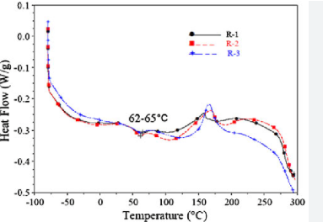

# CHAPTER 4 Proposed Work

1. Synthesize biodegradable polyurethane (PU) foam composites incorporating carboxymethyl cellulose (CMC) to enhance biocompatibility, absorption, and sustainability.
2. Optimize the foam’s porous structure and mechanical properties for efficient drug loading and sustained, controlled drug release.
3. Characterize the physical, chemical, and biological properties of the developed PU-CMC foams using techniques such as SEM, FTIR, swelling tests, and in vitro drug release studies.
4. Evaluate the drug release kinetics and biocompatibility of the foams for potential use in wound dressings, tissue scaffolds, and other biomedical applications.
5. Compare the performance of PU-CMC foams with conventional PU foams to demonstrate improvements in drug delivery efficiency, patient comfort, and environmental impact.

# CHAPTER 5 Summary

Polyurethane (PU) foam is a highly versatile, biocompatible material widely used in medical and healthcare applications due to its flexibility, durability, and ability to be engineered for specific properties. In medicine, PU foam serves crucial roles in wound dressings, orthopedic supports, prosthetics, surgical sponges, and protective packaging for delicate instruments. Its porous, absorbent structure promotes faster wound healing by managing moisture and exudate, while its softness and customizable firmness provide patient comfort and support. PU foam does not typically trigger allergic reactions, resists microbial growth, and can be formulated to be antimicrobial or biodegradable, making it suitable for both short-term implants and eco-friendly, single-use products. Ongoing research continues to expand its applications in drug delivery, tissue engineering, and advanced medical devices, highlighting PU foam’s importance in modern healthcare

# CHAPTER 6 References

1. **Polyurethanes in Biomedical Applications**  
   Nina M.K. Lamba, Kimberly A. Woodhouse, Stuart L. Cooper  
   CRC Press, 1998  
   *Comprehensive coverage of PU chemistry, synthesis, and biomedical device applications, including biocompatibility and manufacturing methods.*
2. **Polyurethanes in Medicine**  
   M.D. Lelah, S.L. Cooper  
   CRC Press, 1986  
   *Classic text detailing the development, properties, and medical uses of polyurethanes, including foams and elastomers.*

**Research Papers**

1. **Developments of polyurethane in biomedical applications: A review**  
   ScienceDirect, 2023  
   *Summarizes recent progress and applications of PU in wound dressings, sensors, orthopedics, and cardiovascular devices.*
2. **Biomedical Applications of Polyurethanes**  
   Bergeron, Lévesque, Guidoin  
   *Discusses PU’s unique structure, mechanical properties, and its role in cardiovascular, reconstructive, and tissue engineering applications.*
3. **Cytotoxic Properties of Polyurethane Foams for Biomedical Applications**  
   Polymers (MDPI), 2023  
   *Examines the mechanical properties and biocompatibility of PU foams used in medical devices.*[4](https://www.mdpi.com/2073-4360/15/12/2754)
4. **PU Foam for Controlled Topical Drug Delivery Systems**  
   Foamtec Medical, 2024  
   *Explores PU foam’s use in drug delivery patches, roll-ons, swabs, and its ability to provide sustained drug release.*
5. **The state-of-art polyurethane nanoparticles for drug delivery applications**  
   Frontiers in Chemistry, 2024  
   *Reviews PU nanoparticles for drug delivery, including preparation, properties, and targeted delivery strategies.*