LOLCODE Markdown Grammar Validation
Project 1 Phase 1 – ANTLR Test Evidence
Kiara Watson
COSC 455 – Programming Languages: Design and Implementation
Fall 2026

Validation approach
I generated the lexer and parser from LOLCODEMarkdown.g with the ANTLR 3 tool used in class. I then ran two legal programs and three illegal programs through the generated recognizer. The tests cover every required annotation, case-insensitive tags, variable definitions and uses, list structure, nested-block restrictions, and an unknown annotation.
Test file | Expected | Actual | Purpose
valid_all_features.lol | Accept | Accepted | Exercises all Phase 1 annotations and a local variable.
valid_scope_structure.lol | Accept | Accepted | Checks lowercase tags and nested variable definitions.
invalid_item_outside_list.lol | Reject | Rejected | A list item cannot appear outside a list.
invalid_nested_paragraph.lol | Reject | Rejected | A paragraph cannot contain another paragraph.
invalid_unknown_annotation.lol | Reject | Rejected | #HEY is not a legal lexical token.

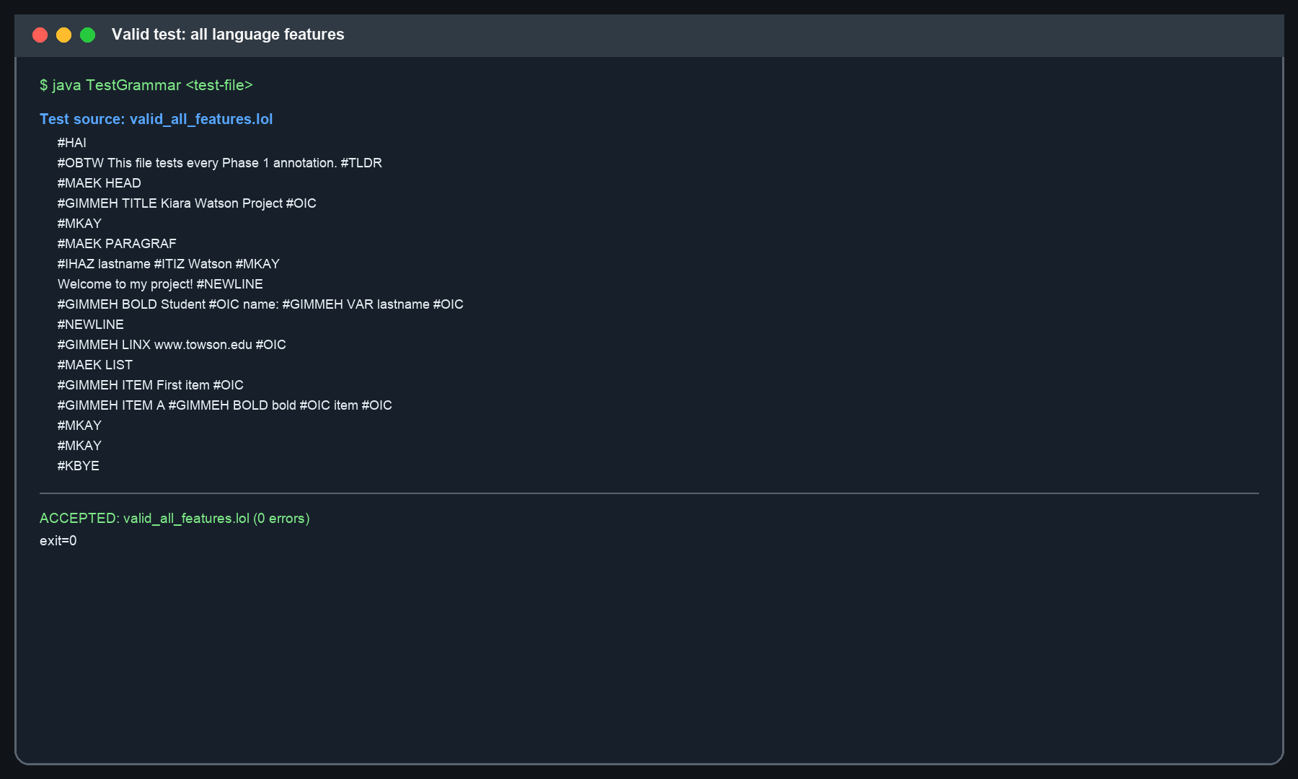

Valid case-insensitive and scope-structure test
This program uses lowercase annotations and defines myname in the document and again inside a paragraph. Phase 1 validates its lexical and syntactic structure; static scope resolution is implemented later.
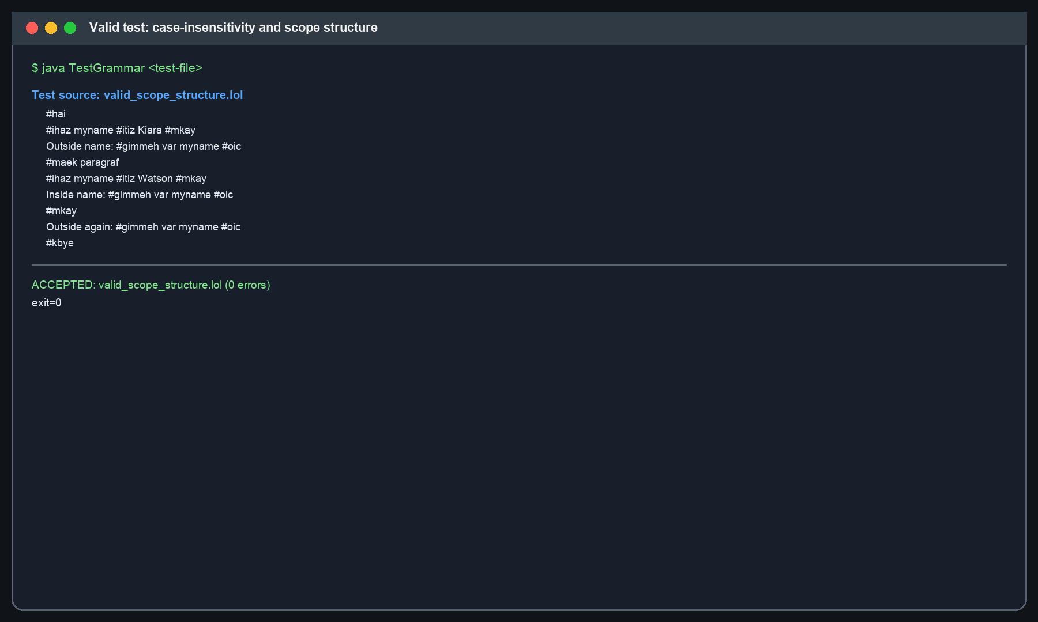

Invalid-case evidence
The recognizer rejects a misplaced item, a nested paragraph, and an unknown annotation. These cover both syntax errors and a lexical error instead of only testing successful inputs.
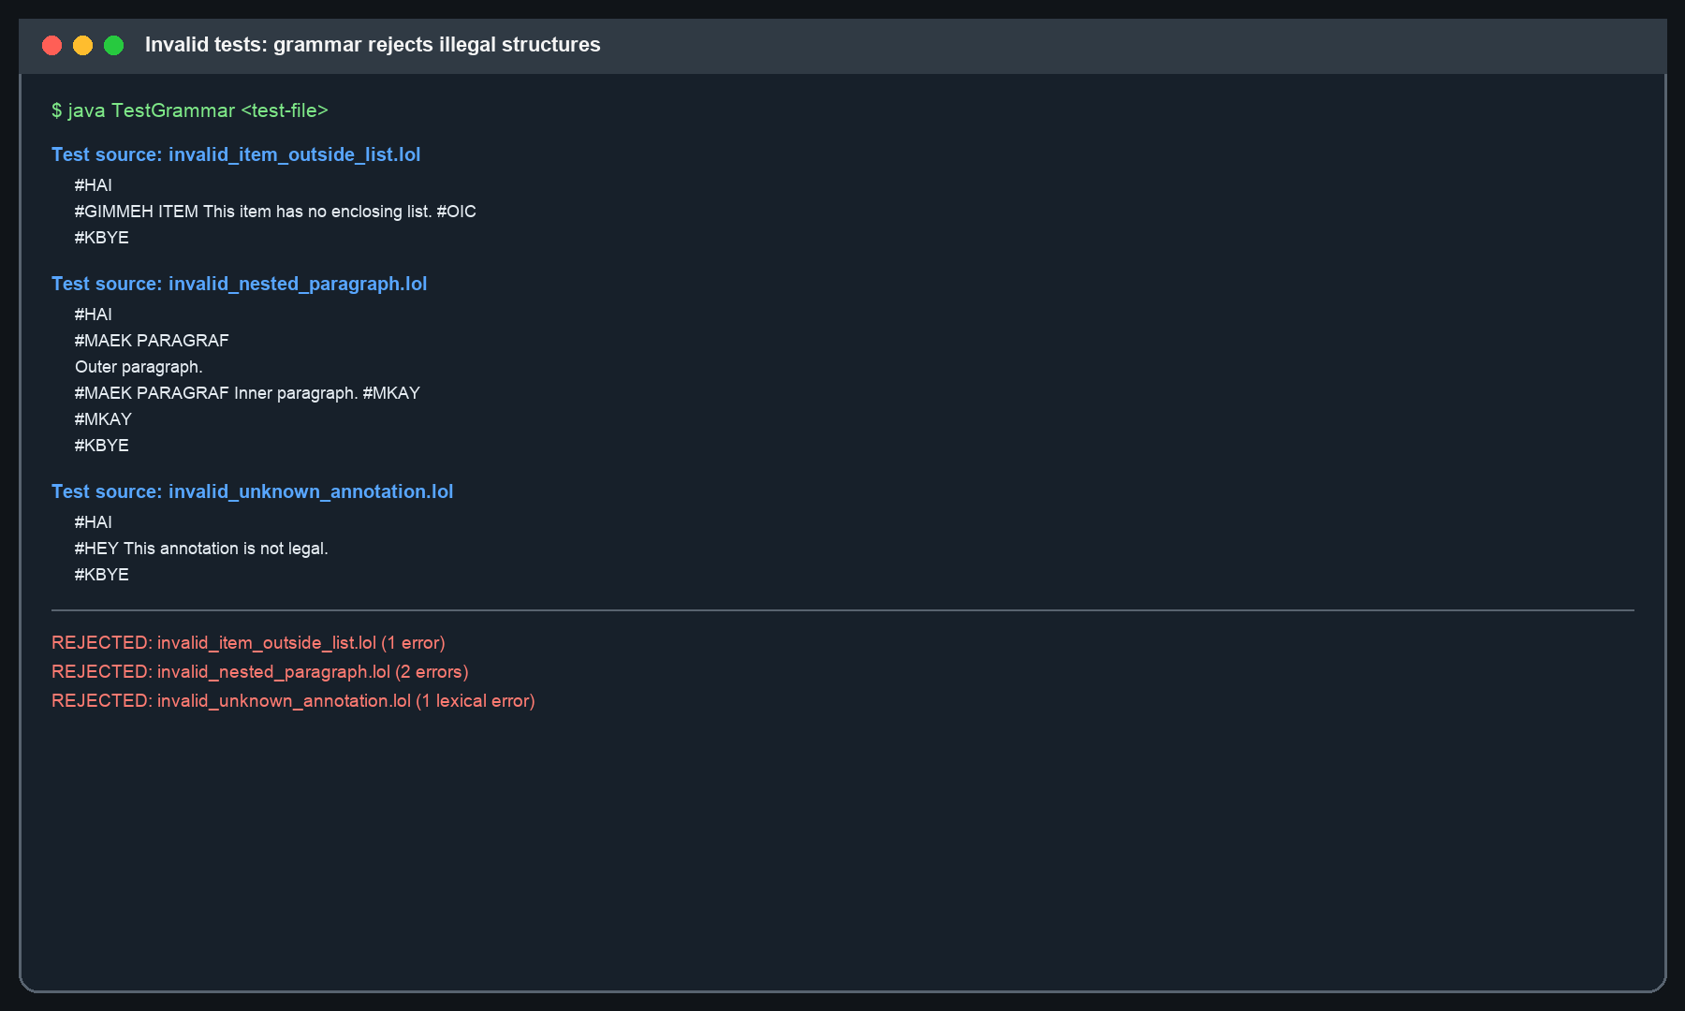

Result
All expected outcomes matched the actual results: both legal programs were accepted, and all three illegal programs were rejected.

