Portfolio 1:

Intelligent Tutoring System for Practical Rhetorical Structure Theory

The initial reason for building this intelligent tutor is to make learning RST more engaging and efficient. Rhetorical Structure Theory (RST) is a linguistics framework, frequently used in information retrieval area, that focuses on identifying relations between sentences. RST, while being a useful framework, has very few learning materials other than academic papers or textbook. Since I personally spent two whole days reading academic paper trying to learn it, which was unengaging and laborious, I decided to explore ways to make the RST learning process more effective and interesting.

The strength of this intelligent tutoring systems is threefold. Firstly, it adopts mastery learning and use adaptive problem selection with problems involving unmastered skills, in order to ensure learners reach mastery in each relation. Secondly, the problems are presented from easy to hard, and give adaptive feedback to ensure learners stay on the right track. Thirdly, it is held on a public server, Tutorshop, which enable its free accessibility by anyone interested in learning or teaching RST.

Cognitive Task Analysis method: Think aloud

Interface: three iteration

Report: Here is the final report for the intelligent tutoring system, which includes our template for CTA (Think Aloud), CTA transcription, Knowledge Component (KC) model and production rules.

Below are how you can play with this tutor:

1. Go to Tutor shop:

<https://school.tutorshop.web.cmu.edu>

2. Use the username and password to log in

Username:

Password:

3.From the Menu on the left hand side, choose Packages, search for “”, click in, go to problem sets, click the green triangle under

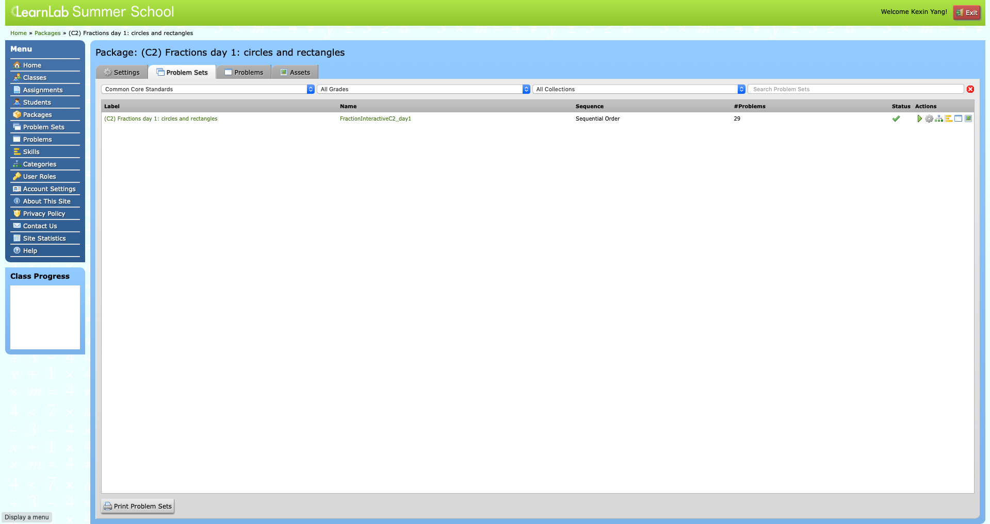

Portfolio 2: Intelligent tutoring system in STEM Area

Here present some small class projects of intelligent tutoring system in STEM area, including math, chemistry and biology. These intelligent tutoring systems demonstrate some features of adaptivity in problem-specific feedback, allowing multiple paths and mastery learning with skill and KC modeling.

Tutor 1:

Domain: Math/ Chemistry:

This intelligent tutoring system aims at teaching students how to do dosage calculation for medicine.

[Tutor 2 Interface]

The feature of this intelligent tutoring system is its ability of 1) calculating for students and 2) mass production.

1. Calculating for Students:

This means when students type in a textInput box a formula such as 120\*3, if the right answer is indeed 360, the tutor can do the calculation for the students and recognize this as correct answer. This function makes use of the AlgEval() algorithm inside CTAT.

2. Mass Production: This is a function made possible by Cognitive Tutor Authoring Tools (CTAT). This enables people to create multiple questions using the same interface components, same production rules, or .brd file. Only thing people need to do is to substitute the problem specific information in the excel form as shown below, in order to create multiple problem in the same nature.

Tutor 2:

Domain: Math

This is a rule-based cognitive tutor that guide users to a little magic in math, by calculating with ease the square of any number ending in 5, no matter how big the number is.

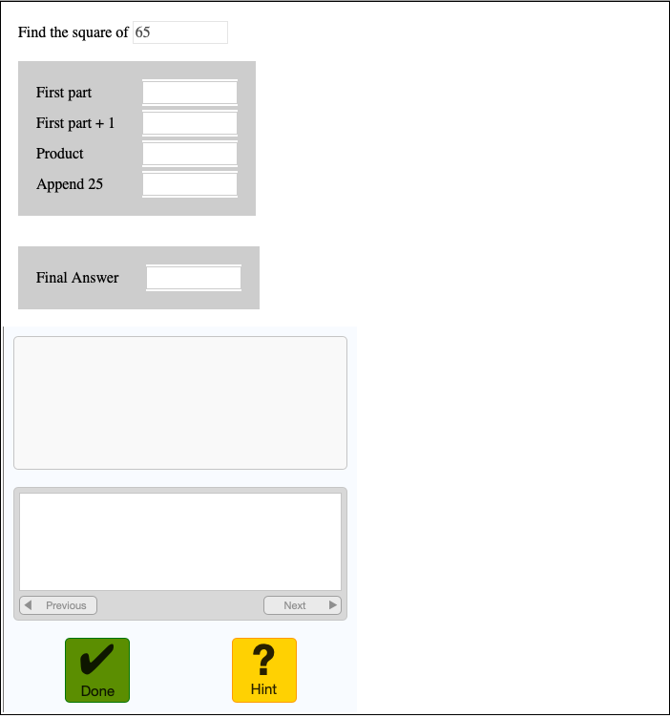

[tutor 3 interface. png]

Tutor 2:

Domain: Math

This is a more sophisticated, rule-based cognitive tutor that decompose proportion problems into inner loops (steps), to guide learners extract information, use common multiple, use common factors, and compare options. Using this tutoring system, it is possible to mass produce problem files with problem specific information, without changing the interface, to practice the same or similar KCs.

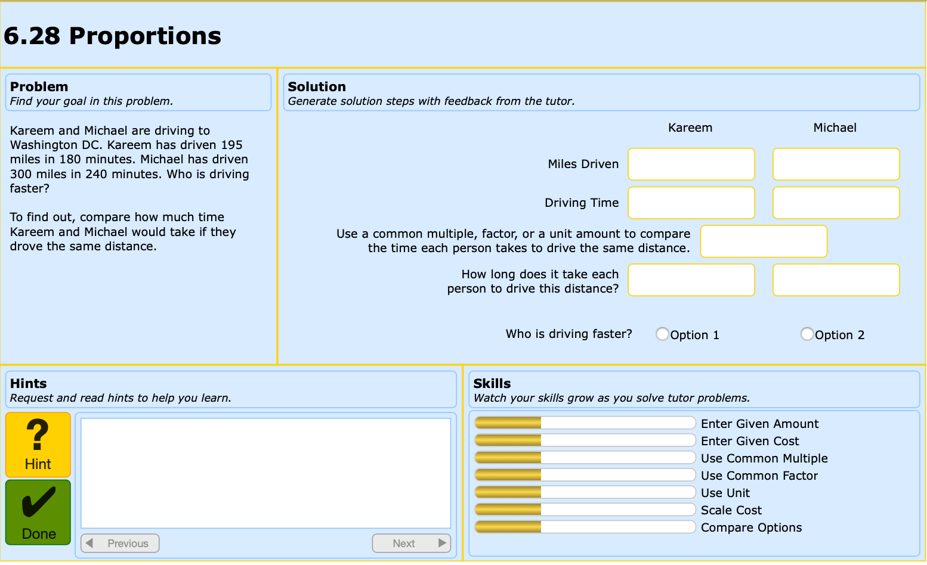

Tutor 4:

Domain: Biology

This is an interesting rule-based tutor that teach students about Mendelian principles of genetic transmission. This tutor guide students to deduct the genotype of each strain based on the proportion of offspring, coming from each cross between two strains (self-cross accepted).

Special feature about this tutor is that it will force students to make all deduction about the genetype, be it partial conclusion or final conclusion about the strains involved in last round of crossing, before carrying on to the next round of crossing.

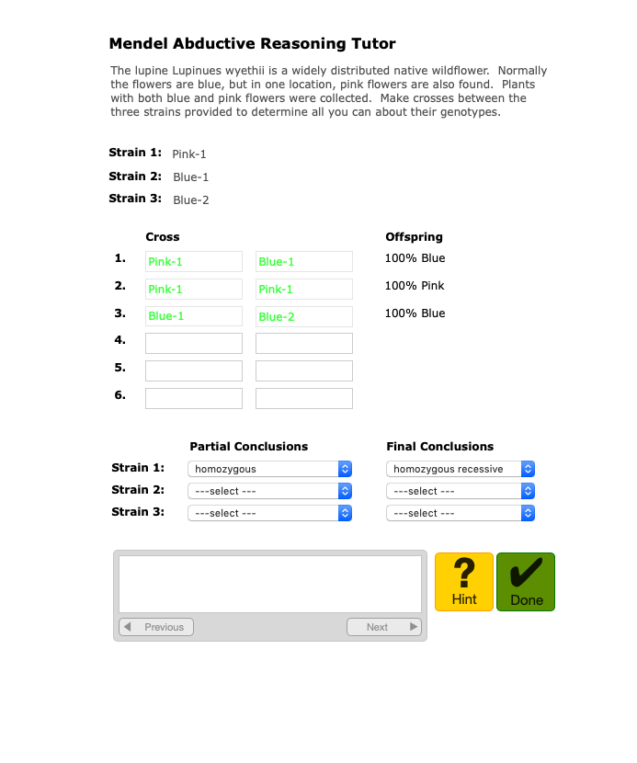

Portfolio 3: Data Visualization

This project involve educational data mining and visualization. In this project advised by Dr. Adam Perer from Human-Computer Interaction Institute in CMU, I explored ways to visualize learning pathways of students who are enrolled in a blended course Principle of Computing in Python. Using D3, tableau and other interactive data visualization tools, me together with my teammates try to visualize students’ data in order to give educators evidence-based recommendation about teaching. This work is submitted to the EdViz workshop in conjunction to 2019 Learning Analytics and Knowledge Conference.

The project is documented in detail here:

<https://metals-ids-18fall.github.io/student-pathway/>

Portfolio 2:

Predicting Organization Score

In a Machine Learning course taught by Dr. Carolyn Rose in CMU, I explored ways of using machine learning methodology to predict the organization score in students’ essays.

Portfolio 3: Argumentative writing Lesson Design

This is a final project for an indispensable, core course for the METALS master program in Carnegie Mellon University, Educational Goals, Instruction and Assessment, taught by Dr. Sharon Carver and Dr. Lauren Herckis.

In this project, I applied the backward design methodology and designed a 10-hour course in argumentative writing for Grade 11-12. I highlighted three phases, namely, learners in context, Goals, Assessment, Instruction and Research& Evaluation. The project draw on educational big ideas from *Understanding by Design* by Grant Wiggins and Jay McTighe, and *The ABC of How we Learn* written by Daniel L. Schwartz, Jessica M.Tsang and Kristen P. Blair*.*

In this project, every phase of educational design is justified by rigorous theoretical support, through many times of iteration, under supervision of Dr. Sharon Carver and Dr. Lauren Herckis in CMU.

Poster: Here is a poster that I presented in Carnegie Mellon University on Dec. 11th 2018.

Here is the 80 pages report:

Research 1:

This research, under the supervision of Dr. Carolyn Rosé from Language Technology Institute in Carnegie Mellon University, aims to make essay grading process more efficient for teachers using text-mining and deep learning technologies. This project is funded by Schmidt Family Foundation and is in collaboration with Turnitin, a language technology company. In the project, I applied Rhetorical Structure Theory (RST) in decomposing students’ essays to give structural feedback. Based on empirical experience, we developed two deliverables to benefit other researchers, including a flowchart and a guideline for RST annotation in the context of student essays. We are now working on parsing to scale up this work using neural networks. This research will be directly applied to the Turnitin company and produce visible results in their essay grading process.

Since this is still unpublished work, the two coding manuals are for now confidential. In specific circumstances, I will consider sharing upon request.

My personal journal for this research project is documented here, a little cluttered, but recorded my first three months journey of this research project.