NeutralVault — Consortium Scam Intelligence Without a Trusted Operator
Team C0NC3PT SQUAD · RMIT Hackathon 2026, Challenge 2: Build Without Blind Trust (TideCloak)
1. The problem
- Fraud spreads faster than any single institution sees it. A mule account flagged by one bank can keep operating at another bank, an e-wallet or a telco, because each organisation only sees its own signals.
- Sharing today means trusting a middleman. A central pool or portal operator holds the database and the keys, so it can read every report, decide who joins and change the rules on its own. A breach or rogue insider at that one party exposes everyone.
- Members can't trust each other with evidence either. Supporting evidence is sensitive; members need a hit/no-hit answer without handing raw account data and case files to competitors.
2. Our solution
NeutralVault is a shared mule-account intelligence workspace for banks, telcos and e-wallets in which the operator is removed as a trusted party. It covers seven workflows:
- Report: an analyst files an account, reason, severity and evidence. The browser computes a keyed HMAC index and encrypts the content before submission; the server only stores ciphertext and hashes.
- Check (Tier 1): another member looks up an account and sees whether it was reported, with reason, severity, reporter and date — never the evidence.
- Disclose (Tier 2): evidence release needs approval from the reporting organisation plus an independent, non-requesting organisation. No self-approval; only the requester gets a 30-minute window.
- Govern: admitting an organisation or changing sharing rules needs a strict majority of active members, one vote per organisation.
- Operator Console and Audit Trail: the host sees only stored ciphertext; self-grant and unilateral-approval attempts are submitted for real and rejected; every check, report, decision and vote is written to a hash-chained ledger with a Verify hash chain button.
3. Value and impact
- Faster detection: one member's report becomes every member's early warning across banking, telco and e-wallet rails.
- Breach-resistant by design: dumping the database reveals ciphertext and opaque index hashes, not account numbers or evidence.
- Shared, not seized, control: no single bank, admin or operator can grant itself access or rewrite membership. This makes it easier for competitors to cooperate.
- Honest privacy: evidence is released case-by-case with justification and expiry instead of bulk data sharing.
4. Why TideCloak is essential
Swap test: with a normal identity provider and a database-held key, the operator holds the key and the “dump the database” moment fails. TideCloak is what makes it true:
- BYOiD login: each analyst signs in with their own Tide identity; there is no shared password database to steal. Server APIs verify tokens, DPoP proofs, roles and organisation membership.
- Policy-controlled encryption: reports, the shared HMAC index key and evidence are encrypted through Tide's doEncrypt/doDecrypt with signed policies bound to a record, so the host never holds a usable key. Evidence is sealed under a write-only policy naming the submitter.
- Decentralised authority: IGA quorum-approved role changes stop admin self-grants; Forseti custom contracts are the target for distinct-organisation approval, requester binding and 30-minute expiry.
5. What is real vs. mocked/simulated
- Real: Next.js + Prisma/SQLite persistent multi-user app; local TideCloak realm (rmithackathon) with roles, organisation groups, DPoP and an exported adapter; server-side token/DPoP verification; browser Tide SDK helpers with signed policy bytes; hash-chained audit; operator ciphertext view.
- Simulated (Sample workspace, clearly labelled): fictional in-memory records using browser AES-GCM and HMAC with temporary local keys; the member selector, approvals and evidence windows do not authenticate Tide users or issue Tide grants.
- Not yet live: Tide owner account linking failed on the network (TIDE-TIDEJS-SIG-BLIND_VERIFY_FAILED), so cross-user shared encryption, quorum disclosure release and governance commitment stay fail-closed. Recorded votes go to “awaiting Tide commitment” and never change membership locally.
- Known limits: the audit chain is tamper-evident, not immutable; a member insider with the index key could brute-force low-entropy account numbers (roadmap: private set intersection); expiry cannot erase evidence already viewed.

Prototype walkthrough (screenshots from the running app at localhost:3000)
All screens below except Figure 1 are the clearly labelled Sample workspace (synthetic data, resets on reload, separate from TideCloak), viewed as Bank B · Requester. Every page carries 'Synthetic data only' and 'Sample workspace' badges.
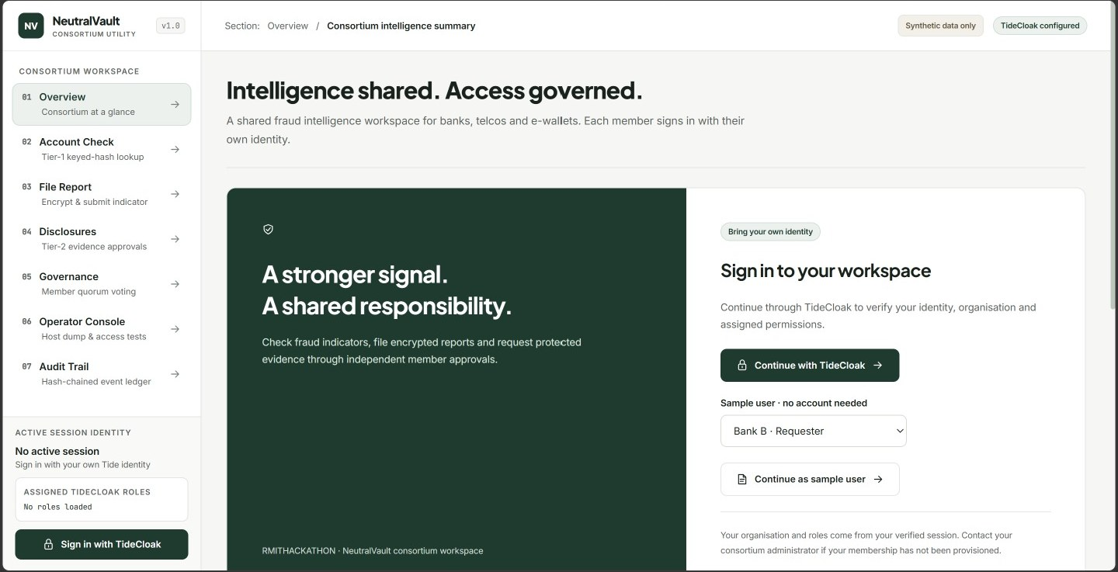
Figure 1. Sign-in. 'Continue with TideCloak' starts real BYOiD login; the sidebar shows no session or roles until a verified token arrives. 'Continue as sample user' opens the separate sample workspace.
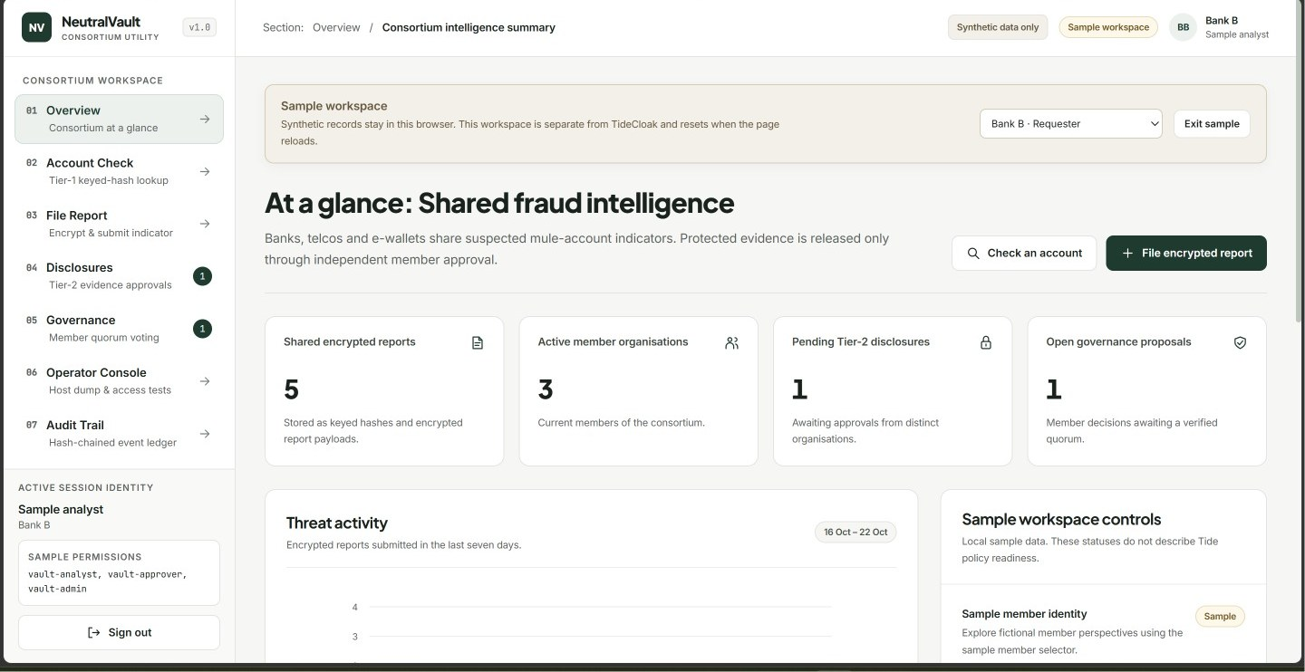
Figure 2. Overview. Consortium at a glance: 5 encrypted reports (stored as keyed hashes and ciphertext), 3 active members, 1 pending Tier-2 disclosure and 1 open governance proposal.
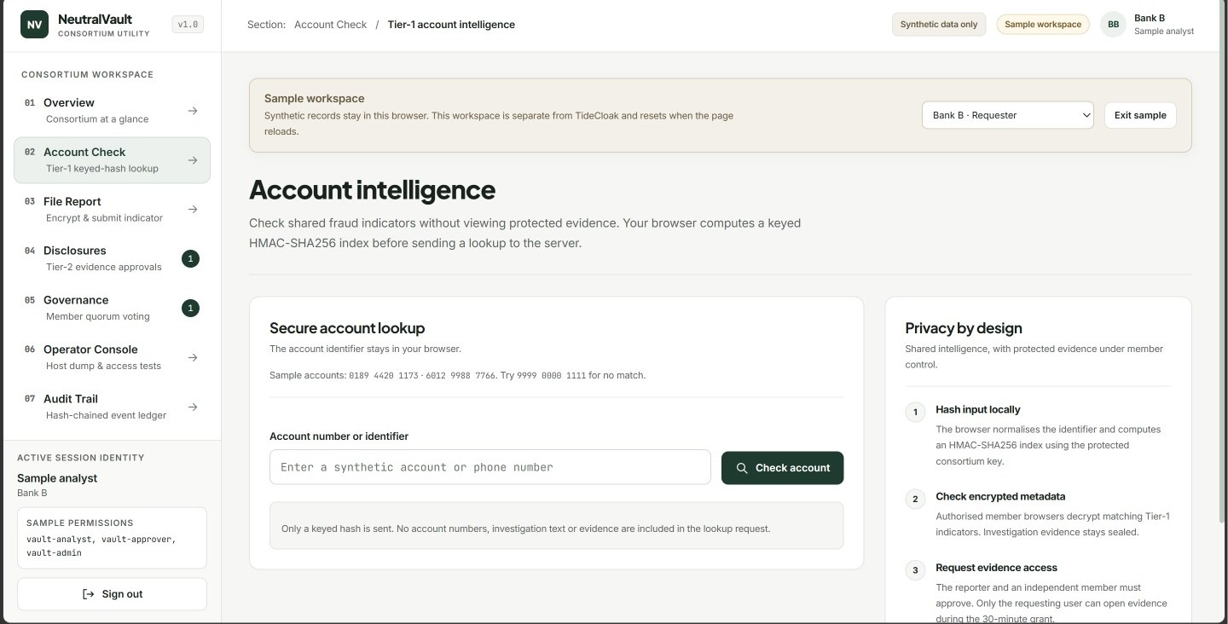
Figure 3. Account Check (Tier 1). The identifier is normalised and HMAC-SHA256 hashed in the browser; only the keyed hash is sent. Hits show metadata, never evidence.
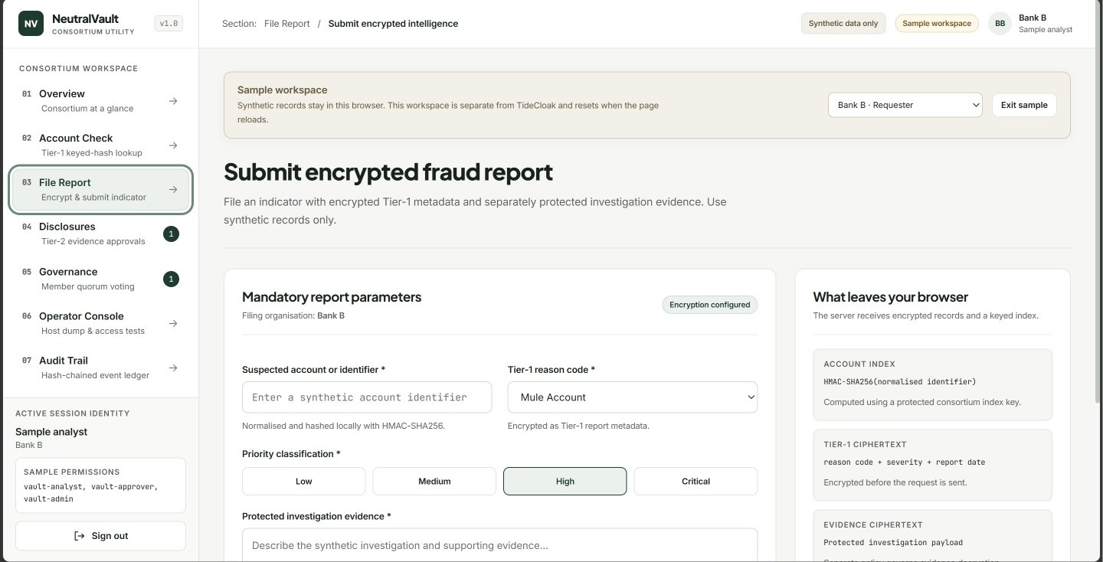
Figure 4. File Report. Account index, Tier-1 ciphertext (reason, severity, date) and evidence ciphertext are produced in the browser; the right panel shows exactly what leaves the browser.
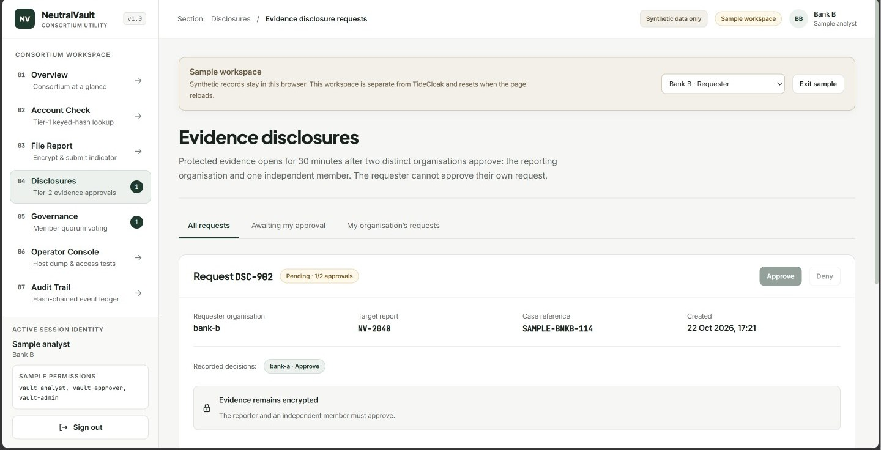
Figure 5. Disclosures (Tier 2). DSC-902 from Bank B on report NV-2048 has 1/2 approvals (Bank A). The requester's own Approve is disabled and evidence stays encrypted until the reporter and an independent member approve.
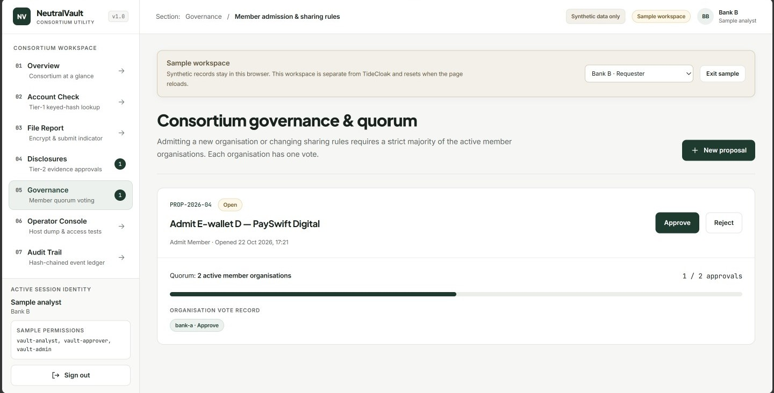
Figure 6. Governance. PROP-2026-04 'Admit E-wallet D \u2014 PaySwift Digital' at 1/2 approvals; strict majority of active members, one vote per organisation.
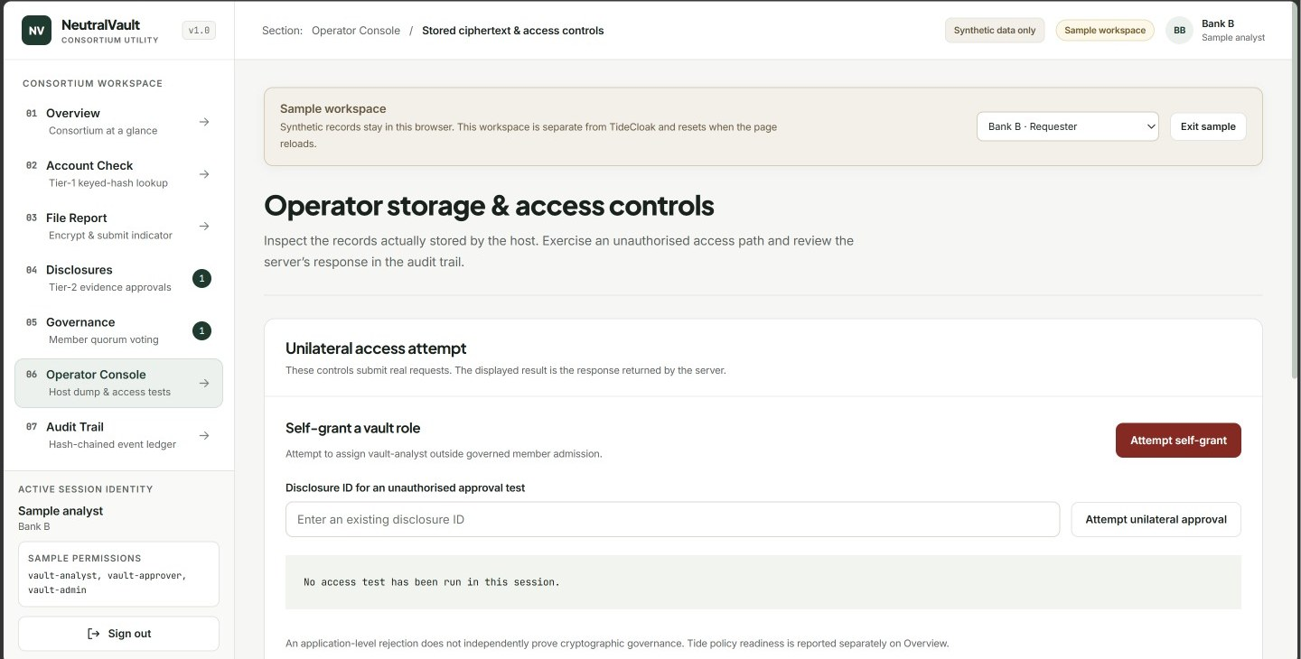
Figure 7. Operator Console. 'Attempt self-grant' and 'Attempt unilateral approval' send real requests and display the server's rejection, which is then audited.
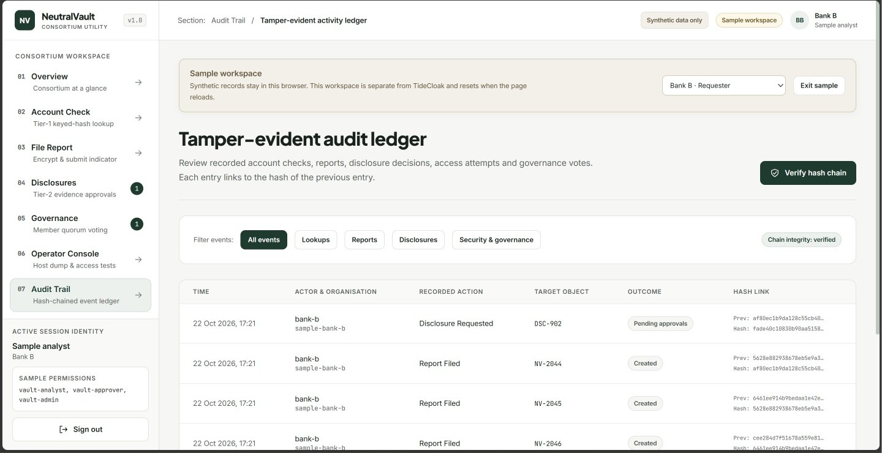
Figure 8. Audit Trail. Each event links the previous entry's hash; 'Verify hash chain' reports 'Chain integrity: verified'. Tamper-evident, not immutable.
Run instructions (summary)
From the repository root: docker compose up -d tidecloak. Then in app/: npm install, npm run db:push, npm run dev, and open http://localhost:3000. Choose 'Continue as sample user' to explore the sample workspace. Checks: npm test, npm run typecheck, npm run build.

