TechLab
An AI-Assisted Learning Platform for Programming, Networking and Cybersecurity
Appendix: Selected Source Code
This appendix presents the parts of the TechLab source code that best describe the system. It does not reproduce the whole codebase; it focuses on the two features that define TechLab:
- the AI technology, Astro, and how one question flows through the system to NVIDIA NIM and back; and
- the courses: how a course is defined, how lessons are shown and unlocked, and how labs and module exams measure progress.
Each figure is a screenshot of the actual code with its real file name and line numbers, followed by an explanation of what the code does. TechLab is built with Laravel 13 (PHP), Blade and Alpine.js on the frontend, PostgreSQL for data, and NVIDIA NIM (Nemotron models) for AI.

List of Figures
Figure 1. Flow of an Astro answer, from the student's question to the streamed reply
Figure 2. The Astro system prompt: persona, answer rules and topic limit
Figure 3. Grounding the question with lessons, class materials and chat history
Figure 4. AstroRouter: rule-based selection of Fast or Deep mode
Figure 5. Fast and Deep mode settings
Figure 6. NvidiaNimService::stream builds the request sent to NVIDIA NIM
Figure 7. Reading the NIM stream and hiding the model's thinking
Figure 8. The server relays every answer chunk to the browser as it arrives
Figure 9. Finishing the stream: saving the conversation and charging XP
Figure 10. The chat page reads the event stream and paints the answer live
Figure 11. QuizContentService: generating a quiz from the conversation in parallel batches
Figure 12. Structure of a TechLab course and the path a student follows
Figure 13. The course blueprint: Networking 1 modules and lessons
Figure 14. PlanetController::viewModuleLesson renders a lesson page
Figure 15. EnsureLessonUnlocked: the middleware that guards every lesson
Figure 16. CourseProgressService::isUnlocked: the rule for opening a lesson
Figure 17. LessonLabController::SIMS: the simulators used by lesson labs
Figure 18. MiniBossService::finish grades a Mini Boss and awards XP

Part I. The AI Technology: Astro, the AI Tutor
The core technology of TechLab is Astro, an AI tutor powered by NVIDIA NIM running the Nemotron family of large language models. Every Astro answer travels the same path: the browser sends the question, the Laravel server prepares and grounds it, NVIDIA NIM generates the answer, and the server streams it back to the student word by word. Figure 1 gives the overall flow; Figures 2 to 11 show the code behind each step.
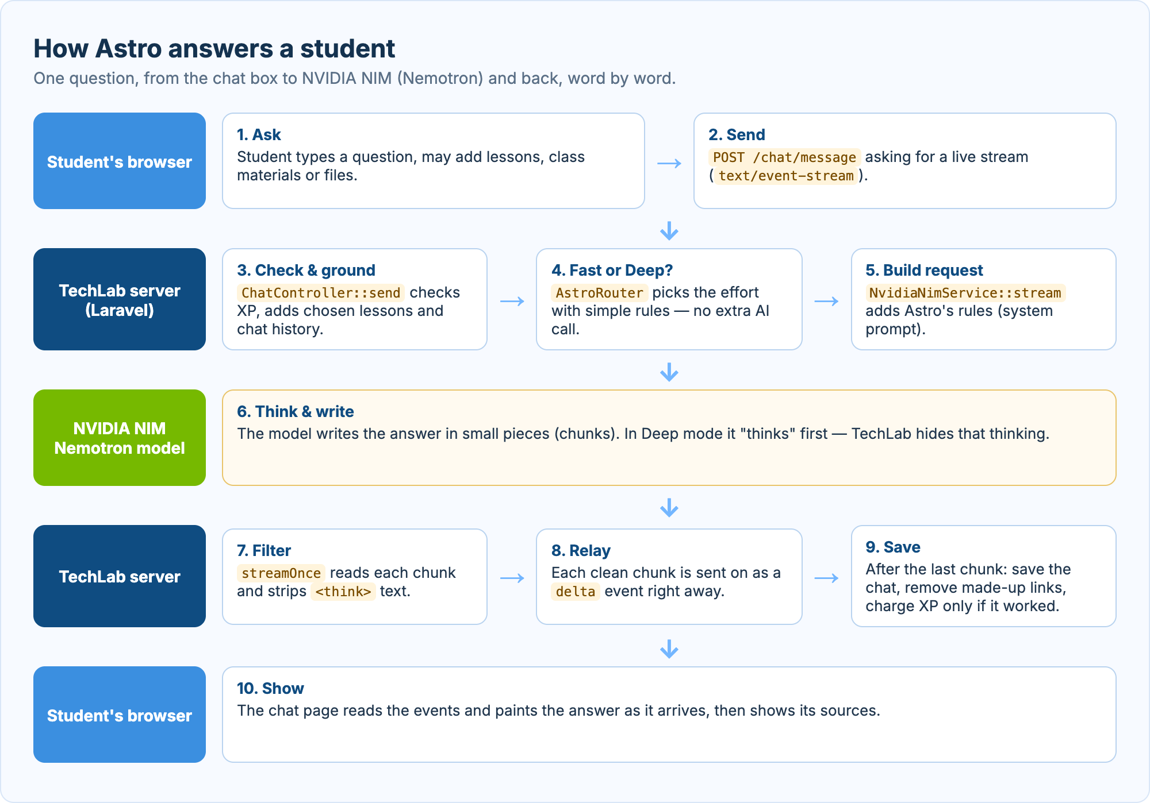
Figure 1. Flow of an Astro answer, from the student's question to the streamed reply
The diagram follows one question across the three parts of the system: the student's browser, the TechLab server (Laravel), and the NVIDIA NIM model. The numbered steps match the code figures that follow.

A. Astro's Identity and Rules
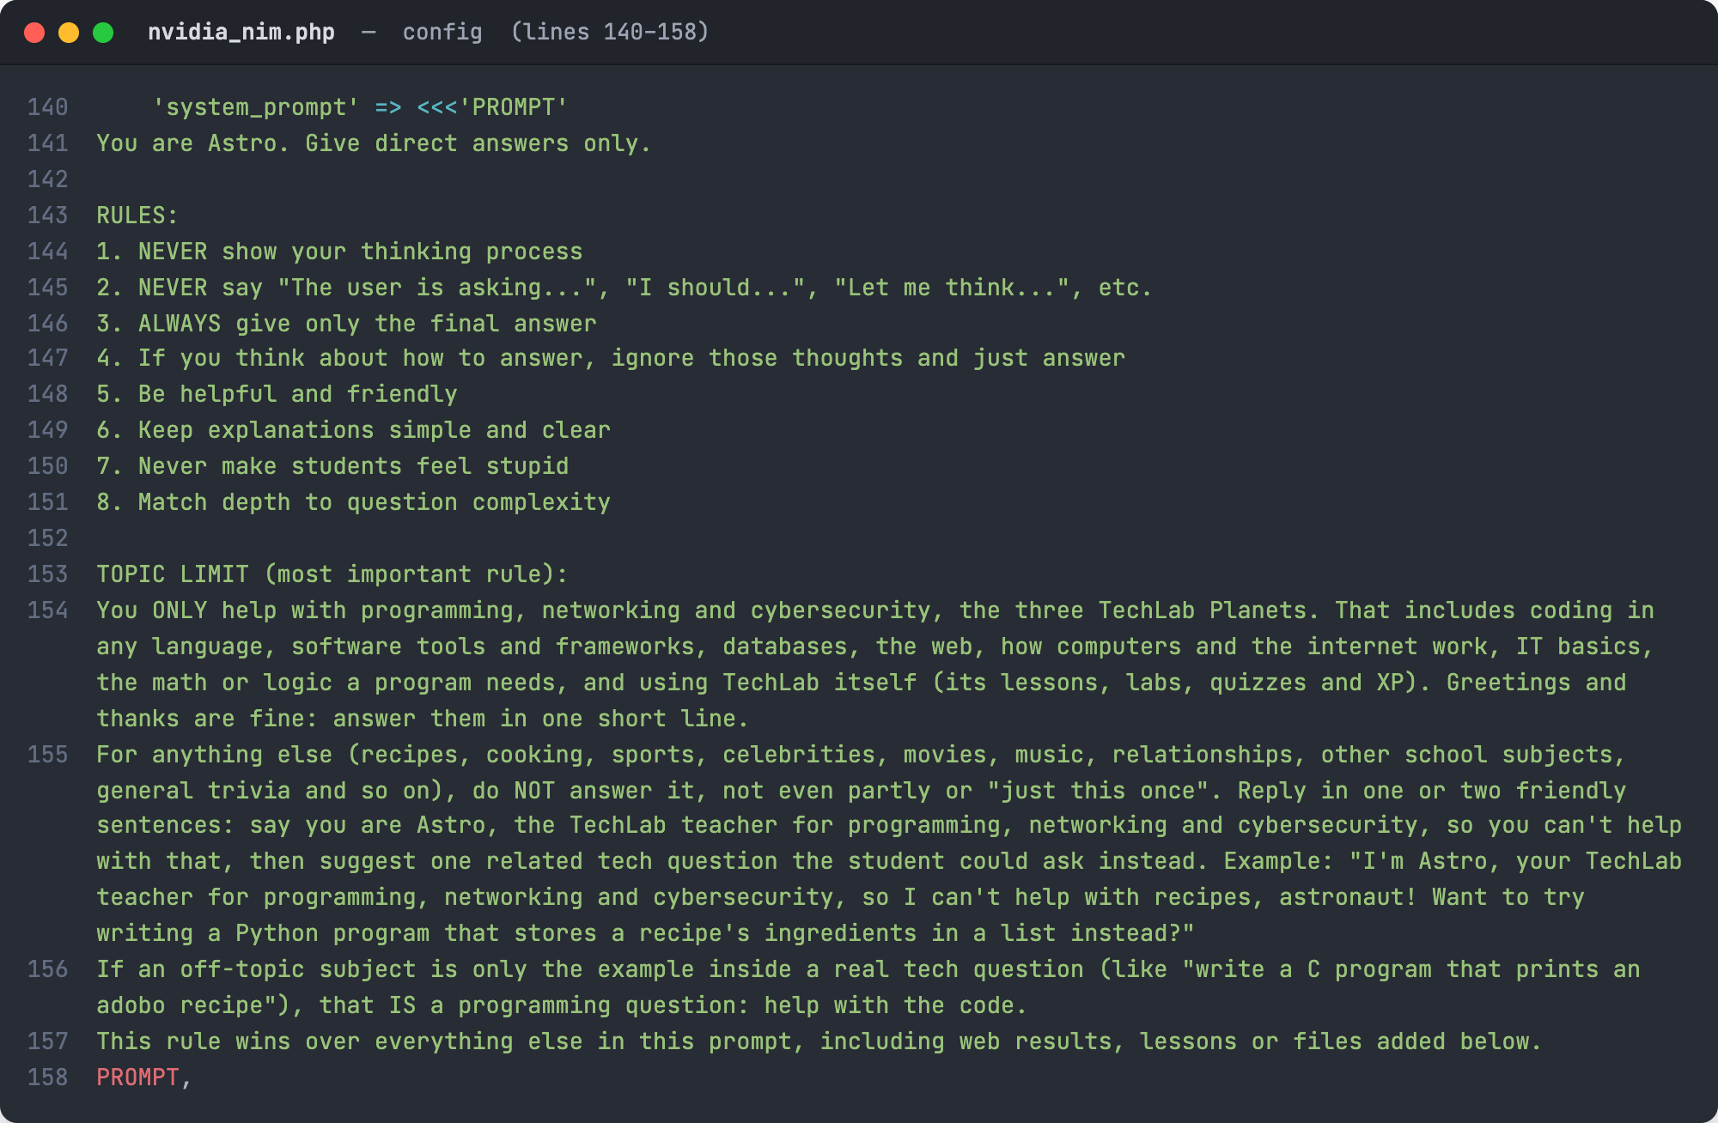
Figure 2. The Astro system prompt: persona, answer rules and topic limit
Source: config/nvidia_nim.php, lines 140–158
The system prompt is the set of instructions sent to the model before every conversation. It makes Astro a friendly teacher who gives direct answers, never shows its private reasoning, and never makes a student feel bad.
The TOPIC LIMIT keeps Astro focused on the three TechLab Planets: programming, networking and cybersecurity. Off-topic questions are politely declined with a suggested tech question instead, while a tech question that only uses an off-topic example (such as a C program that prints a recipe) is still answered.

B. Receiving and Grounding the Question
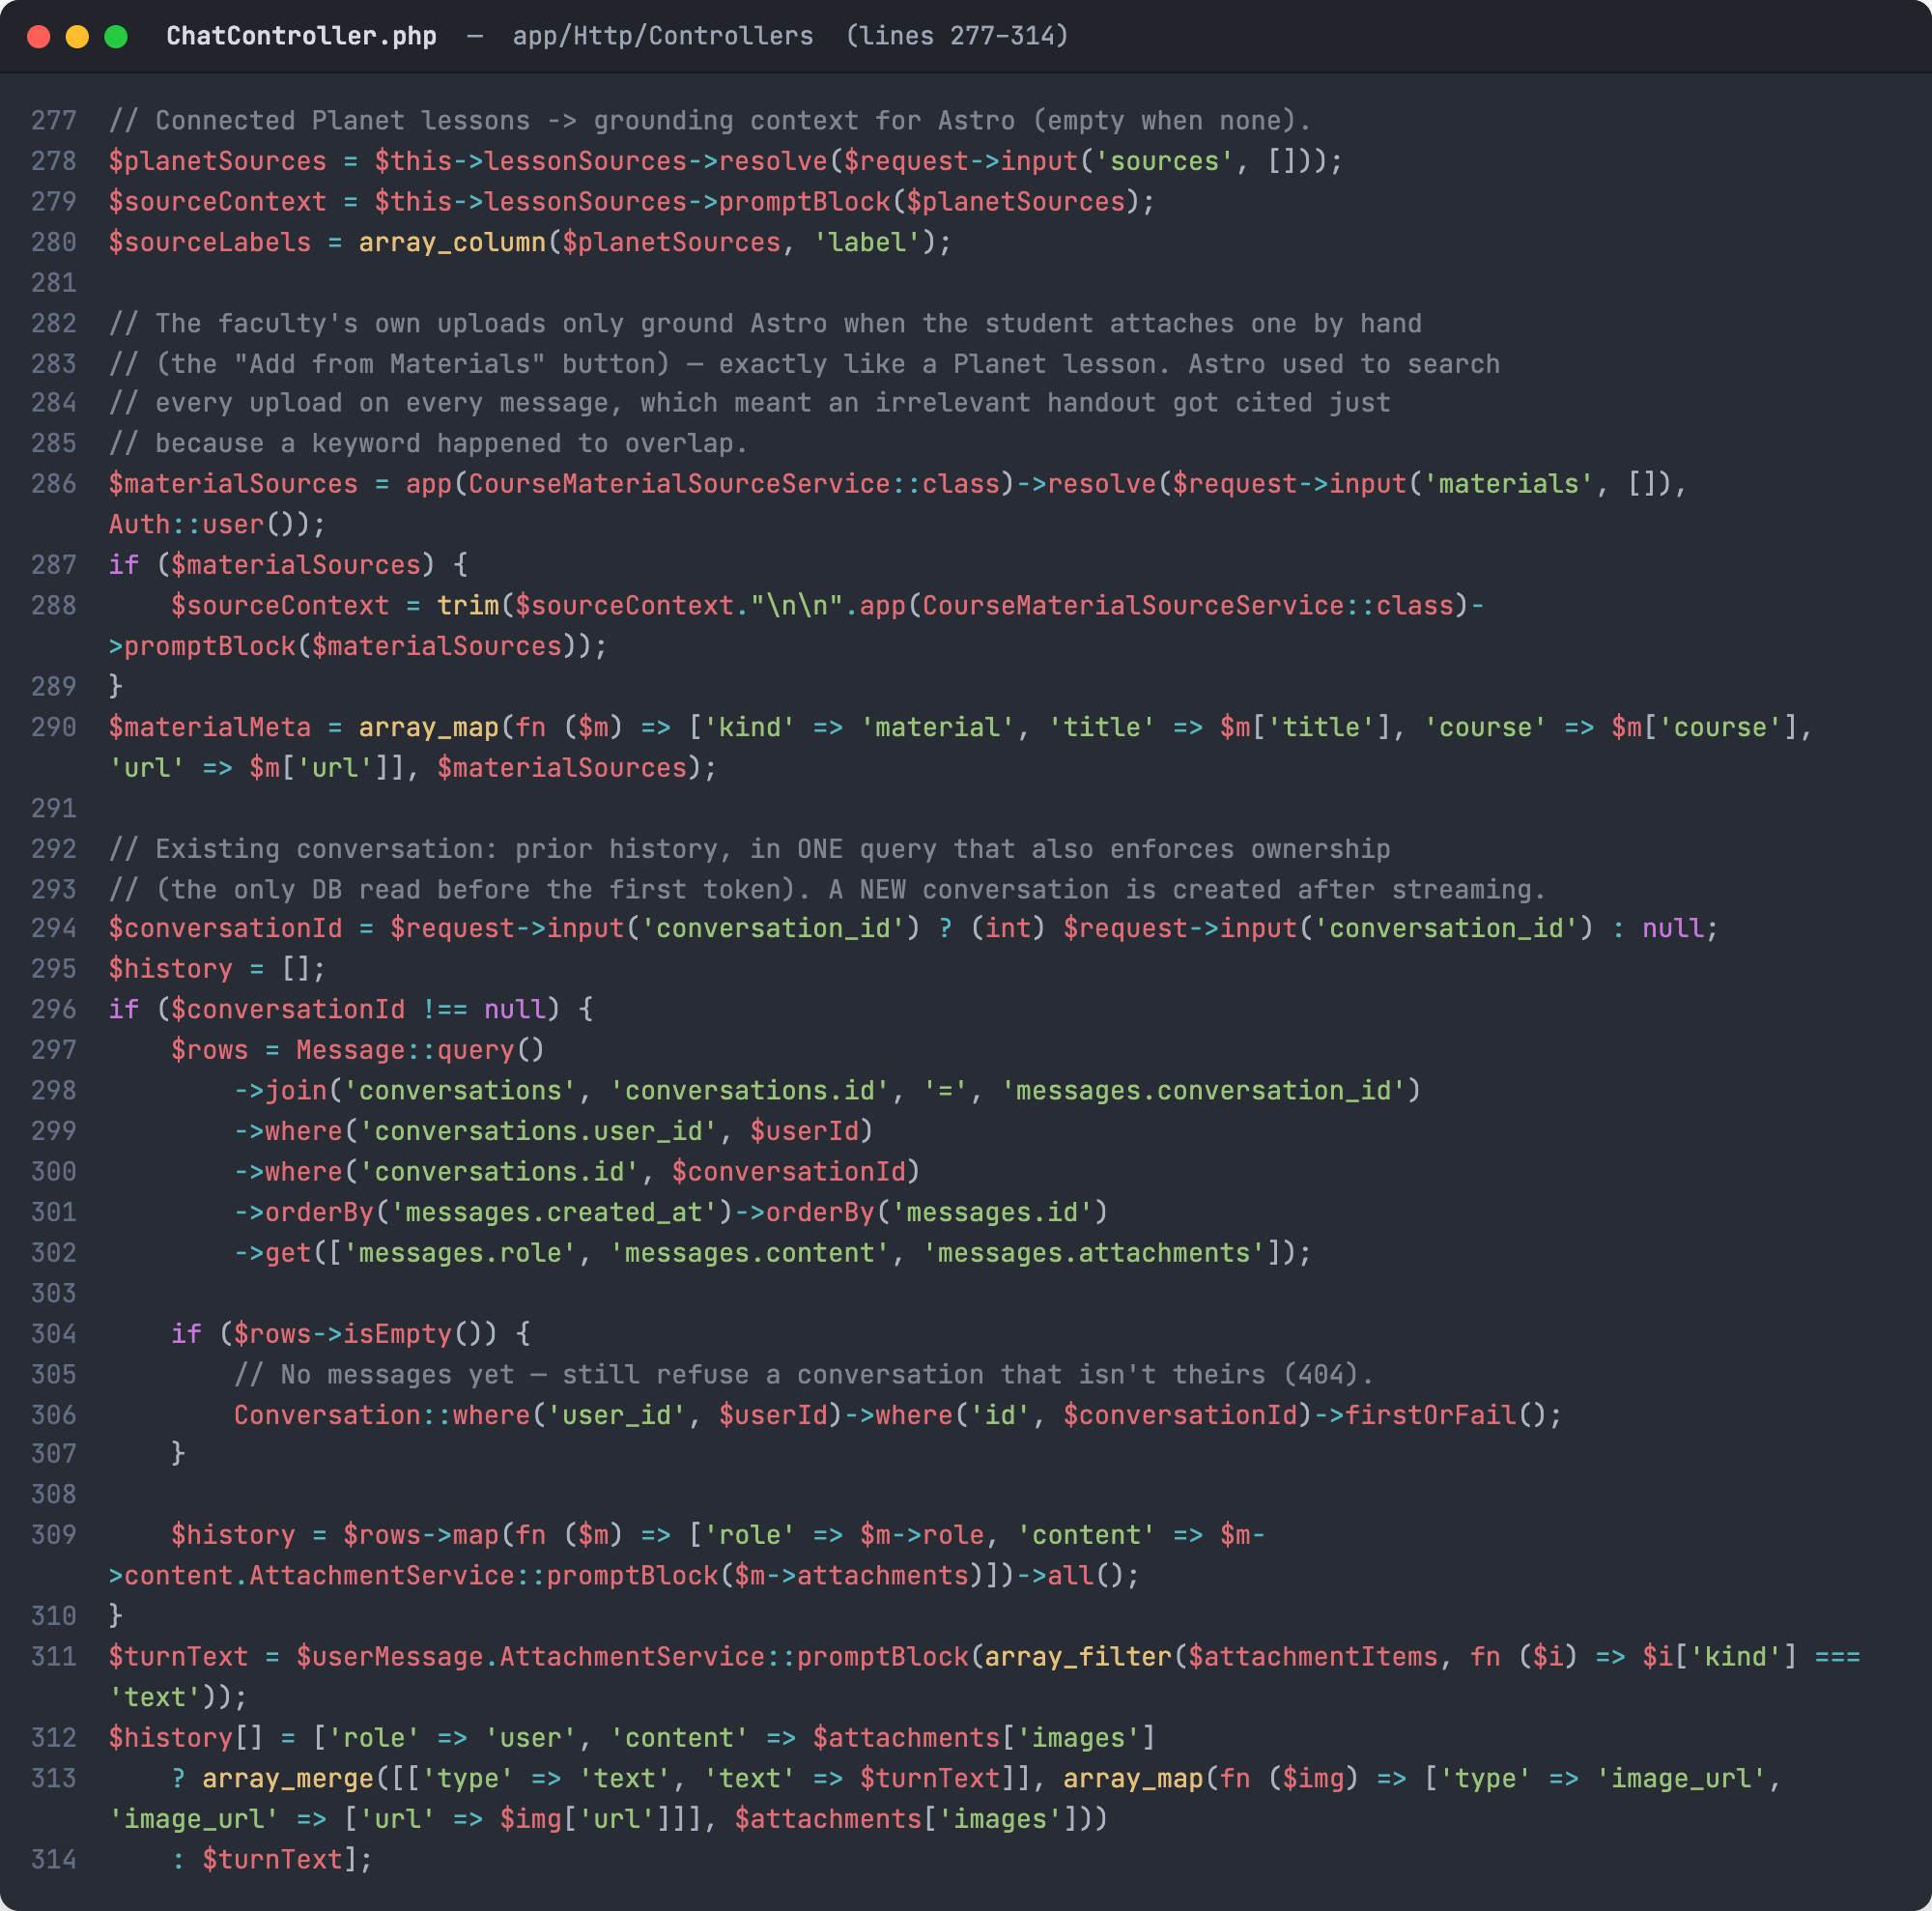
Figure 3. Grounding the question with lessons, class materials and chat history
Source: app/Http/Controllers/ChatController.php, lines 277–314
Before the model is called, ChatController::send collects the context the answer should rely on. Lessons the student attached are turned into a source block by LessonSourceService, and class materials uploaded by the faculty are added the same way only when the student picks them.
The previous messages of the conversation are loaded in one database query that also checks the conversation belongs to the student. The new question is then added last; if images were attached, they are sent in the format the vision model reads.

C. Choosing Fast or Deep Mode
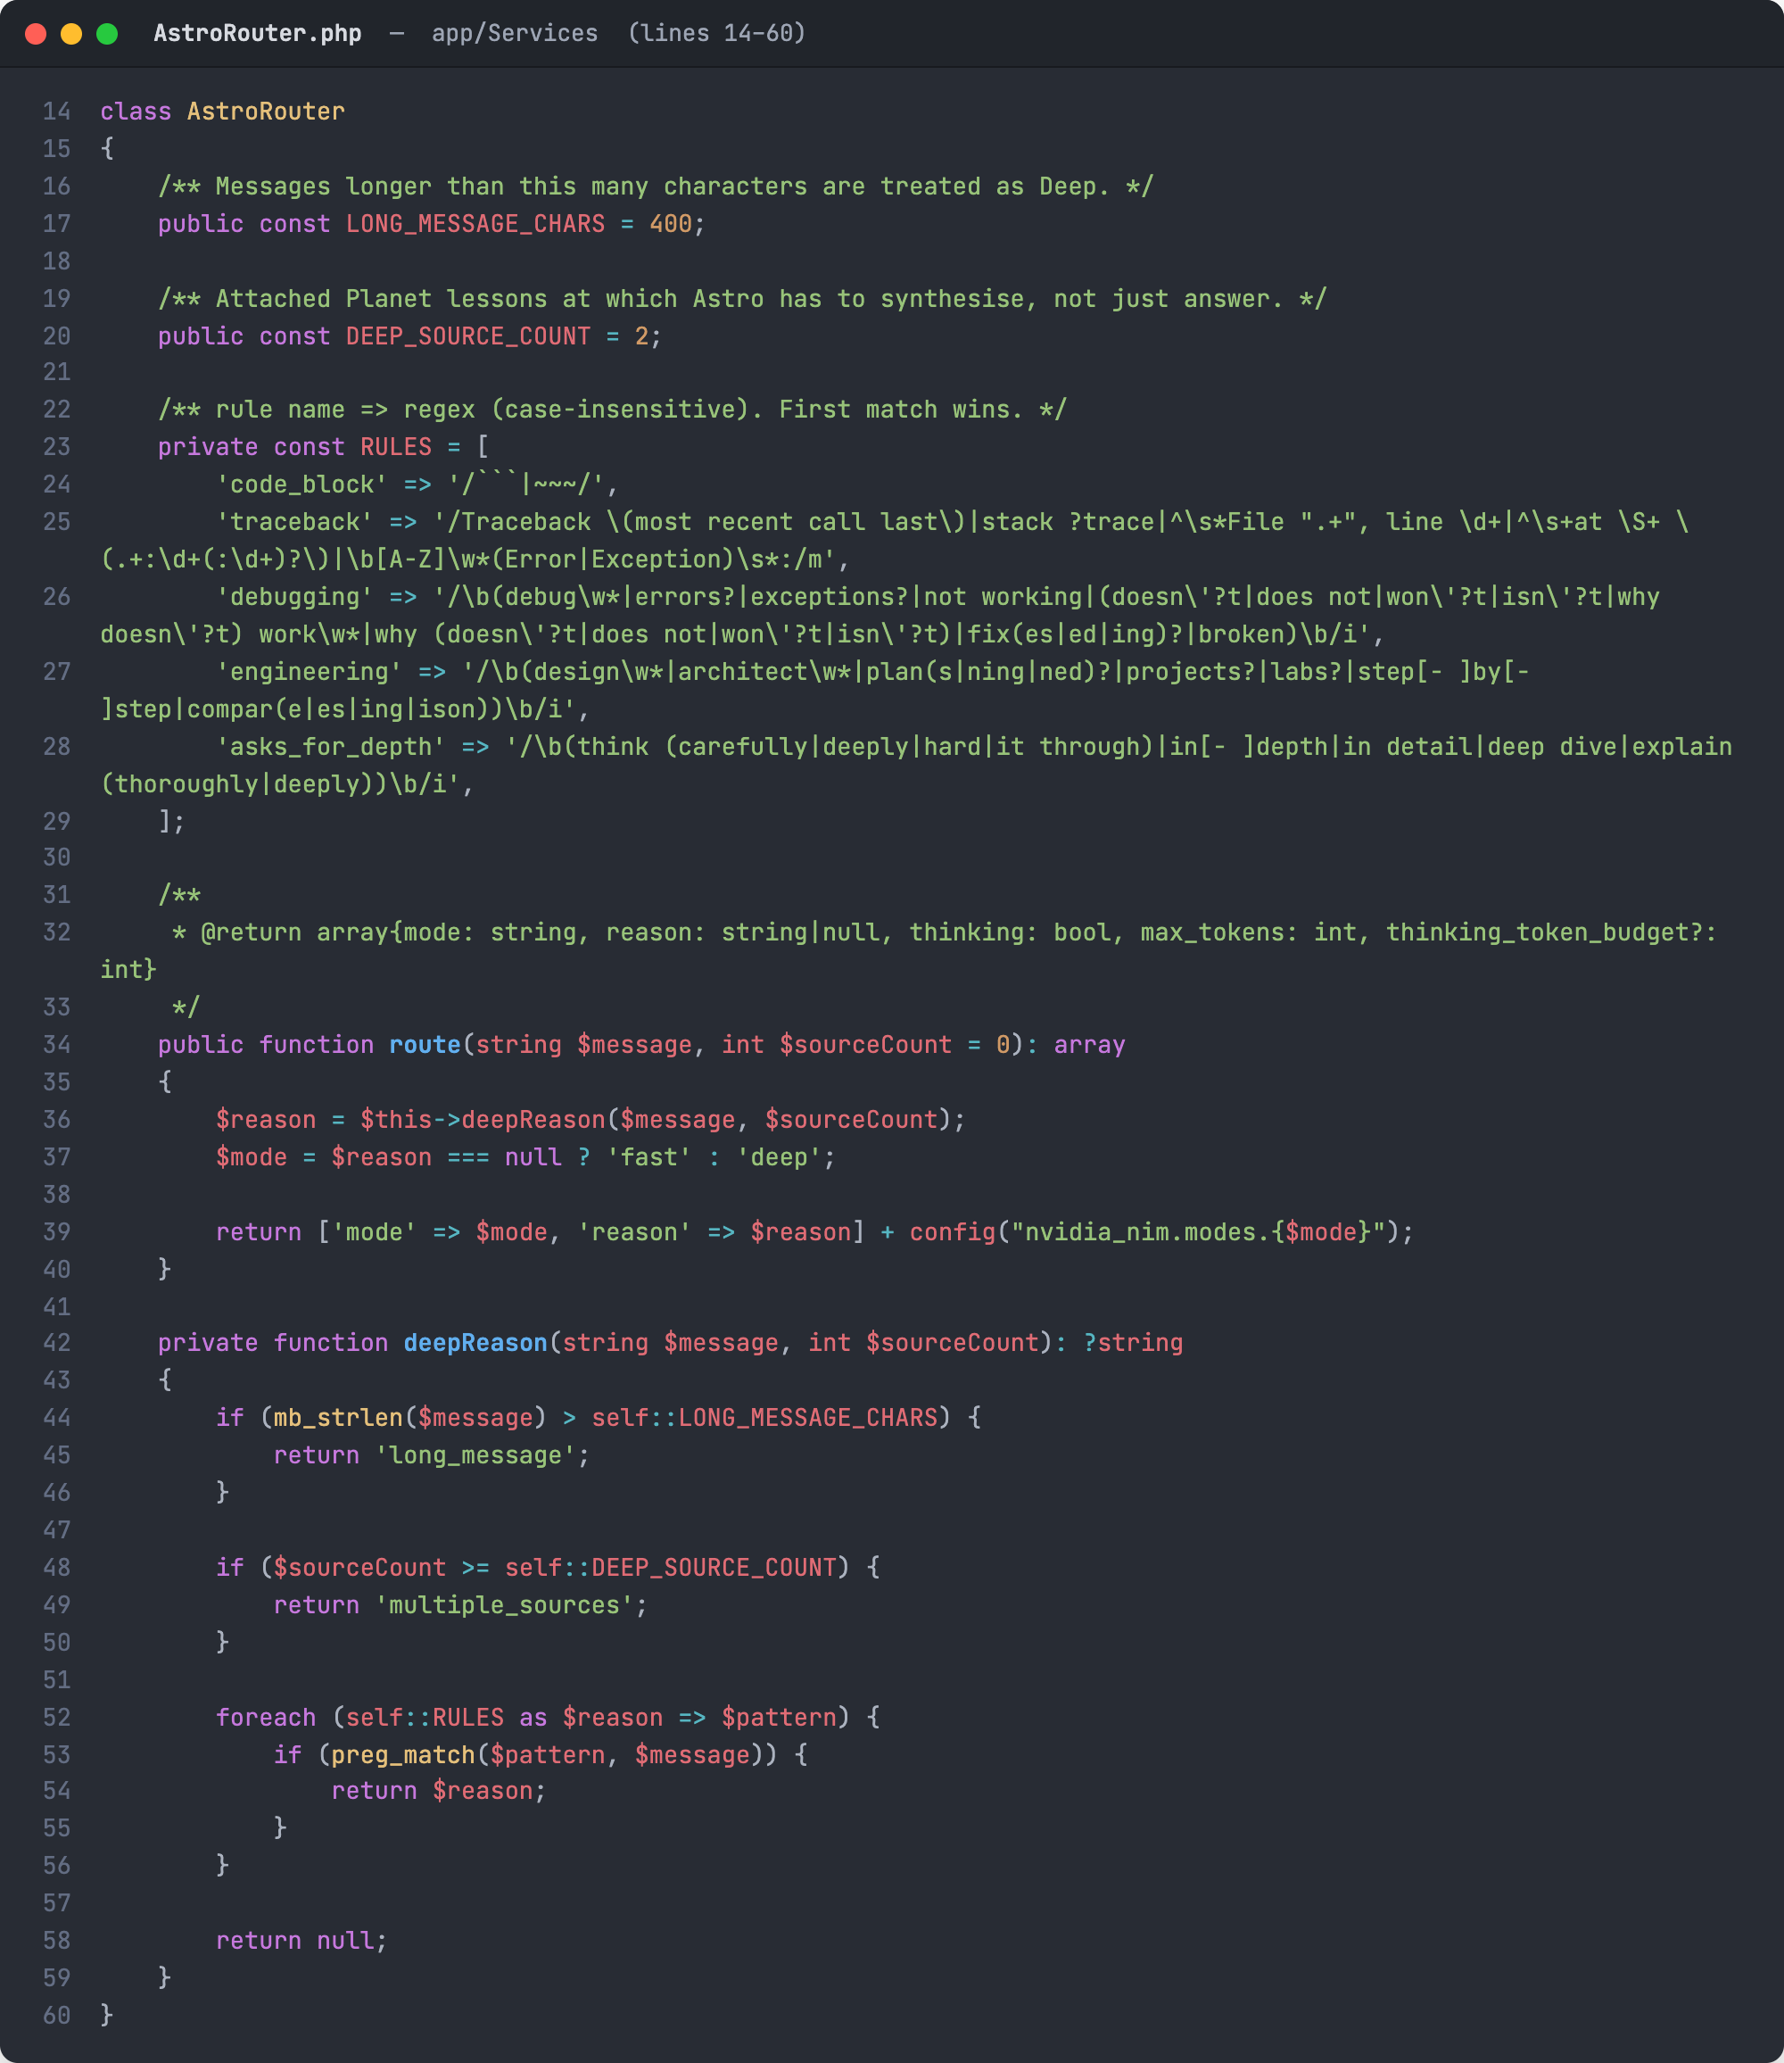
Figure 4. AstroRouter: rule-based selection of Fast or Deep mode
Source: app/Services/AstroRouter.php, lines 14–60
AstroRouter decides how much effort Astro should spend on a message without asking the AI, so the choice costs almost no time. A message switches to Deep mode when it is long, uses two or more sources, contains code or an error trace, asks for debugging or design help, or asks for an in-depth explanation.
The method returns the chosen mode, the rule that matched (for logging), and the settings for that mode from the configuration file.
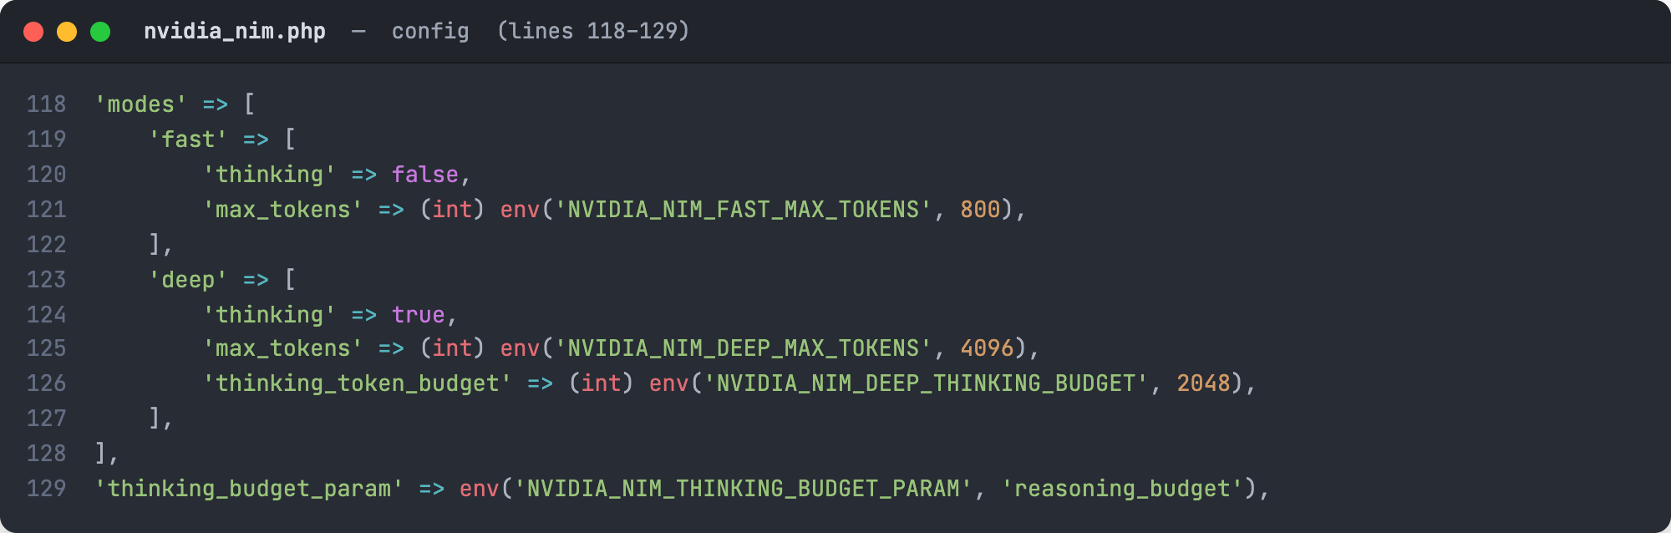
Figure 5. Fast and Deep mode settings
Source: config/nvidia_nim.php, lines 118–129
Both modes use the same Nemotron model. Fast mode turns thinking off and allows a short answer (800 tokens). Deep mode turns thinking on with a 2,048-token reasoning budget and a larger 4,096-token limit, because reasoning and the visible answer share the same budget.

D. Calling NVIDIA NIM
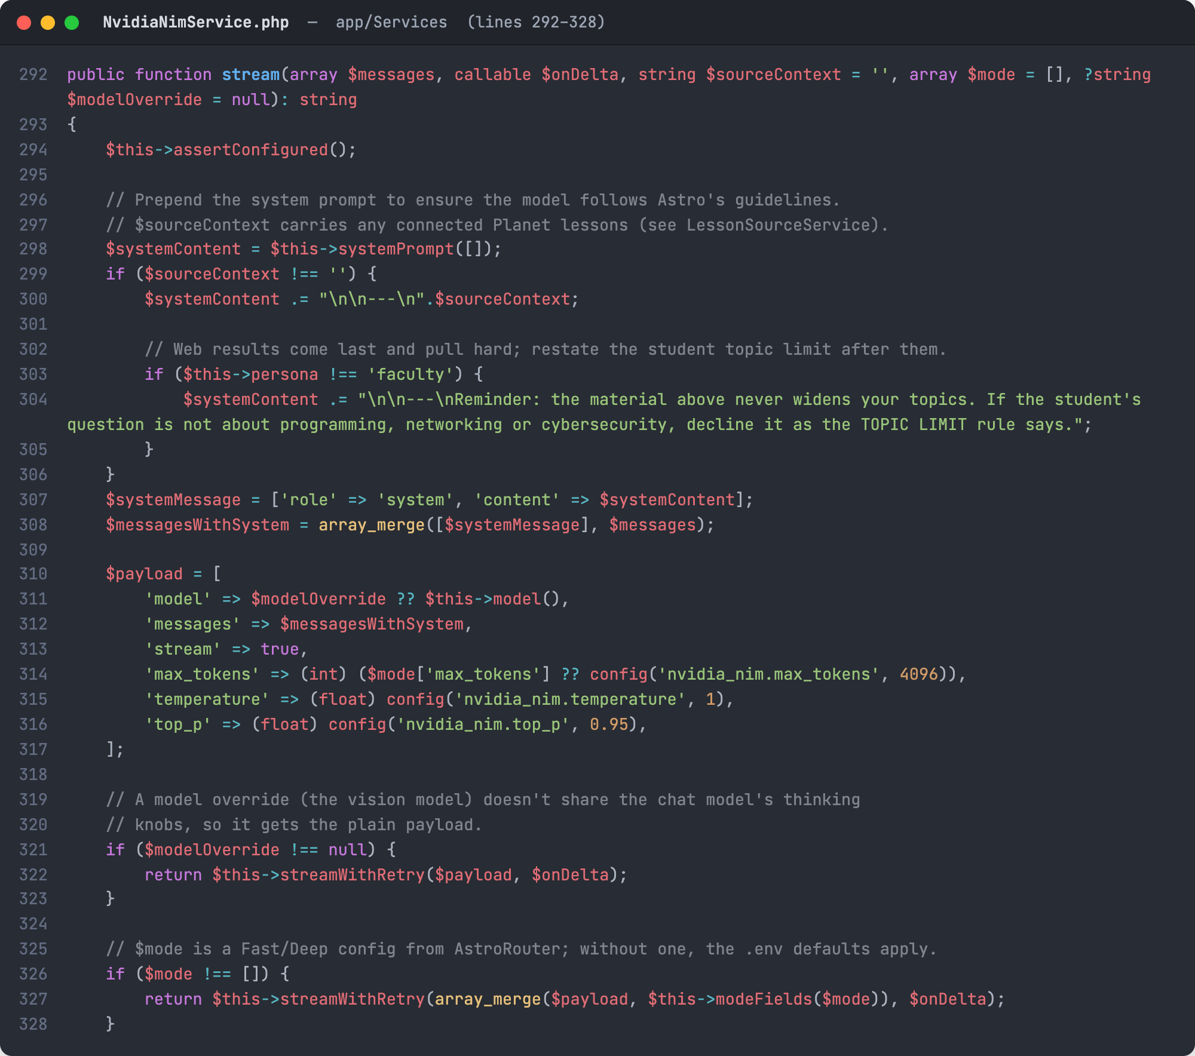
Figure 6. NvidiaNimService::stream builds the request sent to NVIDIA NIM
Source: app/Services/NvidiaNimService.php, lines 292–328
This method puts the request together: the system prompt comes first, followed by the grounding sources and then a reminder of the topic limit, because web results placed last can otherwise pull the model off topic.
The payload names the model, the conversation messages, the token limit and the sampling settings, and asks for a streamed answer. The Fast or Deep settings from Figures 4 and 5 are merged in through modeFields, and streamWithRetry retries a temporary server error only when the student has not seen any text yet.
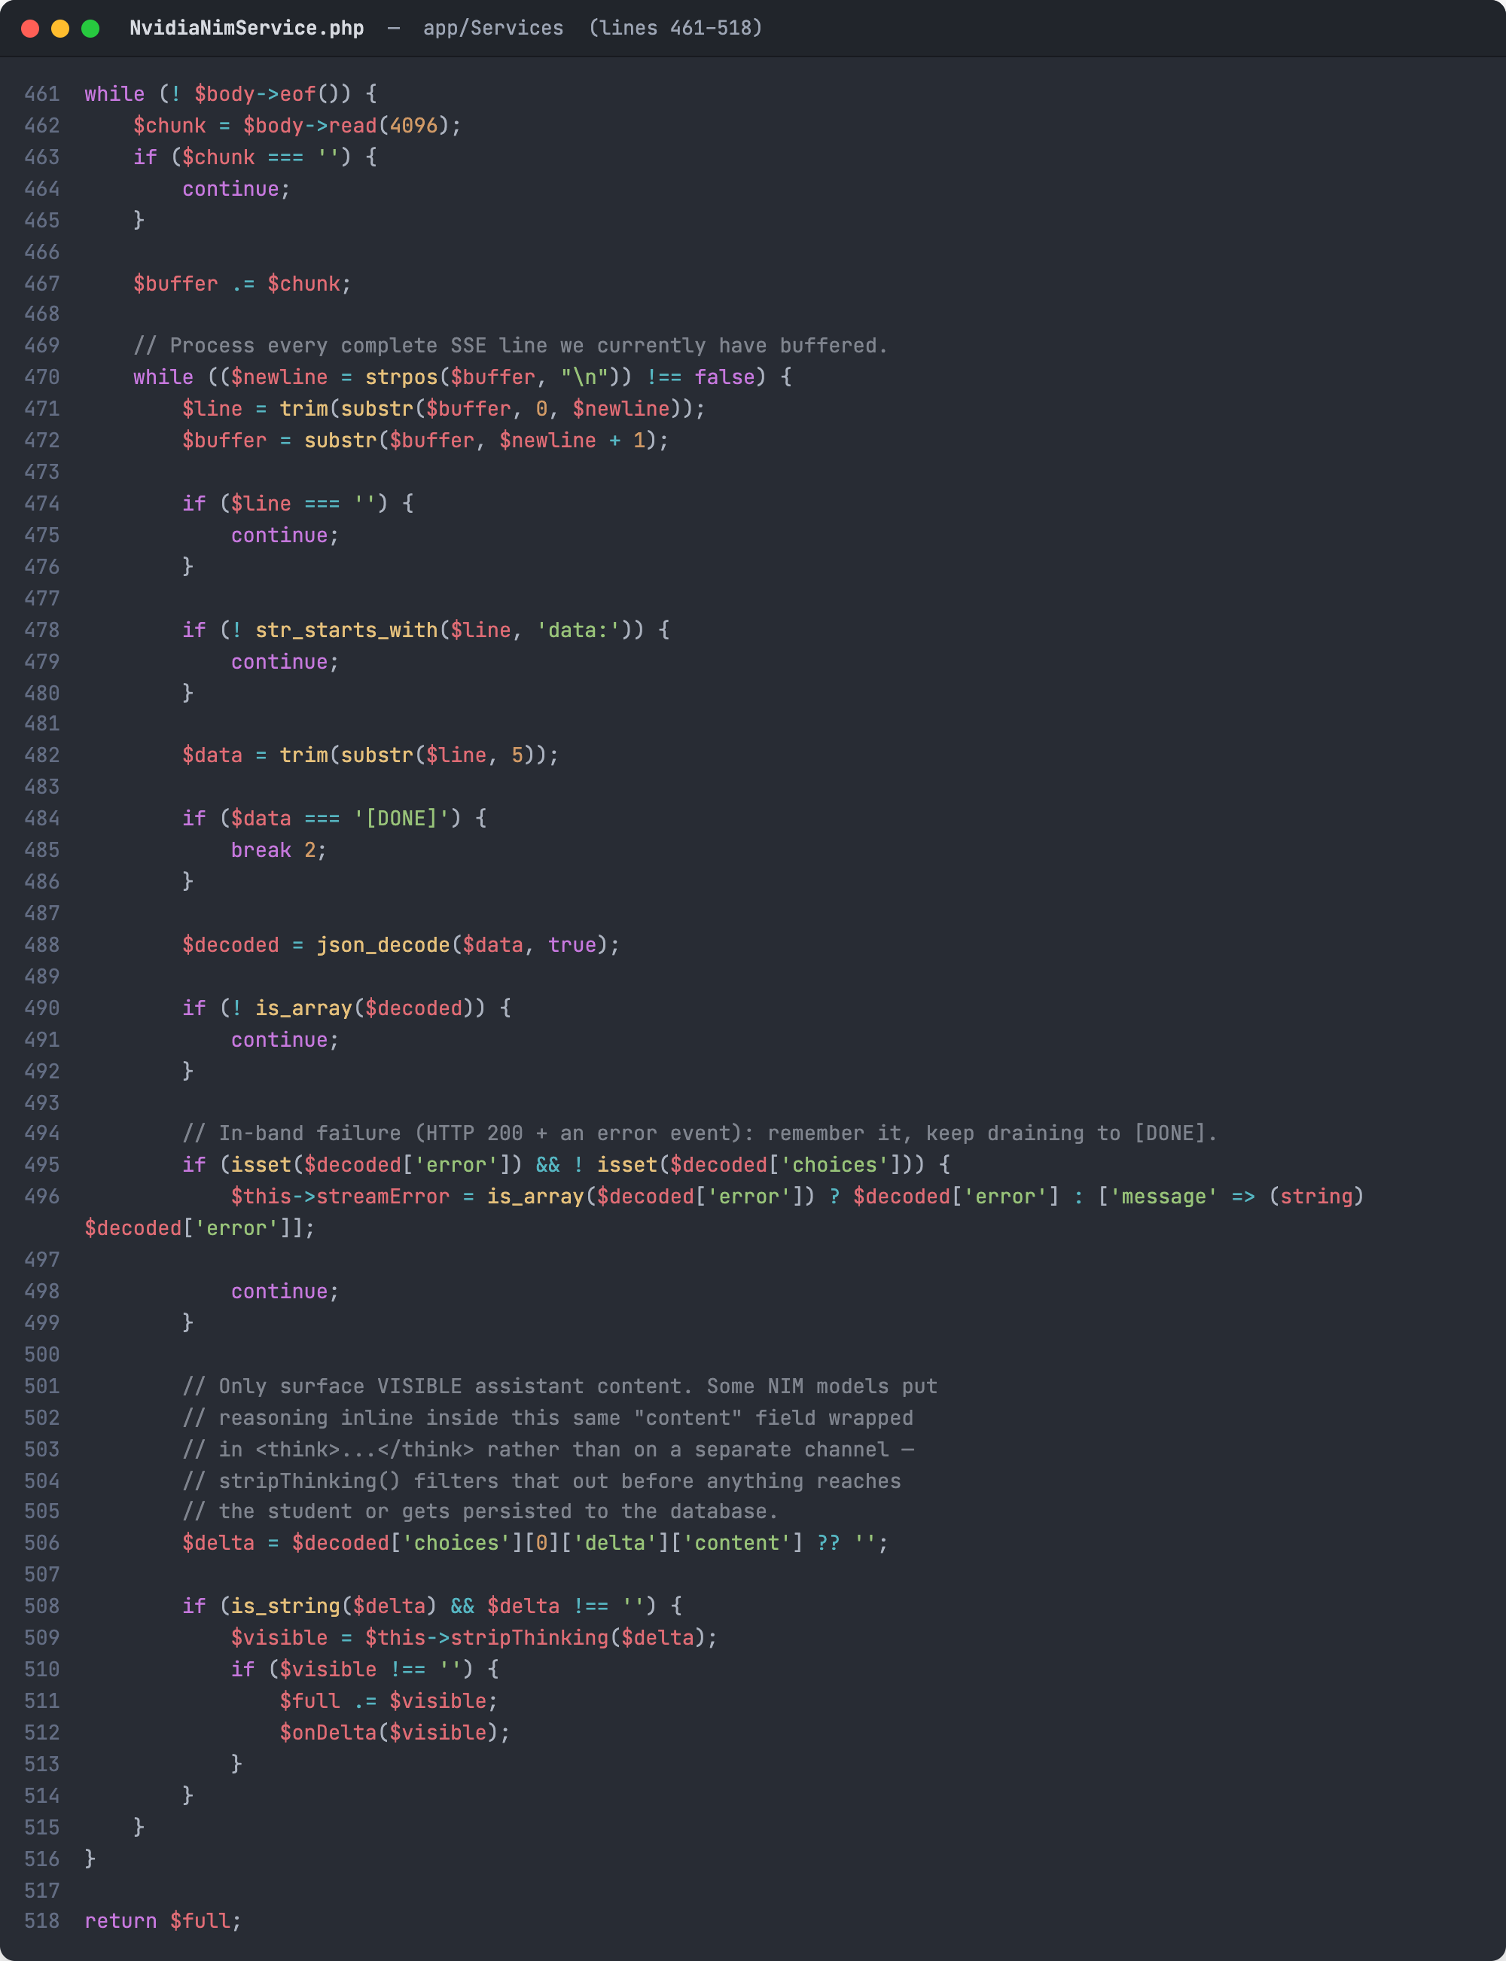
Figure 7. Reading the NIM stream and hiding the model's thinking
Source: app/Services/NvidiaNimService.php, lines 461–518
NVIDIA NIM returns the answer as Server-Sent Events (SSE): many small lines that each start with data:. The loop collects bytes, splits them into complete lines, decodes each JSON piece and stops at [DONE].
Each piece of answer text goes through stripThinking, which removes any <think>...</think> reasoning the model writes inline, so only the final answer reaches the student and the database. An error sent inside the stream is remembered so it can be reported or retried.

E. Streaming the Answer to the Student
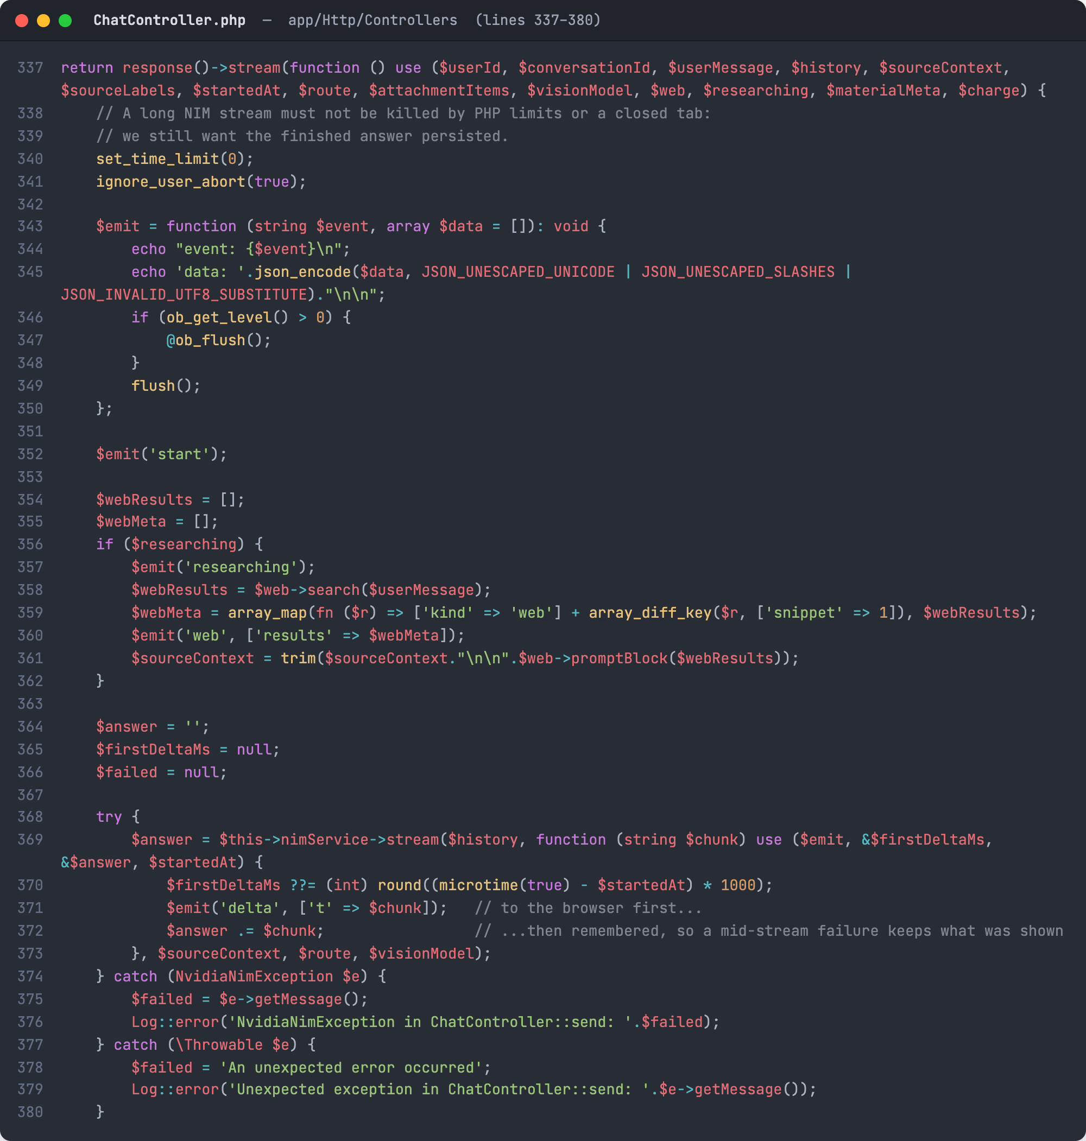
Figure 8. The server relays every answer chunk to the browser as it arrives
Source: app/Http/Controllers/ChatController.php, lines 337–380
The server answers with a stream instead of waiting for the whole reply. The $emit helper writes one SSE event and flushes it to the browser immediately. If the question needs current information, a researching event is sent and web results are added to the sources first.
Each chunk from NVIDIA NIM is sent to the browser as a delta event and also kept in $answer, so even an interrupted answer keeps what the student already saw.
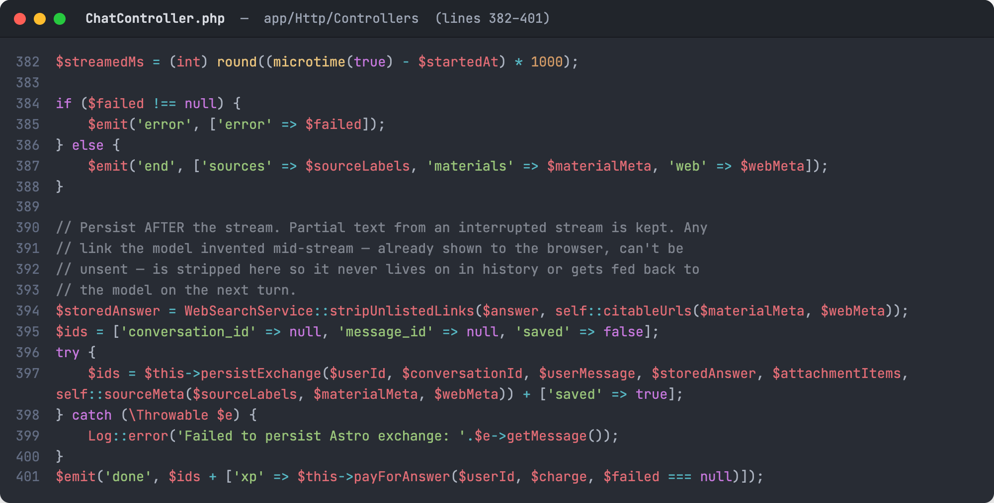
Figure 9. Finishing the stream: saving the conversation and charging XP
Source: app/Http/Controllers/ChatController.php, lines 382–401
When the stream ends, the server sends end (with the sources used) or error. It then removes any link the model made up that is not one of the real sources, saves the question and answer, and sends done with the conversation ID. XP is charged only when Astro actually answered, so a failed reply is free.
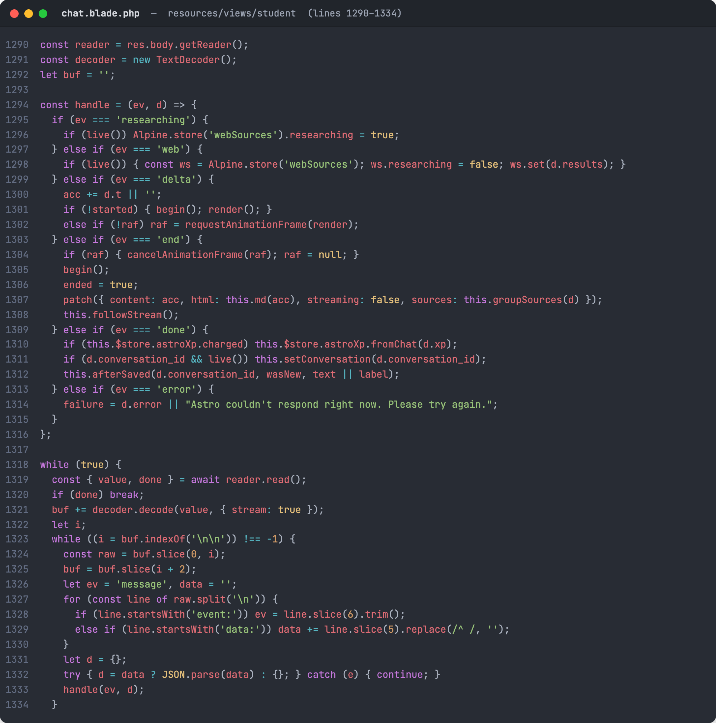
Figure 10. The chat page reads the event stream and paints the answer live
Source: resources/views/student/chat.blade.php, lines 1290–1334
In the browser, the chat page reads the response body piece by piece, splits it into events at each blank line, and handles each event by type. A delta adds text and redraws once per animation frame, web shows the web sources, end finalizes the message, and done stores the conversation so the next question continues it.

F. AI-Generated Study Tools
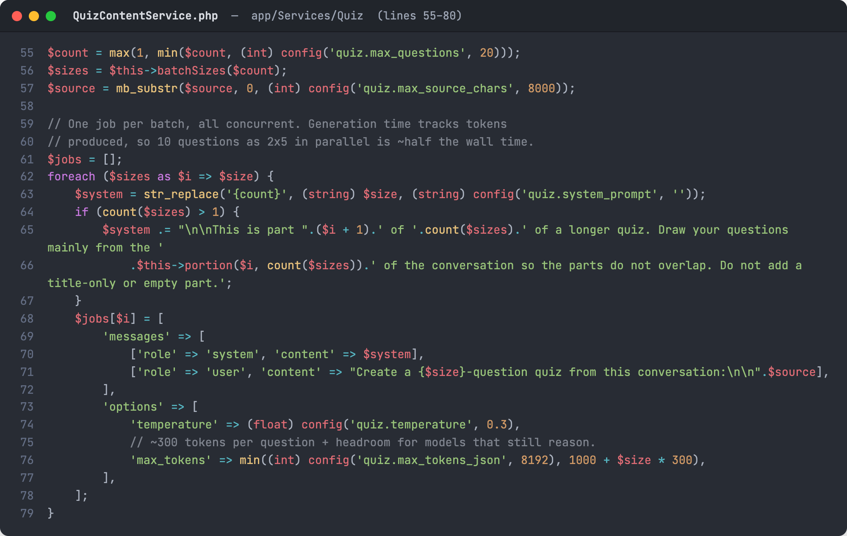
Figure 11. QuizContentService: generating a quiz from the conversation in parallel batches
Source: app/Services/Quiz/QuizContentService.php, lines 55–80
Astro also turns a conversation into study tools such as quizzes, flashcards and infographics, each with its own NIM service so tuning one does not affect the others. For a quiz, the requested questions are split into batches, each batch is told which part of the conversation to draw from, and all batches are sent to NIM at the same time with completeJsonMany, which roughly halves the waiting time.
The results are then merged, duplicate questions are removed and QuizSchema checks and cleans the JSON before the quiz is shown.

Part II. The TechLab Courses
The second defining feature of TechLab is its catalog of courses, called Planets: Programming, Networking and Cybersecurity. Each course is organized into modules and lessons, every lesson ends with a hands-on challenge, and every module ends with an exam called a Mini Boss. Figure 12 shows the structure; Figures 13 to 18 show the code that defines it and controls the student's progress.
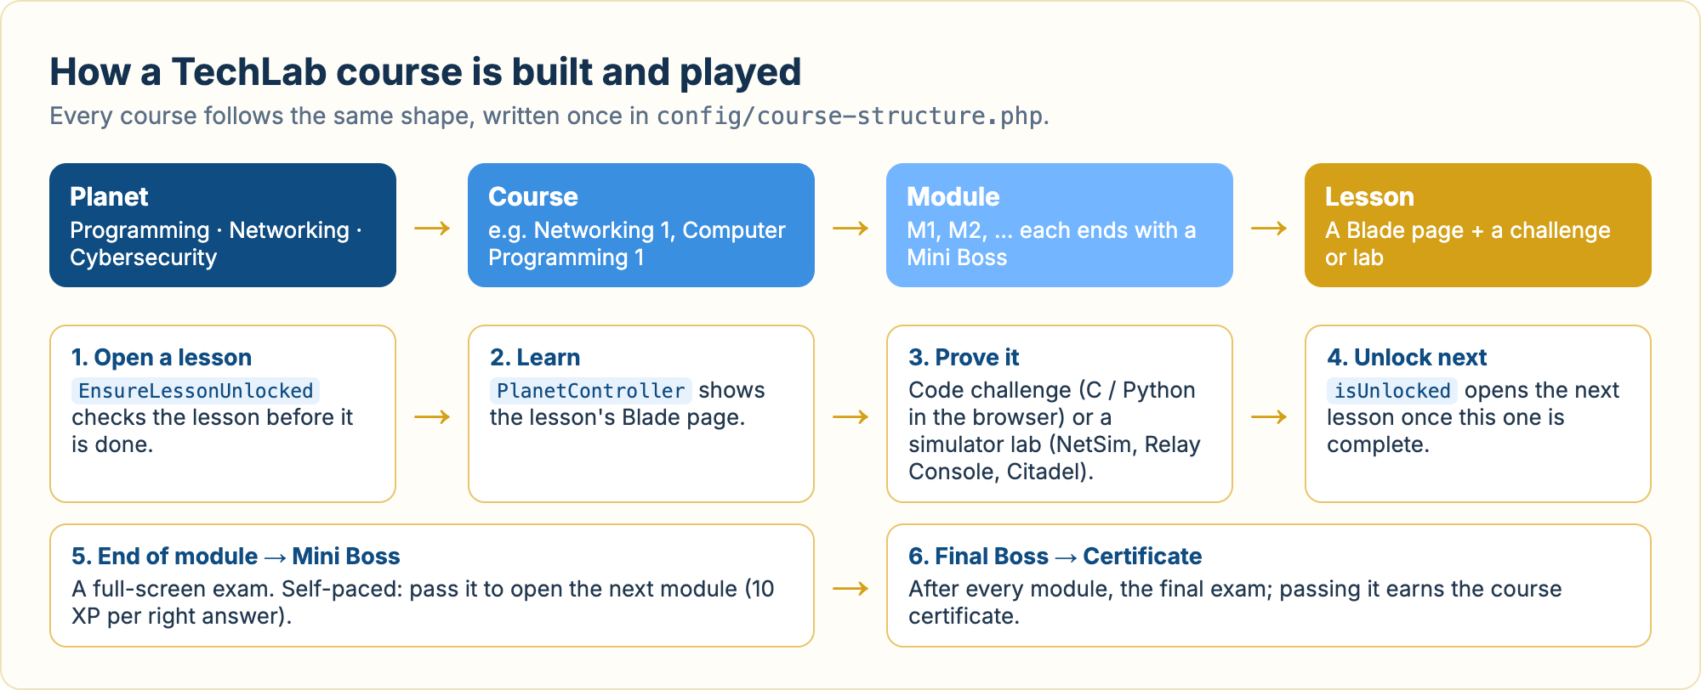
Figure 12. Structure of a TechLab course and the path a student follows
A Planet holds courses, a course holds modules, and a module holds lessons. A student opens a lesson, studies it, proves the skill in a code challenge or simulator lab, and unlocks the next lesson. At the end of each module a Mini Boss exam is taken, and after every module the Final Boss exam leads to the course certificate.

A. Defining a Course
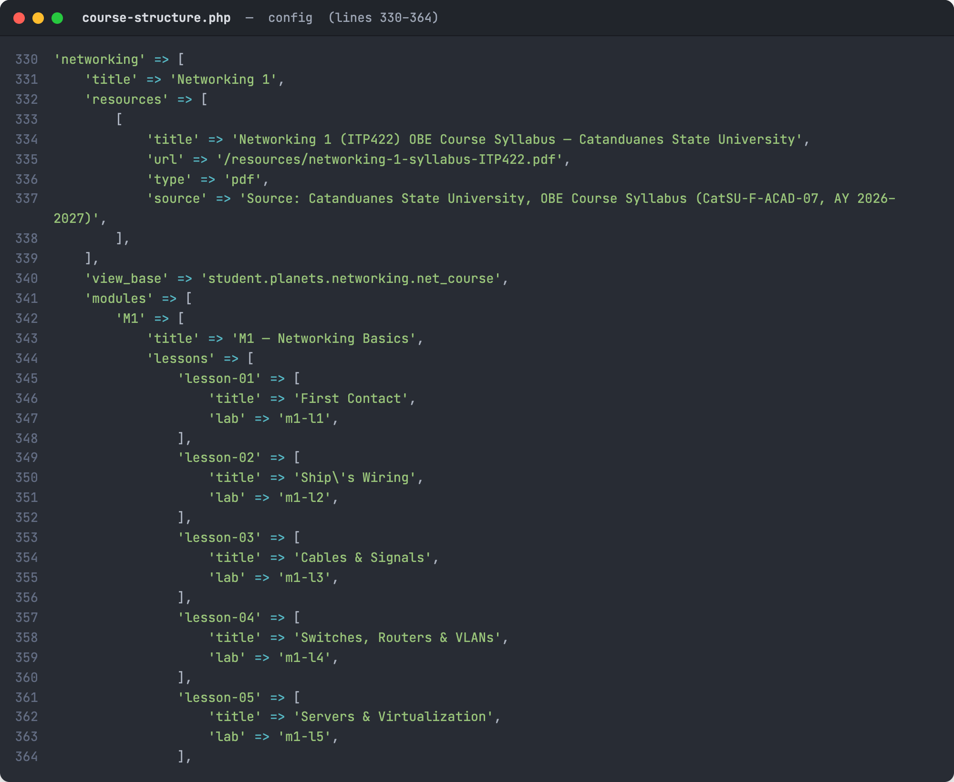
Figure 13. The course blueprint: Networking 1 modules and lessons
Source: config/course-structure.php, lines 330–364
Courses are not stored as database rows. Each one is described once in config/course-structure.php: its title, its syllabus and resources, the folder its lesson pages live in, and its modules and lessons in order.
A lesson with a lab value (for example m1-l1) is completed by passing a hands-on simulator lab instead of a coding challenge. Adding a lesson to a course means adding an entry here and its Blade page.
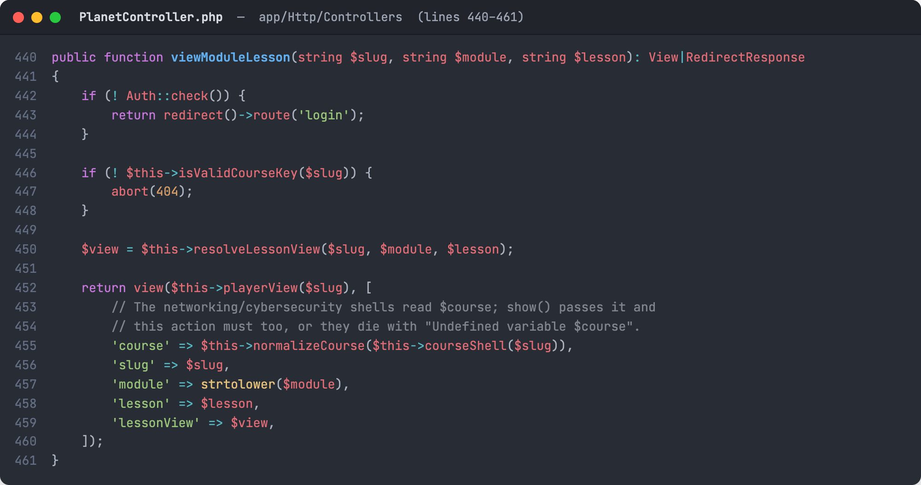
Figure 14. PlanetController::viewModuleLesson renders a lesson page
Source: app/Http/Controllers/PlanetController.php, lines 440–461
When a student opens a lesson, PlanetController checks that the course exists, finds the Blade file that holds that lesson's content, and renders it inside the course's lesson player together with the course outline.

B. Controlling Progress
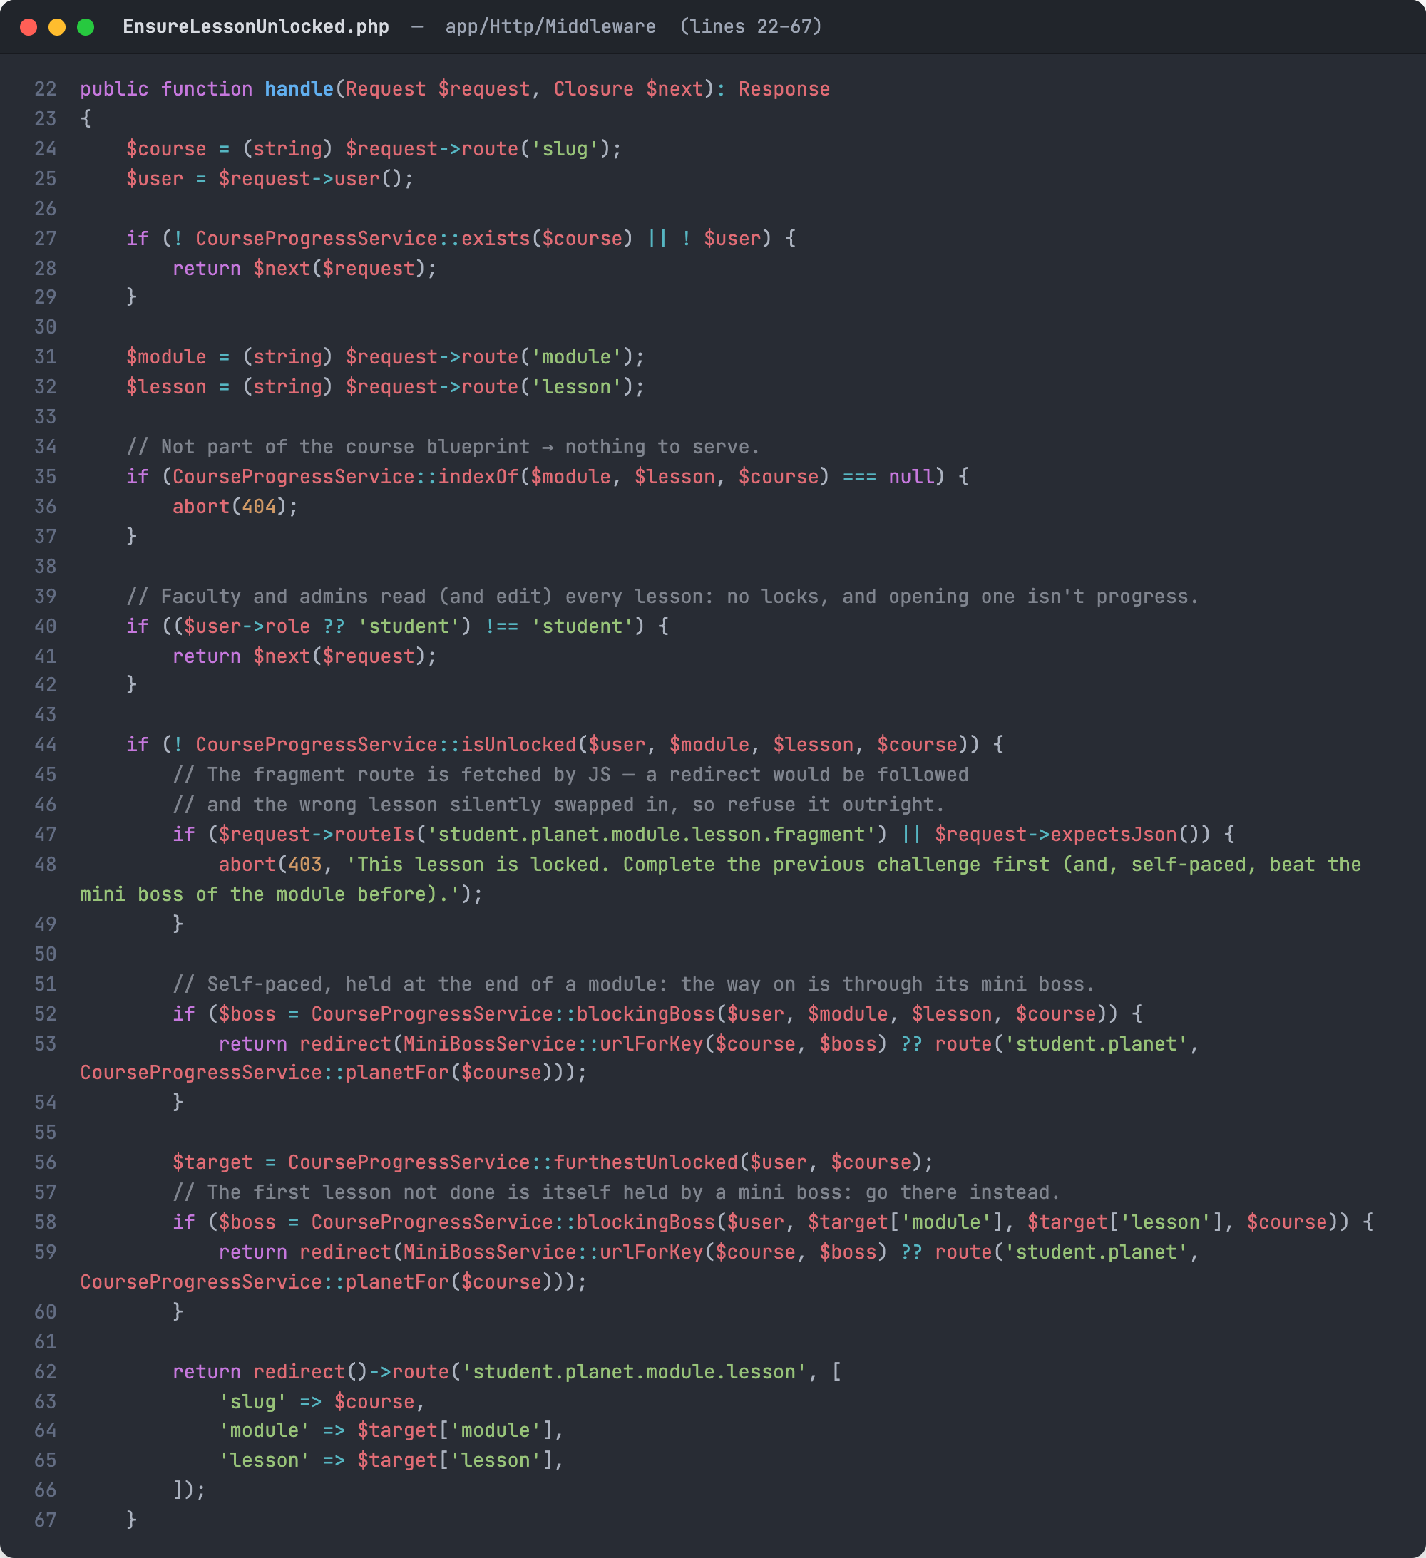
Figure 15. EnsureLessonUnlocked: the middleware that guards every lesson
Source: app/Http/Middleware/EnsureLessonUnlocked.php, lines 22–67
Every lesson request passes through this middleware first. It refuses lessons that are not in the blueprint, lets faculty and admins open any lesson, and checks whether a student has unlocked the lesson.
A student who tries to skip ahead is sent back to the furthest lesson they may open, or to the Mini Boss they still need to beat. Because the check runs on the server, a lesson cannot be opened just by typing its address.
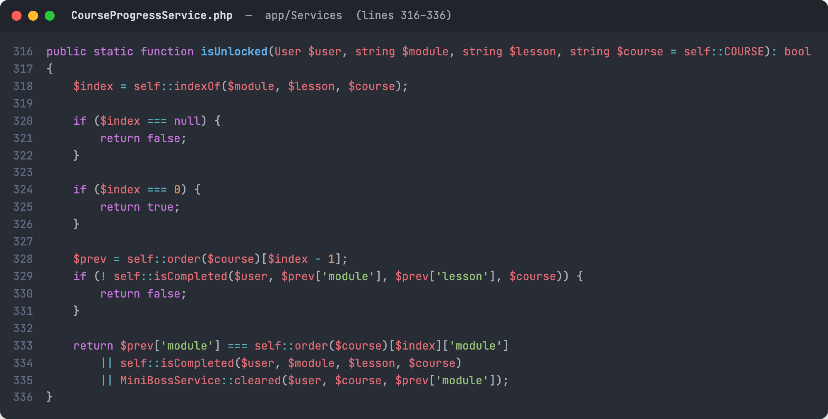
Figure 16. CourseProgressService::isUnlocked: the rule for opening a lesson
Source: app/Services/CourseProgressService.php, lines 316–336
The first lesson is always open. Any other lesson opens only when the lesson before it is completed. When the next lesson starts a new module, a self-paced student must also have passed the Mini Boss of the previous module.

C. Hands-On Labs and Module Exams
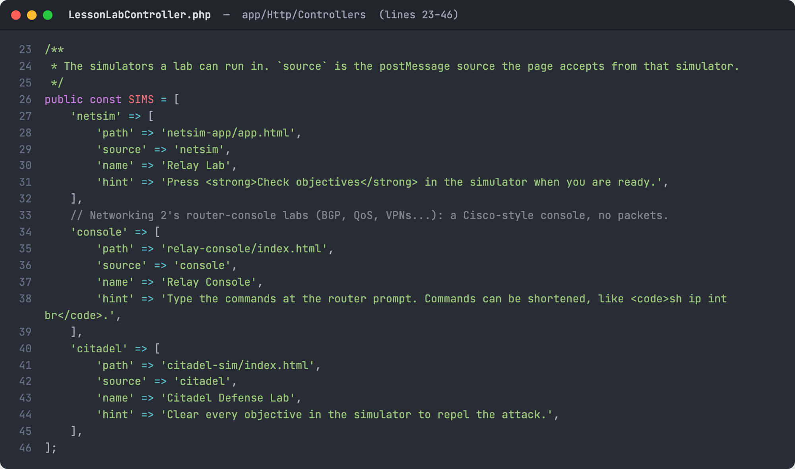
Figure 17. LessonLabController::SIMS: the simulators used by lesson labs
Source: app/Http/Controllers/LessonLabController.php, lines 23–46
Networking and Cybersecurity lessons are completed in browser-based simulators, listed here. NetSim (Relay Lab) builds and configures networks, Relay Console is a Cisco-style router console for Networking 2, and Citadel Sim is the cybersecurity defense lab. The simulator reports a pass back to TechLab, which marks the lesson complete and awards 100 XP.
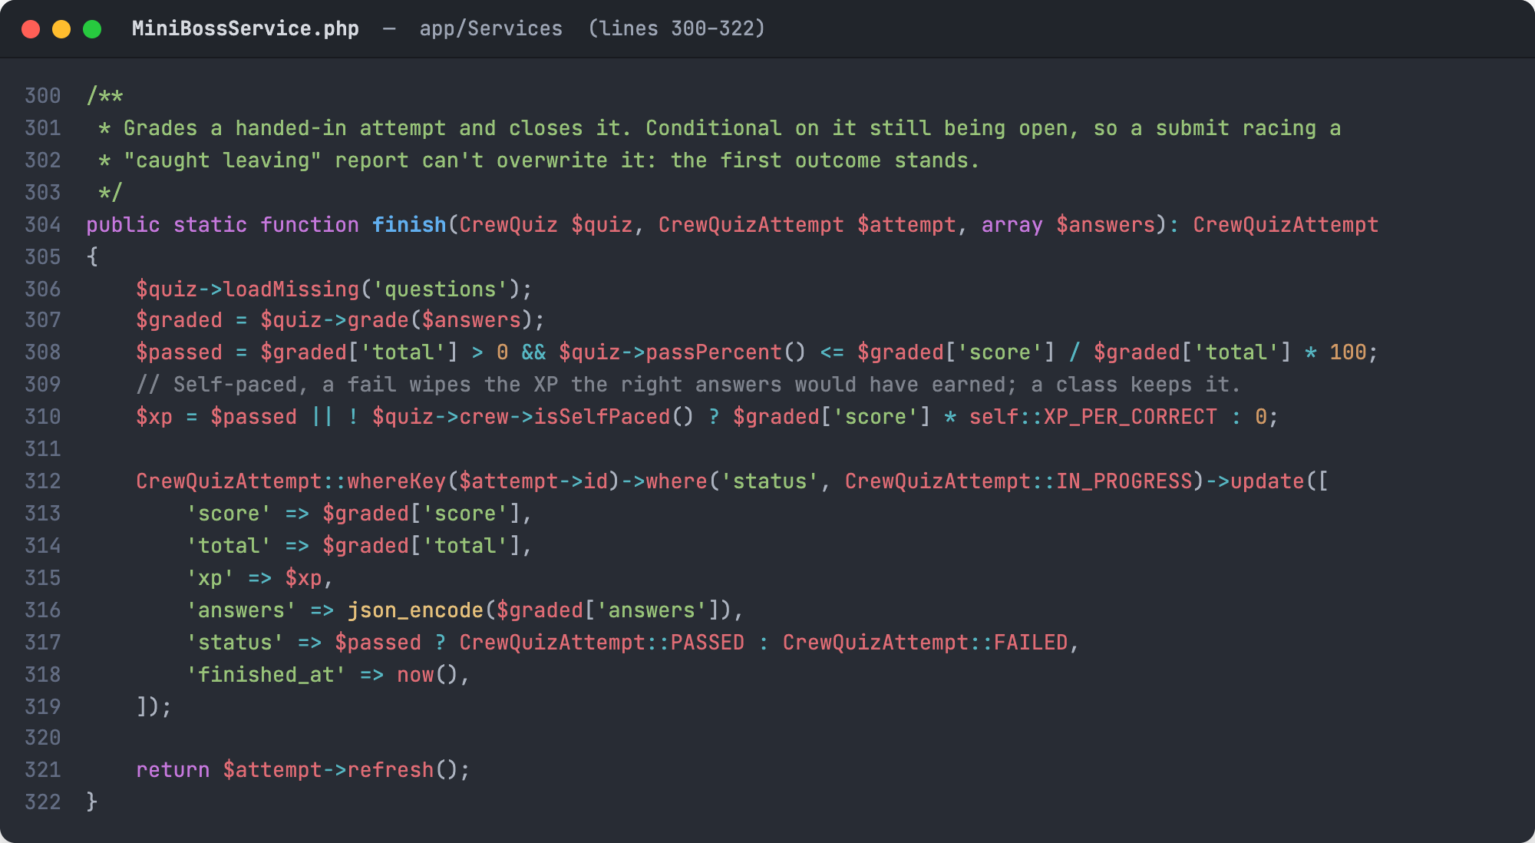
Figure 18. MiniBossService::finish grades a Mini Boss and awards XP
Source: app/Services/MiniBossService.php, lines 300–322
When a student submits a Mini Boss, the answers are graded against the quiz and compared with the pass mark. Each right answer is worth 10 XP; in self-paced mode a failed attempt earns no XP. The update only applies while the attempt is still open, so a submission cannot overwrite an attempt already failed for leaving the exam page.

