TechLab
Storyboard 1: The Self-paced Student
How a student who chooses Self-paced goes from signing up to earning a certificate. Every scene is a real TechLab screen.
Student | Maria Santos (codename StarMaria)
Course | Computer Programming 1 (CC102), Programming City
Track | Self-paced: on her own with Astro, no instructor
Ends with | A TechLab certificate (PDF) with her name on it
Scenes | 17
The journey
Sign up → Onboarding → Dashboard → Choose Self-paced → Lessons → Mini Boss → Final Boss → Certificate

SCENE 01 Sign up  Maria finds TechLab  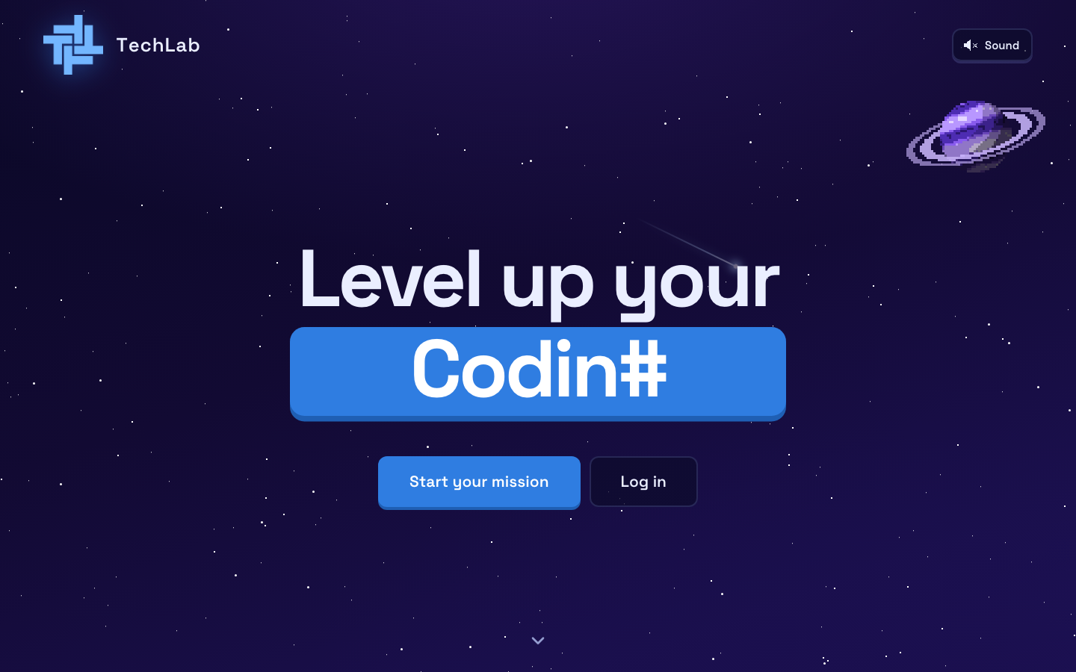  ACTION Maria opens the TechLab home page and clicks Start your mission.  ON SCREEN The landing page with the three planets: Programming, Networking and Cybersecurity. |  | SCENE 02 Sign up  She creates her account  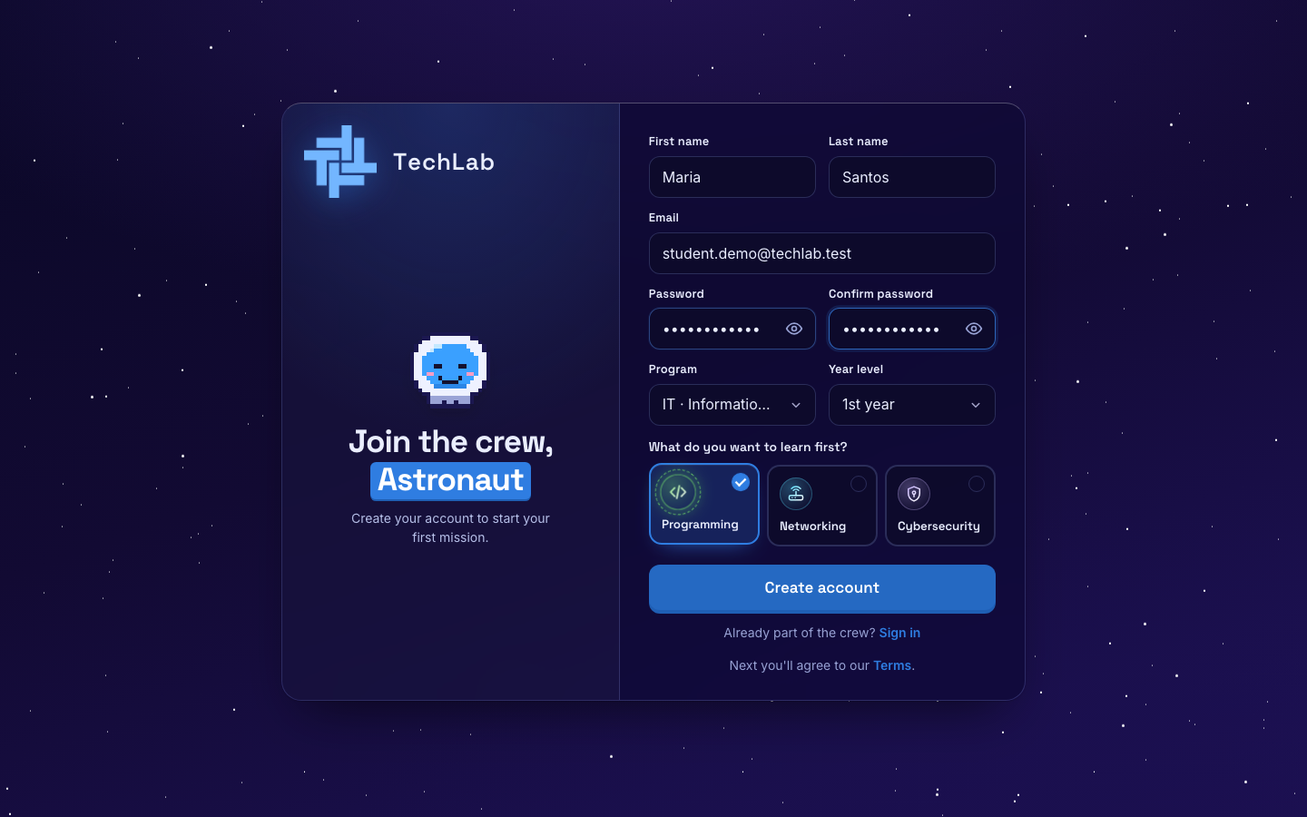  ACTION She types her name, email and password, picks her program and year level, and chooses Programming as her first planet.  ON SCREEN The sign-up form, filled in. She clicks Create account.

SCENE 03 Sign up  She agrees to the rules  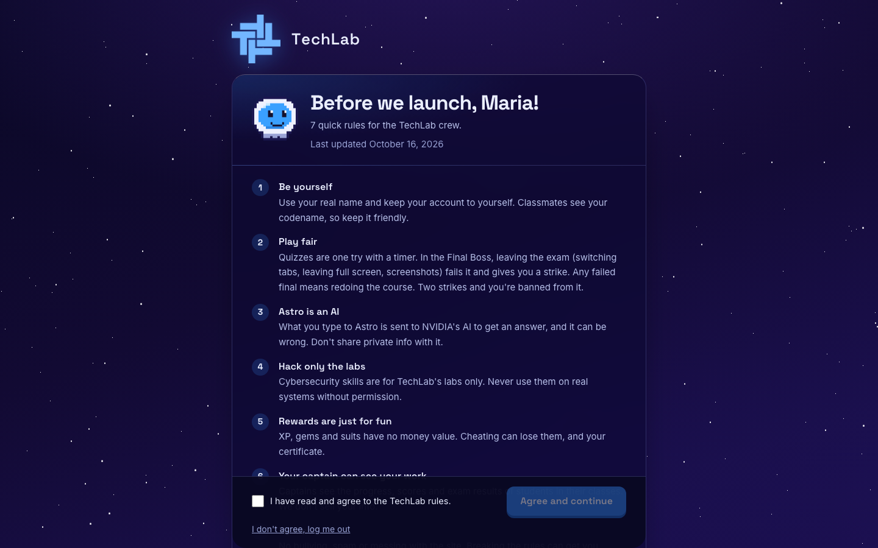  ACTION Maria reads the 7 rules, ticks I have read and agree, and clicks Agree and continue.  ON SCREEN The TechLab rules, including the strict Final Boss rules.  NOTE This is where she first learns that leaving the Final Boss page counts as a strike. |  | SCENE 04 Onboarding  She builds her astronaut  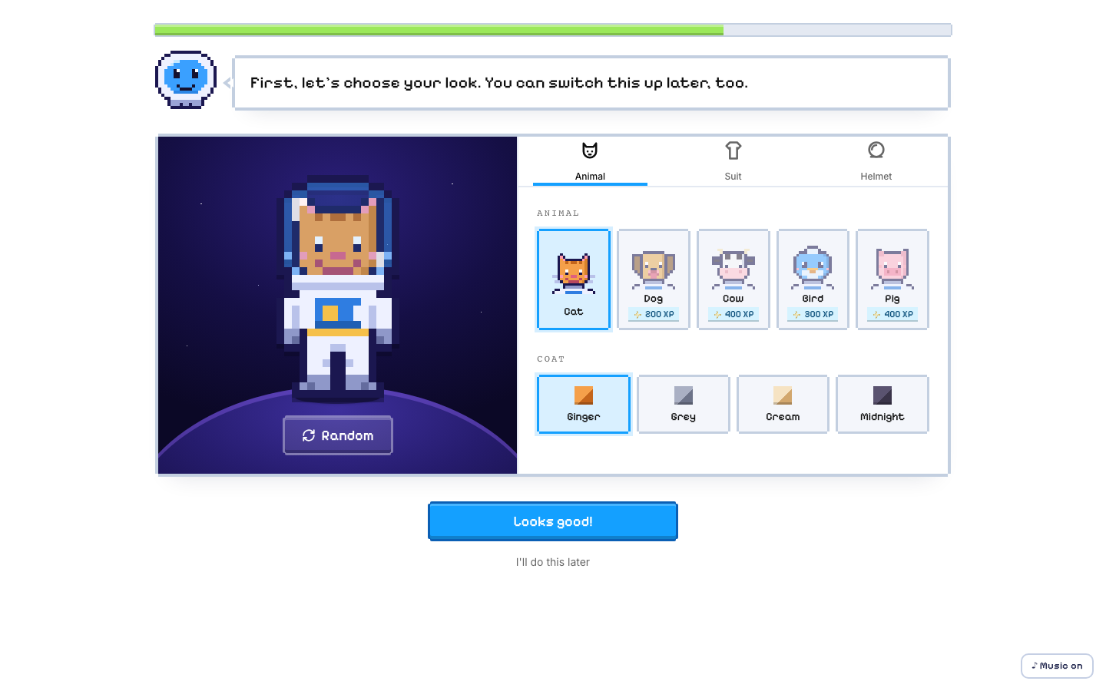  ACTION Astro welcomes her. She picks an animal, suit and helmet for her astronaut.  ON SCREEN The astronaut builder with the Animal, Suit and Helmet tabs.

SCENE 05 Onboarding  She becomes StarMaria  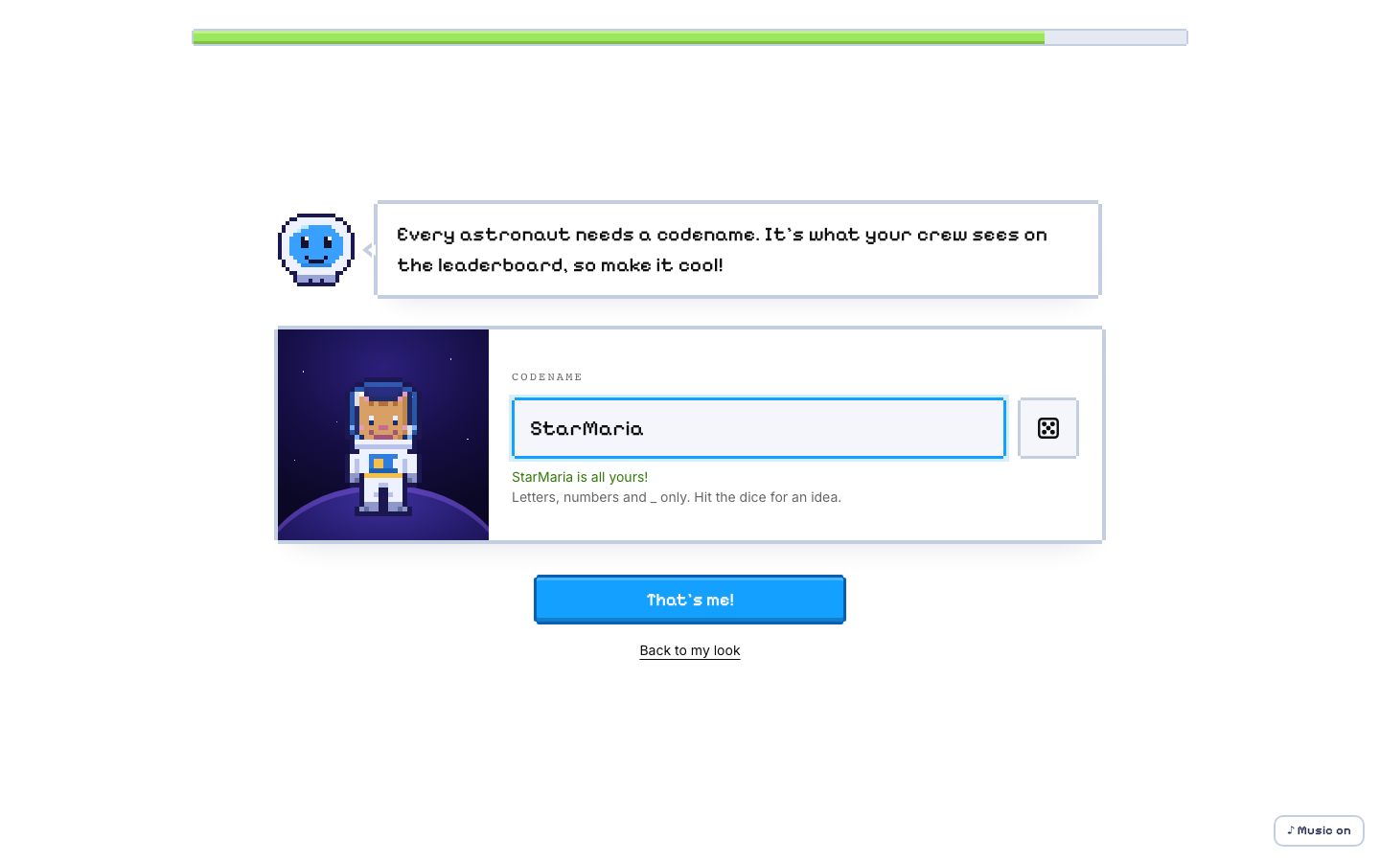  ACTION She types the codename StarMaria and clicks That's me!  ON SCREEN The codename screen. Classmates see her codename, not her real name. |  | SCENE 06 Dashboard  Astro shows her around    ACTION Maria follows Astro's 13-stop tour of the dashboard, clicking Next at each stop.  ON SCREEN The dashboard with Astro's tour bubble.

SCENE 07 Choose a track  She picks Self-paced  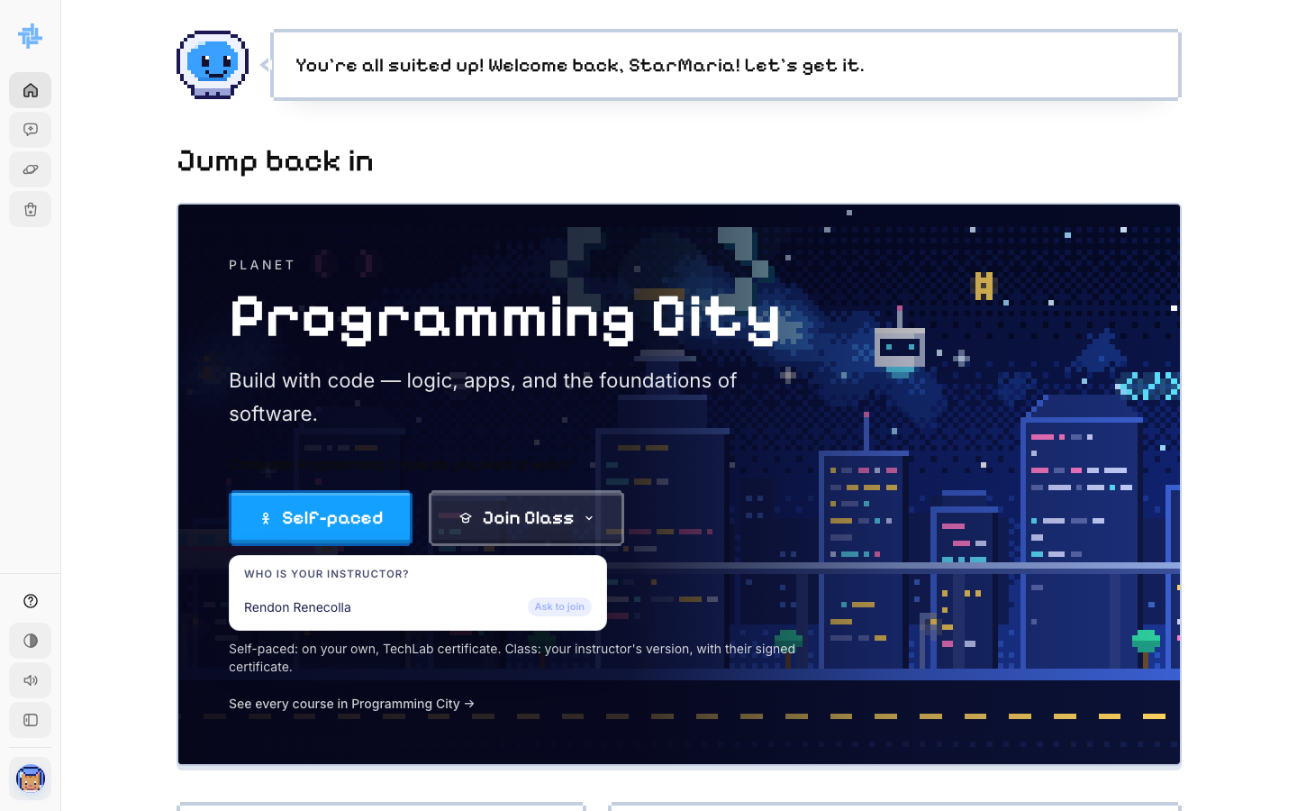  ACTION On the Programming City card she looks at Join Class, then clicks Self-paced to start right away on her own.  ON SCREEN The Self-paced and Join Class buttons. Self-paced needs no instructor and no waiting.  NOTE This choice can't be changed later. Self-paced means the standard TechLab lessons and a TechLab certificate. |  | SCENE 08 Course  Her course page opens  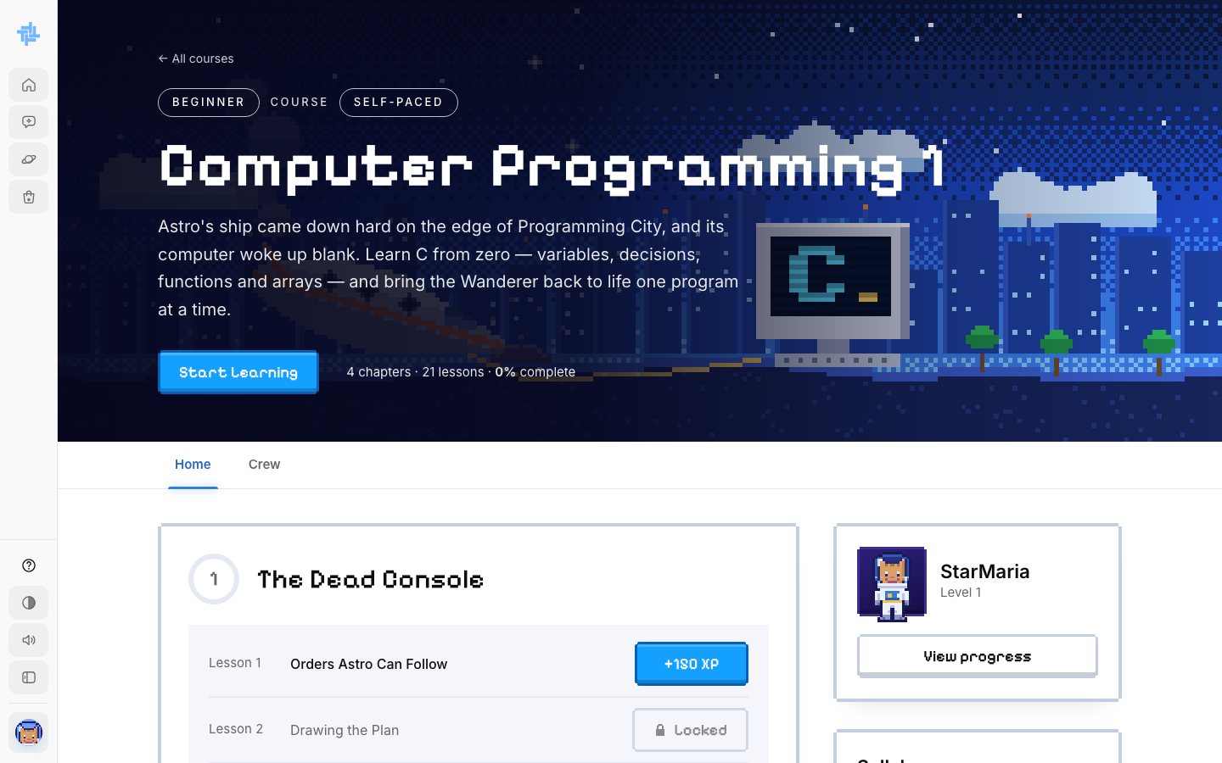  ACTION She lands on Computer Programming 1 (CC102) and clicks Start Learning.  ON SCREEN Every chapter and lesson, the syllabus, her progress and the gems she can earn.

SCENE 09 Lesson  Lesson 1.1 begins  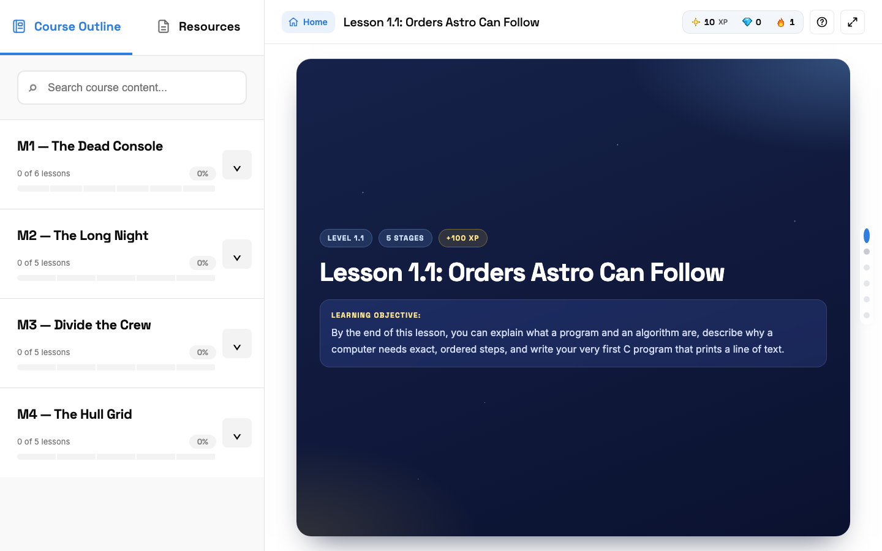  ACTION Maria opens the first lesson and reads Stage 1, the Mission Brief.  ON SCREEN The lesson screen: course outline on the left, XP and streak on top, stage dots on the right. |  | SCENE 10 Lesson  She passes a checkpoint  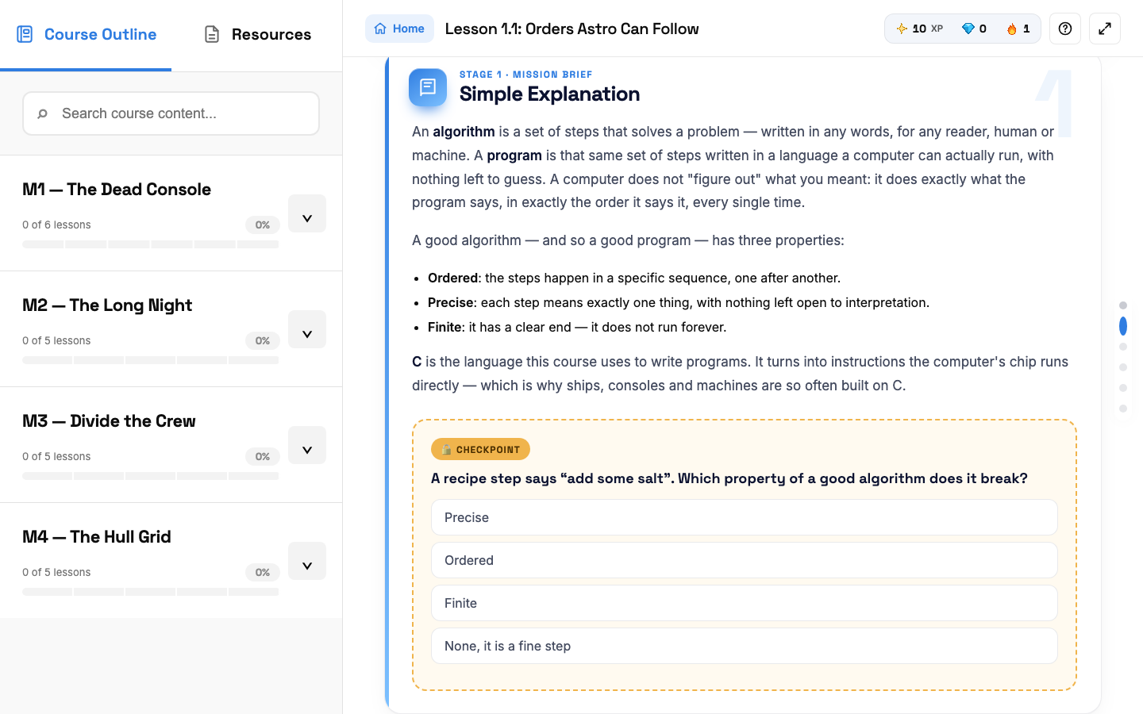  ACTION She answers the checkpoint question at the end of the stage. A right answer opens the next stage.  ON SCREEN One multiple-choice question.  NOTE A wrong answer means a short wait before she can try again.

SCENE 11 Lesson  She sees it as a picture  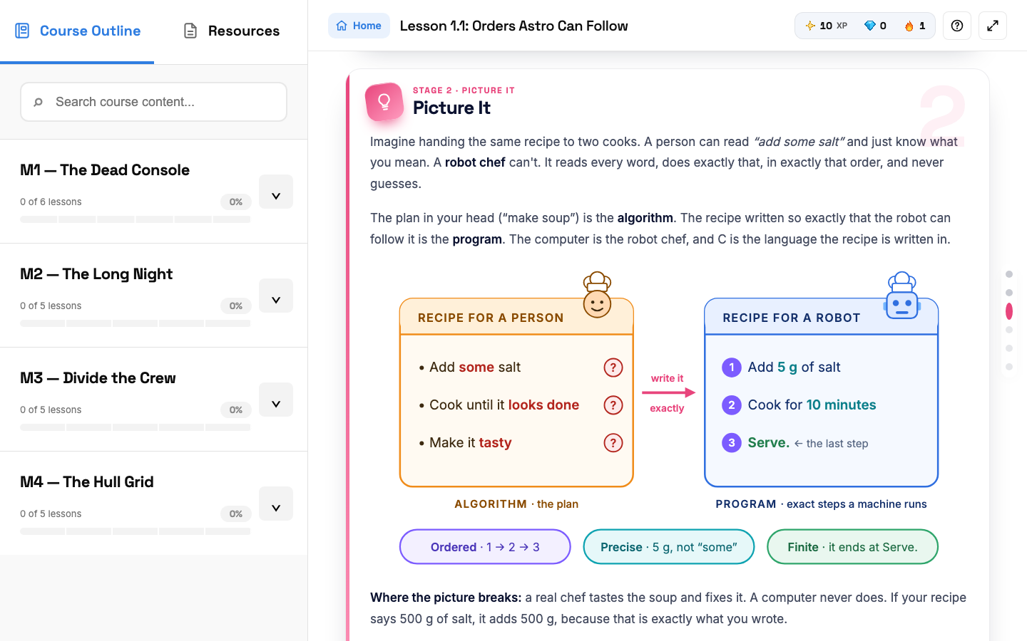  ACTION In Stage 2, Picture It, she reads an everyday example of the idea.  ON SCREEN An everyday comparison with a drawing. |  | SCENE 12 Lesson  Knowledge Check  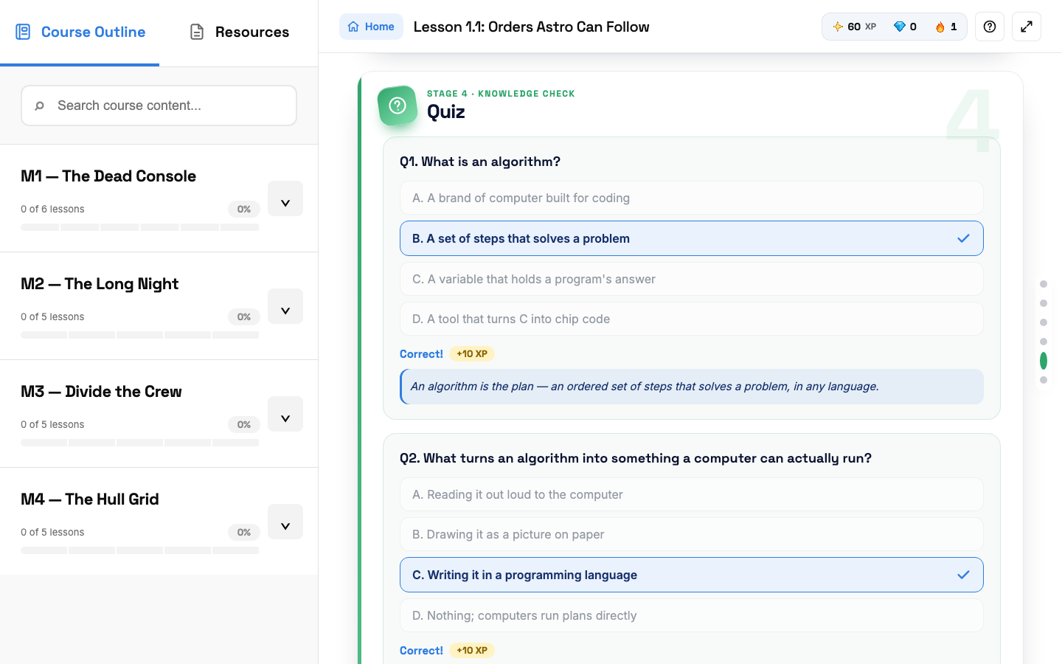  ACTION She answers the lesson quiz. Each right answer gives +10 XP.  ON SCREEN Her answers marked Correct, each with a short explanation.

SCENE 13 Lesson  She writes real C code  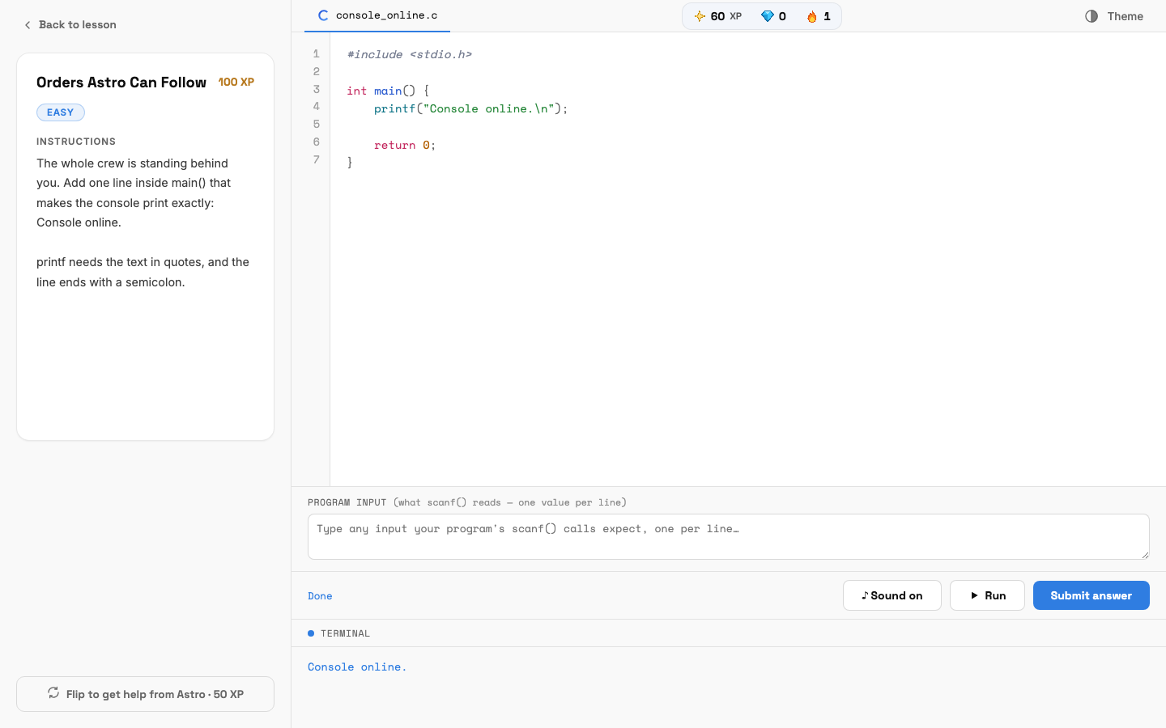  ACTION She clicks Code it yourself, writes her program, clicks Run to test it, then Submit answer.  ON SCREEN The code editor with the instructions on the left and the terminal output below. |  | SCENE 14 Lesson  Challenge complete  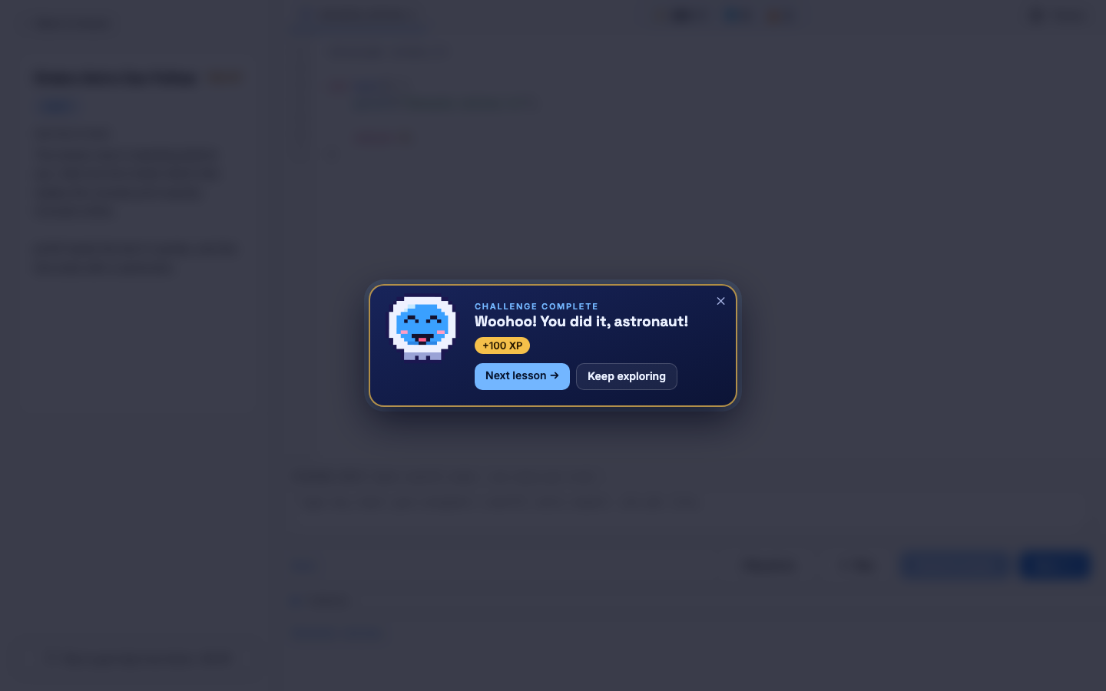  ACTION Her code is correct. She earns +100 XP and clicks Next lesson.  ON SCREEN Astro cheers and the XP is added.

SCENE 15 Mini Boss  She faces the Mini Boss  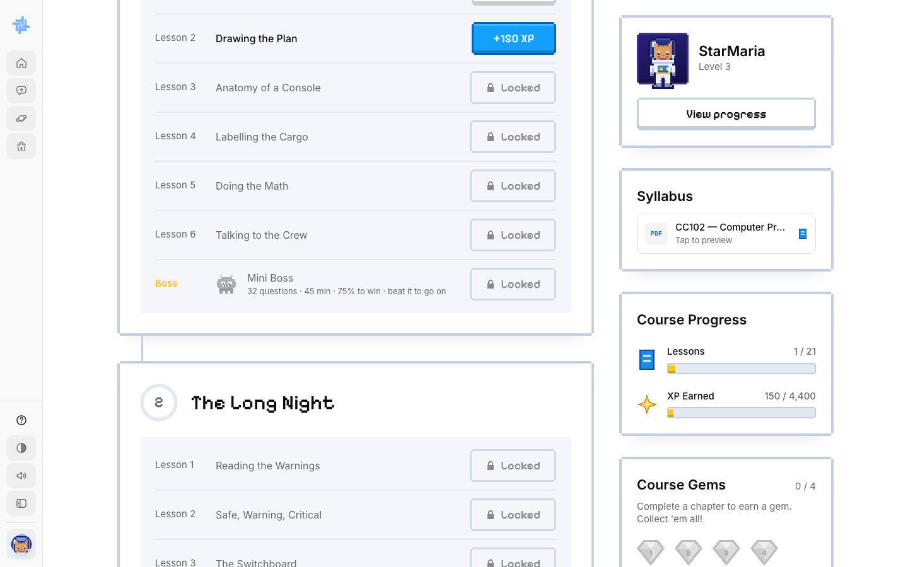  ACTION After the last lesson of the module, Maria takes the Mini Boss: about 30 questions in 45 minutes, 75% to win.  ON SCREEN The Mini Boss row at the end of the module.  NOTE Self-paced: she must win to open the next module. If she loses, she gets 0 XP and waits 60 minutes. |  | SCENE 16 Final Boss  The Final Boss  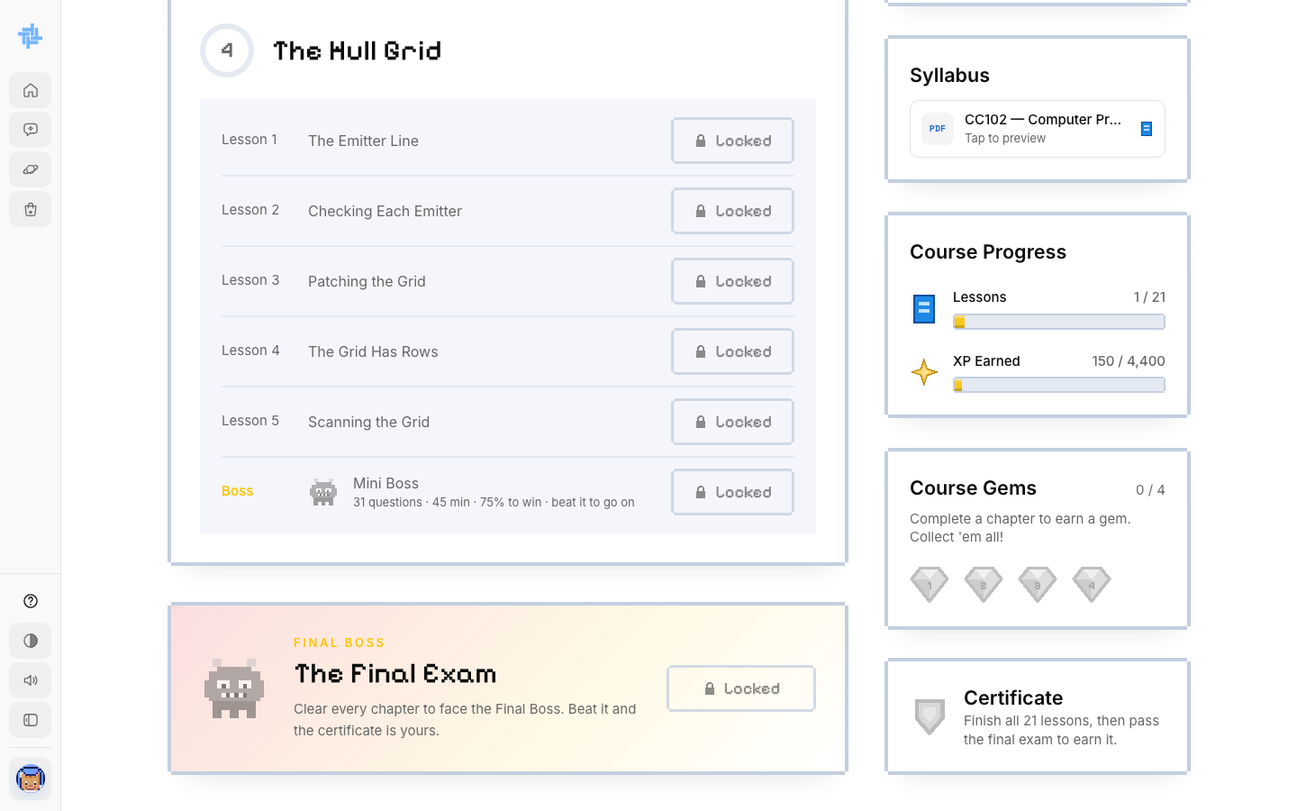  ACTION With every chapter cleared, she opens the Final Exam and stays on the page until she finishes.  ON SCREEN The Final Exam card and the Certificate box on the course page.  NOTE Leaving the page fails the exam and adds a strike. Failing the final resets her course progress.

SCENE 17 Certificate  Maria earns her certificate  ACTION She passes the Final Boss and clicks View certificate in the Certificate box.  ON SCREEN Her certificate opens as a PDF: Computer Programming 1 (CC102), awarded to Maria Santos, issued by TechLab under the Self-paced Learning Program, with the date and a certificate number.  NOTE She can save or print it. A small notice says it is not yet recognized by schools or the IT industry.  The end of the self-paced journey: sign up, learn, beat the bosses, get certified. | 

