TechLab
Storyboard 2: The Join Class Student
How a student who joins a faculty member's class goes from signing up to a certificate signed by their instructor. Every scene is a real TechLab screen.
Student | Leo Cruz (codename MeteorTabby95)
Instructor | Captain Carlo Reyes
Course | Computer Programming 1 (CC102), Programming City
Track | Join Class: Carlo's version of the course, his quizzes and final exam
Ends with | A certificate (PDF) with Leo's name and Carlo's digital signature
Scenes | 17
The journey
Sign up → Onboarding → Ask to join → Captain accepts → Lessons → Mini Boss → Final Boss → Signed certificate

SCENE 01 Sign up  Leo finds TechLab    ACTION Leo opens the TechLab home page and clicks Start your mission.  ON SCREEN The landing page with the three planets: Programming, Networking and Cybersecurity. |  | SCENE 02 Sign up  He creates his account  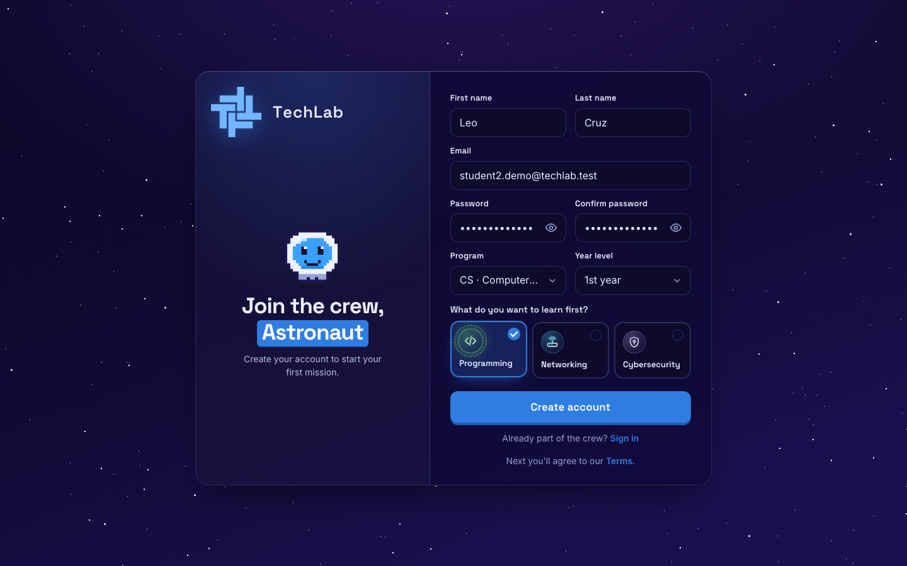  ACTION He types his name, email and password, picks CS and 1st year, and chooses Programming as his first planet.  ON SCREEN The sign-up form, filled in. He clicks Create account.

SCENE 03 Sign up  He agrees to the rules  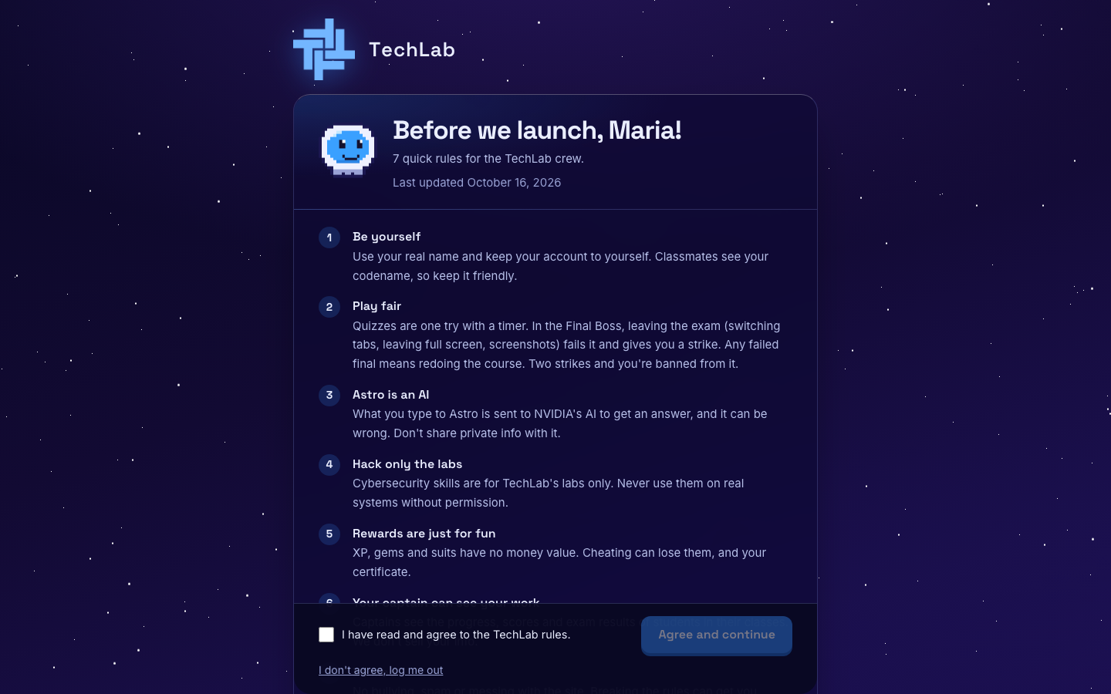  ACTION Leo reads the 7 rules, ticks I have read and agree, and clicks Agree and continue.  ON SCREEN The TechLab rules, including the strict Final Boss rules. |  | SCENE 04 Onboarding  He becomes MeteorTabby95  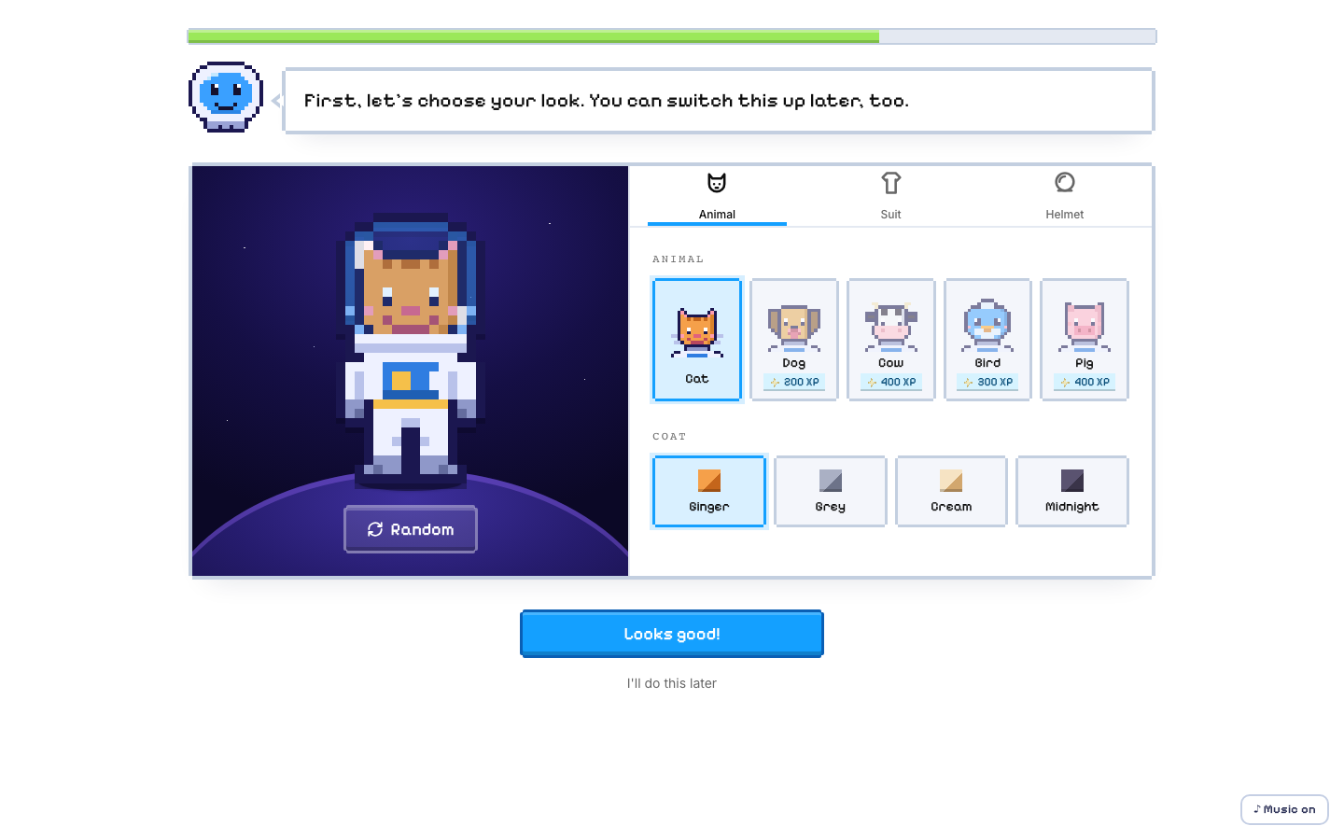  ACTION Astro welcomes him. He builds his astronaut and picks the codename MeteorTabby95.  ON SCREEN The astronaut builder. Classmates see his codename, not his real name.

SCENE 05 Choose a track  He picks Join Class  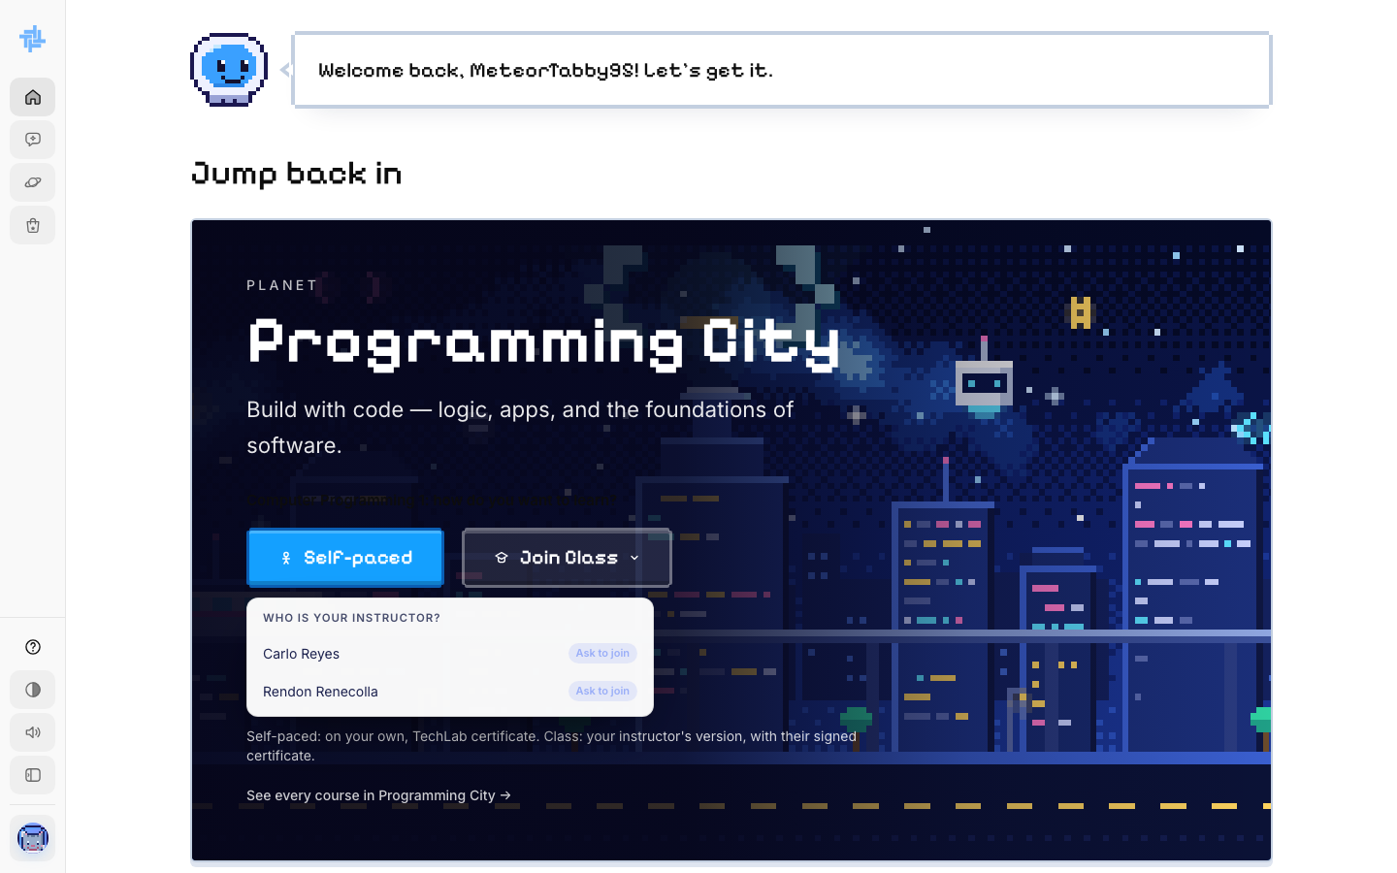  ACTION On the Programming City card Leo clicks Join Class, finds his instructor Carlo Reyes, and clicks Ask to join.  ON SCREEN The list of instructors teaching Computer Programming 1.  NOTE This choice can't be changed later. A class follows the instructor's version of the course. |  | SCENE 06 Choose a track  He waits for his Captain  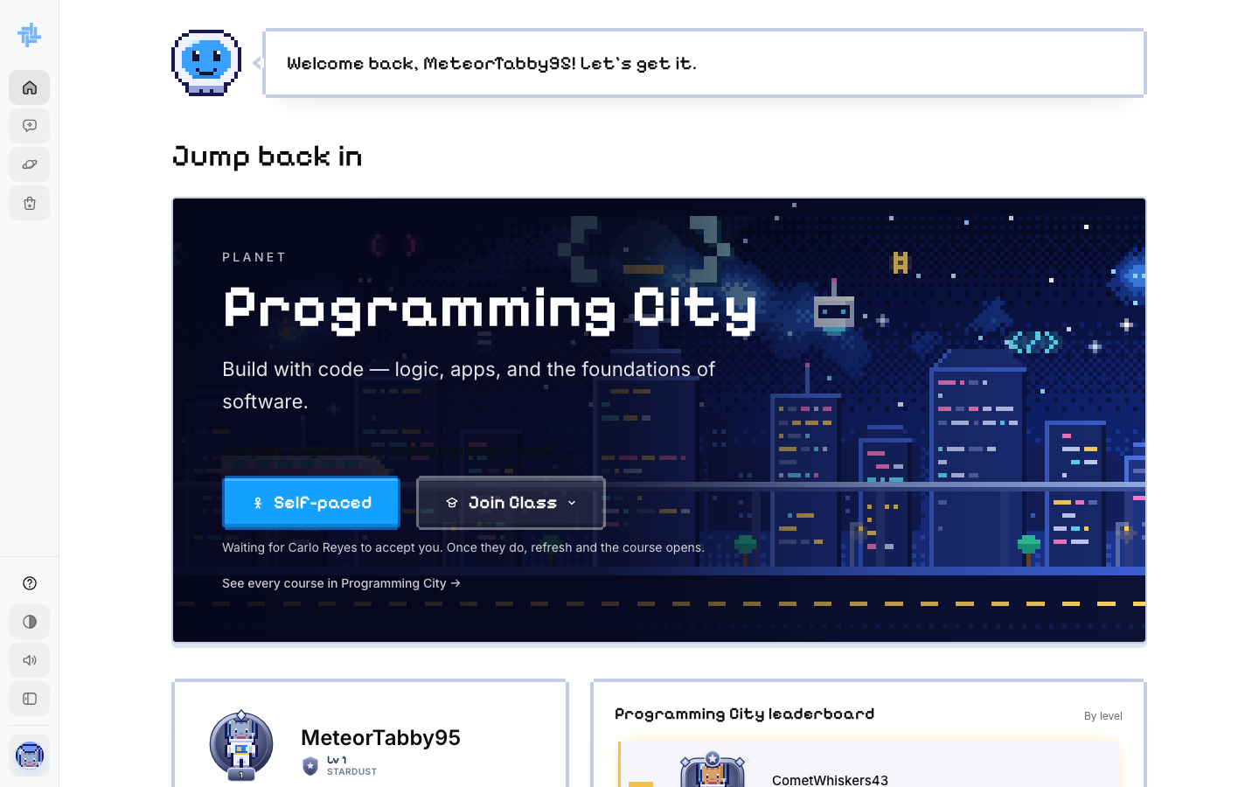  ACTION Leo's request is sent. He waits for Carlo Reyes to accept it.  ON SCREEN "Waiting for Carlo Reyes to accept you. Once they do, refresh and the course opens."

SCENE 07 Captain  Captain Carlo accepts him  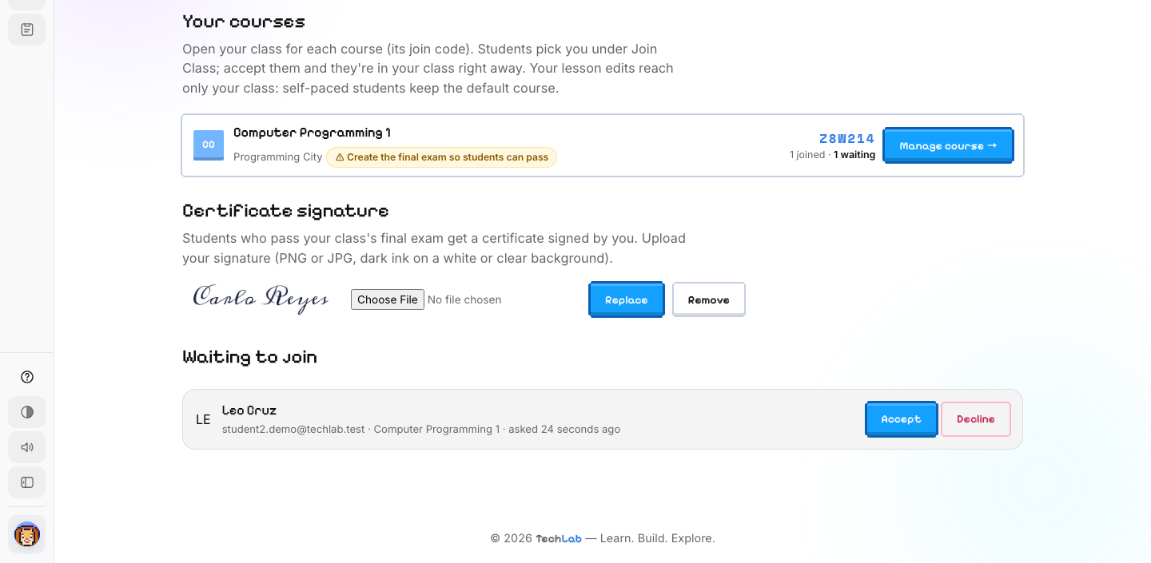  ACTION On his dashboard, Carlo Reyes sees Leo under Waiting to join and clicks Accept.  ON SCREEN Carlo's dashboard. His digital signature is already uploaded under Certificate signature, ready for his students' certificates.  NOTE Faculty upload their signature once (PNG or JPG). Every certificate from their class carries it. |  | SCENE 08 Dashboard  He is in the class  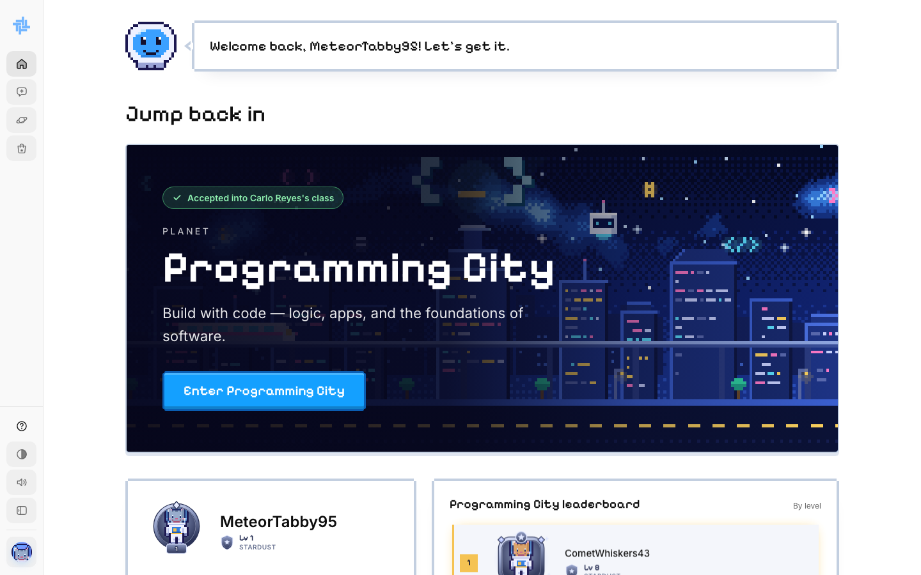  ACTION Leo refreshes his dashboard and clicks Enter Programming City.  ON SCREEN A green badge: Accepted into Carlo Reyes's class.

SCENE 09 Course  His class course page  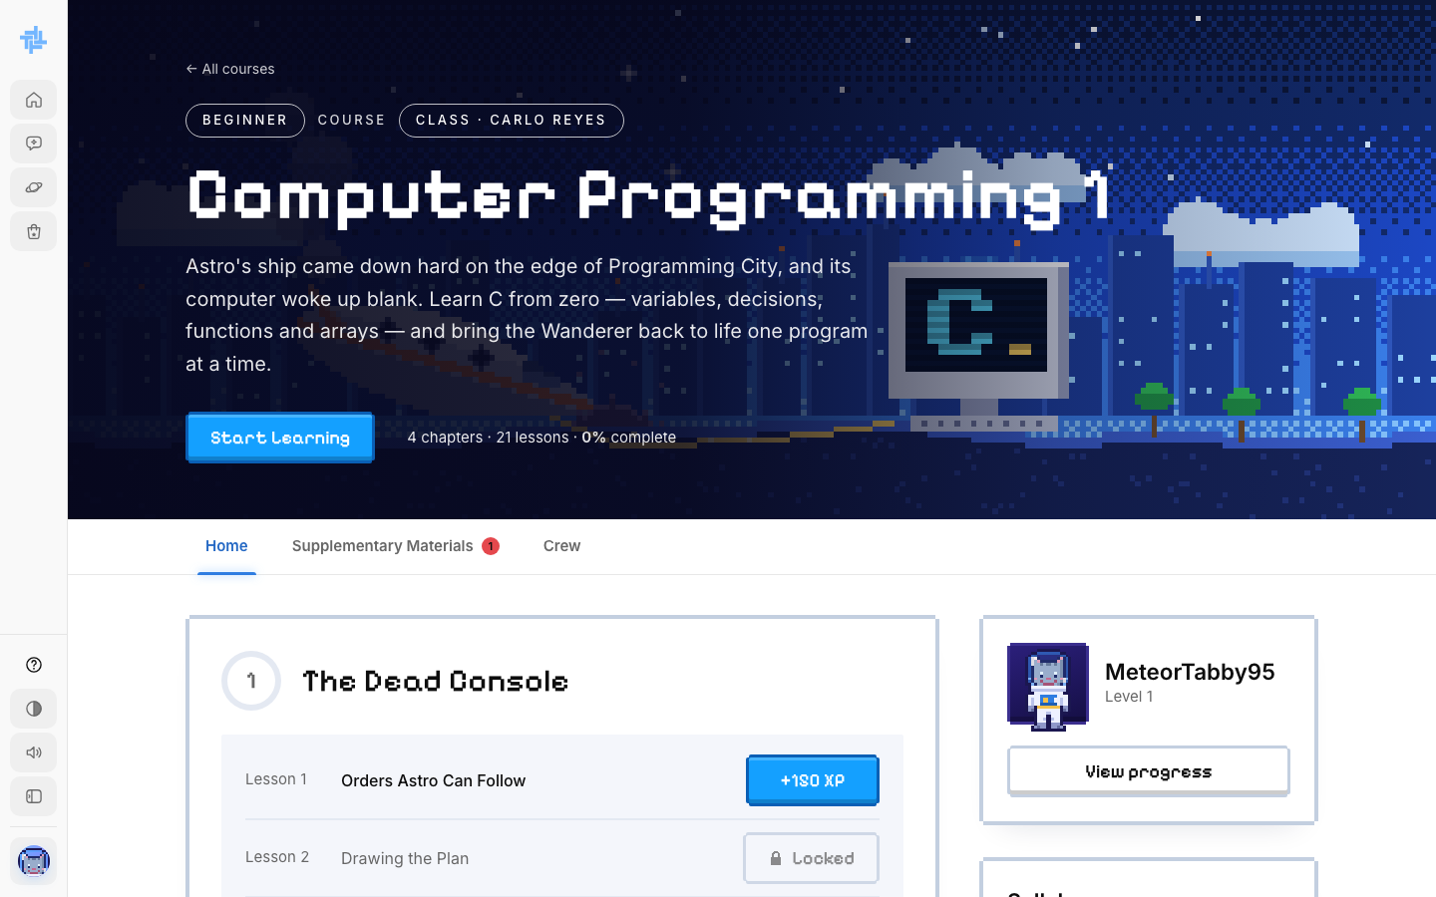  ACTION He opens Computer Programming 1 and clicks Start Learning.  ON SCREEN The badge says Class · Carlo Reyes. The lessons are Carlo's version of the course. |  | SCENE 10 Course  He meets his Captain  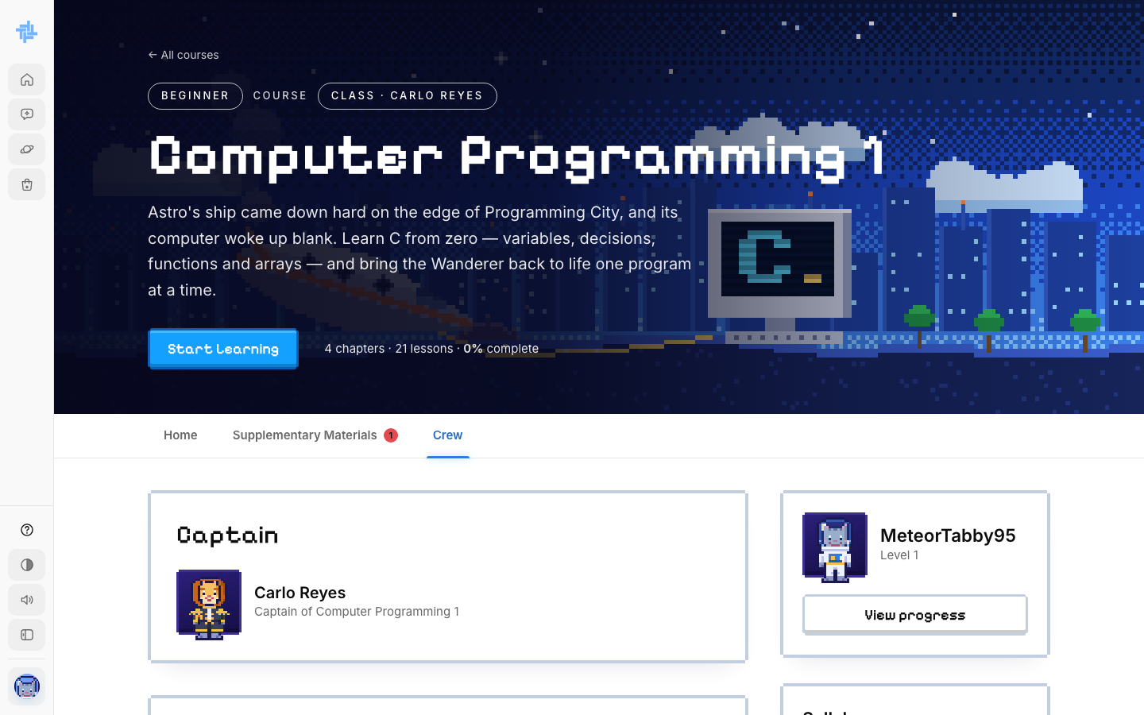  ACTION Leo opens the Crew tab to see who leads his class.  ON SCREEN Captain: Carlo Reyes, Captain of Computer Programming 1, plus the crew leaderboard.

SCENE 11 Lesson  Lesson 1.1 begins  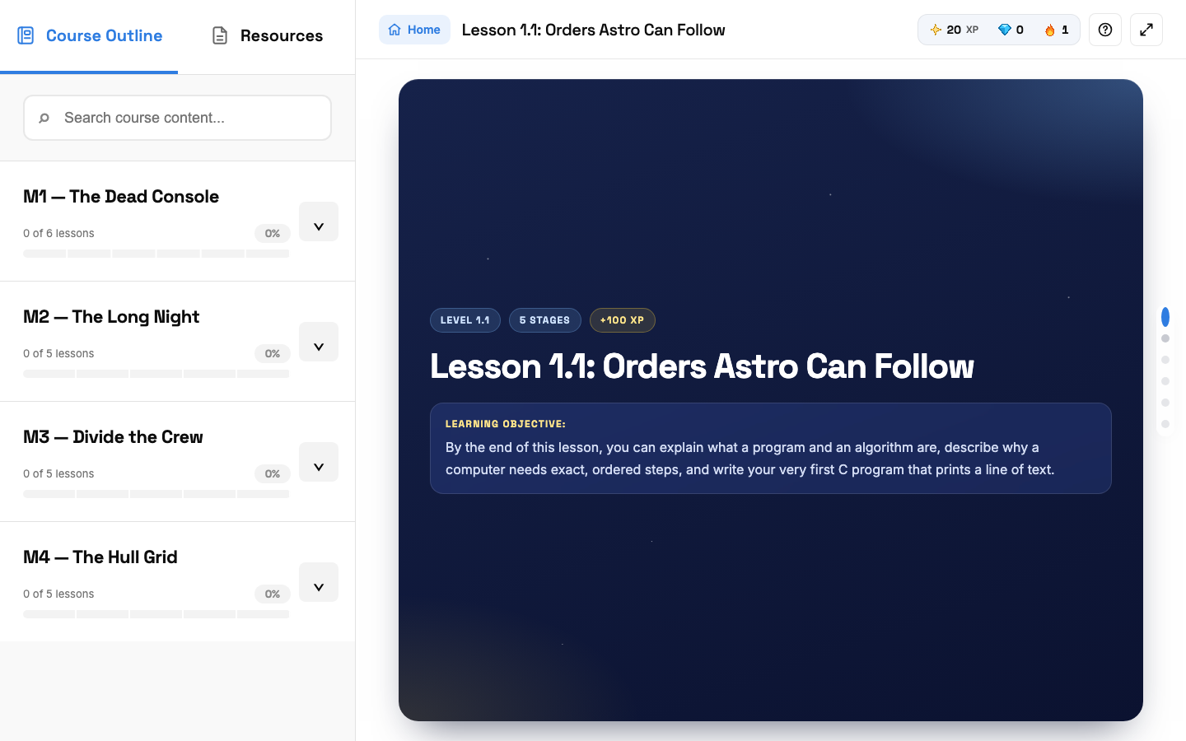  ACTION He opens the first lesson and reads Stage 1, the Mission Brief.  ON SCREEN The lesson screen: course outline on the left, XP and streak on top, stage dots on the right. |  | SCENE 12 Lesson  He passes a checkpoint  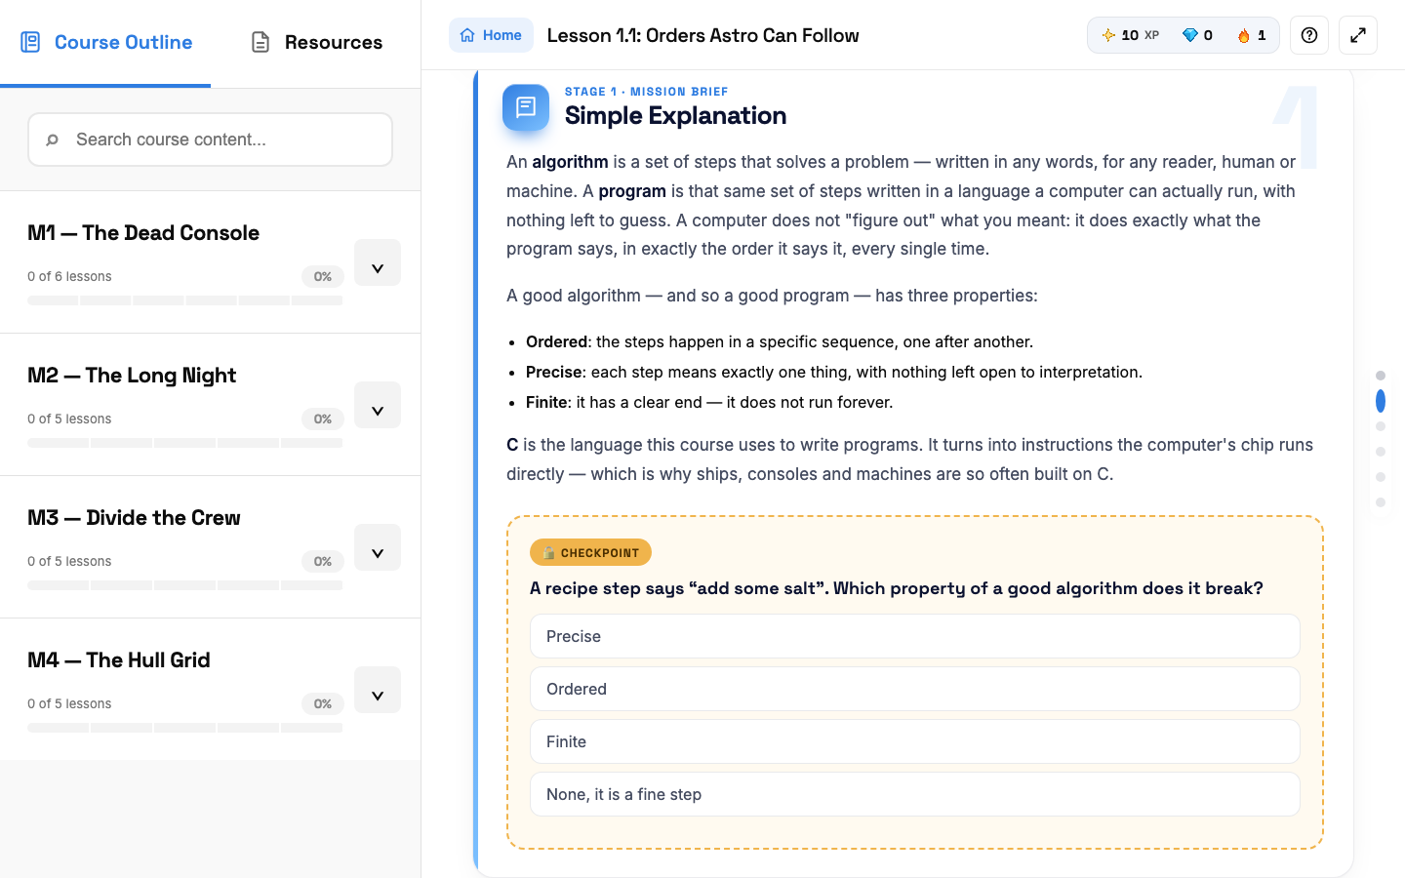  ACTION He answers the checkpoint question at the end of each stage to open the next one.  ON SCREEN One multiple-choice question.

SCENE 13 Lesson  Knowledge Check  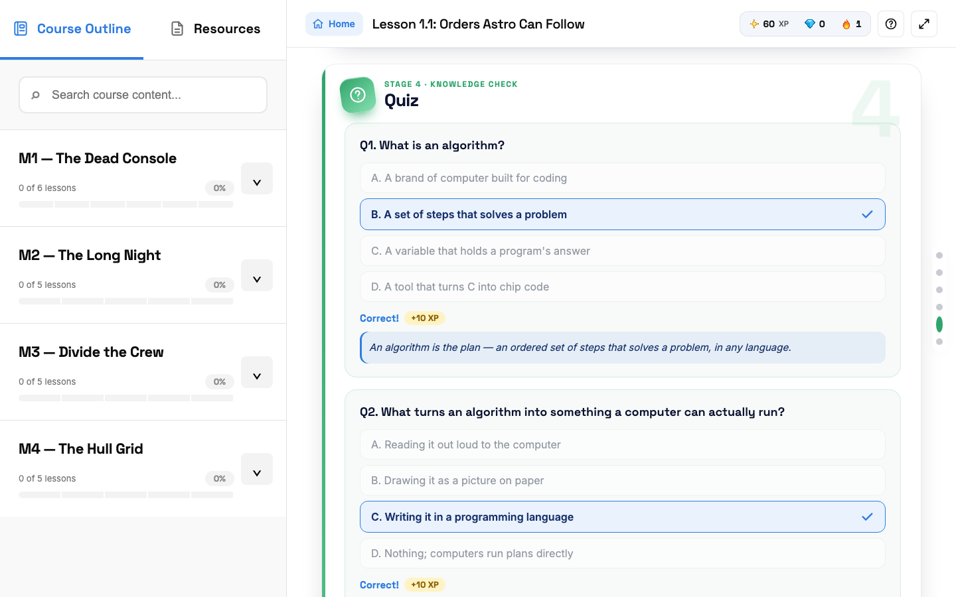  ACTION He answers the lesson quiz. Each right answer gives +10 XP.  ON SCREEN His answers marked Correct, each with a short explanation. |  | SCENE 14 Lesson  He writes real C code  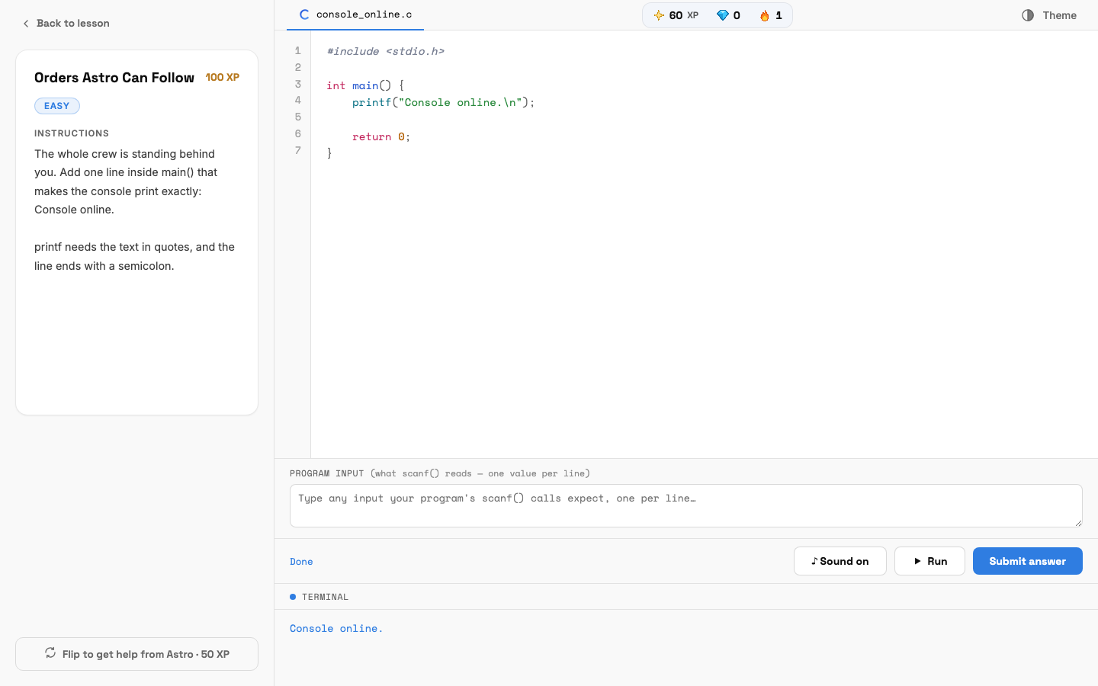  ACTION He clicks Code it yourself, writes his program, runs it and submits it for +100 XP.  ON SCREEN The code editor with the instructions on the left and the terminal output below.

SCENE 15 Mini Boss  One shot at the Mini Boss  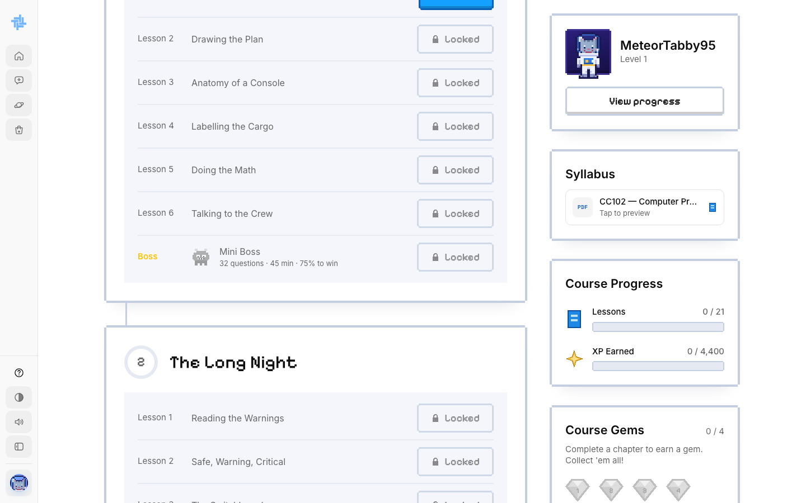  ACTION After the last lesson of Module 1, Leo takes the Mini Boss: about 30 questions in 45 minutes, 75% to win.  ON SCREEN The Mini Boss row at the end of the module.  NOTE Class: one try only. His score is saved for Captain Carlo and nothing locks, so he moves on either way. |  | SCENE 16 Final Boss  The Final Boss  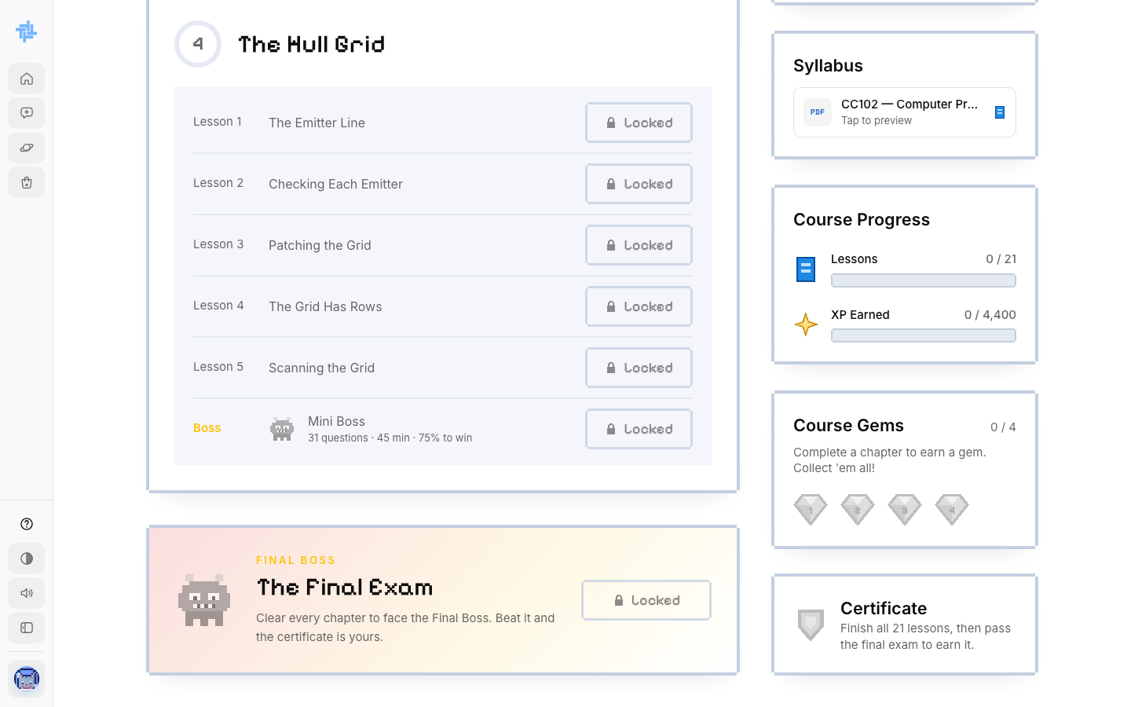  ACTION With every chapter cleared, Leo takes the Final Exam that Captain Carlo built for the class.  ON SCREEN The Final Exam card and the Certificate box on the course page.  NOTE Leaving the page fails the exam and adds a strike. Failing the final resets his course progress.

SCENE 17 Certificate  Leo earns his signed certificate  ACTION He passes Captain Carlo's Final Exam and clicks View certificate in the Certificate box.  ON SCREEN His certificate opens as a PDF: Computer Programming 1 (CC102), awarded to Leo Cruz, signed with Carlo Reyes's digital signature as Instructor, under Class Learning, with the date and a certificate number.  NOTE He can save or print it. A small notice says it is not yet recognized by schools or the IT industry.  The end of the class journey: ask to join, learn with the Captain, beat the bosses, get a signed certificate. | 

