TechLab
Storyboard 3: The Admin
Everything the TechLab admin does: signing in, giving courses their teachers, watching how TechLab grows, managing classes, looking after self-paced learners, and managing admins. Every scene is a real TechLab screen.
Admin | Ana Admin (first admin)
Faculty | Carlo Reyes (Computer Programming 1), Joy Bautista (Networking 1)
Students | Maria, Paolo, Bea, Nina and Kim (self-paced); Leo, Sam and Tomas (Carlo's class); Ivan (Joy's class); Jules and Rica (self-paced Networking 1)
Parts | 1 Getting in · 2 Giving a course its teacher · 3 Watching TechLab · 4 Course assignments · 5 Classes · 6 Self-paced learners · 7 Account and admins
Connects to | Storyboard 1 (Maria, self-paced), Storyboard 2 (Leo, Carlo's class), Storyboard 4 (Faculty, from Carlo's Open class)
Scenes | 42
What the admin does
Sign in → Assign faculty → Watch the Command deck → Manage assignments → Watch classes → Look after self-paced → Manage admins

PART 1
Getting in
Admins have their own sign-in page and no sign-up page. The first admin creates every other admin.

SCENE 01 Admin · Sign in  Ana signs in  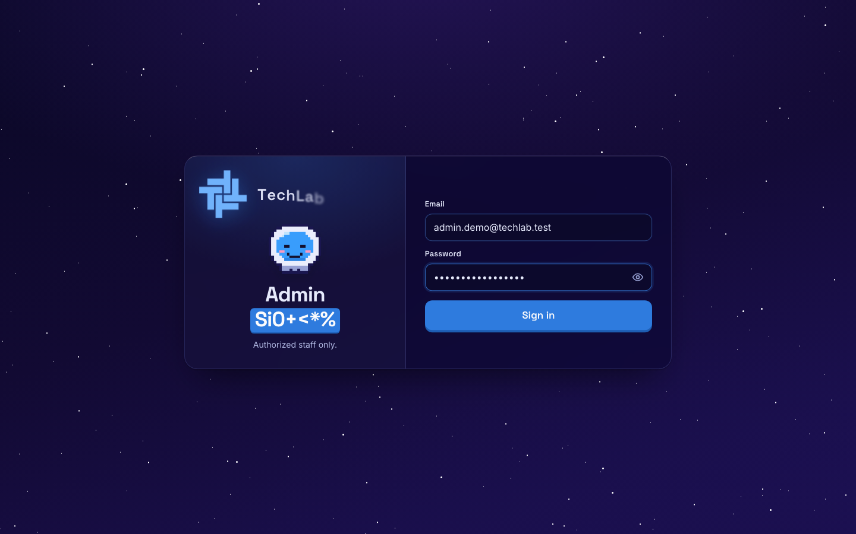  ACTION Ana Admin goes to /admin/login, types her admin email and password, and clicks Sign in.  ON SCREEN The admin sign-in page. A student or faculty account gets the same error as a wrong password. |  | SCENE 02 Admin · Avatar  She picks her avatar  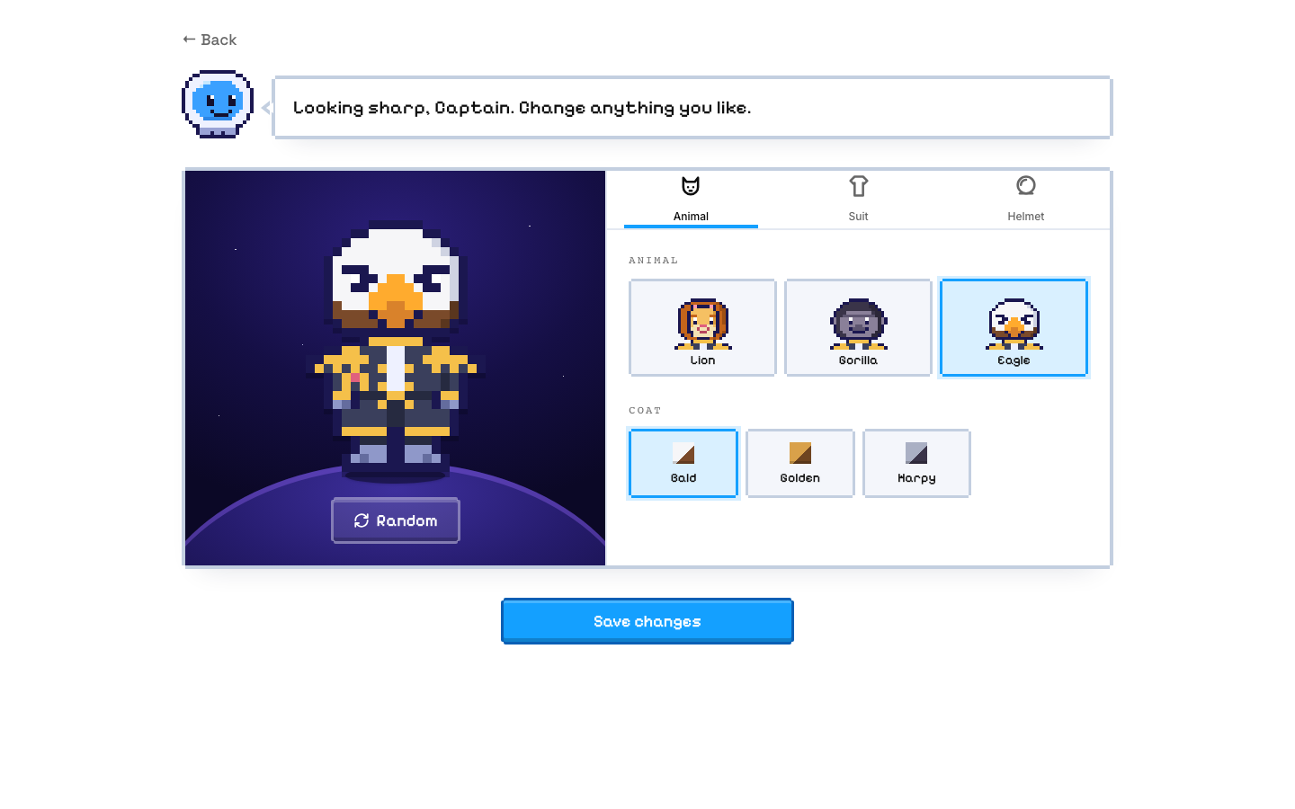  ACTION From the account menu she clicks Change avatar, picks the Eagle, and clicks Save changes.  ON SCREEN The captain builder: Animal, Suit and Helmet tabs, and a Random button.

SCENE 03 Admin · Sidebar
Her four pages
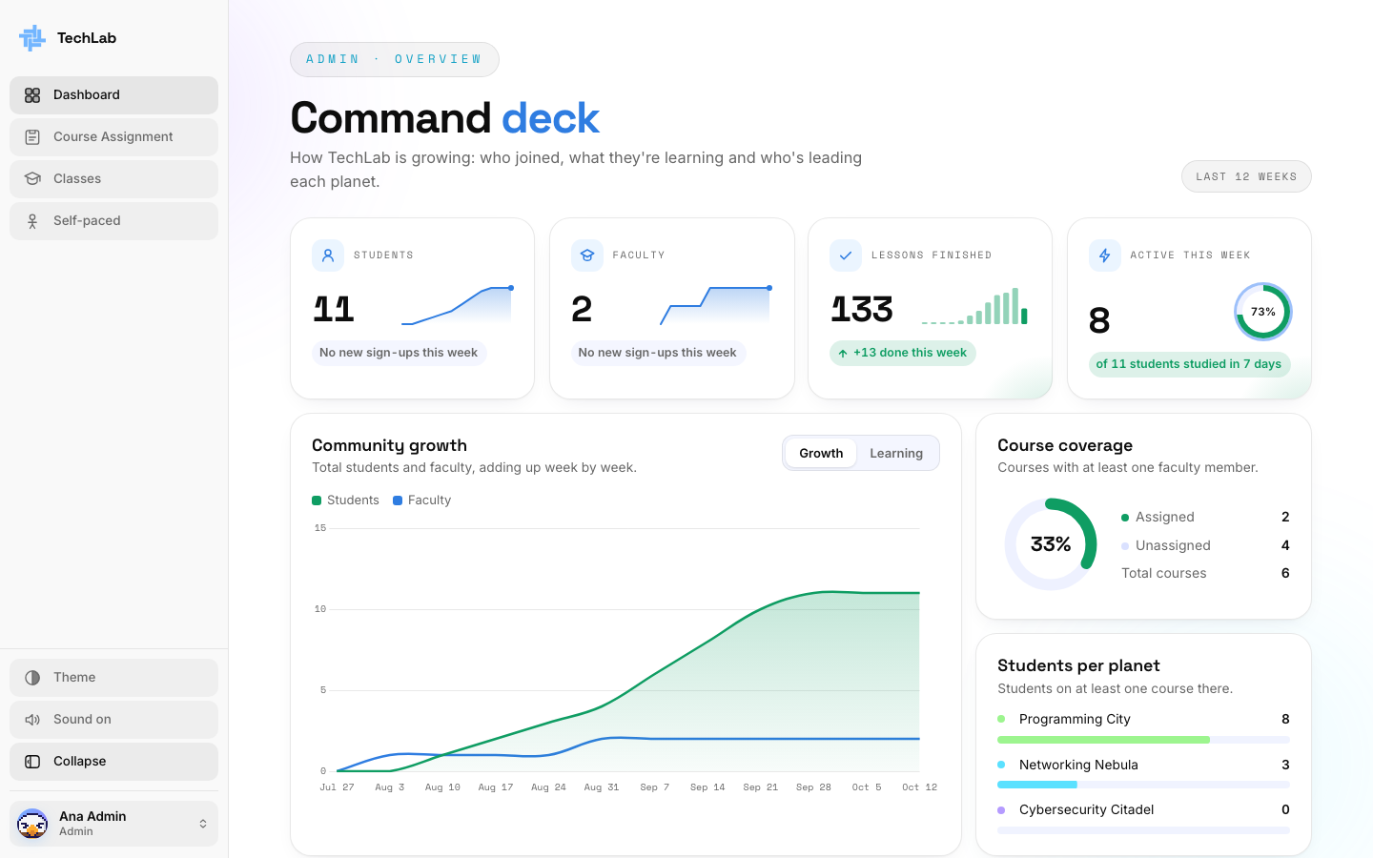
ACTION She clicks Expand to open the sidebar and see every page by name.
ON SCREEN Dashboard, Course Assignment, Classes and Self-paced. At the bottom: Theme, Sound, Collapse and her account.

PART 2
Giving a course its teacher
Ten weeks ago, TechLab was empty. A faculty member has to register before the admin can assign them, so this part follows Ana and Carlo Reyes in turn.

SCENE 04 Admin · Dashboard  An empty Command deck  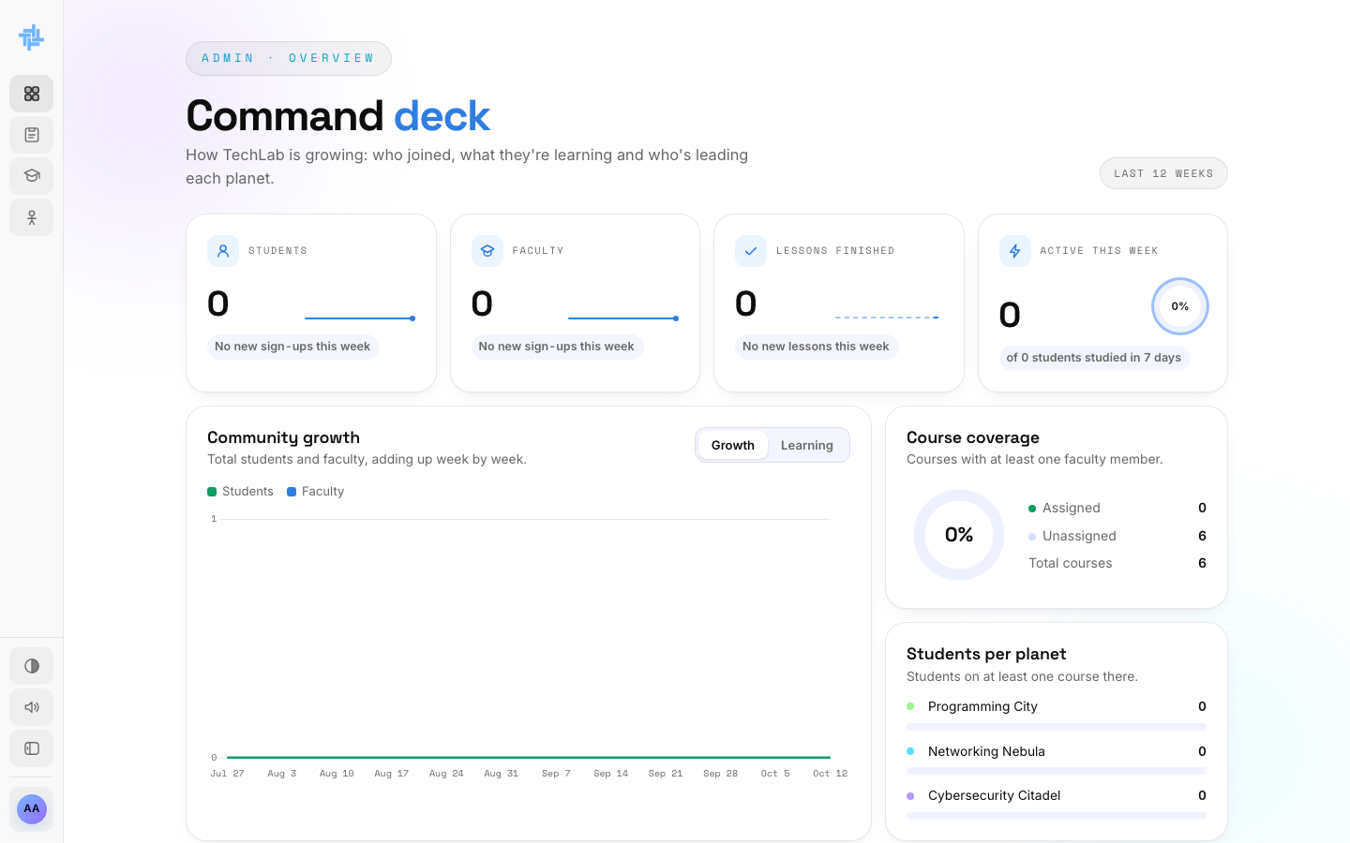  ACTION Ana opens the Command deck to see how TechLab is doing.  ON SCREEN 0 students, 0 faculty. Course coverage: 0 of 6 courses have a faculty member. |  | SCENE 05 Admin · Course Assignment  Nobody to assign yet  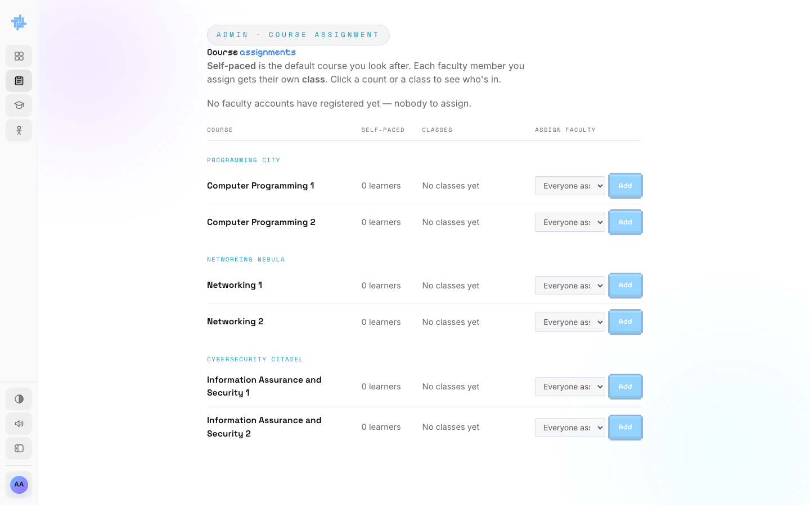  ACTION Ana opens Course Assignment to give Computer Programming 1 a teacher.  ON SCREEN "No faculty accounts have registered yet, nobody to assign."  NOTE Ana can't create faculty accounts. A faculty member has to register first.

SCENE 06 Faculty · Sign up  Carlo finds the faculty page    ACTION Carlo Reyes opens the TechLab faculty page and clicks Create faculty account.  ON SCREEN The faculty home page: "Level up your Lessons". |  | SCENE 07 Faculty · Sign up  He registers with his school email  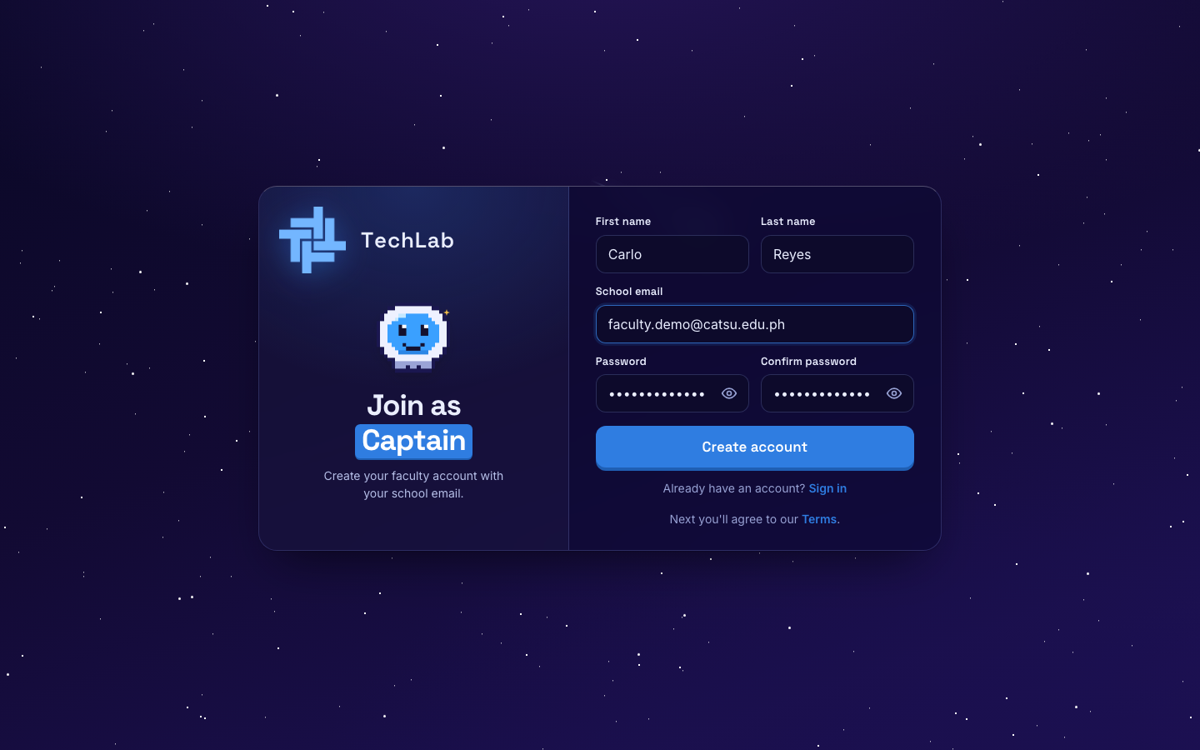  ACTION He types his name, his school email and a password, and clicks Create account.  ON SCREEN The "Join as Captain" form.  NOTE Faculty accounts need a @catsu.edu.ph school email.

SCENE 08 Faculty · Sign up  He agrees to the rules  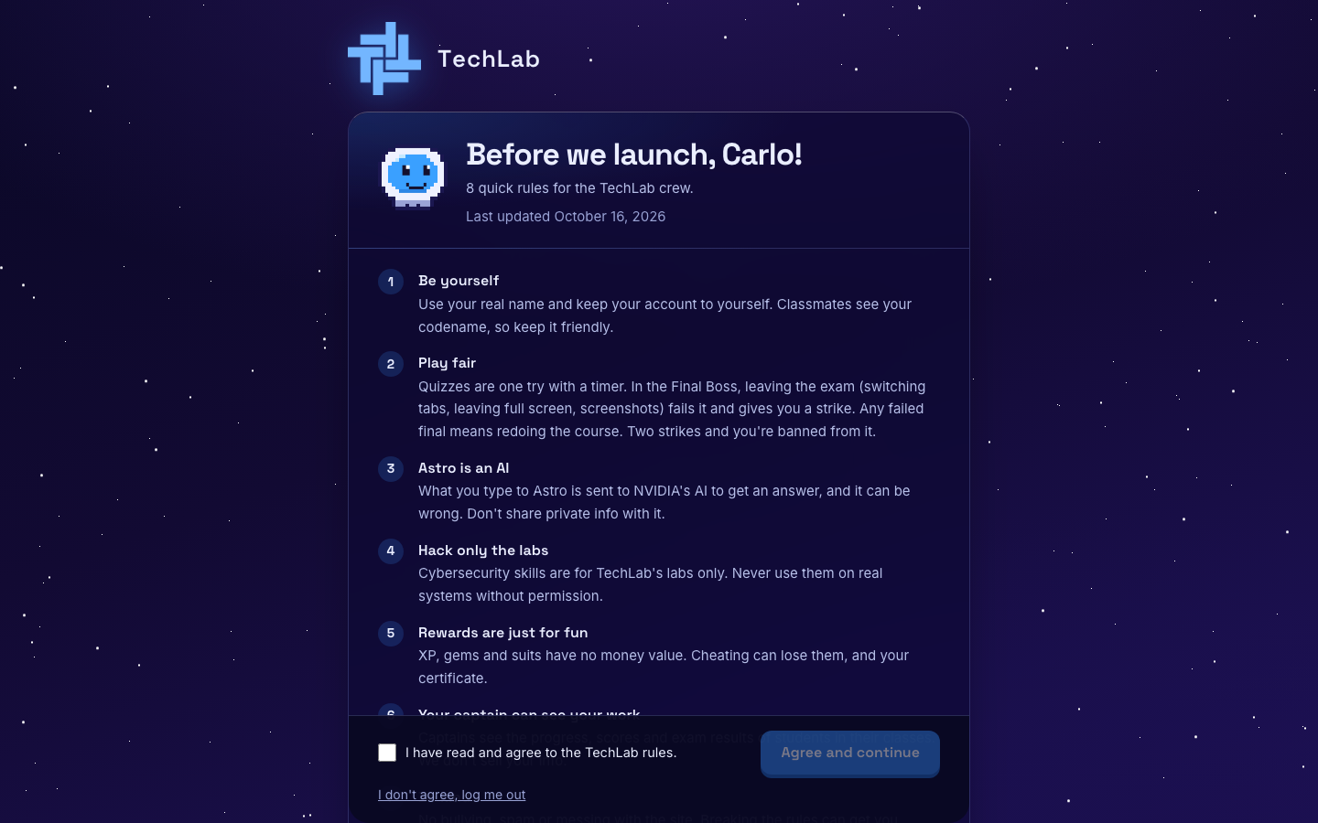  ACTION Carlo reads the rules, ticks I have read and agree, and clicks Agree and continue.  ON SCREEN "Before we launch, Carlo!" and the TechLab rules. |  | SCENE 09 Faculty · Onboarding  He suits up as Captain  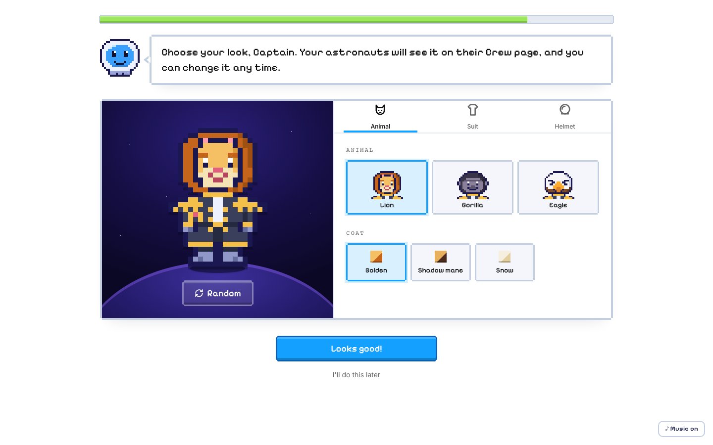  ACTION He picks his Captain's look, clicks Looks good!, then Take command.  ON SCREEN The Captain builder. His students will see this look on their Crew page.

SCENE 10 Faculty · Dashboard  No course yet  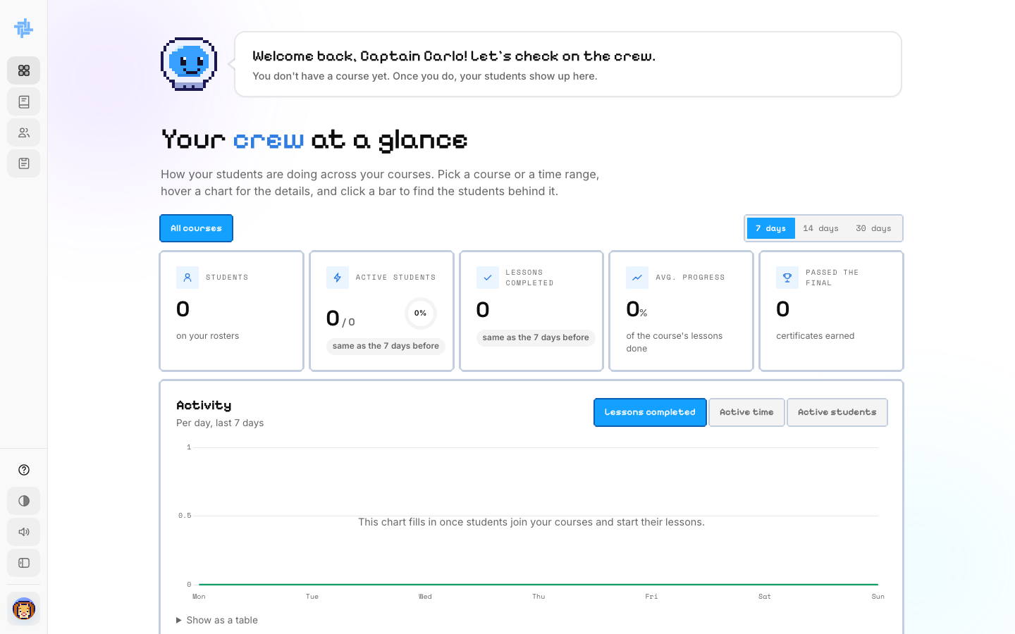  ACTION Carlo lands on his dashboard and waits for a course.  ON SCREEN Astro: "You don't have a course yet. Once you do, your students show up here." |  | SCENE 11 Admin · Dashboard  A new faculty member appears  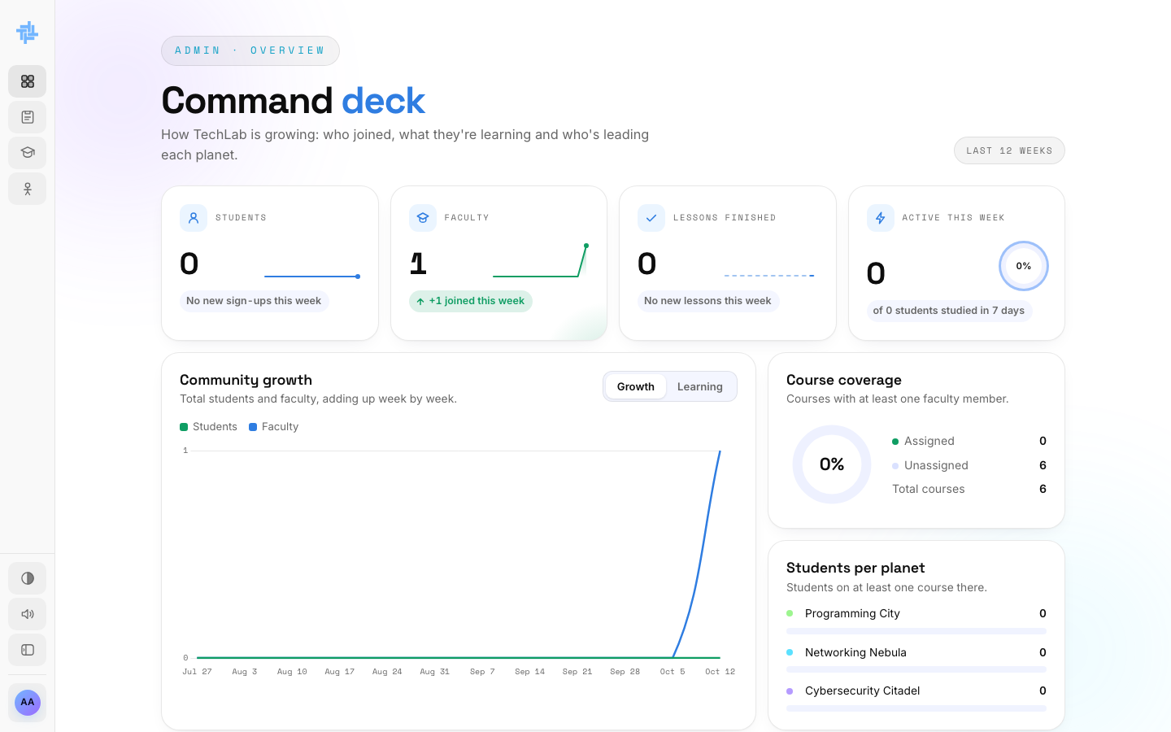  ACTION Back on the Command deck, Ana sees a faculty member has registered.  ON SCREEN Faculty: 1, "+1 joined this week". Course coverage still 0 assigned.

SCENE 12 Admin · Course Assignment  She picks Carlo for Programming 1  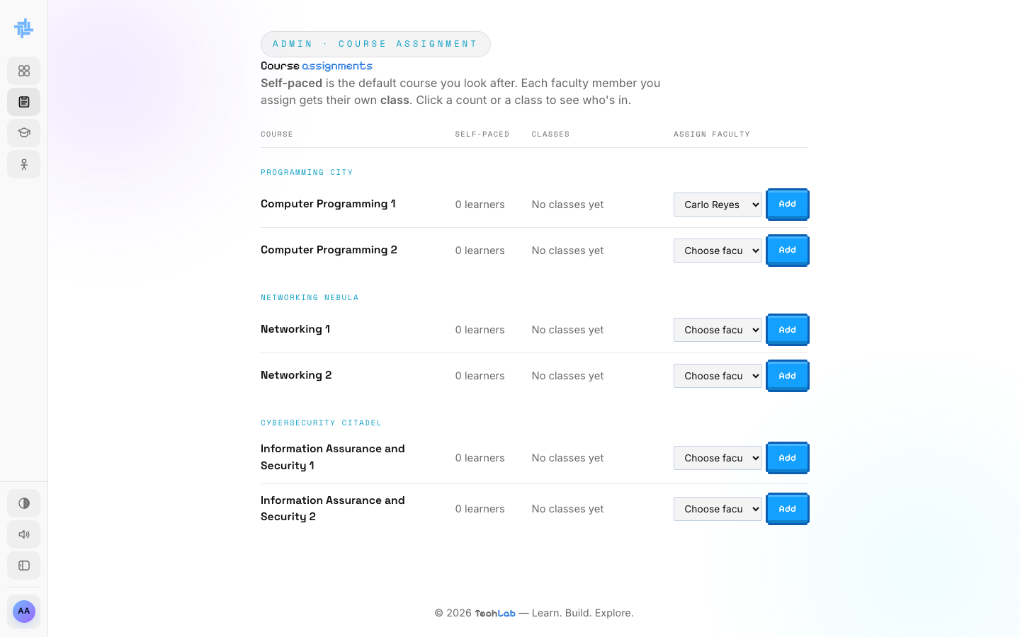  ACTION Next to Computer Programming 1 she opens Choose faculty and picks Carlo Reyes.  ON SCREEN Carlo Reyes now appears in every course's faculty list. |  | SCENE 13 Admin · Course Assignment  Carlo is assigned  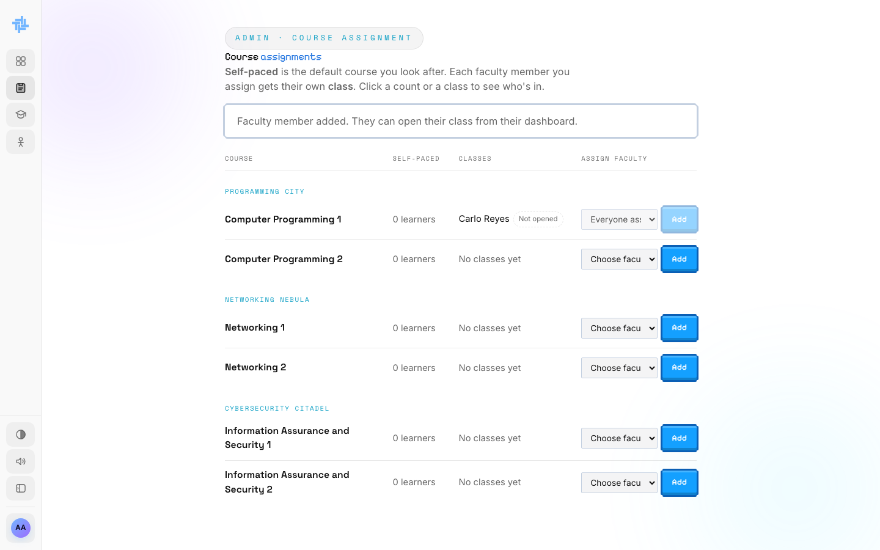  ACTION She clicks Add.  ON SCREEN "Faculty member added. They can open their class from their dashboard." Carlo shows as Not opened.  NOTE A course can have several faculty. Each gets their own class; the Self-paced version stays with the admin.

SCENE 14 Admin · Dashboard  Coverage goes up  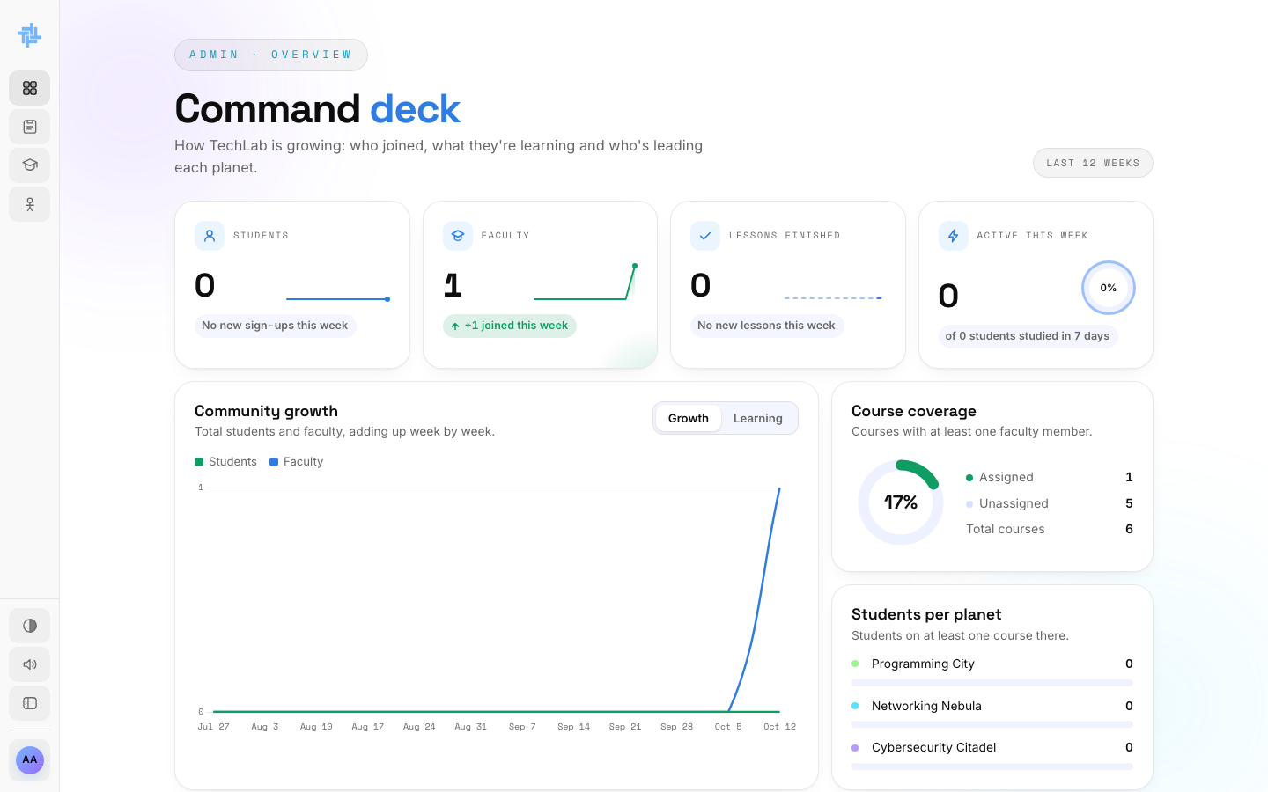  ACTION Ana checks the Command deck again.  ON SCREEN Course coverage: 1 assigned, 5 unassigned (17%). |  | SCENE 15 Admin · Classes  Waiting for Carlo to open his class  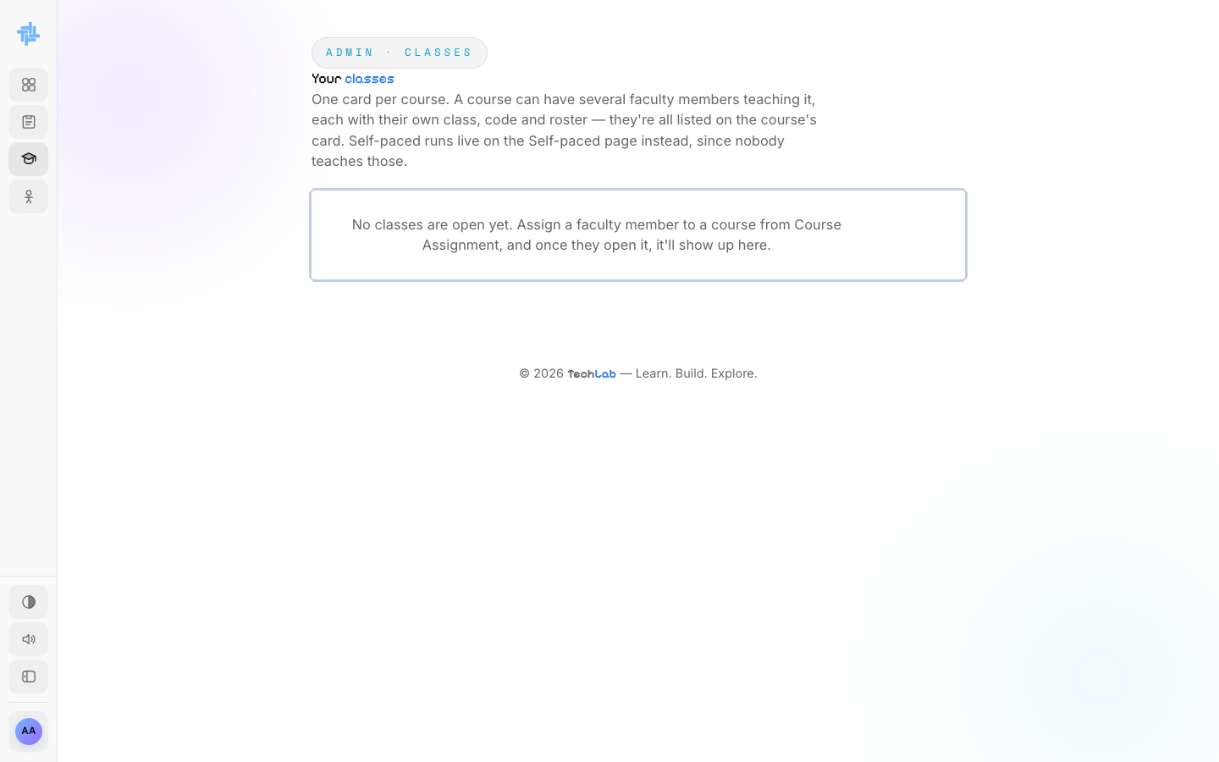  ACTION Ana opens Classes.  ON SCREEN "No classes are open yet." A class shows up here once its faculty member opens it.

SCENE 16 Faculty · Handoff
Carlo gets Computer Programming 1
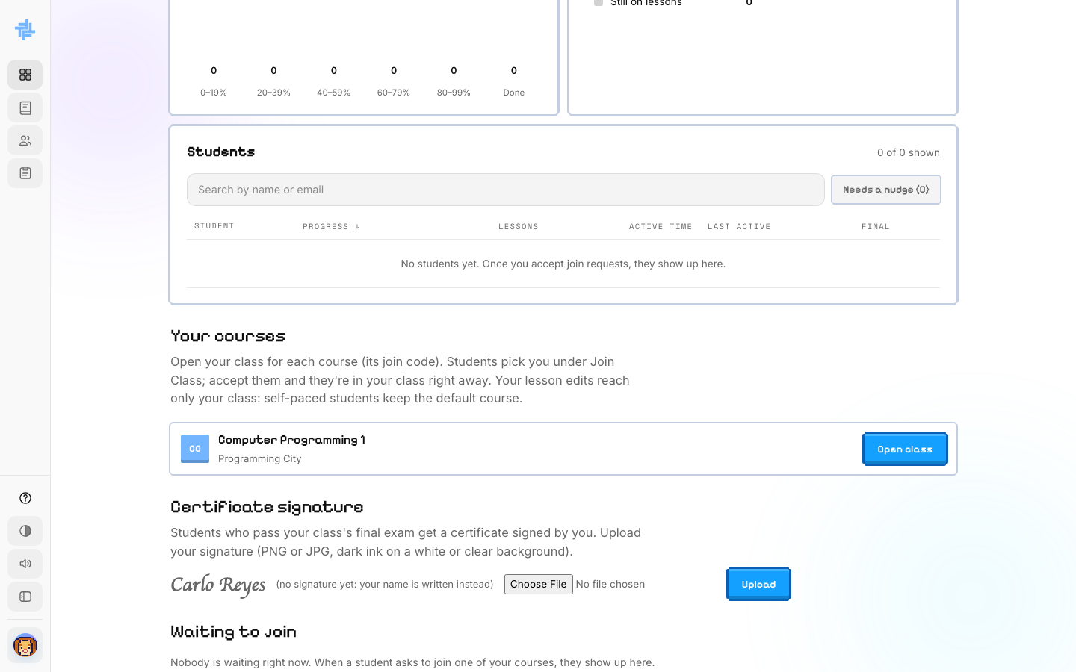
ACTION Carlo signs in and scrolls to Your courses.
ON SCREEN Computer Programming 1 with an Open class button. Storyboard 4 (Faculty) starts here.

PART 3
Watching the whole of TechLab
Ten weeks later: 11 students and 2 faculty. The Command deck shows Ana how TechLab is growing, what students are learning, and who leads each planet.

SCENE 17 Admin · Dashboard  The Command deck  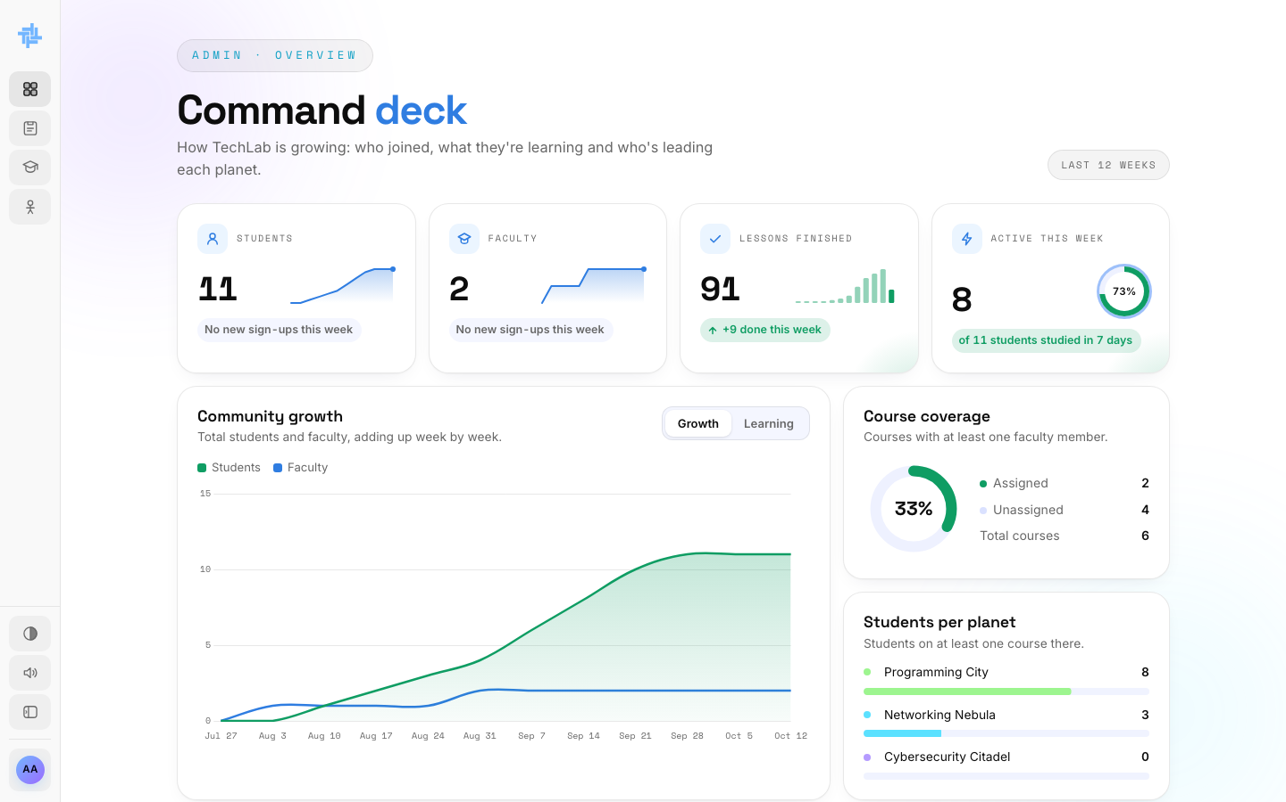  ACTION Ana signs in and reads the four cards at the top.  ON SCREEN Students 11, Faculty 2, Lessons finished 91 (+9 this week), Active this week 8 of 11 (73%). Community growth shows students and faculty adding up week by week. |  | SCENE 18 Admin · Dashboard  What students are learning  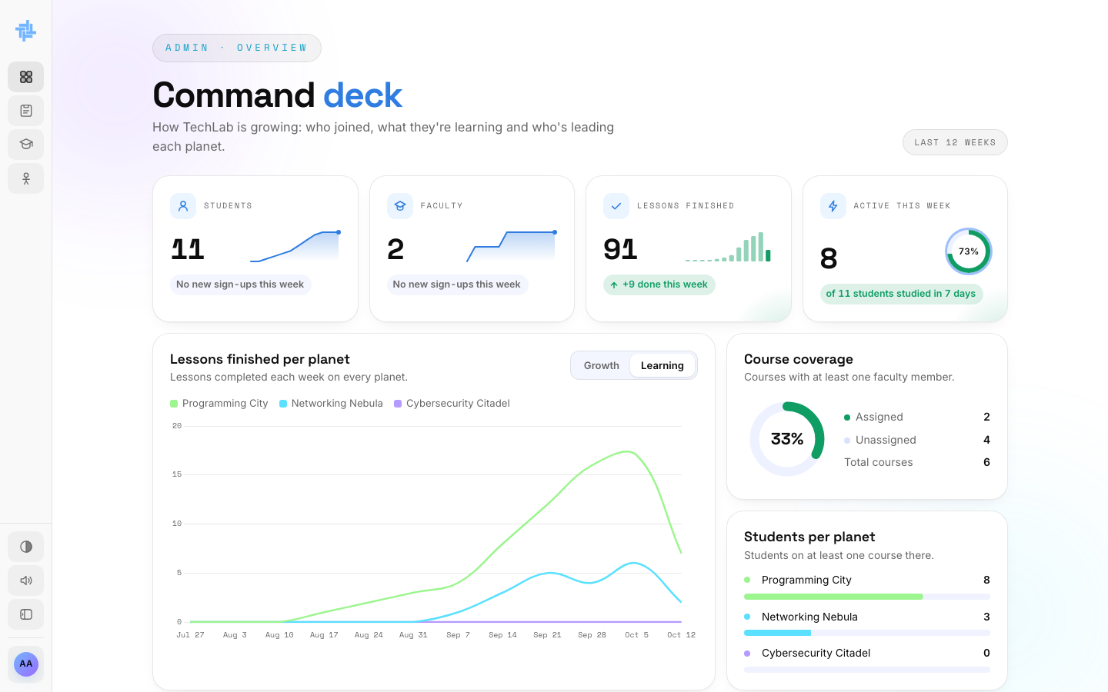  ACTION She switches the big chart from Growth to Learning.  ON SCREEN Lessons finished each week on every planet. On the right: Course coverage (2 of 6 courses, 33%) and Students per planet.

SCENE 19 Admin · Dashboard  Planet leaderboards  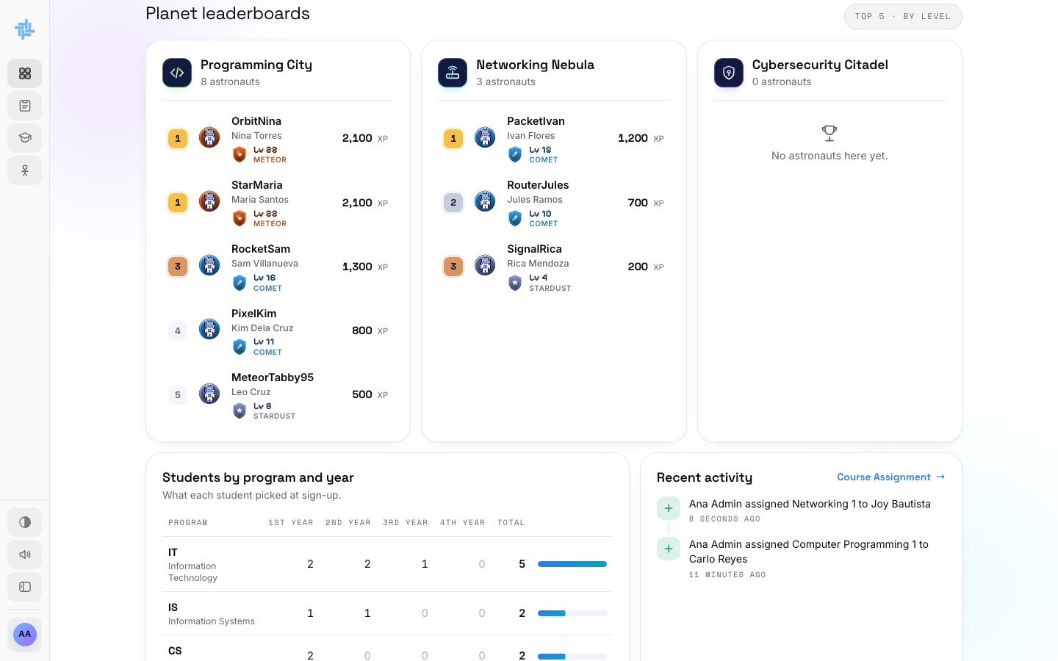  ACTION She scrolls down to the Planet leaderboards.  ON SCREEN The top 5 astronauts on each planet by level, with their codename, real name, rank and XP. |  | SCENE 20 Admin · Dashboard  Students by program and year  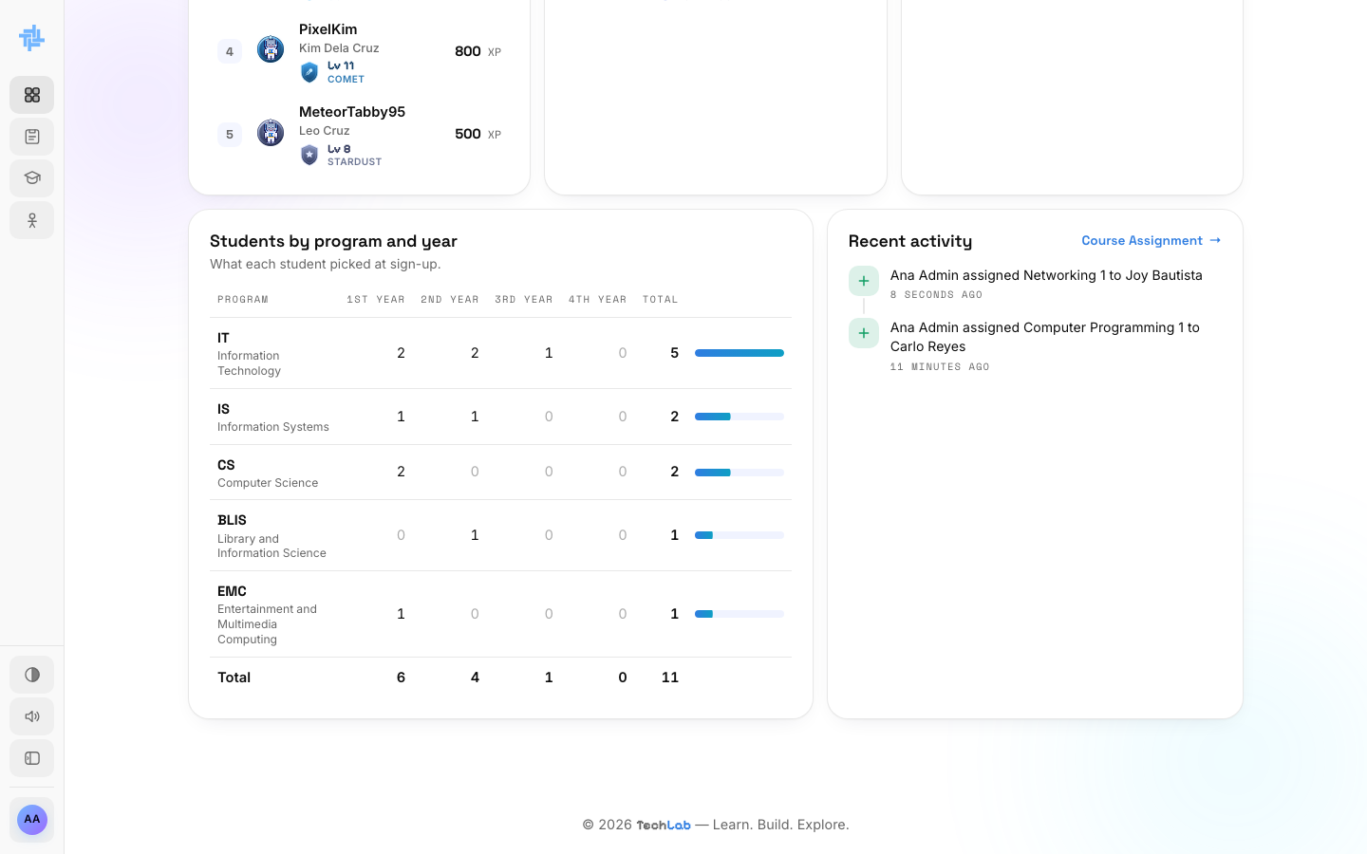  ACTION She scrolls to the bottom of the Command deck.  ON SCREEN How many students are in each program (IT, IS, CS, BLIS, EMC) and year level, and Recent activity: every course assignment an admin made.

PART 4
Managing course assignments
Course Assignment is where Ana decides who teaches what. Every course has a Self-paced version she looks after, plus one class per faculty member she assigns.

SCENE 21 Admin · Course Assignment  Every course at a glance  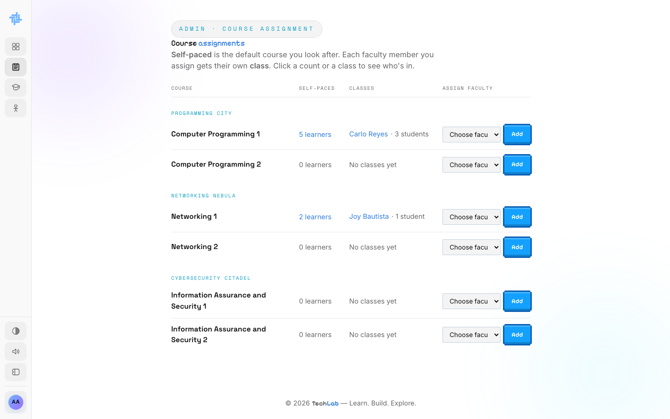  ACTION Ana opens Course Assignment.  ON SCREEN Each course with its self-paced learners, its classes (Carlo Reyes · 3 students, Joy Bautista · 1 student) and a Choose faculty list. |  | SCENE 22 Admin · Course Assignment  Who learns it Self-paced  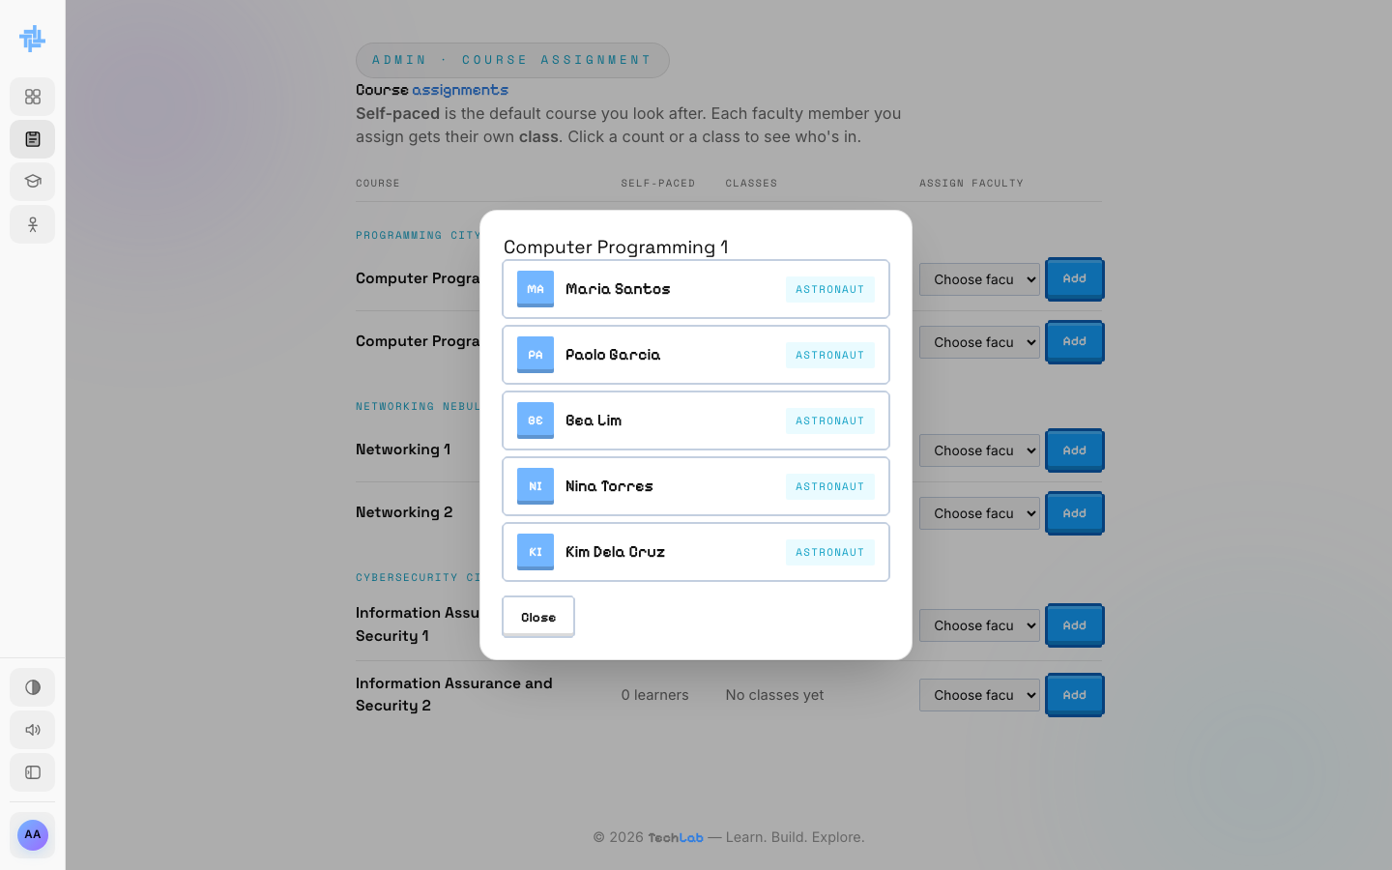  ACTION She clicks 5 learners next to Computer Programming 1.  ON SCREEN The five students taking it on their own: Maria, Paolo, Bea, Nina and Kim.

SCENE 23 Admin · Course Assignment  Who is in Carlo's class  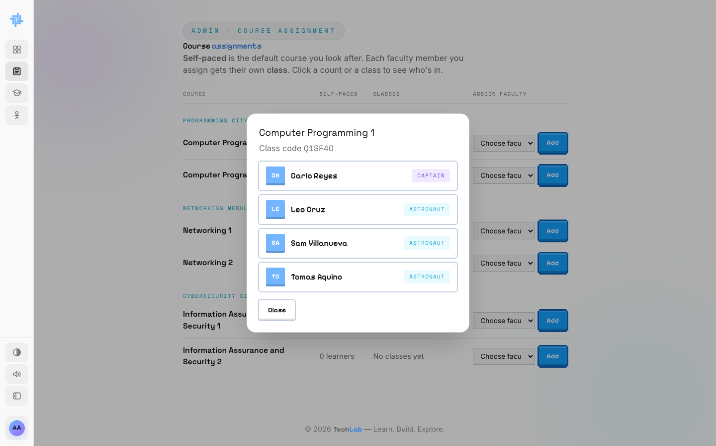  ACTION She clicks Carlo Reyes.  ON SCREEN Carlo as Captain, his three astronauts, and the class code, which is just the class's ID. |  | SCENE 24 Admin · Course Assignment  A second course for Joy  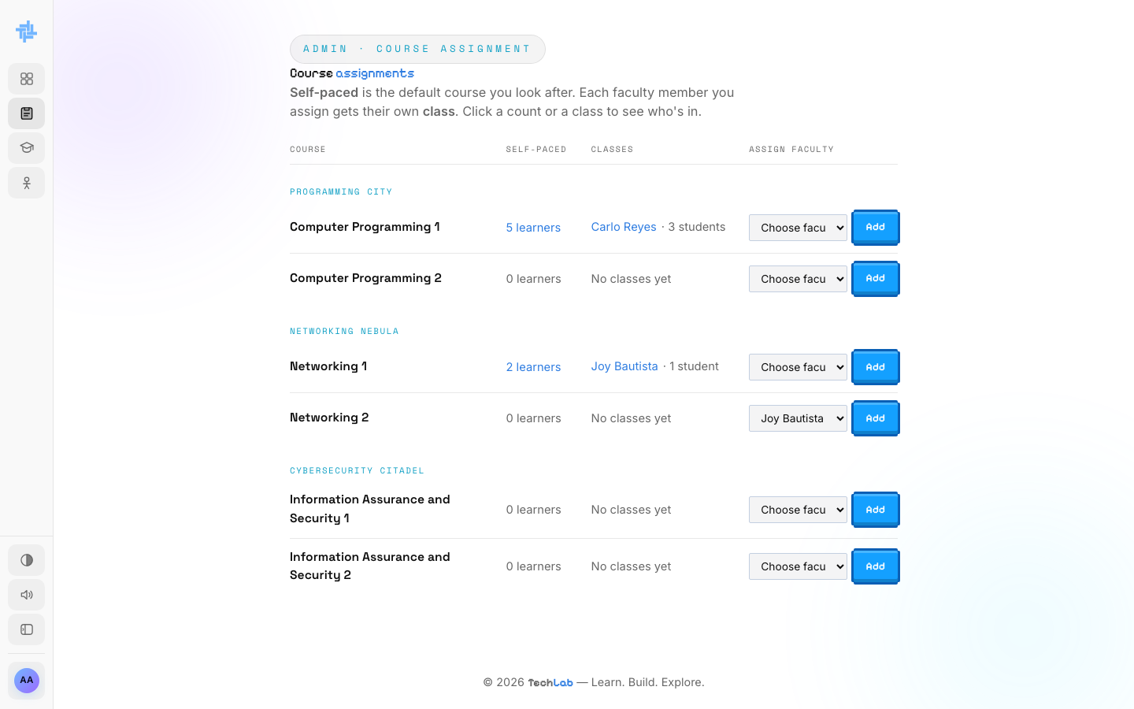  ACTION Next to Networking 2 she picks Joy Bautista.  ON SCREEN Joy already teaches Networking 1.

SCENE 25 Admin · Course Assignment  Joy is added  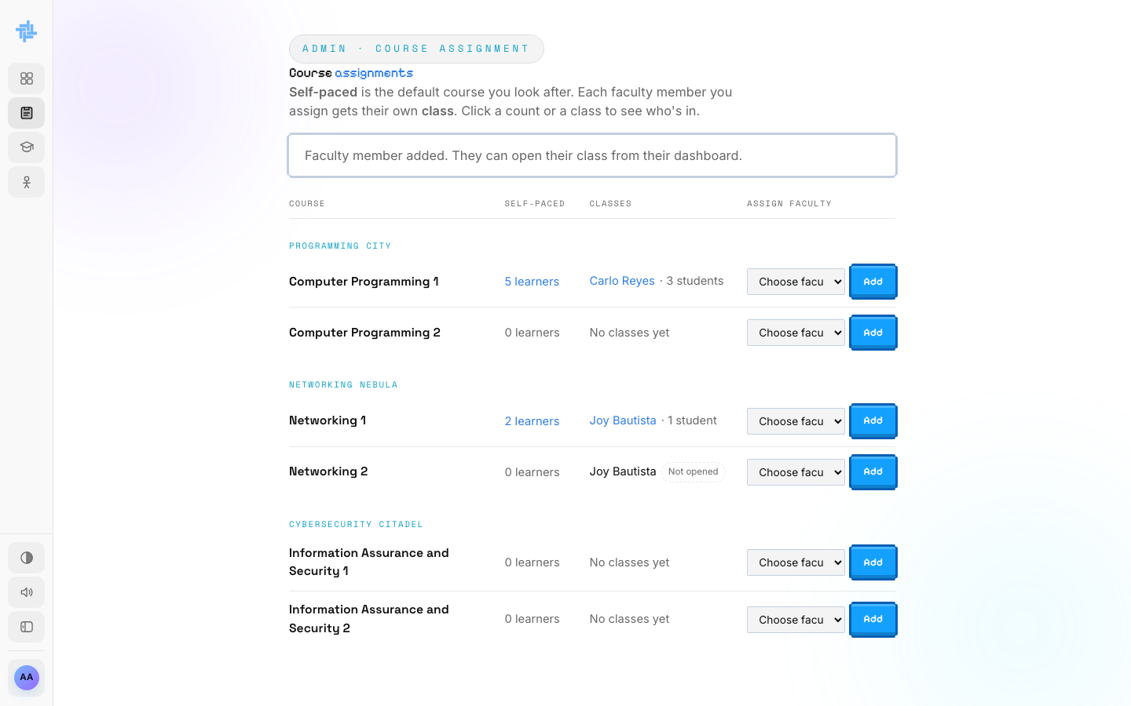  ACTION She clicks Add.  ON SCREEN "Faculty member added." Joy Bautista shows under Networking 2 as Not opened. |  | SCENE 26 Admin · Course Assignment  Taking Joy off again  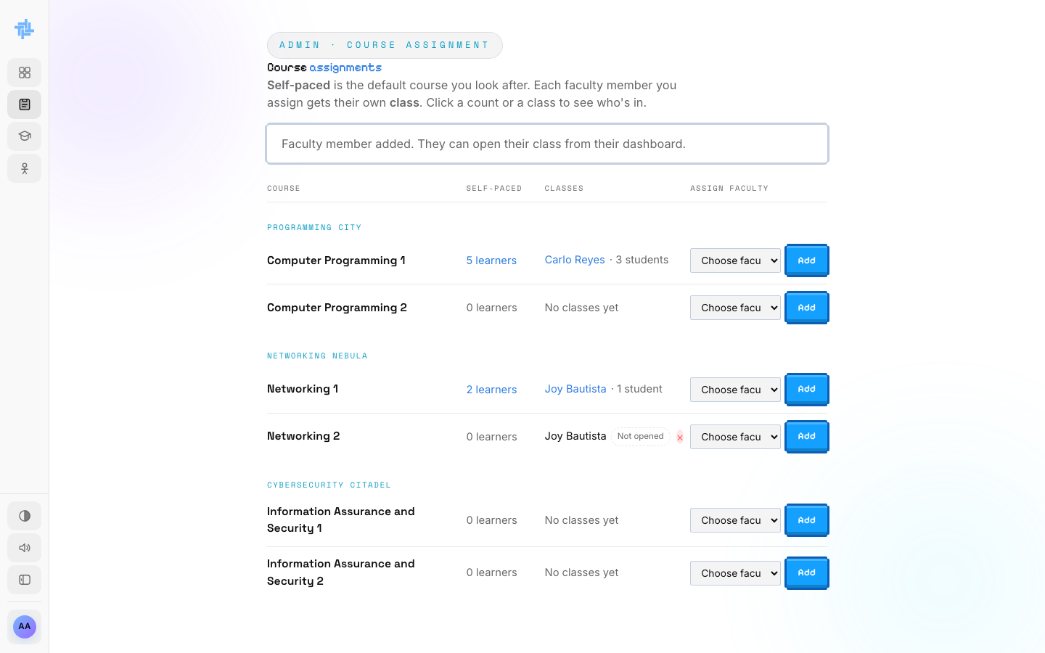  ACTION Ana changes her mind. She points at Joy's name under Networking 2 and clicks the red ×, then confirms "Take Joy Bautista off this course?".  ON SCREEN A small red × appears next to the name.

SCENE 27 Admin · Course Assignment  Joy is removed  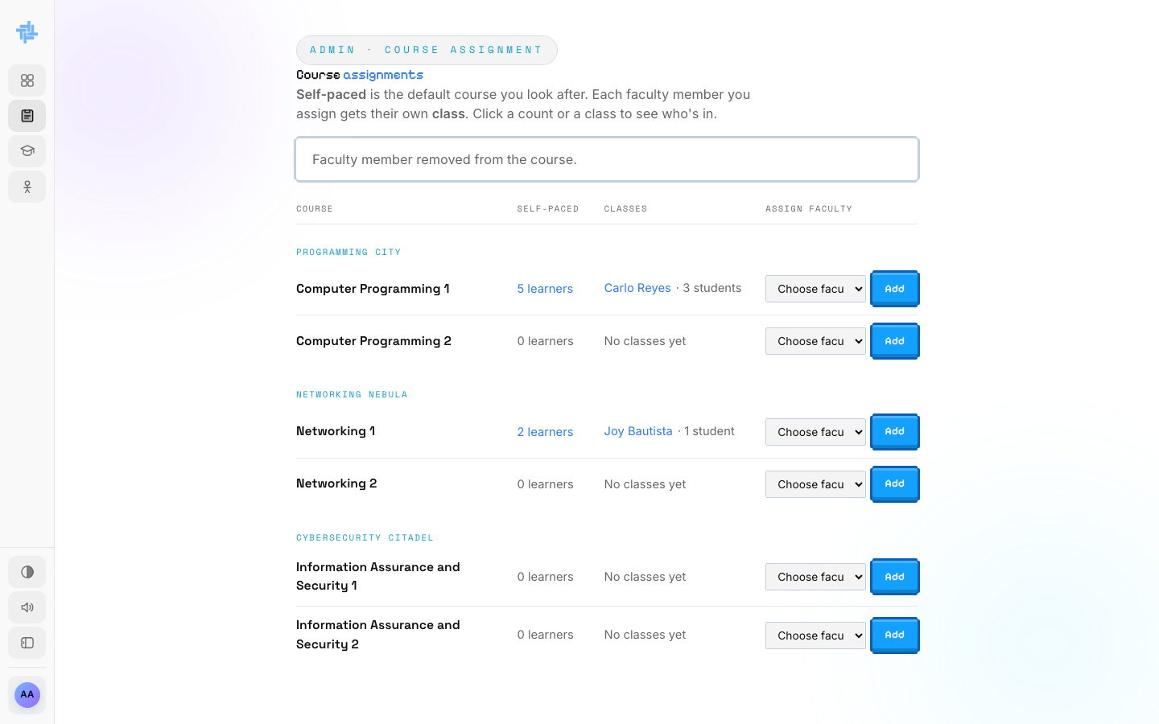  ACTION The page reloads.  ON SCREEN "Faculty member removed from the course." Networking 2 has no classes again. |  | SCENE 28 Admin · Course Assignment  Carlo can't be removed  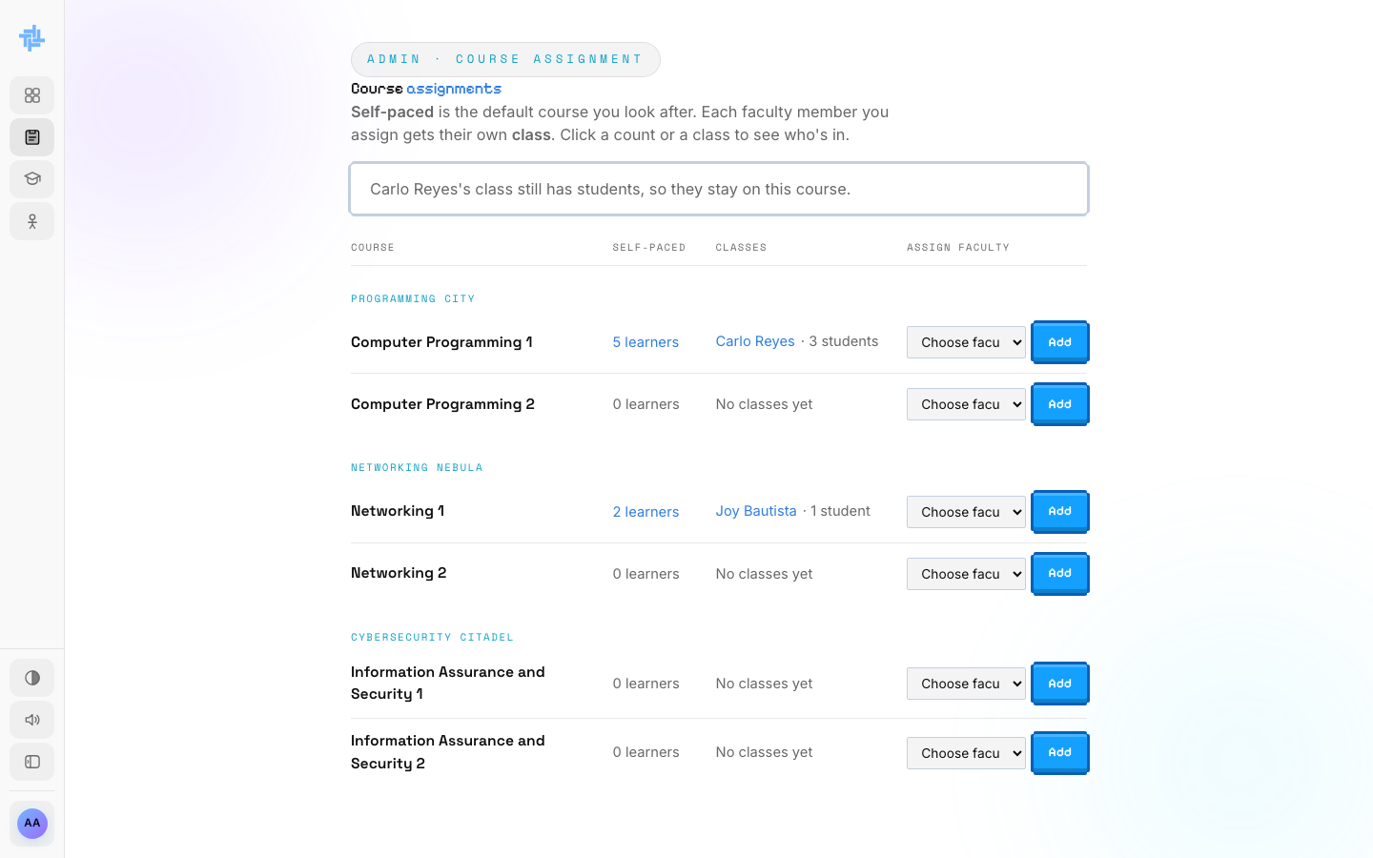  ACTION She tries the × next to Carlo Reyes.  ON SCREEN "Carlo Reyes's class still has students, so they stay on this course."  NOTE TechLab never leaves students without a teacher.

PART 5
Watching classes
The Classes page lists every open class, one card per course, with each faculty member's students.

SCENE 29 Admin · Classes  Every open class  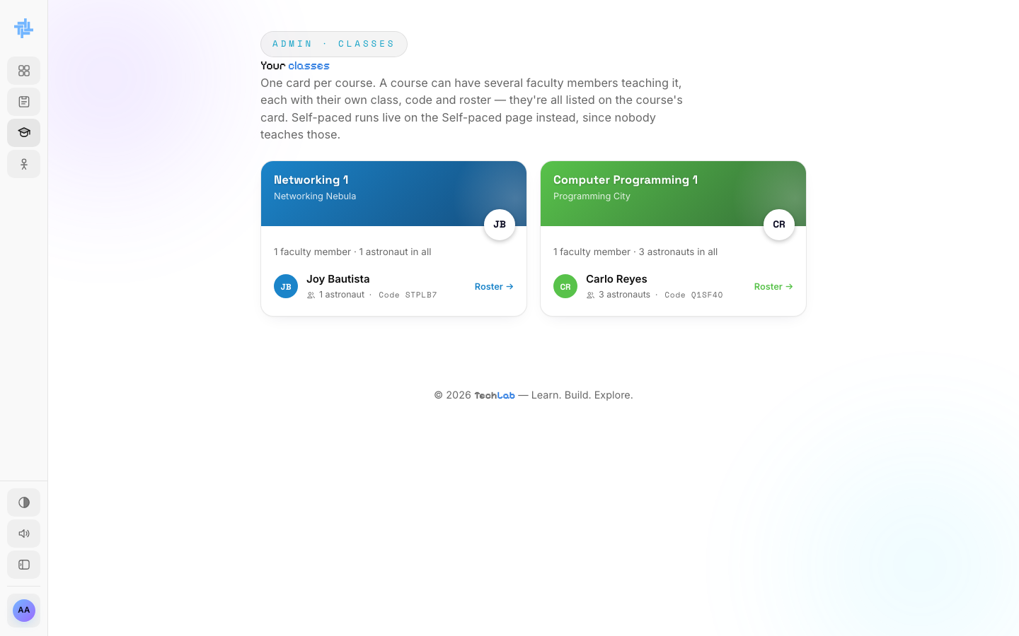  ACTION Ana opens Classes.  ON SCREEN Networking 1 (Joy Bautista, 1 astronaut) and Computer Programming 1 (Carlo Reyes, 3 astronauts), each with its class code.  NOTE Self-paced learners aren't here. They have their own page. |  | SCENE 30 Admin · Classes  A class roster  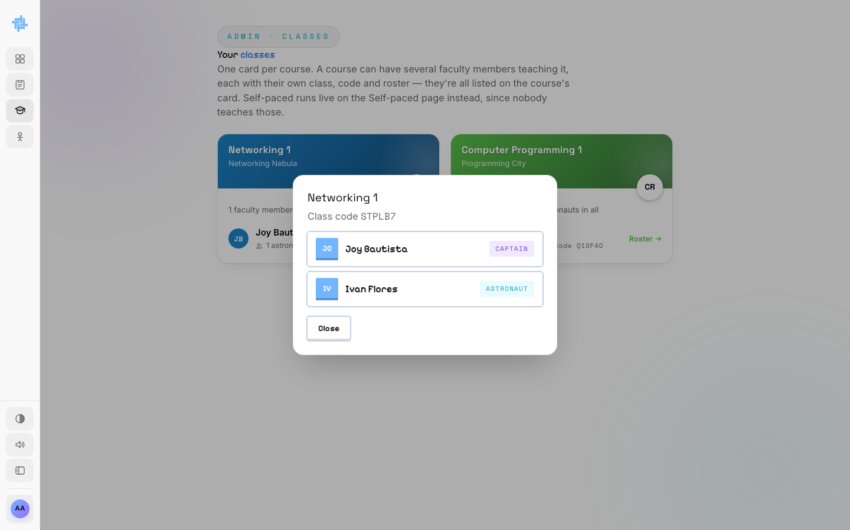  ACTION She clicks Roster next to Joy Bautista.  ON SCREEN Joy as Captain and her astronaut Ivan Flores.

PART 6
Looking after Self-paced learners
Self-paced students have no teacher, so Ana looks after them: how far each one is, and where they stand with the final exam.

SCENE 31 Admin · Self-paced  Where every learner stands  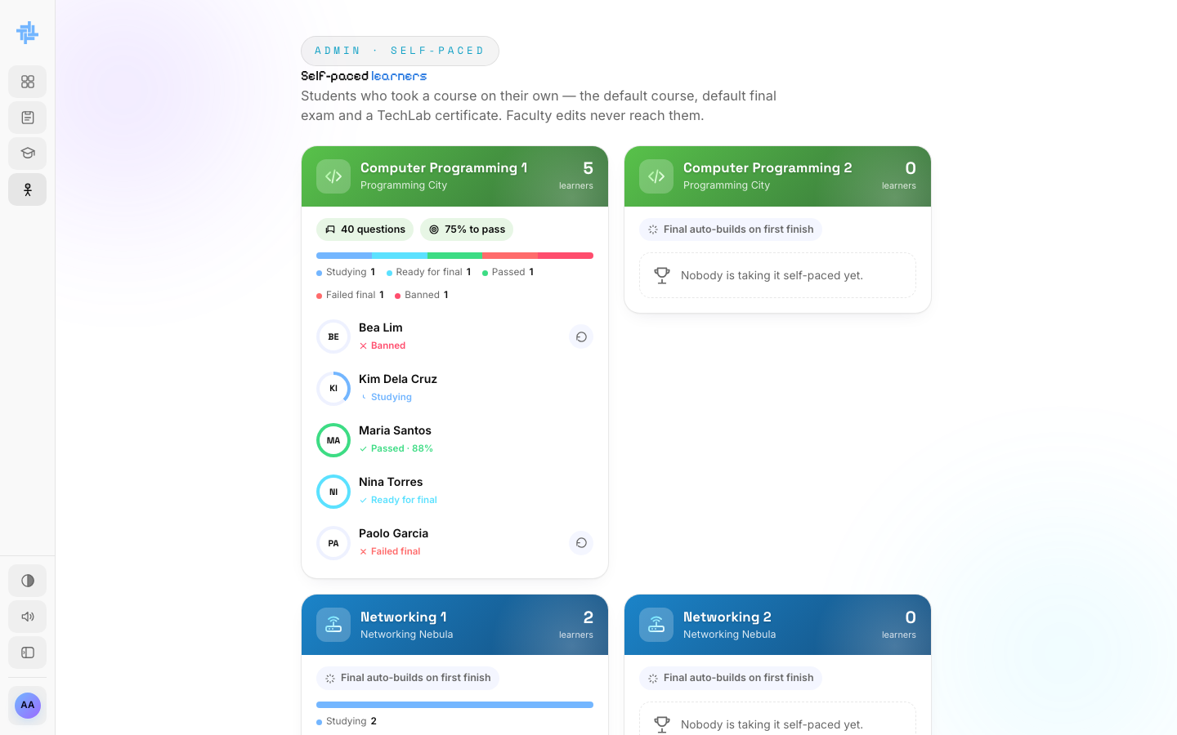  ACTION Ana opens Self-paced.  ON SCREEN Computer Programming 1: 40 questions, 75% to pass. Maria Passed · 88%, Nina Ready for final, Kim Studying, Paolo Failed final, Bea Banned.  NOTE Final auto-builds on first finish: TechLab writes the default final the first time a learner finishes a course. |  | SCENE 32 Admin · Self-paced  Lifting a ban  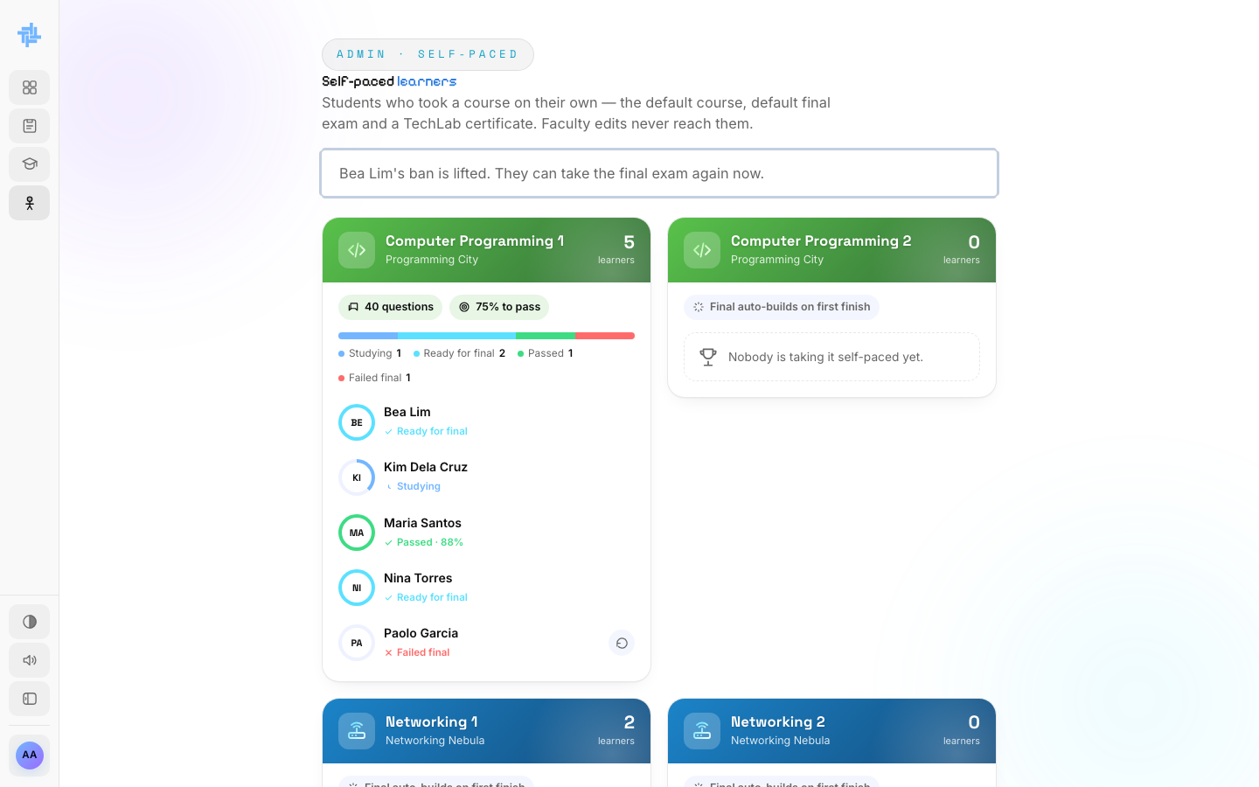  ACTION Bea was caught leaving the final twice. Ana clicks Lift ban next to her name.  ON SCREEN "Bea Lim's ban is lifted. They can take the final exam again now."

SCENE 33 Admin · Self-paced
Allowing a retake
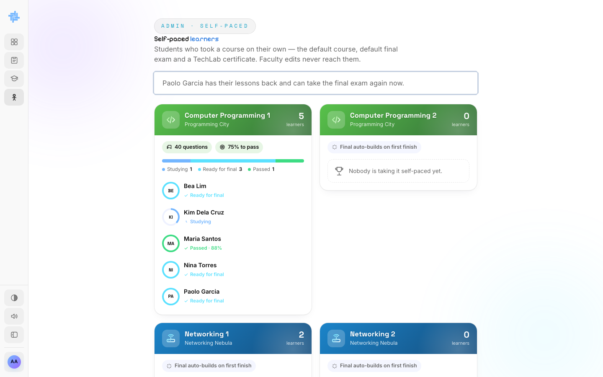
ACTION Paolo failed the final, which wiped his lessons. Ana clicks Allow retake.
ON SCREEN "Paolo Garcia has their lessons back and can take the final exam again now." Paolo and Bea are now Ready for final.

PART 7
Her account and other admins
Ana keeps her own details up to date, and as the first admin she decides who else can be an admin.

SCENE 34 Admin · Account  The account menu  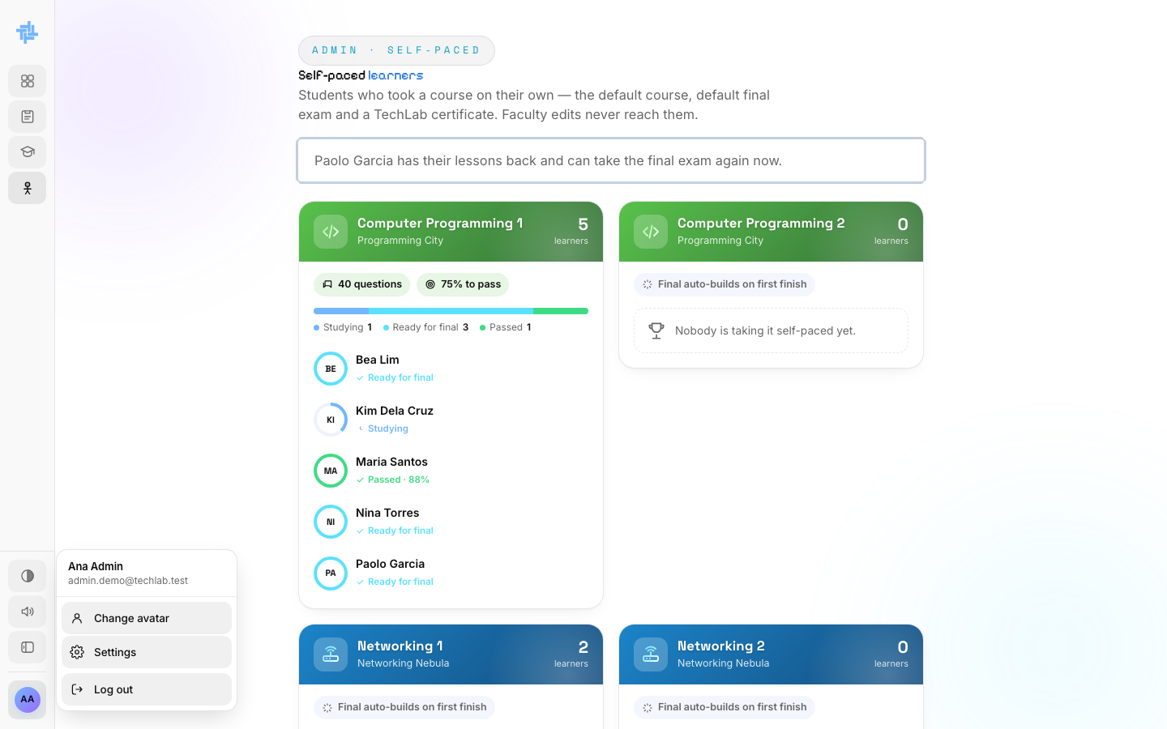  ACTION Ana clicks her avatar at the bottom of the sidebar.  ON SCREEN Change avatar, Settings and Log out. |  | SCENE 35 Admin · Settings  Profile and preferences  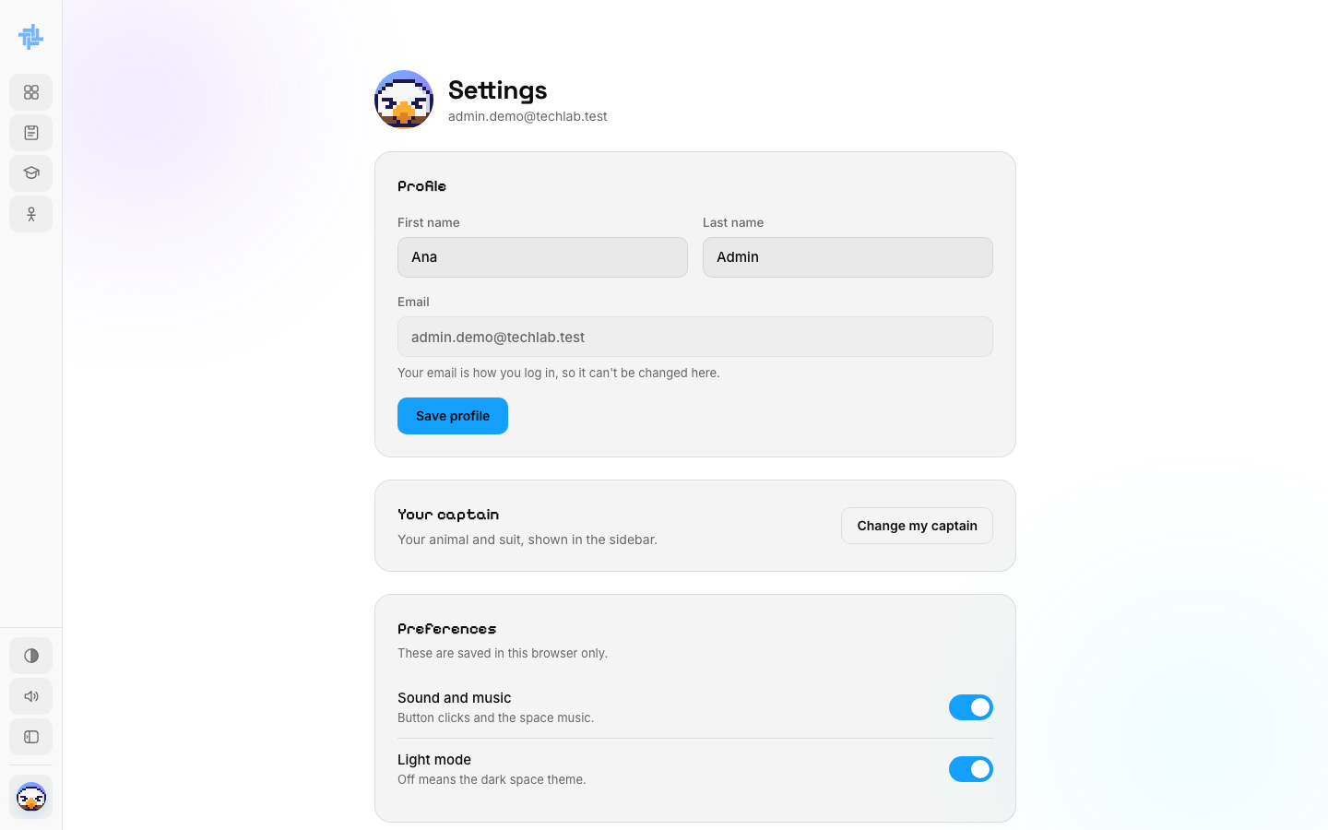  ACTION She opens Settings.  ON SCREEN Profile (first and last name; the email can't change), Your captain, and Preferences: sound and light mode.

SCENE 36 Admin · Settings  Changing her password  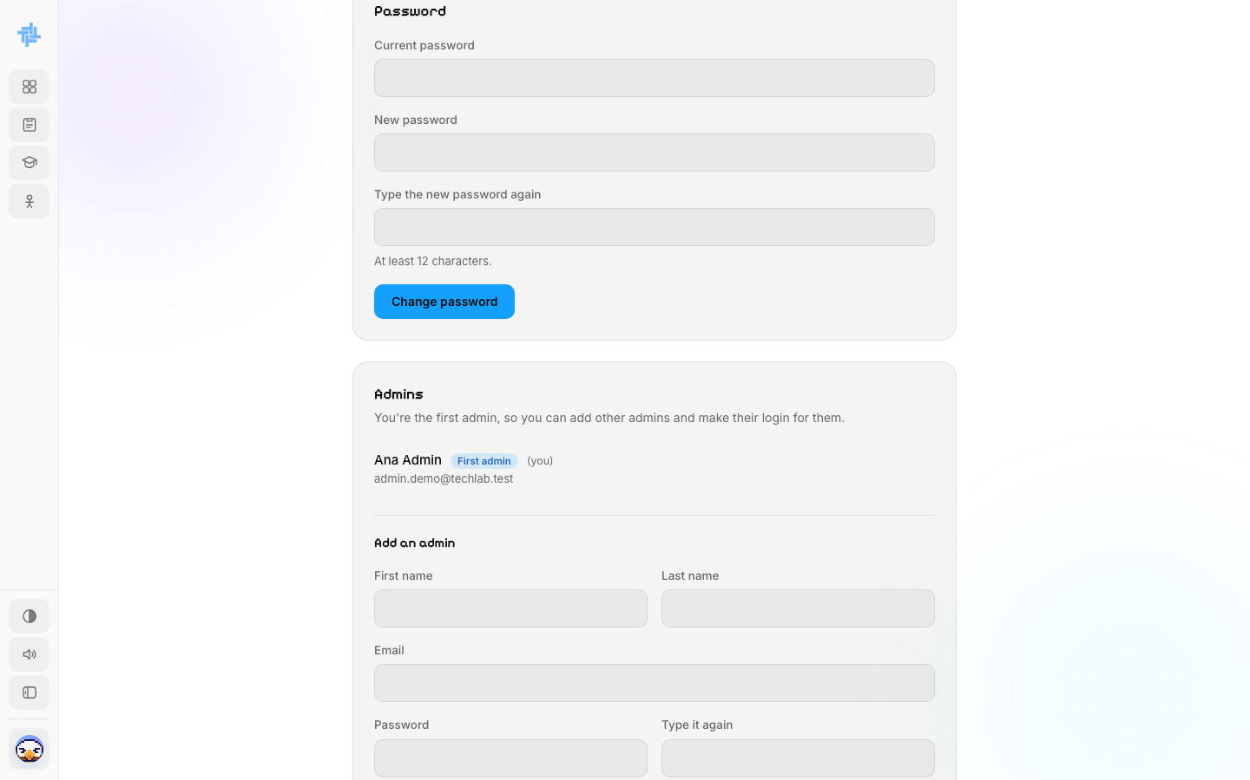  ACTION She scrolls to Password.  ON SCREEN Current password, the new one twice (at least 12 characters), and Change password. |  | SCENE 37 Admin · Admins  Adding an admin  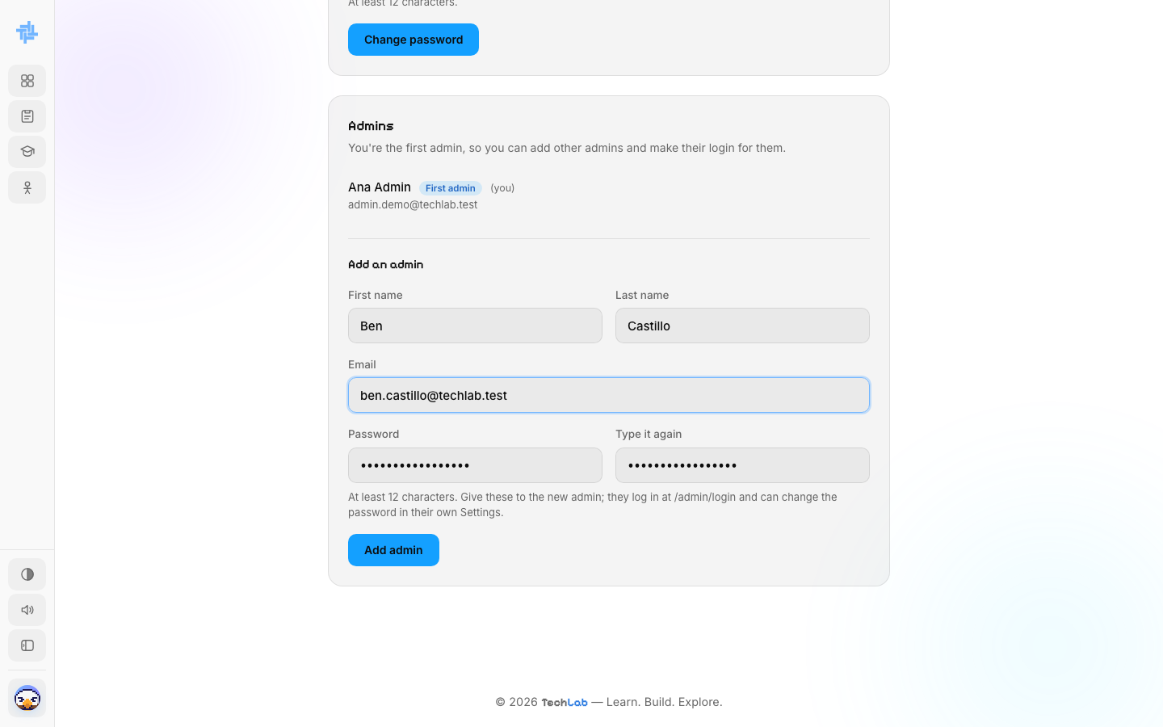  ACTION As the first admin, Ana fills in Add an admin for Ben Castillo and clicks Add admin.  ON SCREEN First name, last name, email and a password she will give him.

SCENE 38 Admin · Admins  Ben is an admin  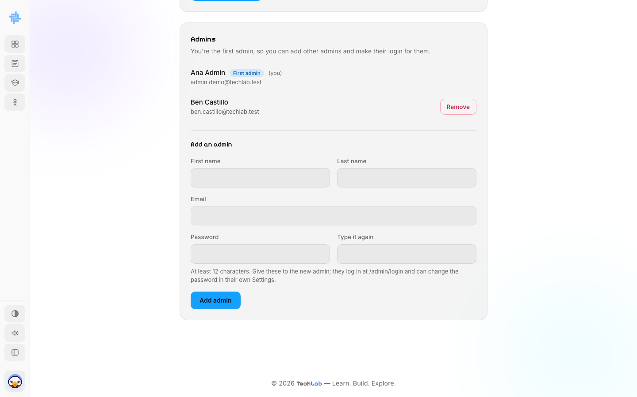  ACTION The page reloads.  ON SCREEN Ana Admin (First admin, you) and Ben Castillo with a Remove button. Ben signs in at /admin/login. |  | SCENE 39 Admin · Admins  Removing an admin  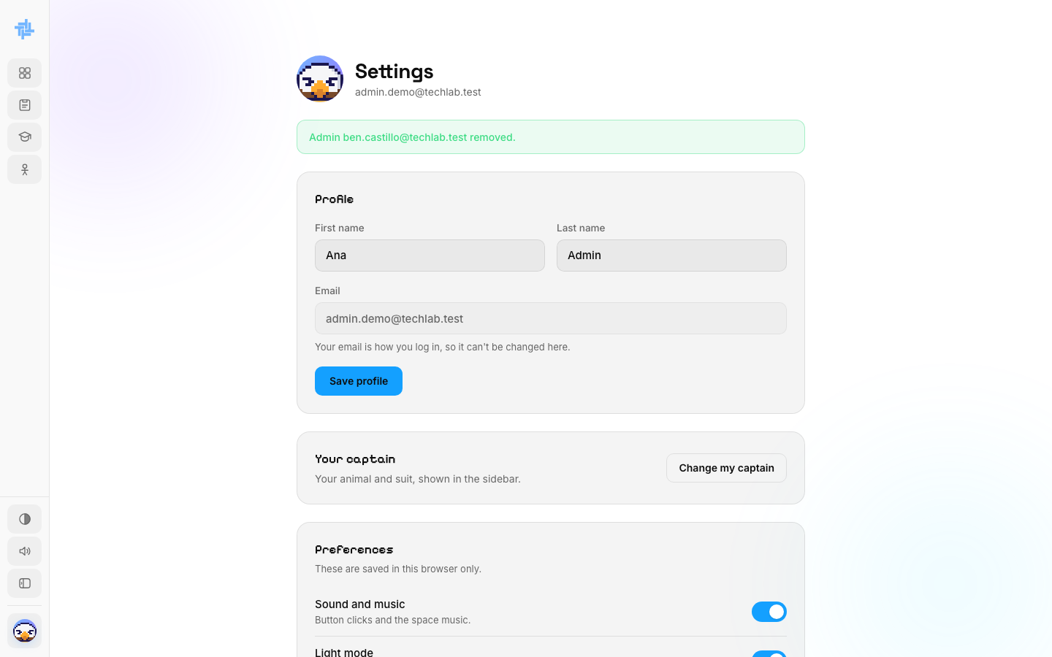  ACTION She clicks Remove next to Ben and confirms.  ON SCREEN "Admin ben.castillo@techlab.test removed." He can't sign in any more.

SCENE 40 Admin · Theme  Dark space theme  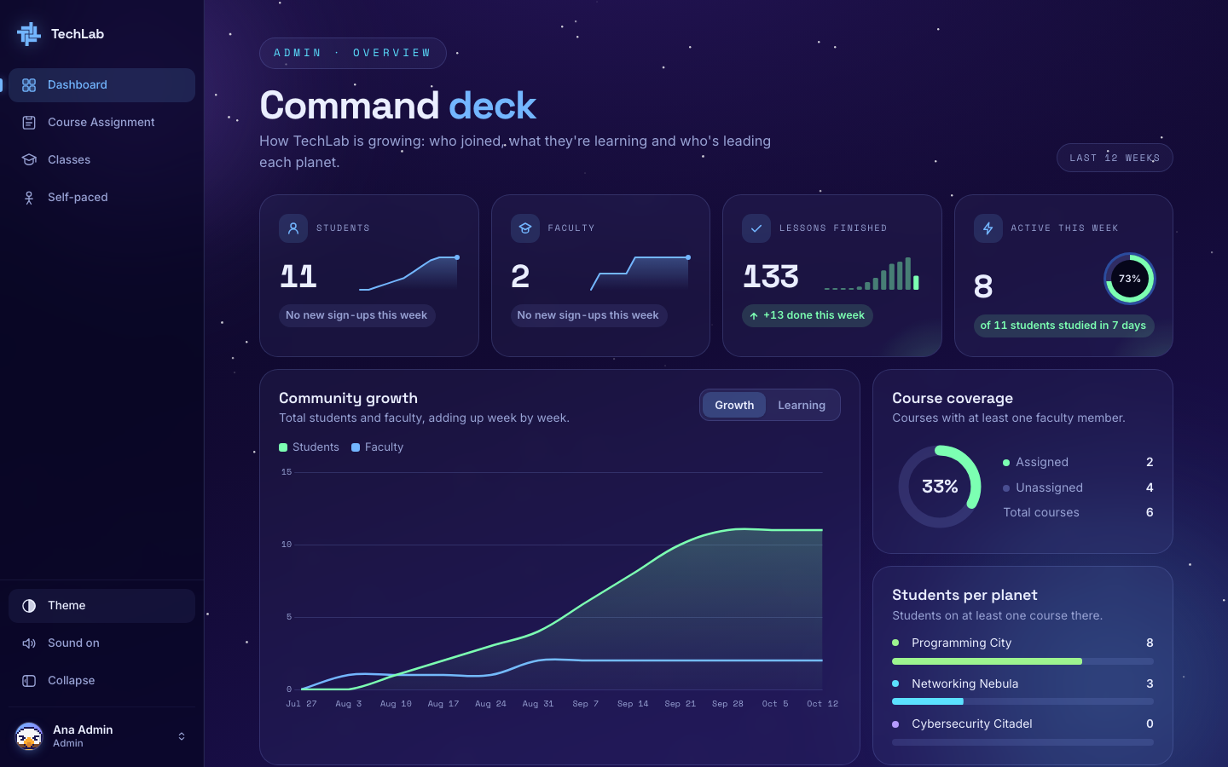  ACTION Ana clicks Theme in the sidebar.  ON SCREEN The Command deck in the dark space theme. Clicking Theme again switches back. |  | SCENE 41 Admin · Dashboard  Everything is on record  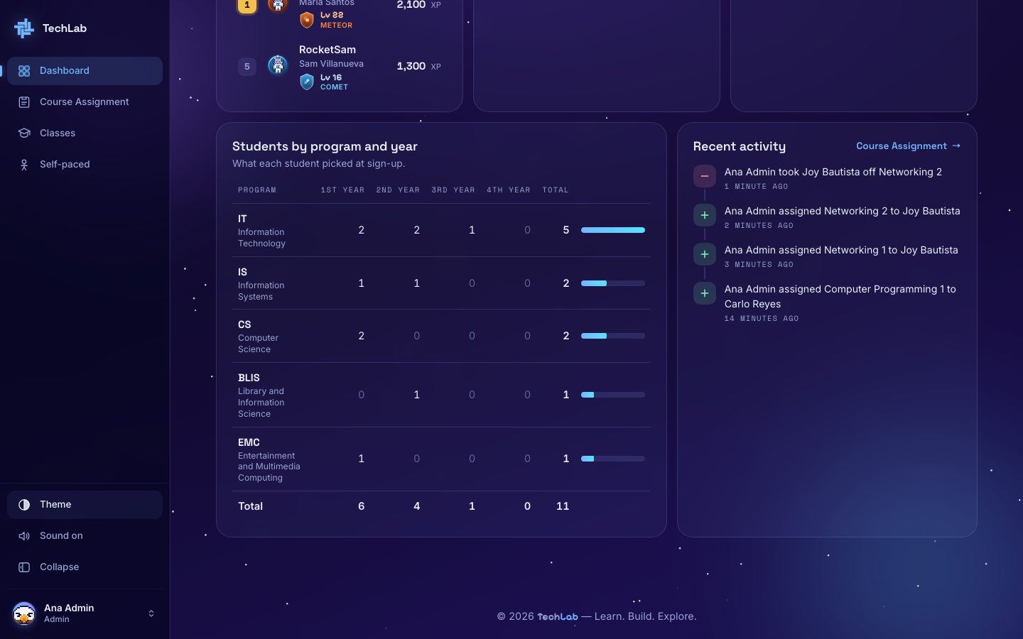  ACTION Back on the Command deck, she scrolls to Recent activity.  ON SCREEN Every assignment and removal she made today: Carlo to Computer Programming 1, Joy to Networking 1 and 2, and Joy taken off Networking 2.

SCENE 42 Admin · Log out
Ana logs out

ACTION Ana opens the account menu and clicks Log out.
ON SCREEN The TechLab home page.
NOTE The demo students, faculty and admins in this storyboard are fictional, made for the demonstration.
The admin never teaches a class. She makes sure every course has a teacher, watches how TechLab grows, and looks after the students who learn on their own.

