TechLab
Storyboard 4: The Faculty Member (Captain)
Everything a TechLab faculty member does: signing up, running a class, sharing materials, editing quizzes, building the final exam, editing course content, and managing their account. Picks up from Storyboard 3, where the admin assigns Carlo his course. Every scene is a real TechLab screen.
Faculty | Carlo Reyes (Captain), faculty.demo@catsu.edu.ph
Course | Computer Programming 1 (CC102), Programming City
Students | Sam Villanueva, Leo Cruz and Tomas Aquino, joined by Grace Villanueva
Parts | 1 Create your account · 2 Your dashboard · 3 Run your class · 4 Learning materials · 5 Lesson quizzes · 6 Mini bosses & final exam · 7 Course content · 8 More tools · 9 Account
Connects to | Storyboard 3 (Admin, hands off Carlo's assignment), Storyboard 2 (Leo, in Carlo's class)
Scenes | 37
What the faculty member does
Sign up → Run the class → Share materials → Edit quizzes → Build the final exam → Edit lessons → Sign a certificate

PART 1
Create your account
Faculty sign up on their own page with their school email. There is no admin step here — anyone with a @catsu.edu.ph email can become a Captain.

SCENE 01 Faculty · Sign up  Carlo finds the faculty page  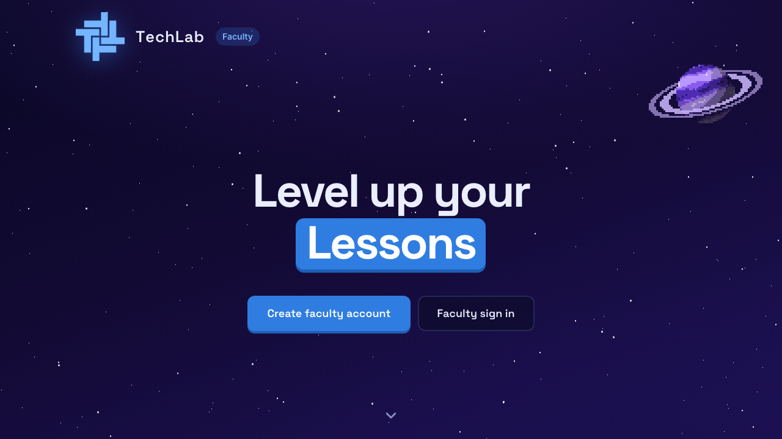  ACTION Carlo Reyes opens the TechLab faculty page and clicks Create faculty account.  ON SCREEN The faculty home page: "Level up your Lessons". |  | SCENE 02 Faculty · Sign up  He registers with his school email  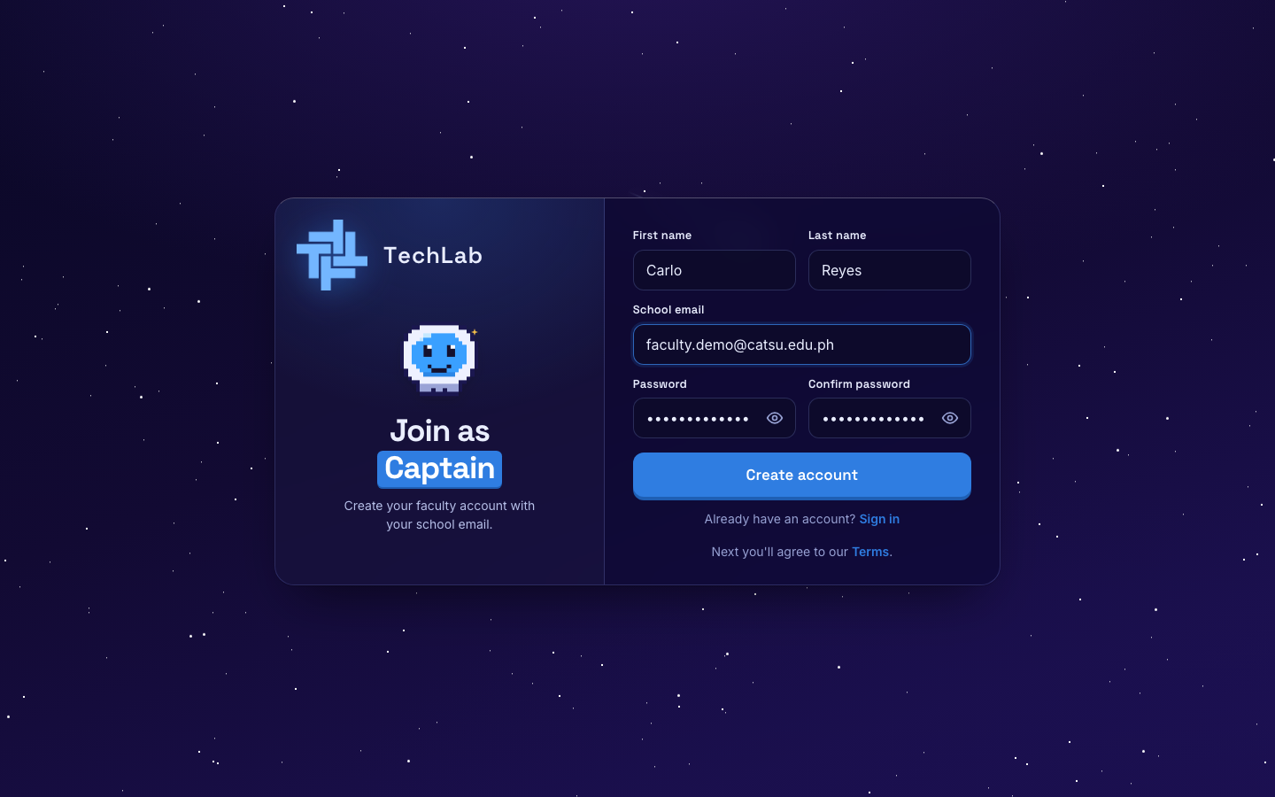  ACTION He types his name, his school email and a password, and clicks Create account.  ON SCREEN The "Join as Captain" form.  NOTE Faculty accounts need a @catsu.edu.ph school email. Other emails are not accepted.

SCENE 03 Faculty · Sign up  He agrees to the rules  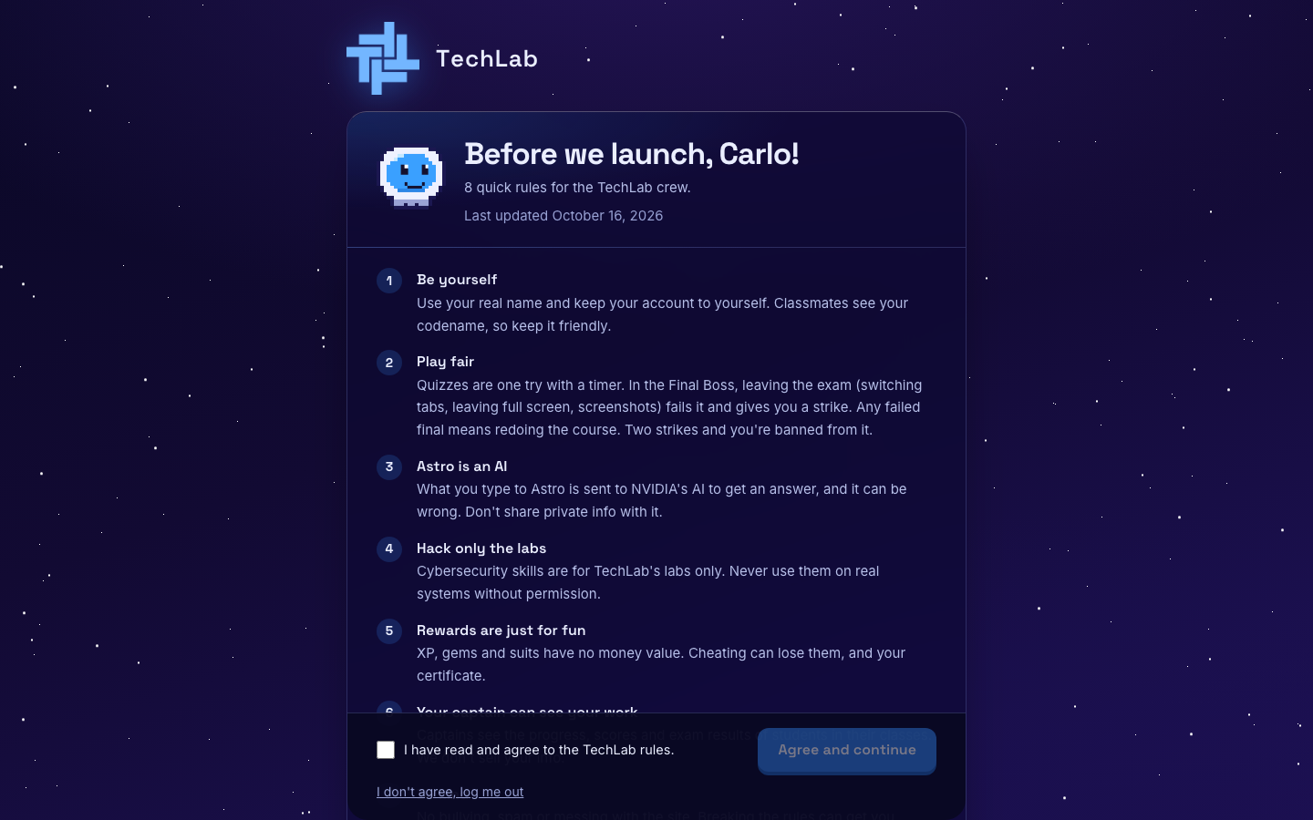  ACTION Carlo reads the rules, ticks I have read and agree, and clicks Agree and continue.  ON SCREEN "Before we launch, Carlo!" Faculty get one extra rule: keep student info private and use it only for teaching. |  | SCENE 04 Faculty · Onboarding  He suits up as Captain  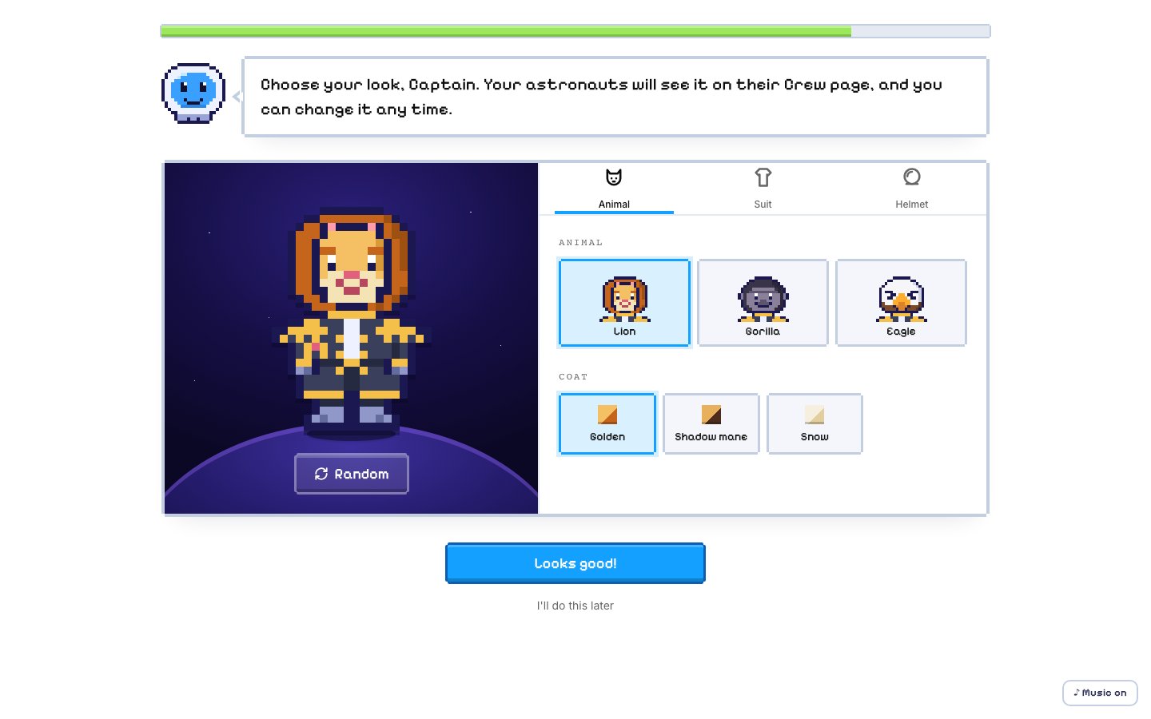  ACTION He picks his animal, suit and helmet, clicks Looks good!, then Take command.  ON SCREEN The Captain builder. Students see this avatar next to his name.

SCENE 05 Faculty · Sign in
Signing in next time
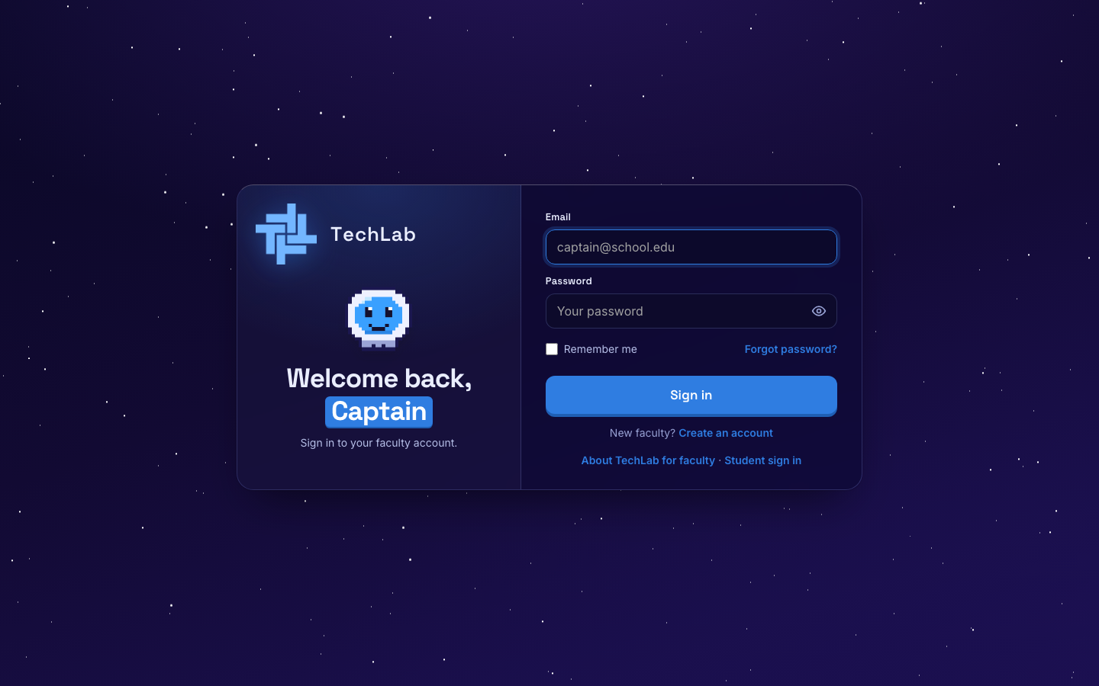
ACTION Carlo goes to /faculty/login, types his school email and password, and clicks Sign in.
ON SCREEN The faculty sign-in page. A student account can't sign in here.

PART 2
Your dashboard
Your dashboard shows how your students are doing, your courses, and who is waiting to join. It starts empty until the admin gives you a course.

SCENE 06 Faculty · Dashboard  No course yet  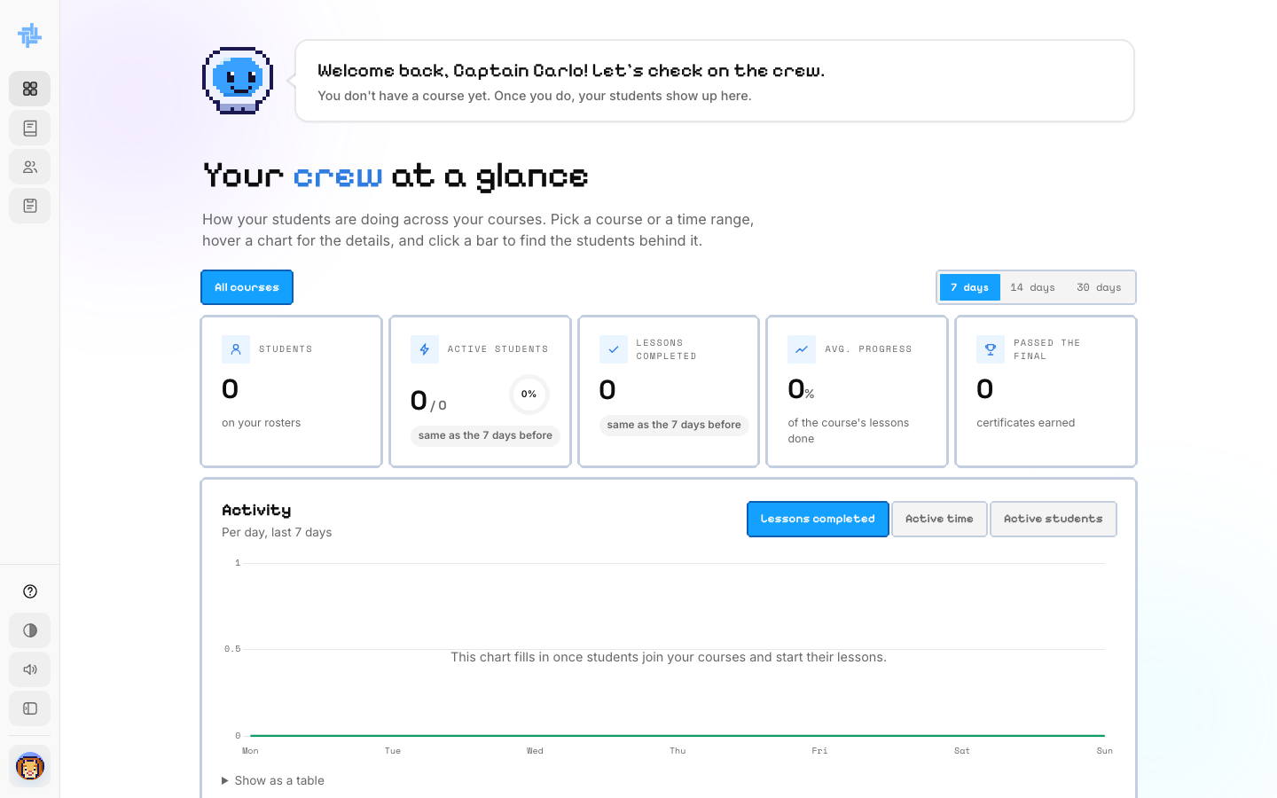  ACTION Carlo lands on his dashboard and waits for a course.  ON SCREEN Astro: "You don't have a course yet. Once you do, your students show up here."  NOTE Admins assign the courses faculty teach. See Storyboard 3 for that side of the story. |  | SCENE 07 Faculty · Dashboard  Four astronauts aboard  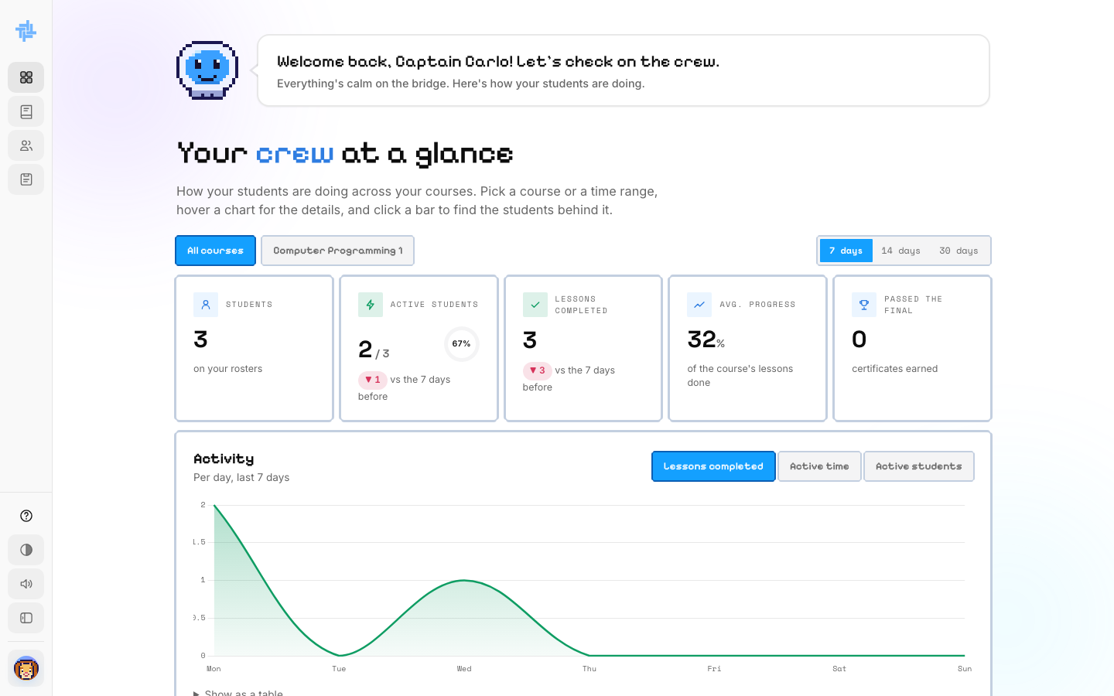  ACTION Ten weeks later, with Computer Programming 1 assigned and students joined, Carlo checks his dashboard.  ON SCREEN 3 students, 2 active, 3 lessons completed, 32% average progress. The Activity chart shows lessons completed each day.

PART 3
Run your class
Every course a faculty member teaches gets its own class, with a class code as its ID. Only students the Captain accepts can get in.

SCENE 08 Faculty · Courses  Find your course  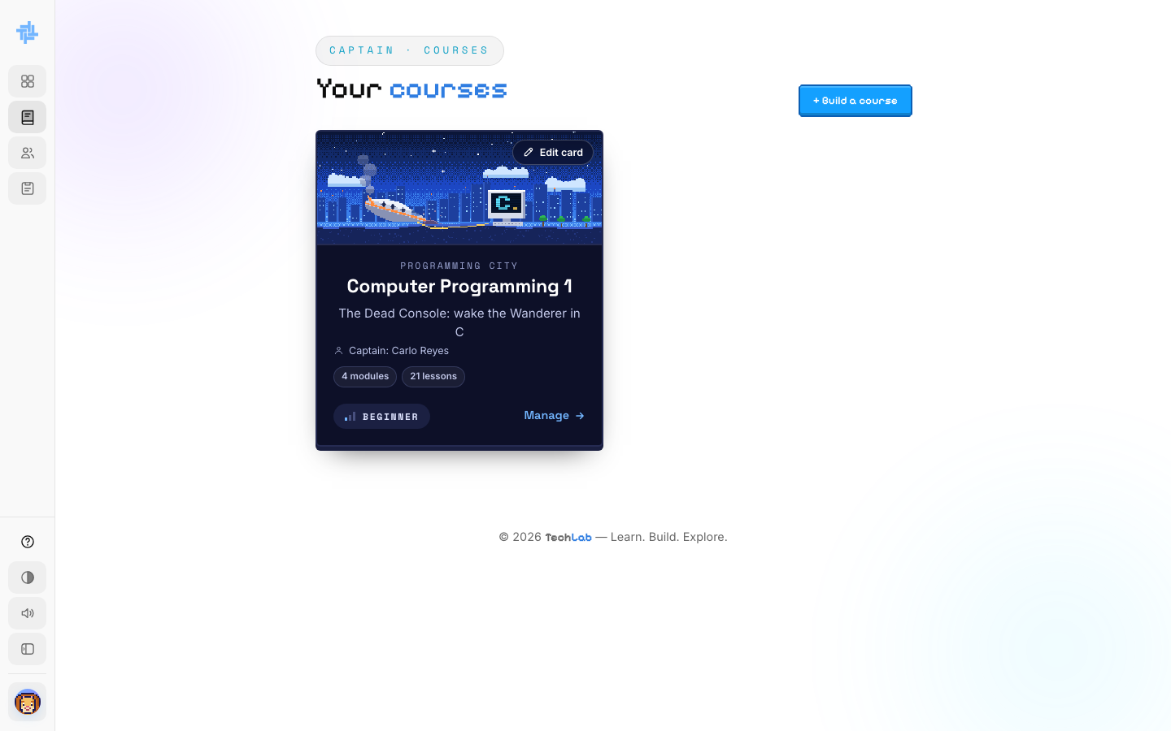  ACTION Carlo clicks Courses in the sidebar.  ON SCREEN Computer Programming 1: 4 modules, 21 lessons, Beginner. Manage opens it for editing, Edit card changes the picture and title, + Build a course starts a new one. |  | SCENE 09 Faculty · Crew  See your crew  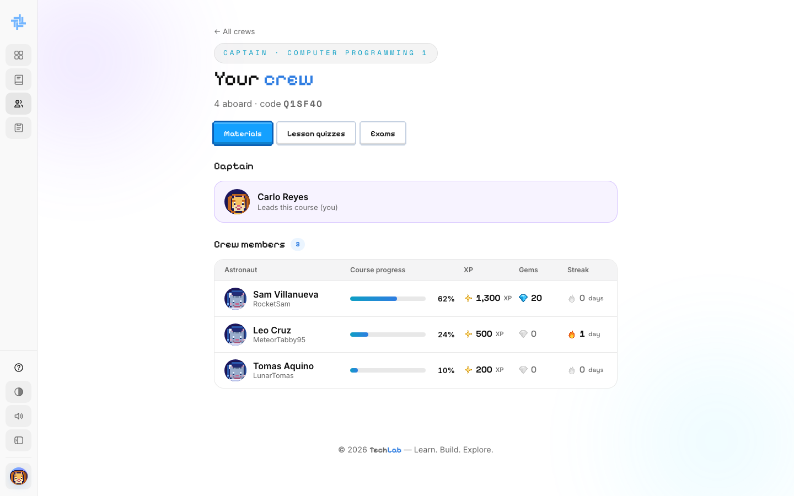  ACTION He clicks Crew in the sidebar.  ON SCREEN "4 aboard · code Q1SF40." Carlo as Captain, and Sam, Leo and Tomas with their progress, XP, gems and streak.  NOTE The class code is just the class's ID. Students never type it — they pick Carlo under Join Class instead.

SCENE 10 Faculty · Dashboard  A student is waiting  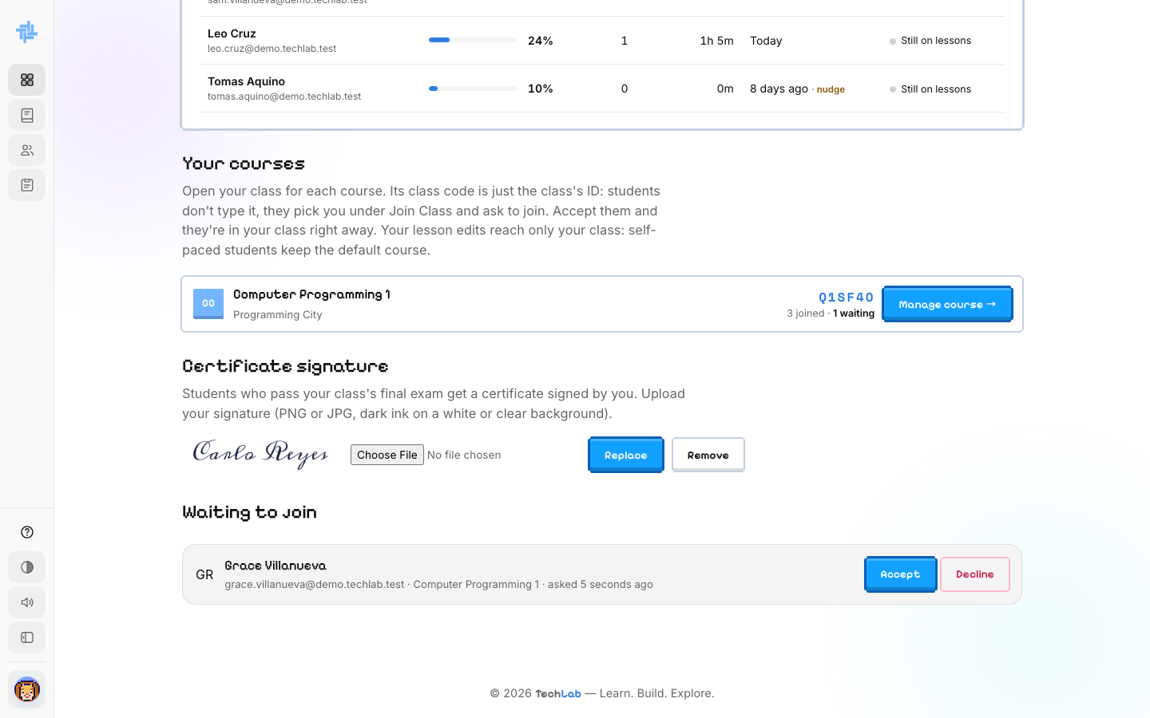  ACTION Grace Villanueva picks Carlo under Join Class and asks to join. She appears under Waiting to join.  ON SCREEN "Grace Villanueva · Computer Programming 1 · asked 5 seconds ago" with Accept and Decline buttons. |  | SCENE 11 Faculty · Dashboard  Carlo accepts her  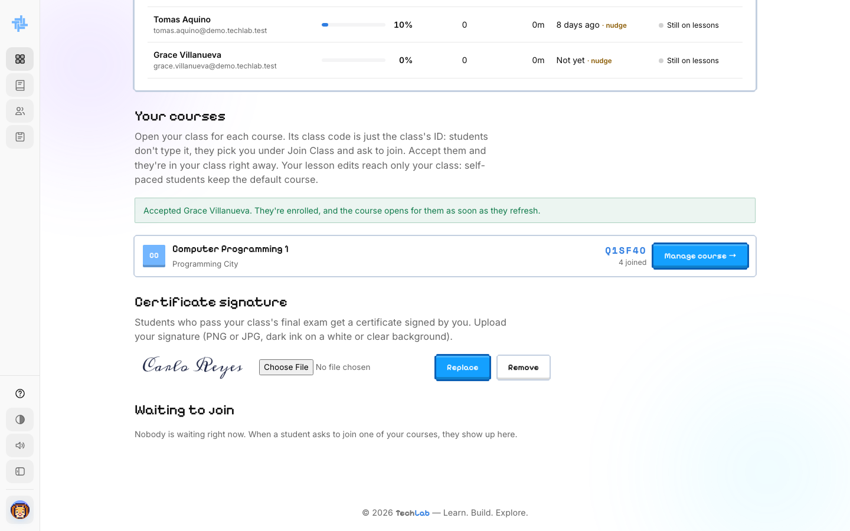  ACTION He clicks Accept.  ON SCREEN "Accepted Grace Villanueva. They're enrolled, and the course opens for them as soon as they refresh." 4 joined now.  NOTE Decline instead, and TechLab emails the student to tell them.

SCENE 12 Faculty · Dashboard  Adding his signature  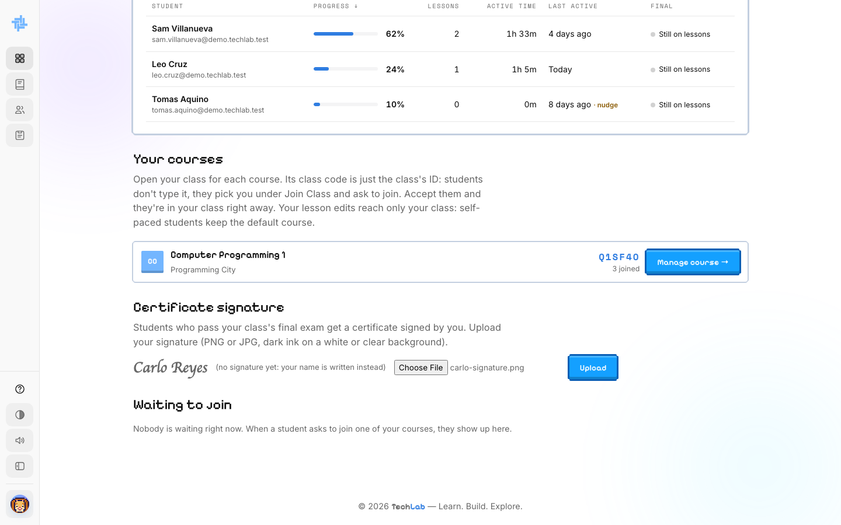  ACTION Under Certificate signature, Carlo clicks Choose File, picks a photo of his signature, and is about to click Upload.  ON SCREEN "Carlo Reyes" written out, since no signature is uploaded yet. |  | SCENE 13 Faculty · Dashboard  Signature saved  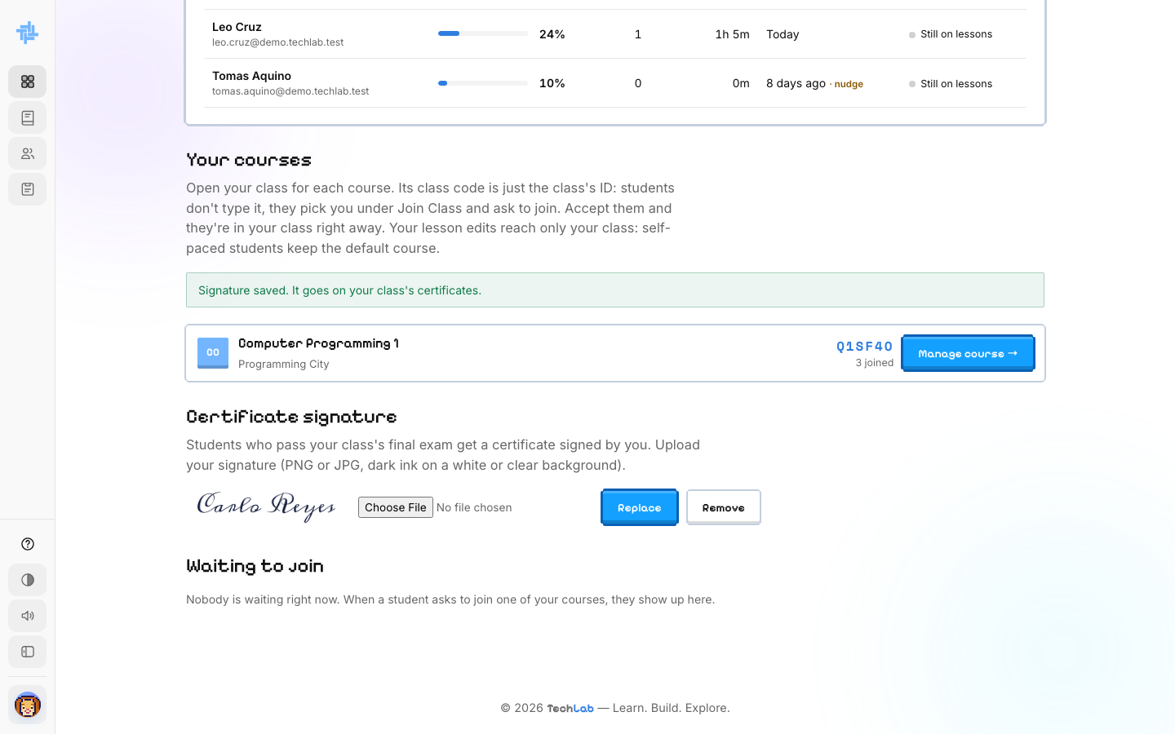  ACTION He clicks Upload.  ON SCREEN "Signature saved. It goes on your class's certificates." His handwritten signature replaces the written name.

PART 4
Share learning materials
Add files and links for students, grouped into modules. Astro can answer students' questions using the PDF, Word, PowerPoint and text files a Captain uploads.

SCENE 14 Faculty · Materials  An empty Materials tab  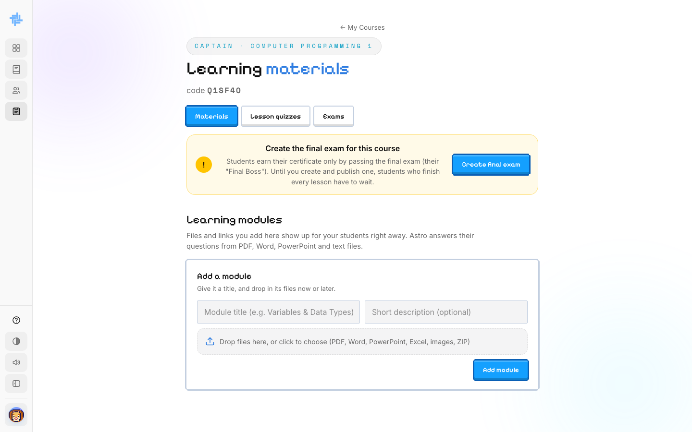  ACTION Carlo opens the Materials tab for the first time.  ON SCREEN "Create the final exam for this course" and an empty Add a module form. |  | SCENE 15 Faculty · Materials  He names a module  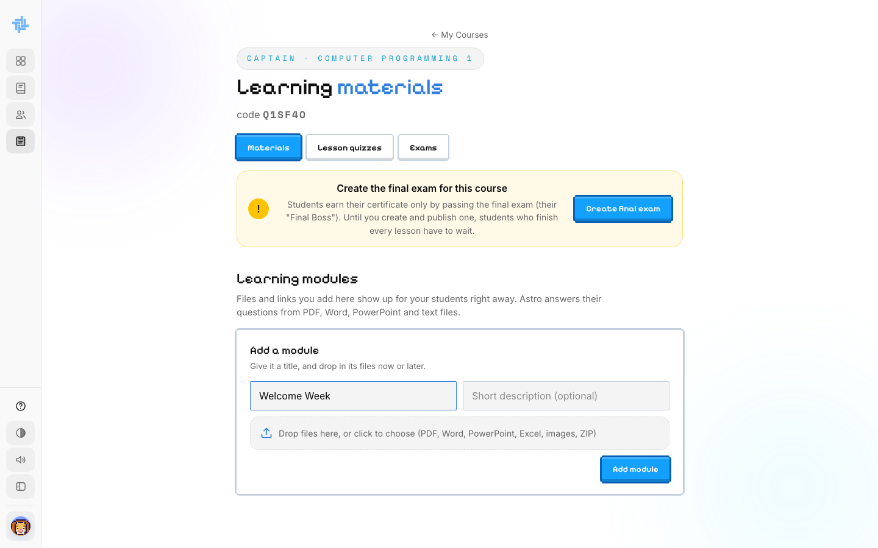  ACTION He types Welcome Week as the module title and clicks Add module.  ON SCREEN The module title field, filled in.

SCENE 16 Faculty · Materials  He adds a link  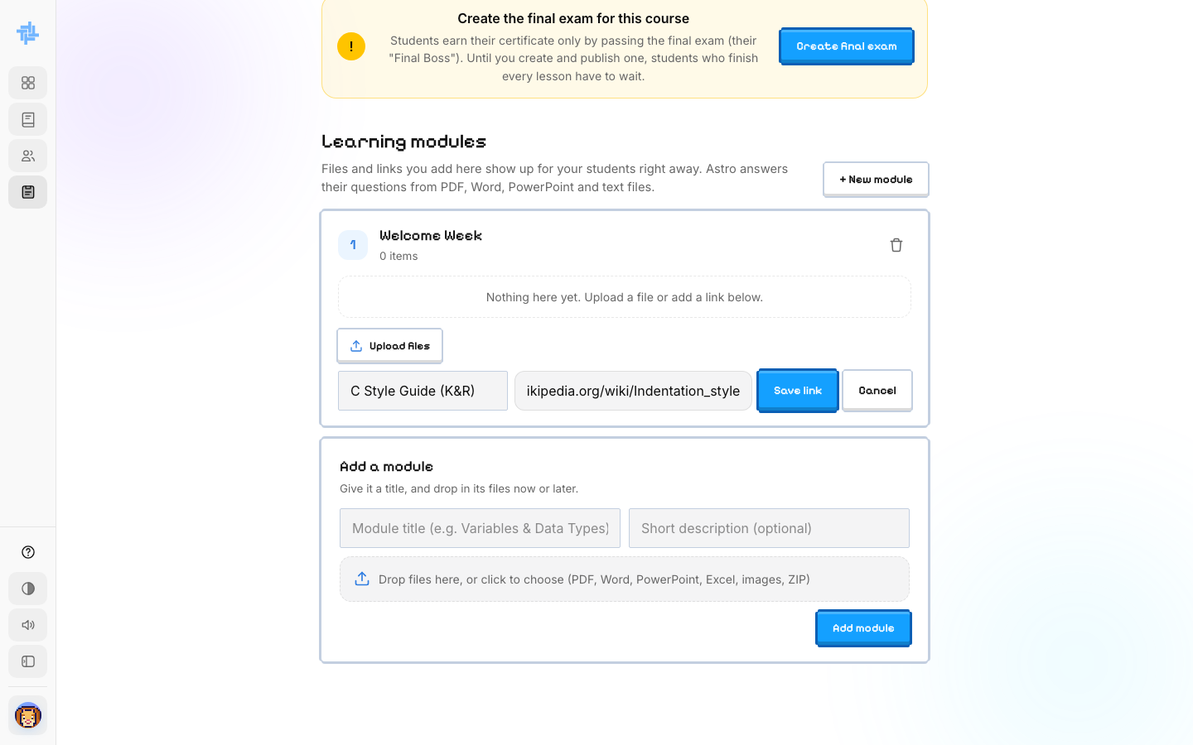  ACTION Inside the new module he clicks Add link, types a title and a web address, and clicks Save link.  ON SCREEN "C Style Guide (K&R)" and its address, ready to save. |  | SCENE 17 Faculty · Materials  Students see it right away  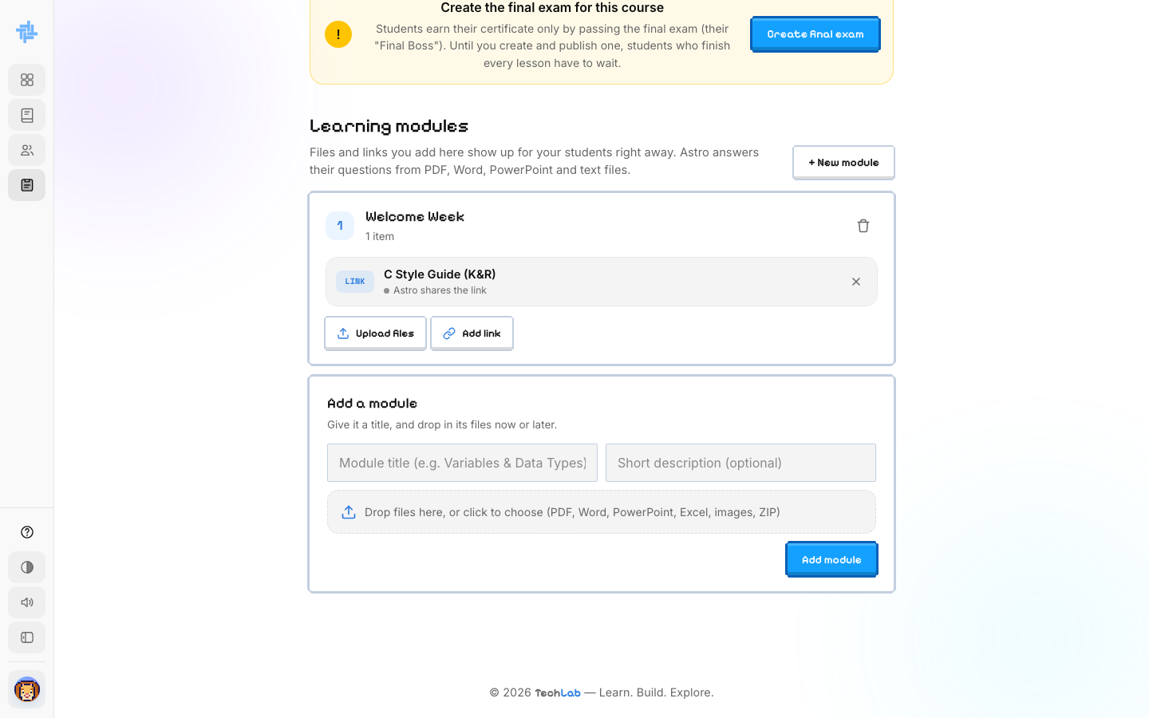  ACTION The link appears under Welcome Week.  ON SCREEN Welcome Week · 1 item: C Style Guide (K&R), with Upload files and Add link to add more.

PART 5
Edit lesson quizzes
Every lesson ends with a ready-made Knowledge Check quiz. A Captain can keep it, or change it for their own class.

SCENE 18 Faculty · Lesson quizzes  Every lesson, listed  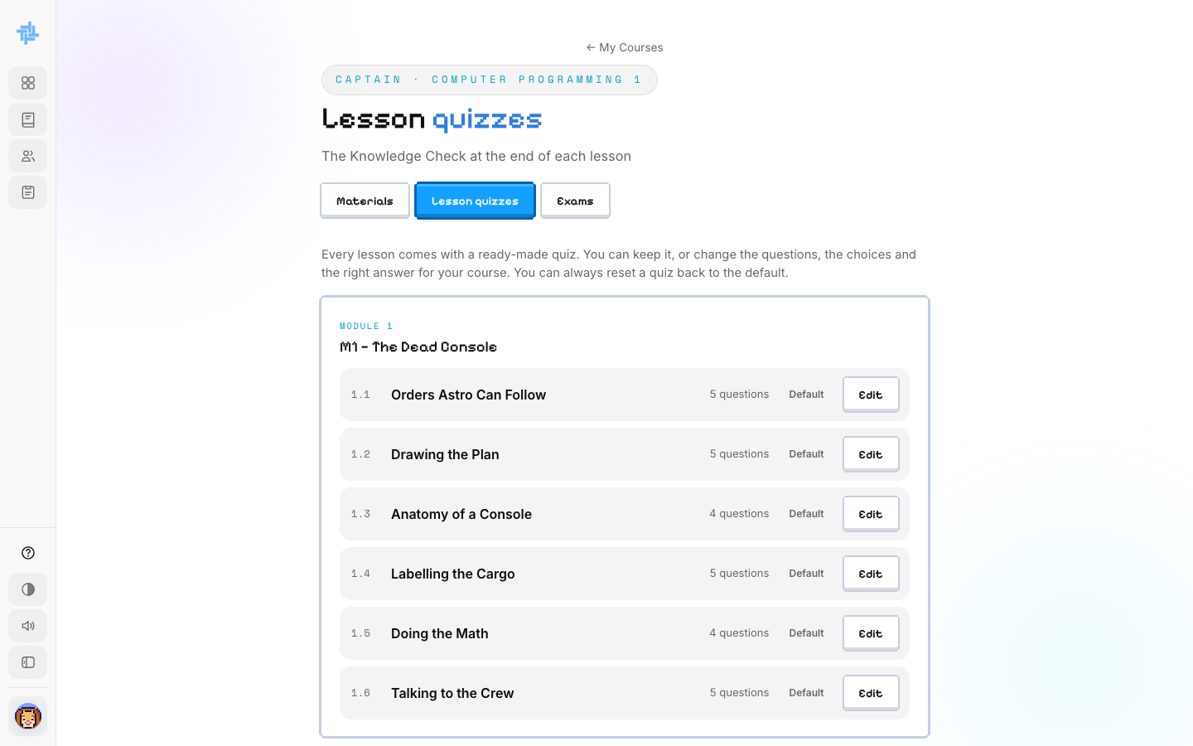  ACTION Carlo opens the Lesson quizzes tab.  ON SCREEN Each lesson with its number of questions, all marked Default. |  | SCENE 19 Faculty · Lesson quizzes  He opens lesson 1.1  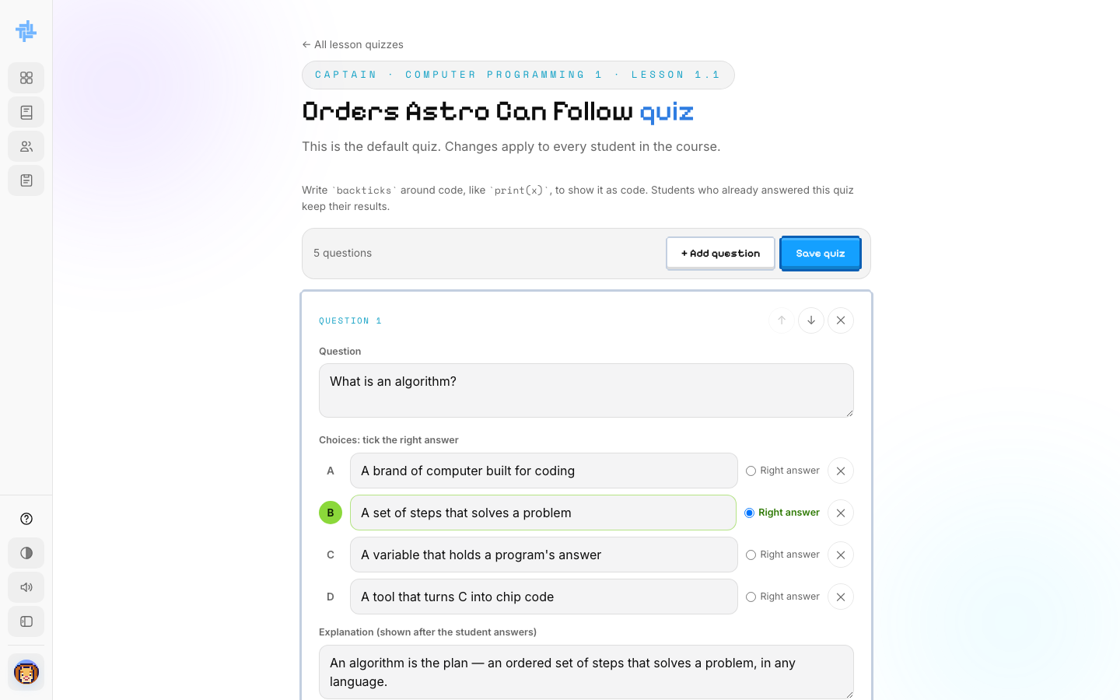  ACTION He clicks Edit next to "Orders Astro Can Follow".  ON SCREEN Question 1, its four choices, the right answer marked, and its explanation.

SCENE 20 Faculty · Lesson quizzes
His edit is saved
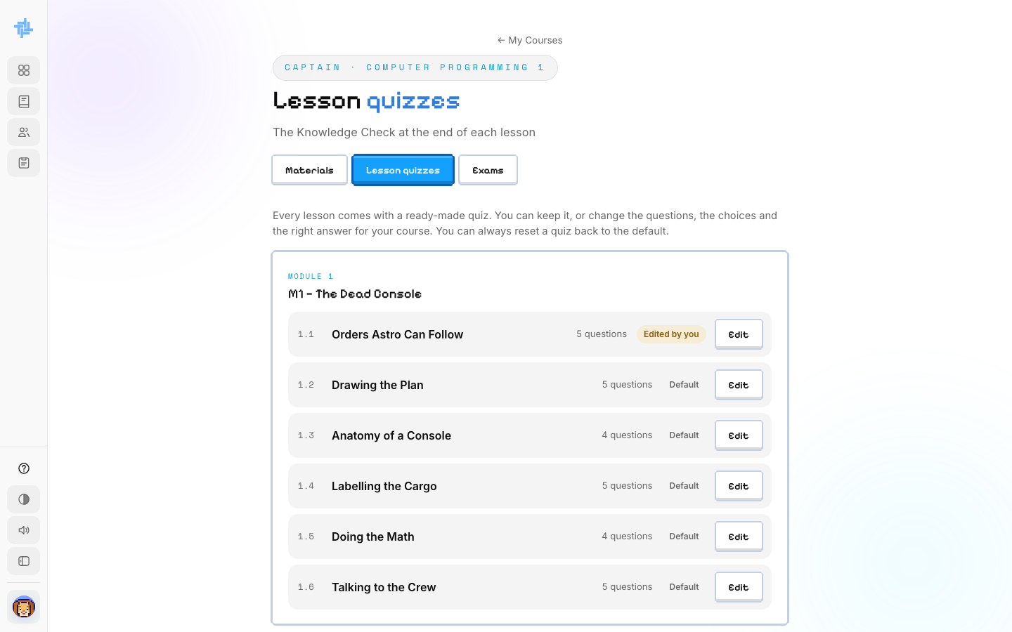
ACTION Carlo rewrites the explanation and clicks Save quiz.
ON SCREEN "Saved. Students now get this quiz." Lesson 1.1 now shows Edited by you instead of Default.

PART 6
Mini bosses and the final exam
Mini bosses close each module. The final exam, the Final Boss, is what earns a student their certificate — nobody gets one until the Captain writes it.

SCENE 21 Faculty · Exams  Mini bosses, ready-made  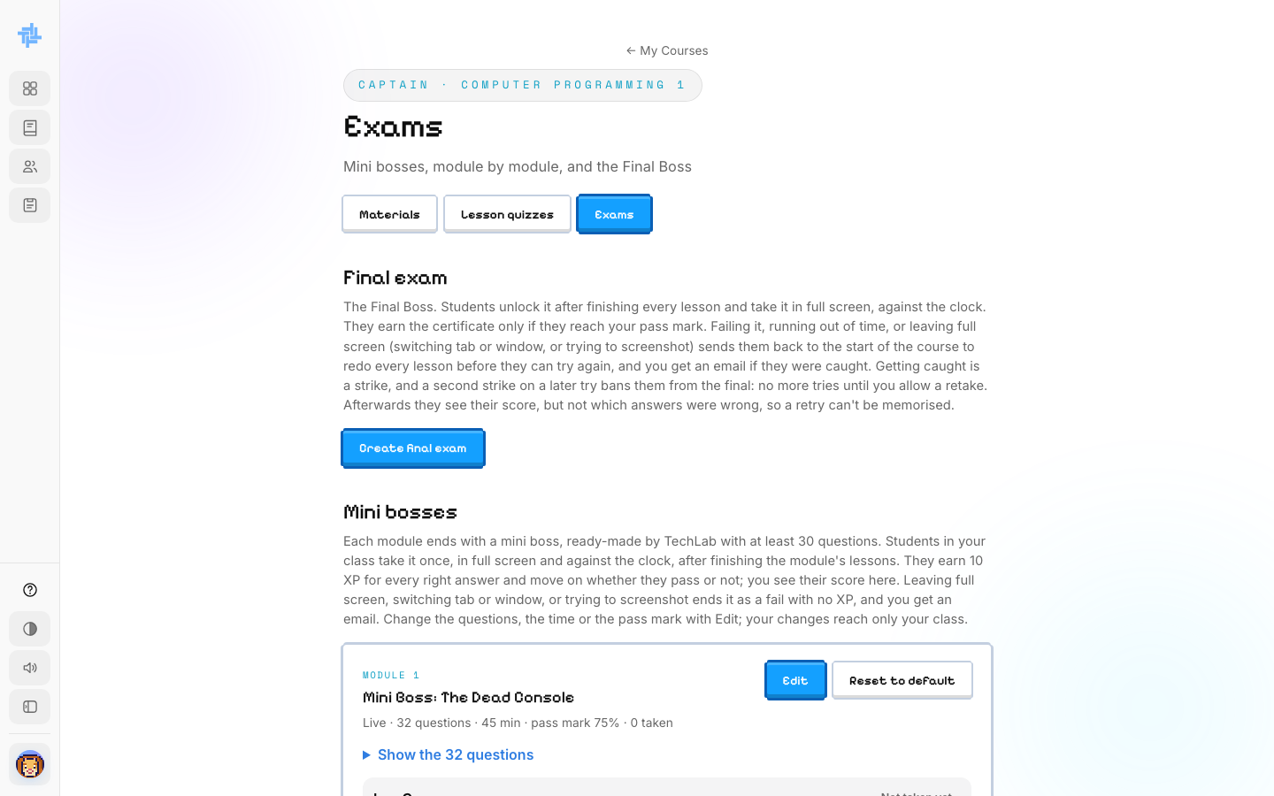  ACTION Carlo opens the Exams tab.  ON SCREEN Create final exam, and Mini Boss: The Dead Console — 32 questions, 45 min, pass mark 75%, 0 taken. |  | SCENE 22 Faculty · Final exam  He starts the builder  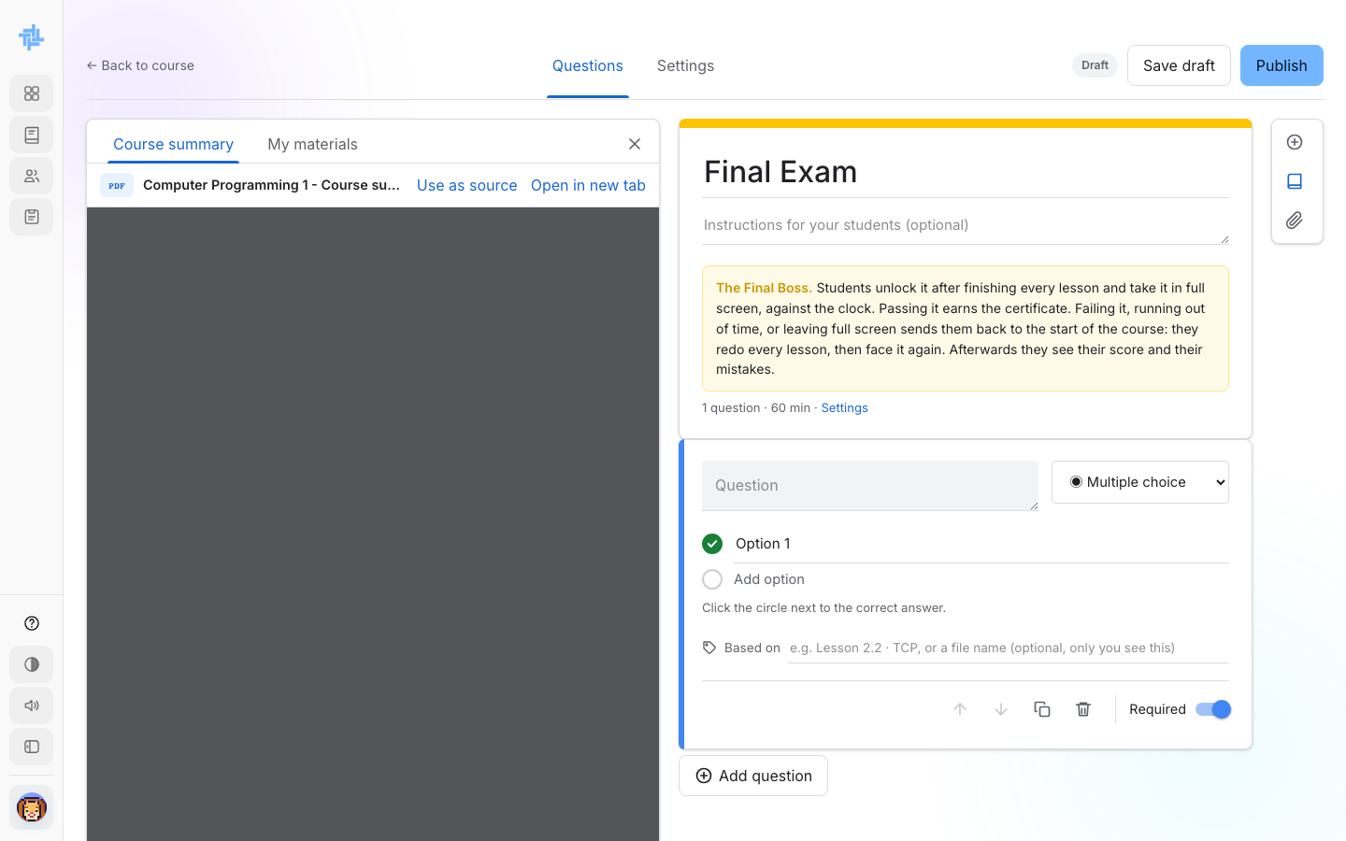  ACTION He clicks Create final exam.  ON SCREEN The Final Exam builder: a Question panel, Questions and Settings tabs, and the course summary on the left to write questions from.

SCENE 23 Faculty · Final exam  His first question  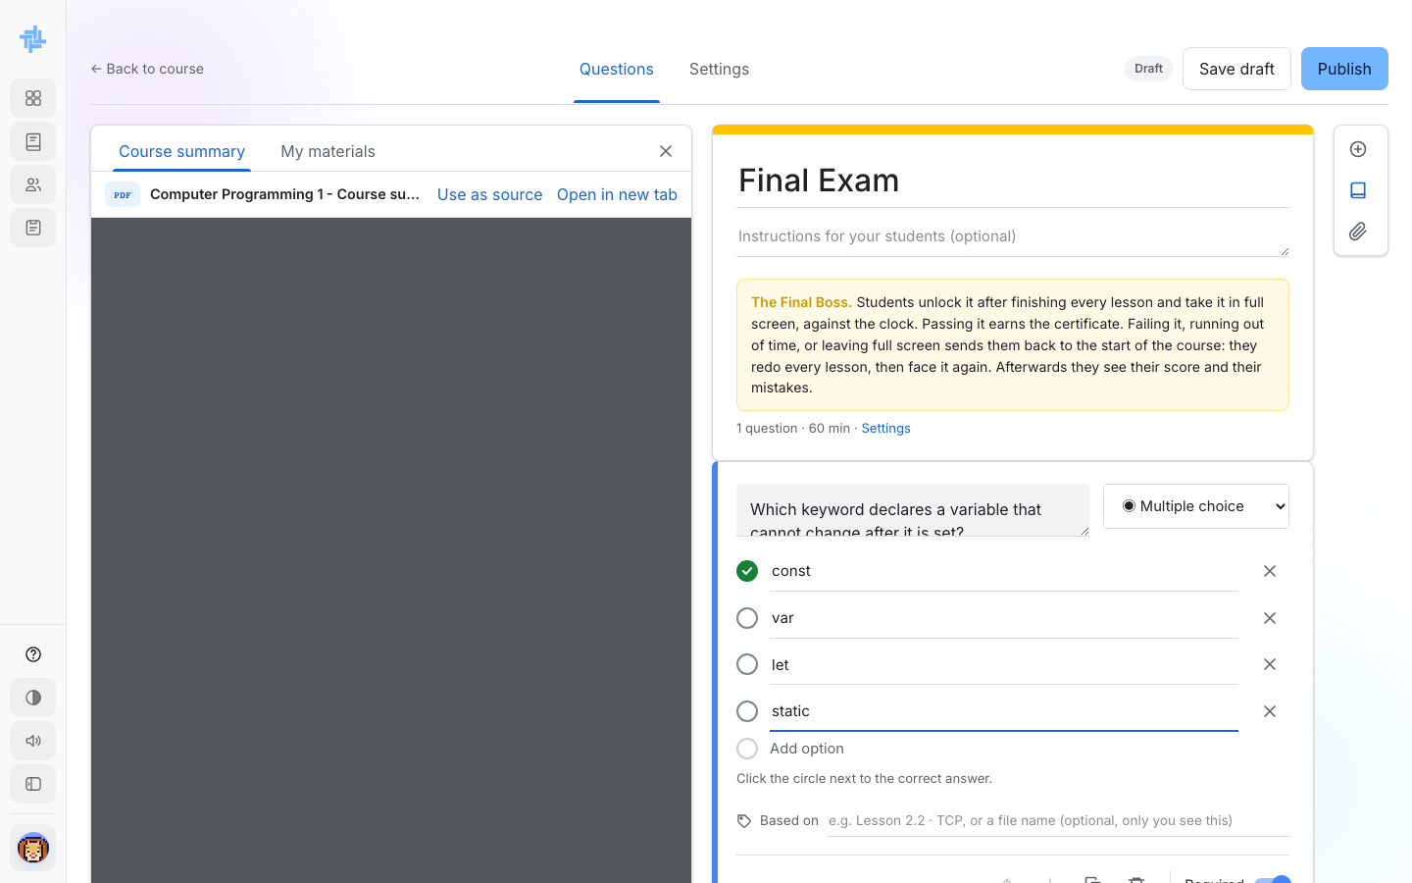  ACTION He types a multiple-choice question and marks const as the right answer.  ON SCREEN "Which keyword declares a variable that cannot change after it is set?" with four options. |  | SCENE 24 Faculty · Final exam  A second question  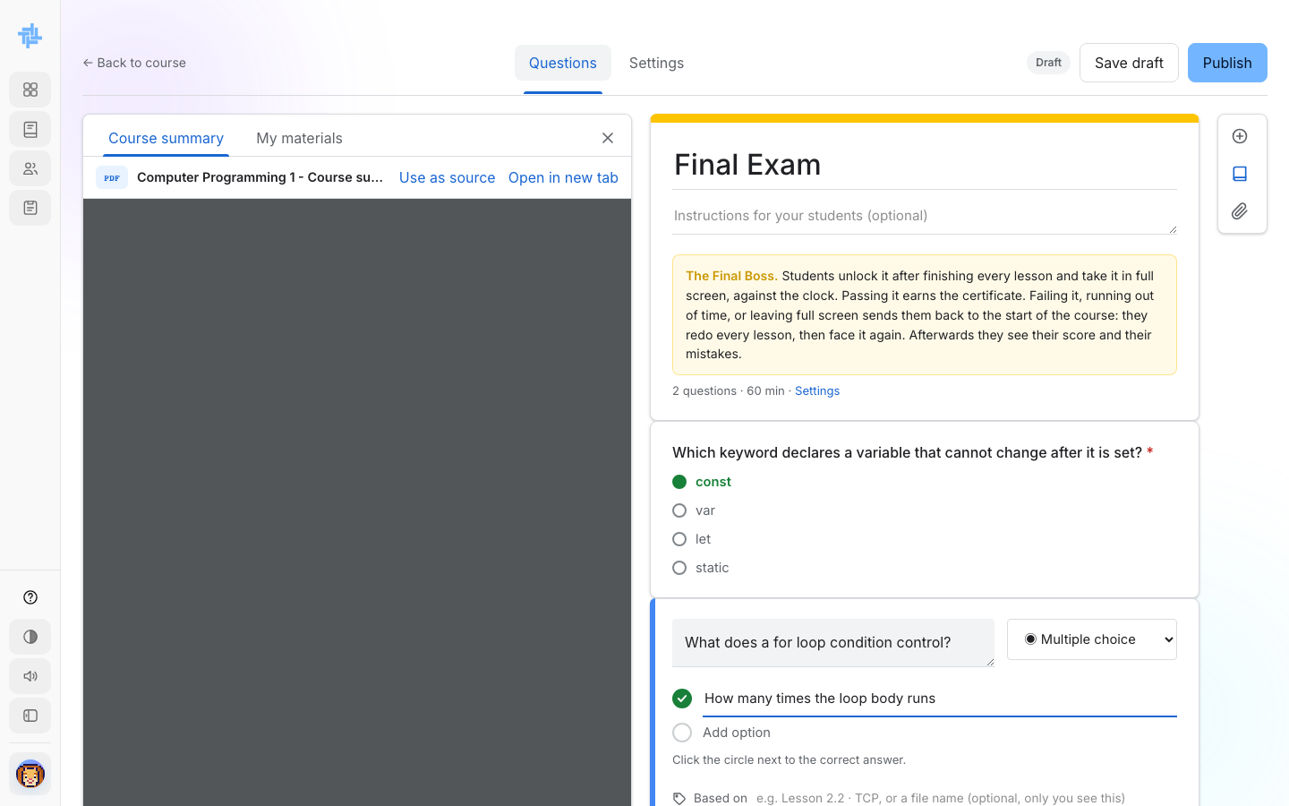  ACTION He clicks Add question and writes one about for loops.  ON SCREEN Question 1 collapses to its saved view; Question 2 is open and being written.

SCENE 25 Faculty · Final exam  Time limit and pass mark  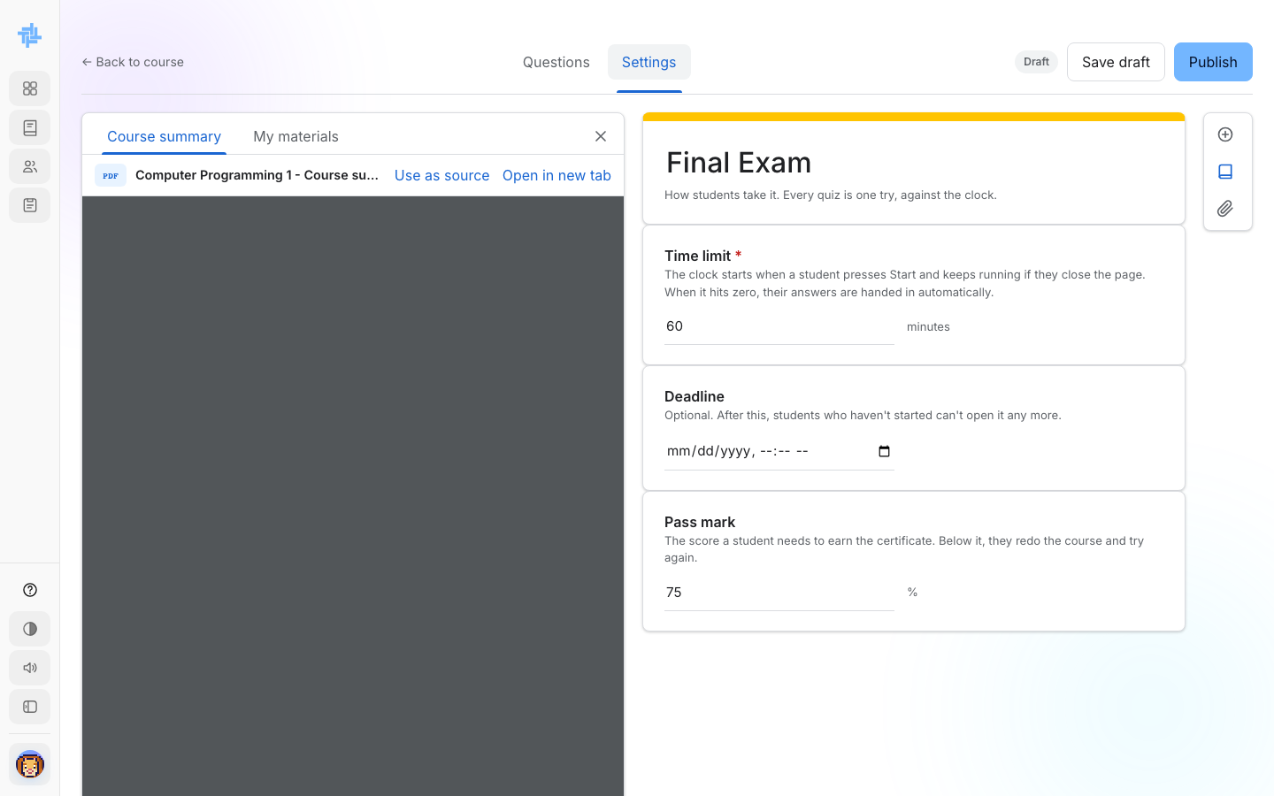  ACTION He opens the Settings tab.  ON SCREEN Time limit 60 minutes, an optional Deadline, and Pass mark 75%. |  | SCENE 26 Faculty · Final exam  He publishes it  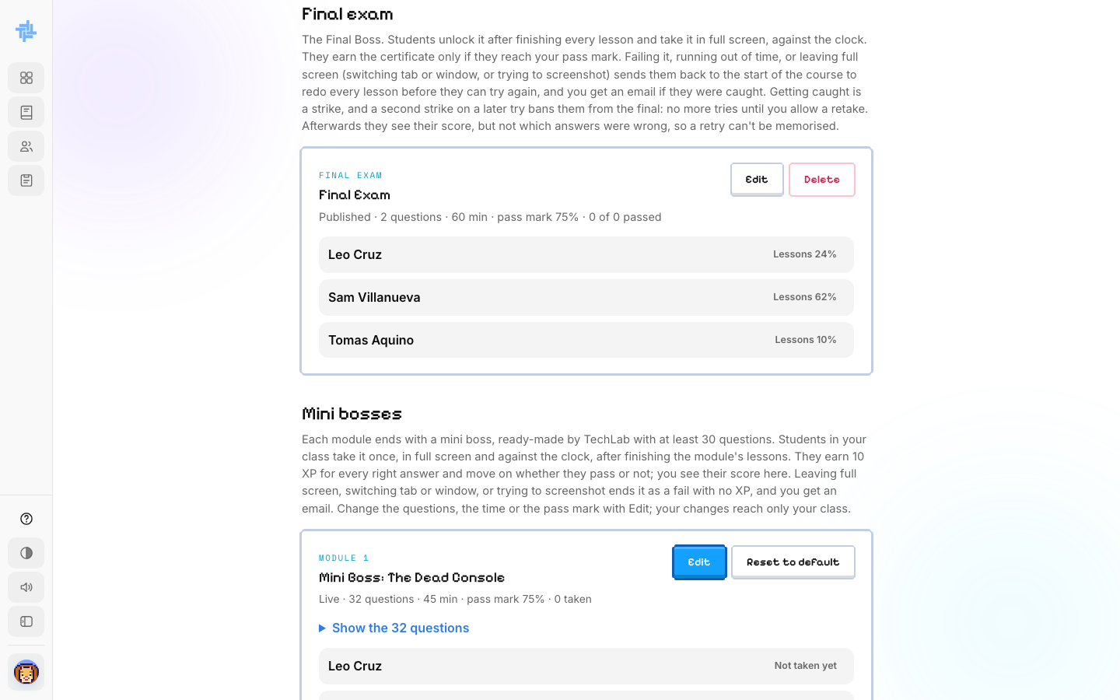  ACTION Back in Exams, the Final Exam is live.  ON SCREEN "Published · 2 questions · 60 min · pass mark 75% · 0 of 0 passed", with Leo, Sam and Tomas listed below by their lesson progress.  NOTE Until a Captain creates and publishes one, students who finish every lesson have to wait.

PART 7
Edit course content
A Captain can change the lessons for their own class. Edits reach only their class — self-paced students keep the standard TechLab course.

SCENE 27 Faculty · Lesson  Opening a lesson to edit  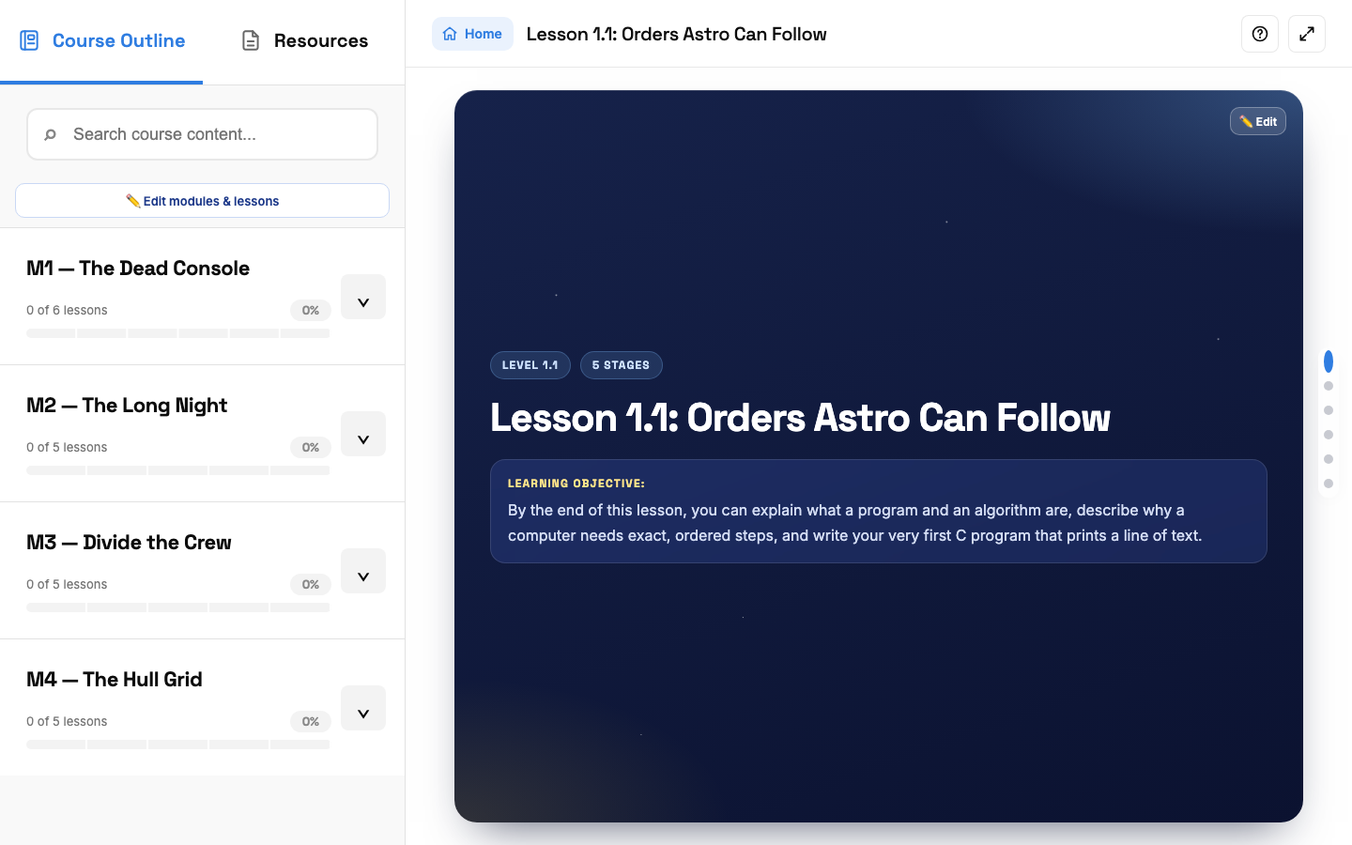  ACTION From Courses, Carlo clicks Manage. The lesson opens with ✏️ Edit buttons on every part.  ON SCREEN Lesson 1.1, with the Course Outline on the left and Edit buttons on the title, each stage and the lab. |  | SCENE 28 Faculty · Outline  Renaming and reordering  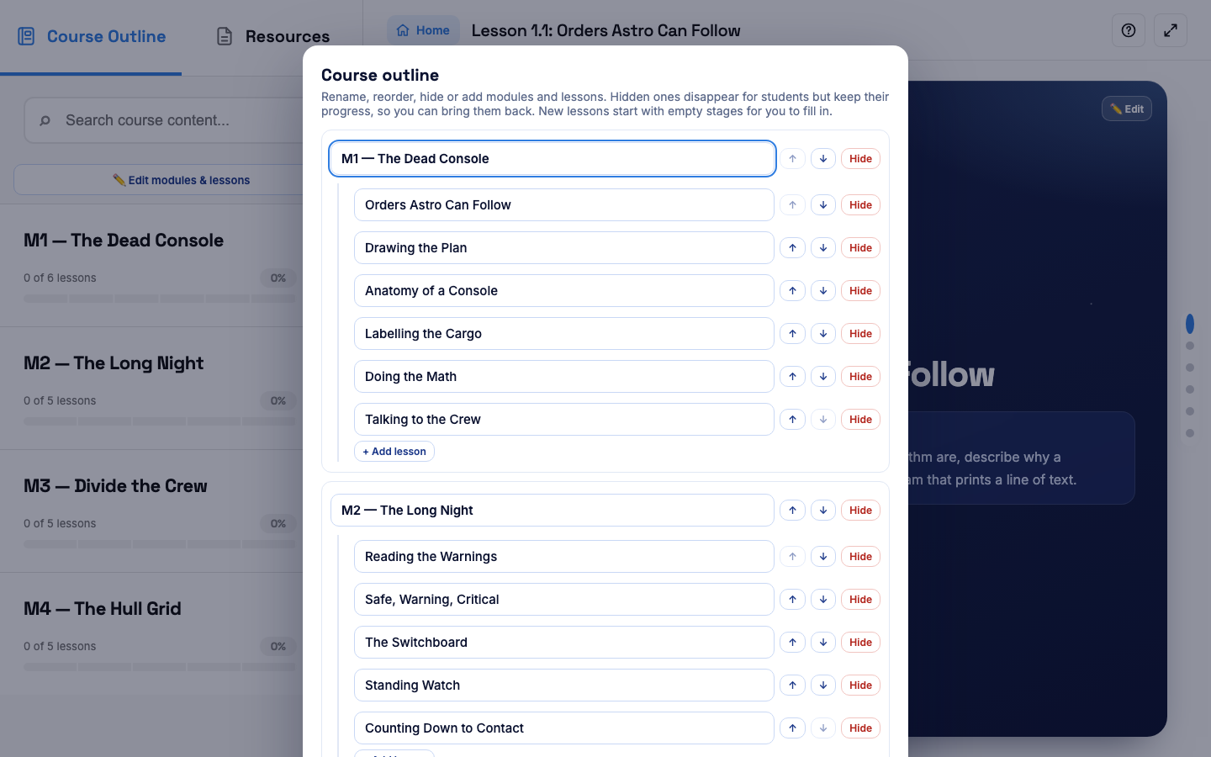  ACTION He clicks Edit modules & lessons.  ON SCREEN Every module and lesson in a renameable box, with ↑ ↓ to reorder and Hide to hide one without losing a student's progress.

SCENE 29 Faculty · Stage  Editing the title and objective  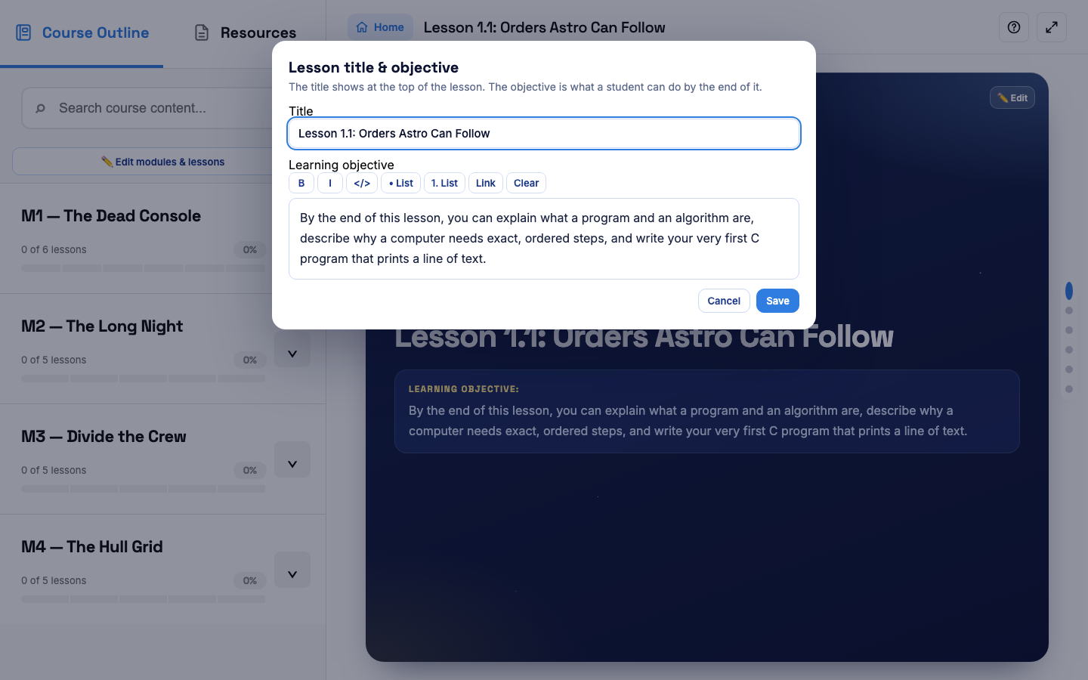  ACTION He clicks Edit on the lesson title.  ON SCREEN A text box for the title, and a formatted box for the learning objective, with bold, italics, code and list buttons. |  | SCENE 30 Faculty · Lab  Editing the coding lab  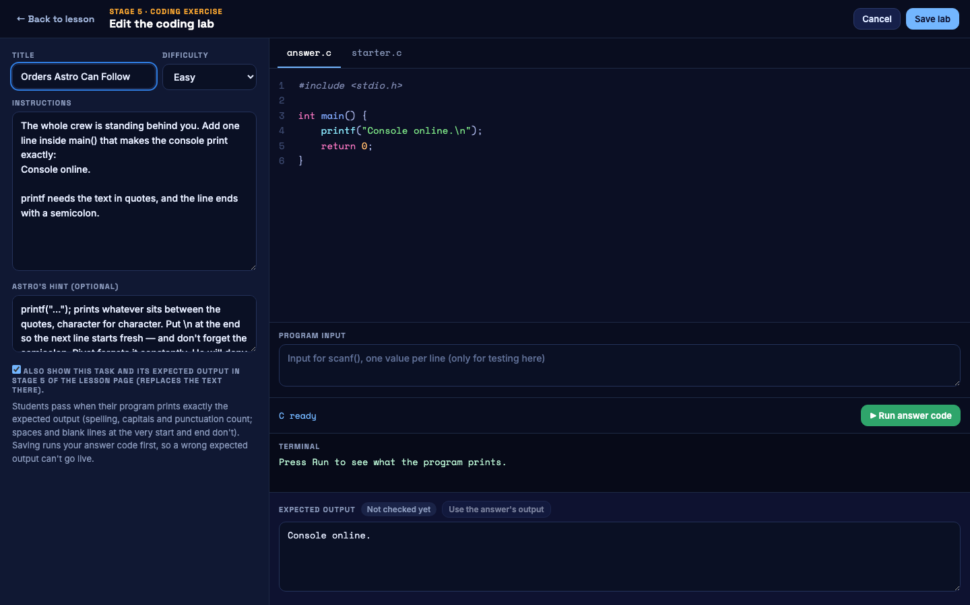  ACTION He clicks Edit lab on Stage 5.  ON SCREEN The title, difficulty, instructions, Astro's hint, the answer.c and starter.c code, and the expected output.  NOTE Saving runs the answer code first, so a wrong expected output can't go live.

SCENE 31 Faculty · Course card
Changing the course card
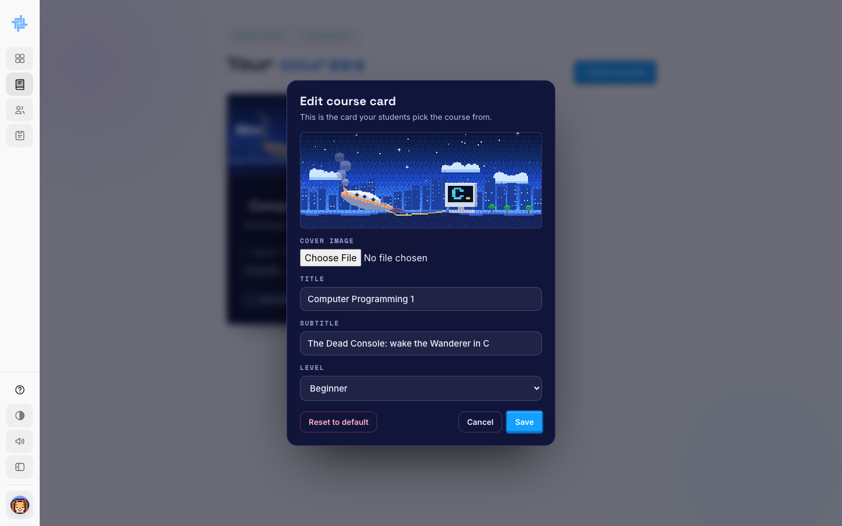
ACTION On Courses, he clicks Edit card.
ON SCREEN The cover image, title, subtitle and level — the card students pick the course from.

PART 8
More tools
Beyond editing an assigned course, a Captain can build an entirely new one from scratch, and keep their own class schedule in TechLab.

SCENE 32 Faculty · New course  Building a course from scratch  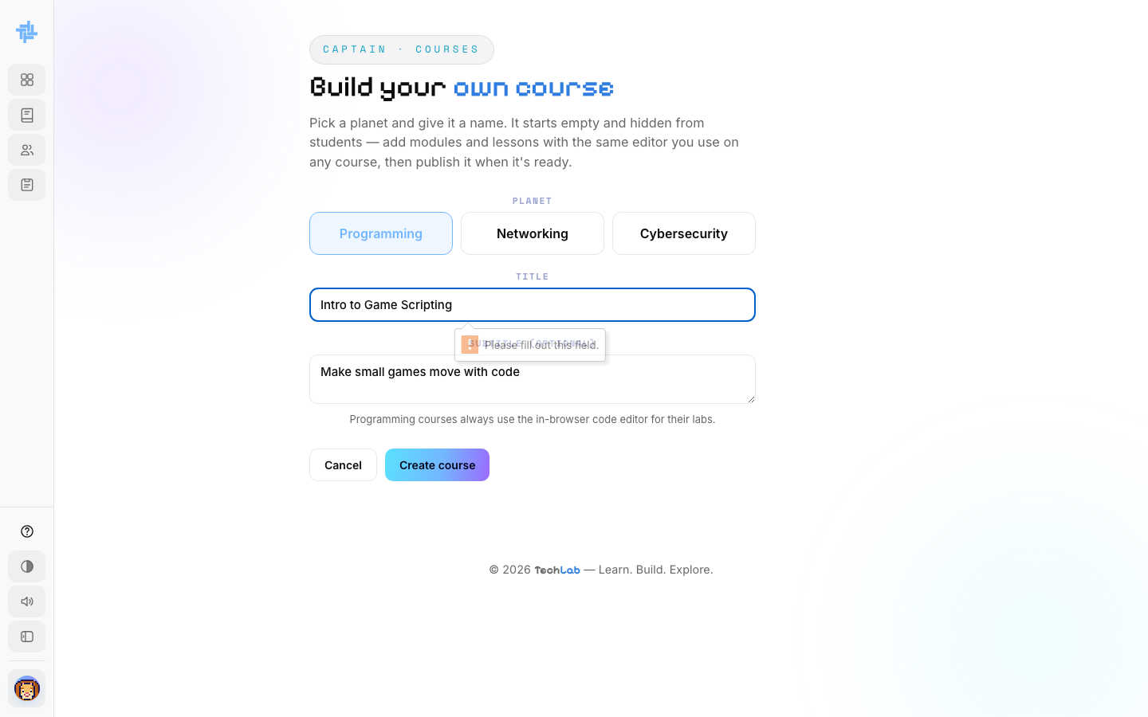  ACTION He clicks + Build a course, picks Programming, and types a title and subtitle.  ON SCREEN "Intro to Game Scripting" — "Make small games move with code". |  | SCENE 33 Faculty · New course  It starts empty and hidden  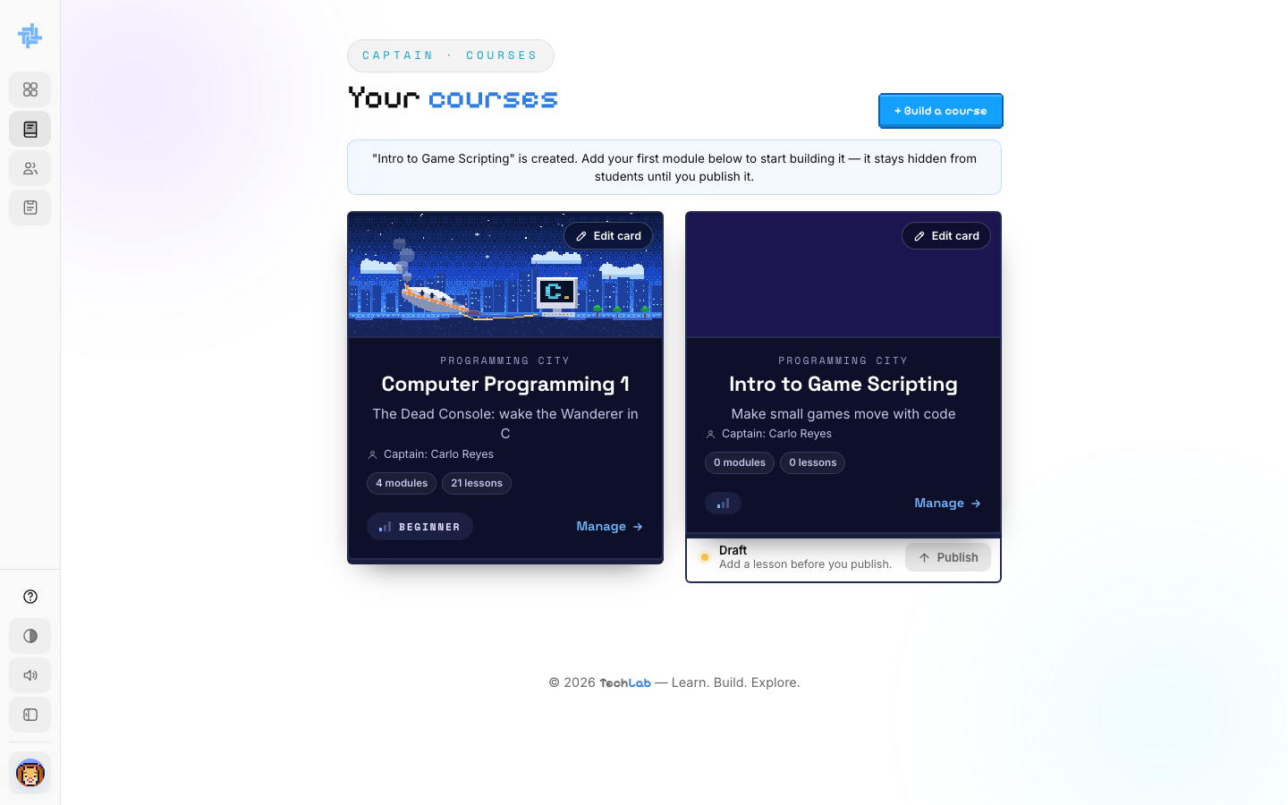  ACTION He clicks Create course.  ON SCREEN "Intro to Game Scripting" is created. 0 modules, 0 lessons, in Draft, hidden from students until he publishes it.

SCENE 34 Faculty · Schedule
Uploading a class schedule
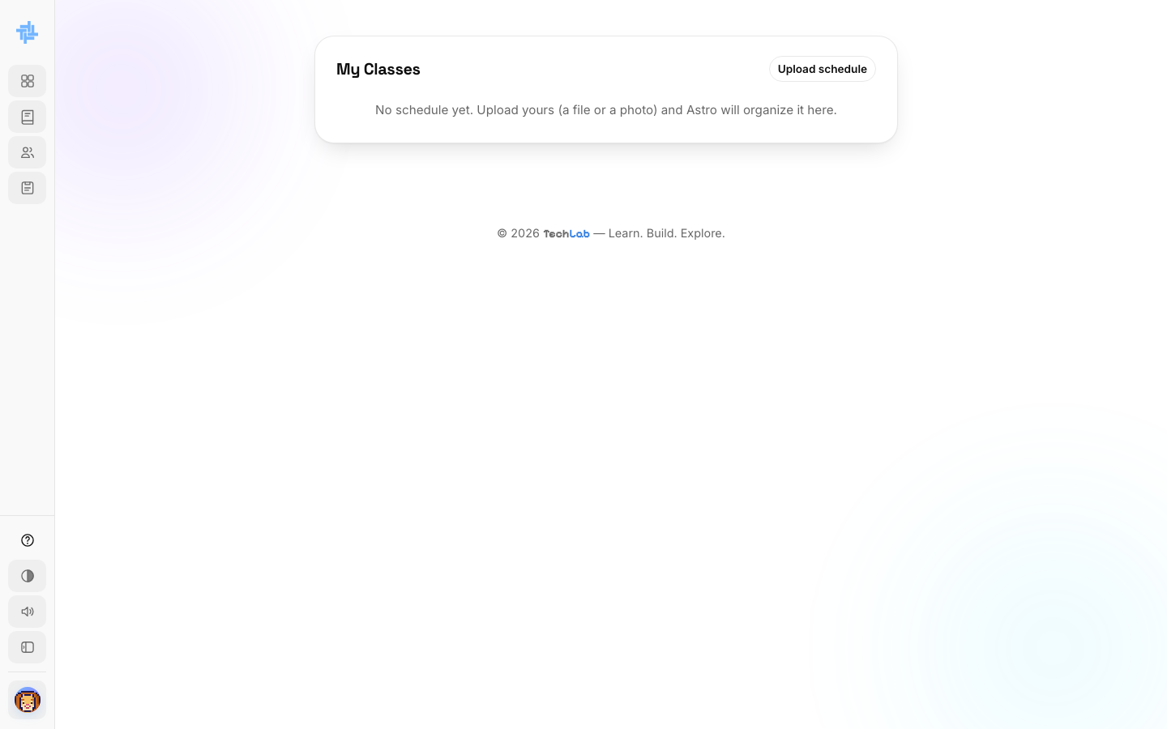
ACTION Carlo opens My Classes and clicks Upload schedule.
ON SCREEN "No schedule yet. Upload yours (a file or a photo) and Astro will organize it here."

PART 9
Account and logging out
Carlo keeps his own details up to date, and signs out when he's done.

SCENE 35 Faculty · Account  The account menu  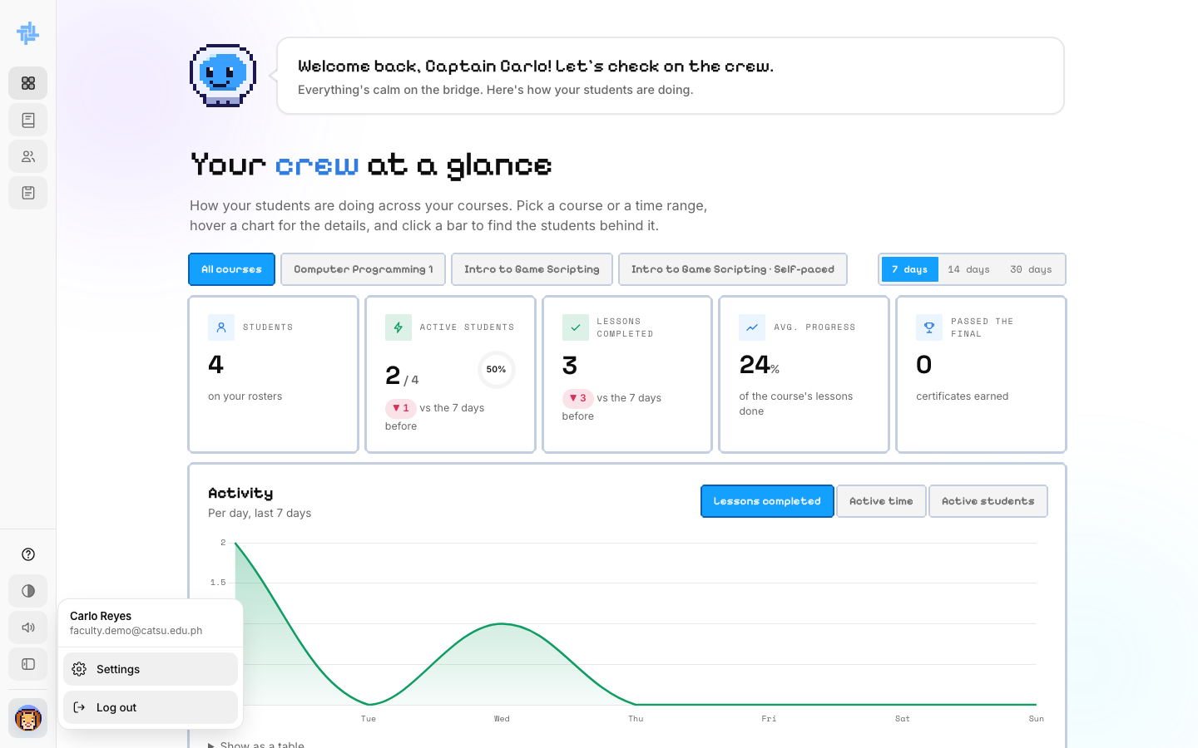  ACTION He clicks his avatar at the bottom of the sidebar.  ON SCREEN Carlo Reyes, Settings and Log out. The course filter now lists both his courses. |  | SCENE 36 Faculty · Settings  His profile  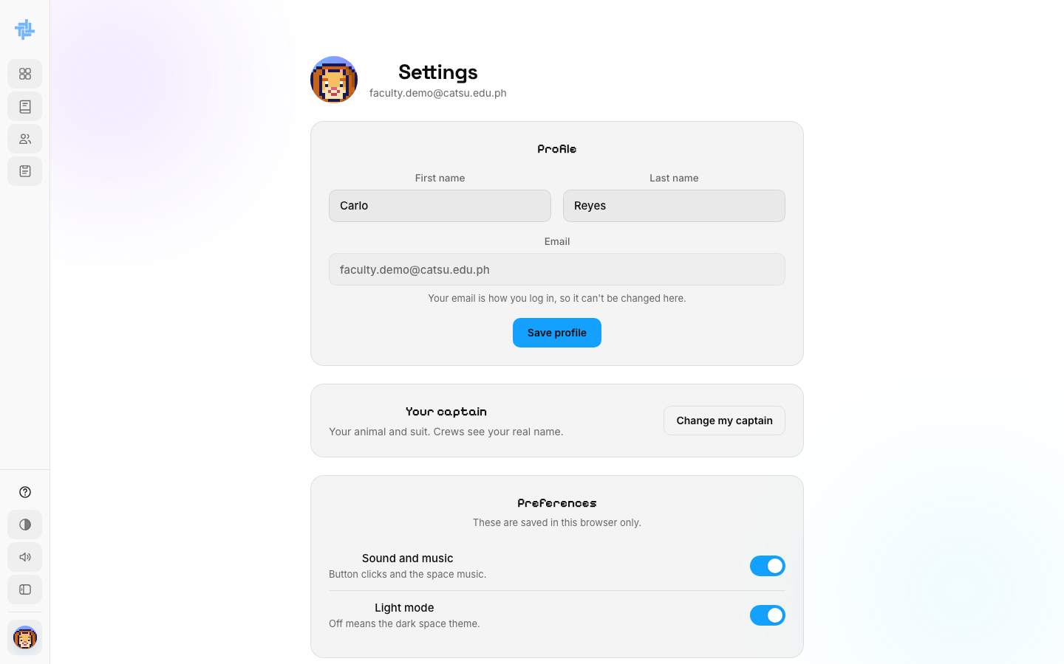  ACTION He clicks Settings.  ON SCREEN Profile (first and last name; the email can't change), Your captain, and Preferences: sound and light mode.

SCENE 37 Faculty · Certificate  Leo earns a certificate Carlo signed  ACTION Weeks later, Leo Cruz passes Carlo's Final Exam and opens his certificate.  ON SCREEN Computer Programming 1 (CC102), awarded to Leo Cruz, signed with Carlo Reyes's own handwritten signature as Instructor, under Class Learning.  NOTE This is why a Captain uploads a signature early: every certificate their class earns from then on carries it.  From an empty dashboard to a signed certificate: everything a Captain builds reaches their students directly. | 

