TechLab

TechLab Admin Manual
A step-by-step guide for TechLab admins. Admins watch how TechLab is doing, decide which faculty teach which course, and look after students who learn Self-paced. Each step has a real screenshot.

Screenshots use a demo admin, Ana Admin, with demo faculty Carlo Reyes and demo students Maria Santos and Leo Cruz. Captured 18 October 2026.

Contents

If the contents list is empty, right-click it in Word and choose Update Field.

Who has which account
Who | How they get an account
Students | Sign up themselves on the TechLab home page
Faculty | Sign up themselves on the faculty page, with a @catsu.edu.ph email
Admins | Only another admin (the first admin) can add one. There is no sign-up page.

ADMIN · PART 1

Sign in
Admins have their own sign-in page.

Step 1. Sign in at /admin/login
Go to /admin/login. Type your admin email and password, then click Sign in.
Only admin accounts can sign in here. A student or faculty account gets the same error as a wrong password.
FIRST TIME? The first admin gives you your email and password. Change the password in Settings after you sign in (Step 13).
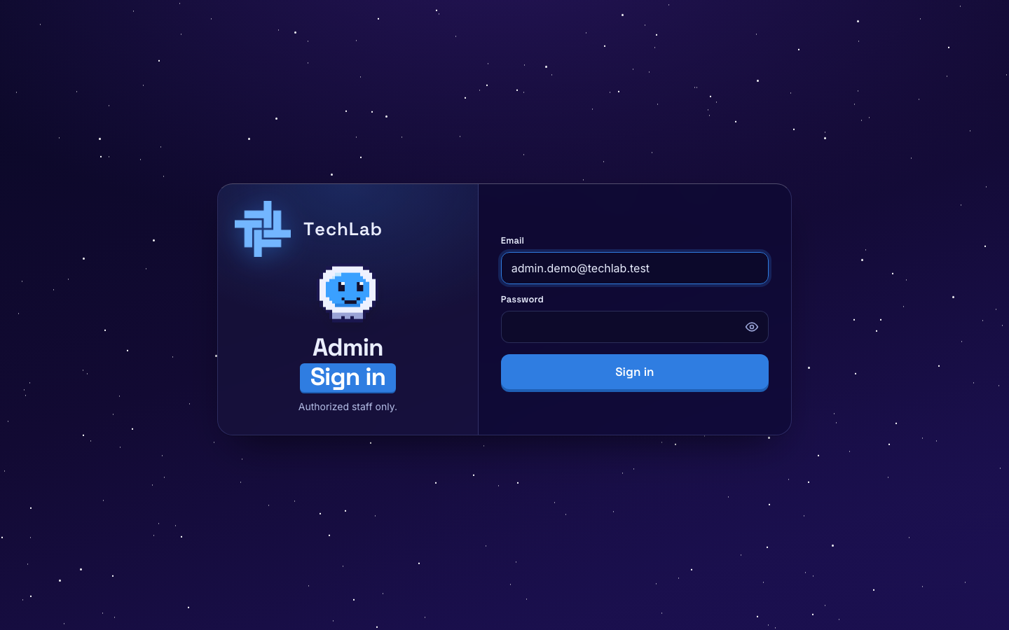
The admin sign-in page

ADMIN · PART 2

The Command deck
Your dashboard shows how TechLab is growing over the last 12 weeks.

Step 2. Read the top numbers
The sidebar has Dashboard, Course Assignment, Classes and Self-paced. On the dashboard, the four cards at the top show:
- Students and Faculty: how many accounts there are, and how many joined this week.
- Lessons finished: lessons completed, and how many this week.
- Active this week: students who studied in the last 7 days, as a number and a percentage.
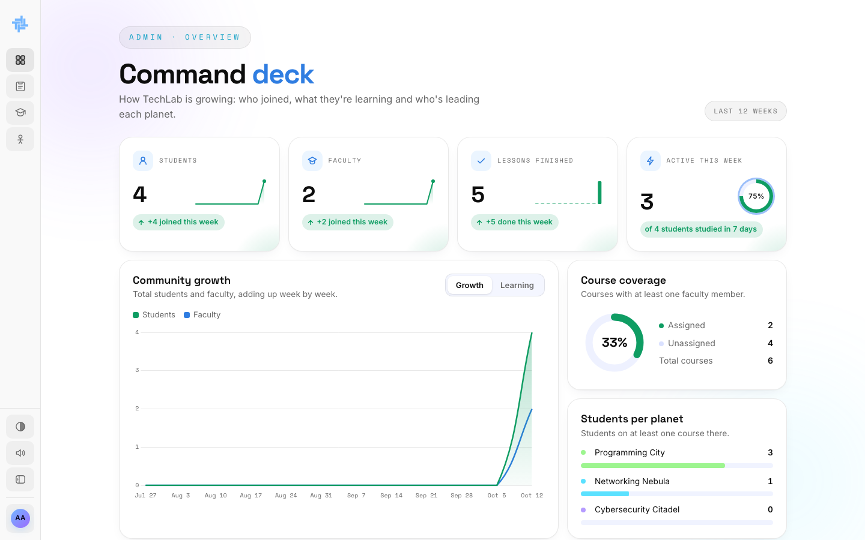
The Command deck

Step 3. Switch the charts
The big chart has two views. Click Growth to see students and faculty adding up week by week. Click Learning to see lessons finished each week on each planet.
On the right, Course coverage shows how many courses have at least one faculty member, and Students per planet shows how many students are on each planet.
TIP: If Course coverage shows unassigned courses, students can only take those Self-paced. Assign faculty in Part 3.
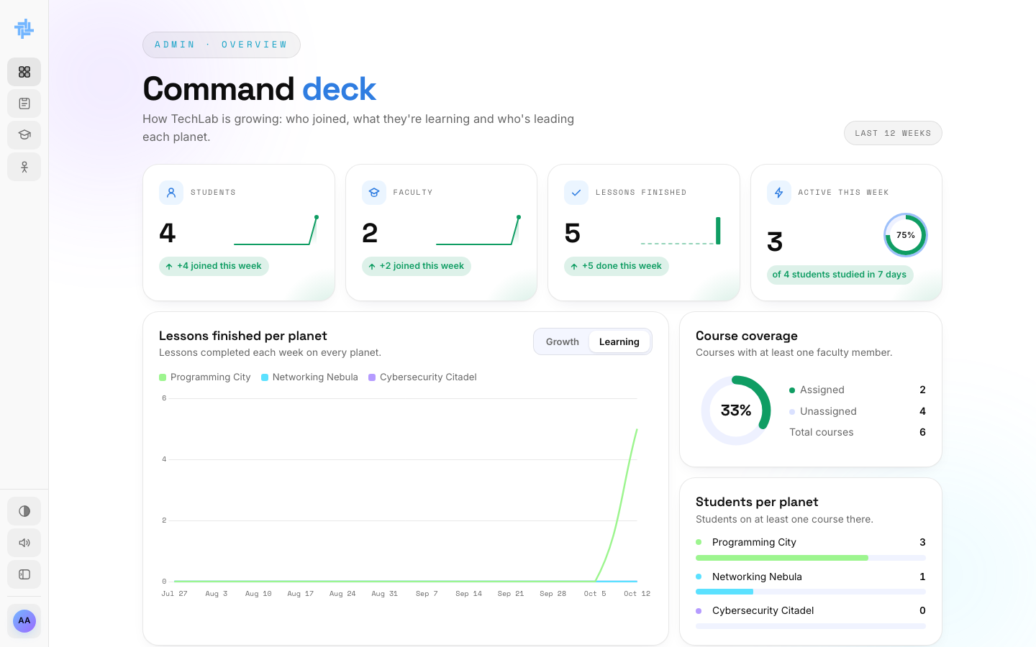
The Learning view

ADMIN · PART 3

Assign faculty to courses
Every course has a Self-paced version that you look after. Each faculty member you assign gets their own class for that course.

Step 4. Open Course Assignment
Click Course Assignment in the sidebar. Every course is listed by planet, with:
- Self-paced: how many students take it on their own. Click the number to see who.
- Classes: each faculty member teaching it and how many students they have. Click a name to see that class.
- Assign faculty: a list of faculty you can add.
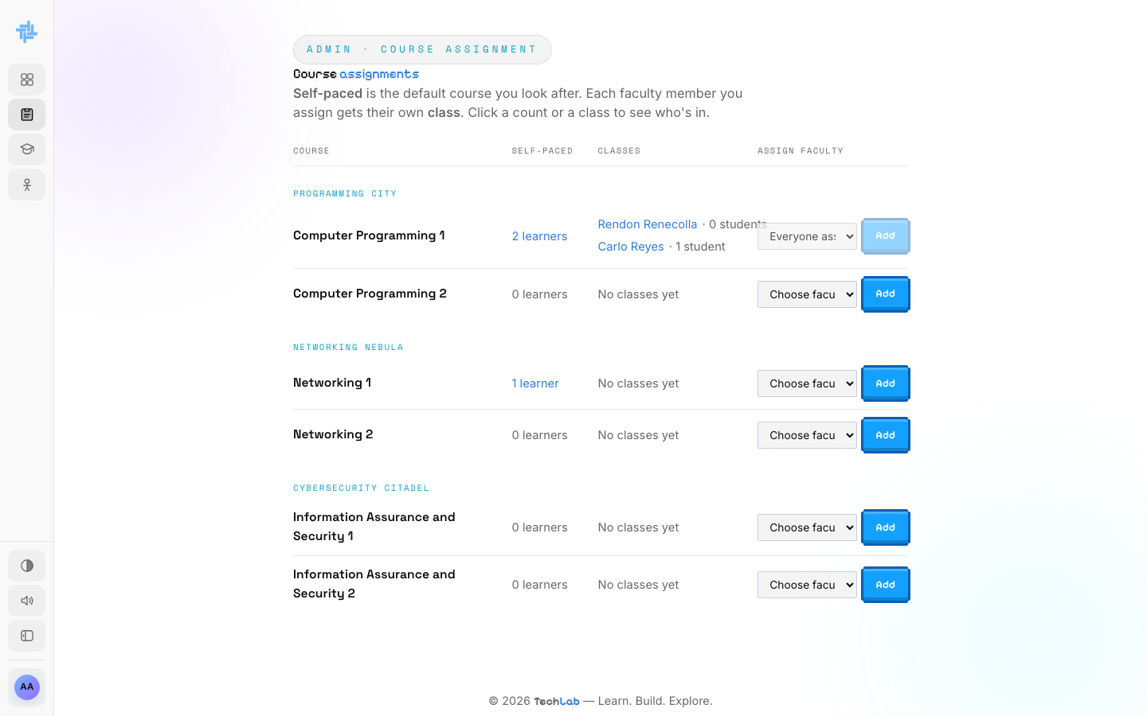
Course Assignment

Step 5. Assign a faculty member
- Find the course. Open its Choose faculty list and pick a name.
- Click Add.
You see Faculty member added. Their name shows under Classes with Not opened until they open the class from their dashboard. The course also appears on their Courses page.
A course can have several faculty. Everyone assigned means all faculty already teach it.
GOOD TO KNOW: Faculty must sign up first (on the faculty page) before you can pick them here.
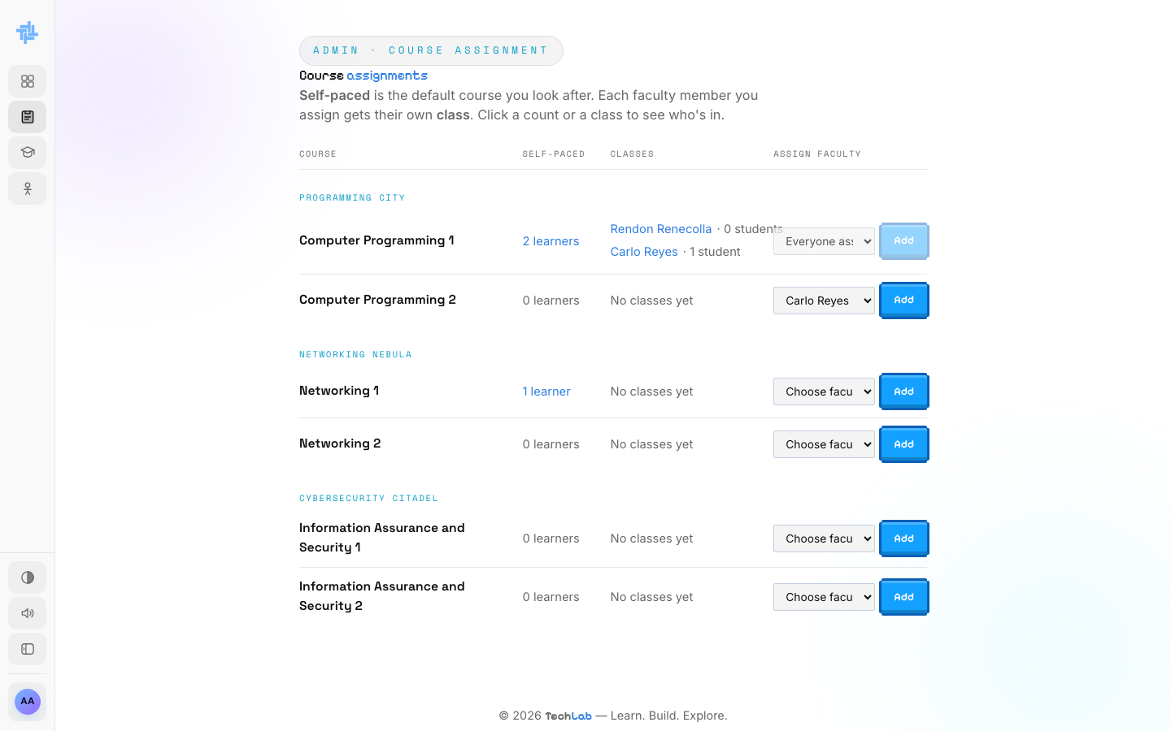
Picking a faculty member
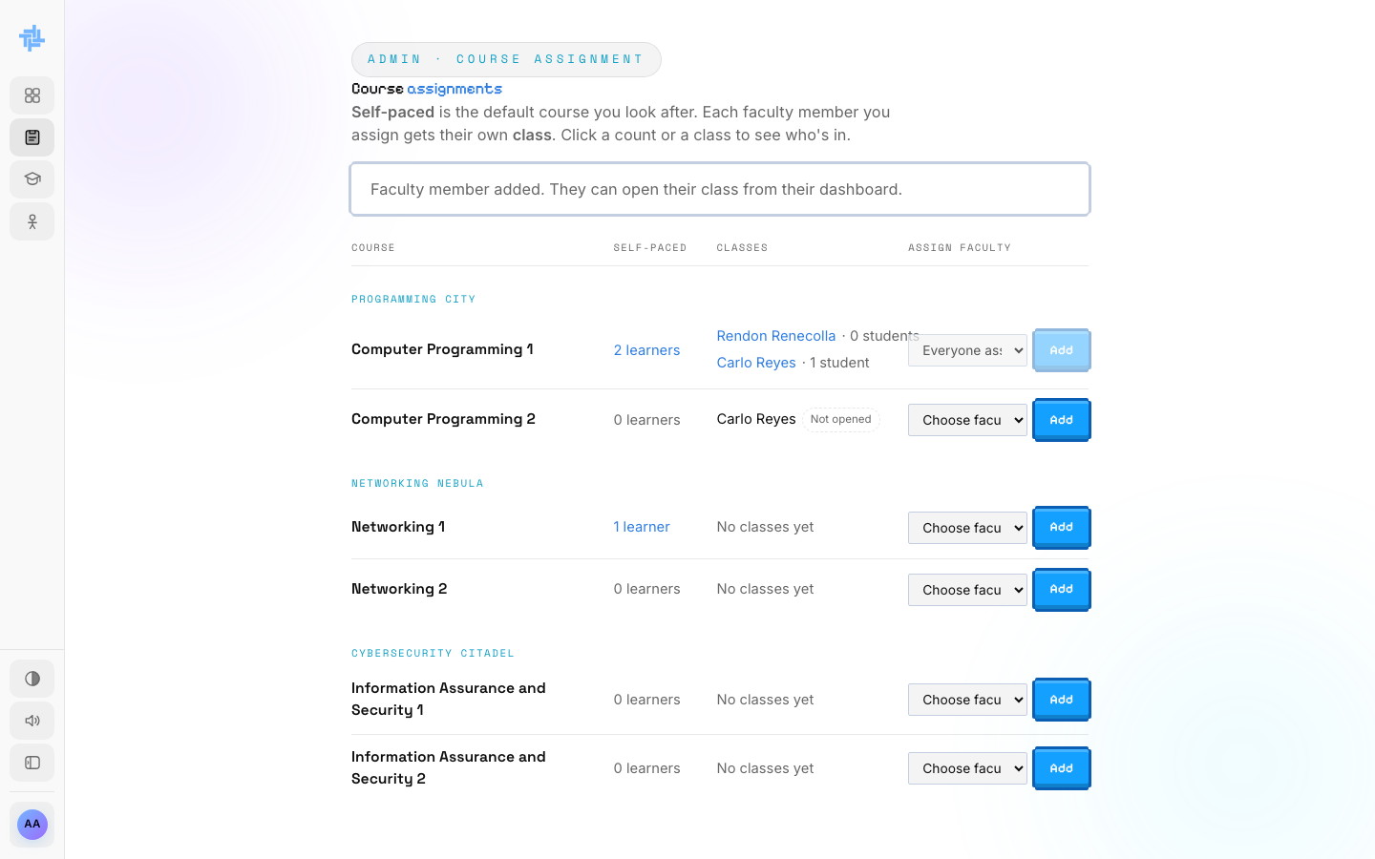
Faculty member added

Step 6. Take a faculty member off a course
Point at the faculty member's name under Classes. A small red × appears next to it. Click it, then confirm Take them off this course?
You see Faculty member removed from the course.
CAN'T REMOVE? If their class still has students, TechLab keeps them on the course so the students aren't left without a teacher.
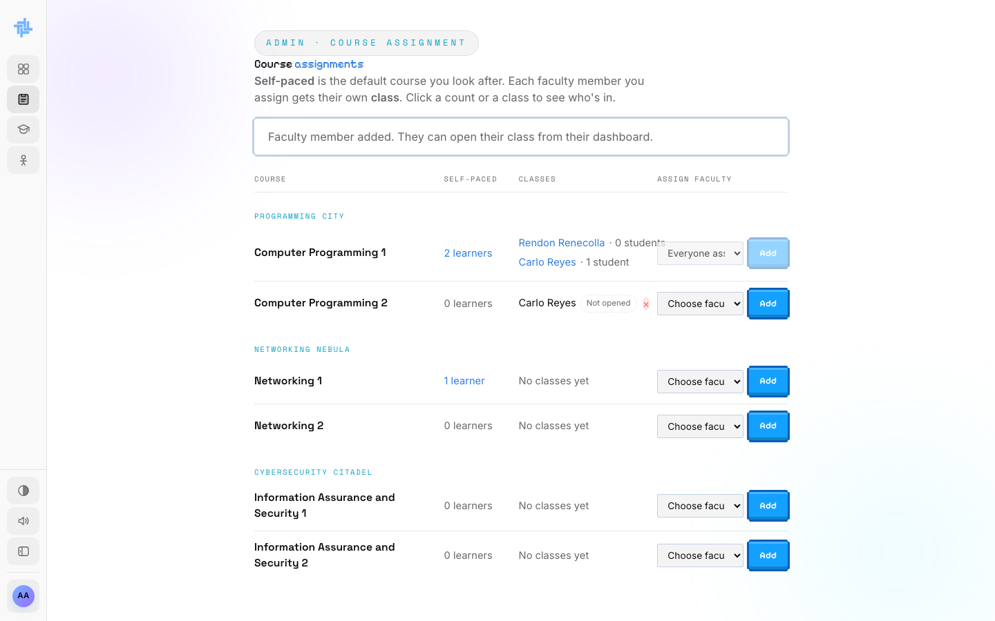
The × next to a faculty member's name

Step 7. See who learns a course Self-paced
Click the learners number in the Self-paced column. A list opens with every student taking that course on their own. Click Close when done.
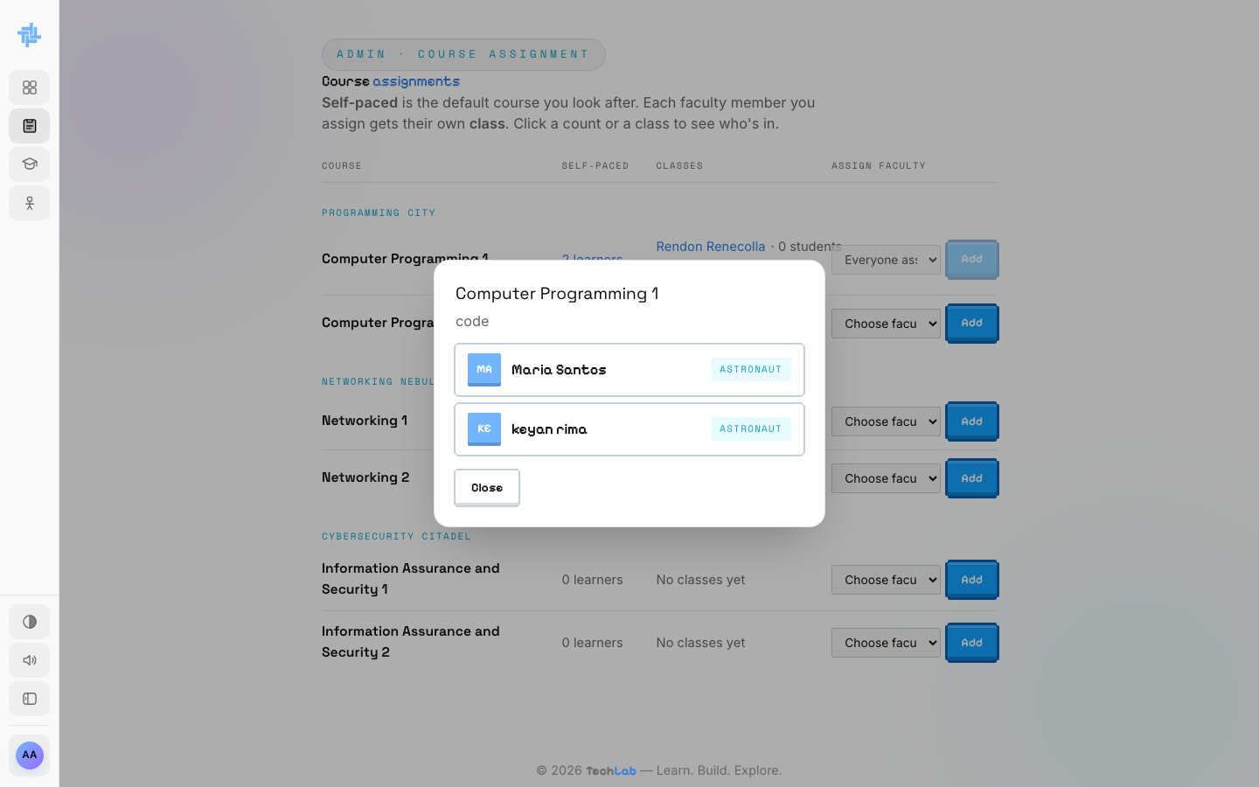
Self-paced learners for a course

ADMIN · PART 4

Look at classes
See every faculty member's class, its class code and its students.

Step 8. Open Classes
Click Classes in the sidebar. There is one card per course. Each card lists every faculty member teaching it, with their number of students (astronauts) and their class code. The code is only the class's ID: students never type it, they pick their instructor under Join Class.
Self-paced students are not shown here. They are on the Self-paced page (Part 5).
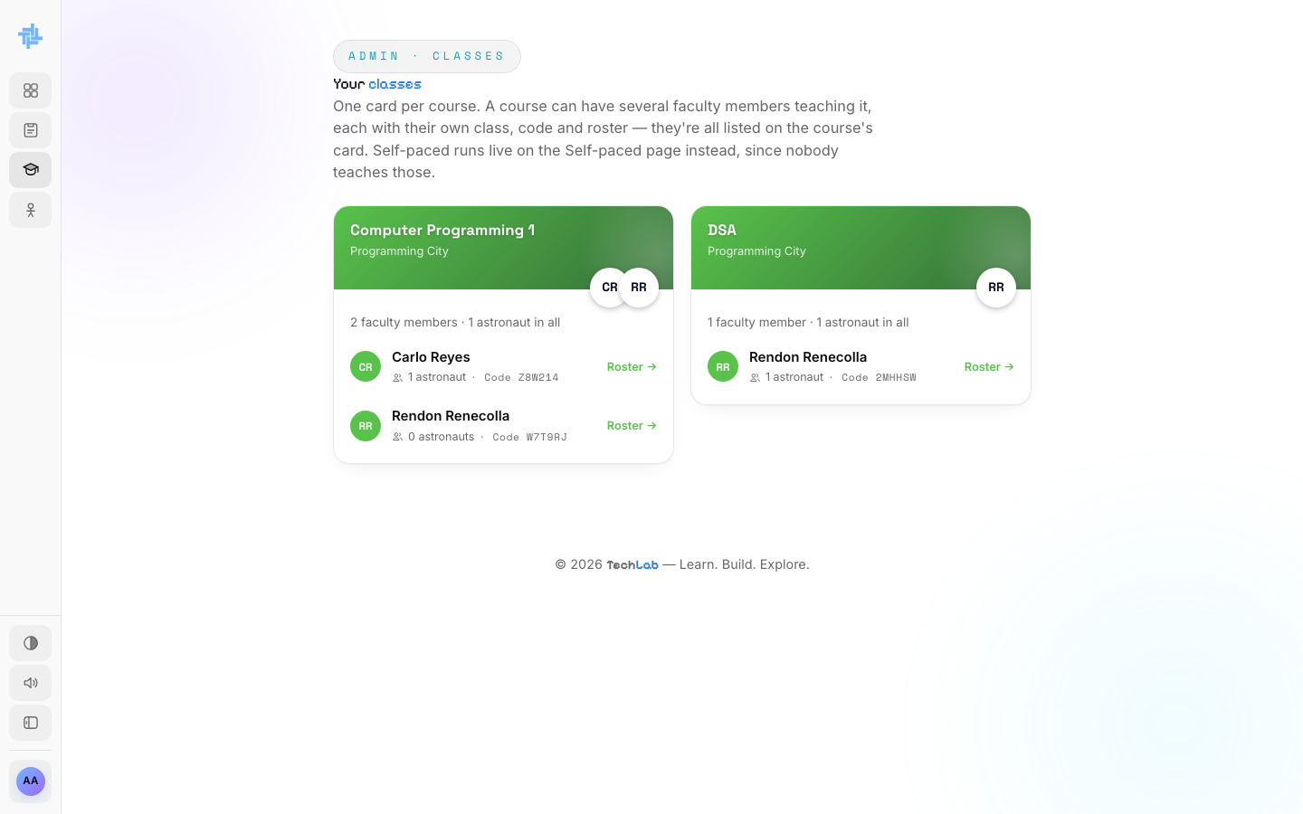
All classes

Step 9. See a class roster
Click Roster → next to a faculty member. A list opens with the Captain (the faculty member) and every student in the class. Click Close when done.
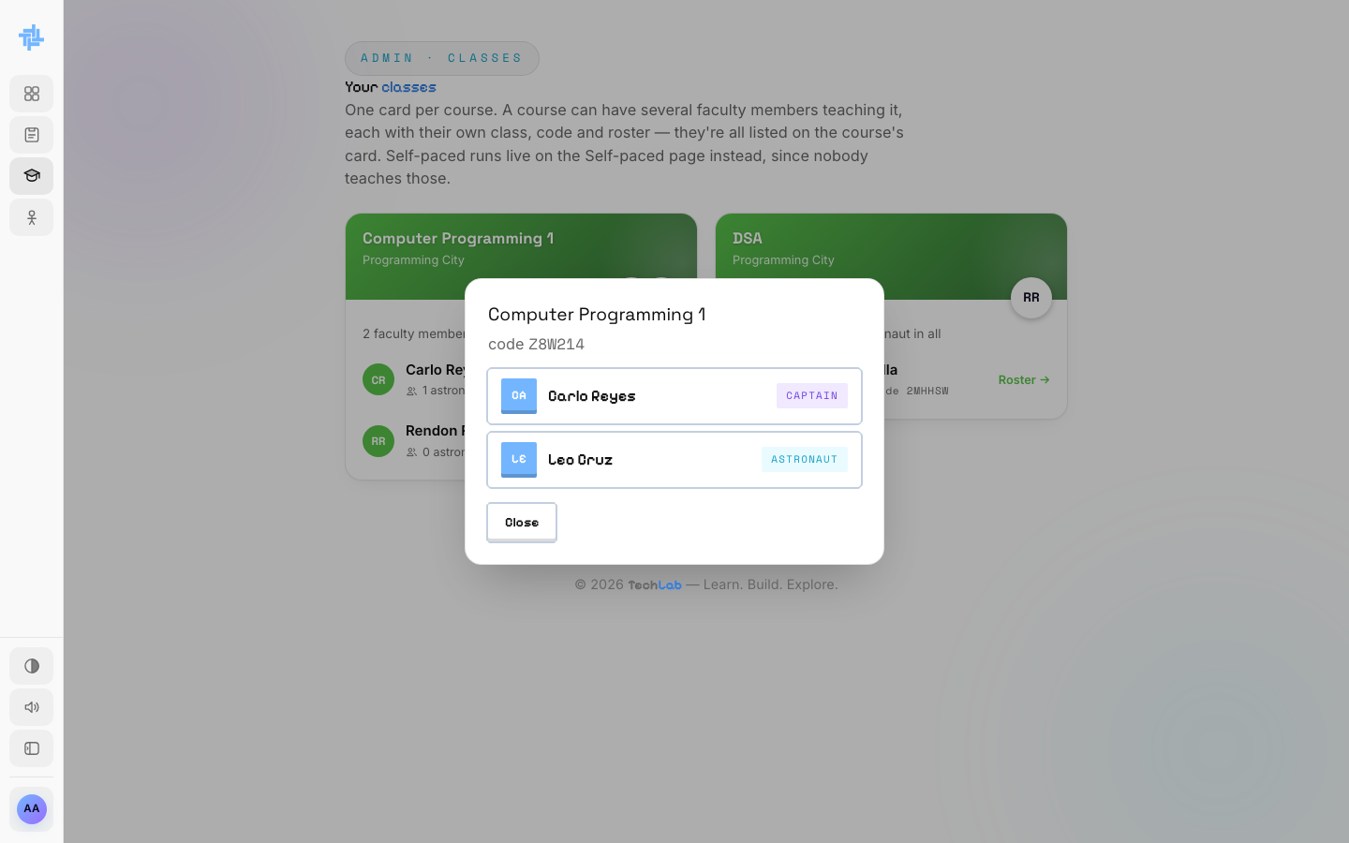
A class roster

ADMIN · PART 5

Look after Self-paced learners
Self-paced students use the standard TechLab course, the default final exam and get a TechLab certificate. Faculty edits never reach them.

Step 10. Open Self-paced
Click Self-paced in the sidebar. Each course card shows how many learners it has and where each one is:
Status | What it means
Studying | Still working through the lessons
Ready for final | Finished every lesson, can take the final exam
Passed | Passed the final and earned the certificate (with their score)
Failed final | Failed the final and has to redo the course
Banned | Caught leaving the final exam twice

Final auto-builds on first finish means you don't have to write the final exam. TechLab builds the default one the first time a learner finishes the course.
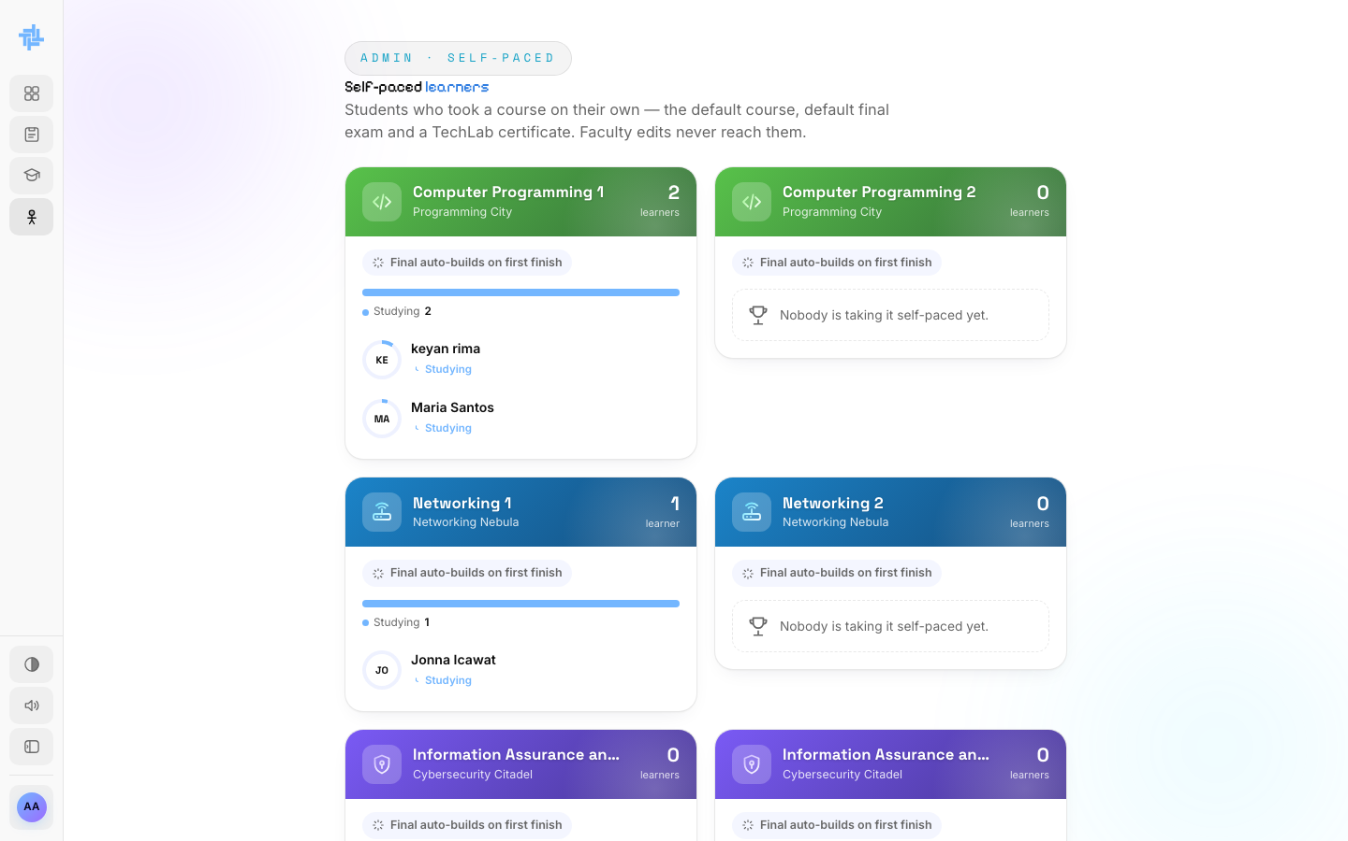
Self-paced learners by course

Step 11. Allow a retake or lift a ban
Next to a learner who failed the final, click Allow retake to let them try again. Next to a banned learner, click Lift ban to let them back into the final.
WHY BANS HAPPEN: Leaving full screen, switching tabs or trying to screenshot during the final counts as a strike. Two strikes ban the student from the final until you lift it.

ADMIN · PART 6

Your account and other admins
Change your details and password, and manage who else is an admin.

Step 12. Open the account menu
Click your avatar at the bottom of the sidebar. Choose Change avatar, Settings or Log out.
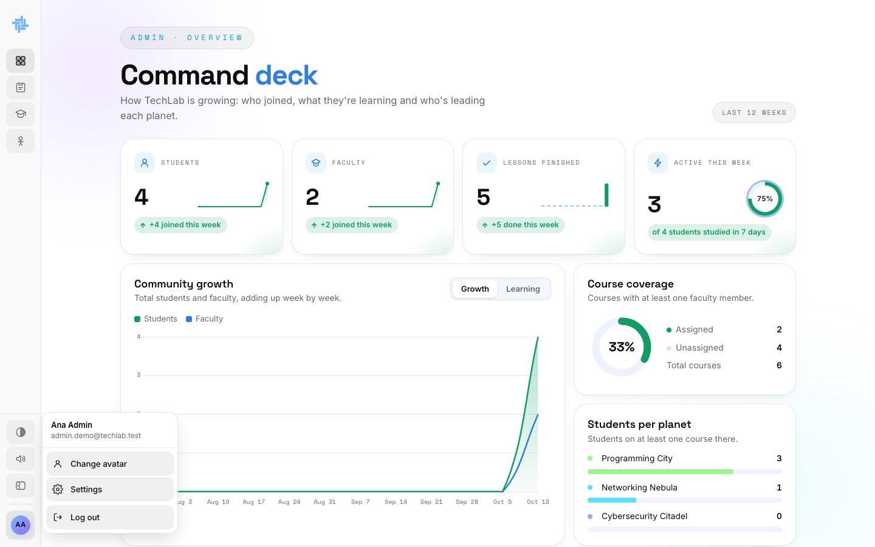
The admin account menu

Step 13. Update your profile and password
- Profile: change your first and last name, then click Save profile. Your email can't be changed.
- Your captain: click Make my captain to pick an avatar.
- Preferences: sound and light mode, saved on this browser only.
- Password: type your current password and the new one twice (at least 12 characters), then click Change password.
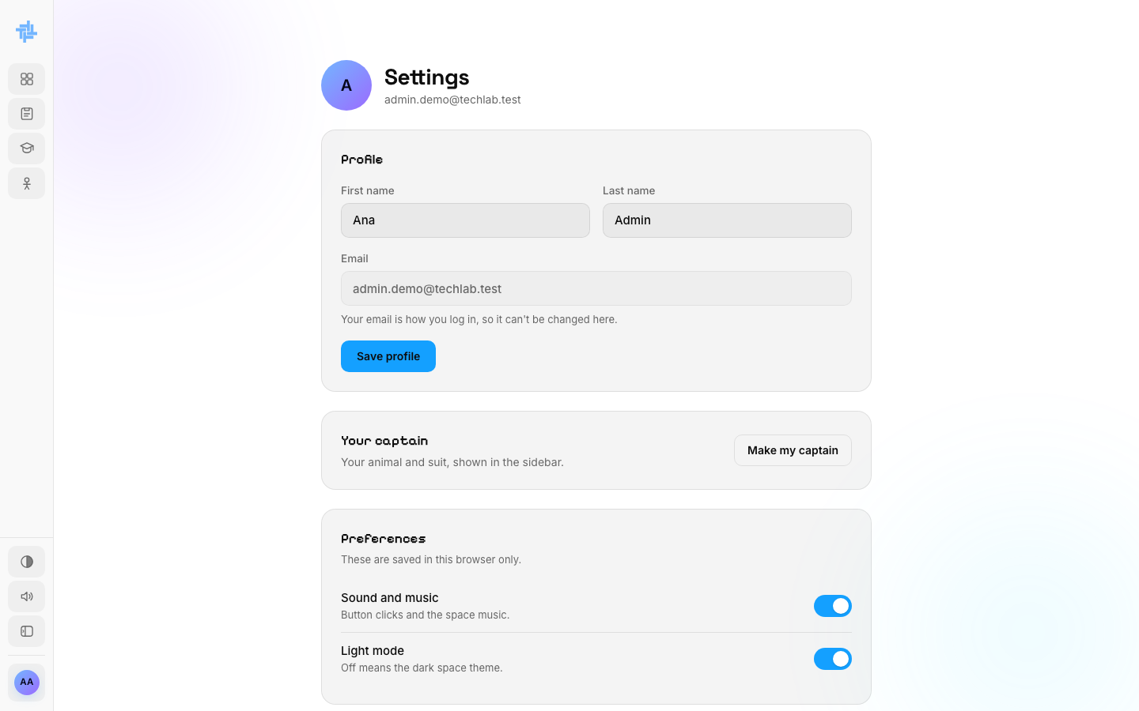
Admin settings

Step 14. Add or remove admins
Scroll to Admins at the bottom of Settings. Every admin is listed. Only the first admin can add or remove admins.
If you are the first admin, you also see Add an admin:
- Type their first name, last name and email.
- Pick a password (at least 12 characters) and type it again.
- Click Add admin. Give them the email and password. They sign in at /admin/login and can change the password in their own Settings.
To remove an admin, click Remove next to their name and confirm. They can't sign in any more.
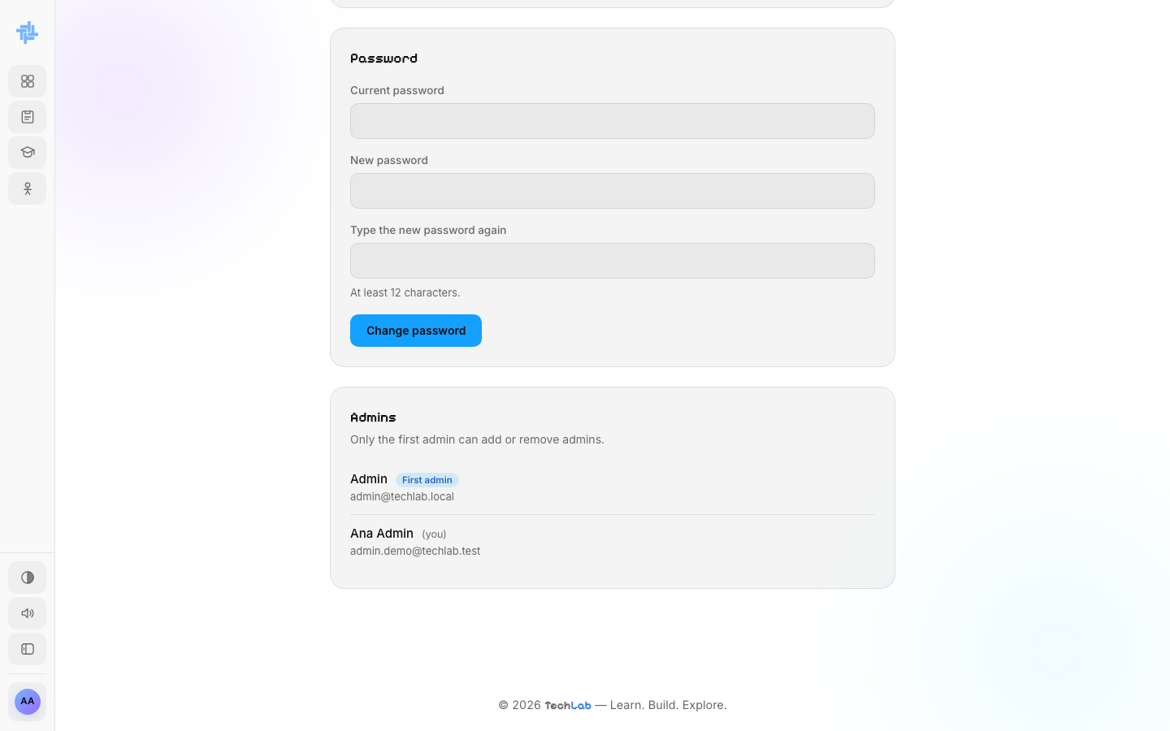
The Admins list

