TechLab

TechLab Faculty Manual
A step-by-step guide for faculty (called Captains in TechLab). It covers setting up your account, running your class, and changing lessons, quizzes and exams for your students. Each step has a real screenshot.

Screenshots use a demo faculty member, Carlo Reyes, teaching Computer Programming 1, with a demo student, Leo Cruz. Captured 18 October 2026.

Contents

If the contents list is empty, right-click it in Word and choose Update Field.

FACULTY · PART 1

Create your faculty account
Faculty sign up on their own page, with their school email.

Step 1. Open the faculty page
Go to the TechLab faculty page (/faculty). You can also click Faculty? Sign in here at the bottom of the main TechLab page.
Click Create faculty account. Already have one? Click Faculty sign in and skip to Step 6.
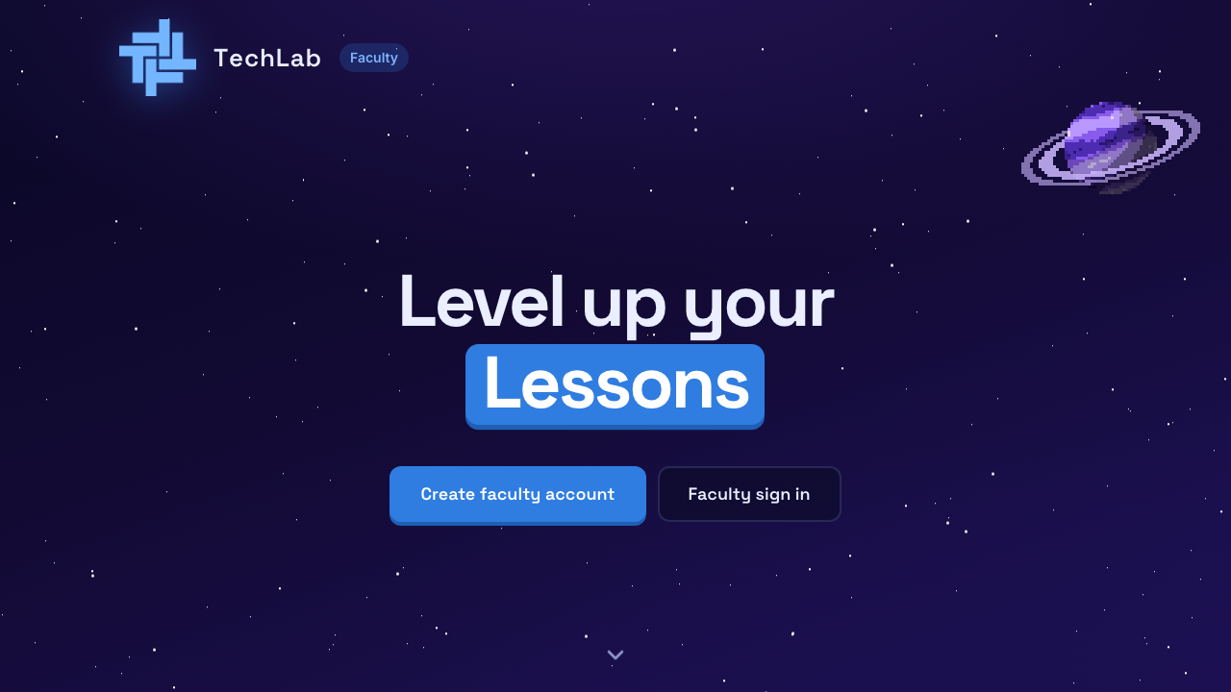
The faculty welcome page

Step 2. Fill in the sign-up form
- Type your first name and last name.
- Type your school email. It must end in @catsu.edu.ph. Other emails are not accepted.
- Pick a password with at least 8 characters, then type it again.
Click Create account.
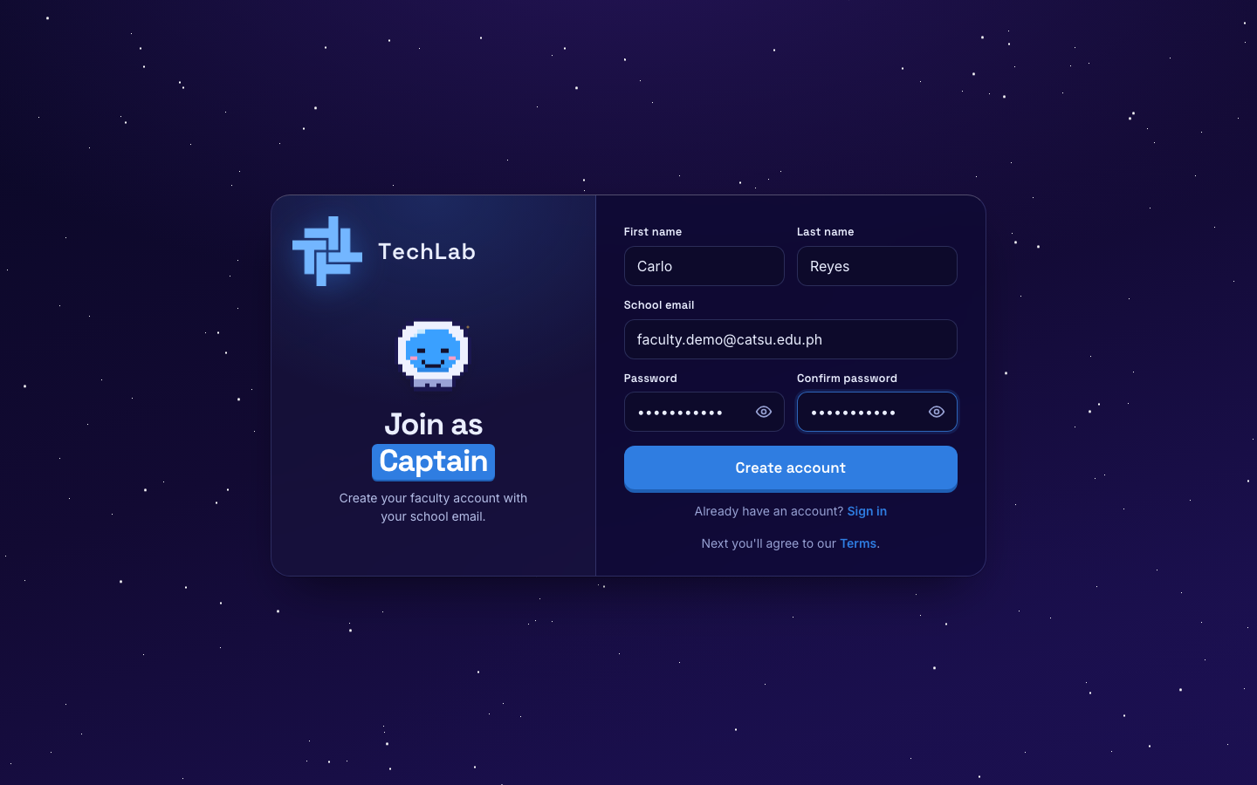
The faculty sign-up form

Step 3. Agree to the rules
Read the TechLab rules. Faculty get one extra rule, Captain rules: keep student info private, use it only for teaching, and only upload files you are allowed to share.
Tick I have read and agree, then click Agree and continue.
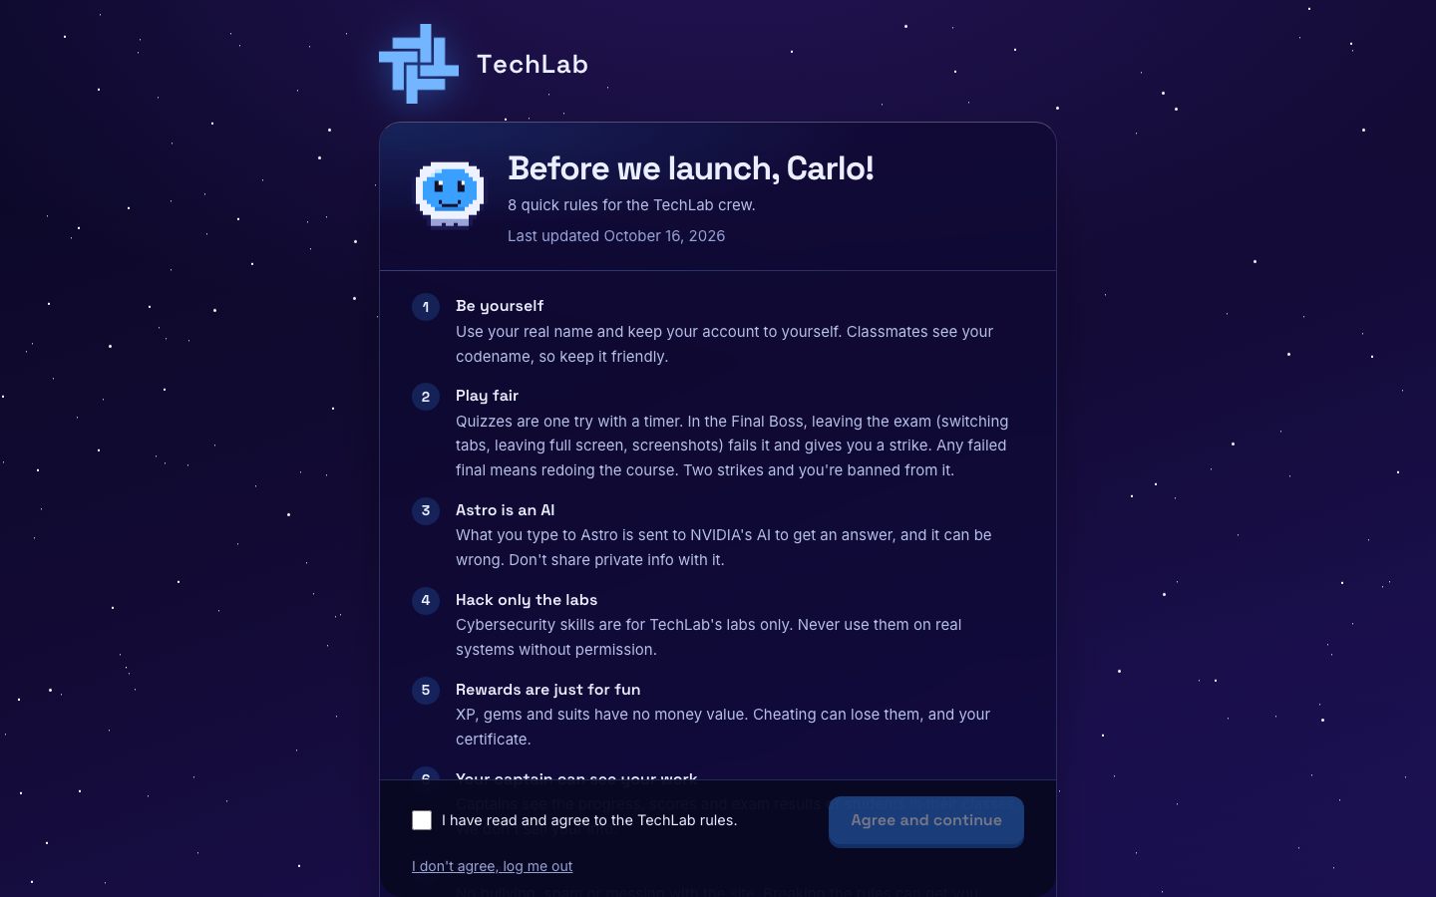
The rules, including Captain rules

Step 4. Meet Astro and build your captain
Astro welcomes you. Click Continue through the messages, then Suit me up.
Pick your animal, suit and helmet, then click Looks good!. Students see this avatar next to your name.
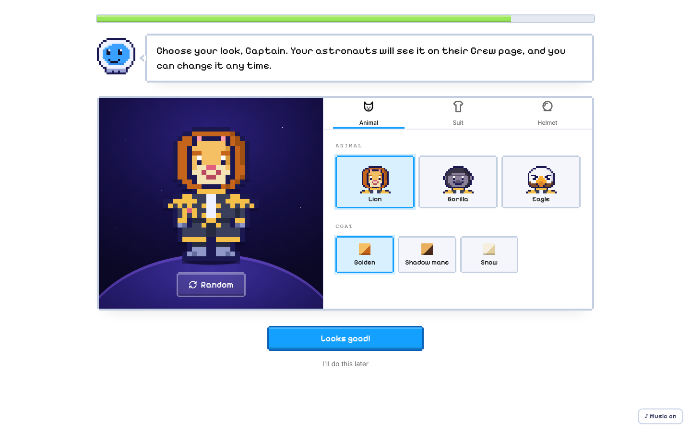
Building your captain avatar

Step 5. Take command
Check your captain and click Take command to open your dashboard. Click Change something to go back.
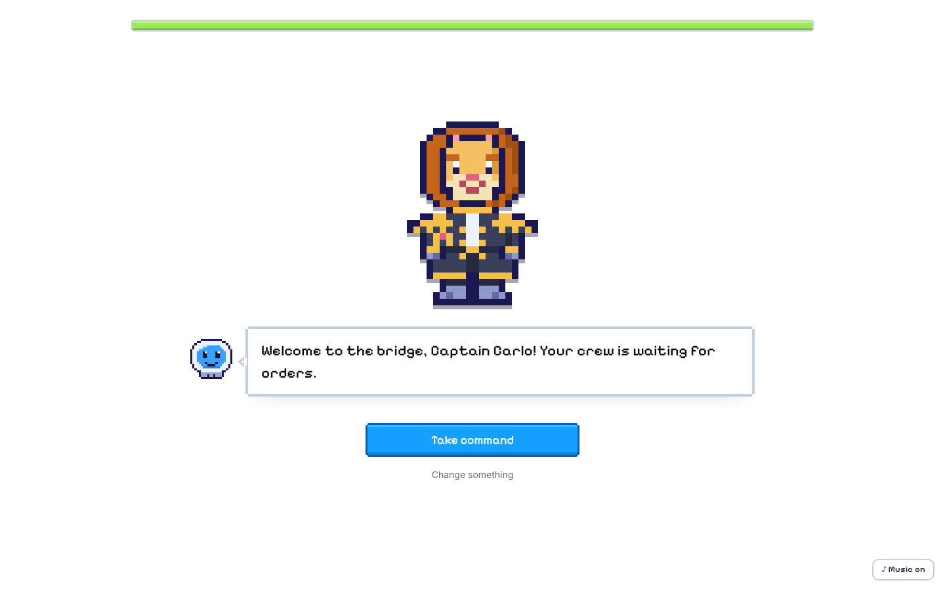
Ready to take command

Step 6. Sign in next time
Go to /faculty/login, type your school email and password, and click Sign in. A student account can't sign in here.
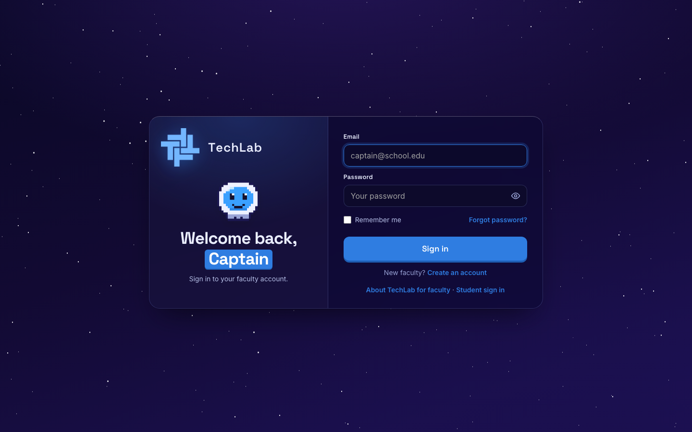
The faculty sign-in page

FACULTY · PART 2

Your dashboard
Your dashboard shows how your students are doing, your courses, and who is waiting to join.

Step 7. Follow Astro's tour
The first time you arrive, Astro gives an 11-stop tour of the faculty pages. Click Next or press the right arrow key. Click Skip tour to close it, or the ? button in the sidebar to see it again.
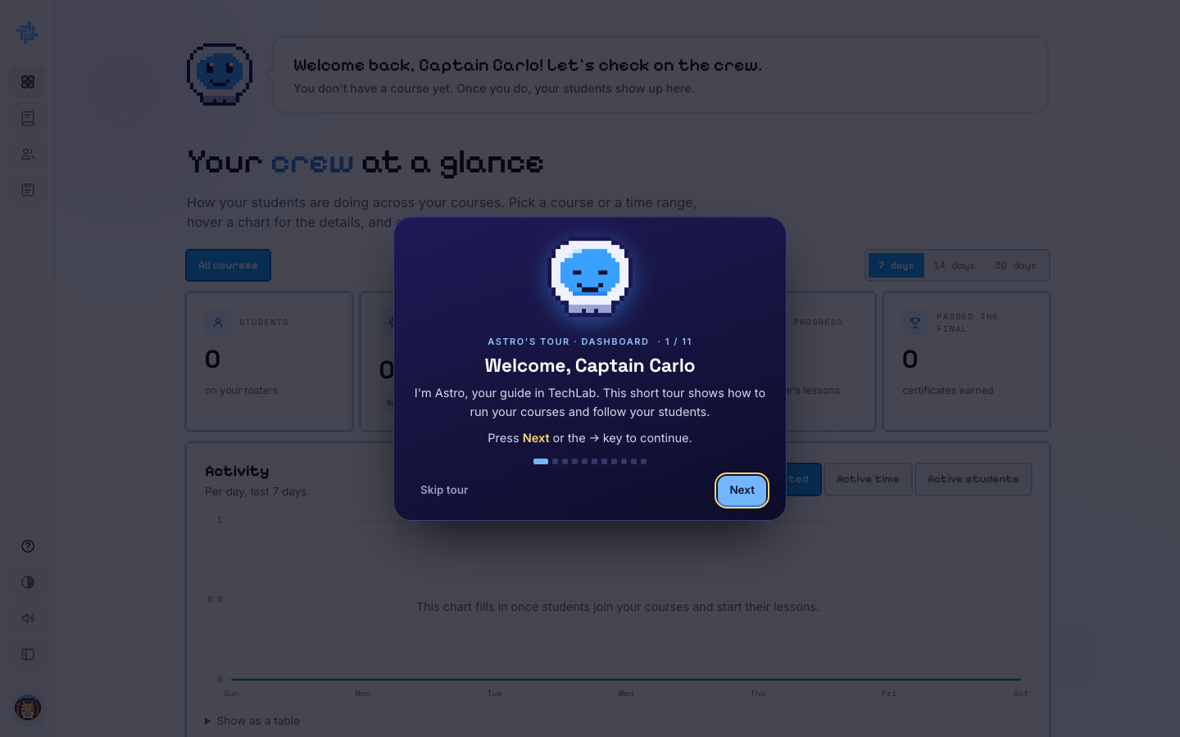
Astro's faculty tour

Step 8. Wait for your admin to give you a course
A new faculty account has no course yet. The dashboard says You don't have a course yet.
Your admin assigns you the courses you teach. Ask them to add you. Once they do, the course appears on your dashboard and on the Courses page.
TIP: Want to make a brand-new course of your own instead? See Step 27.
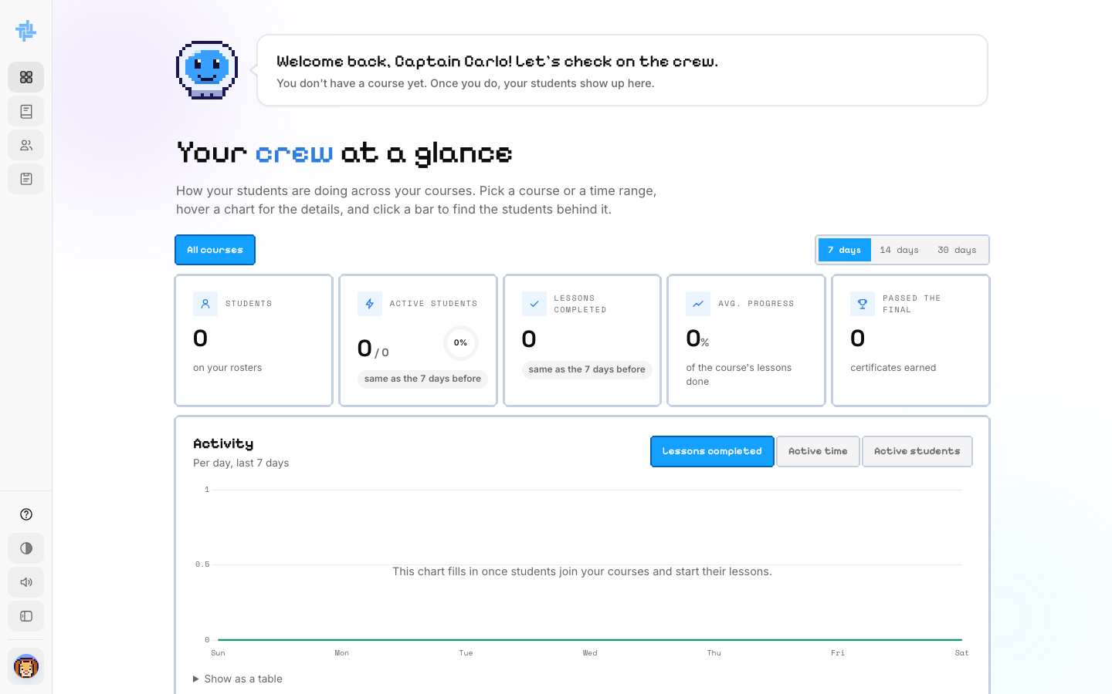
The dashboard before a course is assigned

Step 9. Read your dashboard
The sidebar has Dashboard, Courses, Crew and Materials. On the dashboard:
- Your crew at a glance: students, active students, lessons completed, average progress and certificates earned. Pick a course or 7, 14 or 30 days.
- Activity chart: lessons completed, active time or active students per day.
- Students table: each student's progress, lessons, active time and last visit. Needs a nudge shows students who haven't been active.
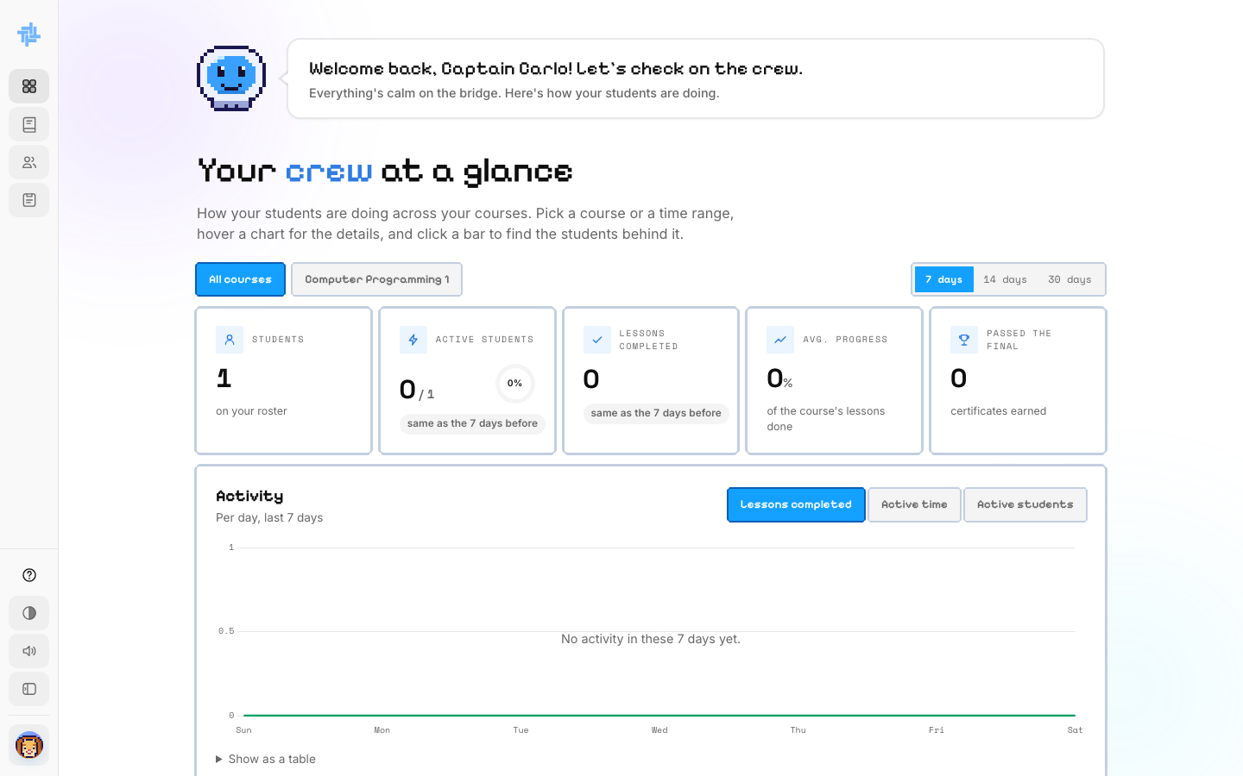
Dashboard numbers after a student joins

FACULTY · PART 3

Run your class
Every course you teach gets its own class, with a class code as its ID. Only students you accept can get in.
 | Your class | Self-paced
Who is in it | Students you accept | Students learning on their own
Lessons | Your edited version | The standard TechLab version
Mini bosses | One try, you see scores | Must pass to move on
Certificate | Signed by you | TechLab certificate

Step 10. Find your course
Click Courses in the sidebar. Each course card shows its modules, lessons and level.
- Manage opens the course lessons so you can edit them (Part 7).
- Edit card changes the picture, title and subtitle students see (Step 26).
- + Build a course makes a new course from scratch (Step 27).
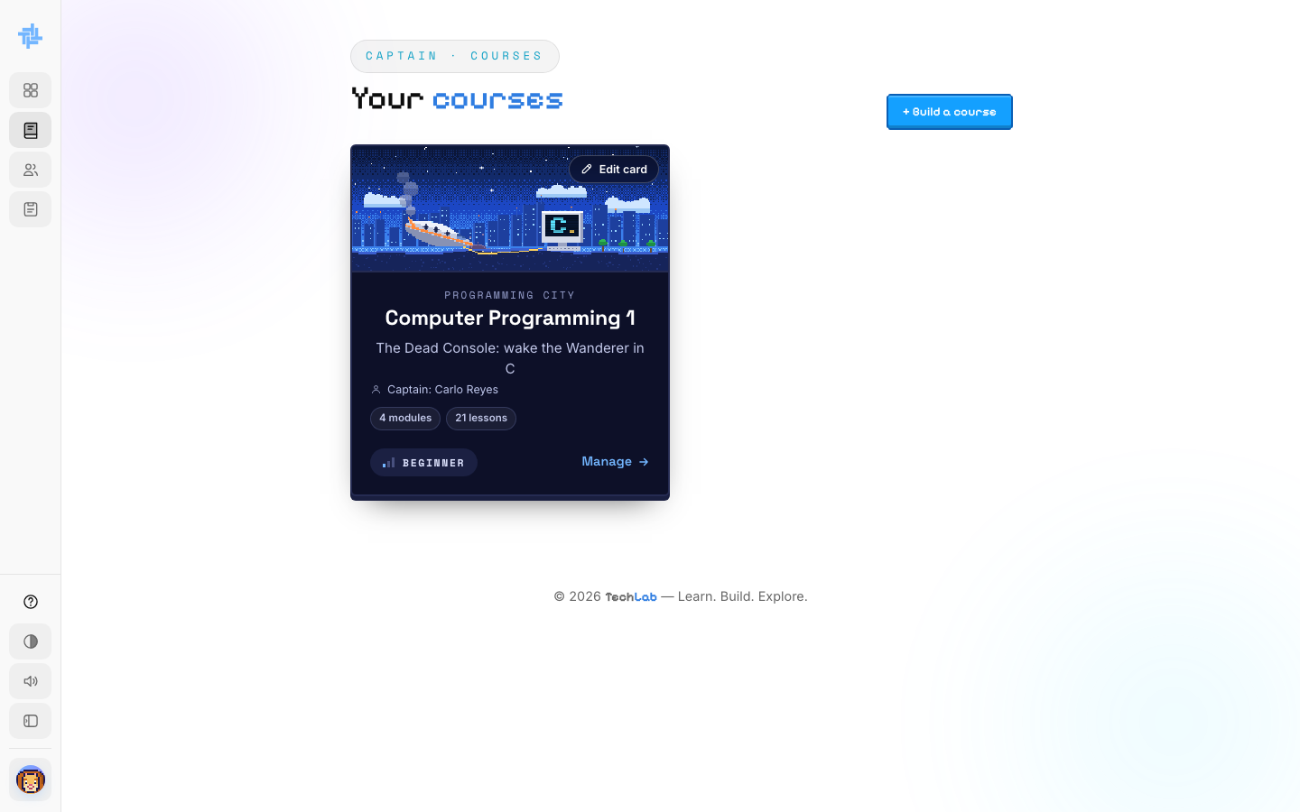
Your courses

Step 11. Accept students into your class
Scroll down your dashboard to Your courses. Each course shows its class code (for example Z8W214) and how many students joined or are waiting. The code is just your class's ID: students never type it.
Students pick you under Join Class and click Ask to join. They appear under Waiting to join.
- Click Accept to let them in. They are enrolled right away.
- Click Decline to say no. TechLab emails the student to tell them.
GOOD TO KNOW: A student who already chose Self-paced or another class for this course can't ask to join yours.
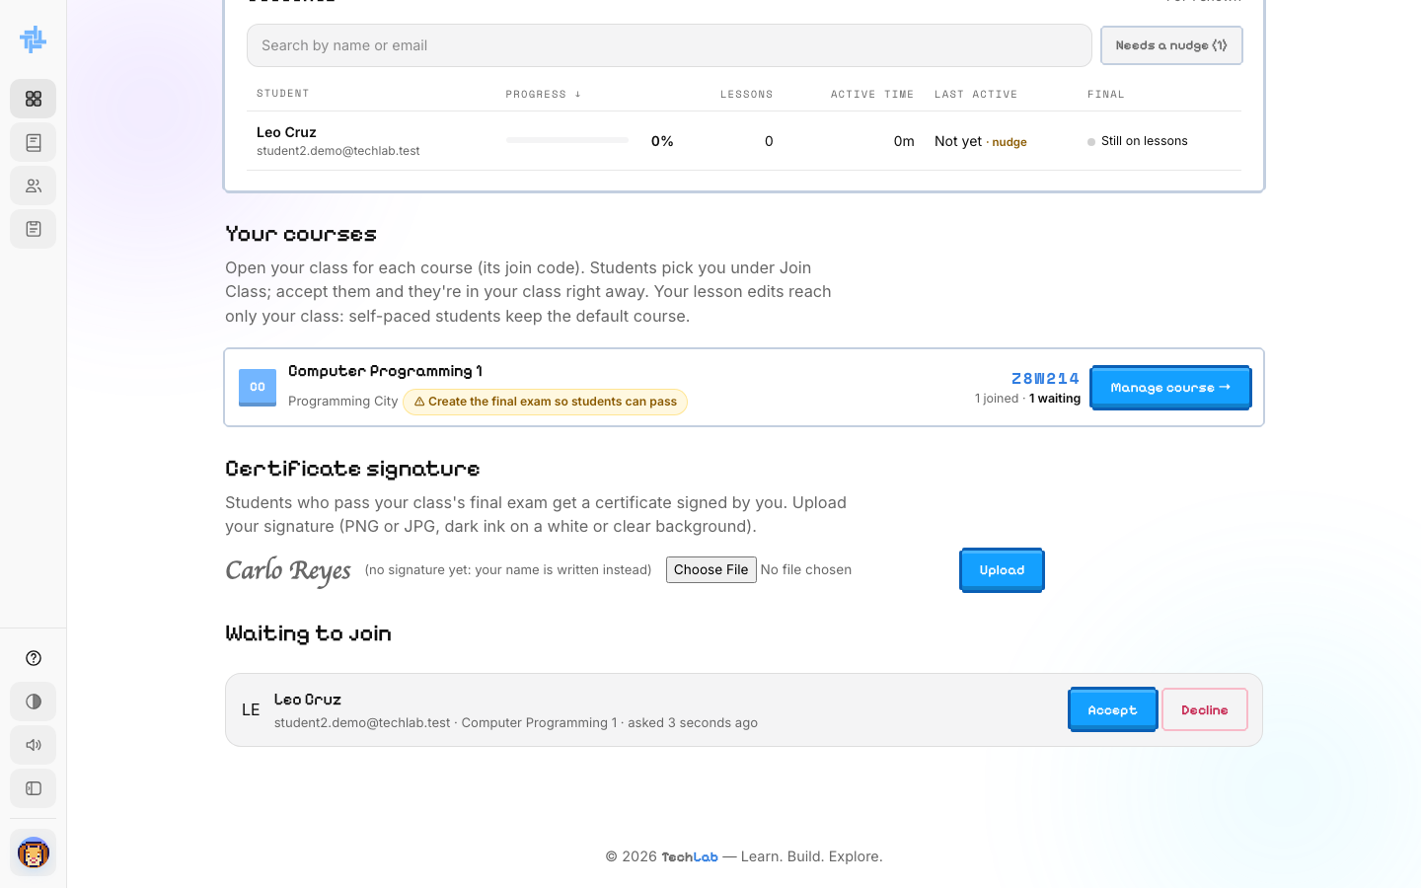
Your courses, certificate signature and the waiting list

Step 12. See your crew
Click Crew in the sidebar (or Manage course on the dashboard). You see your class code and every student with their course progress, XP, gems and day streak.
The tabs at the top open the class's Materials, Lesson quizzes and Exams.
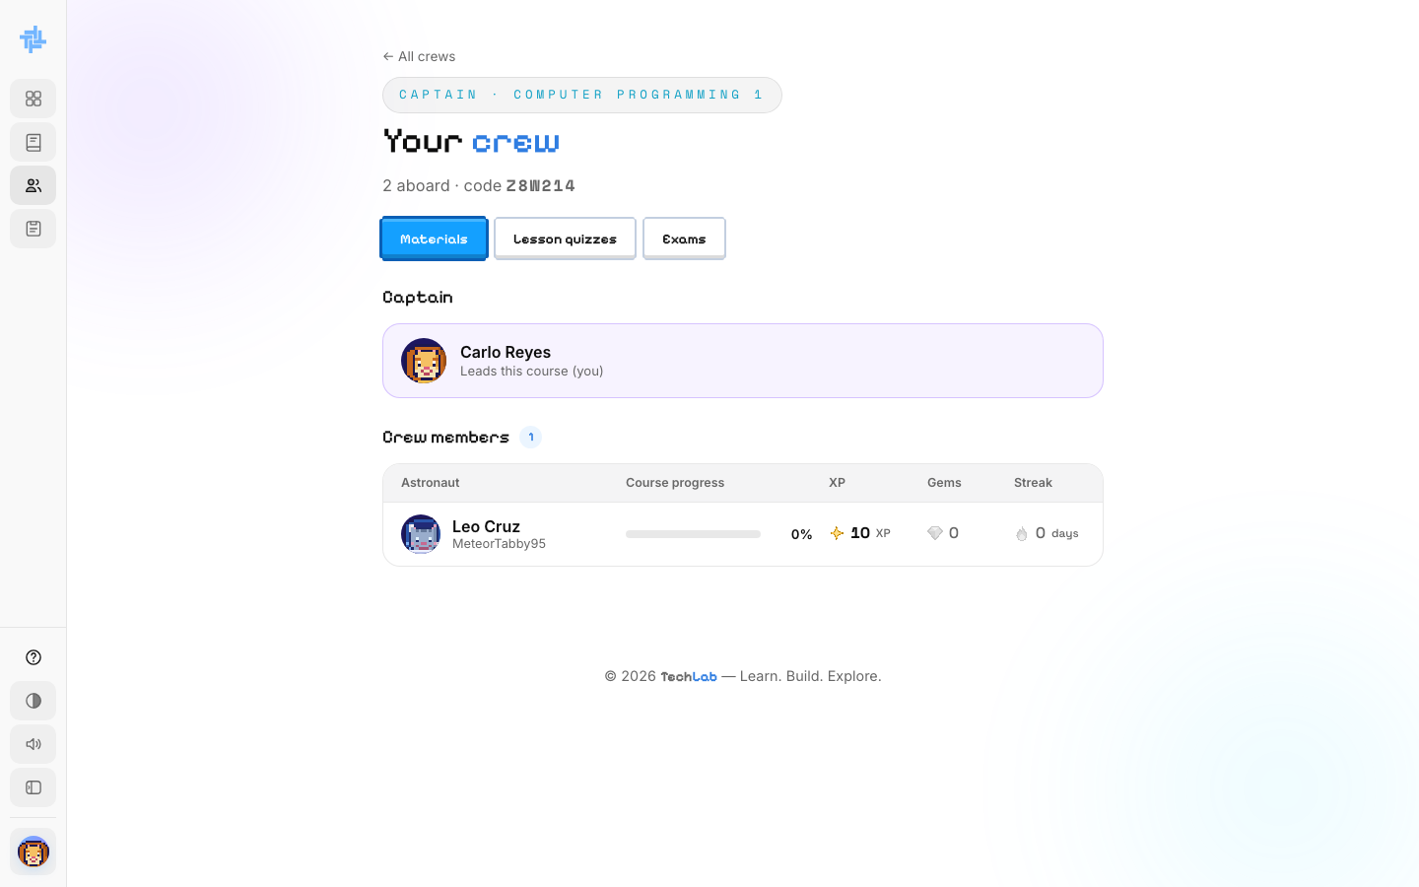
Your crew list

Step 13. Add your certificate signature
Students who pass your class's final exam get a certificate signed by you. On the dashboard, under Certificate signature, click Choose File, pick a picture of your signature (PNG or JPG, dark ink on a white or clear background) and click Upload.
Until you upload one, your name is written on the certificate instead.

FACULTY · PART 4

Share learning materials
Add files and links for your students, grouped into modules. Astro can answer students' questions using your PDF, Word, PowerPoint and text files.

Step 14. Add a module
Open your course's Materials tab. Under Add a module, type a title and an optional short description.
You can drop files in now (PDF, Word, PowerPoint, Excel, images or ZIP) or add them later. Click Add module.
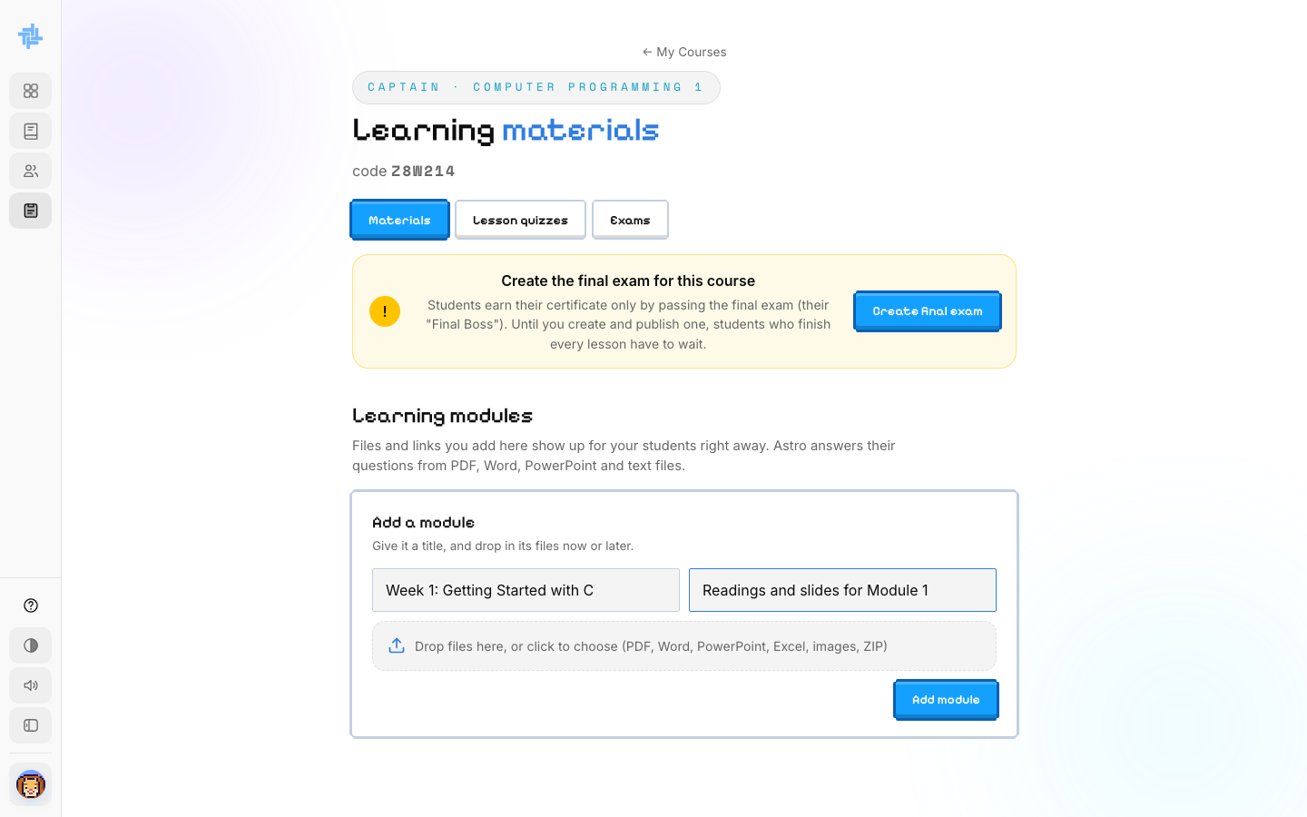
Adding a module

Step 15. Add files and links
Inside a module, click Upload files to add files, or Add link to add a web link (type a link title and the address, then Save link).
Students see new materials right away. Click the ✕ next to an item to remove it, or the bin icon to delete the whole module.
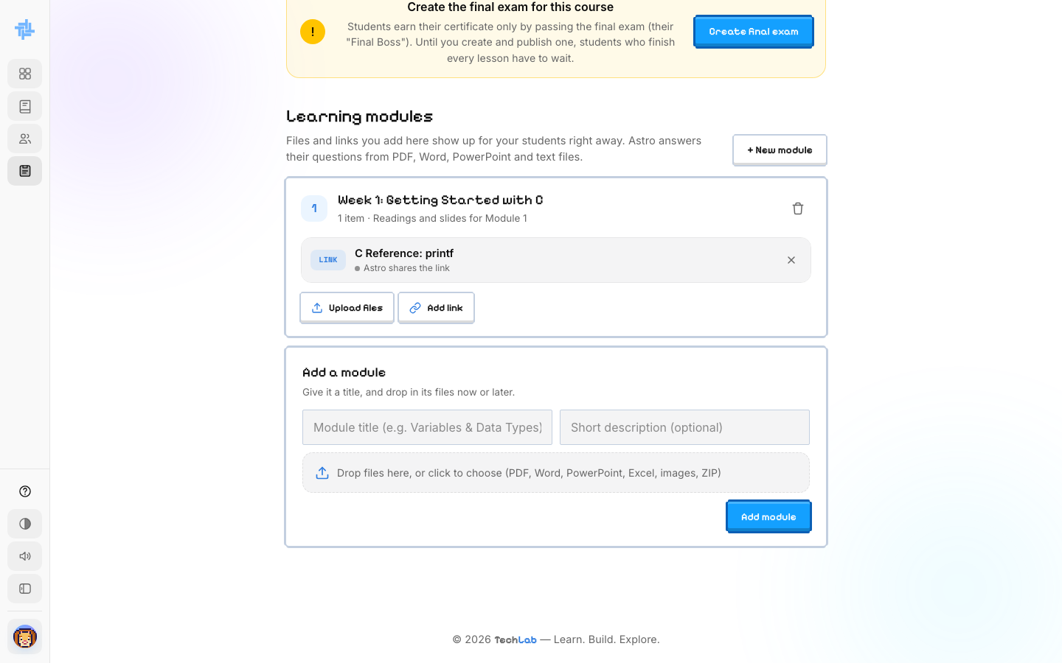
A module with a link

FACULTY · PART 5

Edit lesson quizzes
Every lesson ends with a ready-made Knowledge Check quiz. You can keep it or change it for your class.

Step 16. Pick a lesson quiz
Open the Lesson quizzes tab. Every lesson is listed by module, with its number of questions. Default means it is still the TechLab version.
Click Edit next to a lesson.
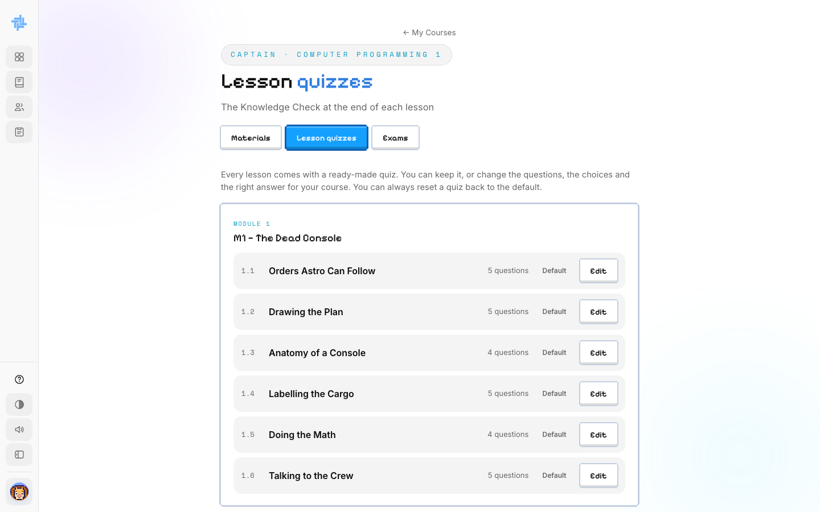
All lesson quizzes

Step 17. Change questions and answers
- Edit the question, the choices and the explanation students see after they answer.
- Click the circle next to the right answer to mark it.
- Use ↑ ↓ to reorder questions, ✕ to delete one, and + Add question to add more.
Click Save quiz when you are done. You can always reset a quiz back to the default.
TIP: Keep all choices about the same length, and don't always put the right answer in the same spot. Students notice patterns.
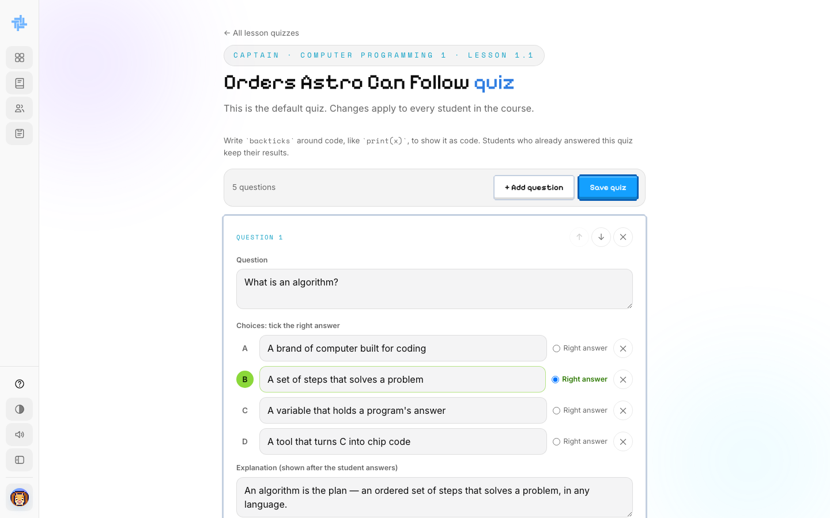
Editing a lesson quiz

FACULTY · PART 6

Mini bosses and the final exam
Mini bosses close each module. The final exam (the Final Boss) gives the certificate.

Step 18. Check your mini bosses
Open the Exams tab. Each module has a ready-made Mini Boss with at least 30 questions.
- Students in your class take it once, in full screen with a timer, after the module's lessons. They earn 10 XP per right answer and move on whether they pass or not.
- Leaving full screen, switching tabs or trying to screenshot ends it as a fail with no XP, and you get an email.
- Click Edit to change its questions, time or pass mark, or Reset to default to undo your changes. Scores appear under each mini boss.
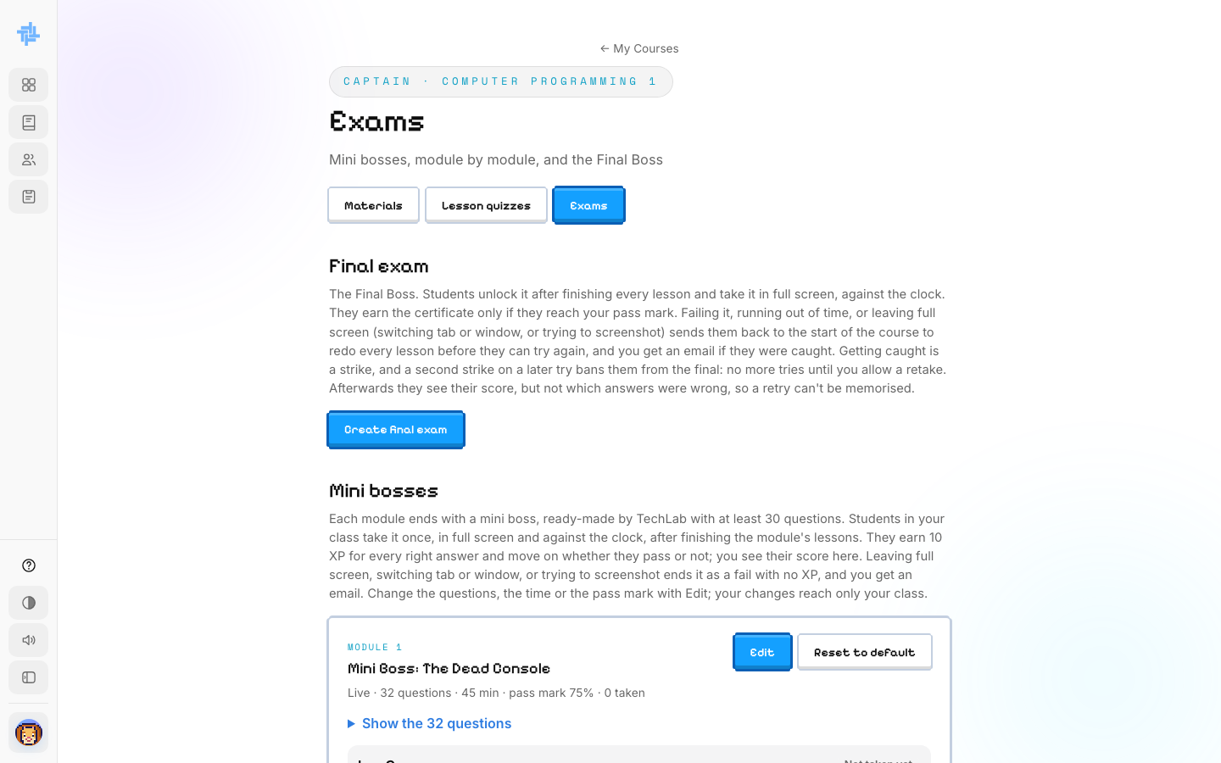
The Exams tab

Step 19. Create the final exam
DO THIS FIRST: Students can only earn the certificate by passing your final exam. Until you create and publish one, students who finish every lesson have to wait.
Click Create final exam. In the Questions tab:
- Type each question, and pick the answer type: multiple choice, checkboxes, drop-down or true/false.
- Type the options and click the circle next to the right answer.
- Click Add question for the next one. Use the icons to move, copy or delete a question.
The panel on the left shows the Course summary and My materials, so you can write questions from them.
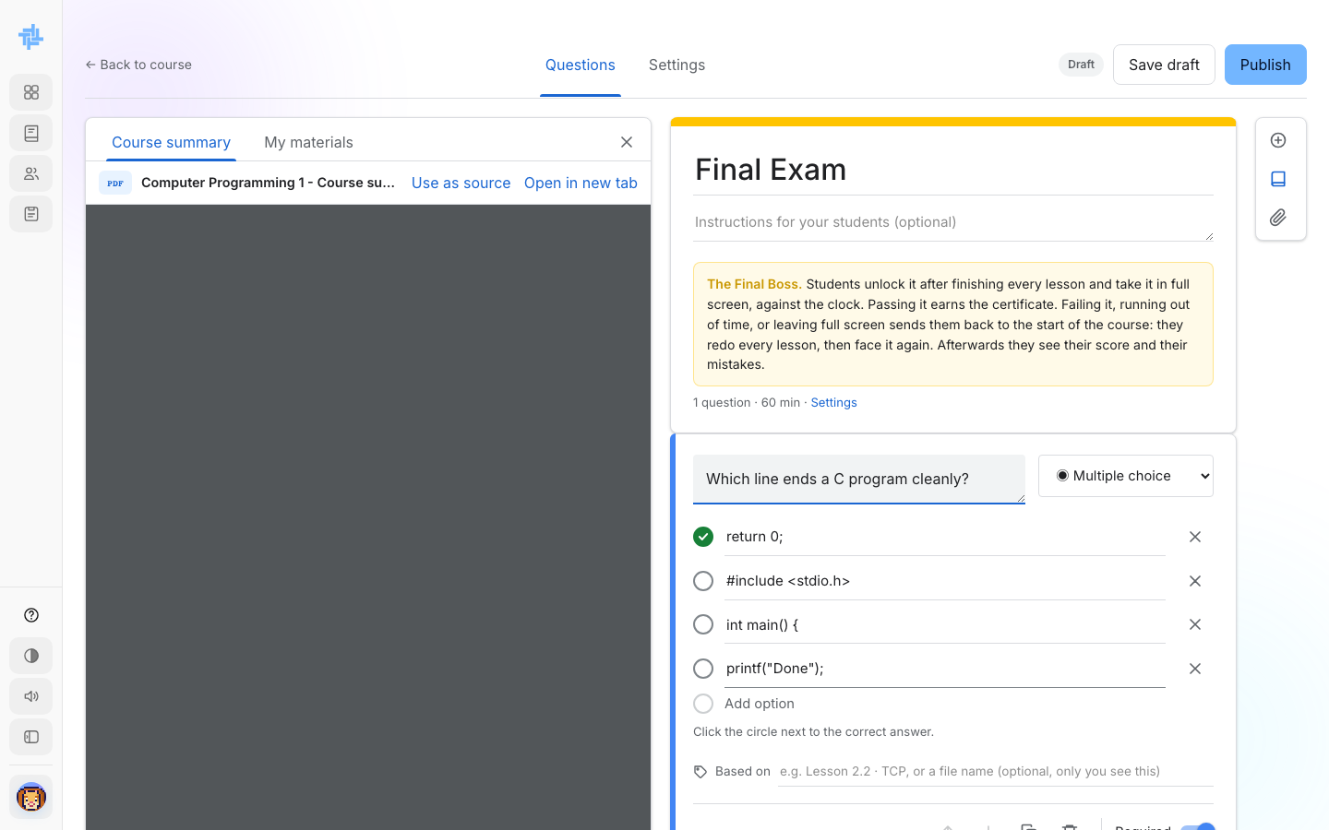
Writing final exam questions

Step 20. Set the time and pass mark, then publish
Open the Settings tab:
- Time limit (required): the clock starts when the student presses Start. When it hits zero, their answers are handed in.
- Deadline (optional): after this, students who haven't started can't open it.
- Pass mark: the score needed for the certificate (75% by default).
Click Save draft to keep working later, or Publish to make it live.
HOW THE FINAL WORKS: Leaving full screen, switching tabs or trying to screenshot fails the exam. The student goes back to the start of the course and you get an email. That is a strike. A second strike bans them from the final until you allow a retake. Students see their score but not which answers were wrong.
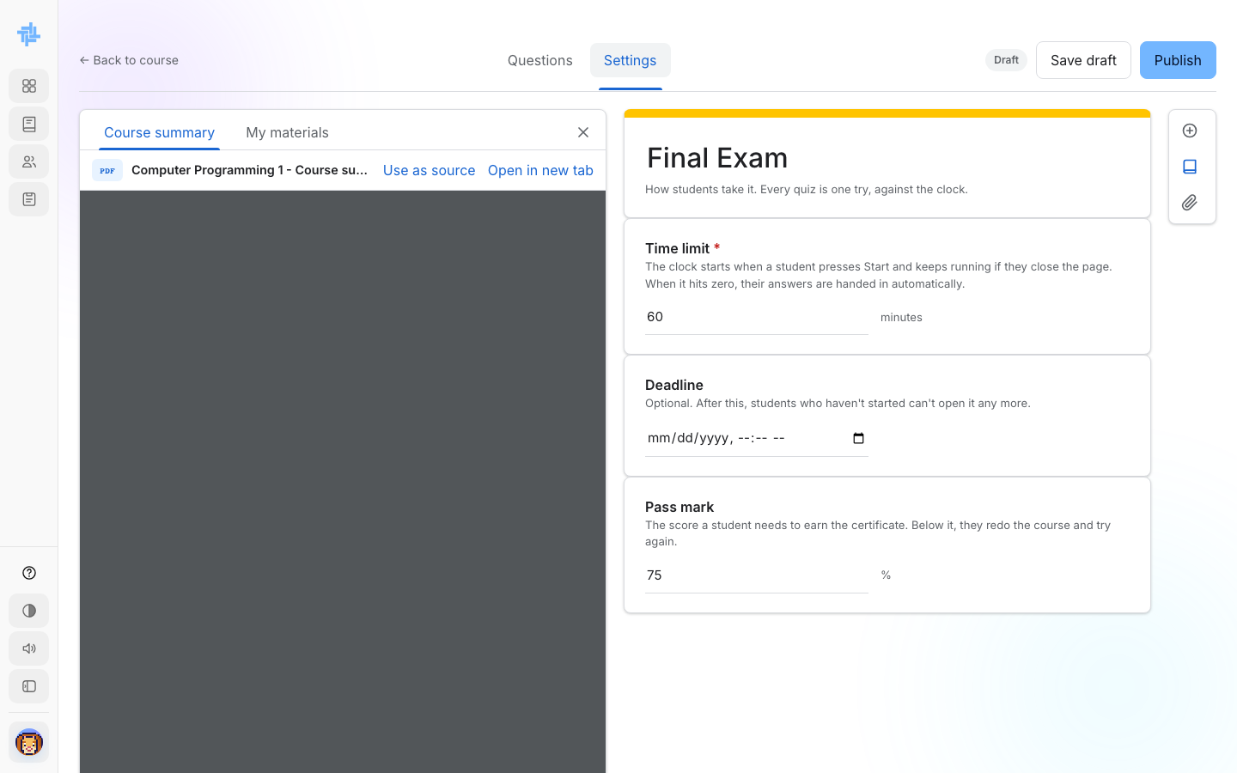
Final exam settings

FACULTY · PART 7

Edit course content
You can change the lessons for your class. Your changes only reach your class. Self-paced students keep the standard course.

Step 21. Open a lesson in edit mode
On the Courses page, click Manage. The lesson opens with ✏️ Edit buttons on every part: the title, each stage, each checkpoint, the quiz and the lab.
Use the Course Outline on the left to move between lessons.
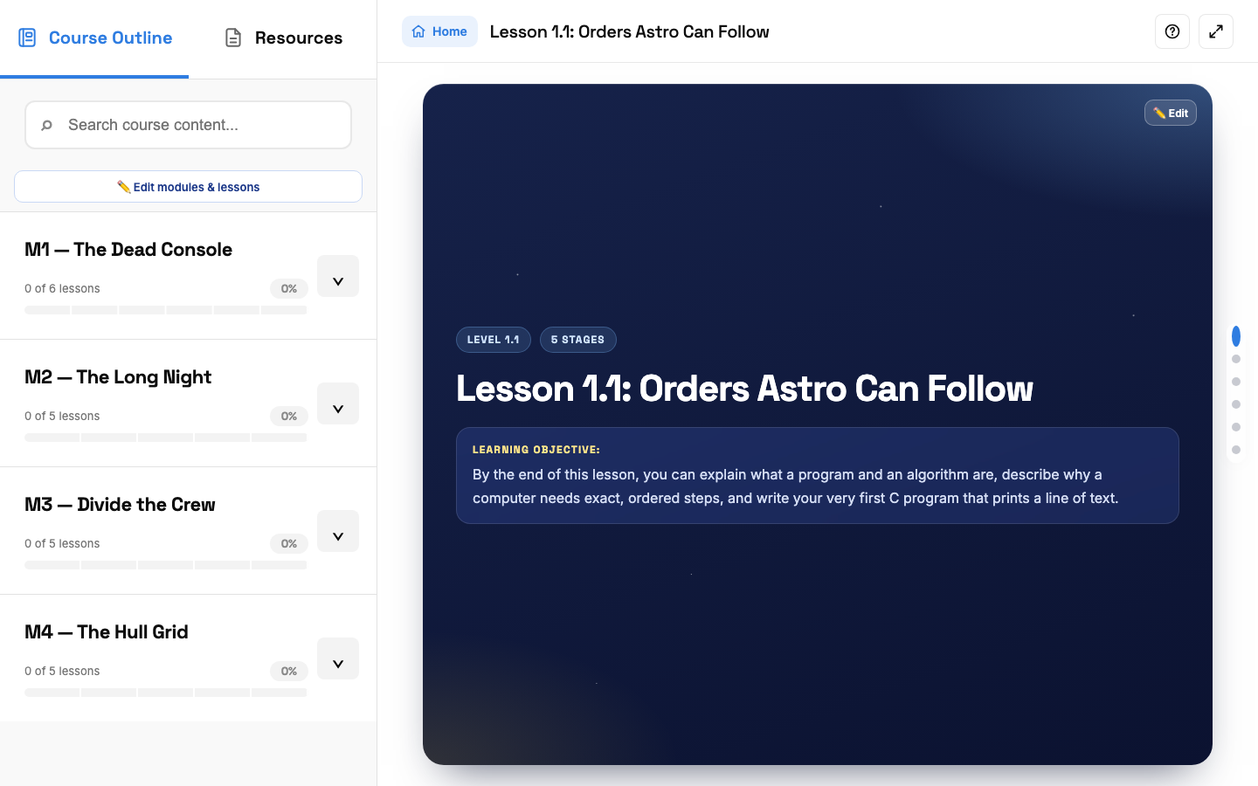
A lesson in edit mode

Step 22. Change modules and lessons
Click ✏️ Edit modules & lessons above the outline. You can:
- Rename any module or lesson by typing in its box.
- Use ↑ ↓ to change the order.
- Click Hide to hide one from students. Their progress is kept, so you can bring it back.
- Click + Add lesson to add a new lesson with empty stages for you to fill in.
Click Save, or Reset outline to go back to the standard one.
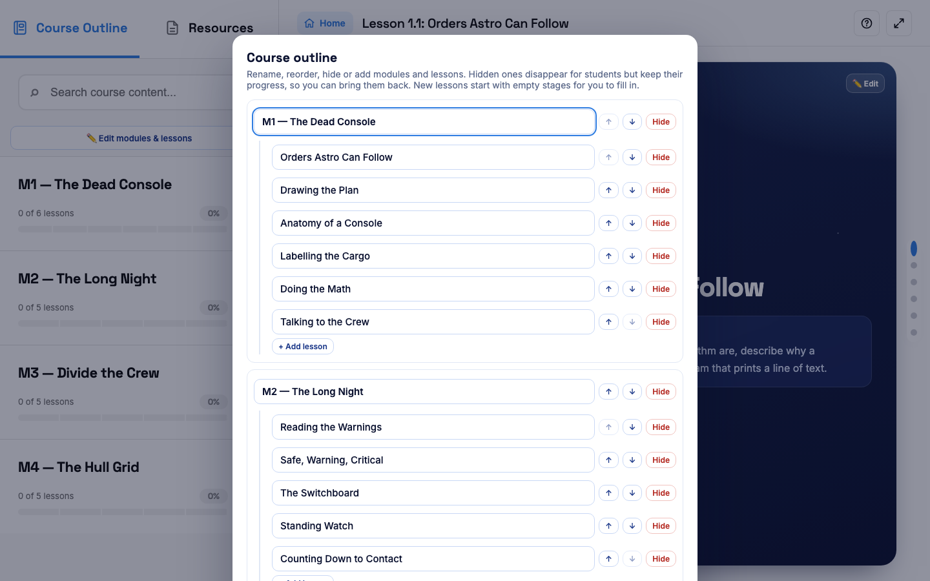
The course outline editor

Step 23. Edit a stage's text
Click ✏️ Edit on any part of the lesson. Change the text, using the buttons for bold, italics, code, lists and links. Click Save.
✏️ Edit checkpoint works the same way for the question at the end of each stage.
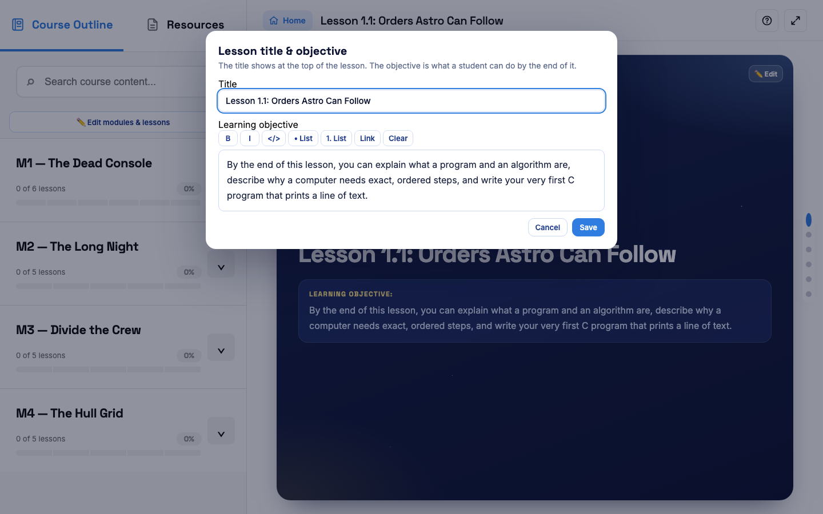
Editing the lesson title and objective

Step 24. Edit the coding lab
Click ✏️ Edit lab on Stage 5. You can change:
- The title, difficulty, instructions and an optional hint from Astro.
- answer.c (your correct program) and starter.c (what students start with).
- The expected output. Students pass when their program prints exactly this.
Click Run answer code to test, then Save lab. Saving runs your answer first, so a wrong expected output can't go live.
Networking and Cybersecurity lessons have simulator labs instead, edited the same way.
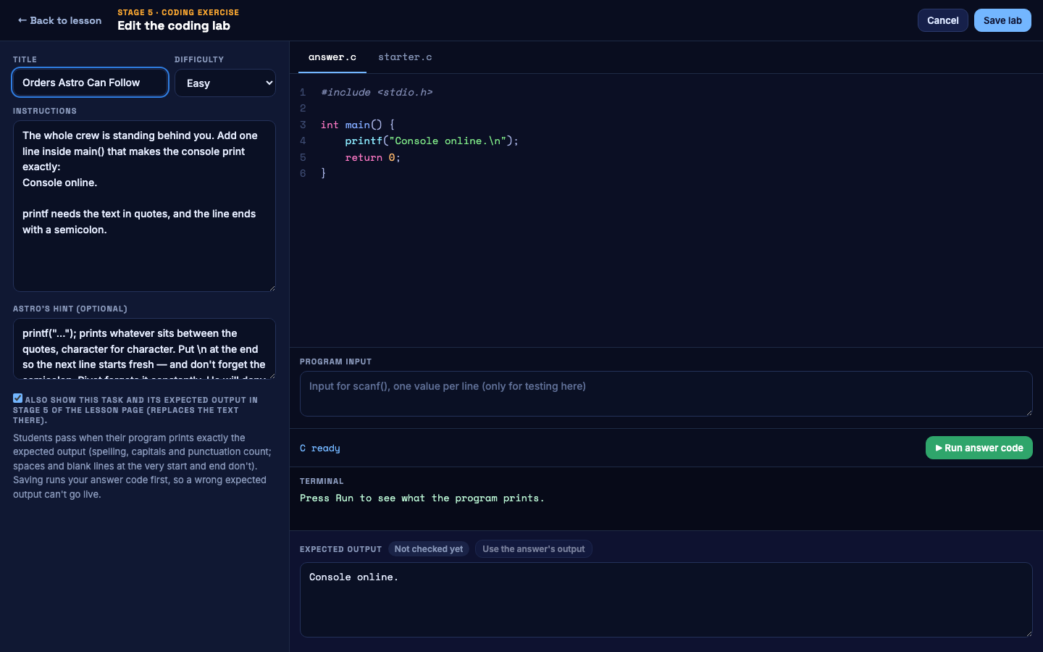
The coding lab editor

Step 25. Change the course card
On the Courses page, click Edit card. Change the cover image, title, subtitle or level, then click Save. This is the card your students pick the course from.
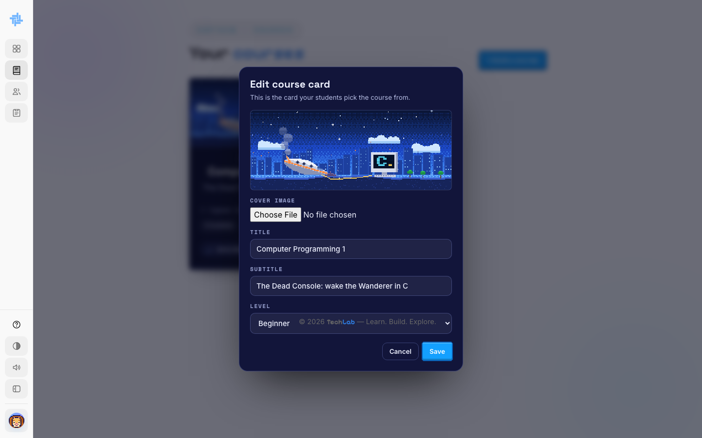
Editing the course card

FACULTY · PART 8

More tools
Build your own course and keep your class schedule.

Step 26. Build a course from scratch
On the Courses page, click + Build a course. Pick a planet (Programming, Networking or Cybersecurity), type a title and an optional subtitle, and click Create course.
The new course starts empty and hidden from students. Add modules and lessons with the same editor as Part 7, then publish it when it's ready.
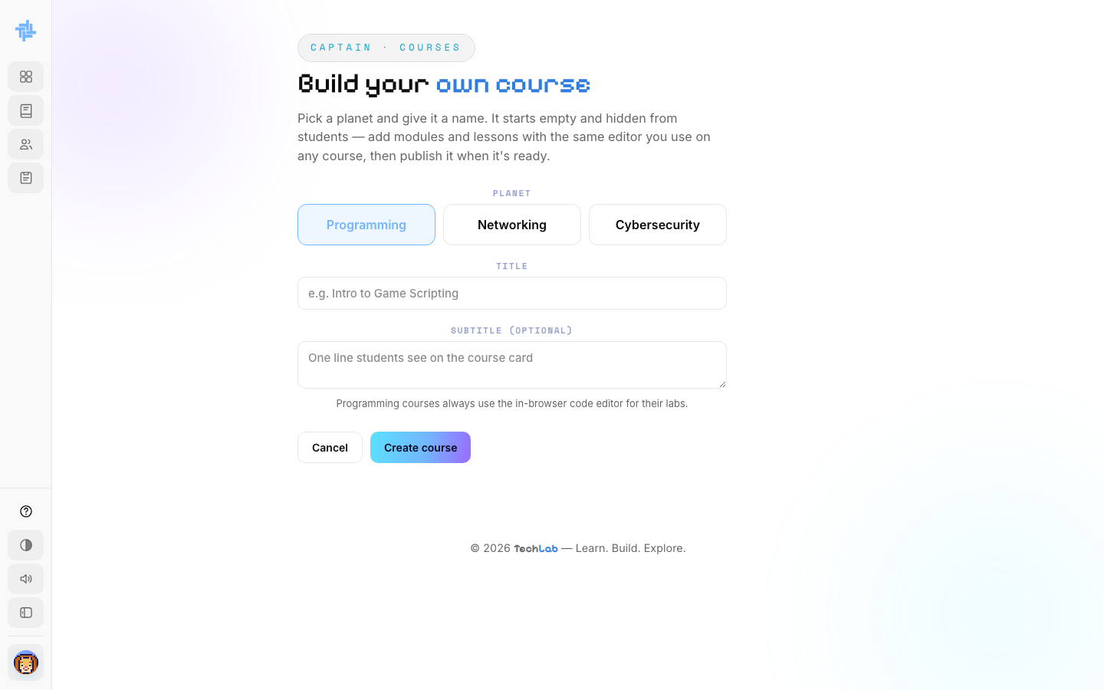
Building a new course

Step 27. Upload your class schedule
Open My Classes (/faculty/classes). Click Upload schedule and choose a file or a photo of your schedule. Astro reads it and lays out your classes here.
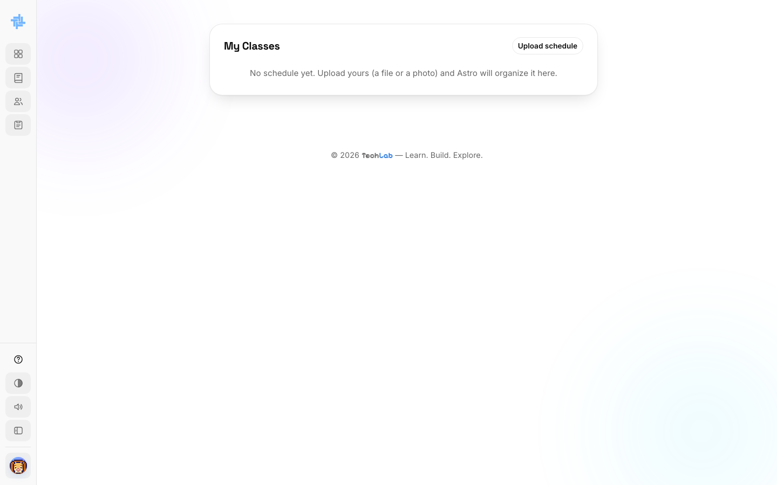
My Classes

Step 28. Settings and logging out
Click your avatar at the bottom of the sidebar. Choose Settings to change your name, password or captain avatar, or Log out.
You can delete your account from Settings. If you still lead a course with students, TechLab asks you to hand it over first.

