TechLab

TechLab Student Manual: Join Class
A step-by-step guide for students who join an instructor's class: you ask to join, your instructor (your Captain) accepts you, follows your progress, and signs your certificate. Each step has a real screenshot.

Screenshots use a demo student, Leo Cruz (codename MeteorTabby95), in Captain Carlo Reyes's class for Computer Programming 1. Some shared steps show Maria Santos, another demo student. Captured 18 October 2026.
Learning the other way? See the Self-paced student manual.

Contents
Create your account
Your dashboard
Join your instructor's class
Take a lesson
Mini Bosses and the Final Boss
Ask Astro
Planets, XP and the Shop
Settings and logging out

If the contents list is empty, right-click it in Word and choose Update Field.

STUDENT · PART 1

Create your account
Takes about three minutes. You will sign up, agree to the rules, and build your astronaut.

Step 1. Open TechLab and start your mission
Go to the TechLab home page. Click Start your mission to make a new account.
Already have one? Click Log in instead and skip to the next part.
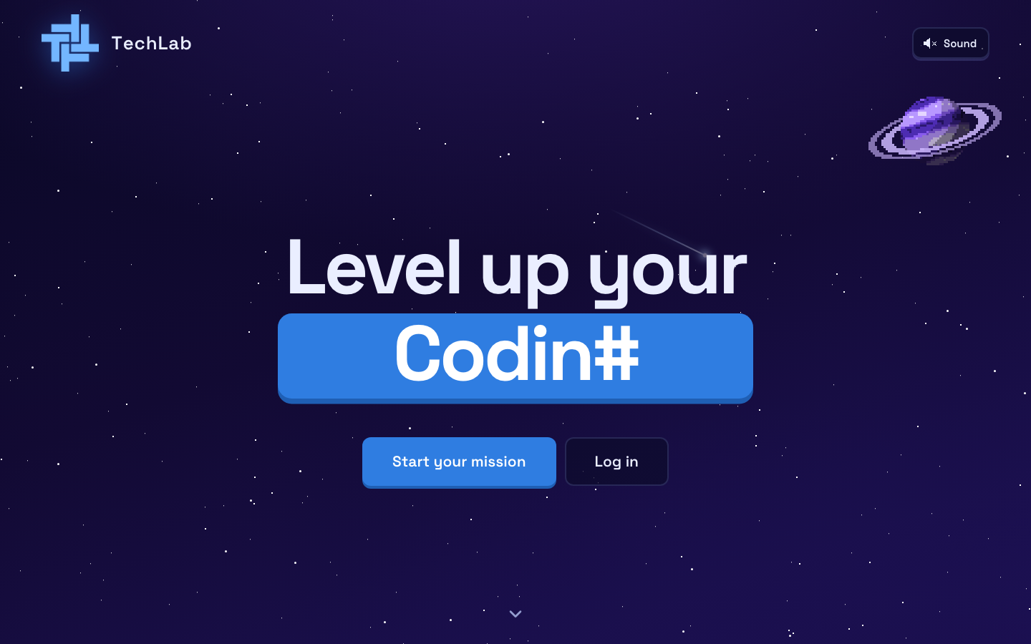
The TechLab home page

Step 2. Fill in the sign-up form
- Type your first name and last name. Use your real name: it is printed on your certificate.
- Type your email. This is what you log in with, and it can't be changed later.
- Pick a password with at least 8 characters, then type it again to confirm.
- Choose your program (IT, IS, CS, BLIS or EMC) and year level.
- Pick the planet you want to learn first: Programming, Networking or Cybersecurity. You can only pick one now. The others unlock later.
Click Create account.
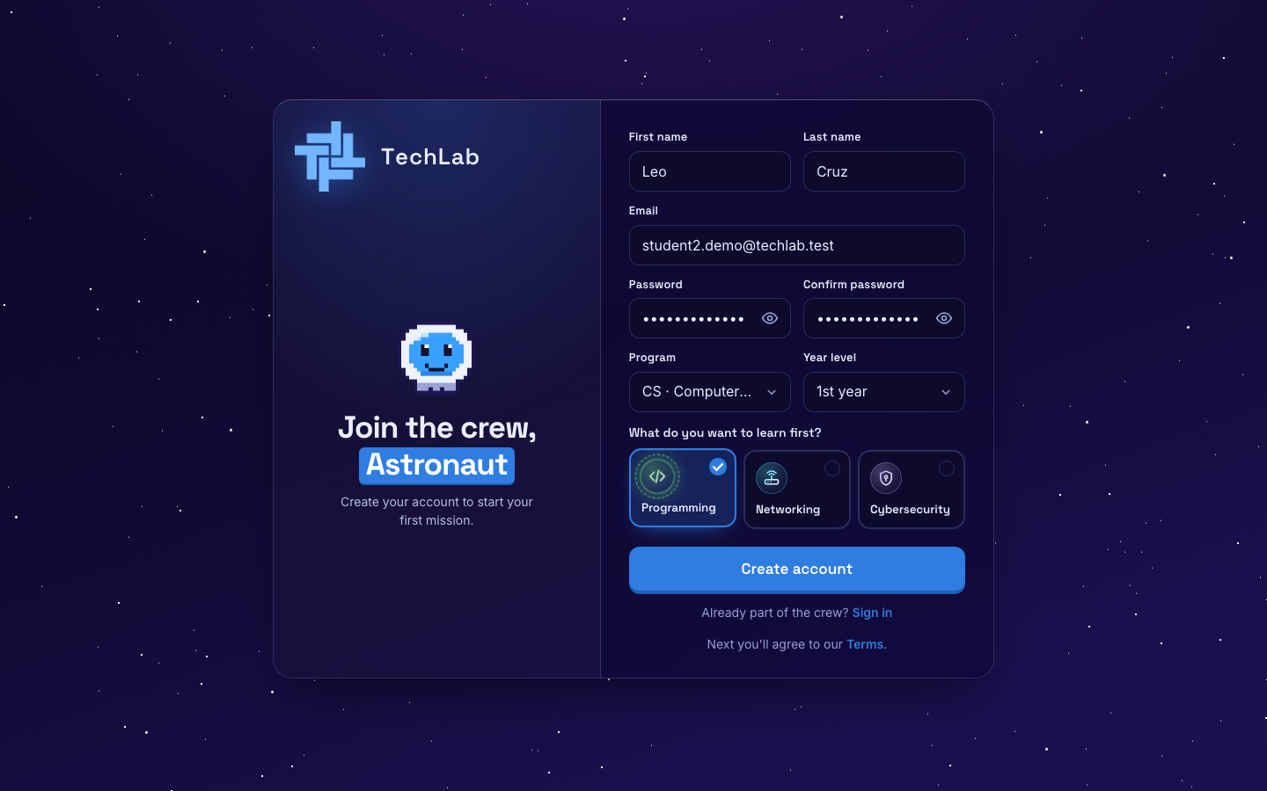
The sign-up form, filled in

Step 3. Read and agree to the rules
TechLab has 7 short rules. Read them, tick I have read and agree, then click Agree and continue.
KNOW THIS EARLY: Quizzes give you one try with a timer. In the Final Boss, switching tabs, leaving full screen or taking screenshots fails the exam and gives you a strike. Two strikes and you are banned from that course.
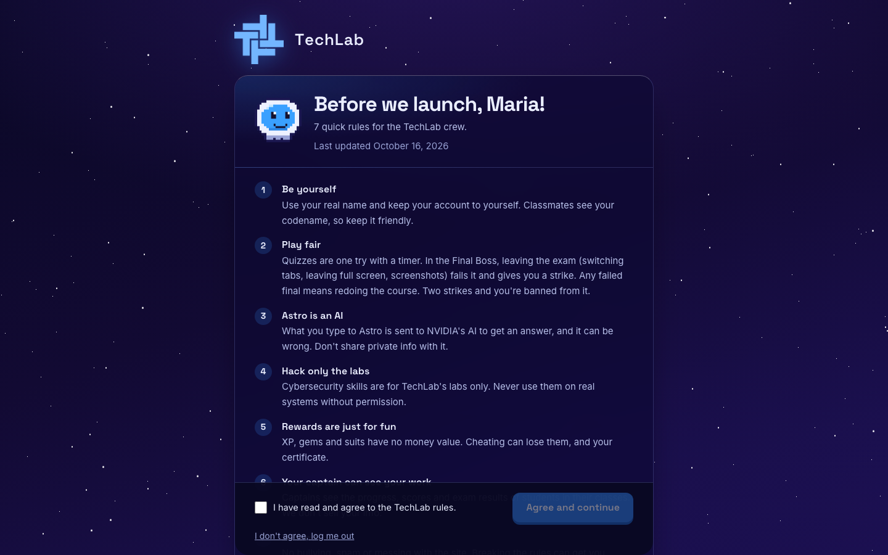
The TechLab rules

Step 4. Meet Astro and build your astronaut
Astro is your AI guide. Click Continue to read each message, then Make my astronaut. Music plays here: use Music on in the corner to turn it off.
Use the Animal, Suit and Helmet tabs to choose your look. The Cat is free. Other animals cost XP, so you can buy them later in the Shop. Click Looks good! when you're done.
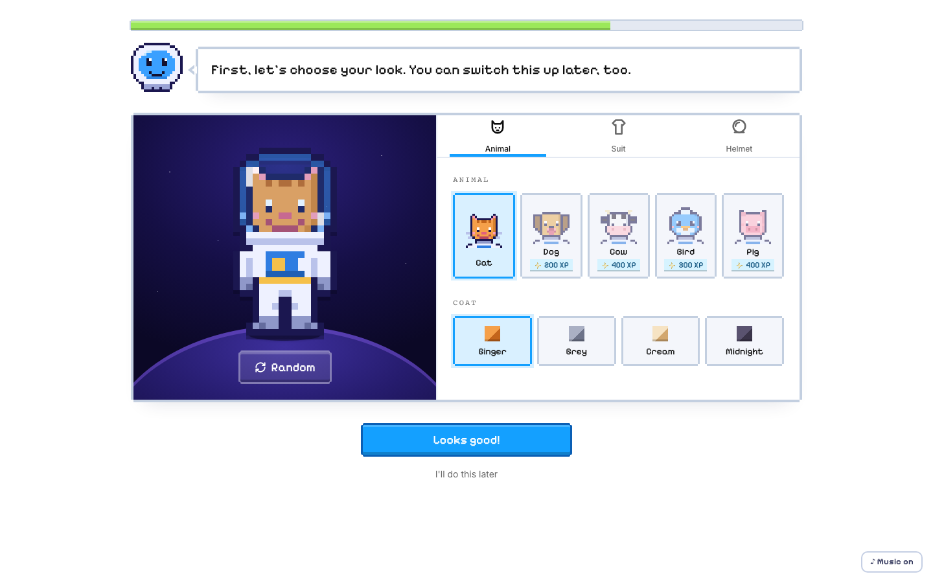
The astronaut builder

Step 5. Pick a codename
Your classmates see your codename, not your real name. Keep it friendly. Stuck? Click Give me a codename idea.
Click That's me!, then Start my mission.
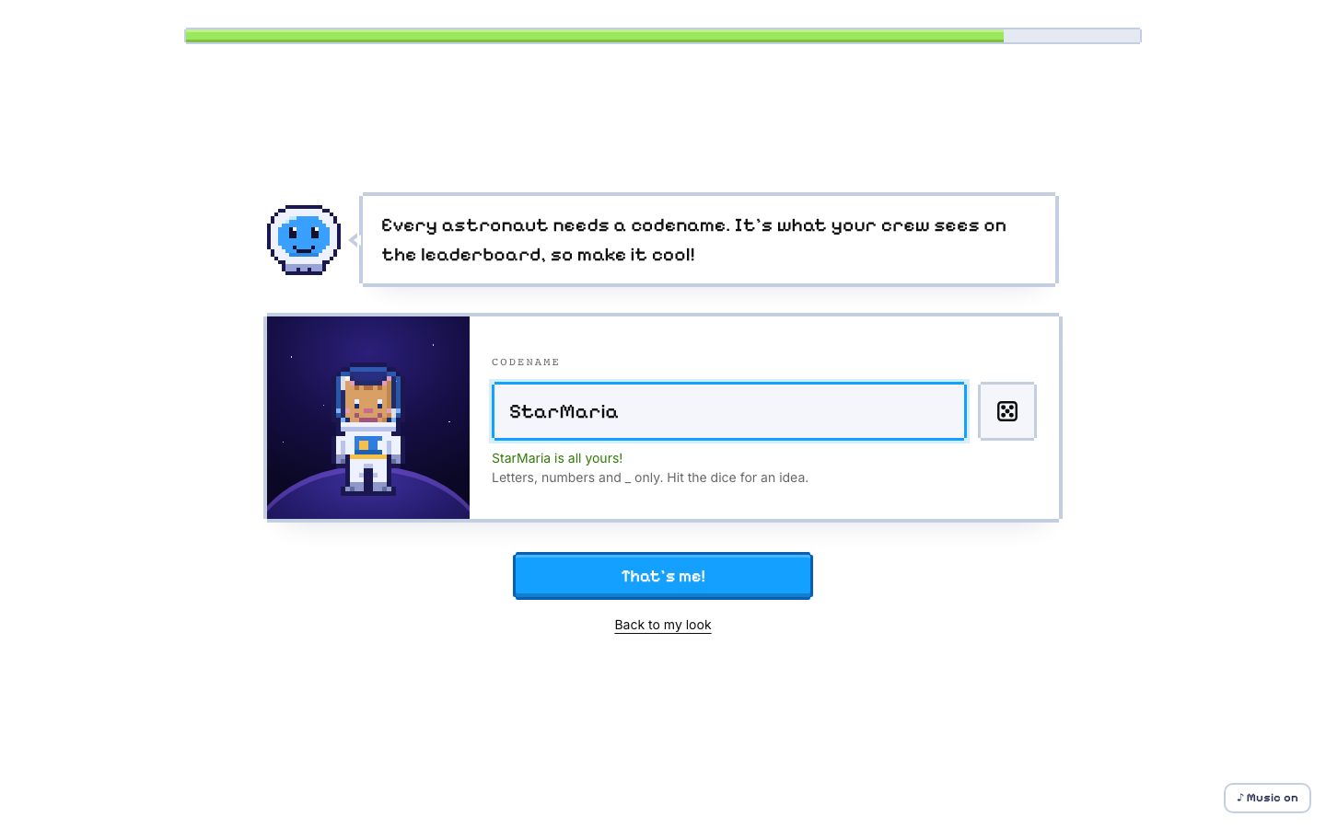
Choosing a codename

STUDENT · PART 2

Your dashboard
Home base. It shows your planet, your level and the leaderboard.

Step 6. Follow Astro's tour
The first time you arrive, Astro gives a short tour. Click Next or press the right arrow key to move on. Click Skip tour to close it.
Want it again later? Click the ? (Tour) button in the left sidebar.
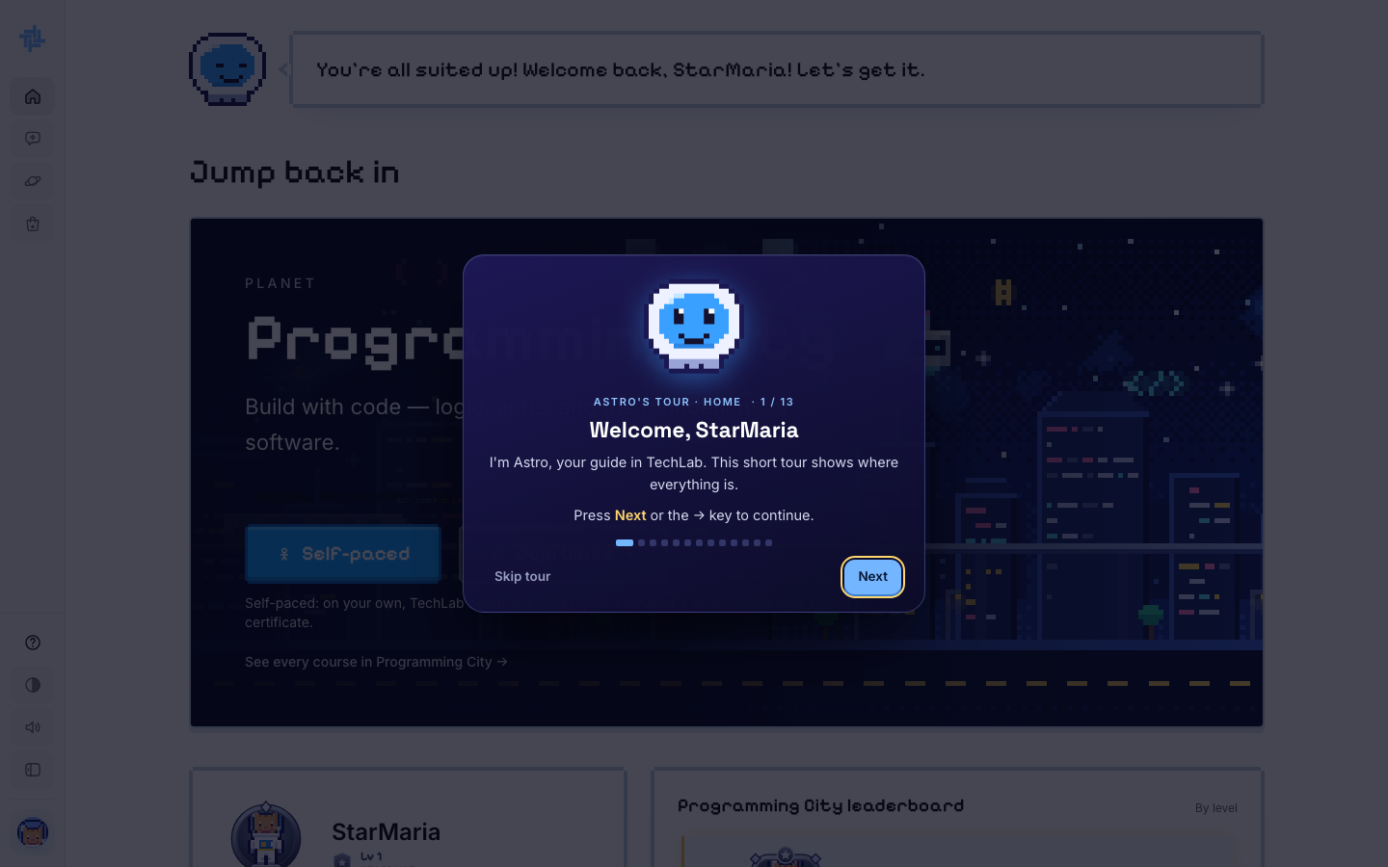
Astro's tour

Step 7. Find your way around
The left sidebar is on every page:
- Home: this dashboard
- Chat: talk to Astro
- Planets: all three planets and their courses
- Shop: spend XP on frames, animals and suits
- At the bottom: Tour, light/dark theme, sound, and your account menu (your avatar)
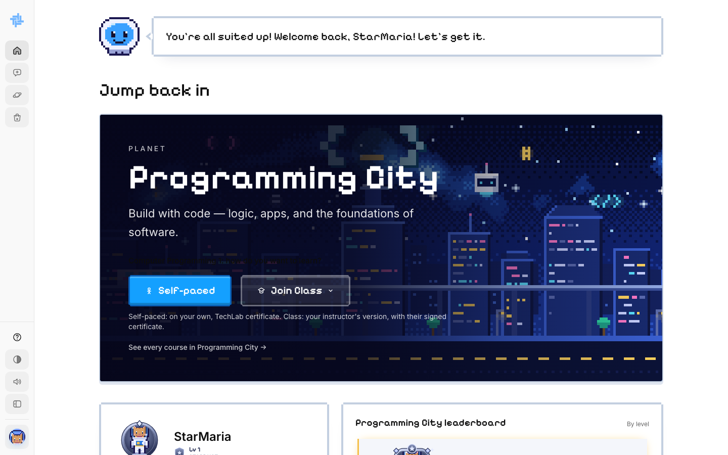
The dashboard and sidebar

STUDENT · PART 4

Join your instructor's class
Join Class means you learn with an instructor, called your Captain. They follow your progress, may change lessons and quizzes for your class, write your final exam and sign your certificate. Here is how it compares to Self-paced.
 | Self-paced | Join Class
Who teaches | Just you and Astro | Your instructor (your Captain)
How you start | Right away, one click | Ask to join; your instructor accepts you
Prerequisites | Must finish the course before it (e.g. Programming 1 before Programming 2) | None: your instructor decides who joins
Lessons and quizzes | The standard TechLab version | Your instructor's version, which may be edited
Extra files | None | Supplementary Materials from your instructor
Mini Boss you fail | Next module stays locked, 0 XP, wait 60 min, try again | One try, score saved for your instructor, nothing locks
Final exam | TechLab's standard final | The final your instructor writes
Who watches your progress | TechLab admins | Your instructor
Certificate | Issued by TechLab (Self-paced Learning Program) | Signed by your instructor (Class Learning)

Step 11. Ask to join your instructor's class
- On your dashboard's planet card, click Join Class.
- Under Who is your instructor?, find your instructor's name.
- Click Ask to join next to it.
You don't need a code. Just pick the right name. Ask your instructor if you're not sure which one is yours.
CHOOSE CAREFULLY: Once you join a class for a course, you can't switch to Self-paced or to another instructor's class for that course. If you already started a course Self-paced, you can't ask to join a class for it.
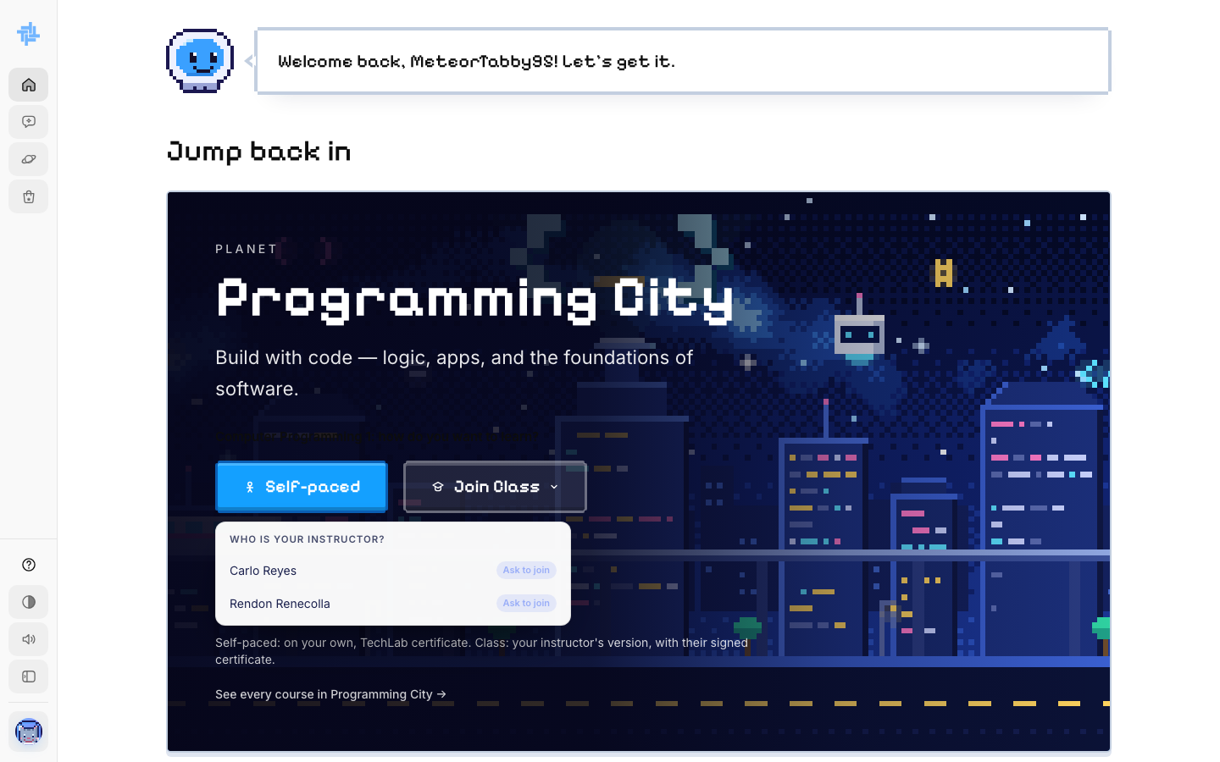
Picking your instructor under Join Class

Step 12. Wait for your Captain to accept you
Your request is sent. The card says Waiting for (your instructor) to accept you.
Your instructor sees your name under Waiting to join on their dashboard and clicks Accept. If they decline, TechLab emails you. You can then ask a different instructor.
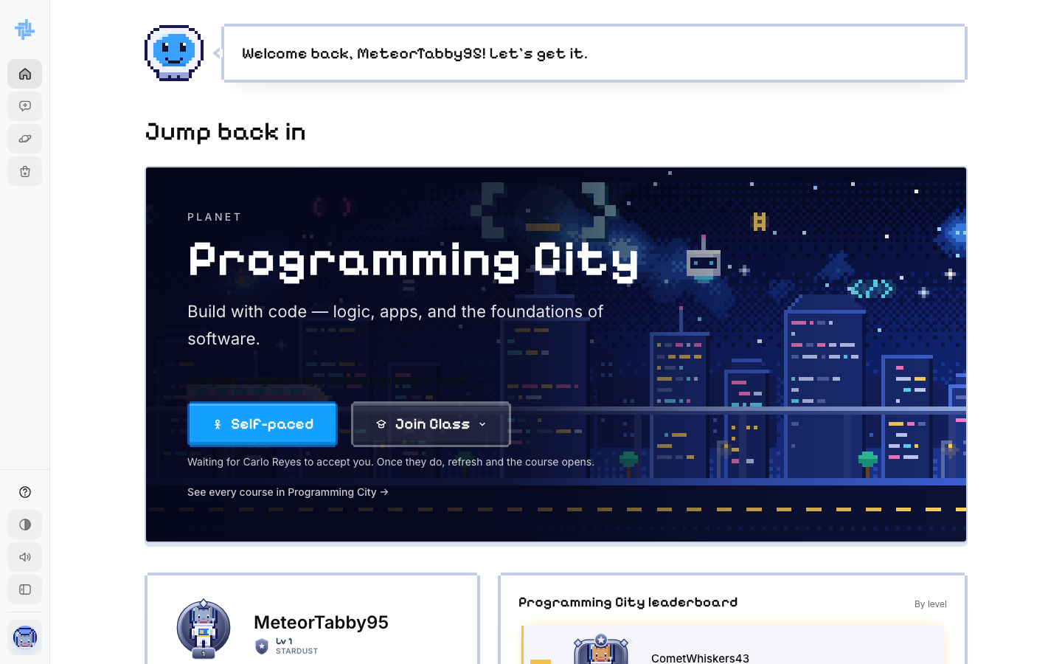
Waiting for the instructor to accept
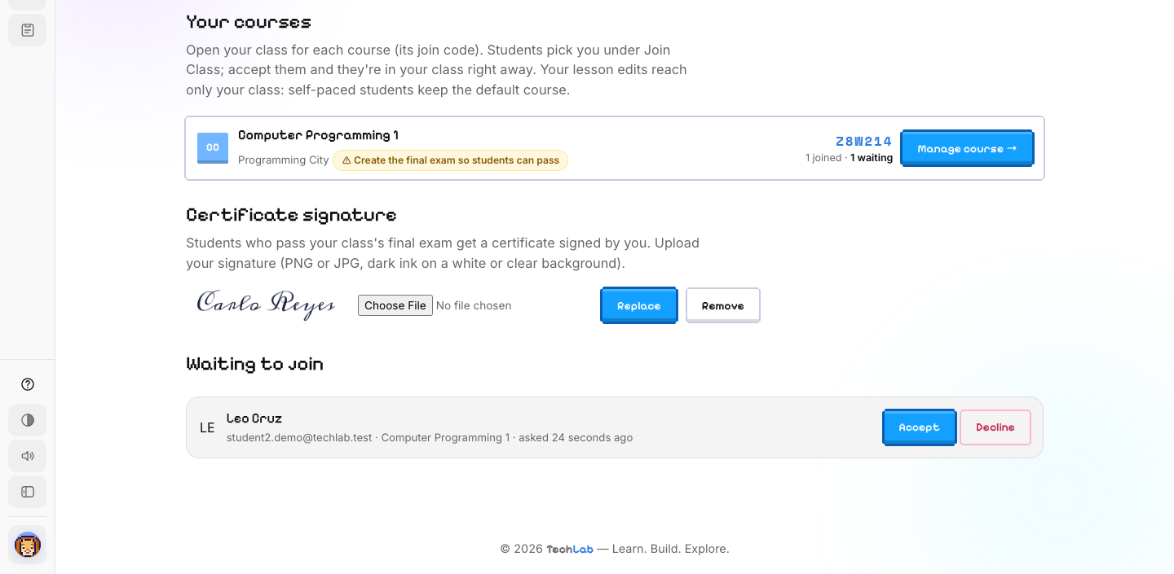
What your instructor sees: Accept or Decline

Step 13. Enter your class
Once you are accepted, refresh your dashboard. A green badge says Accepted into (your instructor)'s class. Click Enter Programming City (or your planet's name).
Joining a class starts the course fresh, with your instructor's version of the lessons.
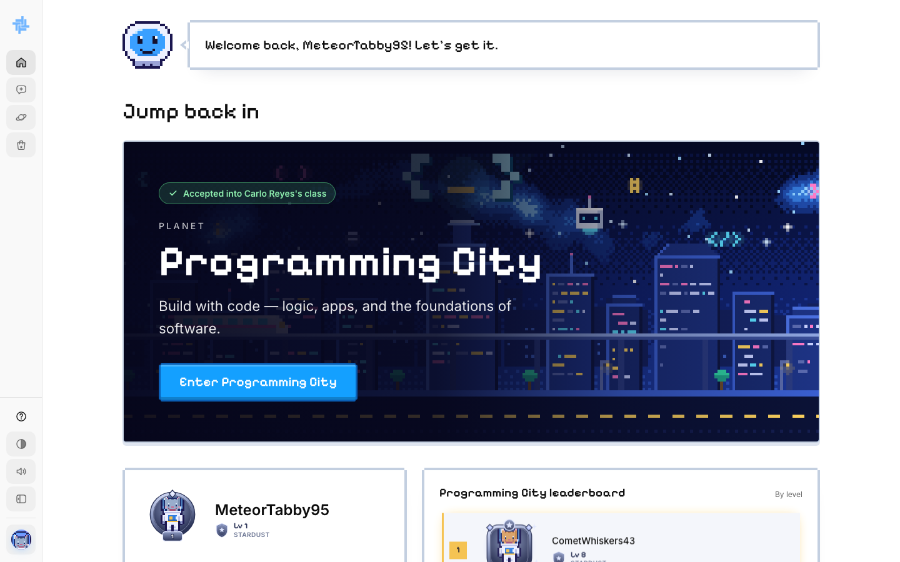
Accepted into the class

Step 14. Look at your class course page
The badge at the top says Class · (your instructor). The course page lists every chapter and its lessons. Lessons unlock in order.
Click Start Learning to begin.
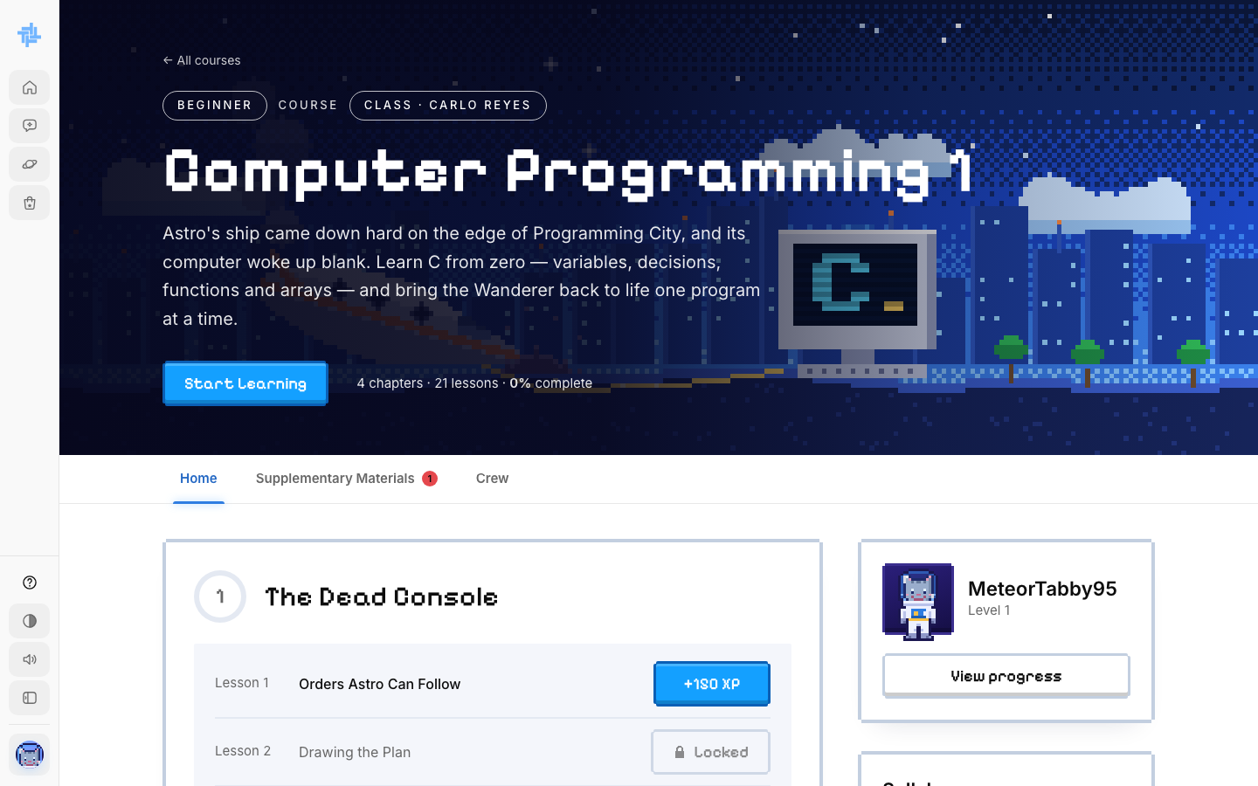
A class course page

Step 15. Open your instructor's materials
Click the Supplementary Materials tab. Here you find the files and links your instructor added, grouped by week or module. A red number on the tab means something new was added since you last looked.
Astro can also answer questions using your instructor's PDF, Word, PowerPoint and text files.
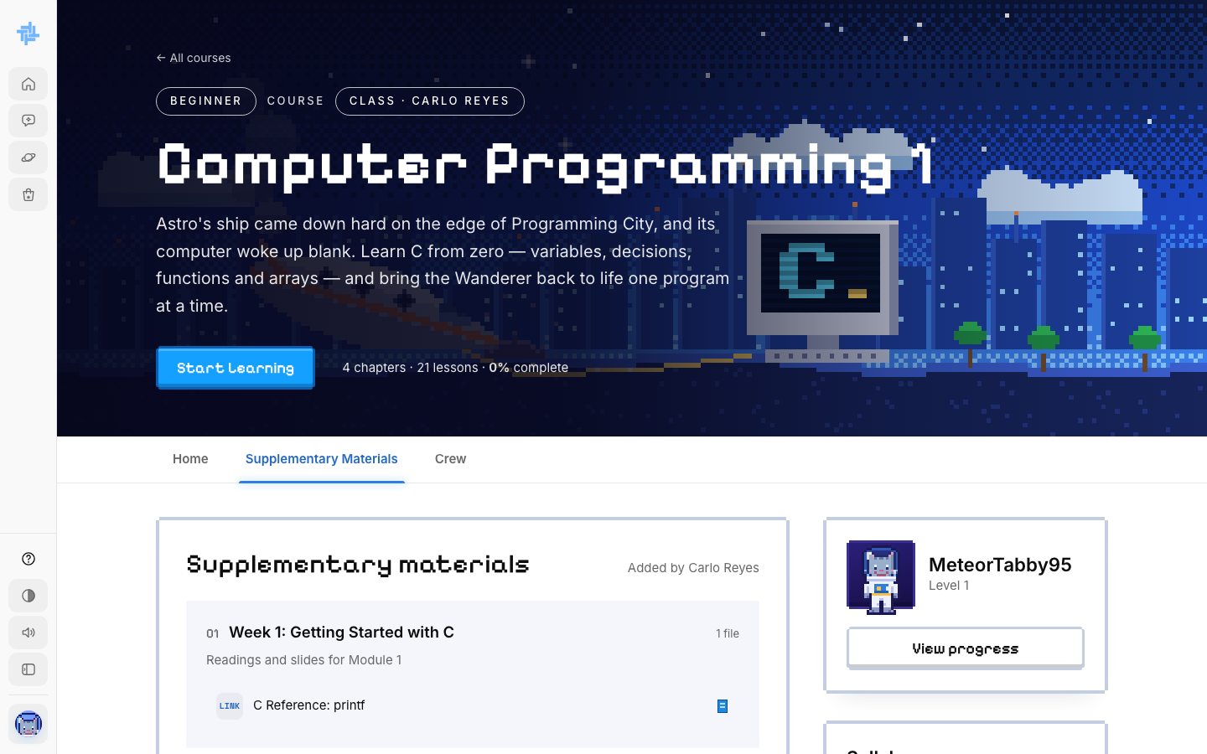
Supplementary Materials from the instructor

Step 16. Meet your Captain and crew
Click the Crew tab. It shows your Captain (your instructor) and a leaderboard of everyone in your class.
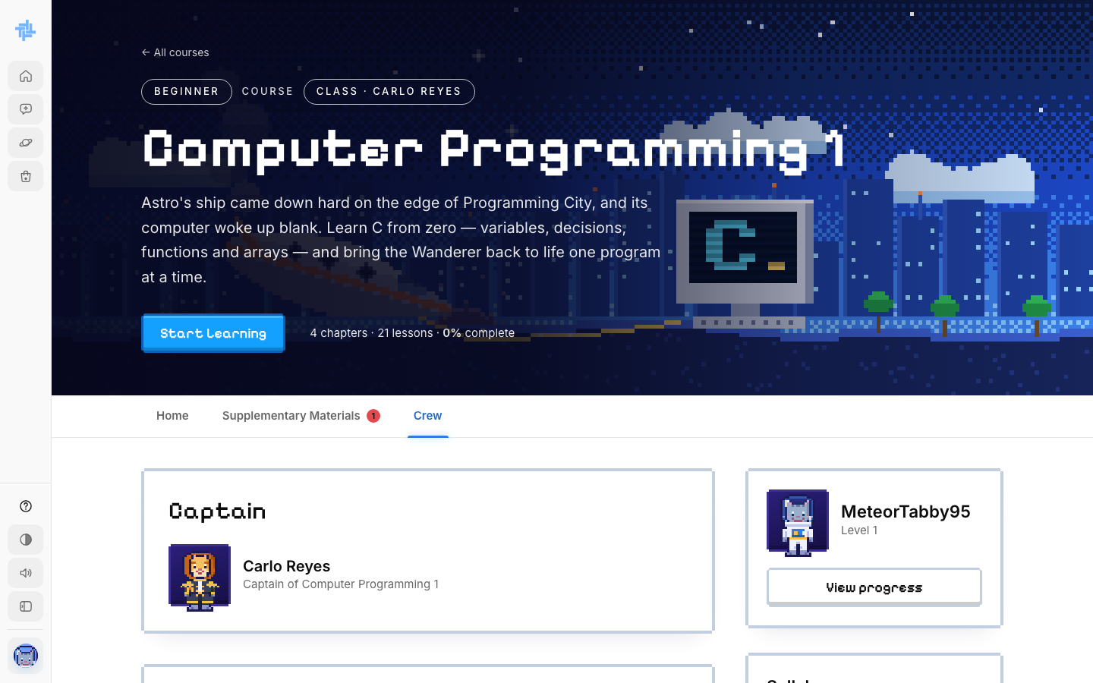
Your Captain and crew

STUDENT · PART 5

Take a lesson
Every lesson has the same 5 stages. You unlock each stage by passing a short checkpoint question. In a class, your instructor may have changed some lesson text, quizzes or labs.
Stage | Name | What you do
1 | Mission Brief | Read the simple explanation
2 | Picture It | See the idea as an everyday example with a picture
3 | Field Diagram | Study the diagram and the code example
4 | Knowledge Check | Answer the quiz (10 XP per right answer)
5 | Coding Exercise / Lab | Write code or do a hands-on lab (100 XP)

Step 17. Read the lesson screen
- Left: the Course Outline. Open a module to see its lessons. The Resources tab has files.
- Top: your XP, gems and day streak.
- Right edge: dots that jump to each stage.
- The expand button (top right) makes the lesson full screen.
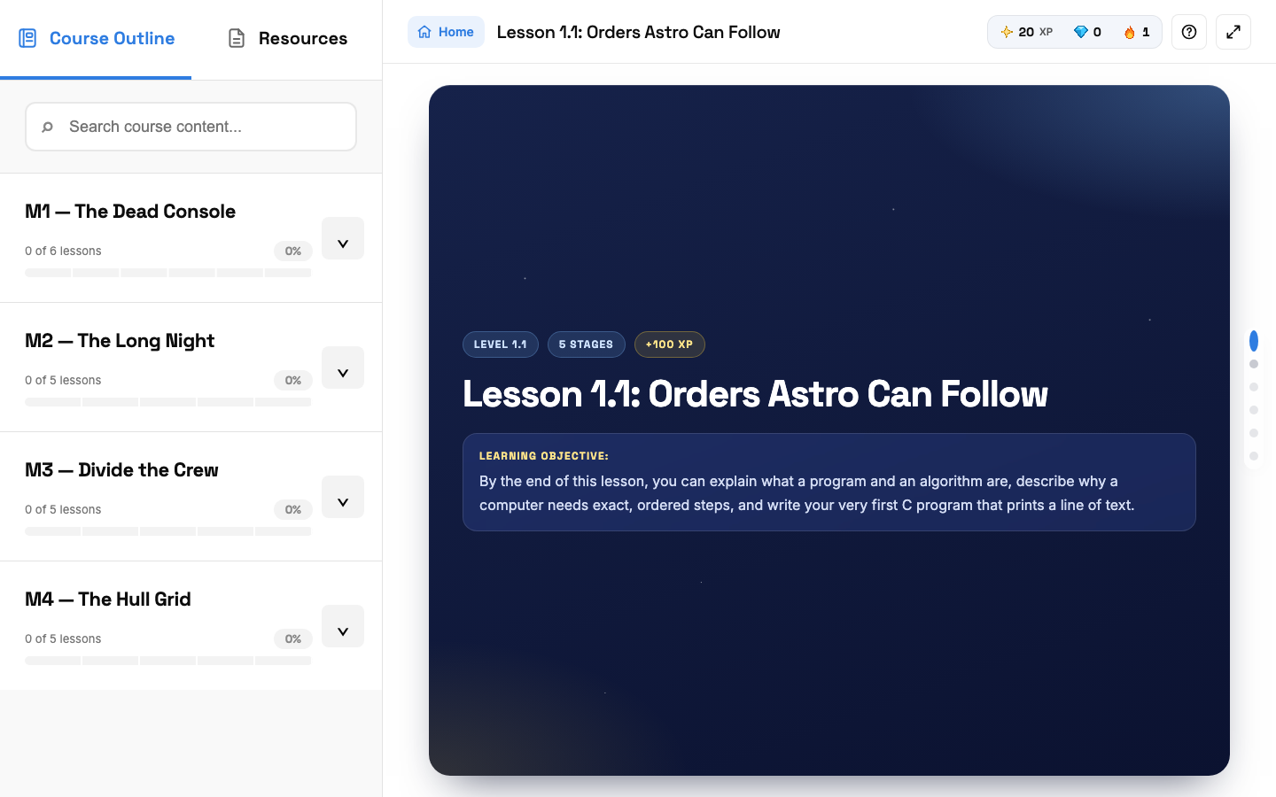
The start of Lesson 1.1

Step 18. Read each stage and pass its checkpoint
Read the stage. At the bottom, click I've read it: start the checkpoint and answer the one question. A right answer opens the next stage straight away. A stage you haven't unlocked yet shows a lock message.
WRONG ANSWER? You have to wait a short time before trying again. The wait gets longer each time you miss, so read carefully.
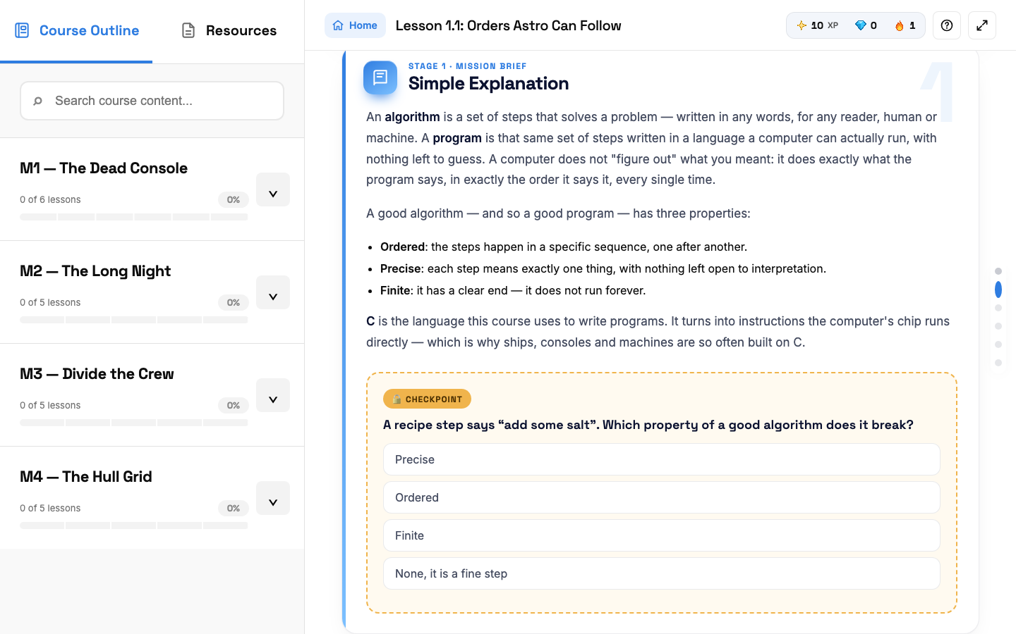
A checkpoint question
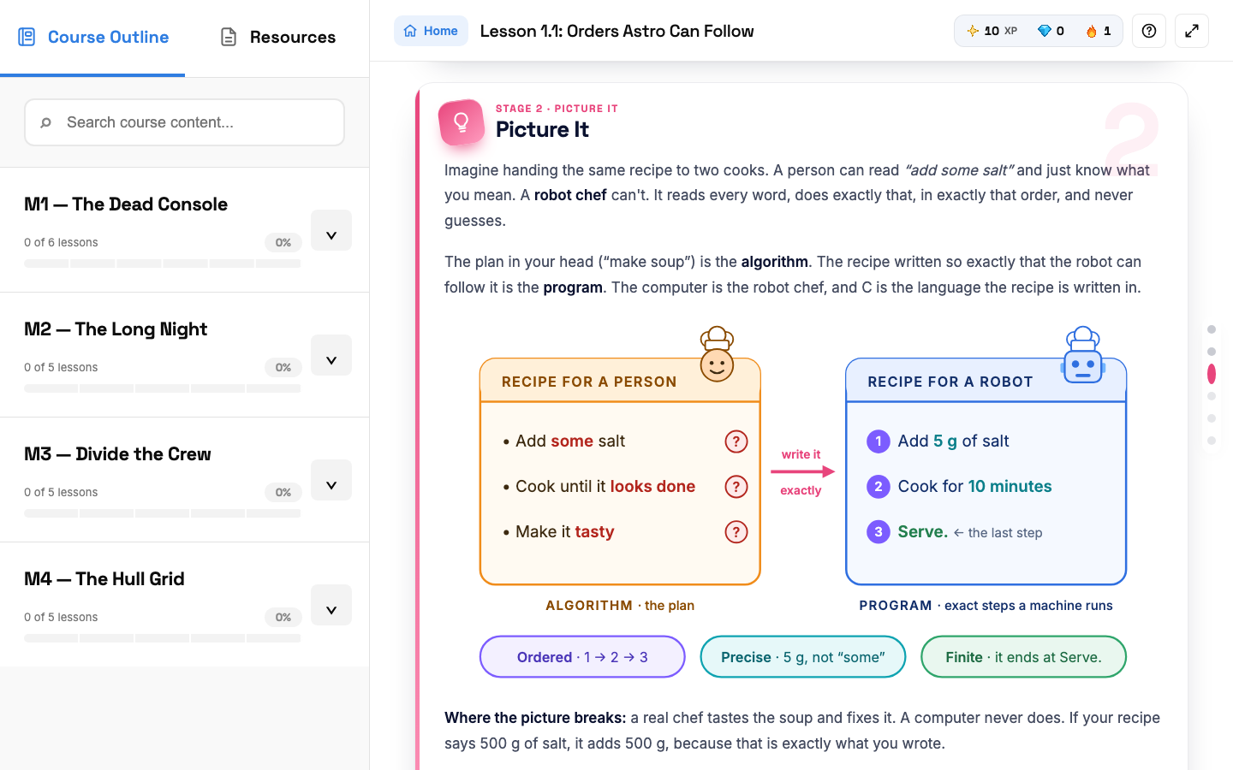
Stage 2: Picture It

Step 19. Answer the Knowledge Check
Click one answer per question. You see right away if it was correct, plus a short explanation. Each right answer gives +10 XP.
RULE: You can miss at most 2 questions. Miss more and the coding stage stays locked until you retake the quiz.
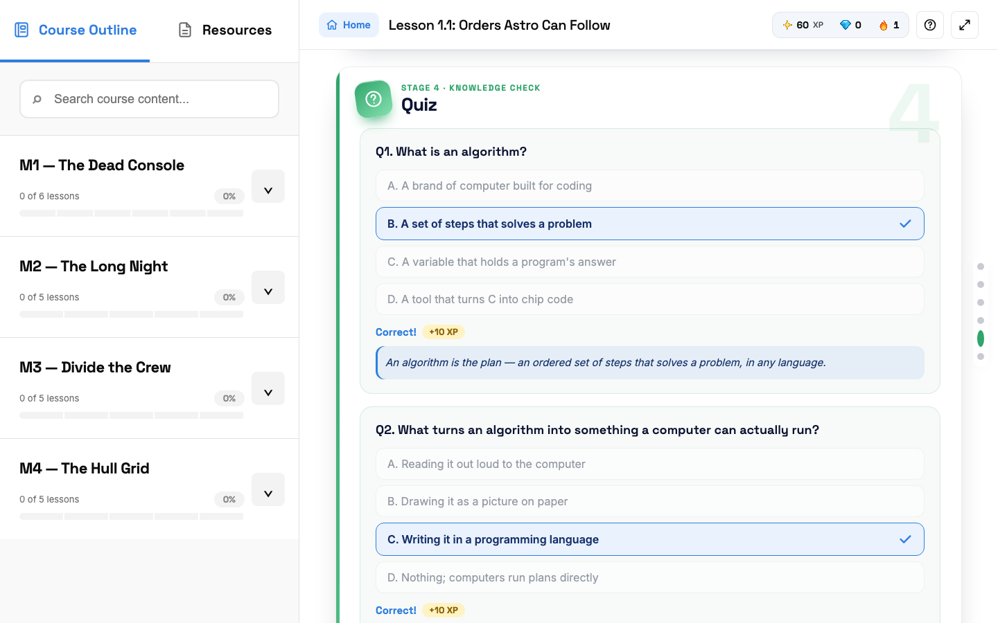
Knowledge Check answers marked Correct

Step 20. Do the coding exercise
Click Code it yourself. The editor opens with the instructions on the left.
- Type your code in the editor.
- If your program asks for input, type it in Program Input, one value per line.
- Click Run to test. The result shows in the Terminal.
- Click Submit answer when it looks right.
Stuck? Flip to get help from Astro costs 50 XP. Networking and Cybersecurity lessons open a simulator lab here instead of a code editor.
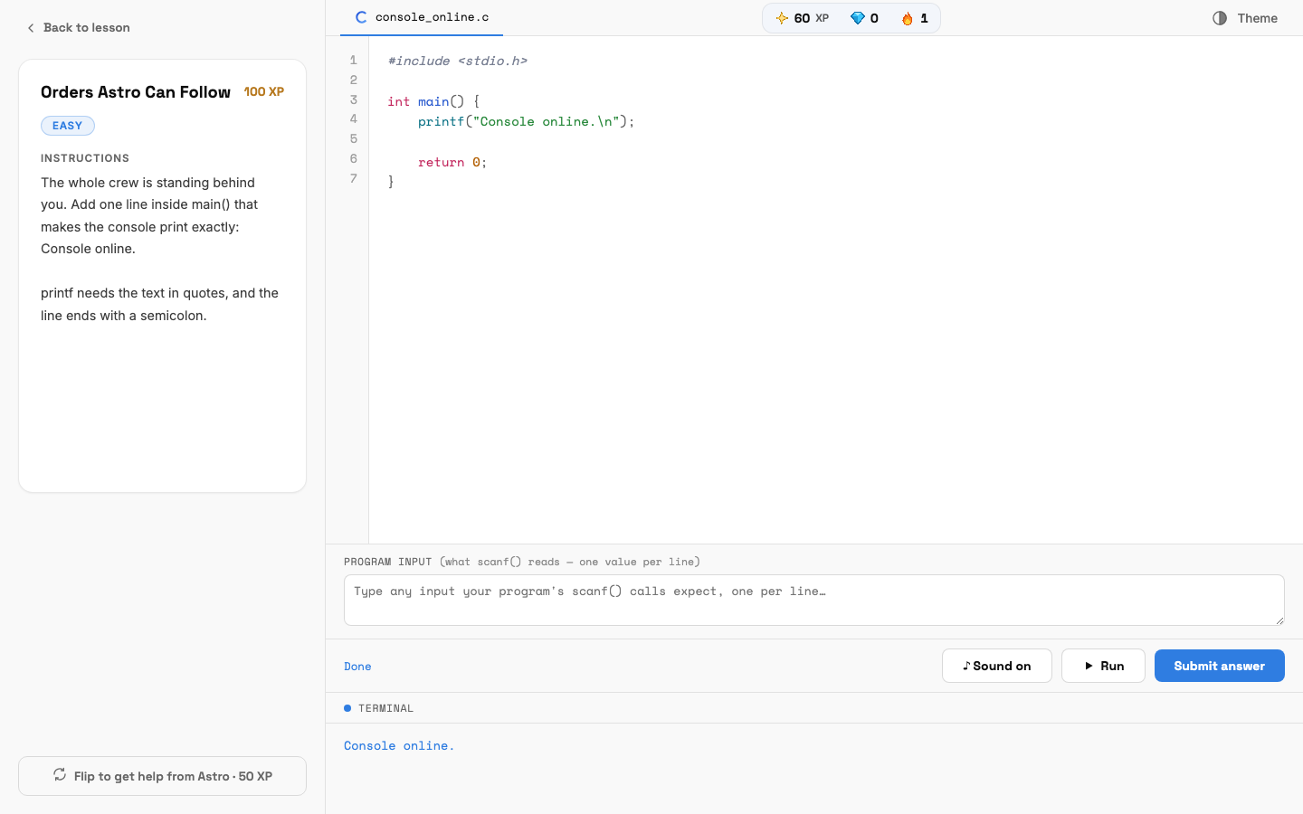
The code editor with the program output

Step 21. Finish the lesson
If the answer is wrong, you see Not quite. Check the terminal output, fix your code and submit again.
When it's right, Astro cheers and you get +100 XP. Click Next lesson to keep going.
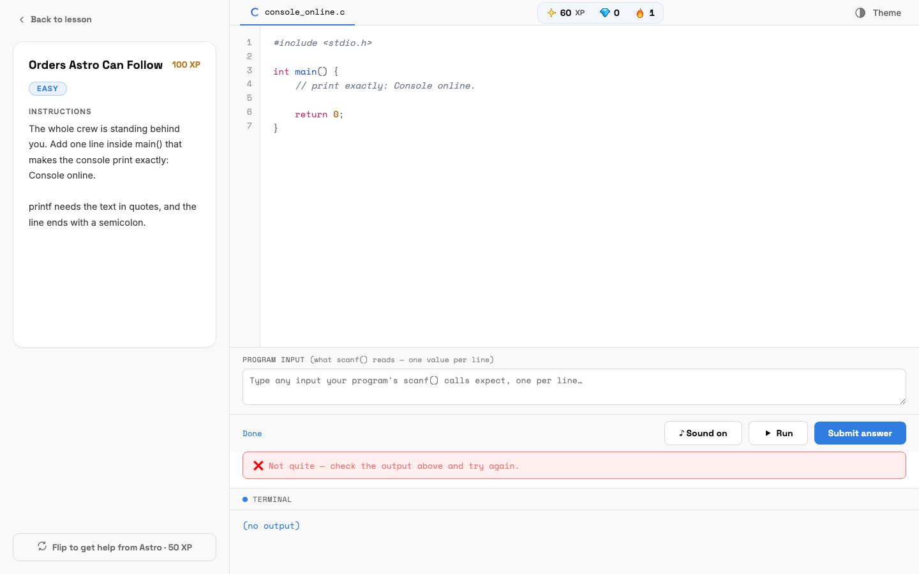
A wrong answer
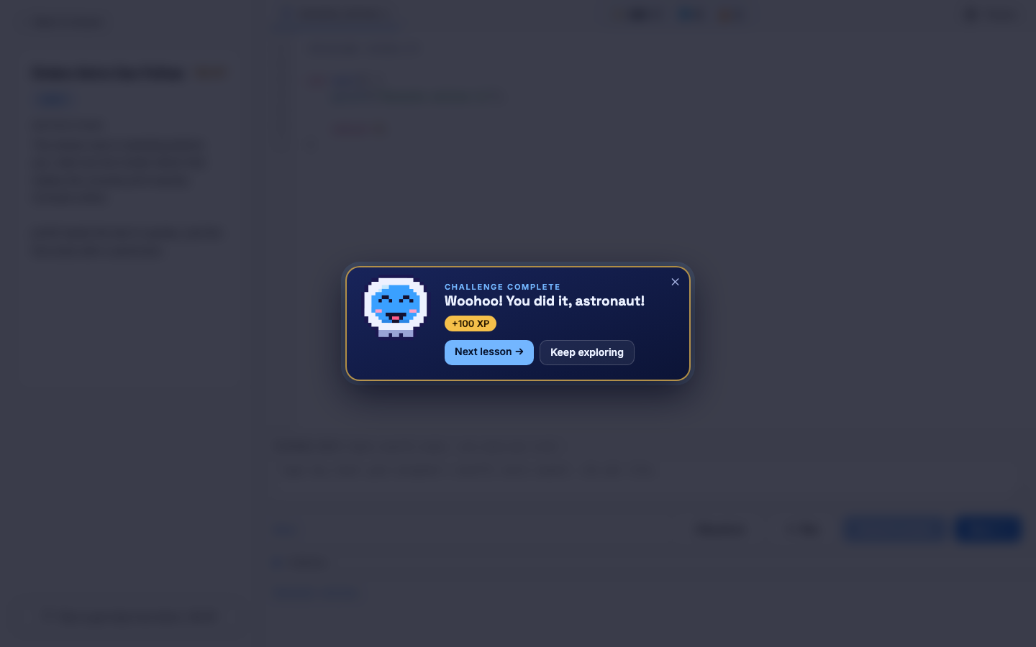
Challenge complete

STUDENT · PART 6

Mini Bosses and the Final Boss
Big exams that open full screen, against the clock. Read the rules before you start one.

Step 22. Beat the Mini Boss at the end of each module
After the last lesson of a module, the Mini Boss unlocks. It has about 30 questions, a 45-minute timer, and a pass mark of 75% (your instructor may change these). Each right answer is +10 XP.
CLASS RULE: You get one try only. Your score is saved for your instructor, and nothing locks: you move on to the next module either way. Leaving full screen ends it as a fail with no XP, and your instructor is told.
Finishing a module also earns you a gem.
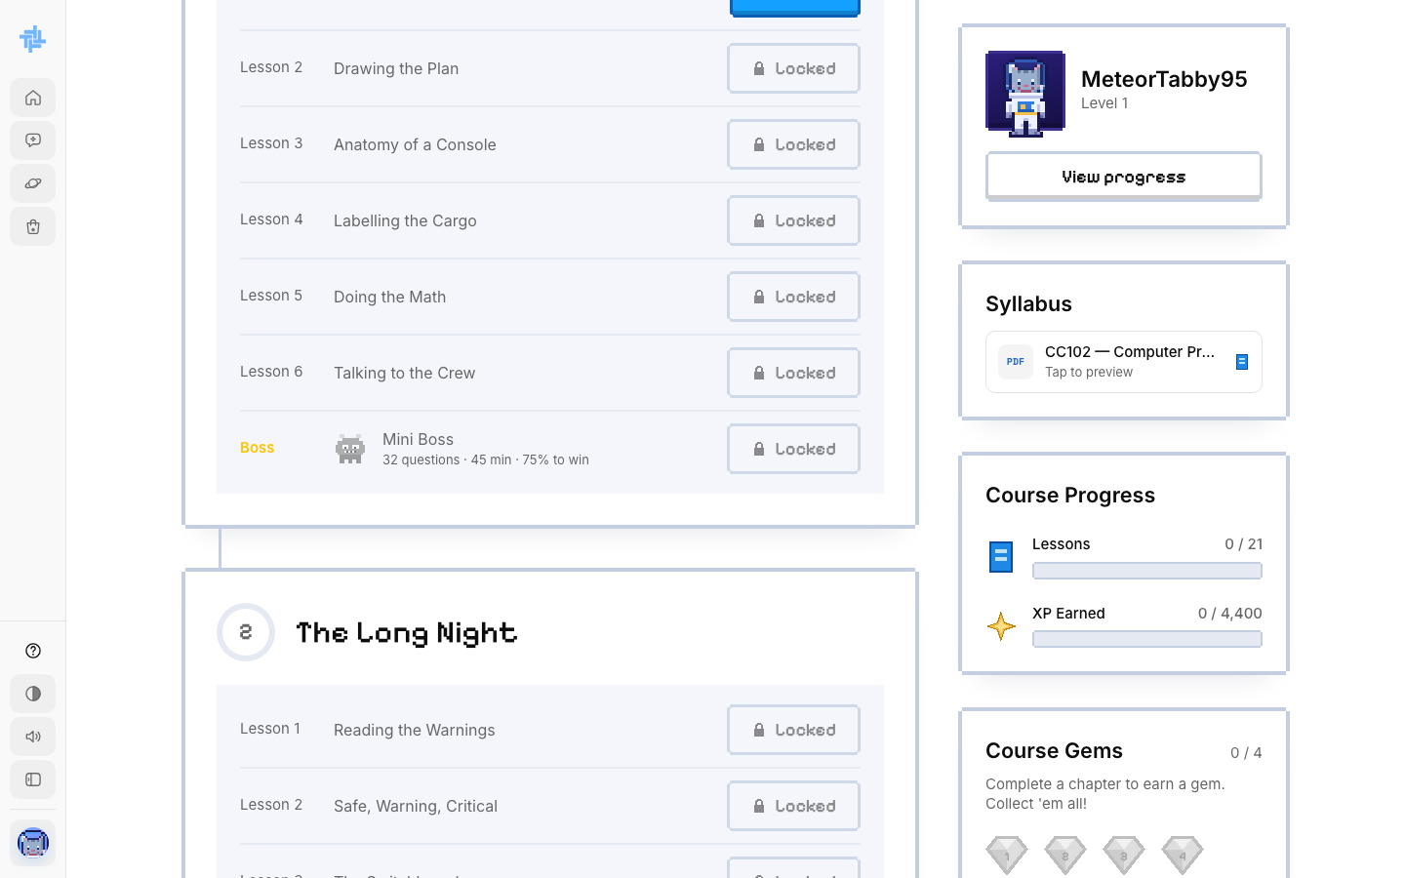
The Mini Boss in a class

Step 23. Face the Final Boss
Clear every chapter and the Final Exam unlocks at the bottom of the course page. In a class, the final is written by your instructor. If they haven't published it yet, you wait until they do.
STRICT RULES: Stay on the exam page the whole time. Switching tabs, leaving full screen or taking a screenshot fails the exam and adds a strike. Two strikes bans you from the final until your instructor allows a retake. Failing the final also resets your course progress, so you redo the course. You only see your score after, not which answers you missed.
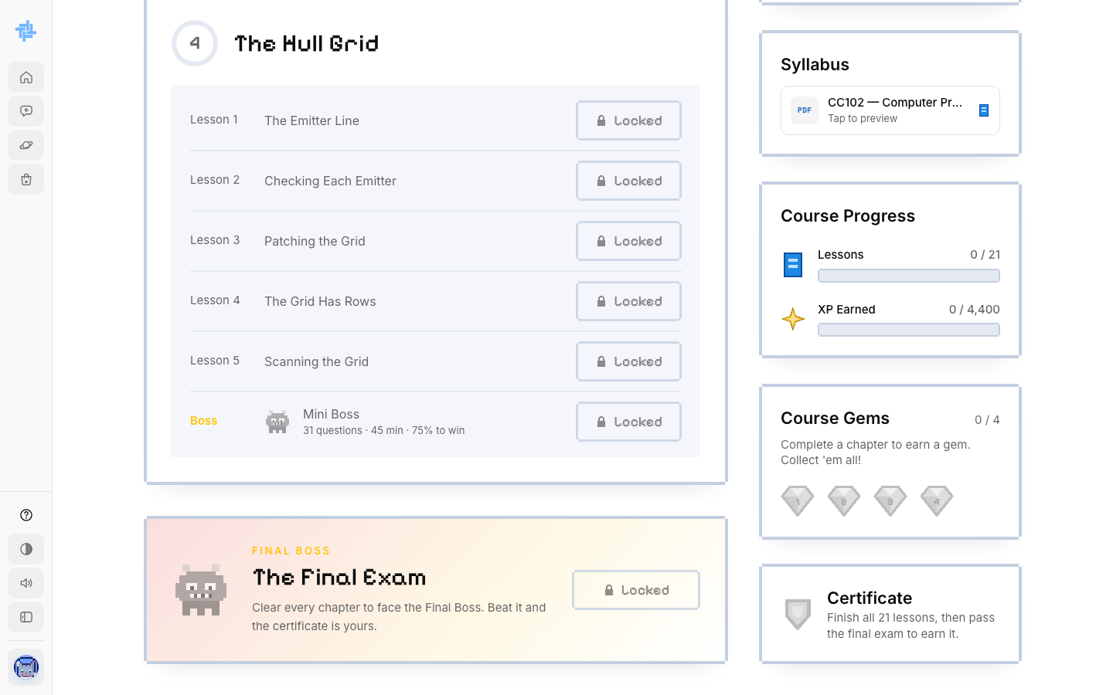
The Final Boss and Certificate box

Step 24. Open your certificate
After you pass the Final Boss, click View certificate in the Certificate box on the course page. It opens as a PDF you can save or print.
Your class certificate shows your name, the course, the date and a certificate number, with your instructor's digital signature and name, under Class Learning.
The name on the certificate comes from your profile. Check it in Settings before you take the Final Boss.
GOOD TO KNOW: A TechLab certificate shows you finished the course on TechLab. It is not yet recognized by schools or the IT industry, and it does not replace school credit or an official industry certification.
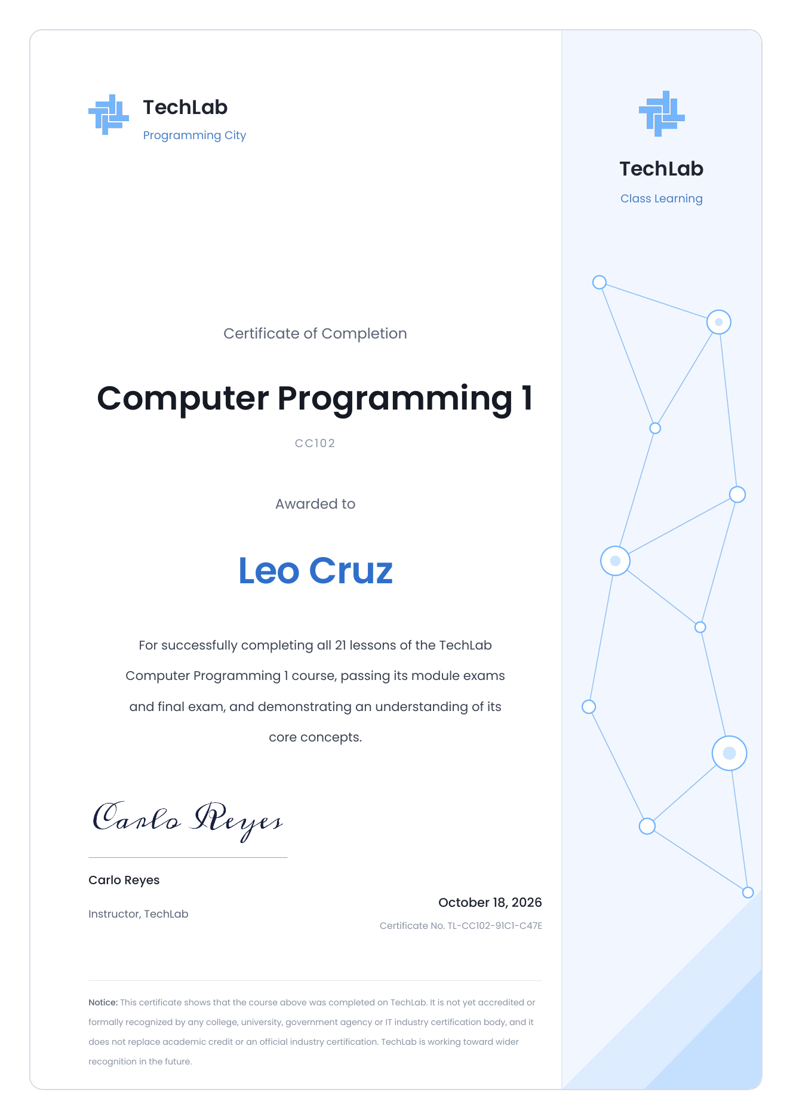
A class certificate, signed by the instructor

STUDENT · PART 7

Ask Astro
Astro is an AI tutor. Ask it to explain anything you are stuck on.

Step 25. Start a chat
Click Chat in the sidebar. Type your question in Ask Astro or create something and press Enter.
Click + to attach a file (PDF, Word, PowerPoint, text or code) or a photo. Up to 4 files, 2 MB each.
You have a set number of free messages, shown under the box. Click New chat to start a fresh topic.
REMEMBER: Astro can be wrong. Don't share passwords or private info. If you see an error, wait a moment and send your message again.
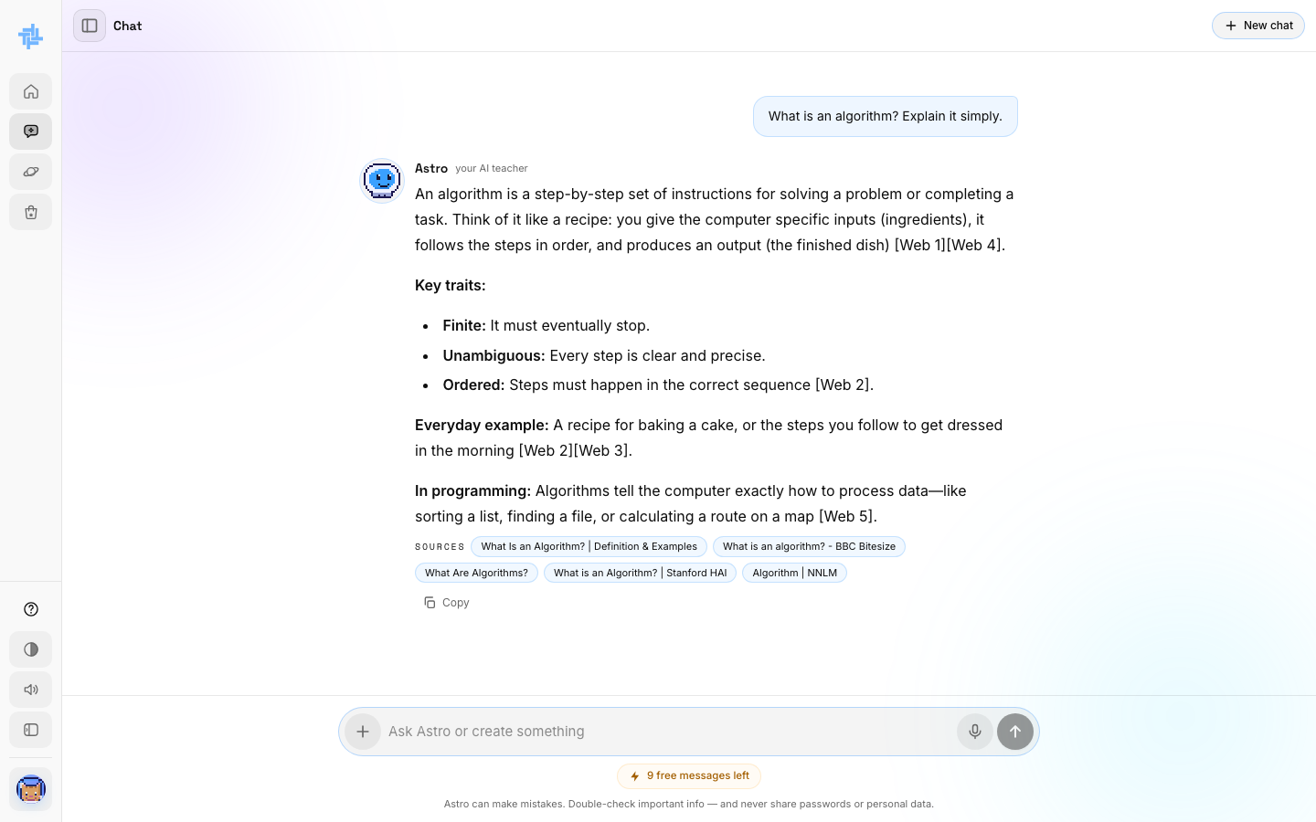
Astro answering a question

STUDENT · PART 8

Planets, XP and the Shop
Learning earns XP and gems. They raise your level and unlock new planets and gear.
You do this | You get
Log in for the day | +10 XP
Right answer in a lesson quiz or Mini Boss | +10 XP
Pass a coding exercise or lab | +100 XP
Finish a module | 1 gem
Trade in the Shop's Gem exchange | 1 gem = 50 XP

Step 26. Unlock new planets
Click Planets. Your first planet is open. The others show what they need to unlock. For example, Networking Nebula needs 500 XP and 3 gems.
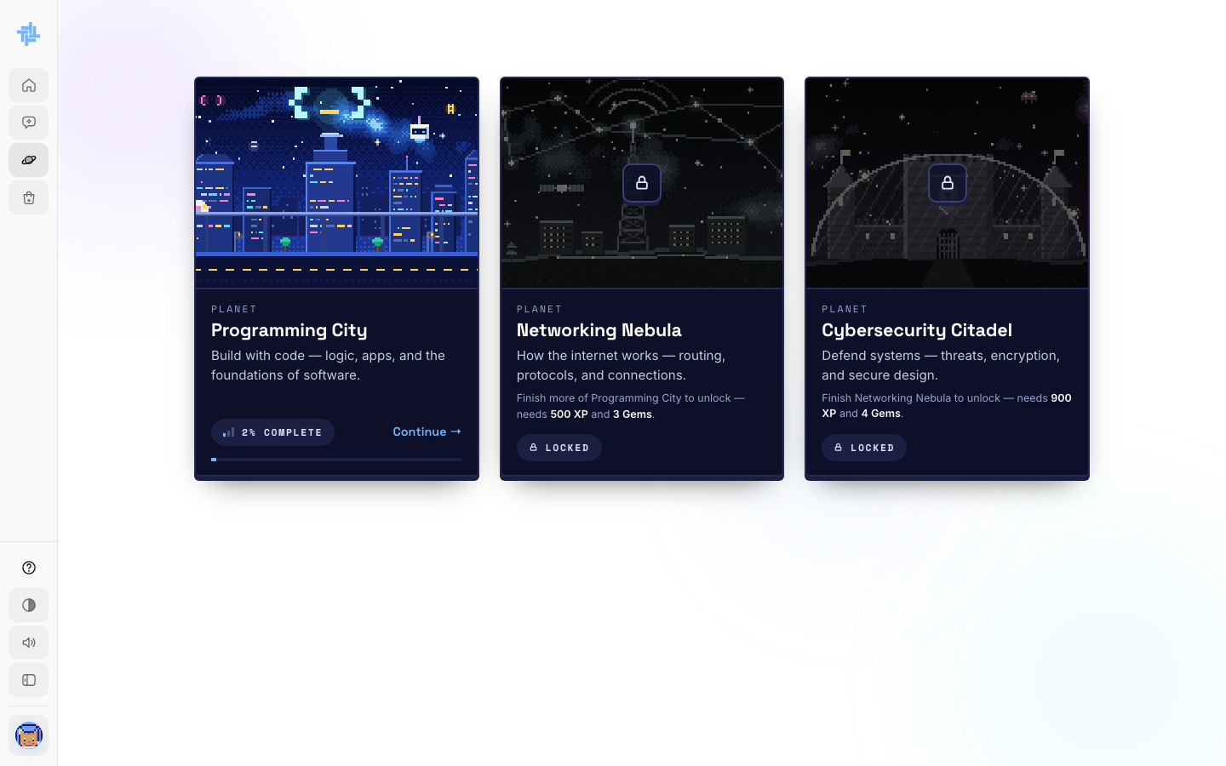
The three planets

Step 27. Spend XP in the Shop
Click Shop. Use the tabs to buy Frames, Animals and Suits, or trade gems in Gem exchange. Spending XP does not lower your level: your level counts all the XP you ever earned.
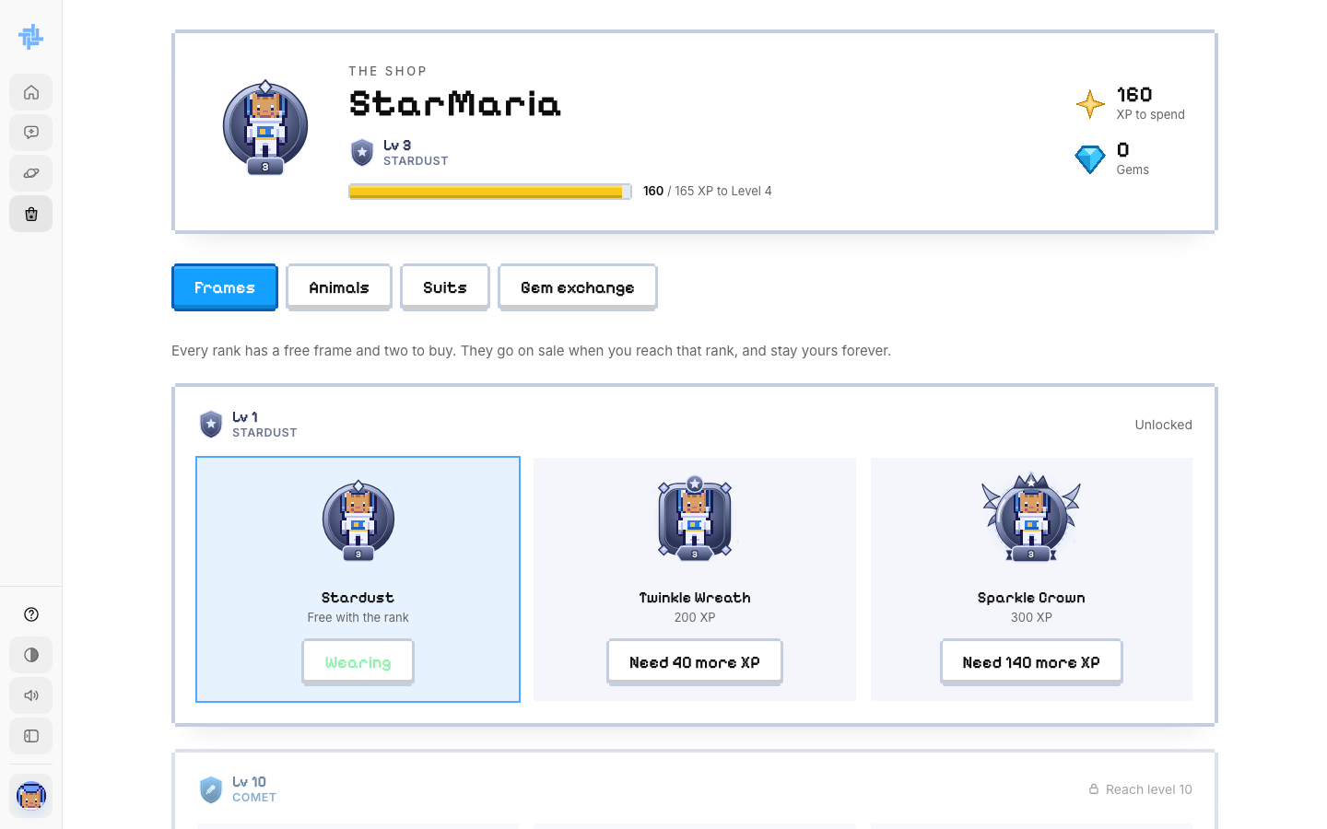
The Shop

Step 28. Check your progress
Click View progress on the dashboard or course page. You see your total XP, day streak, gems, planet rank, active hours and the lesson to continue. Your instructor can see your progress too.
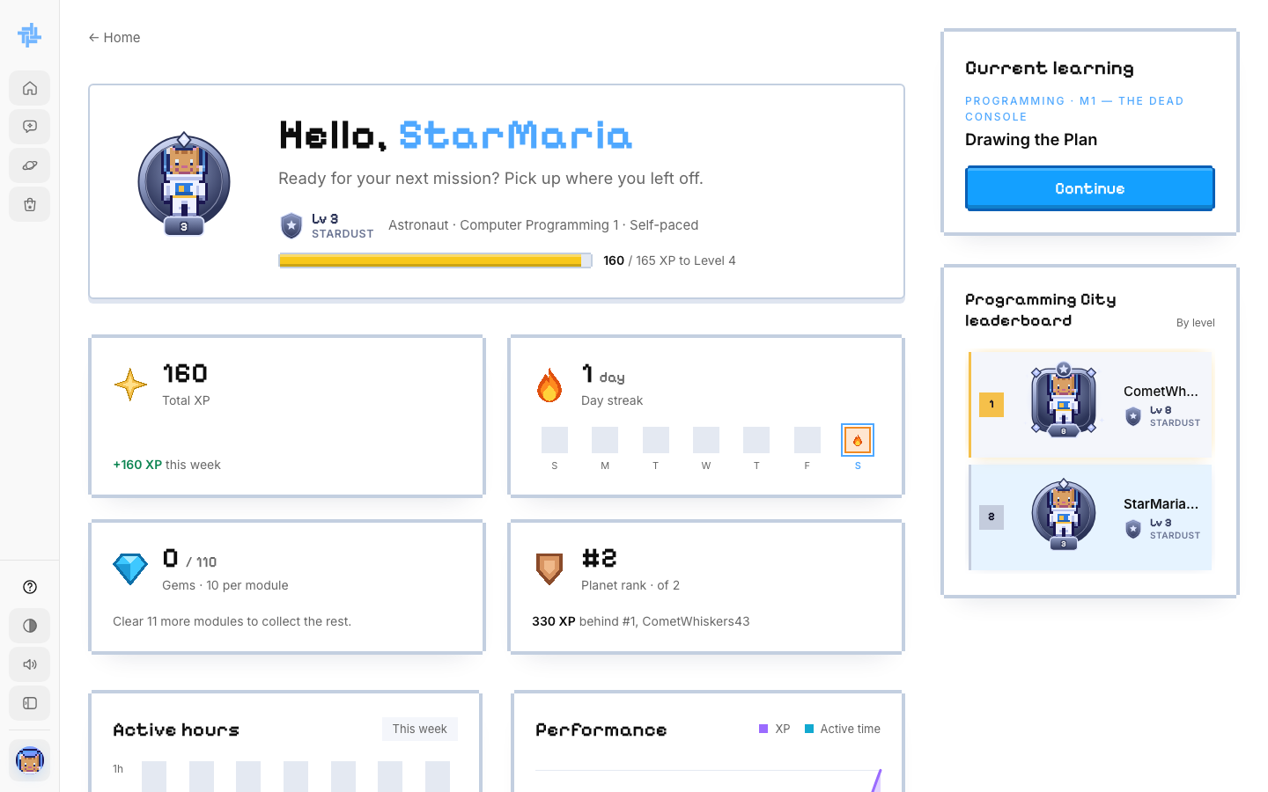
The progress page

STUDENT · PART 9

Settings and logging out
Change your details, your look and your preferences.

Step 29. Open the account menu and settings
Click your avatar at the bottom of the sidebar. Choose Settings or Log out.
- Profile: change your name, program or year, then click Save profile.
- Your astronaut: click Change my astronaut to edit your look or codename.
- Preferences: sound and light mode (saved on this browser only).
- Further down: change your password, or delete your account.
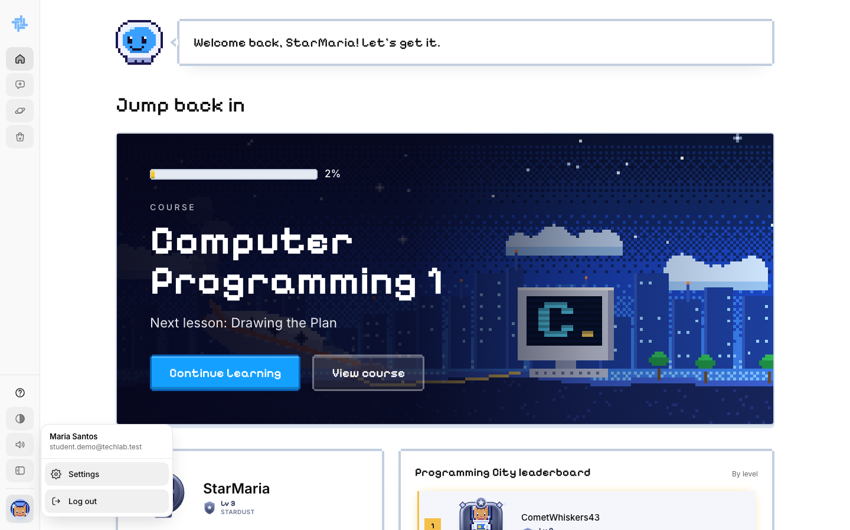
The account menu
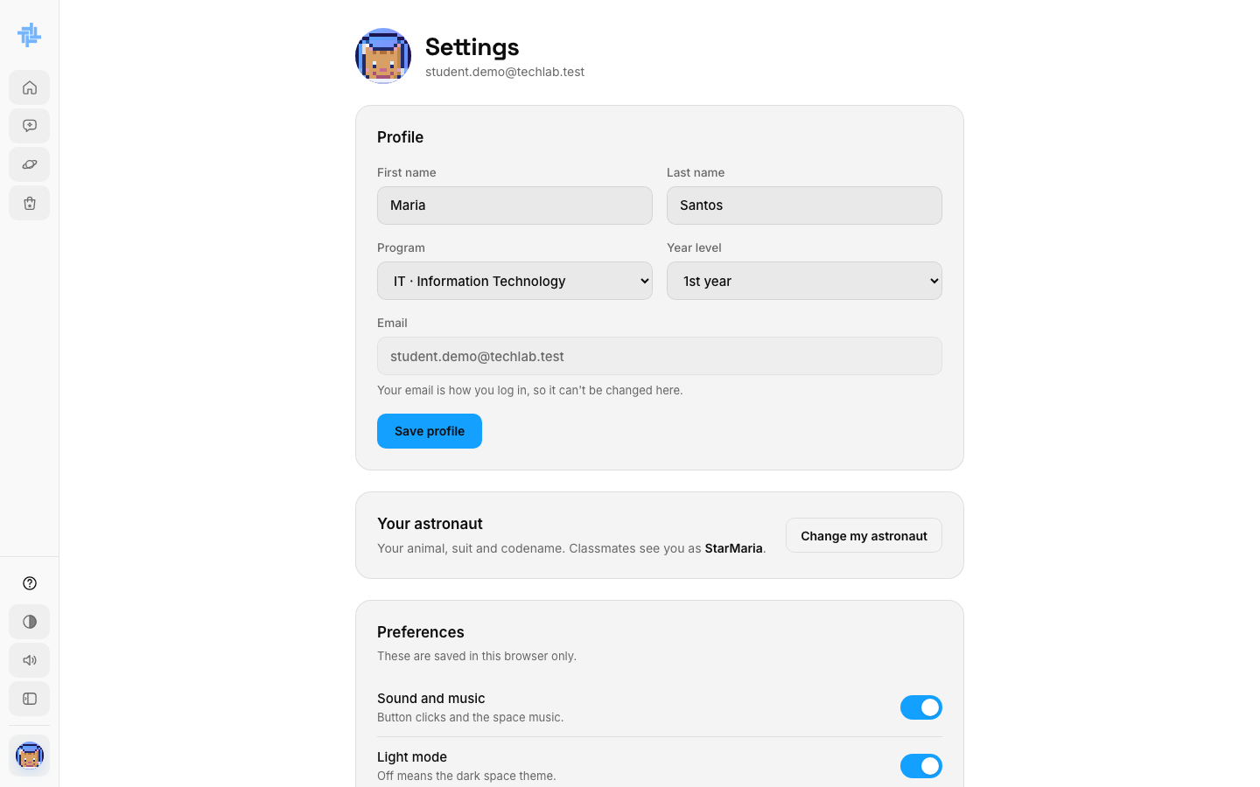
Settings

Step 30. Log back in next time
Go to TechLab and click Log in. Type your email and password, then click Sign in. Forgot your password? Click Forgot password? to get a new one by email.
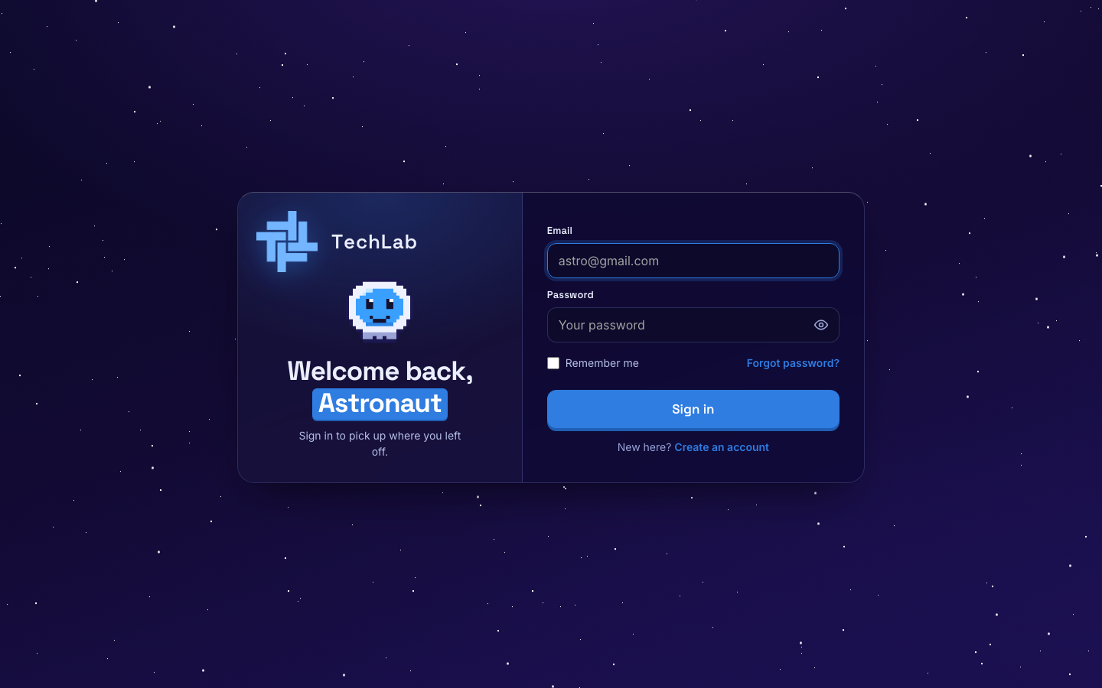
The sign-in page

